Simple rules for plantwide control

See also: Springer Chapter on “control structure design”

Rules for CV-selection:

1. Control active constraints
   * Purity constraint on expensive product is always active (overpurification gives loss):
2. Unconstrained degrees of freedom (if any): Control “self-optimizing” variables (c).

* The ideal variable is the gradient of J with respect to the inputs (Ju = dJ/du), which always should be zero, independent of disturbances d, but this variable is rarely available
  + Exception: Parallel systems (stream split, multiple feed streams/manifold) with given throughput (or given tota gas flow, etc.)
  + Should have equal marginal costs Jiu = dJi/du, so Ju = J1u - J2u, etc.
  + Heat exchanger splits: equal Jächke temperatures, JT1 = (T1 – Th1)^2/(T1-T0)
* In practice, one prefers to control single variables, c=Hy (where y are all available measurements and H is a selection matrix), which are easy to measure and control, and which have the following properties:
  + 1. Optimal value for c is almost constant (independent of disturbances): Want small magnitude of dcopt(d)/dd.
    2. Variable c is sensitive to changes in input: Want large magnitude of gain=dc/du (this is to reduce effect of measurement error and noise).
  + If the economic loss with single variables is too large, then one may use measurement combinations, c=Hy (where H is a “full” matrix).

1. Unconstrained degrees of freedom: NEVER try to control a variable that reaches max or min at the optimum (in particular, never control J)
   * Surprisingly, this is a very common mistake, even (especially?) with control experts

Rules for inventory control (special for process control systems):

1. Radiation rule (PC, LC, FC ++)
2. **Avoid having all flows in a recycle system on inventory control** (this is a restatement of Luyben’s rule of “fixing a flow inside a recycle system” to avoid snowballing)
   1. A special case is a closed system

Rules for pairing:

1. Sigurd’s pairing rule: **“Pair MV that may (optimally) saturate with CV that may be given up”**

•          Reason: Minimizes need for reassigning loops

•          BUT: May be in conflict with other criteria–        Dynamics        Interactions

•          If conflict: Go for multivariable control (MPC)

Example (which is not so interesting really): distillation column where V is used to control btm composition (cheap product). If energy is expensive then xbtm is active, but if energy is cheap that we should have V=max and btm should be overpurified (give up xbtm).

If btm is the expensive product then Sigurd’s rule says that we should use V to control xD and L to control xB (hm…., this is in conflict with dynamics)

Example 1. Heat exchangers in parallel. Cannot control J = T (mix. Temperature which should be maximized)

Example 2. Concentrator case study

A three-stage evaporation process operated at 1 bar is used to concentrate a mixture of water and some heavy impurity (H) from about xHF=50% (feed F) to xHC=70% (product LC). Note that xH should not exceed 70% because of the mixture may self-ignite if it is too concentrated. The feed F is assumed to be given (disturbance). The system has three degrees of freedom (the steam flow to each evaporation step)

MV = [VA VB VC]

The original control system is shown in Figure 1. The steam flow to the first two evaporators (VA, VB) are adjusted so that the steam temperatures on the hot side (TsA, TsB) are kept constant (Footnote: Actually, the control system keeps the steam pressures constant, but this is equivalent to keeping constant steam temperatures constant because the steam is saturated). The steam flow to the third stage (VC) is adjusted to keep a constant ratio between the total steam rate and feed flow (V/F). In summary, the controlled variables are:

CV = [psA, psB, V/F]

The setpoint (V/F)s is adjusted manually by the operators to achieve the desired product concentration (xHC=70%). This system was in operation for several years, but it was found to be troublesome as it required frequent manual adjustments of the setpoints to all three controllers.

We will now go through the first steps of the plantwide procedure and we will find that the three chosen CVs are against all the three given CV-rules.

Step 1. Operational objectives. The objective is to minimize the amount of steam (J=V), subject to satisfying the purity constraint (xH=70%). Note that since the feedrate is given, minimizing V is equivalent to minimizing V/F.

Step 2. Optimal operation. There are 3 steady-state degrees of freedom (VA, VB, VC). Because we are not allowed to overpurify, the purity constraint (xH=70%) is always active. There are then two remaining unconstrained degrees of freedom, so we need to select two self-optimizing variables in step 3. Some obvious candidates are the steam split ratios (VA/V, VB/V, VC/V, where V=SA+VB+VC) and the compositions in the first two stages (xHA, xHB). These are “obvious” because their optimal values are independent of F, which is the main disturbance.

Step 3. Selection of economic Cvs (CV1). Based on the above, one good choice would be CV = [xHA, xHB, xHC), where xHA and xHB are “self-optimizing” variables related to the two unconstrained degrees of freedom and xHC is the active constraint. Compositions are often difficult to measure, but fortunately for a saturated binary mixture with constant pressure, we may use the directly related temperatures, so one may for practical purposes choose CV = [TA, TB, TC]. An alternative involving ratios, could be CV=[VA/V, VB/V, TC].

Analysis of original structure.

The original control structure violates all three CV rules: 1) The active constraint (xHC or TC) is not controlled. 2) The cost function (V/F) is selected as a CV. 3) The steam temperatures (TsA, Tsb) are not “self-optimizing” variables because their setpoints must increase when F increases.

To prove the latter, consider the equation for the heat transferred in stage A: QA = UA (TsA-TA). Here UA is constant and TA is optimally constant. However, QA/F is optimally constant (at least for a given feed composition), which means that we need to increase TsA when F increases, so TsA is not a good “self-optimizing” variable to keep constant.

should be increase when F increases

Proposed control structure

Based on step-wise procedure, we propose to select CV1 = [TA, TB, TC]. The simplest implementation would be to have three temperature controllers that directly manipulate the three manipulated variables, MV = [VA, VB, VC]. However, since the original control system had some desirable features and was trusted by the operators, it was decided to implement a two-layer structure, with the original control system as a “stabilizing” layer, except that the ratio control was changed from controlling V/F to controlling VC/V. The CVs of the “stabilizing” layer are then

CV2 = [TsA, Tsb, VC/V].

The «economic» (supervisory) layer has CV1 = [TA, TB, TC] and uses the setpoints for these variables as degrees of freedom, that is, we have cascade control with MV1 = CV2s. The implemented control system is shown in Figure 2. One

Example 3. Degasser

The objective is to remove as much gas as possible from a liquid a two-stage separation scheme (see Figure). The original control scheme attempted to control the gas fraction in the liquid product, which again is the same as the objective….

MV = V2.

The implemented control scheme is to select CV = [liquid in V2]

Comment: This is a the same as the concentrator example for the case where the total steam is fixed (V) and we want to maximize xH in the product.

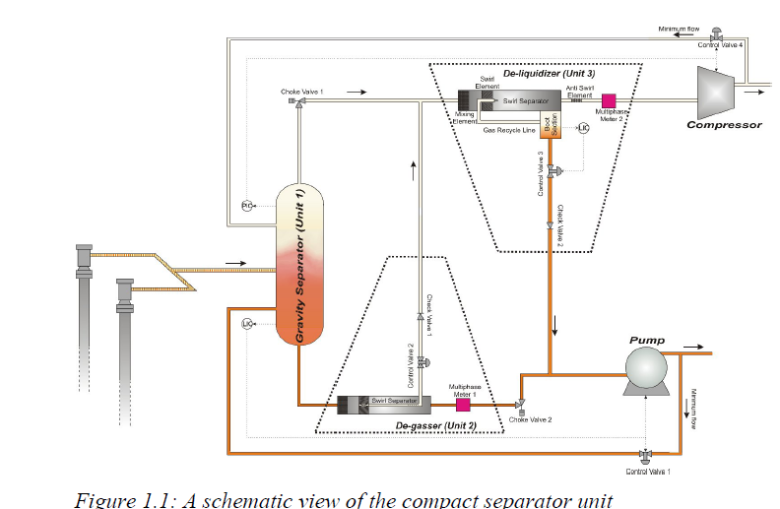

MV=V2

CV(alt.1)=vapor fraction

CV(alt.2)=liquid fraction