Septic Training Course: Lesson 3

Goal:
- Control 4 x Cvr with 5 x Mvr, learn more about tuning and priorities.
- Getting familiar with som more functions in Septic

Preparation

The config file of this lesson is MPC_Del2.cnfg. Some changes from Lesson 2:
- Dvrs Fin, F1, Heat1 and F2 are chenged to Mvrs
- Tvrs L1, T1 and L2 are changed to Cvrs
- An MPC table has been defined in group 7 (MpcTabell display group)

Look through the config file for these changes. Note that L1 and L2 are configured with the parameter Integ= 1, this is necessary for integrating variables like an uncontrolled level. The experimental step response type models assume that the response is steady after the last model coefficient, while an uncontrolled level is (almost) never stable after a flow change, but the level change per time unit is principally stable. So Septic must be told that the level is an integrator such that the model can be made for the time derivative of the level.

Exercise 1: Generate models

First, copy the 3 models from lesson 2 to the subfolder models of øving3. Then make a subfolder adoc and copy the general part of the HTML doc.

Put + or – into the table below where you expect a model between the Mvr/Dvr and the Cvr. A + for positive gain in the model and a - for negativ gain. The starting point is the uncontrolled process.

 | Cvr: L1 | Cvr: L2 | Cvr : T1 | Cvr : T2
Mvr : Fin
Mvr : F1
Mvr : F2
Mvr : Heat1
Mvr : Heat2
Dvr : Tin

Start Septic and make all the models you need by the same method as was used in Lesson 2. The step size for the Mvr/Dvr must be larger that 10% of the Span for the actual variable to be defines as a step, at the same time you should avoid to large flow steps due to the level ranges. Remember Apply to activate and file save of the models. Write the resulting steady state process gain in the table below, for L1 and L2 that means gains against the time derivatives. Compare to your expected + and - before starting and comment.

 | Cvr: L1 | Cvr: L2 | Cvr : T1 | Cvr : T2
Mvr : Fin
Mvr : F1
Mvr : F2
Mvr : Heat1
Mvr : Heat2
Dvr : Tin

Exit Septic.

Exercise 2: Verify models

Theory/motivation

The experimental step response models are linear. This means that Septic will use them in all process states and simply scale the expected responses according to the changes in the Mvrs and Dvrs. Septic will also use the principle of superposition, which means that the resulting Cvr response is the sum of the individual responses to each Mvr/Dvr. Most often, such models will be good enough for control purposes.

If we know the process nonlinearities, some nonlinear compensation can be done by changing the model gains and sometimes also the model dynamics dependent on the process state. This can be easily realized in Septic and is used in some real applications. Examples:

- A Cvr for the controller output (valve) to keep the basic control loop unsaturated but at the same time almost fully open. This gives very different responses over the valve range.
- A Cvr for delta P in a distillation column to avoid flooding but still maximize up to that point. Relatively small changes can give large responses close to the flooding limit.

Strong process nonlinearities may call for a mechanistic model based on fundamental mass, energy and reaction balances. Septic can use such models (as we do in several blending applications at the moment). For our simulated process we might use a similar model in the MPC application as in the process.

Exercise

Copy the event series below into the config file:

Event: MPC_Del2 N= 10 Cmd= "/Appls/MPC_Del2/Dvrs/Tin.DeasOn= 50"
Event: MPC_Del2 N= 50 Cmd= "/Appls/MPC_Del2/Dvrs/Tin.DeasOn= 40"
Event: MPC_Del2 N= 100 Cmd= "/Appls/MPC_Del2/Mvrs/Heat1.DeasOn= 40"
Event: MPC_Del2 N= 180 Cmd= "/Appls/MPC_Del2/Mvrs/Heat1.DeasOn= 50"
Event: MPC_Del2 N= 260 Cmd= "/Appls/MPC_Del2/Mvrs/Heat2.DeasOn= 20"
Event: MPC_Del2 N= 340 Cmd= "/Appls/MPC_Del2/Mvrs/Heat2.DeasOn= 30"
Event: MPC_Del2 N= 420 Cmd= "/Appls/MPC_Del2/Mvrs/Fin.DeasOn= 15"
Event: MPC_Del2 N= 420 Cmd= "/Appls/MPC_Del2/Mvrs/F1.DeasOn= 15"
Event: MPC_Del2 N= 420 Cmd= "/Appls/MPC_Del2/Mvrs/F2.DeasOn= 15"
Event: MPC_Del2 N= 510 Cmd= "/Appls/MPC_Del2/Dvrs/Tin.DeasOn= 50"
Event: MPC_Del2 N= 550 Cmd= "/Appls/MPC_Del2/Dvrs/Tin.DeasOn= 40"
Event: MPC_Del2 N= 600 Cmd= "/Appls/MPC_Del2/Mvrs/Heat1.DeasOn= 40"
Event: MPC_Del2 N= 680 Cmd= "/Appls/MPC_Del2/Mvrs/Heat1.DeasOn= 50"
Event: MPC_Del2 N= 760 Cmd= "/Appls/MPC_Del2/Mvrs/Heat2.DeasOn= 20"
Event: MPC_Del2 N= 840 Cmd= "/Appls/MPC_Del2/Mvrs/Heat2.DeasOn= 30"

Save the config, and start Septic. Simulate 1000 steps with activated events.

Explain the process / model deviations for T1 and T2. Paste the expanded T1 plot below.
ANSWER: Expanded T1 plot, explanation of model discrepancy for T1 and T2.

Exit Septic, remove the event series from the config file and save the config.

Exercise 3: Modelling with process noise

Copy the noise prosess from lesson 2 into your current config file (at the correct place):

NoisProc: Noise
NoisXvr: NOIS
Text1= ""
Text2= ""
SgnlVldt= OFF
SgnlHigh= 1e+010
SgnlLow= -1e+010
Sine= OFF
SineT= 5
SineA= 0.1
BiasA= 0
Ramp= OFF
RampR= 0
RampMaxA= 0
Wite= ON
WiteMaxA= 2
Iwite= ON
IwiteMaxA= 0.2
Filt= ON
FiltT1= 1

DmmyAppl: Calc
Nhist= 1000
Npred= 0

Tvr: NOIS PlotMax= 10 PlotMin= -10 Meas= 0

CalcModl: CalcMod
CalcPvr: T2 Alg= "T2+NOIS"

Then copy/paste the event series below into the bottom of the config file:

Event: MPC_Del2 N= 10 Cmd= "/Appls/MPC_Del2/Mvrs/Heat1.DeasOn= 53"
Event: MPC_Del2 N= 130 Cmd= "/Appls/MPC_Del2/Mvrs/Heat1.DeasOn= 47"
Event: MPC_Del2 N= 260 Cmd= "/Appls/MPC_Del2/Mvrs/Heat1.DeasOn= 55"
Event: MPC_Del2 N= 400 Cmd= "/Appls/MPC_Del2/Mvrs/Heat1.DeasOn= 49"
Event: MPC_Del2 N= 510 Cmd= "/Appls/MPC_Del2/Mvrs/Heat1.DeasOn= 46"
Event: MPC_Del2 N= 650 Cmd= "/Appls/MPC_Del2/Mvrs/Heat1.DeasOn= 55"
Event: MPC_Del2 N= 800 Cmd= "/Appls/MPC_Del2/Mvrs/Heat1.DeasOn= 50"

Save the config and start Septic. Activate events and simulate 1000 steps. The simulation is faster when fewer variables are displayed, so you can expand T2 when simulating.

Change to Plot 5, fetch the T2_Heat1 model, and expand it. Make a new model based on the last step in Heat1 (LastStepResponse). It picks all the noise, and the picture should look at least almost like that below:

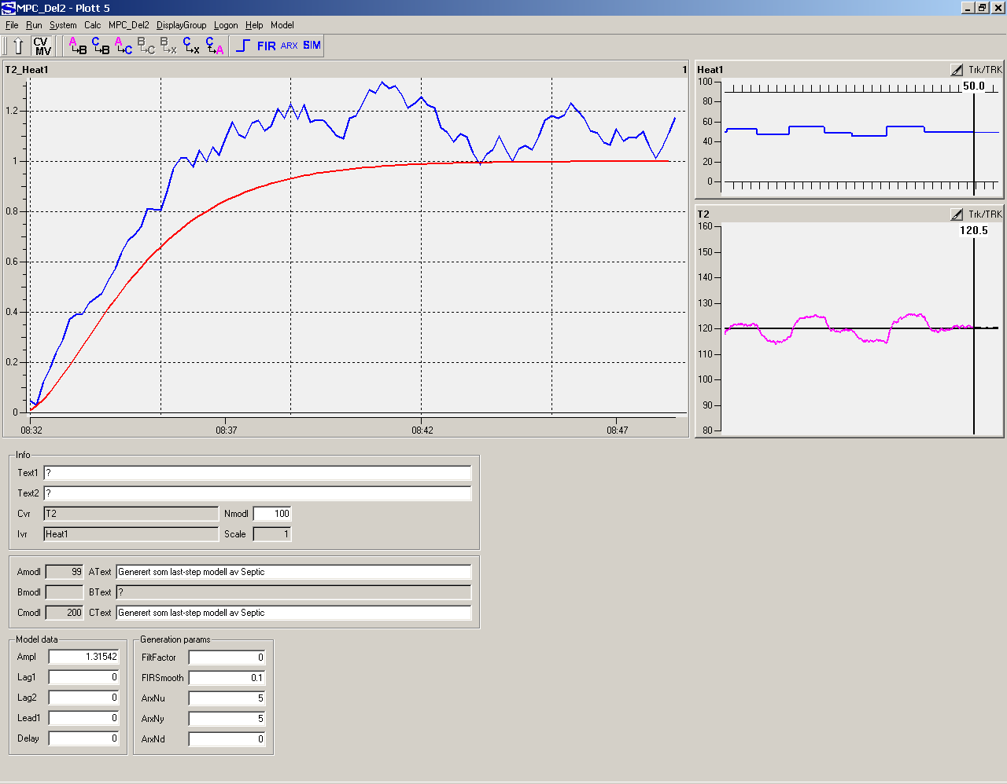

The match of this model to the whole data window can be found by pressing Sim in the Toolbar, that function simulates the Cmodl with the historical Heat1 as input. Do this, and you will get the plot below:

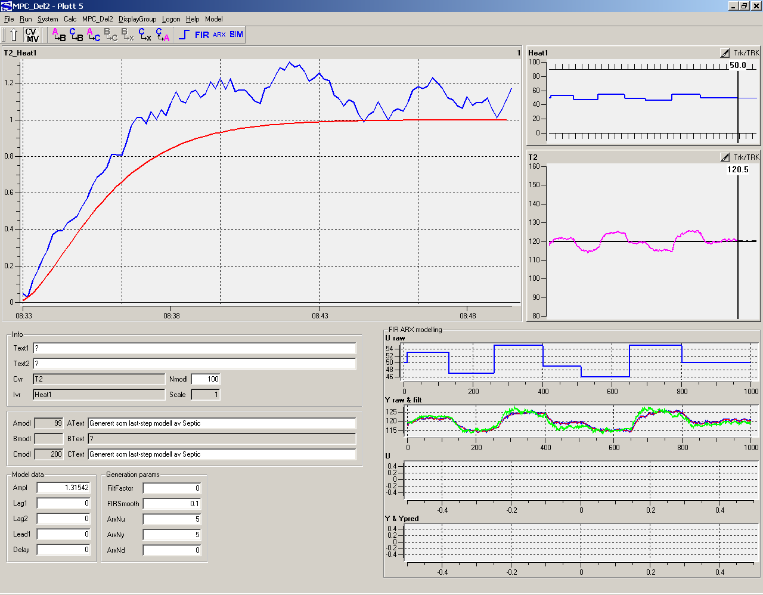

The green curve in the window ”Y raw & filt” is the simulated response.

Then make a FIR model (use Toolbar). After a while you get a new blue model that may be better than the LastStepResponse model, but not that perfect as the red active model made from a noise-free simulation. Septic has calculated 100 model coefficients such that the model is the "best" representation of the measured response in the entire window, that is based on all steps in Heat1. Septic has only the visible history available since data is stored in a circular buffer.

This way of modelling works reasonably well when there are no changes in other variables that affects T2 in between the Heat1 steps. Paste the expanded T2_Heat1 plot below.

Exit Septic. Open the config file and remove what you copied to do this exercise (noise and event series). Save the cleaned config file.

Exercise 4: Control a 2x2 system, weights and priorities

Heat 1 and Heat 2 shall be used to control T1 and T2.

Preparation

Open the config file, change the tuning parameters according to what you realized in Lesson 2. Concentrate on the variables that are to be activated (Heat1, Heat2, T1, T2). NOTE: Always a space between the keyword (e.g. "Fulf=") and the value you specify. Change Mode from TRACKING to ACTIVE for the 4 variables, and DesMode from TRACKING to ACTIVE for SmpcAppl. Save the config file.

Start Septic and exit again. Open MPC_Del2.out in a text editor and verify that there are no error messages. Call for assistance if there are any error messages.

Exercise

Start Septic. Simulate, change T1 and T2 set points and evaluate the responses. Tune if you are not satisfied, also impose som changes to the disturbance Tin. If you want to challenge the model errors yu can do so but still try to keep the levels within limits. If you change tuning, remember to update the config file so you get a correct restart.

Enter Explorer and browse the SepticDetails.html that you find on the adoc folder. Read carefully chapter 2 (priorities). Call the instructor to have it presented in English.

Lower Heat2 high limit to 40. Change T1 set point to 90 and T2 set point to 140. Simulate 100 steps. What happens and why?

Then double Fulf for T2. Simulate 100 steps more, describe what happens and why.

Change T2 Fulf back again. Change T1 SetPntPrio to 10. Change T2 SetPntPrio to 5. Simulate 100 steps, describe what happens and why.

Activate T1.High and then change it to 95. Change T1.HighPrio= 10. Simulate 100 steps, desribe what happens and why.

Change T1.HighPrio to 5. Simulate 100 steps, describe what happens and why.

Change T1.HighPnlty from 5 to 2.5. Simulate 100 steps, describe what happens and why.

Change T1.HighPrio to 3. Simulate 100 steps, describe what happens and why.

Paste a GUI plot for Plott 5 that shows Heat1, Heat2, T1 and T2 below.

Change Heat2.High to 90 and T2.SetPnt to 120. Simulate 100 steps.

Activate and set Heat2.Iv = 60. There are now 3 ”set point type" specifications you want to achieve (T1.SetPnt= 90, T2.SetPnt= 120, Heat2.Iv= 60). If you disregard high and low limits, can all the desired values be fulfilled?

Simulate 100 steps and comment.

Now you are going to realize a hierarchy of priorities as below (highest priority from the top):
- Respect T1 high limit
- Achieve T2 set point
- Achieve Heat2 ideal value
- Achieve T1 set point

When you have done the appropriate changes, simulate 100 steps. Change Heat2.Iv to 10 and simulate 100 steps more. Did you achieve the priorities you wanted?

Paste Plott 5 below. Exit Septic.

Exercise 5: Control of total system, defining sub-applications

You will now make a complete controller for:
- Mvr: Fin, F1, F2, Heat1, Heat2
- Cvr: L1, L2, T1, T2
- Dvr : Tin

NOTE: Lack of time? Then it is possible to rename MPC_Del2.cnfg to any other name, and then rename MPC_Del2_oppg5.cnfg to MPC_Del2.cnfg. "MPC_Del2_oppg5.cnfg" has the priorities and the sub-applications (see below) implemented already, and some initial tuning for the level control as well. It has not been optimized with respect to temperature control.

The following control objectives shall be attained in prioritized sequence:

- Fin maximum ROC (Rate Of Change) 0.1 T/H per execution (10 s).
- Levels L1 and L2 below 80% and above 20% (PSD 90% and 10%), should be driven towards 50% to keep disturbance buffer capacity.
- T1 below 95 degrees due to equipment.
- T2 at 120 degrees (downstream requirement), standard deviation < 0.2 degrees.
- Maximize Fin (but <= 15 T/H).
- T1 at 93 degrees. Heat1 is cheaper than Heat2, but wants to back-off the 95 degrees limit to reduce the probability to cross the limit due to disturbances.
- Reduce F2 variations, rapid changes not good for downstream process. Dynamically it can be allowed to reach 18 T/H.

The controller shall be split in 2 sub-applications ("Gruppeinndeling" and "kritiske variable" in the HTML doc, or call the instructor):

- Temperature control: T1, T2, Heat1 and Heat2 must be active for this to work.
- Level control: L1, L2, F1 and F2 must be active for this to work. Fin shall not be ACTIVE if the level control is inactive.

Assure that the config and tuning changes you are doing are reflected on the config file when you finish this exercise.

Familiarize with the Mpc Table in plot group MpcTabell.

The answer to this exercise is a GUI picture of MpcTabell and one of the Prosess (plot 1) that shows your historic changes to verify that your priorities are correct. Paste both below.

Make sure the config file is updated. Exit Septic.

Paste the event series below into the config file:

Event: MPC_Del2 N= 10 Cmd= "/Appls/MPC_Del2/Mvrs/Fin.HighOn= 15"
Event: MPC_Del2 N= 10 Cmd= "/Appls/MPC_Del2/Mvrs/Fin.LowOn= 5"
Event: MPC_Del2 N= 10 Cmd= "/Appls/MPC_Del2/Mvrs/Heat1.HighOn= 80"
Event: MPC_Del2 N= 10 Cmd= "/Appls/MPC_Del2/Mvrs/Heat1.LowOn= 0"
Event: MPC_Del2 N= 10 Cmd= "/Appls/MPC_Del2/Mvrs/F1.HighOn= 21"
Event: MPC_Del2 N= 10 Cmd= "/Appls/MPC_Del2/Mvrs/F1.LowOn= 2"
Event: MPC_Del2 N= 10 Cmd= "/Appls/MPC_Del2/Mvrs/Heat2.HighOn= 80"
Event: MPC_Del2 N= 10 Cmd= "/Appls/MPC_Del2/Mvrs/Heat2.LowOn= 10"
Event: MPC_Del2 N= 10 Cmd= "/Appls/MPC_Del2/Mvrs/F2.HighOn= 18"
Event: MPC_Del2 N= 10 Cmd= "/Appls/MPC_Del2/Mvrs/F2.LowOn= 2"
Event: MPC_Del2 N= 10 Ncycle= 1000 Cmd= "/Appls/MPC_Del2/Dvrs/Tin.Mode= STOPPED"
Event: MPC_Del2 N= 400 Ncycle= 1000 Cmd= "/Appls/MPC_Del2/Dvrs/Tin.DeasOn= 25"
Event: MPC_Del2 N= 500 Ncycle= 1000 Cmd= "/Appls/MPC_Del2/Dvrs/Tin.DeasOn= 55"
Event: MPC_Del2 N= 600 Ncycle= 1000 Cmd= "/Appls/MPC_Del2/Dvrs/Tin.DeasOn= 40"
Event: MPC_Del2 N= 700 Ncycle= 1000 Cmd= "/Appls/MPC_Del2/Dvrs/Tin.Mode= TRACKING"
Event: MPC_Del2 N= 710 Ncycle= 1000 Cmd= "/Appls/MPC_Del2/Dvrs/Tin.DeasOn= 25"
Event: MPC_Del2 N= 810 Ncycle= 1000 Cmd= "/Appls/MPC_Del2/Dvrs/Tin.DeasOn= 55"
Event: MPC_Del2 N= 910 Ncycle= 1000 Cmd= "/Appls/MPC_Del2/Dvrs/Tin.DeasOn= 40"
Event: MPC_Del2 N= 1010 Cmd= "/Appls/MPC_Del2/Mvrs/Heat2.HighOn= 50"

Ncycle= 1000 for some of the events give a cyclic activation of those with 1000 steps interval.

Restart Septic, activate events, simulate 1000 steps, and then 1000 steps more. Then you can change Heat2.High as you want and continue simulation if you want to tune for improved control. When you are satisfied, update the config file, restart Septic, activate the events and paste 2 pictures that shows the performance for the first 1000 steps and the last 1000 steps respectively.

And that ends the standard lessons. Exit Septic.

If you have spare time, you may:

- Read about SetpTref and IvROC in the HTML doc, test it in your application.
- Add meas noise to T2 and T1, simulate and tune with events on
- Repeat whar you have done and learnt
- Move on to lesson 4 that has a configuration similar to MPC_Del2_oppg5.cnfg but with a mechanistic application model instead of experimental models.

