Septic Training Course: Lesson 2

Goal:
- Control T2 by Heat2, with disturbance feedforward from Tin and Heat1
- Getting familiar with some more functions in Septic

Terminology

In Exercise 1 we changed som input variables to get responses to temperature and level in the two tanks. All the input variables were defined as Dvr (disturbance variable) in the configuration file. This was done because Septic internally in simulation mode only transfers the value of two types of variables from the application (in this case DmmyAppl: SimInOut) to the simulated process.

Throughout this exercise you will get to know the following types of variables:

- Mvr (Manipulated variable)
- Dvr (Disturbance variable)
- Cvr (Controlled variable)
- Tvr (Trend variable)

Briefly, an MPC controller like Septic will actively use all available manipulated variables to control the controlled variables optimally according to modelled responses and the control objectives, while at the same time compensating optimally for the measured disturbances in a feedforward manner.

When Septic controls a real process, it first collects the measurements, then uses the models in the computation of new manipulated variables and writes those back to the DCS. With the simulator environment we use here also a change of a Dvr will affect the process as was evident in the previous lesson.

Configuration changes from lesson 1

The configuration file to be used here is MPC_Del1.cnfg. On that file we have changed the DmmyAppl: SimInOut to SmpcAppl: MPC_Del1. We have also changed T2 from a Tvr to a Cvr type of variable and Heat2 from a Dvr to an Mvr type of variable. We have also defined an ExprModl: mdl4expr. Open the config file and that from Lesson 1 (SimProsess.cnfg) in an editor and go through both of them to recognize the differences.

The configured variables (Mvr, Cvr, Dvr and Tvr variables) and (the empty) model ExprModl: mdl4expr are objects that belong to SmpcAppl: MPC_Del1. You will observe that later in the Septic GUI.

Close the files again.

Startup and getting more familiar with menus

Start Septic with the shortcut SimMPC_Del1. Choose Run/100 steps. Choose DisplayGroup/Manipulerte, DisplayGroup/Forstyrrelser, DisplayGroup/Regulerte og DisplayGroup/Meldinger in sequence (changing plot groups).

Choose DisplayGroup/Plott 5. This is empty. Choose MPC_Del1/Cvrs/T2 as shown below. T2 will then appear in Plott 5.

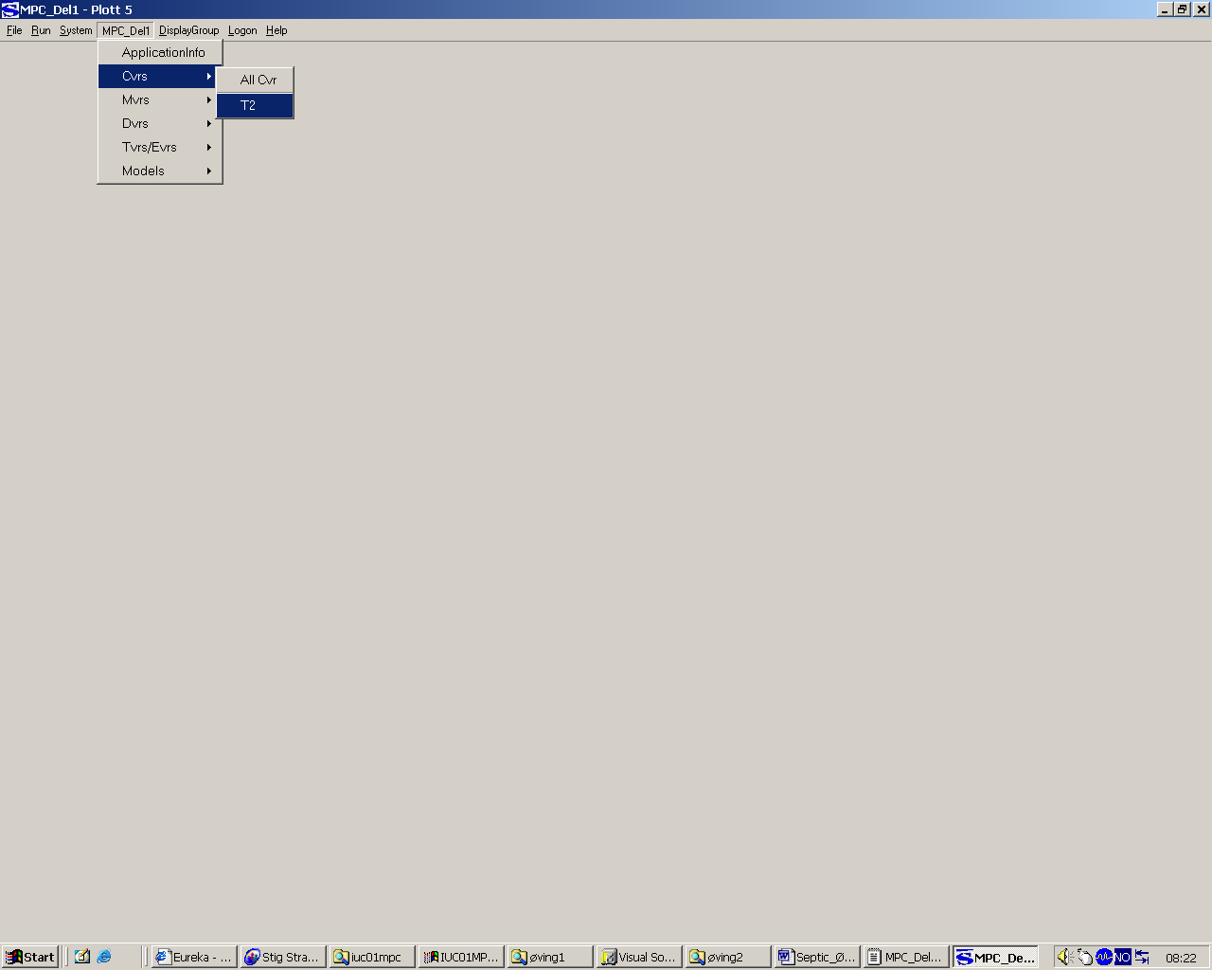

Now we want to add more plots to this display, but with a special structure. Enter the menu DisplayGroup/Group/Grid.., and set Rows= 3 and Cols= 3. Press OK or Enter and your display looks like:

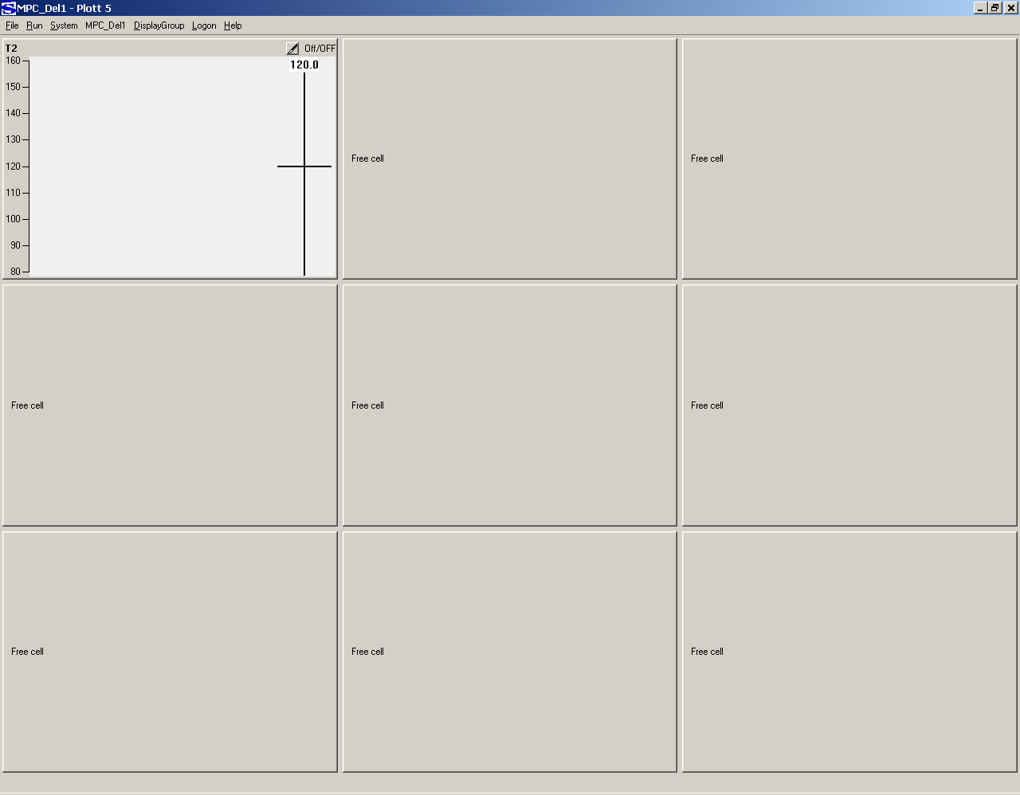

We want to move T2 to row 2 and column 3. Just click and drag the label T2 and drop it in the correct grid point. Ask if it doesn't work.

Put Heat2 into (1,1), Tin into (2,1), Heat1 into (3,1). You find these variables under MPC_Del1/Mvrs or MPC_Del1/Dvrs. Put the model against T2 from Heat2 to (1,2). You get this by MPC_Del1/Models/T2/T2_Heat2. Put the models against T2 from Tin and Heat1 to (2,2) and (3,2). The models are empty at the moment but you will generate them soon. Then your display should look like:

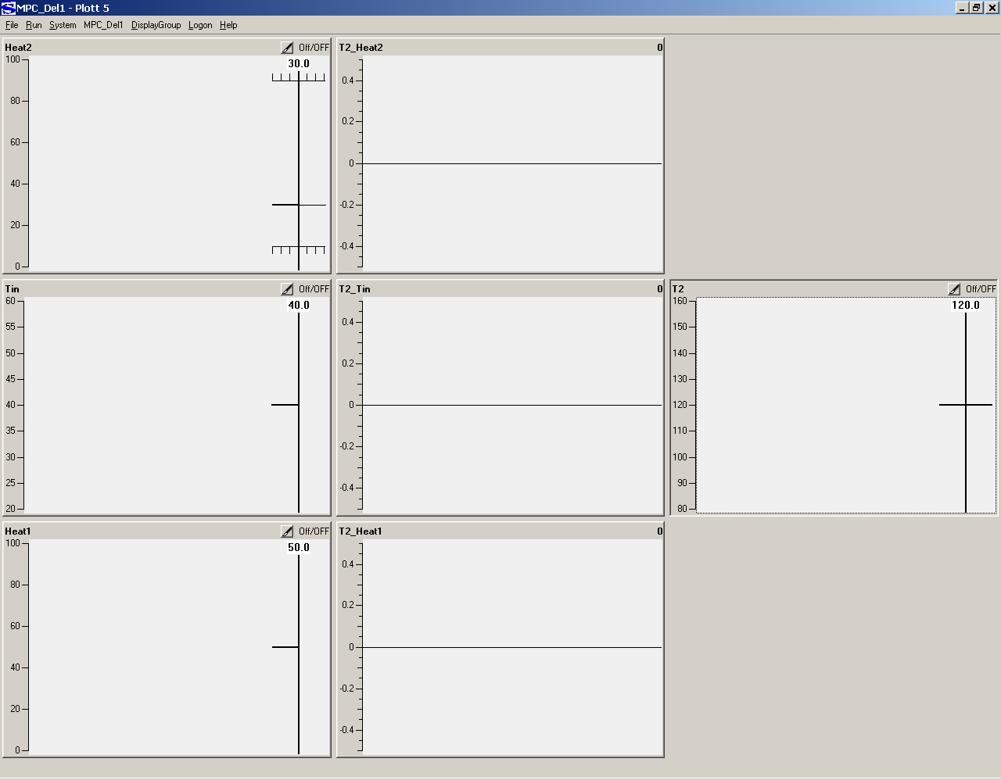

Exercise: Experimental modelling

Change Heat2 from 30 to 35 and simulate 100 steps. Observe the T2 response, look for more details by double-clicking the T2 window and then back to the main display again. Has T2 become constant at the new value after the dynamic transient? If so you are ready to model the response from Heat2 to T2.

Before you proceed, verify that your display looks like the one below.

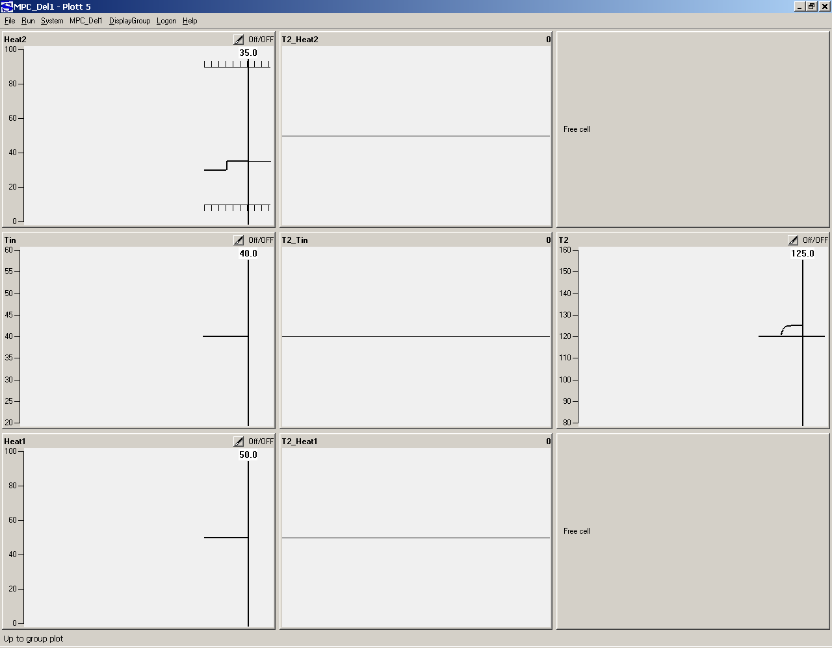

Double click in the T2_Heat2 window, and press the blue step-function 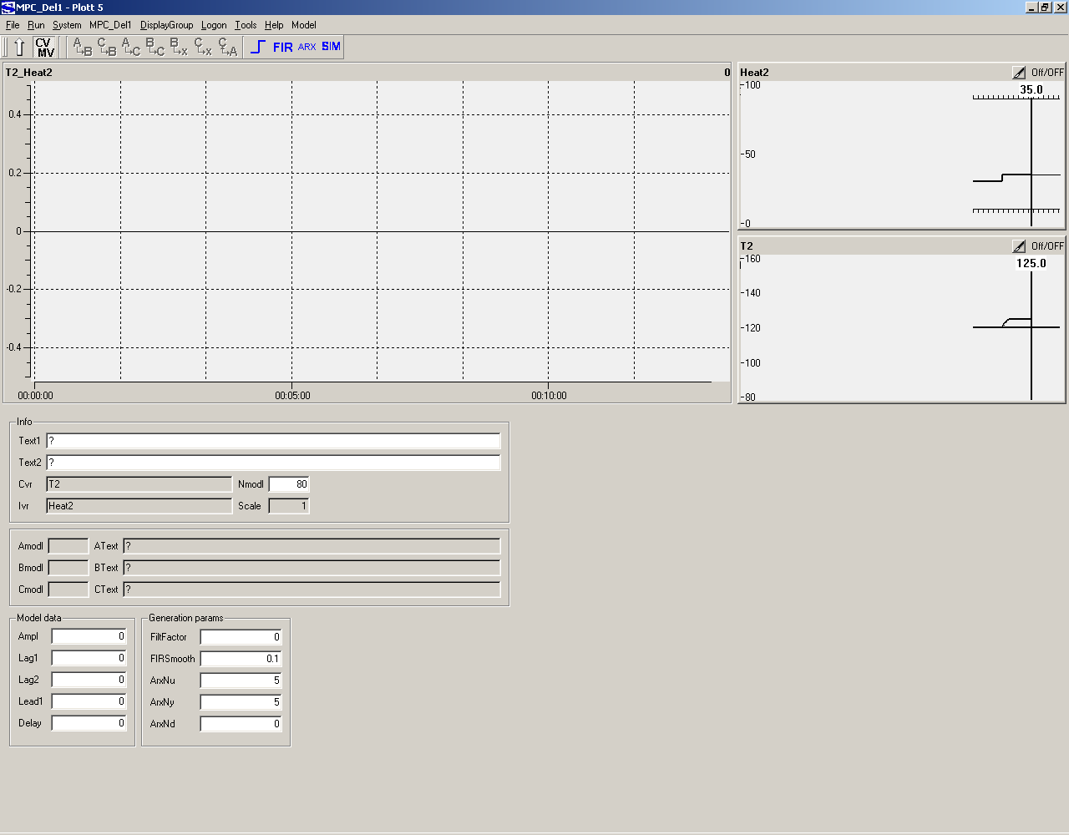 in the toolbar. First you can move the mouse pointer across the different toolbar symbols to se which functions are offered. When you have pressed the step function button your display will look like that below. Some more functions can now be chosen. Look what they do.
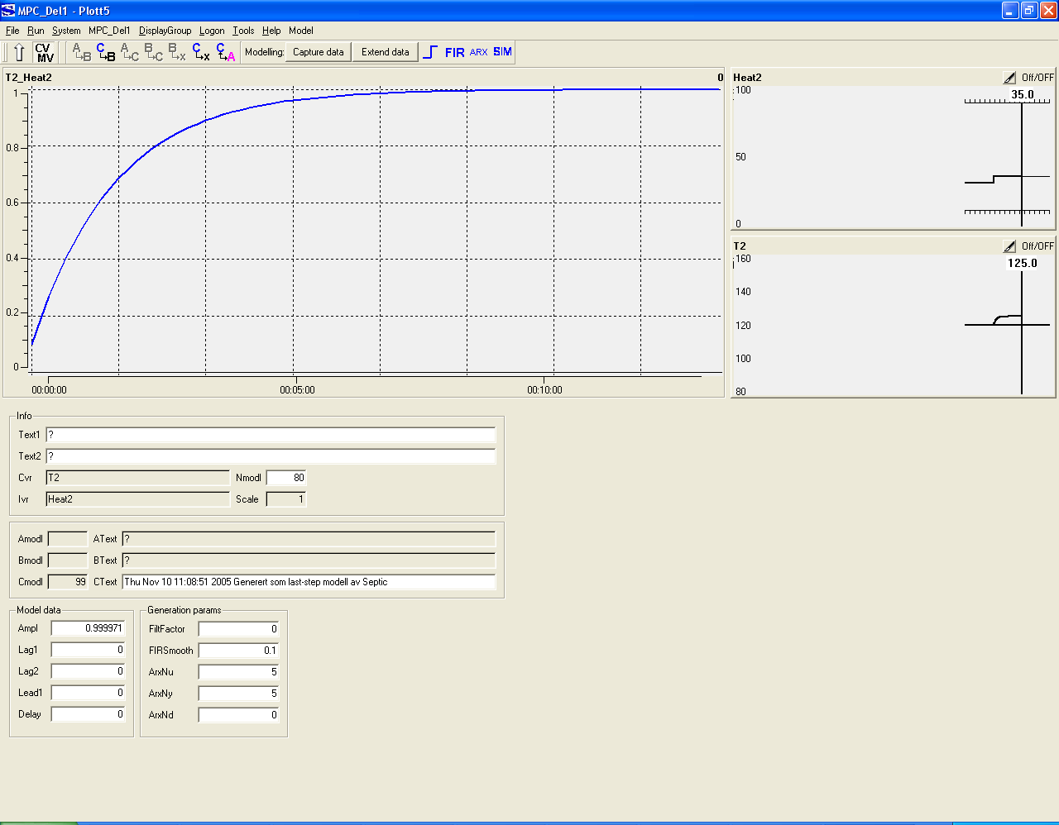

Explanation: Septic goes through Heat2 and finds the most recent step in the variable. From the point in time of that step the modelling tool assumes that the dynamic change in T2 is a response to that step and only that step in Heat2. So the model may be good if T2 was stable before the Heat2 step occured and nothing else influenced T2 in the simulation period after the step. The generated model is blue, and is called Calculated Model (Cmodl in the parameter picture).

Enter the parameter field Ctext and write ”This is my first model, ” before the text already in there. Press Enter.

Press the symbol for ”Apply calculated model” to the left of the step function in the toolbar. You will see a pink model curve above the blue one. Simulate one step and the pink model changes to a red one, which is Septics "receipt" for the model.

The model is purely experimental, as it was made from measured process data only. You changed Heat2 from 30 to 35 and got a steady state response of 5 degrees for T2. The model expresses the T2 response due to a unit positive step in Heat2, which means that Septic scaled the response with a factor of 5. The steady state response in T2 is 1 degree for a unit step in Heat2. But it takes some time before the full response has showed up, and it has reached about 63% after approximately 1.5 min (time axes in hours:minutes). The dynamic response can be described with a time constant (lag1) and a steady state gain (here ampl).

Make a model by entering lag1= 2.5 and then ampl= 1. You get the picture shown below.

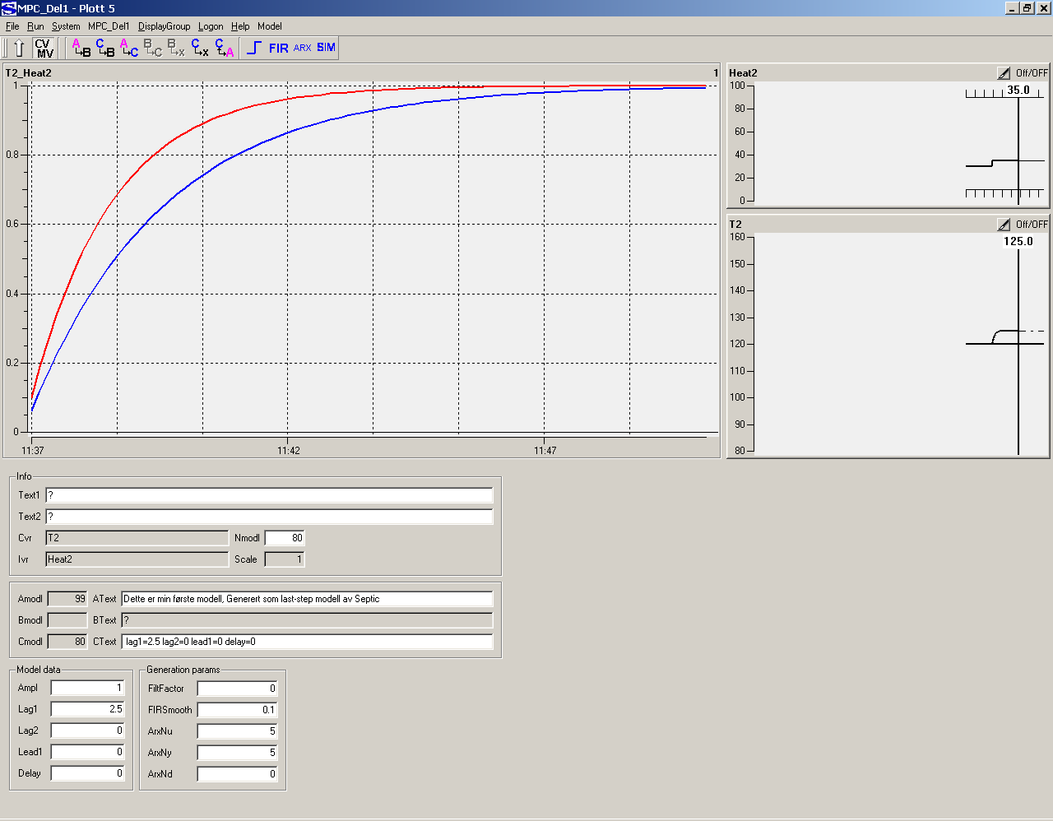

As we knew when we found the dominating time constant by inspection (time to 63% of the final value), 2.5 minutes is too slow. Change lag1 to 1.5 and set Ampl to 1 and you have a good match betwwen the blue model and the red active model. This illustrates an alternative way to make a model, by response inspection to decide the dynamics and gain.

Go back to the main display of Plott 5.

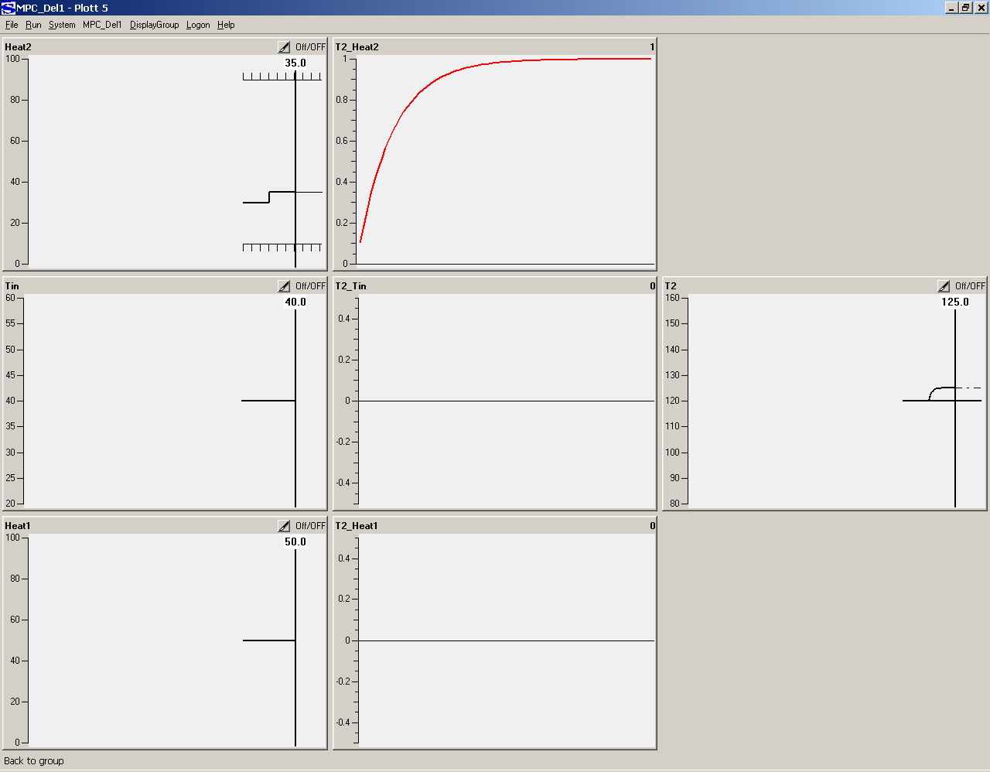

Make the models T2_Tin and T2_Heat1. When you are finished paste the GUI window for Plott 5 here. That is expected to show all the steps in the input variables and all the 3 models.

ANSWER: GUI window showing variables and models

When completed, assure that all models are Active (red color), then you can terminate Septic.

You have got 3 model files on the subfolder ”models”: T2_Heat2.mdf, T2_Tin.mdf og T2_Heat1.mdf. Open them in a text editor to get familiar with the model representation.

When you restart Septic later on the object ExprModl: mdl4expr on the config file will search the models subfolder for files with names cvrid_ivrid.mdf, where cvrid represents all Cvr names and ivrid represents all Mvr/Dvr names configured for SmpcAppl: MPC_Del1, and automatically use the matching model files.

Exercise: Control of T2 to set point by manipulating Heat2 without disturbances

Preparation

Copy the content of c:\septic\BrukerKurs\adoc to c:\septic\BrukerKurs\øving2\adoc. In order to produce the HTML documentation by the menu choice File/HtmlDoc, there must exist a sub folder adoc. And the general part of the documentation must reside on that folder to be available. So this must be done also for later exercises when the HTML documentation is required or desired.

Start up

Restart Septic. Choose Plott 5, grid to 2x2, put Heat2 into (1,1), T2 into (2,1), MPC_Del1/ApplicationInfo into (1,2) and System/Messages/MpcMelding into (2,2). Choose Run/10 steps. Plott 5 should now look like:

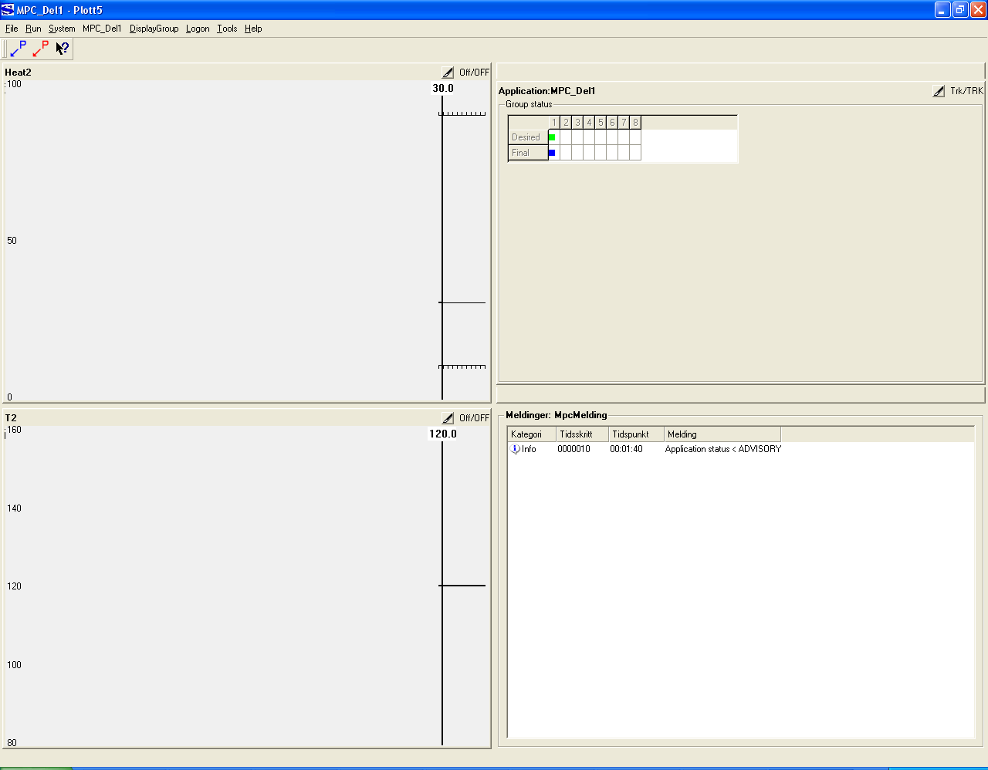

Up to the right in the plots for MPC_DEL1, T2 and Heat2 you can read Trk/TRK, Off/OFF and Off/OFF, respectively. You will now activate all three of them. To activate T2, you can either right-click anywhere in the plot and choose Change, or you can left-click on the pencil symbol to the left of the status information (Off/OFF). Choose Active and press OK. Do the same for Heat2. For the Application: left-click the pencil symbol and change to Active. You have now told Septic that you want to activate this SISO controller, i.e. you have switched the desired status Active. Choose Run/SingleStep in the menu, and after that you should have a display like below. Act/ACT up to the right shows the desired status (Act) and the resulting (final) status (ACT). The message box writes some information from the MPC optimization. You have got an Active MPC application.

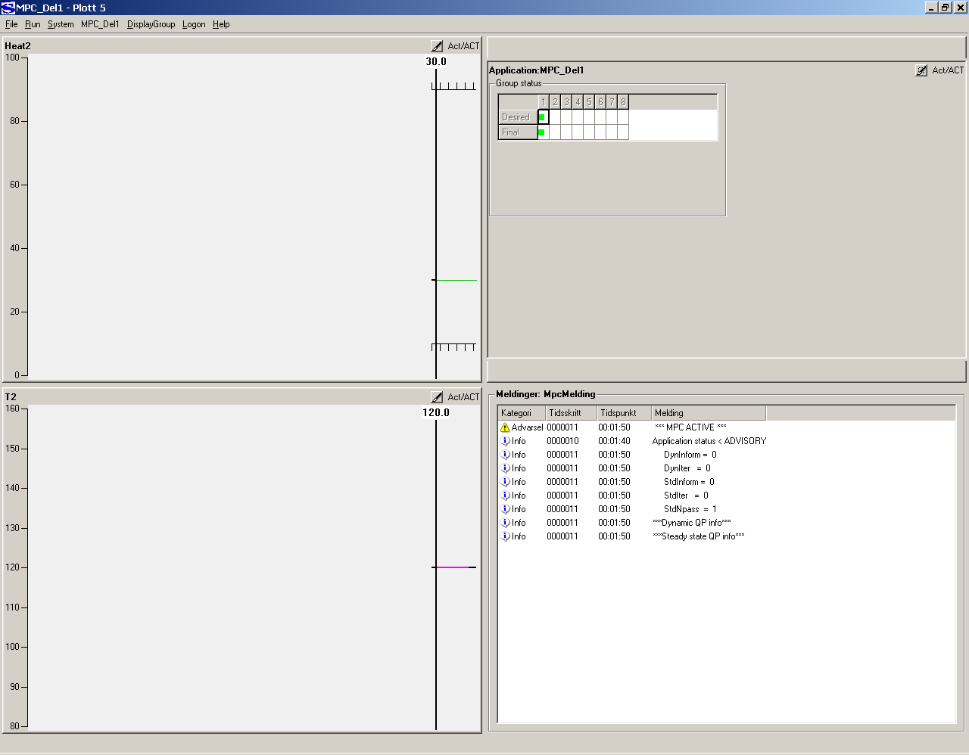

Right-click the T2 plot, and Change the SetPnt value from 120 to 130, followed by Run/10 steps.

Expand the T2 plot. The historic measured T2 (Cvr) is red for the ACTIVE period. There are two prediction curves, one black and one pink. The black one is the prediction when the manipulated variable is kept constant at the current value into the future ("open-loop" prediction), while the pink one is the optimized prediction ("closed loop"). You can also see a green curve that is constant, that one is the deviation between the process and the model. If it is constant, then you have made a perfect experimental model for just this case.

Return to the main Plott 5, should look like the picture below. Heat2 is approximately at the planned high value, and predicts a reduction. Expand the Heat2 plot to see the blocking, i.e. the piecewise constant future prediction. This makes the computations more efficient, because the number of optimization variables will be the sum of "blocks" over all manipulated variables. Later you may read about the Mvr parameter Blocking in the documentation.

Choose Run/nsteps and choose 20. After 20 steps the value of T2 is close to 130 and Heat2 has come to a constant value.

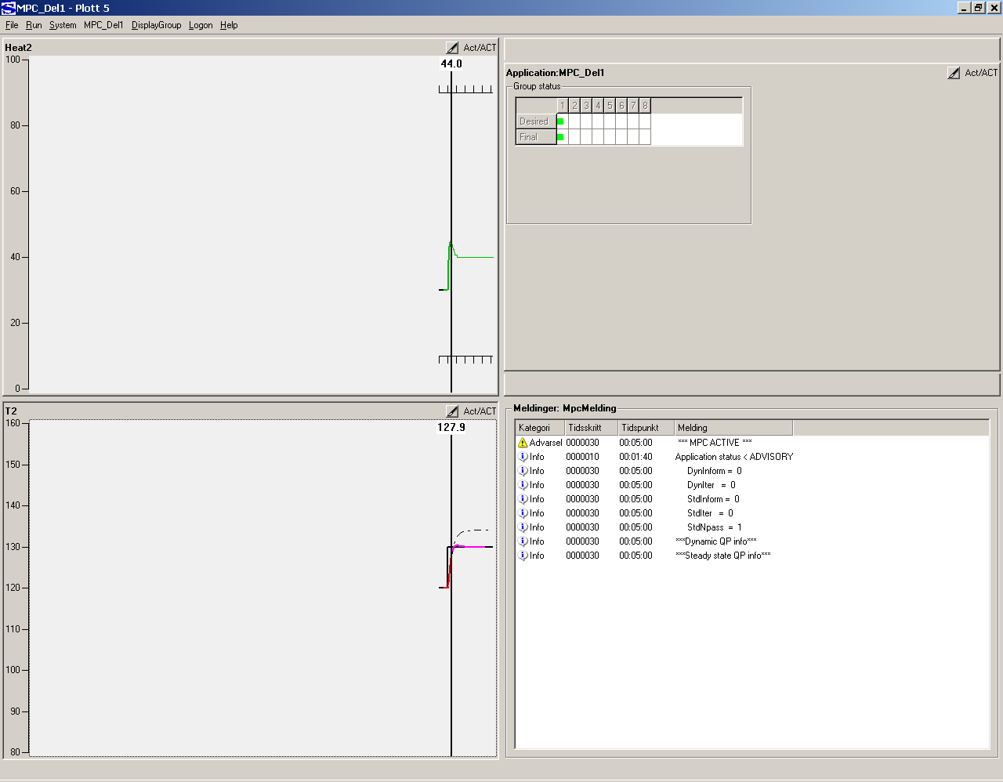

Choose File/HtmlDoc, and Septic will generate the HTML doc to the adoc subfolder.

Let Septic rest in this state, and get the HTML doc into Explorer by double-clicking on MPC_DEL1.html in the adoc subfolder.

STARTING POINT: You have one Cvr (T2) that is controlled to a set point, and one Mvr (Heat2) available for control. And you have a simulator without disturbances or model errors.

QUESTION 1: Which tuning parameters can be used on line (that is without loading a new configuration) to change the controller performance, and how will they affect the performance?

TIP: Explore the different Mvr and Cvr parameters. Also find the link to applikasjonstuning (application tuning) or load SepticDetails.html into Explorer if you cannot find the link.

ANSWER TO QUESTION 1:

QUESTION 2: Which parameters may affect the performance but have to be changed on the configuration file followed by a Septic restart?

ANSWER TO QUESTION 2:

Now you can return to Septic and simulate long enough to fill up the history window (1000 steps since startup). In this period you can do several T2 set point changes with different values of the tuning parameters.

Paste the GUI here, and make some comments about the responses you got, as expected? At this point you can discuss your tuning with the course instructor.

ANSWER: GUI picture with the tuning history

Decide upon a tuning you want to keep for the further work. Open MPC_DEL1.cnfg in a text editor and cahnge the tuned parameters for Heat2 and T2. Save the file. Terminate Septic.

Exercise: T2 set point control with Heat2 and disturbances

Preparation

Copy the event series you find below to the end of MPC_DEL1.cnfg. Note that Tin and Heat1 get Mode TRACKING at N= 450, which corresponds to a manual setting of desired status from the GUI. When Septic as a consequence (as you will see in the simulation) changes Final Status from OFF to TRK, the disturbances will change from an unmeasured to a measured one. The status switches at N= 1 automate your actions from the previous lesson.

Event: MPC_Del1 N= 1 Cmd= "/Appls/MPC_Del1/Cvrs/T2.Mode= ACTIVE"
Event: MPC_Del1 N= 1 Cmd= "/Appls/MPC_Del1/Mvrs/Heat2.Mode= ACTIVE"
Event: MPC_Del1 N= 1 Cmd= "/Appls/MPC_Del1.DesMode= ACTIVE"
Event: MPC_Del1 N= 50 Cmd= "/Appls/MPC_Del1/Dvrs/Tin.DeasOn= 50"
Event: MPC_Del1 N= 150 Cmd= "/Appls/MPC_Del1/Dvrs/Heat1.DeasOn= 55"
Event: MPC_Del1 N= 250 Cmd= "/Appls/MPC_Del1/Dvrs/Heat1.DeasOn= 40"
Event: MPC_Del1 N= 250 Cmd= "/Appls/MPC_Del1/Dvrs/Tin.DeasOn= 40"
Event: MPC_Del1 N= 350 Cmd= "/Appls/MPC_Del1/Dvrs/Heat1.DeasOn= 50"
Event: MPC_Del1 N= 450 Cmd= "/Appls/MPC_Del1/Dvrs/Tin.Mode= TRACKING"
Event: MPC_Del1 N= 450 Cmd= "/Appls/MPC_Del1/Dvrs/Heat1.Mode= TRACKING"
Event: MPC_Del1 N= 500 Cmd= "/Appls/MPC_Del1/Dvrs/Tin.DeasOn= 50"
Event: MPC_Del1 N= 600 Cmd= "/Appls/MPC_Del1/Dvrs/Heat1.DeasOn= 55"
Event: MPC_Del1 N= 700 Cmd= "/Appls/MPC_Del1/Dvrs/Heat1.DeasOn= 40"
Event: MPC_Del1 N= 700 Cmd= "/Appls/MPC_Del1/Dvrs/Tin.DeasOn= 40"
Event: MPC_Del1 N= 800 Cmd= "/Appls/MPC_Del1/Dvrs/Heat1.DeasOn= 50"

Exercise

Start Septic. Turn on data storage to file. Turn on event series reading. Plot T2, Heat2, Tin, Heat1 and the application in Plott 5. Simulate 1000 steps. Paste the GUI picture of Plott 5 below. Explain what happens. Tip: Expand the T2 plot and compare the model (blue curve) to the measurement.

ANSWER 1: GUI picture of Plott 5

ANSWER 2: Your explanation

Find the Cvr parameters BiasTfilt and BiasTpred via T2 in the HTML doc.

QUESTION: How would a change in BiasTfilt and BiasTpred affect the simulated response?
ANSWER:

Exit Septic. Rename MPC_DEL1_1.dta to MPC_DEL1_BASE.dta, and configure it as base case into MPC_DEL1.cnfg.

Tune the parameters (on the configuration file) you would expect to improve the performance for the same series of events taht you just simulated. Save the config file and start Septic. Simulate 1000 steps with events and compare with base case. Change tuning and repeat the simulation till you are satisfied, and then paste your Plott 5 GUI window below and explain what you have done.

ANSWER: GUI window for Plott 5 and explanation.

We have seen the effect of unmeasured and measured distubances and some tuning parameters that can be used to improve the performance under different disturbance scenarios. What if there is some measurement noise on the Cvr?

Exit Septic and open the config file MPC_DEL1.cnfg. Below the following line:

// Under her limes NoiseProc: Noise og DmmyAppl: Calc inn

and above the following line:

// Over her limes NoiseProc og DmmyAppl inn

paste the following:

NoisProc: Noise
NoisXvr: NOIS
Text1= ""
Text2= ""
SgnlVldt= OFF
SgnlHigh= 1e+010
SgnlLow= -1e+010
Sine= OFF
SineT= 5
SineA= 0.1
BiasA= 0
Ramp= OFF
RampR= 0
RampMaxA= 0
Wite= ON
WiteMaxA= 2
Iwite= ON
IwiteMaxA= 0.2
Filt= ON
FiltT1= 1

DmmyAppl: Calc
Nhist= 1000
Npred= 0

Tvr: NOIS PlotMax= 10 PlotMin= -10 Meas= 0

CalcModl: CalcMod
CalcPvr: T2 Alg= "T2+NOIS"

This establishes a noise generator NoiseProc: Noise that has a variable called NOIS. The measurement of this variable is put into the Tvr: NOIS and the CalcModl object CalcMod with the child CalcPvr : T2 fetches the T2 measurement, adds the niose (NOIS) andwrites the result back to the T2 measurement. As DmmyAppl: Calc appears before SmpcAppl: MPC_DEL1 in the config file, it will execute first and hence the MPC application will se a noisy measurement.

Save the config file and start Septic. Retune on the config file and replay Septic until you are satisfied, then paste a GUI picture like Plott 5 below and comment.

ANSWER: Plott 5 GUI picture with measurement noise, comments.

This ends lesson 2, terminate Septic.

