Septic Training Course: Exercise 1

Goal:
- Get to know the simulated process
- Be familiar with some functions in Septic

Startup

Enter the directory C:\septic\BrukerKurs\Øving1. Double-click the short-cut SimProsess. This starts the simulator, and you get the GUI (general user interface). Choose Run/100 steps as illustrated below, and the prosess will simulate 100 steps.

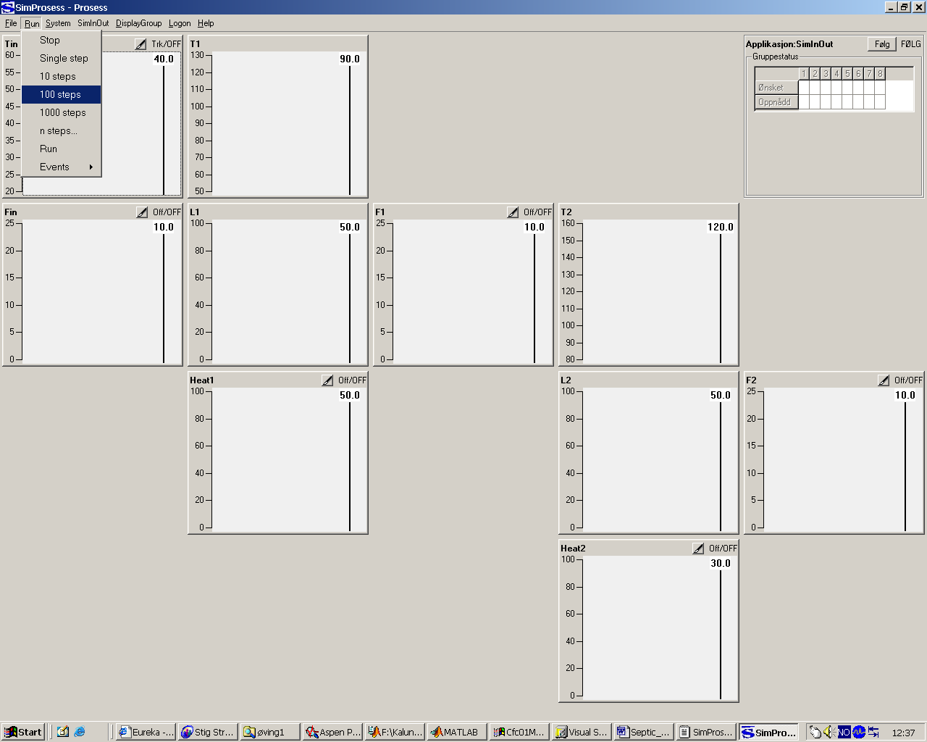

Process description

This simple process has two liquid tanks in series. Each tank has its heating element (Heat1 and Heat2). The feed rate and temperature to the first tank is Fin and Tin respectively. The tanks are not provided with level control, but the flow rates out of each (F1 og F2) can be adjusted (flow control). The level and temperature responses of both tanks to changes in Tin, Fin, Heat1, F1, Heat2 and F2 are modelled.

Process inputs: Fin, Tin, Heat1, F1, Heat2, F2
Process responses: L1, T1, L2, T2

Change of process input

Double-click in the plot of Tin. You get another plot as shown below, when you choose ”Application engineer parameters”. Mark the Deas (Dragged Meas) box, and change the value from 40 to 50. Press Enter.

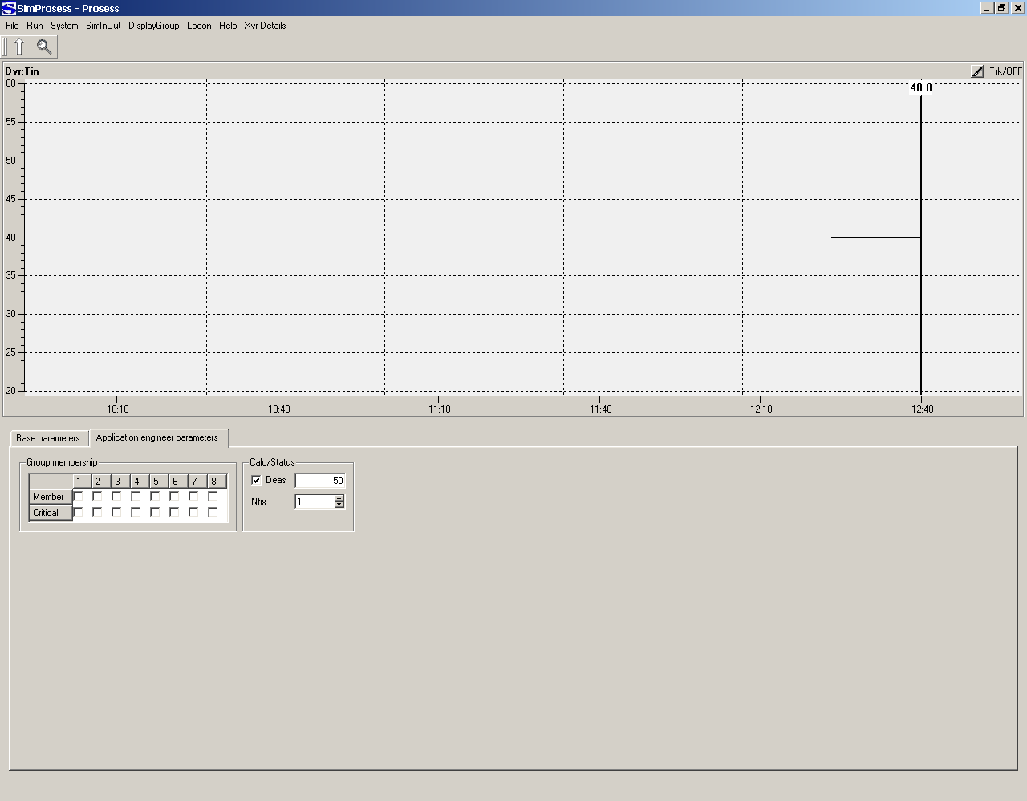

Choose Run/100 steps. You should then have the picture shown below when the simulator stops.

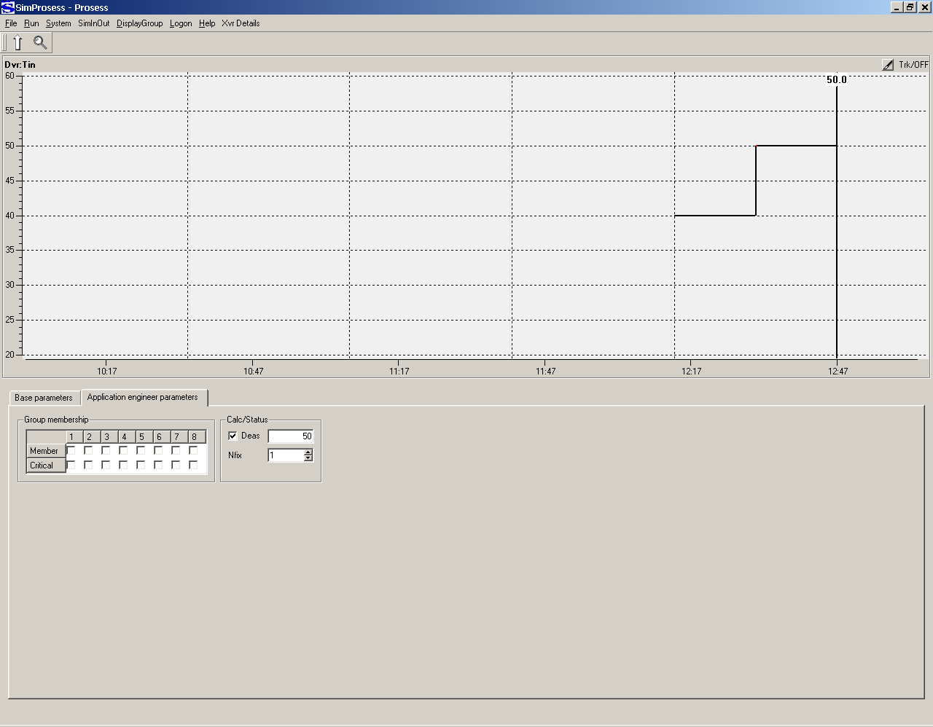

The vertical line is current time, past is to the left and future to the right. The vertical line has a fixed location in the plot given by the parameters Nhist (number of historical samples to be displayed) and Npred (number of prediction samples). We will show later how the meaning of different parameters can be found and where they can be set.

Change Deas back to 40 and simulate another 100 steps.

When the simulator stops: Go back to your initial plot (i.e. out of the expanded Tin plot). To do so, you can either push the upwards-pointing arrow in the upper left corner, or right-click the mouse and choose Group Plot. Now you can see the main plot shown below.

Explain the process responses you are seeing..

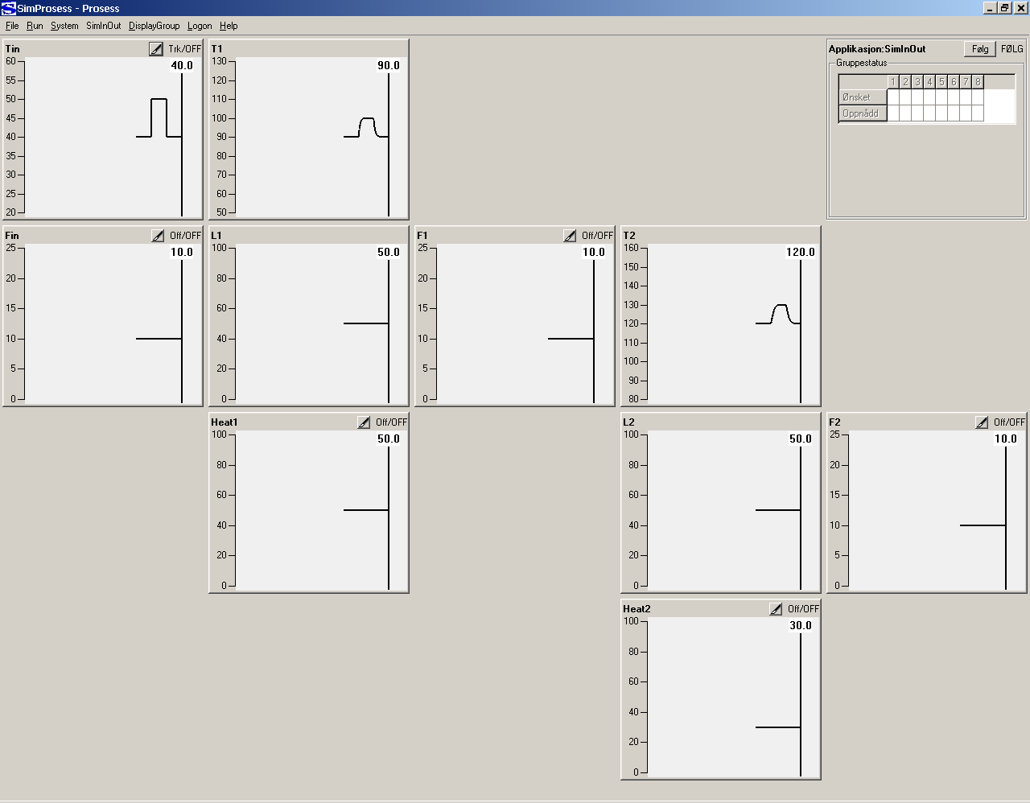

Choose File/Exit and Septic terminates.

You have got 2 new files on your directory. They are both ASCII files that can be read in a text editor (e.g. WordPad).

- SimProsess.out: Septic writes error messages, debug print-outs and so on to this file. Should include only ” Online documentation assistant (assistant.exe) not in path ”.
- SimProsess.chg: Septic writes the initial configuration to this file, and then it logs some of the changes made to the running system.

Exercise: Define a series of events for simulation

Open SimProsess.chg in a text editor. At the end of the file you will find a series of events that shows what you have done during simulation. One looks like:

Event: SimProsess N= 100 Cmd= "/Appls/SimInOut/Dvrs/Tin.DeasOn= 50"

This event was produced when you changed Tin.Deas from 40 to 50. Then you have a similar for N = 200 that reflects setting it back to 40.

Copy the first event (for N= 100) from SimProsess.chg and add it to SimProsess.cnfg, at the end of that file. The last file is the configuration file that is started together with the Septic program by the short-cut.

- Expand to an event series that defines steps up and down again for every input variable in sequence. Find the Meas-value for the respective variables to know their initial values and hence which values you should define to get appropriate steps.

Tip:

The input variable Tin is configured as shown below in SimProsess.cnfg:

Dvr: Tin
Text1= ""
Text2= ""
Mode= TRACKING
PlotMax= 60
PlotMin= 20
PlotGrp= 0000000000000000000000000000000
XvrMnu= 00000000
Nfix= 1
Unit= "¤C"
Meas= 40
GrpMask= 00000000
GrpType= 00000000
Span= 10

The configuration is such that Meas (measured value) equals the initial process state, i.e. Tin starts at 40. The following two events should then be appropriate for this variable:

Event: SimProsess N= 50 Cmd= "/Appls/SimInOut/Dvrs/Tin.DeasOn= 50"
Event: SimProsess N= 100 Cmd= "/Appls/SimInOut/Dvrs/Tin.DeasOn= 40"

Nhist is defined to 1000 samples, so all the events should be finished before sample 1000 (N= 1000), then you can see all the responses in the historic plot.

Exercise: Simulate with events

When SimProsess.cnfg is ready and saved, you can start the simulator again with the short-cut. Choose Run/Events/Active as shown below.

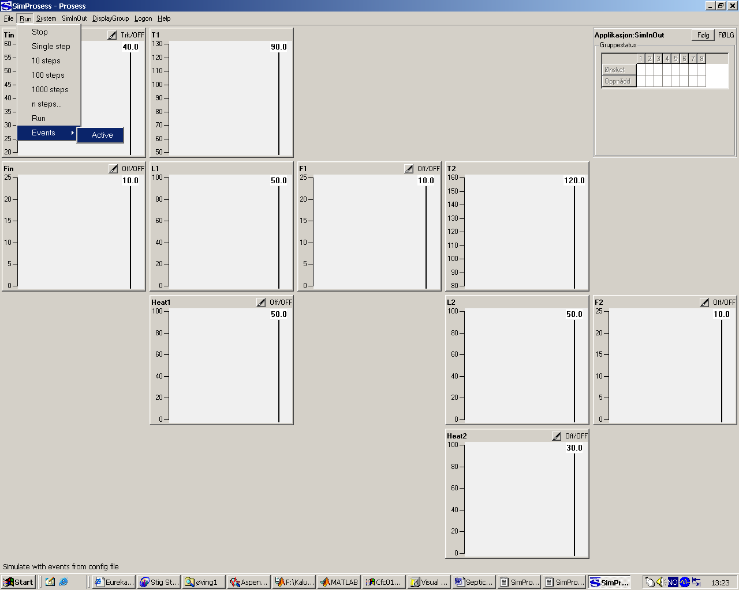

Choose Run/1000 steps.

Did the levels exceed the plotting limits? If so, choose File/Exit, edit the events in SimProsess.cnfg, and rerun the simulation until the levels stay inside the plot.

When you are satisfied, press Alt-PrintScrn on the keyboard and paste the picture below:

ANSWER: GUI-plot showing simulated event series.

Choose File/Exit to terminate Septic.

Exercise: Save data to file and plot old data along with the simulation

Restart Septic. Choose DisplayGroup/Plott 2, choose System/SystemInfo, double-click this plot, when it expands you can hook the box ”Data logging” under Master debug. This choice starts the data file storage of the simulation. Choose DisplayGroup/Prosess, choose Run/Events/Active and then Run/1000 steps. Choose File/Exit to terminate after the simulation is finished.

You have got 2 new files on the working directory:

- SimProsess_1.cfg: Save of current configuration at the same moment that you chose ”Data logging” under Master debug
- SimProsess_1.dta: Stores data along with the simulation (sample per sample).

Open SimProsess_1.dta in a text editor. The file heading shows the different data columns, followed by the process values for the 1000 samples, one sample per line. Close the file again.

Open SimProsess.cnfg in an editor. Lokk from the top and downwards until you find:

// FdtaProc: SimProsess_1.dta Mode= BaseCase

Remove the double slash at the start of the line so it looks like:

FdtaProc: SimProsess_1.dta Mode= BaseCase

Move to the bottom of the file and change the event series so that all steps are only half the size.

Save SimProcess.cnfg and start the simulator. Choose Run/Events/Active. Choose Run/1000 steps.

The pink curves are data from SimProsess_1.dta, and you can see these together with the current simulation. This facilitates for instances the comparison of different tunings when it comes to control. Paste the GUI picture here.

ANSWER: GUI-plot showing simulated event series and BaseCase from previous simulation. You can now keep the simulator alive.

Exercise: Get to know the ”online” documentation

Copy the content of the directory C:\septic\BrukerKurs\adoc to C:\septic\BrukerKurs\øving1\adoc. You just copied some general files for the documentation system. Then choose File/HtmlDoc in the simulator menu. This will produce some HTML files that is automatically stored to the directory C:\septic\BrukerKurs\øving1\adoc.

Enter the C:\septic\BrukerKurs\øving1\adoc and double click the file SimProsess.html. Explorer will bring you into the on line produced simulator (application) documentation.

Make yourself familiar with the documentation, experiment by changing some values in the simulator for instance Text1 for Tin, run File/HtmlDoc again and verify that these online changes are reflected in the documentation.

Question: Explain the parameter Nfix for a variable?
Write the answer here.

Exercise: Summary exercise 1

Lessons learnt? (write below)

Comments? (write below)

This ends exercise 1.

