Chapter 0. Introduction to Course

  - Background and Motivation

Chemical processes are designed and operated for manufacturing value added chemicals, the value addition providing the economic incentive for the existence of the process. The fiercely competitive business environment constantly drives research and innovation for significantly improving existing process technologies and for developing new technologies to satisfy man’s ever growing needs. On the operation side, the processes are operated to meet key production objectives that include process safety, product specifications (production rate and quality) and environmental regulations. These key production objectives must be satisfied even as the process is subjected to disturbances such as changes in the fresh feed composition, variation in the ambient temperature, equipment fouling, sensor noise / bias etc. In other words, the process operation must ensure proper management of the process variability so that the key production objectives are met even in the presence of the process variability. This naturally leads to the idea of proper management of process variability, the task accomplished by a well designed automatic process control system.
Consider the heat exchanger in Figure 0.1. Steam is used to heat a process stream to a certain temperature. Due to variations in the process stream flow rate and inlet temperature, the stream outlet temperature varies over a large range. From the process operation perspective, this is unacceptable since the large variation in the process stream temperature disturbs the downstream unit (eg. a reactor). The installation of a temperature controller that manipulates the steam flow rate to hold the outlet stream temperature constant mitigates this problem to a very large extent. This is illustrated in the outlet stream temperature and steam flow rate profiles in Figure 0.2. For open loop operation (no temperature control), the temperature varies over a large range while the steam flow rate remains constant. On the other hand, for closed loop operation (with temperature control), the variation in the outlet stream temperature is significantly lower with the steam flow rate showing large variability. The temperature controller thus transforms the variability in the outlet stream temperature to the steam flow rate. This simple example illustrates the action of a control loop as an agent for transformation of process variability.
Condensate Out
Process Stream In

HEAT EXCHANGER
Steam in
Control
Valve
Temperature Controller
Process Stream Out

Transmitter
TC
TT
Figure 0.1. Heat exchanger with temperature controller

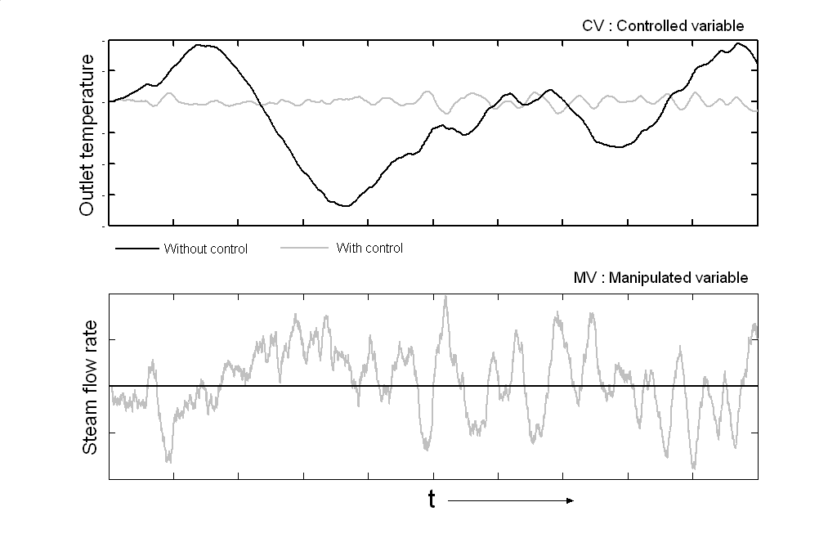
Figure 0.2. The manipulated (steam flow rate) and controlled variable (outlet temperature of process stream) with and without control

A chemical process consists of various interconnected units with material and energy recycle. Controlling a process variable by adjusting the flow rate of a process stream necessarily disturbs the downstream / upstream process due to the interconnection. Material and energy recycle can cause the variability to be propagated through the entire plant. Considering the plant-wide propagation / transformation of process variability, the choice of the variables that are controlled (held at / close to their set-points), the corresponding variables that are manipulated and the degree of tightness of control (loose / tight control) are then key determinants of safe and stable process operation. The choice of the controlled and manipulated variables is also sometimes referred to as the control structure. Modern control text books provide very little guidance to the practicing engineer on the key issue of control structure selection for individual unit operations and the complete process, choosing instead to focus on the control algorithms and their properties with typical mathematical elegance. How does one go about choosing the most appropriate plant-wide control structure for a given set of production objectives? This work attempts to provide an engineering common sense approach to the practicing engineer for answering this key question.
Given a control system that ensures safe and stable process operation in the face of ever present disturbances, crucial economic variables must be maintained to ensure economically efficient or optimum process operation. Depending on the prevailing economic circumstances, optimality may require process operation at the maximum achievable throughput or lower throughputs. At the optimum steady state, multiple process constraints are usually active such as reactor operation at maximum cooling duty/level/temperature/pressure or column operation at its flooding level etc. How close can the process operate to these constraint limits is intimately tied with the basic plant-wide control strategy implemented. The converse problem is that of designing the regulatory plantwide control system such that the back-off from the constraint limits is the least possible. In this work, we also develop a systematic procedure for designing such an economic plantwide control system.
In summary, this book is targeted at the practicing engineer to help him design effective plant-wide control systems through an appreciation of the major issues the control system must address. It is hoped that the targeted audience finds the work of practical utility. The author invites suggestions, comments and criticisms for improving upon the work.

  - Organization of the Course

The course is organized into four modules, excluding this Introduction. In Module 1, the reader is introduced to the essentials of process control. Only the most practical aspects of process control theory are presented. Mathematical rigor is deliberately done away with in favour of a more colloquial style to keep the discussion focused on the most essential and practical aspects of process control theory. Module 2 is devoted to the control of common unit operations found in the process industry. The control of distillation columns is exhaustively dealt with and includes simple, heat integrated and complex column configurations. The control of industrially common reactor configurations and heat exchangers is covered next. Finally common control configurations for miscellaneous systems such as furnaces, heat refrigeration systems and compressors are discussed. Module 3 elaborates upon the key issues in the design of a plant-wide control system. The need for balancing the reactant inventory and the interaction between the reaction and separation section of a plant are described. We then go about developing a systematic procedure for economic plantwide control system design. Three elaborate case studies on realistic chemical processes are then presented to demonstrate the application of the methodology. Comparisons with conventional plantwide control structures show that an economic plantwide control structure can significantly improve (2-20%) the achievable profit (or maximum throughput) for a given process. Proper design of the plantwide control system is thus shown to be crucial to achieving economically optimal process operation.

MODULE I

ESSENTIAL PROCESS CONTROL BASICS

In this module, we cover essential aspects of process control theory, necessary for proper control system design. A hands-on approach to covering process dynamics, PID control algorithm, identification, tuning, advanced control structures and multivariable decentralized control is used, in contrast to the mathematically elegant but abstruse treatment in most controls texts. Only the most essential and relevant aspects are covered. In the interest of brevity, since this is a course on plantwide control and not control theory, we do not provide many detailed solved examples to back the theory and refer the reader to standard text-books for the same.
Chapter 1. Process Dynamics

Process dynamics refers to the time trajectory of a variable in response to a change in an input to the process. All of us have an inherent appreciation of process dynamics in the sense that the effect of a cause takes time to manifest itself. It thus takes 20 minutes for a pot of rice to cook over a flame, 5-10 minutes for the water in the geyser to heat up sufficiently, years and years of dedicated practice to become an adept musician (or a good engineer, for that matter!) and so on so forth. In each of these examples, a change in the causal variable (flame, electric heating or dedicated practice) results in a change over time in the effected variable (degree of “cookedness” of rice, geyser water temperature or a musician’s virtuosity). Process dynamics deals with the systematic characterization of the time response of the effected variable to a change in the causal variable. In process control parlance, the causal variable is referred to as an input variable and the effected variable is referred to as an output variable.
In order to fix ideas in the context of chemical processes, Figure 1.1 shows the schematic of a simple distillation column. An equimolar ABC feed is separated to recover nearly pure A as the distillate with the bottoms being a BC mixture with trace amounts of A. The fresh feed, reflux and reboil constitute the inputs to the column while the distillate and bottoms flow / composition and the tray composition / temperature profiles constitute the outputs.
B
A, B & C
(equimolar)
Pure A
B & C
F
L
D
F: Feed
D: Distillate
L: Reflux
V_{s}: Boil-up
B: Bottoms
Q: Heat Duty
V_{S}
Q
Figure 1.1. Schematic of a distillation column

1.1. Standard Input Changes

To systematically characterize the transient response of an output to a change in the input, the input change is usually standardized to a step change, a pulse change or an impulse change. These standard input changes are depicted in Figure 1.2. A step change in the input, the simplest input change pattern, is used in this work to characterize the process dynamics.
t
t
u(t)
u(t)
t
u(t)
Step change Pulse change Impulse change
Area =1
Figure 1.2. Standard input changes

1.2. Basic Response Types

The dynamics of every process are. Even so, the variety of transient responses can be characterized as an appropriate combination of one or more basic response types. These transient responses correspond to the solution of linear ordinary differential equations (ODEs). Linear ODEs can be compactly represented using Laplace transforms. For example consider a second order differential equation
$τ^{2}\frac{d^{2}y(t)}{{\text{dt}}^{2}}+2\text{ζτ}\frac{\text{dy}(t)}{\text{dt}}+y(t)=K_{P}u(t)$
where y(t) and u(t) are the process output and input respectively. The Laplace transform representation in the s domain is obtained by replacing the n^{th} order derivative operator by s^{n} so that for the second order ODE above
$τ^{2}\text{.}s^{2}y(s)+2\text{ζτ}\text{.}s\text{.}y(s)+y(s)=K_{P}u(s)$
Rearranging, the input-output transfer function becomes
$G_{P}=\frac{y(s)}{u(s)}=\frac{K_{P}}{τ^{2}s^{2}+2\text{ζτ}s+1}$
The ODEs and corresponding Laplace transform representation is noted in Table 1.1.

1.2.1. First Order Lag

The first order lag is the simplest transient response where the output immediately responds to a step change in the input (see Figure 1.3(a)). The ratio of the change in the output to the change in the input is referred to as the process gain, K_{p}. The time it takes for the output to reach 63.2% of its final value corresponds to the first order time constant τ_{p}. The output reaches ~95% of its final value in 3 time constants.

Table 1.1. Various differential equations and their Laplace transform
Terminology | Differential equation | Laplace Transform
Gain
Derivative |  | s
Integrator
First order lag
First-order lead
Second Order Lag
Underdamped
ζ <1
Critically damped
ζ =1
Overdamped
ζ >1
Deadtime
Lead-lag

1.2.2. Higher Order Lags

If the output from a first order lag is input to another first order lag, the latter’s output behaves as a second order lag with respect to the input to the first lag. The overall transient response is S shaped with the output not responding immediately to a change in the input. When the time constant of the two lags are different, the response is called an over-damped second order response. The response for the special case where the two time constants are equal is called the critically damped second order response. Higher order systems result as more first order lags are connected in series with the transient response becoming increasingly sluggish.

1.2.3. Second Order Response

Sometimes, a step change in the input causes the output to oscillate before settling at the final steady state. The simplest such response corresponds to a second order underdamped system. The damping coefficient, ζ, can be used to characterize all second order responses – overdamped (ζ > 1), critcally damped (ζ = 1) and underdamped (ζ < 1). The second order response is shown in Figure 1.3(b).
To gain an appreciation of the impact of damping coefficient on the transient response, Table 1.2 reports the ratio of the second overshoot to the first overshoot for different values of ζ. A quarter decay ratio is observed for a damping coefficient of 0.218. Sustained oscillations (decay ratio = 1) are observed for a damping coefficient of 0. As ζ increases to 1, the overshoot in the output disappears.

Figure 1.3. Output response for unit step change to (a) First order & (b) Second order process.

Table 1.2. Decay ratio for various different damping coefficients
Damping Coefficient, ζ | 0 | 0.05 | 0.1 | 0.2 | 0.218 | 0.4 | 0.6 | 1
Decay ratio | 1.000 | 0.730 | 0.532 | 0.277 | 0.250 | 0.064 | 0.009 | 0.000

1.2.4. Other Common Response Types

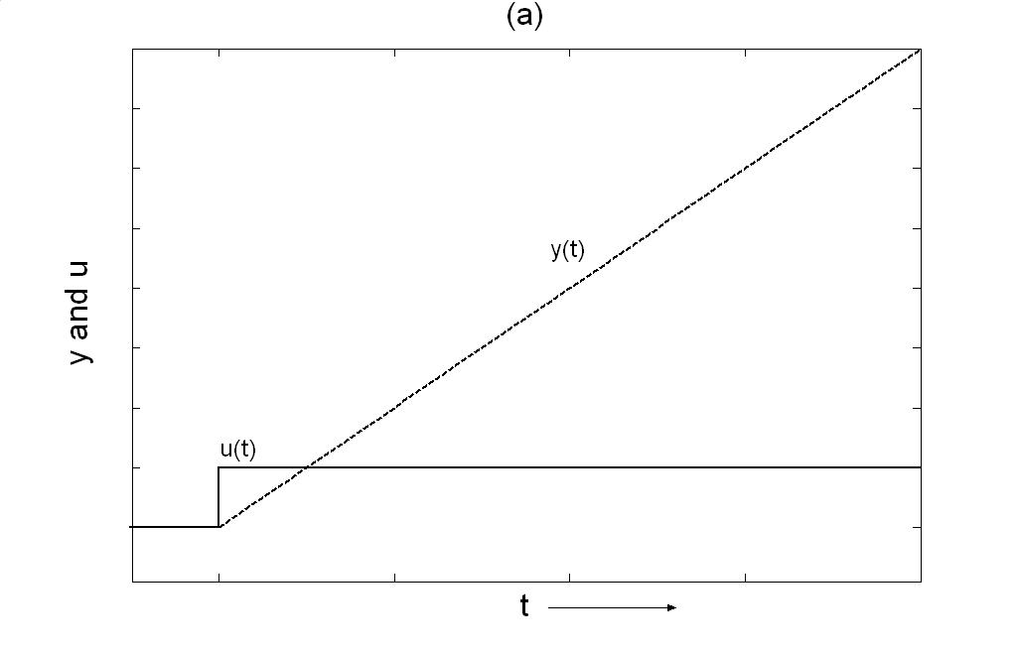
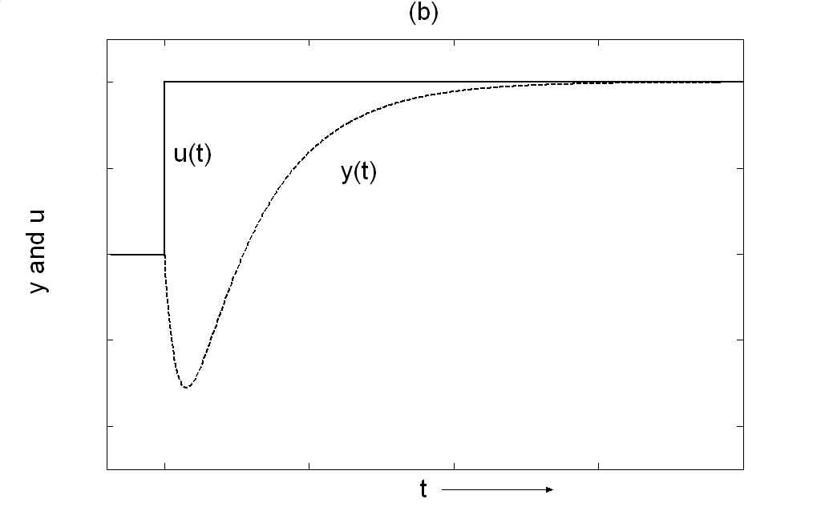
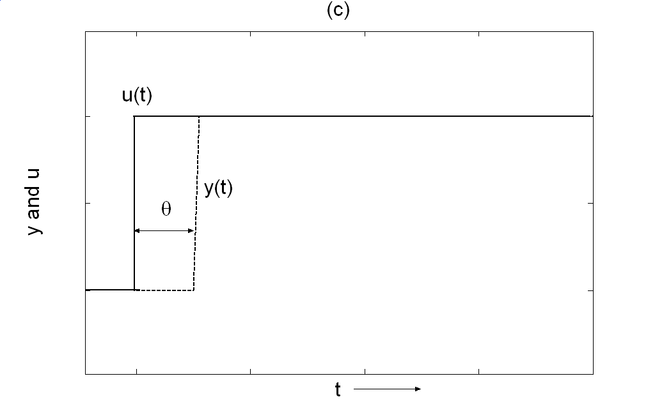
Other types of responses include the pure integrator, the pure dead-time, and the inverse response. The transient response to a unit step change can be seen in Figure 1.4 and are self explanatory.
Figure 1.4. The output response for a unit step change for (a) pure integrator, (b) inverse response and (c) pure dead time process.
The most common example of a pure integrator is the response of the tank level to change in the inlet / outlet feed rate. Unless the inlet and outlet flows are perfectly equal, the tank level is either rising or falling in direct proportion to the mismatch in the flows. The level in a tank is thus non-self regulating with respect to the connected flows. A controller must be used to stabilize all such non-self regulating process variables. Dead time is very common in chemical processing systems and is due to transportation delay. A very common example of the inverse response is the response of the liquid level in a boiler to a change in the heating duty. As the heating duty is increased, the vapour volume entrapped in the liquid increases causing the liquid interface level to rise initially. Over longer duration, the level of course reduces since more liquid is being vaporized. As will be seen later, dead time and inverse response can create control difficulties.

1.2.5. Unstable Systems

Some systems may be inherently unstable. Unstable transient responses are shown in Figure 1.5. The unstable response may be non-oscillatory or oscillatory as in the Figure. Reactor temperature runaway is an example of an unstable process. A control system must be used to stabilize an inherently unstable system.
1.3. Combination of Basic Responses
(a)
(b)
Y(t)
t
t
Oscillatory
Non-oscillatory
Figure 1.5. The output response for unstable process. (a) Oscillatory and (b) non-oscillatory

Any transient response can be reasonably represented as a combination of the above basic response types. One such combination is the first order lag plus dead time that has been found to represent the transient response of many chemical processing systems very well. The response is illustrated in Figure 1.6(a). Another example of such a combination is the inverse response which can be represented by the parallel combination of two first order lags. One of the lags has a small gain and a small time constant (ie a fast response) while the other lag has a gain of larger magnitude and opposite sign with a much larger time constant (i.e. a slow response in the opposite direction). Figure 1.6(b) illustrates this concept.

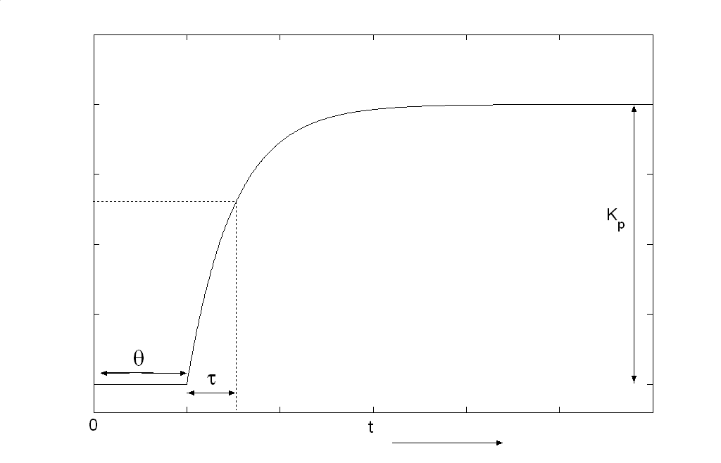
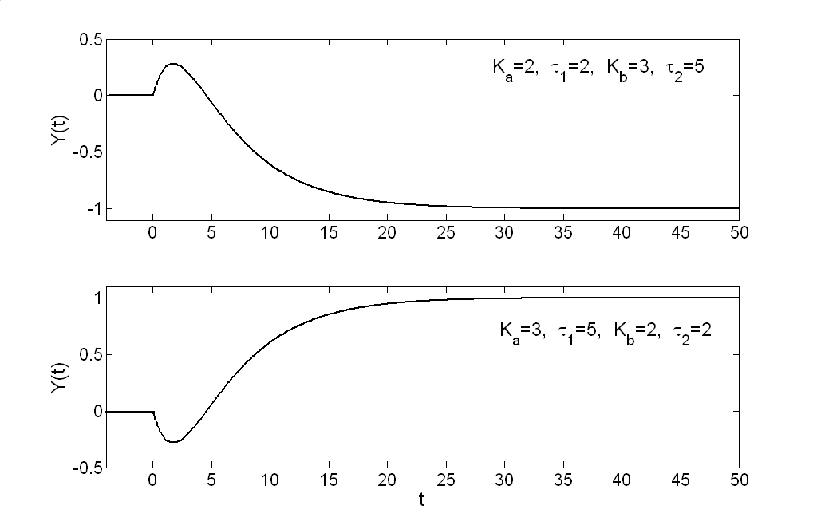
U(s)
y(s)
(a)
—
+
U(s)
y(s)
(b)
Figure 1.6. Unit step responses (a) first order plus dead time process (FOPDT) and (b) Inverse response
Chapter 2. Feedback Control

The safe and stable operation of a process requires that key variables be maintained at or close to their design values in the face of disturbances entering the process. For example, it may be necessary to hold a process stream flow rate nearly constant even as the upstream / downstream pressure fluctuates. Similarly the temperature at the inlet to a packed bed reactor must be maintained at its design value to prevent reactor run-away and also ensure the desired conversion to products(s) for varying flow rates of the process stream. Maintaining a process variable at or near a certain value requires a manipulation handle that can be appropriately adjusted. For example, the valve opening can be adjusted to maintain the flow rate through the pipe. Similarly the heating duty of the furnace can be used to heat the process to maintain the reactor inlet stream temperature. This leads to the idea of feedback control where the deviation in the variable to be maintained at / near its design value is used to make appropriate adjustments in the manipulation handle. The variable to be maintained at its design value is referred to as the controlled variable and the adjustment handle is called the manipulated variable. The algorithm / procedure used to quantitatively translate the deviation in the controlled variable to the adjustment in the manipulated variable is known as the control algorithm.

2.1. The Feedback Loop and its Components

A feedback control loop is schematically illustrated in Figure 2.1. Its primary components are the sensor, transducer, transmitter, controller, I/P converter and the final control element. The sensor is the sensing element used to measure the controlled variable (and other important process variables that may not be controlled). Flow, temperature and pressure sensors are routinely used in the process industry. Composition analyzers are used less frequently to measure only key compositions such as the product purity. Most sensors translate a change in the state of the variable to be measured into an equivalent mechanical signal such as the stretching / bending of a Bourdon tube. The mechanical signal needs to be converted into an electrical signal for onward transmission to the control room (or stand-alone controller). This is accomplished by the transducer. For standardization across different manufacturers, the range of the input and output signal from a controller is 4-20 mA. The range corresponds to the sensor / final control element span. The transmitter converts the electrical signal from the transducer to the 4-20 mA range. The transmitter signal is input to the controller. The desired value for the controlled variable, referred to as the set-point, is also input to the controller. The controller output signal is again between 4-20 mA. In the process industry, this electrical signal is converted to an equivalent 3-15 psig pneumatic pressure signal using an I/P converter. The pressure signal (or rather change in the pressure signal) is used to move the final control element to bring about a change in the manipulated variable. In the process industry, almost all final control elements are control valves that adjust the flow rate of a material stream.
The controller subtracts the current value of the controlled variable from its set-point to obtain the error signal as
e_{t} = y^{SP} - y_{t}
where y is the controlled variable. The subscript t refers to the current time. The error signal is input to the control algorithm to determine the change in the manipulated variable (control input) to be implemented. This is schematically illustrated in Figure 2.2. The most popular control algorithm, namely the PID algorithm is discussed next.

PROCESS
Sensor
Transducer
Controller
I/P Converter
Set point,
4-20 mA
Output
Variables
Input
Variables
Control valve (final control element)
Transmitter
Pressure, 3-15 psig
4-20 mA
4-20 mA
Figure 2.1. Schematic of a process with feed back control scheme
Control valve
(Final control element)

Process
Measuring element
e = y^{SP}- y_{t}
e
y_{t}
y^{SP}
Controller
Figure 2.2. Block diagram of a feed back control
2.2. PID Control

2.2.1. The Control Algorithm

Almost all controllers in the process industry use the Proportional Integral Derivative (PID) control algorithm. Even as instrumentation and computation technologies have witnessed a transition from the analog era to the digital revolution, the good old PID control algorithm remains the most widely used algorithm, not withstanding the onslaught of advanced model predictive control algorithms. The positional form of the algorithm states that
$$u_{t}=K_{C}\left(e_{t}+\frac{1}{τ_{I}}\int_{0}^{t}{e(t)\text{dt}}+τ_{D}\frac{{\text{de}}_{t}}{\text{dt}}\right)+\text{bias}$$
where u is the controller output (input to the process), e is the error in the controlled variable, and K_{C}, τ_{I} and τ_{D} are controller tuning parameters. The tuning parameters are referred to respectively as the controller gain, reset (or integral time) and derivative time. The bias term in the expression is provided to make the LHS equal the RHS at time t = 0 for proper initialisation. The three terms in the algorithm correspond to Proportional, Integral and Derivative action, hence the acronym PID.
The velocity form of the algorithm is more amenable to understanding the effect of each of the P, I and D actions. Differentiating the above equation, we get
$\frac{{\text{du}}_{t}}{\text{dt}}=K_{C}\left(\frac{{\text{de}}_{t}}{\text{dt}}+\frac{1}{τ_{I}}e_{t}+τ_{D}\frac{d^{2}e_{t}}{{\text{dt}}^{2}}\right)$
The controller gain or proportional gain, K_{C}, determines the fastness of response with larger values resulting in a fast response to deviations from set-point. This can be verified from the first term in the velocity form equation where the rate of change of the control input is directly proportional to the rate of change in the error, K_{C} being the proportionality constant. The larger the K_{C}, the larger the change in the control input, the faster the return to set-point.
The integral action is provided to ensure zero offset in the controlled variable. If the controlled variable deviates from its set-point, the controller acts to settle the system at a new steady state. At this new steady state all time derivatives are zero (by definition) implying the LHS in the equation above is zero. The RHS also therefore must be zero which requires that the error term, e_{t}, must be zero at the final steady state (t → ∞). The error term in the velocity form above is due to the integral mode so that integral action moves the control input until the error in the controlled variable is driven to zero i.e. ensures a zero offset. P and D action do not guarantee zero offset as at the final steady state, the LHS and RHS terms corresponding to P and D action are zero. For a P or PD controller with no integral action, the velocity form of the algorithm imposes no restriction on the output error at the final steady state. A non-zero offset thus can and does result sans integral action.
The derivative action causes the controller to “think ahead” and is usually introduced to suppress oscillations from the “seeking behaviour” caused by integral action. In effect, the derivative action puts brakes on the control action as the controlled variable approaches the set-point thus avoiding large oscillations around the set-point. Most controllers in the industry are P or PI controllers and the D action is set to zero. This is because the D action amplifies noise so that the controller input signal must be pre-filtered appropriately to reap the benefit of D action. It is easier to simply turn the D action off and properly tune the controller gain and reset time for the desired control performance.

2.2.2. Controller Tuning

Empirical rules have been developed for tuning PID controllers. These tuning rules are based on the idea of ultimate gain and ultimate period. Figure 2.3 plots the closed loop response for a unit step change in the set-point of a first order plus dead time process for a P only controller as the controller gain is increased. Notice that as the controller gain is increased, the steady state offset reduces. Also, the response becomes faster. For larger gains the closed loop response is oscillatory. As the gain is increased further, sustained oscillations result. Any further increase in the controller gain results in an unstable system with the oscillations increasing in magnitude with time. The controller gain for which the closed loop response exhibits sustained oscillations corresponds to the transition from a stable to an unstable closed loop response. This controller gain at which the closed loop system borders on instability is referred to as the ultimate gain, K_{U}. The period of the sustained oscillations is known as the ultimate period, P_{U}. The empirical tuning rules recommend the controller gain to be a fraction of the ultimate gain and the reset time and derivative time as fractions (multiples) of P_{U}. Two popular tuning rules are the Zeigler-Nichols and Tyreus-Luyben tuning rules are tabulated in Table 2.1. For a given ultimate gain and ultimate period, the controller gain is the least for a PI controller. This is due to the “seeking behaviour” caused by integral action for zero offset. The closed loop system thus goes unstable for a lower controller gain implying that it should be lower. The controller gain is the maximum for a PID controller due to the stabilizing effect of D action. As discussed before, D action is however used rarely in practice due to noise amplification. The PI algorithm is most commonly used in the industry. The tuning rules show that Zeigler-Nichols tuning is more aggressive than the Tyreus-Luyben tuning. Application of the ZN tuning rule can cause process upsets such as a distillation column flooding due to a sudden large increase in the vapour boil-up caused by a controller. The more conservative TL tuning rule is preferred in the process industry for a smooth and bumpless handling of transients avoiding large and sudden changes in the control input.

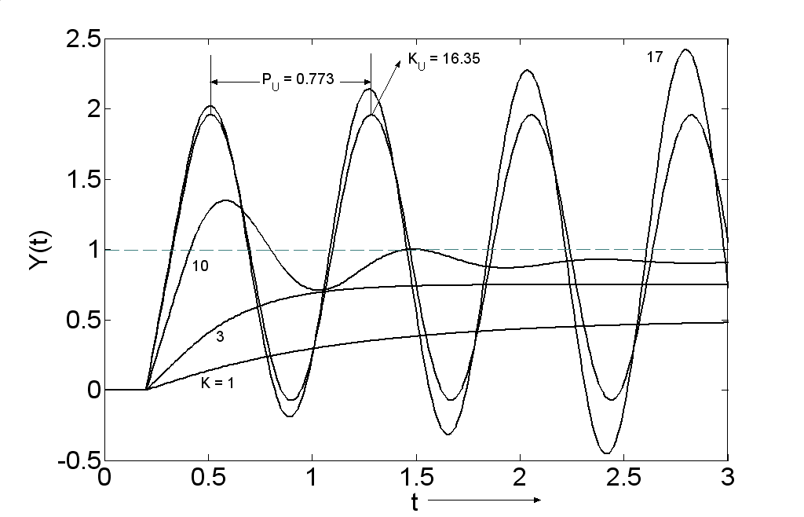
Figure 2.3. Closed loop response of a first order plus dead time process using P controller with different controller gains (K).

Table 2.1
 | P | PI | PID
Ziegler-Nichols
K_{C} | K_{U}/2 | K_{U}/2.2 | K_{U}/1.7
τ_{I} | -- | P_{U}/1.2 | P_{U}/2
τ_{D} | -- | -- | P_{U}/8
Tyreus -Luyben
K_{C} | -- | K_{U}/3.2 | K_{U}/2.2
τ_{I} |  | 2.2P_{U} | 2.2P_{U}
τ_{D} | -- | -- | P_{U}/6.3

It is appropriate to highlight that a controller is required to handle two types of changes namely, a change in the output set-point and a change in the measured / unmeasured disturbance into the process. The closed loop response for these is respectively referred to as the servo and the regulator response. A disturbance into a process is also sometimes referred to as a load change. Control systems in the process industry are typically designed for effective load rejection. In contrast, set-point tracking is the primary objective in the design of control systems for aerospace systems such as aeroplanes, rockets and missiles.
Figure 2.4 plots the regulator response for a unit step in the load variable with a P, PI and PID controller tuned using the ZN and TL tuning rules for the first order plus dead time process considered earlier. Notice that P only control results in an offset at the final steady state. This offset is larger for TL tuning due to the lower controller gain. The PI and PID regulator responses show no offset at the final steady state due to integral action. Also notice that the aggressive ZN tuning results in a quicker but oscillatory return to the set-point for the PI controller. These oscillations are suppressed by the D action in a PID controller. PID control leads to a faster and smoother return to set-point due to the stabilizing effect of D action. It is also highlighted that the TL tuning leads to a comparatively sluggish but non-oscillatory response due to the more conservative tuning parameters. Large and sudden changes in the control input are not desirable in the process industry to avoid hitting operating constraints (e.g. flooding / weeping in sieve tray towers) during transients. Also, the process equipment changes its dynamic characteristics due to equipment fouling, change in process through-put, wear and tear over time etc so that the need for retuning a control loop is mitigated using conservative controller settings. The TL settings thus represent a good compromise between control performance and robustness.
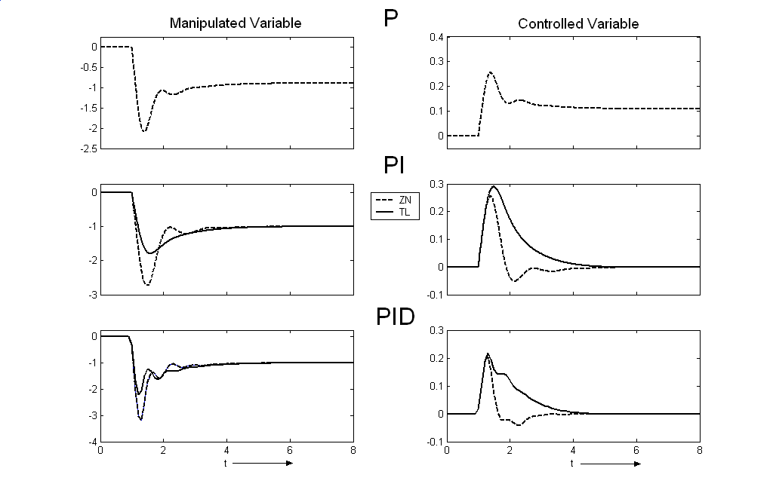
Figure 2.4. Dynamics of manipulated and controlled variables using P, PI and PID controllers with ZN and TL controller parameters for a unit step change in load. (Regulatory response).
2.3. Process Identification

Obtaining the ultimate gain and period of a control loop by increasing the controller gain causes the process to be driven towards instability. Considering the hazardous nature of chemicals processed in any chemical plant, such a methodology for tuning loops must be avoided. Alternative methods are needed that can be used for proper tuning. Two practical methodologies namely, the process reaction curve and auto-tune variation are presented next.

2.3.1. Process Reaction Curve Fitting
The process reaction curve is the open-loop response of the output variable to a step change in the manipulated variable which usually corresponds to a step change in a valve position. Most of the transient responses can be well represented by a first order plus dead time model. The model parameters are obtained as illustrated in Figure 2.5. The model parameters can be obtained by two methods as illustrated in Figure 2.5. In both methods, the ratio of the change in the controlled variable (output) from the initial to the final steady state to the magnitude of the step change gives the process gain K_{P}. For the controller, both input and output are 4-20 mA signals corresponding to the sensor and final control element span. In most commercial DCS systems, this range is represented as an equivalent 0-100% range. The units of K_{P} are then % change in controlled variable per % change in manipulated variable.
The two methods differ in the manner in which the dead time, θ, and the first order time constant, τ_{P}, are obtained. In Method 1, a tangent at the inflection point in the process reaction curve is drawn. Its intersection with the time axis gives the dead time θ. Its intersection with the horizontal line Y = Y_{SS}, where Y_{ss} is the final steady state equals θ + τ_{P}, from where τ_{P} is obtained. Equivalently, τ_{P} is obtained as
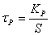
where S is the slope of the tangent drawn at the inflection point.
In Method 2, the time it takes for the response to reach 28.3% and 63.2% of the final steady state are noted. Denote these two times with t_{28.3%} and t_{63.2%} respectively. Noting that for a first order lag, 28.3% and 63.2% response completion occurs in τ_{P}/3 and τ_{P} time units respectively, we have
θ + τ_{P}/3 = t_{28.3%}
θ + τ_{P} = t_{63.2%}
Subtracting the two equations to eliminate θ, we have
τ_{P} = 1.5(t_{63.2%} - t_{28.3%})
and finally θ = 1.5 t_{28.3%} - 0.5 t_{63.2%}
The response of the fitted model using the two methods in shown in Figure 2.11. Method 2 is clearly simpler and fits the actual process reaction curve better.
Figure 2.5.Fitting a first order plus dead time model to the process reaction curve

With the fitted model, K_{U} and P_{U} can be obtained either by simulation or complex variable analysis. The ZN or TL tunings can then be calculated as in Table 2.1.
2.3.2. Autotuning

Astrom and Hagglund (1984) proposed a powerful auto-tune variation (ATV) method for obtaining the ultimate gain and ultimate period. The method consists of putting a relay at the error signal that toggles the process input by ±h% on detecting a zero crossing. This is schematically illustrated in Figure 2.6(a). The action of the relay causes the process input to toggle around the steady state by ±h% for every zero crossing in the error signal corresponding to the output crossing the set-point. Sustained oscillations result and the system ends up in a limit cycle as depicted in Figure 2.6(b). The period of oscillations is the ultimate period P_{U}. The amplitude a of the output oscillations gives the ultimate gain K_{U} as
$K_{U}=\frac{4h}{aπ}$
The ATV method has advantages over open loop step methods. The method automatically finds the critical frequency (or period) of the process. Also, large deviations away from the steady state are avoided as this is a closed loop test. Finally, the amplitude at the critical frequency (ultimate period) is obtained so that the identification procedure is more accurate than step / pulse tests.

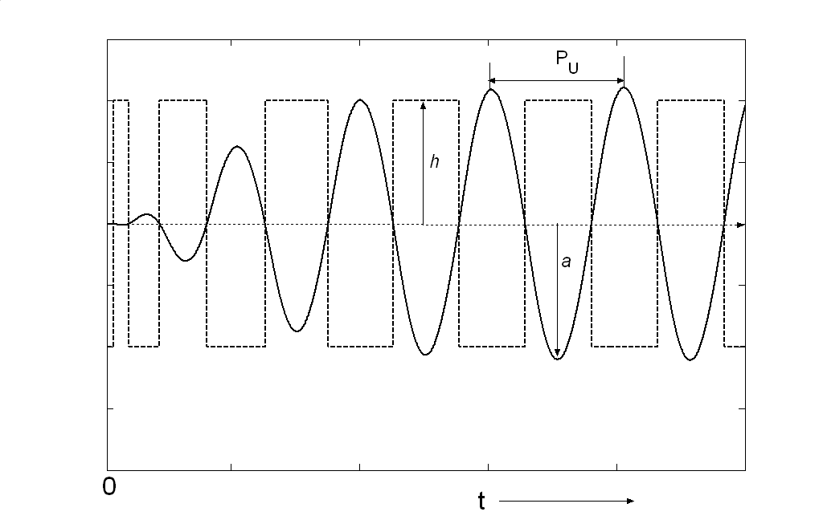
Figure 2.6(b). Relay feed back experiment a process with positive steady state gain
Relay
Process
+
input
output
Figure 2.6(a). Block diagram of relay feedback approach
2.4. Controller Modes and Action

In all DCS systems, the controller can be in the indicator, manual, automatic or cascade mode. In the indicator mode, the controller is off and the process variable (controlled variable) is displayed. The control valve position cannot be adjusted by the operator. In the manual mode, the controller is off. The process variable reading is displayed and the operator can manually input the control valve position. Open loop step / pulse tests are performed in the manual mode with the operator giving a step change to the control valve position. In the automatic mode, the controller is on so that the control valve position is now set by the controller. The operator inputs the set-point for the controlled variable. In the cascade mode, the controller receives the set-point for the controlled variable from a master controller (and not the operator).
Depending on the sign of the process gain, the controller action must be specified to be “direct” or “reverse”. Usually a “direct” acting controller increases the controller output as the controlled variable increases above the set-point. A reverse acting controller, on the other hand, decreases the controller output as the controlled variable increases above set-point. For a negative process gain, the controller is “direct” acting while for a positive process gain the controller is “reverse” acting. The definition of “direct” or “reverse” action can vary from one vendor to the other and it is always best to confirm the definition. Another consideration in correctly specifying the controller action is whether the control valve fails open (air-to-close) or fails closed (air-to-open). Process safety considerations dictate if a control valve fails open or fails closed. For example the cooling water valve for removing heat from a reactor would fail open while the steam valve into a reboiler would fail close. If the controller action for a fail open valve is “direct”, the action would be “reverse” for a fail close valve in the same control loop.
In control parlance, the controller gain is many-a-times reported as proportional band. The proportional band is defined as
$\text{PB}=\frac{\text{100}}{K_{C}}$%
The higher the proportional band, the lower the controller gain and vice versa.

2.5. Rules of Thumb for Controller Tuning

Almost all control loops in the process industry are one of the following
Flow control loop
Pressure control loop
Level control loop
Temperature control loop
Product quality control loop
Some heuristics are discussed for tuning these loops that reflect common industrial practice. Depending on the application, exceptions to these heuristics are always possible.

2.5.1. Flow Loops

Flow is usually controlled using a PI controller. The signal from the flow sensor is noisy due to turbulent flow so that a large proportional band (about 150%) is used. A small reset time (10-20s) is used for good set-point tracking.

2.5.2. Level Loops

Most liquid levels provide surge capacity for filtering out flow disturbances. For example, the reflux drum in a distillation column allows for the reflux into the column to be held constant even as the vapour condensation rate and distillate rate vary. If the drum is not provided, the reflux into the column would fluctuate unnecessarily disturbing the column. The reflux drum thus acts as a surge capacity. In order to filter out flow disturbances, the level should be controlled loosely. The control objective is to maintain the liquid level within acceptable limits. Accordingly, a P controller is used for level control. A proportional band of 50% is commonly used so that the valve fully closes / opens for a 25% change in the level assuming the valve is initially 50% open. Note the use of PI controllers for level control of surge capacities is not recommended as a change in the inlet (outlet) flow would require that the outlet (inlet) flow increase above (decrease below) the inlet flow before becoming equal to the inlet flow in order to bring the level back to its set-point (zero offset). The flow disturbance thus gets magnified downstream (upstream). This magnification would only worsen for a series of interconnected units defeating the very purpose of providing surge capacity for attenuating flow disturbances. There are, of course, exceptions where tight level control is desired. For example, the level in a CSTR should be controlled tightly to maintain the residence time.

2.5.3. Pressure Loops

The dynamics of pressure in a can be very fast (flow like) or slow (level like) depending on the process system. For example, the pressure dynamics are extremely fast for a valve throttling the vapour outlet line from a tank. On the other hand, the dynamics are slow for the cooling water flow adjusting the pressure in a condenser due to the heat transfer and water flow lag. PI controllers are usually used for pressure loops with a small proportional band (10-20%) and integral time (0.2-2 mins) for tight pressure control. Tight pressure control is usually desired in most processing situations. For example, in distillation columns, the pressure must be controlled tightly as large pressure deviations would require compensation of the temperature controller set-points that ensure inferential product quality control. Similarly, most gas phase reactors are designed for near maximum pressure operation for maximum reaction rates so that large pressure deviations are not acceptable.

2.5.4. Temperature Loops

Temperature loops are moderately slow due to sensor lags and heat transfer lags. PI and PID controllers are often used. In most processing situations, tight temperature control is desired so that the proportional band is low (2-20%). The integral time is usually set to about the same value as the process time constant. In situations where derivative action is used for faster closed loop response, the derivative time constant is set to about one-fourth the process time constant or less depending on the transmitter signal noise.

2.5.5. Quality Loops

Composition control loops are usually applied for maintaining the product quality. In terms of relative importance, these loops are probably the most crucial for process profitability. If the product quality shows large variability, the process must be operated at a mean product quality that is significantly better than the quality specification to ensure the production of on-spec or better quality product all the time. This results in a quality giveaway adversely affecting the process profitability. The quality giveaway can be reduced by ensuring tight product quality control. The concept of quality give-away is illustrated in Figure 2.7.
Typical composition measurements involve large dead-times or lags. For example the dead-time introduced by a gas-chromatograph can vary from a few minutes to an hour. Some compositions may be measured once a shift or once a day through laborious analytical measurements. Of all the measurements, analytical composition measurements are the most expensive and unreliable. The product specifications increasingly require the measurement of ppm / ppb levels of trace impurities so that a logarithmic scale is more appropriate in many situations. Product quality measurements are typically used to make small / incremental adjustments in the set-point of a loop. The frequency of the changes may vary from once a day to once every hour etc. Whenever PID controllers are applicable, a large proportional band is used (100-2000%). A large reset time (0.1 – 2 hrs) must be used due to the lag introduced by the composition measurement as well as the usually slow process dynamics.

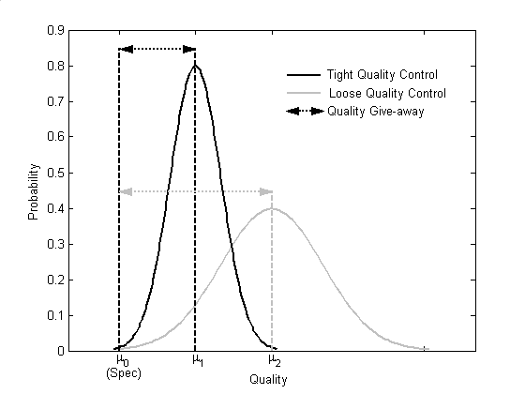
Figure 2.7. The concept of quality give-away
Chapter 3. Advanced Control Structures

The feedback control loop, discussed at length, forms the backbone of control systems applied in the process industry. Some typical feedback control loops are schematically illustrated in Figure 3.1. Over the years, enhancements to the basic feedback control structure that lead to significant improvement in control performance, have been developed. These advanced control structures include ratio control, cascade control, feed-forward control, over-ride control and valve positioning control and are briefly described in the following.

Figure. 3.1. Typical feed back control schemes commonly employed in distillation columns. (a) Feed flow control, (b) Level control in reboiler drum using bottoms flow, (c) Tray temperature control using reboiler duty and (d) Column pressure control using condenser duty.
TC
TT
(c)
(d)
PT
PC
LT
LC
(b)
FT
FC
(a)

3.1. Ratio Control

Ratio control, as the name suggests, is used for maintaining the ratio between two streams. The independent stream is referred to as the wild stream. The ratio controller adjusts the flow of the other stream to keep it in ratio to the wild stream. The implementation of ratio control is illustrated in Figure 3.2. The wild stream flow measurement is multiplied by the ratio set-point to obtain the flow set-point for the manipulated stream. The calculated flow set-point is input to the flow controller on the manipulated stream. Ratio control is implemented as a feed-forward strategy (to be discussed later) where two flows are increased in tandem so that the change in the wild stream is compensated for before it affects the process output. For example, if the feed flow rate into a distillation column increases by 10%, the reboiler duty necessary to maintain the same separation should also increase by about 10%. It therefore makes sense to ratio the reboiler duty to the fresh feed rate so that the necessary change in the reboiler duty is implemented apriori. This leads to tighter product purity control with the change in the feed rate causing only small deviations in the product purity.
Flow controller
Flow set point
Wild stream
Manipulated stream
Constant
FT
FT
FC
X
Multiplier
Figure. 3.2. Implementation of ratio control.

3.2. Cascade Control

Cascade control is arguably one of the most useful concepts in chemical process control. The cascade control scheme consists of two control loops, namely the master loop and the slave loop, with the master loop setting the set-point for the slave loop. The concept is best illustrated by an example. Consider a jacketed CSTR where cooling water is recirculated in the jacket to remove the exothermic reaction heat. The typical feedback reactor temperature control scheme and the cascade reactor temperature control scheme is shown in Figure 3.3. In the feedback arrangement, the reactor temperature controller directly adjusts the cooling water valve to maintain the reactor temperature at set-point. In the cascade arrangement, a slave loop is introduced that controls the jacket temperature by manipulating the cooling water valve. The master reactor temperature loop adjusts the jacket temperature set-point.
At first glance, the advantage of cascade arrangement over simple feedback control is not very obvious. To appreciate the same, consider an increase in the coolant temperature as an input disturbance. In the simple feedback scheme, the reactor temperature must rise before the controller opens the cooling water valve to bring the reactor temperature back to set-point. In the cascade control scheme, the jacket temperature controller senses the increase in the cooling water temperature and adjusts the cooling water valve to maintain the jacket temperature. The reactor temperature would thus show comparatively much smaller / negligible deviations from set-point. The slave controller acts to remove local disturbances into the process and prevents its effect on the primary controlled variable. Another subtle advantage is that the slave controller compensates for the non-linearity in the slave loop so that the master controller ‘sees’ a more linear system. In the current example, the non-linear characteristics of the cooling water valve are compensated for by the slave controller. Since the slave loop has much faster dynamics than the master loop (else the cascade arrangement is infeasible), the master loop does not have to compensate for the valve non-linearity. It therefore sees a less non-linear system compared to simple feedback control resulting in improved control performance. The improvement is however at the expense of installing, tuning and maintaining an additional slave controller.
LC
TT
TC
TC
TT
(b)
LC
TT
TC
(a)
Figure 3.3. Temperature control of an exothermic CSTR. (a) the typical feedback reactor temperature control scheme and (b) the cascade reactor temperature control scheme.

To tune a cascade control structure, the slave loop is first tuned with the master loop in manual. P only controllers with a small proportional band (large controller gain) are commonly used in the slave loop for a fast response to a set-point change from the master controller. Integral action is usually not applied in the slave loop as an offset in the secondary measurement is acceptable. The tuned slave loop is then put on automatic and the master loop is tuned. Note that for the cascade control system to be stable, the dynamics of the slave loop should be much faster than the master loop allowing the slave loop to keep-up with the set-point changes received from the master loop. A typical rule of thumb is that the time constant for the master loop should be more than thrice that of the slave loop.
Cascade control loops are quite common in the process industry. Some common configurations are shown in Figure 3.4. The interpretation of these configurations is left as an exercise to the reader.

3.3. Feed-forward Control
Figure 3.4. Some typical cascade arrangements
TC
SP
x_{D}
CC
SP
FC
TC

The concept of feed-forward control has already been alluded to earlier. If a measured disturbance enters a process, the control input can be adjusted to compensate for effect of the disturbance on the output. Perfect compensation would cause the controlled output to show no deviations from its set-point even as a disturbance has entered the process. This apriori compensation to mitigate the transient effect of a measured disturbance on the controlled output is referred to as feed-forward control. A very simple example of feed-forward control is driving a car. Adjusting the hot and cold water knobs for the right temperature water from the shower is an example of feedback control. As discussed previously, ratio control compensates for disturbances in a feed-forward manner.
The design of a feed-forward compensator is illustrated using block diagrams in Figure 3.5. G_{d} represents the disturbance to output transfer function while G_{p} represents the control input to output transfer function. The control input u must be varied such that
G_{p}.u + G_{d}.d = 0
The control input is adjusted by the feed-forward compensator with the transfer function G_{ff} so that
u = G_{ff}.d.
Substituting into the previous equation and solving for G_{ff} gives the feed-forward compensator design as
G_{ff} = -G_{d}/G_{p}
Assuming that G_{d} and G_{p} are first order plus dead time transfer function, the feed-forward compensator is then a lead-lag plus dead time transfer function. Modern DCS allow lead-lag plus dead time blocks to be configured into the control system.
For a better appreciation of the improvement in control performance using feed-forward compensation, consider a very simple example where

G_{d} = 1/(s+1)
and G_{p} = 1/(5s+1)

Then G_{ff} = -(5s+1)/(s+1)

Figure 3.6. plots the simulated transient output response for a unit step change in the measured disturbance with and without feed-forward compensation.
Since there is no plant-model mismatch, perfect feed-forward compensation is observed with the output showing no deviations from set-point. In a real-life scenario, the presence of a plant-model mismatch may cause small transient deviations. The feed-back controller compensates for these small deviations resulting in an overall tighter closed loop response.
Process
Output
(a)
G_{P}
G_{d}
d
u(s)
y(s)
Disturbance
Input
G_{P}
G_{d}
d
y(s)
Disturbance
G_{ff} = - G_{d} / G_{P}
Input
(b)
Output
Figure 3.5. Design of feed forward compensator. (a) Process and (b) process with feed forward compensator.

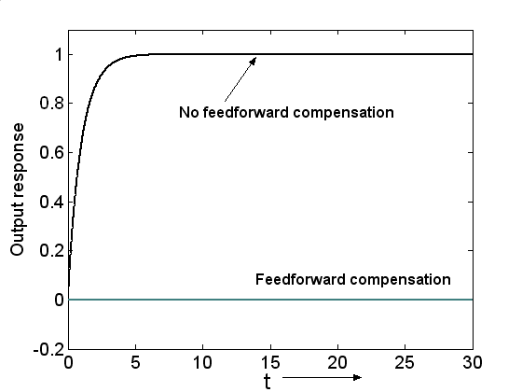
Figure.3.6. Deviation in the output with and without feed forward action
3.4. Override Control

Over-ride control is employed to ensure that an unsafe condition does not arise during process operation. As the name suggests, an over-ride controller over-rides the output of another controller as an unsafe condition develops and acts to move the process away from the unsafe condition. This is an example of multivariable control where the same manipulated variable can be adjusted at any time by one of many controlled variables. An example best illustrates the concept of over-ride or selective control. Consider the bottom section of a distillation column. The bottom sump level is controlled by the bottoms flow rate. During normal operation, the steam rate into the reboiler is manipulated to control a tray temperature. During severe transients, a situation may arise where the bottoms level is low and continues to fall even as the bottoms flow rate is zero. An unsafe situation can arise with the reboiler tubes getting exposed to vapour and fouling. Also, the bottoms pump may lose suction as the reboiler dries up. A sensible operator would put the temperature loop on manual and cut back on the steam rate to ensure the reboiler tubes remain submerged. In effect, the temperature controller output, the signal to the steam valve, gets over-ridden to maintain the liquid level. The over-ride controller automates this action as shown in Figure 3.7. The base level signal is input to a multiplier. A multiplier value of 5 is used so that if the level is above 20%, the multiplier output is above 100%. As the level decreases below 20%, the multiplier output decreases below 100%. If the level continues to decrease, the multiplier output would eventually decrease below the temperature controller output. The low select would then pass on the multiplier signal to the steam valve over-riding the temperature controller. The steam rate would thus decrease. Once the level begins to rise, the multiplier output would increase above the temperature controller output so that the low select would pass the manipulation of the steam valve back to the temperature controller. In addition to the level over-ride controller, the low select may also receive signals from a pressure over-ride controller or a temperature over-ride controller to reduce the steam flow rate. Pressure over-ride would be needed if the column pressure goes too high. Similarly temperature over-ride may be necessary if the base temperature goes too high.
LS
5
Steam
Bottoms
Low base level
override controller
LC
LT
TT
TC
Fig. 3.7. Override control scheme
In temperature or pressure over-rides, a PI controller is needed unlike the P only controller for a level over-ride. This is because a pressure / temperature over-ride is needed only for a very small range of the total transmitter span. A very large proportional gain would then be necessary which can destabilize the closed loop system. Therefore a PI controller with lower gain and fast reset action is used to achieve the tightest control possible.

3.5. Valve Positioning (Optimizing) Control

Valve positioning control was originally proposed by Shinskey as an effective way of minimizing the energy consumption in distillation columns. The pressure in a distillation column is set by the condenser cooling duty. For a given separation, as the column pressure increases, more stages are needed as the x-y VLE plot moves towards the 45 degree line as shown in Figure 3.8. Translated to process operation, the same separation can be achieved at lower reboil as the column operating pressure is reduced. To minimize energy consumption, the column should be operated at lowest possible pressure corresponding to the maximum condenser duty. This can be accomplished by the valve positioning control scheme as illustrated Figure 3.9. The column pressure is typically controlled by adjusting the condenser cooling water valve. The VPC controller takes in the pressure controller output signal and adjusts the pressure set-point. If the valve is not nearly open, the controller reduces the column pressure set-point so that the pressure controller increases the cooling duty to reduce the column pressure. The VPC controller thus ensures that any underutilized cooling capacity is exploited to reduce the column operating pressure. The column pressure thus floats with the condenser duty being near maximum. The VPC controller is tuned to be slow with the fast pressure controller rejecting any pressure disturbances.

P : Pressure
x : Liq. mole fraction
y : Vap. mole fraction
0 x 1
P
0

y

1

Y

Figure 3.8. Typical x-y diagram with varying Pressures

PC
SP = 95%
SP
Figure 3.9.Valve positioning control scheme
Another simple VPC application is shown in Figure 3.10. Let us say a high capacity variable speed pump is providing feed to N parallel trains of processes. We would like to minimize the pump electricity consumption while ensuring the desired flow setpoints for each of the parallel trains is achieved. The electricity consumption gets minimized by running the pump at as low an rpm as possible. This gets achieved by ensuring that the most open process feed valve is nearly fully open. The high select passes the position of the most open valve. A valve position below the nearly fully open VPC setpoint (say 80%) indicates unnecessary valve throttling. The VPC then reduces the pump rpm. In response, the flow controllers would open the valves to maintain the flow. The VPC reduces the pump rpm till the most open valve position reaches the VPC setpoint (80%) ensuring the pump operates at as low an rpm as possible while maintaining the desired flow to each of the parallel trains.
Figure. 3.10. VPC for minimizing variable speed pump electricity consumption
FC
F₁^{SP}
F₂^{SP}
F_{N}^{SP}
Train 1
Train 2
Train N
HS
SP =80%
FC
FC
VPC
SC
Chapter 4. Multivariable Systems

Single input single output (SISO) systems have been treated till now. Most practical control system design problems are multivariable in nature with multiple inputs multiple outputs (MIMO). A 2 X 2 multivariable system is shown in Figure 4.1. There are two inputs, u₁ and u₂ and two outputs y₁ and y₂. In the most general case, a step change in an input causes a transient response in both the outputs. The input output relationship may be compactly represented in matrix notation as
$\left[\begin{matrix}y_{1}(s) \\ y_{2}(s)\end{matrix}\right]=\left[\begin{matrix}G_{\text{11}}(s) & G_{\text{12}}(s) \\ G_{\text{21}}(s) & G_{\text{22}}(s)\end{matrix}\right]\left[\begin{matrix}u_{1}(s) \\ u_{2}(s)\end{matrix}\right]$
and the corresponding block diagram is shown in Figure 4.1.
G₁₁(s)
G₂₁(s)
G₁₂(s)
G₂₂(s)
u₁(s)
u₂(s)
y₁(s)
y₂(s)
+
+
+
+
Figure 4.1. A block diagram of a 2 X 2 multi variable system

In general, G_{ij} denotes the transfer function between the j^{th} input and the i^{th} output. The non-diagonal terms with i ≠ j are the interaction terms. The simplest way of controlling a multivariable process is to control each of the outputs by manipulating an input using a PID controller. This is referred to as multivariable decentralized control and is illustrated in Figure 4.2. for the example 2x2 system. Controller 1 manipulates u₁ to maintain y₁ and controller 2 adjusts u₂ to maintain y₂.
In the design of a multivariable decentralized control system, choice exists as to which manipulated variable is used to control an output. For the 2x2 example, there are a total of two control structures with y₁ being controlled by u₁ or u₂. The number of such possibilities grows exponentially as the number of inputs / outputs increase. In the most general sense, the design of a plant-wide decentralized control system for a complex chemical process is a multivariable problem of high order. The high order problem is naturally broken down into smaller process unit specific controller design problems and controller design for managing plant-wide issues such as inventory balancing. A high order unit specific controller design problem can also be further broken down into a smaller subset of fast loops and slow loops based on the process dynamics. An example is the simplification of the 5x5 controller design problem for a simple distillation column into a 2x2 problem. In a distillation column, the pressure, reflux drum and bottom levels and two temperatures (or compositions) may be controlled. Since the tray temperature dynamics are significantly slower than the pressure / level dynamics, SISO controllers are applied for the latter reducing the 5x5 problem into a 2x2 design problem for the two temperature controllers. Any complex high order control system design problem can thus be simplified into subsets of simple SISO, 2x2 or in the worst case 3x3 decentralized control system design problems. A systematic unit specific and plant-wide control system design methodology for complete chemical plants will be developed in the subsequent chapters.

G₁₁(s)
G₂₁(s)
G₁₂(s)
G₂₂(s)
u₁(s)
u₂(s)
y₁(s)
y₂(s)
+
+
+
+
+
+
G_{C1}(s)
G_{c2}(s)
y_{1, SP}
y_{2, SP}
y₁
y₂
Figure 4.2. Block diagram of a multivariable decentralized control for a 2X2 system

4.1. Interaction Metrics

The selection of the input-output pairing in a decentralized control system is usually made based on engineering considerations which shall be covered in greater detail in subsequent chapters. The individual controllers in a decentralized control system may need to be detuned in order to maintain process stability. This is because the interaction between the loops during closed loop operation can lead to instability. The magnitude of interaction depends on the aggressiveness of the individual controller tunings employed. Detuning or less aggressive tuning mitigates the interaction to ensure closed loop stability. The Niederlinski Index and Relative Gain Array are two commonly used quantitative measures of interaction between control loops. Both are based on the open-loop steady state gain matrix K_{P}, where
y = K_{P} u

4.1.1. Niederlinski Index

The Niederlinski Index for a control structure where the i^{th} input is used to control the i^{th} output is then defined as
$\text{NI}=\frac{\left|K_{P}\right|}{\prod_{i}{K_{\text{ii}}}}$
The NI for any control structure can thus be obtained through appropriate relabeling of the outputs and inputs so that the i^{th} input controls the i^{th} output. If the Niederlinski Index is negative, the closed loop system is guaranteed to be integral closed loop unstable. If the NI is positive, the closed loop system may or may not be stable. In other words, the criteria NI>0 is a necessary but not sufficient condition for closed loop stability. Input-output pairings with small positive or large positive (>>1) NI values indicate ill-conditioning problems and should be avoided. Control structures with NI close to 1 indicate favourable interaction. For example, an NI value of 1 for a 2X2 system indicates that either K₁₂ or K₂₁ or both are zero implying one-way or no steady state interaction between the loops. The primary use Niederlinski Index is for rejecting unworkable control structures.

4.1.2. Relative Gain Array

The relative gain is another popular metric that measures the interaction of a control loop with other loops as the ratio of the steady state process gain the controller sees with all other loops off to the process gain with all other loops on (all other outputs at their set-points). Mathematically, if the i^{th} output is controlled by the j^{th} input, its relative gain is defined as
$λ_{\text{ij}}=\frac{{\left(\frac{∂y_{i}}{∂u_{j}}\right)}_{u_{k}=\text{cons}\text{tan}t,k≠j}}{{\left(\frac{∂y_{i}}{∂u_{j}}\right)}_{y_{k}=\text{cons}\text{tan}t,k≠i}}$
If the relative gain is negative, the i^{th} output should not be paired with the j^{th} input as the process gain sign would change depending on whether the other loops are on automatic or manual mode. Input-output pairings with relative gain close to 1 may be preferred as the process gain the controller sees is independent of the state of the other loops. The relative gain array is obtained as i and j are varied for respectively all outputs and inputs.
The relative gain array is an effective tool for input-output pairing when the primary control objective is set-point tracking. For set-point tracking, lower interaction between the loops increases the degree of independence of the different control loops so that each can be separately tuned for tight set-point tracking. Interaction is thus undesirable for set-point tracking. For load disturbance rejection, interaction is not necessarily undesirable and may actually favour disturbance rejection. This was demonstrated in an early article by Niederlinski (1971). Since the primary objective in chemical process control is load rejection, the application of RGA for control structure selection makes little sense. Candidate control structures should be proposed based on engineering considerations and unworkable structures further eliminated using the Niederlinski Index. The same arguments can be applied to recommend the use of dynamic decouplers only when the primary control objective is set-point tracking. Dynamic decoupling is not covered here as load rejection is the primary control objective in chemical process control systems.
4.2. Multivariable Decentralized Control

Consider the 2x2 multivariable open loop system in Figure 4.1. We would like to hold both the outputs at their respective setpoints. The simplest way to do it is to implement individual PI controllers for y₁ and y₂. Without loss of generality, let us assume that y₁ is paired with u₁ and y₂ is paired with u₂. The multivariable control system is shown in Figure 4.2. Notice that even as u₁ and u₂ affect both y₁ and y₂ through the interaction transfer functions G₁₂ and G₂₁, the adjustment made to u₁ is based purely on e₁ and the adjustment made to u₂ is based purely on e₂. In other words, the y₁ controller moves are based purely on y₁ and does not consider the effect of the control moves made by the y₂ controller. Similarly, the y₂ controller moves are based purely on y₂ and does not consider the effect of control moves made by the y₁ controller. Thus even as the actual system is multivariable, the individual controllers do not take the interaction into consideration. This is referred to as decentralized control.
For the decentralized control system, notice that the interaction terms introduce an additional feedback path as shown in blue in Figure 4.3. This additional feedback tends to further destabilize the closed multivariable control system. If each controller is tuned individually with the other controller on manual (other loop is open) and the Zeigler Nichols tunings applied, then when both the loops are closed, the system response is likely to be highly oscillatory and may even be unstable due to the additional feedback path. In the individual tuning of the controllers, since the other loop is open, this additional feedback path is inactive and therefore not accounted for in the determination of the tuning parameters. Clearly the individual ZN tuning parameters need to be detuned due to the additional feedback path to ensure the overall closed loop response is sufficiently away from instability.

4.2.1. Detuning Multivariable Decentralized Controllers
The obvious next question is that how does one tune a decentralized multivariable controller. Typically, in practical settings, tight control of one of the outputs is much more important than the other. A sequential tuning procedure can then be applied, where the more important output controller is tuned individually so that we get the tightest possible controller tuning. The less important output controller is then tuned with the other loop on automatic. Since the other loop is on, the additional feedback path is active and the necessary detuning due to the same gets accounted for in the tuning parameters of this less important loop. This sequential tuning procedure thus gives the tightest possible control of the more important output at the expense of a highly detuned controller for the less important output. The sequential procedure can be easily extended to more than 2 outputs when the prioritization of the controlled outputs is clear.
There are however situations where the need for tight control of each of the outputs is comparable. The detuning due to multivariable interaction then needs to be taken in all the loops. How does one systematically go about the detuning. For the 2x2 multivariable system, we have for the open loop system
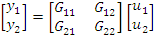
or more simply
y = G_{P} u

where G_{P} is the open loop process transfer function matrix. For a decentralized controller, we have
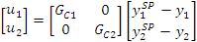
or in matrix notation
u = G_{C} (y^{SP} – y)
where the controller matrix, G_{C}, is diagonal for decentralized control. Combining the above two matrix equations, we get
y = G_{P} G_{C} (y^{SP} – y)
or (I + G_{P} G_{C}) y = G_{P} G_{C} y^{SP}
or y = (I + G_{P} G_{C})⁻¹ G_{P} G_{C} y^{SP}
This is the multivariable closed loop servo response equation and its analogy with SISO systems is self evident. Each element of the (I + G_{P} G_{C})⁻¹ matrix would have det(I + G_{P} G_{C}) as its denominator. The closed loop multivariable characteristic equation is then
det(I + G_{P} G_{C}) = 0
Similar to SISO systems, if any of the roots of the multivariable characteristic equation is in the right half plane, the closed loop multivariable system is unstable.
To systematically detune the controllers, an empirical analogy with the Nyquist stability criterion for SISO systems is used. For a SISO system, the closed loop servo response equation is
y = [G_{P} G_{C}/(1 + G_{P} G_{C})] y^{SP}
where G_{P} is the open loop transfer function and G_{C} is the controller transfer function. The Nyquist stability criterion then guarantees stability for the closed loops system if the polar plot of the open loop transfer function between y^{SP} and y, ie G_{P}G_{C}, does not encircle (-1, 0). Gain margin and phase margin are criteria that are commonly used to quantify the distance from (-1, 0) at a particular frequency. To ensure that the distance from (-1, 0) is sufficient at all frequencies, the 2 dB closed loop maximum log modulus criterion is often used, where the closed loop log modulus is defined as
L_{CL}(ω) = 20 log|G_{P}G_{C} / (1+G_{P}G_{C})|_{s=jω}
L_{CL} is calculated by putting s = jω in the transfer functions, G_{P} and G_{C}, and is therefore a function of ω. The SISO PI tuning parameters (K_{C} and τ_{I}) are chosen such that the maximum closed loop log modulus (with respect to ω) is 2dB. This ensures that the closed loop servo response is fast and not-too-oscillatory.
To develop a closed loop maximum log modulus criterion for multivariable systems, we note that the SISO closed loop characteristic equation is
1 + G_{P}G_{C} = 0
and the transfer function whose polar plot is used to see encirclements of (-1,0) is then
-1 + (1+G_{P}G_{C})
ie -1 + closed loop characteristic equation
For a multivariable system, we then define by analogy
W = -1 + det(I + G_{P} G_{C})
where W is -1 + closed loop characteristic equation. The multivariable closed loop log modulus (L_{MVCL}) is then defined as
L_{MVCL} = 20 log|W/(1+W)|.
The tuning parameters for the individual controllers should be chosen such that
L_{MVCL}^{MAX} = 2 N_{C}
where N_{C} is the number of loops.
A simple algorithm for systematic detuning of the individual controller for the 2x2 decentralized control system is then:
- Obtain individual ZN tuning parameters, (K_{C1}^{ZN}, τ_{I1}^{ZN}) and (K_{C2}^{ZN}, τ_{I2}^{ZN}), for each loop.
- Detune the individual tuning parameters by a factor f (f > 1) to get the revised tuning parameters as (K_{C1}^{ZN}/f, f.τ_{I1}^{ZN}) and (K_{C2}^{ZN}/f, f.τ_{I2}^{ZN})
- Adjust f such that L_{MVCL}^{MAX} = 4 dB.
The above procedure can be easily extended to an NxN (N > 2) decentralized control system.

As a parting thought, we re-emphasize that in chemical processes, the dominant time constants of different loops can differ by up to two orders of magnitudes. Thus for example, the residence time of a surge drum may be ~5 minutes while it may take 2-5 hrs for transients caused by a change in its setpoint to reach back after passing through the different downstream units, the material recycle and the upstream units. Similarly, on a distillation column, while the column pressure time constant with respect to condenser duty is ~1 min and the reflux drum / bottom sump level residence times are ~ 5 mins, the tray temperature response times to changes in reflux / boilup rates are much slower (~15-20 mins). Thus even as the dual-ended distillation column control problem is 5x5 (2 levels, 1 pressure and 2 temperatures), the separation in time constants allows the level and pressure controllers to be tuned first followed by the two temperature controllers. The 5x5 problem thus reduces to a 2x2 problem due to the separation in time constants. In industrial practice, most high order multivariable problems reduce to 2x2 or at most 3x3 problems, which are mathematically tractable.
G₁₁(s)
G₂₁(s)
G₁₂(s)
G₂₂(s)
u₁(s)
u₂(s)
y₁(s)
y₂(s)
+
+
+
+
+
+
G_{c1}(s)
G_{c2}(s)
y_{1,sp}
y_{2,sp}
y₁
y₂
Figure 4.3. Additional feedback path due to multivariable interaction

Illustrative Example:
Consider a 2x2 openloop multivariable system
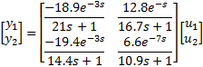

- Calculate its RGA. Based on the RGA, what input-output pairing would you recommend.
- Calculate the Niederlinski Index for the recommended pairing. What can you say about closed loop integral stability of the recommended pairing.
- Calculate the Niederlinki Index for the other alternative pairing (the one that is not recommended). What can you say about the closed loop integral stability of this other pairing.
- For the recommended pairing, design a feedforward dynamic decoupler showing its complete block diagram and also the physically realizable feedforward compensator transfer functions.

Solution:
(a) The steady state input-output relationship is

so that the steady state gain matrix is
Inverting the matrix, we get
The RGA is then obtained as
RGA = K.*(K⁻¹)^{T}
where the ‘.*’ operator denotes element-by-element multiplication. Performing the necessary operations, we get
Notice that the row/column sum of the RGA is 1. This is a property of the RGA (can you prove it?).
Rejecting the IO pairings corresponding to the negative RGA elements, the recommended pairing based on the RGA is y₁-u₂ and y₂-u₁.

(b) The steady state IO relation for the recommended pairing is
The Niederlinski Index is then
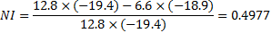
Since NI > 0 for the recommended pairing, the multivariable decentralized control system may be integrally stable.

(c) The other possible pairing is y₁-u₁ and y₂-u₂. For this pairing, the IO relation is
The Niederlinski Index is then
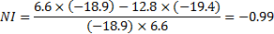
Since the NI for this pairing is < 0, the multivariable decentralized control system is guaranteed to be integrally unstable. This pairing should therefore not be implemented.

(d) If we look at the open loop 2x2 system with the recommended pairing (y₁-u₂ and y₂-u₁), a change in u₂ affects both y₁ (its controlled variable, CV) and y₂ (other CV). Similarly, a change in u₁ affects both y₂ (its CV) and y₁ (other CV). When both the control loops are on, the adjustment made by a loop ends up disturbing the other loop. A dynamic decoupler uses feedforward compensation ideas to make appropriate adjustments in the “other” process input so that a change in a process input only affects its CV and not the other CV. The dynamic decoupler block diagram for the recommended pairing is shown in Figure 4.4. We are looking for the feedforward compensator G_{I}^{ff} (G_{II}^{ff}) so that a change in u₂* (u₁*) only affects its CV, y₁ (y₂) with no effect on the other CV y₂ (y₁).

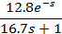
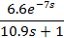
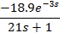
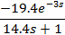
+
+
+
+
u₂
u₁
y₁
y₂
G_{I}^{ff}
G_{II}^{ff}
+
+
+
+
u₁*
u₂*
Process
Decoupler
Figure 4.4. 2x2 process example with dynamic decoupler

From the block diagram, the ideal compensator G_{I}^{ff} would be such that
y₂ = G₂₂u₂* + G₂₁G_{I}^{ff}u₂* = 0
so that G_{I}^{ff} = -G₂₂/G₂₁
Similarly, we have G_{II}^{ff} = -G₁₁/G₁₂
Putting in the appropriate transfer functions, we get
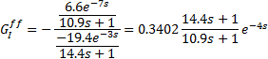

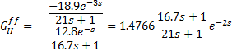

The feedforward compensators consist of a gain, a lead-lag and a deadtime. In some cases, it is possible that we get an exponential term of form e^{+Ds} (D > 0) implying a negative dead-time. This means that a change in the causal variable leads to a change in the effected variable in the past, which is impossible. The term e^{+Ds} is then physically unrealizable and dropped from the compensator.
MODULE II

CONTROL OF COMMON UNIT OPERATIONS

Having covered the essential aspects of control theory, in this module we consider control systems as applied to common unit operations in the process industry. We thus treat simple and complex distillation configurations (including heat integrated sequences), reactors, heat exchangers and miscellaneous systems such as furnaces, compressors, refrigeration cycles and boiler houses. Several of the examples shown here can be found in “Plantwide Process Control” by Luyben, Tyreus and Luyben (McGraw Hill, 1998) and “Process Control Systems” by Shinskey (McGraw Hill, 1996). We have attempted to present these examples afresh in the hope that readers readily assimilate the concepts.
Chapter 5. Control of Distillation Systems

5.1. Distillation Basics

Distillation is unarguably the most preferred unit operation used for separating mixtures. In the design of chemical processes, other separation techniques are considered only if distillation is found to be economically unviable. It is thus not surprising that the final product stream from a plant is typically a product steam from a distillation column. This Chapter provides guidelines for designing effective control systems for distillation columns.

5.1.1. The Simple Distillation Column

A proper understanding of the basic physics of a distillation column (or any other process for that matter) is a pre-requisite for designing an effective control system. Figure 5.1 shows the schematic of a simple distillation column along with the control valves. It consists of a tray section, a condenser, a reflux drum and a reboiler. The feed mixture is fed on a feed tray. The trays above the feed tray constitute the rectifying / enriching section and those below constitute the stripping section. The overhead distillate and the bottoms are the two product streams from a simple distillation column. Steam is typically used to provide vapour reboil into the stripping section. The liquid reflux into the enriching section is provided by the condenser. Cooling water is commonly used as the coolant in the condenser. The condenser may be a total condenser, where all the vapour is condensed, or a partial condenser where only a part of the vapour is condensed. The overhead distillate is a liquid stream for a total condenser. A partial condenser column may be operated at total reflux where all the liquid is refluxed back into the column and the distillate stream is a vapour stream. Alternatively (and more commonly) both a vapour and a liquid distillate stream are drawn. The reflux drum provides surge capacity to adjust the reflux and distillate rate during transients. The bottom sump provides the surge capacity for adjusting the bottoms and steam rate.
The vapour generated when a volatile liquid feed mixture is boiled is richer in the more volatile component. The remaining liquid is then richer in the heavier components. Chemical engineers refer to this as flashing a mixture. If the flashed vapour is condensed and partially vaporized again, the vapour from the second flash would be further enriched in the volatiles (light boilers). Similarly, if the liquid from the first flash is further vaporized, the heavies composition of the liquid from the second flash would increase. Theoretically speaking, a sufficiently large number of flash operations on the vapour can result in a final vapour stream that is almost 100% pure lightest component. Similarly a series of flash operations on the liquid can result in a final liquid product that is 100% heaviest component. The array of trays in a distillation column accomplishes this series of flash operations. The temperature difference between the liquid and vapour streams entering a tray causes condensation / vaporization so that as one moves up the column, the composition of the lightest component increases monotonically. Alternatively, as one moves down the column, the composition of the heaviest component keeps on increasing. Since heavier components boil at higher temperatures, the tray temperature increases as one moves down the column with the condenser being the coolest and the reboiler being the hottest. The reboiler and the condenser are the source of vaporization and condensation respectively for the series of vaporization / condensation.

Bottoms
Reflux
Distillate
Reboiler Steam
Feed
Condenser
Figure 5.1 Schematic of a simple distillation column along with the control valves.

5.1.2. Splits in a Simple Distillation Column

Consider a five component equimolar ABCDE mixture feed into a simple distillation column. The components are in decreasing order of volatility so that A is the lightest and E is the heaviest. The feed rate is 100 kmol/h. The steady state distillate to bottoms product split is primarily determined by the choice of the distillate (or bottoms) rate. Assuming a sufficiently large number of trays, adequate reboil and reflux, for a distillate rate of 40 kmol / hr, which is equal to the component A and component B flow rate in the feed, essentially all of the A and B would leave up the top so that the distillate would contain traces C, D and E impurities in decreasing order of composition. The bottoms would be a CDE mixture with traces of B and A, in decreasing order of composition. The column thus accomplishes a split between components B and C with the liquid preventing C from escaping up the top and the vapour reboil preventing B from escaping down the bottoms. Components B and C, are referred to as the light key (LK) and heavy key (HK) respectively. The LK is the dominant impurity in the bottoms stream and the HK is the dominant impurity in the distillate stream. The component split is referred to as an AB/CDE split. The component that is the next lighter component than the LK is called the lighter than light key (LLK). The heavier than heavy key (HHK) can be defined in a complementary manner. Components A and E are respectively the lightest and heaviest and therefore referred to as the lightest key and the heaviest key.

For the ABCDE mixture, there are four possible splits – A/BCDE, AB/CDE, ABC/DE and ABCD/E. The first one, where the light key is also the lightest key is referred to as the direct split. The last one, where the heavy key is also the heaviest key is referred to as an indirect split. The remaining splits where the key components are intermediate boilers are referred to as intermediate splits. It is helpful to categorize the column split into these basic types.

5.2. Basic Control Structures

A simple distillation column with a total condenser has a total of six valves as in Figure 5.1. Of these six valves, the feed valve is usually set by an upstream unit in the process. Also two valves must be used to control the reflux drum level and the reboiler level as liquid levels are non-self regulating. Another valve must be used to regulate the column pressure which represents the vapour inventory in the column. Typically, the cooling duty valve in the condenser is used for pressure control. After implementing the three inventory loops, the position of the remaining two control valves can be set by an operator or a controller to regulate the separation. This gives a operation degree of freedom of two for a simple distillation column. The operation degree of freedom is more for complex column configurations that are considered later.
Four control structure types result for a distillation column corresponding to the choice of valve used for reflux drum and reboiler level control. These are the LQ, DQ, LB and DB structures and are illustrated in Figure 5.2. The nomenclature corresponds to the two control degrees of freedom (valves) that remain to regulate the separation. The LQ control structure corresponds to the distillate (D) controlling the reflux drum level and the bottoms (B) controlling the reboiler level. This leaves the reflux (L) and reboiler duty (Q) as the two valves for regulating the separation achieved, hence the label LQ. In the DQ structure, the condenser level is controlled using the reflux while in the LB structure, the bottoms level is controlled using the reboiler duty. Lastly in the DB control structure, the reboiler duty and reflux are used for controlling the reboiler and condenser levels respectively.

5.2.1. The Energy Balance (LQ) Structure

The LQ control structure is the most natural control structure for a simple distillation column. This is because the separation in a distillation column occurs due to successive condensation and vaporization of the counter-current vapour and liquid streams flowing through the column. Adjusting the cold reflux, the source of condensation, and the reboiler duty, the source of vaporization, is then a natural choice for regulating the separation achieved in the column. The LQ control structure is thus the most commonly applied distillation control structure. It is also sometimes referred to as an energy balance structure as changing L (cold reflux) or Q alters the energy balance across the column to affect the distillate to bottoms product split.

Figure 5.2. Schematics of LQ, DQ, LB and DB control structures
Feed
Reflux
Distillate
Bottoms
Reboiler steam
Condeser
LC
FC
LC
FC
PC
FC
LQ
L
Q
Feed
Reflux
Distillate
Bottoms
Reboiler steam
Condeser
LC
FC
PC
FC
LC
FC
(b) DQ
D
Q
Feed
Reflux
Distillate
Bottoms
Reboiler steam
Condeser
LC
PC
FC
FC
FC
LC
(c) LB
B
L
Feed
Reflux
Distillate
Reboiler steam
Condeser
LC
PC
FC
FC
LC
FC
Bottoms
(d) DB
B
D
5.2.2. Material Balance Structures

The other control structures are referred to as material balance structures as the product split is directly adjusted by changing the distillate or bottoms stream flow rate. The material balance structures are applied when a level loop for the LQ structure would be ineffective due to a very small product stream (D or B) flow rate. The DQ structure is thus appropriate for columns with very large reflux ratio (L/D > 4). The distillate stream flow is then a fraction of the reflux stream so that the reflux drum level cannot be maintained using the distillate. The level must then be controlled using the reflux. The LB structure is appropriate for columns with a small bottoms flow rate compared to the boil-up. The bottoms stream is then not appropriate for level control and the reboiler duty must be used instead. The DB control structure is used very rarely as both D and B cannot be set independently due to the steady state overall material balance constraint. In dynamics however, the control structure may be used when the reflux and reboil are much larger than the distillate and bottoms respectively. This occurs in super fractionators which will be discussed later in this Chapter.

5.2.3. Other Control Structure Variants

Other variants of the basic control structure types include the L/D-Q, L/D-B and D-Q/B. In the first two structures the reflux ratio is adjusted for regulating the separation. In the last structure the reboil ratio is adjusted. These control structures are illustrated in Figure 5.3. Note that when the reflux is adjusted in ratio with the distillate, the distillate stream can be used to control the reflux drum level even as it may be a trickle compared to the reflux rate. Similarly, when the reboil rate is adjusted in ratio with the bottoms, a small bottoms stream can provide effective level control.
Maintaining the reflux ratio is quite common in distillation control as it provides feedforward compensation in the reflux for a change in the distillate rate. Such a feedforward compensation can significantly improve quality control as the column dynamics are slow with respect to a change in the reflux rate due to the slow liquid hydraulics with every tray having a time constant of 15-30 s. Pure feedback adjustment of the reflux can thus result in large purity deviations. Maintaining the reboil ratio is not very popular. This is because all the tray compositions / tray temperatures respond almost immediately to a change in the reboil due to the fast vapour dynamics. Adjustment of the reboiler duty in a feedback arrangement is thus usually sufficient for effective regulation.

5.3. Temperature Based Inferential Control

The distillation column performs a separation between the light key and the heavy key so that heavy key and light key impurity levels respectively in the distillate and bottoms are below design specifications. The primary control objective then is to ensure these impurity levels remain below specifications for load changes. A change in the flow rate and composition of the feed into the column are the two major load disturbances that must be rejected by the control system. Feedback control based on the impurity levels in the product streams is usually not acceptable due to the large delays / lags introduced by composition measurements. Also, control action would only be taken after the product purity deviates in a feedback system. Considering that the column consists of an array of trays, the trays would respond to a load disturbance much before the effect of the disturbance reaches the product streams. It therefore makes sense to control an appropriate tray process variable so that the disturbance is compensated for before the product purities are affected. This would lead to tighter product purity control.
The tray temperature is almost always used as an inferential variable for the tray composition. The boiling point of a mixture depends on the pressure and the mixture composition. At a constant pressure, the boiling point increases as the concentration of heavies increases and vice versa. A change in the tray composition can thus be inferred from a change in the tray temperature. The relationship is exact for a binary mixture and is approximate for a multi-component mixture.
Figure 5.3. Schematics of L/D-Q, L/D-B, and D-Q/B control structures.
Feed
Reflux
Distillate
Condeser
LC
PC
FC
FC
L/D
LC
FC
Reboiler steam
Bottoms
(b) L/D-B
Feed
Reflux
Distillate
Bottoms
Reboiler steam
Condeser
LC
FC
PC
FC
LC
FC
Q/B
(c) D-Q/B
Feed
Reflux
Distillate
Bottoms
Reboiler steam
Condeser
LC
LC
FC
PC
FC
FC
L/D
L/D-Q

5.3.1. Single-Ended Temperature Control

Controlling a single tray temperature in a column is usually referred to as single-ended temperature control. Either of the two operation degrees of freedom can be used as the manipulation handle. For example, in the LQ control structure, the reflux rate or the reboiler duty can be manipulated for maintaining a tray temperature. This is shown in Figure 5.4(a). Manipulation of Q is usually preferred due to the fast response of all the tray temperatures to a change in Q. The dynamics with respect to reflux rate are slower due to the associated tray liquid hydraulic lags. The reflux rate can also be used for maintaining a tray temperature if the control tray location is not too far below the reflux (say about 10 trays). The single ended variants for the DQ and LB control structures are shown in Figure 5.4(b) and (c) respectively. In the DQ structure, if the distillate rate is used to control a tray temperature, the temperature controller is nested with the reflux drum level controller. This means that the temperature controller would work only if the reflux drum level controller is working. Similarly, in the LB structure, if the bottoms flow rate controls a tray temperature, the temperature controller is nested with the reboiler level controller. In both these cases, the level controller must be a tightly tuned PI controller, else the temperature control would be extremely sluggish. Note that the reflux and the reboil are the only two causal variables that affect the tray temperature so that any control scheme must directly / indirectly effect a change in these causal variables.

5.3.2. Dual-Ended Temperature Control

Theoretically speaking, since the column degree of freedom is two, two tray temperatures can be controlled in a column. This is referred to as dual-ended temperature control. For example, in the LQ control structure, the reflux rate can be used for controlling a rectifying tray temperature and the reboiler duty can be used to control a stripping tray temperature as in Figure 5.5. Industrial practice is to control a single tray temperature as controlling two tray temperatures usually requires detuning of the temperature controllers due to interaction between the temperature loops. More importantly, the two controlled tray temperatures may not be sufficiently independent so that, in the worst case, the control system may seek infeasible temperature set-points. Dual temperature control is possible for long towers so that two tray temperatures that are far apart are sufficiently independent.

5.4. Temperature Sensor Location Selection

Various criteria have evolved for the selection of the most appropriate tray location(s) for temperature control. Prominent among these are selection of tray with the maximum slope in the temperature profile, sensitivity analysis and SVD analysis.

5.4.1. Maximum Slope Criterion

The maximum slope criterion is the simplest to use and requires only the steady state temperature profile. From the temperature profile, the tray location where the temperature changes the most from one tray to the other is chosen as the control tray. The temperature profile usually also shows a large change / break at the feed tray location. The feed tray should however not be chosen for control as the changes in temperature would be due to changes in the feed composition / temperature and not due to a change in the separation. A large change in the temperature from one tray to the other reflects large separation between the key components so that disturbances in the separation would affect this separation zone much more than other locations. It therefore makes sense to place the temperature sensor at that location.
Figure 5.4 Single ended temperature control structures using LQ and DQ scheme
(a)

Feed
Reflux
Distillate
Bottoms
Reboiler steam
Condenser
LC
FC
LC
PC
FC
TC
LQ_{T}
T
L
FC
Reflux
Distillate
Bottoms
Reboiler steam
Condenser
LC
LC
FC
PC
TC
L_{T}Q
T
Q
(b)
Feed
Reflux
Distillate
Bottoms
Reboiler
steam
Condenser
LC
TC
PC
FC
LC
FC
DQ_{T}
T
D
Feed
Reflux
Distillate
Bottoms
Reboiler steam
Condenser
LC
FC
PC
FC
LC
TC
D_{T}Q
T
Q

(c)
Reflux
Distillate
Bottoms
Reboiler
steam
Condenser
LC
PC
FC
FC
LC
TC
LB_{T}
T
L
Feed
Reflux
Distillate
Reboiler
steam
Condenser
LC
PC
FC
L_{T}B
TC
FC
LC
Bottoms
T
B
(d)
Feed
Reflux
Distillate
Reboiler steam
Condenser
LC
PC
FC
D_{T}B
FC
LC
Bottoms
TC
T
B
Reboiler
steam
Feed
Reflux
Distillate
Condenser
LC
PC
FC
LC
FC
Bottoms
TC
DB_{T}
T

D

Figure 5.4 Single ended temperature control structures using LB and DB scheme

Figure 5.5. Dual ended temperature control structures using LQ, DQ, LB and DB schemes.
Feed
Reflux
Distillate
Bottoms
Reboiler steam
Condenser
LC
LC
PC
FC
(a) LQ
TC
TC
T_{R}
T_{S}
Feed
Reflux
Distillate
Bottoms
Reboiler
steam
Condeser
LC
TC
PC
FC
(b) DQ
LC
TC
T_{R}
T_{S}
Feed
Reflux
Distillate
Bottoms
Reboiler
steam
Condeser
LC
PC
FC
(c) LB
LC
TC
TC
T_{R}
T_{S}
Feed
Reflux
Distillate
Reboiler
steam
Condeser
LC
PC
FC
(d) DB
LC
Bottoms
TC
TC
T_{R}
T_{S}
5.4.2. Maximum Sensitivity Criterion

Sensitivity analysis recommends controlling the tray with maximum sensitivity to the control input. The causal variables that effect a change in the tray temperature are the reflux rate (or ratio) and the reboiler duty. The sensitivity of the i^{th} tray temperature to the reflux rate (L) and reboiler duty (Q) is defined as
$S_{\text{iL}}=\frac{∂T_{i}}{∂L}$
and
$S_{\text{iQ}}=\frac{∂T_{i}}{∂Q}$
respectively. Controlling the most sensitive tray location provides muscle to the controller as a smaller change in the manipulated variable is needed to bring the deviating temperature back to its set-point. The open loop steady state gain is large so that a low controller gain suffices. The low controller gain mitigates sensor noise amplification. Also, a small bias in the temperature sensor can be tolerated. Plotting the sensitivity of all the trays with respect to Q and L would reveal the most sensitive tray location. In case two distinct regions of high sensitivity are observed, dual temperature control should be possible. If not, dual temperature control is likely to result in the two temperature controllers fighting each other.

5.4.3. SVD Criterion

The SVD analysis is another useful technique for selecting the tray temperature locations. The sensitivity matrix
S = [S_{L} S_{Q}]
where S_{L} and S_{Q} are column vectors of tray sensitivities, is decomposed using the singular value decomposition (SVD) as
S = UΣV^{T}.
In the above U and V are orthogonal matrices with the columns constituting the left singular and right singular vectors, respectively. The Σ matrix is a diagonal matrix. A plot of the first two left singular vectors (first two columns of U) shows the two most independent locations in the column. The index of the element of the first left singular with the maximum magnitude corresponds to the tray location that should be controlled in a single-ended scheme. If dual temperature control is to be implemented, the corresponding index for the second left singular vector gives the tray location for the second temperature sensor. The feasibility of dual ended temperature control is reflected in the ratio of the two diagonal elements, σ₁ and σ₂, of Σ. The diagonal elements in Σ are always in decreasing order of magnitude. If the two singular values are comparable, ie the ratio σ₁/ σ₂ is not too large (say < 10), dual temperature control should be possible.
Of the above three criteria, the maximum slope criteria is the simplest to use. Sensitivity analysis and SVD analysis requires the availability of a rating program to calculate the tray temperature sensitivities to the manipulated variables. The SVD technique further requires a module to obtain the SVD decomposition of the sensitivity matrix S. In most distillation column studies, the three techniques would agree on sensor location. However, for columns with highly non-ideal columns, the use of the SVD technique is recommended for selecting the tray location.
5.5. Considerations in Temperature Inferential Control

5.5.1. Effect of LLK / HHK

The temperature composition relationship is not exact for multi-component mixtures.
If the feed LLK composition increases, the LLK must leave up the top of the column. For the same LK/HK split, the tray temperatures in the enriching section should be lower as the LLK composition must increase due to the increase in its feed composition. This dip in the temperature would be more as one moves up the enriching section since the LLK accumulates at the top. If a tray temperature near the top is controlled using the reboiler duty and the tray temperature set-point is not reduced on increase of feed LLK, more of the HK would be pushed up the top of the column by the action of the controller. Controlling a tray temperature near the feed tray would mitigate this effect. Another option is to measure the HK composition in distillate and use it to compensate the control tray temperature set-point. Note that the volatilities dictate that any LLK entering the column must exit up the top. In case LLK in the distillate is not acceptable, action must be taken upstream to ensure LLKs do not enter the column. Troubleshooting the process would typically reveal an upstream column not doing its job.
Similar to LLK, if a stripper tray temperature low down the column is being controlled using boilup, an increase in feed HHK would cause more LK to leak down the bottoms, unless the tray temperature setpoint is appropriately increased.

5.5.2. Flat Temperature Profiles

When the key components in a mixture are close boiling, the column temperature profile is flat with only a small change in adjacent tray temperatures. This is typical of superfractionators that use a large number of trays and a high reflux ratio as the separation is inherently difficult. Controlling a tray temperature is then not desirable as variations in the tray pressure with changes in column internal flow rates would swamp any subtle variations in the tray temperature due to composition changes. Controlling the difference in two tray temperatures that are located close by mitigates the effect of pressure variation as the change in the local pressure for the two trays would be about the same. The differential temperature measurement then reflects the change in the HK (or LK) composition between the trays. Care must be exercised in the use of a differential temperature measurement as the variation in ∆T with the bottoms composition depends on the location of the separation zone inside the column. If the measurement trays are below the separation zone, ∆T increases as the steam rate is decreases. Once the separation zone passes below the ∆T trays, a decrease in the steam would cause the ∆T to decrease. The gain thus changes sign depending on the location of the separation zone inside the column.

5.5.3. Easy Separations

The other extreme to a flat temperature profile is an extremely sharp temperature profile. This occurs when the separation is very easy so that the separation zone shows a large change in temperature over a few trays ie a sharp temperature profile. During transients, this sharp separation zone may move up or down the column leading to temperature transmitter saturation. Once the separation zone moves up and continues to move up, the error signal that the controller sees does not change so that the burden of bringing the profile back falls on the integral action. The problem is compounded by the low controller gain due to the extreme sensitivity of the tray temperature to a change in the manipulated variable. The problem is solved by controlling the average temperature of the trays over which the profile moves.

5.6. Control of Complex Column Configurations

5.6.1. Side-draw Columns

Side product streams are sometimes withdrawn from a column when the product purity specifications are not very tight and there is small amount of impurity in the feed that must be purged. Two common configurations are a liquid side-draw from a tray above the feed tray or a vapour side draw below the feed tray. Consider an ABC ternary mixture. If the component flow rate of A in the fresh feed is small, the liquid side stream withdrawal above the feed tray allows most of the B to be removed in the side stream. The side-draw must be liquid as A being the LLK would be present in smaller amounts in the liquid phase. The vapour side draw below the feed tray is used when there is a small amount of C (compared to A and B) in the fresh feed. The C HHK would separate into the liquid phase so that a vapour side stream that is mostly B with small amounts of C can be withdrawn below the feed tray. The side stream (liquid or vapour) provides an additional opearation degree of freedom and its flow rate may be adjusted to maintain the B purity in the side draw. The control schemes are illustrated in Figure 5.6.
Alternative simpler control schemes are possible when the light A or heavy B impurities occur in very small amounts in the fresh feed. The purge rate is flow controlled with a set-point corresponding to the maximum expected impurity component flow in the feed. When the impurity is below this maximum, small amount of LK or HK would be lost with purge. However, the loss is acceptable due to the very small purge rate. The alternative simpler control schemes for the two common side draw configurations are shown in Figure 5.7.

5.6.2. Side Rectifier / Side Stripper Columns

The side rectifier and side stripper columns are an extension of the side-draw column discussed above. As with side-stream columns, these are used when there is a small amount of light or heavy impurity in the feed that is removed as a small purge stream. However the purity specs on the main products are tight. The vapour or liquid side stream respectively, must then be further rectified or stripped to ensure that the impurity is pushed back into the main column and does not escape with side-product stream to ensure high purity. The side stripper and side rectifier column arrangements are shown in Figure 5.8(a) and (b). An additional operation degree of freedom is introduced in the form of the reflux rate or the reboiler duty. The side draw rate and the reflux rate or reboiler duty can then be adjusted to maintain the two impurities in the side-product. The corresponding control schemes are shown in Figure 5.8(a). Along with the two composition loops in the main column, these schemes represent a highly coupled 4X4 multivariable system. Simpler control schemes with only one temperature (or composition) being controlled in each of the main column and the side-column are much more practical.

Feed
Reflux
Reboiler Duty
PC
FC
Bottoms
CC
LC
LC
LC
CC
CC
Distillate
Side stream
Condenser
D x_{D, B}

S x_{S, B}

B x_{B, B}

Figure 5.6. Control of side stream column
Feed
ABC
Reflux
Reboiler Duty
Bottoms
Distillate
Side stream
Condenser
Liquid sidestream
A
B
C
Feed
ABC
Reflux
Reboiler Duty
Bottoms
Distillate
Side stream
Condenser
Vapor sidestream
B
A
C
Figure 5.7. Control of purge columns of (a) Liquid side draw and (b)Vapor side draw
F
L
Q
PC
FC
B
LC
FC
LC
LC
TC
FC
D
S
FT
Light Purge
Ratio
(a)
F
L
Q
PC
FC
B
FC
LC
FC
LC
TC
D
S
Heavy Purge
(b)
FFeed
BBottoms
DDistillate
QReboiler Duty
LReflux
F
L
Q
B
LC
D
CC
LC
CC
CC
CC
LC
PC
FC
Figure. 5.8(a). Side stream column with stripper

F
L
Q
B
LC
D
CC
LC
LC
CC
LC
PC
FC
PC
CC
CC
Figure 5.8(b). Side stream column with rectifier

F
L
Q
B
LC
D
FC
CC
FC
PC
LC
LC
CC
CC
PC
LC
CC
x_{B1, A}
x_{B2, B}
x_{S2, B}
x_{D2, A}
Figure 5.9. Side stream column with prefractionator
5.7. Control of Heat Integrated Columns

Heat integration arrangements in columns consist of the hot vapour from high pressure column providing the energy for reboil in a low pressure. The reboiler for the low pressure column then also acts as the condenser for the high pressure column. Three possible heat integration schemes are shown in Figure 5.10. In the feed split scheme (Figure 5.10(a)), a binary fresh feed is split and fed to two columns. One of the columns is operated at high pressure and the other at low pressure. The pressure difference is chosen so that the hot vapour is 10-15 C hotter than the low pressure column reboiler temperature. The temperature difference provides the driving force for reboiling the liquid in the low pressure column. In the control structure shown, note that the feed to the low pressure column is adjusted so that the bottoms composition is maintained. This is because the reboiler duty in the low pressure column cannot be manipulated. Heat integration thus leads to the loss of a control degree of freedom. Also note that this heat integration scheme is used for a binary separation as the presence of LLK / HHK components can affect the column temperature profiles sufficiently so that the temperature driving force necessary for heat transfer in the low pressure column reboiler disappears.
CC
LC
LC
LC
CC
PC
LC
CC
LP
HP
D₁
B₁
B₂
Feed
D₂
(b)
LC
CC
CC
LC
CC
PC
LC
LC
CC
HP
LP
Feed
B1
B2
D1
(a)
Figure 5.10(b) shows the reverse light split heat integration scheme. Approximately, half the light component is removed as the distillate from the first low pressure column. The bottoms is fed to the high pressure column to remove the light and heavy components as the distillate and bottoms respectively. The hot vapour from the top of this column is condensed to provide vapour reboil into the low pressure column. The direction of heat integration is reverse to that of the process flow. Hence the name, reverse light split. The forward light split configuration is also possible. The control structure for this heat integration scheme is self-explanatory.
CC
LC
LC
LC
CC
PC
LC
CC
LP
HP
D₁
B₁
B₂
Feed
D₂
(c)
CC
S₂
Figure. 5.10. Heat integrated columns (a) Split of feed (binary); (b) Light split reverse (binary); (c) Prefractionator reverse (ternary)
Figure 5.10(c) shows another heat integration scheme that can be used for ternary mixtures. The scheme is the same as prefractionator side-draw complex column discussed previously (Figure 5.9) except for reboiler in the pre-fractionator (low pressure column) acting as the condenser for the main column (high pressure) through heat integration. The control structure for this configuration is again self explanatory.

5.8. Control of Homogenous Extractive Distillation System

Homogenous extractive distillation is used to separate a binary AB mixture that cannot be separated due to relative volatility approaching one or the presence of a binary azeotrope. As shown in Figure 5.11, A heavy solvent S is added near the top of the first column, the extractive column, to soak in one of the components (say B). The distillate from the first column is then near pure A. The bottoms, a mixture of S and B, are fed to the solvent recovery column that recovers the heavy S in the bottoms and recycles it back to the extractive distillation column. The distillate from the solvent recovery column is pure B. The control scheme depicted in the Figure manipulates the reboiler duty in the two columns to keep respectively A and B from falling down the bottoms in the two columns. The solvent into the extractive column is ratioed to ensure fresh feed rate to ensure enough solvent for extracting component B. Note that the bottom sump level is not controlled and the sump must provide enough surge capacity for handling the expected variation in the fresh feed flow rate. Any loss of the solvent over long time is made up by a make-up solvent stream (not shown).
Solvent Recovery Column
Figure 5.11. Control of Extractive distillation column
LC
TC
FC
LC
PC
LP
HP
Feed
A&B

TC
FT
Ratio
FC
Solvent
FC
LC
PC
Solvent Extractive Column
A
B

5.9. Plant-wide Considerations

In the plant-wide context, the distillate and / or bottoms would feed into a downstream unit such as another distillation column. The variation in the distillate / bottoms flow rate then acts as a disturbance into the downstream unit. The LQ control structure is particularly preferable as the reflux drum and reboiler levels are controlled using the P only controller which results in a smooth flow change into the downstream unit. If however, the DQ (or LB) control structure is used in a high reflux ratio (reboil ratio) column and a tray temperature is controlled using D, the reflux drum level controller manipulates L and must be tightly tuned for a fast dynamics of the of closed loop temperature controller. The D would then show large changes disturbing the downstream unit. Feedforward control action can and should be used to mitigate the propagation of variability to downstream units. For example, the distillate rate may be ratioed to the feed rate with the composition / temperature controller setting the ratio set-point. Alternatively, the distillate may be moved in ratio with reflux with the composition controller setting the reflux ratio set-point. The reflux level controller is then tuned as a P only controller for smooth changes in the reflux and hence the distillate. The variability in the distillate rate can thus be greatly reduced improving the overall plant-wide control performance.
The vapour distillate from a partial condenser can be manipulated to control the tower pressure. This is however not a good idea if the vapour stream feeds directly into a downstream unit and not a surge tank. In such a scenario, the column pressure should be controlled using the condenser cooling duty, the reflux drum level controlled using the reflux rate and the vent rate moved in ratio with the reflux. This arrangement mitigates the propagation of variability downsteam.
The control of energy integrated distillation columns can also be problematic as a disturbance on the hot vapour side necessarily affects the boil-up in the reboiler using the hot vapour as the heat source (instead of steam). To maintain the control tray temperature in the heat integrated column, an auxiliary reboiler (or condenser, as appropriate) is provided. The heat integrated reboiler and the auxiliary reboiler may be arranged in a parallel or a series arrangement. The series arrangement is preferred as the temperature variations in the hot vapour are attenuated due to variation in the temperature driving force in the auxiliary reboiler as shown in Figure 5.12(a). In the parallel arrangement, the auxiliary reboiler must adjust for the variability on the hot vapour side after it has entered the column. One way to prevent this is to use a total heat input controller as shown in Figure 5.13.

Figure 5.12. Reactor/column heat integration with auxiliary reboiler in (a) series (b) parallel
BFW
FORCED CIRCULATION
TC
TC
PC
LC
Orifice
set
(a)
BFW
TC
PC
LC
set
TC
(b)

TC
PC
LC
QC
BFW
set
Σ
FT
TC
FT
set
Figure 5.13 Reactor/column heat integration with auxiliary reboiler in parallel and Q controller

Chapter 6. Control of Reactors

A reactor is the heart of a chemical process where the reactants undergo the desired chemical transformation to the products. The transformation is usually incomplete and is also accompanied by undesirable transformation to by-products through side reactions. The reactor operating conditions of temperature, concentration and flow rates determine the production rate of the main product and the side-products. The downstream separation load for separating the unreacted reactants from the products and recycling them back to the reactor is also determined by the reactor. Proper operation and control of the reactor is then crucial to determining the overall process operating profit. The reactor conversion (or yield) and selectivity are the two most commonly used reactor performance metrics that are directly related to the economics of the process. The conversion is defined as the fraction (or %age) of reactant in the feed that reacts to form product(s). The yield is the conversion of a key reactant, usually the limiting reactant. The selectivity is defined as the desired product generation rate relative to the total product generation rate (including all undesired side products). The yield and selectivity represent two key economic objectives of any process. A lower conversion would result in greater energy consumption to separate the unreacted reactants from the products and recycle them back to the reactor. The energy cost per kg product would then go up. A low selectivity represents an economic loss as more of the costly reactant gets converted to the undesired product with lower (or worse, a negative) profit margin. Typically, as the conversion increases, the selectivity decreases so that the usual philosophy is to operate the reactor near the maximum conversion for which the selectivity is acceptable (say >95%).
Even as proper reactor operation is the key to profitability, controlling a reactor offers unique challenges as most reactions are accompanied by the generation or consumption of heat. The reaction heat generation / consumption alters the temperature of the reaction mixture which in turn affects the reaction rate and hence the rate of heat generation / consumption. The coupling of the thermal and reaction effects leads to a highly coupled non-linear system. The reaction rate, r (kmol.s⁻¹.m⁻³ or kmol.s⁻¹.kg⁻¹ catalyst), for an irreversible reaction A + B → C would generally vary as
r = k.c_{A}^{α}.c_{B}^{β}.
In the above expression, c_{A} and c_{B} are the concentrations (kmol.m⁻³) of A and B respectively, k is the reaction rate constant, and α and β are the reaction order (typically > 0) with respect to A and B respectively. The units of the reaction rate constant depend on the reaction order and it follows the Arrhenious temperature dependence as
k = k₀.e^{(-E/RT)}
where E is the activation energy and k₀ is the Arrhenius frequency factor.
The form of the kinetic expressions above shows that the reactant concentration and the reaction temperature are the two basic manipulation handles for adjusting rate of product generation in a reactor. The reaction rate doubling for every 10 deg C increase in the temperature is an oft quoted rule of thumb. The reactor temperature is thus a dominant variable that significantly affects the reaction rate. When the reactant concentration is adjusted for changing the production rate, altering a key reactant concentration affects the reaction rate more than changing the concentration of other reactants. This is because most reactors must be operated such that one of the reactants is limiting, i.e. in excess of other reactants. The non-stoichiometric environment is necessary to suppress side reactions. For example, consider the main irreversible reaction A + B → C. The product C can further react irreversibly with B to form an undesired product D as C + B → D. For this reaction scheme, the reactor must be operated in an excess A environment so that the limited availability of B for further participation in the side-reaction suppresses by-product generation. Clearly, changing the limiting reactant B concentration would affect the reaction rate more than changing the excess reactant A concentration. In many industrial reactors, the reactor temperature and the limiting reactant concentration are the two dominant variables that are directly / indirectly adjusted for changing the product generation rate.
In exothermic reactions, the use of a selective catalyst lowers the activation energy for the main reaction. The activation energy for the side reactions is thus more than for the main reaction. In case the temperature is increased for increasing the production rate, the Arrhenius temperature dependence of the rate constant causes a larger relative change in the side-reaction rate. Thus if the main reaction rate increases by say 5%, the side reaction rate would increase by more than 5% (say ~10%). The reaction selectivity thus goes down. The adjustment of the reactor temperature for increasing the production rate thus must consider the detrimental effect on selectivity. In many industrial reactors, the reactor temperature is usually adjusted to compensate for catalyst poisoning / deactivation so that the overall reaction rates do not decrease over time.

6.1. Basic Reactor Types

The continuous stirred tank reactor, the plug flow reactor and the packed reactor are the most common reactor types used in the continuous process industry. These basic reactor types are shown in Figure 6.1. The PFR and PBR are similar except that the latter holds a catalyst bed to facilitate the reaction. The CSTR and the PFR (or PBR) differ fundamentally in terms of back mixing. In the PFR (and PBR), the fluid travels along a pipe as a plug so that every atom entering the reactor spends the same amount of time inside the reactor before exiting. This time is also referred to as the reactor residence time. Plug flow, by definition, implies no back mixing. The exact opposite of plug flow is perfect back mixing as in the CSTR. The back mixing is accomplished using agitators, spargers and fluidization.
CSTR
Products out
Reactants in
Products out
Reactants in
PFR
Coolant out
Products out
Reactants in
Coolant in
PBR
Figure 6.1. Basic reactor types

6.2. Plug Flow Reactor

6.2.1. PFR Basics

To understand the behaviour of a PFR (or PBR), imagine a plug of fluid flowing through the reactor. As it moves through, the concentration of the reactants goes down as they undergo reaction. Assuming adiabatic operation and an exothermic reaction, the heat released due to reaction would heat up the plug. The increase in the plug temperature causes the reaction rate to increase further so that the temperature in the initial part of the reactor increases exponentially. At a sufficient length down the reactor, the reaction rate begins to decrease due to the limited availability of reactants. For a large enough reactor length, the reaction rate would go to zero as the limiting reactant gets exhausted. The temperature profile for an adiabatic PFR thus resembles a sigmoid as shown in Figure 6.2. The difference in the inlet and outlet temperature is referred to as the adiabatic temperature rise. If the reaction is highly exothermic, the adiabatic temperature rise is large, which is usually unacceptable due to reasons such as promotion of side reactions at the higher temperatures, possibility of catalyst sintering in a PBR, increase in the material of construction cost etc. The cooled PFR / PBR is then used
Reactor length
T
Figure 6.2. Temperature profile for an adiabatic PFR
.

The most common cooled PBR arrangement is shown in Figure 6.3. Catalyst is loaded in the tubes of a shell and tube heat exchanger. Pressurized water is re-circulated on the shell side. The water carries the reaction heat to form steam in the steam drum. The high recirculation rate ensures a near constant temperature on the shell side. Unlike adiabatic operation, the temperature profile initially increases as the rate of heat generation is more than the cooling rate and later decreases with the reaction rate decreasing due to reactant depletion and the cooling rate increasing due to the higher temperature driving force. The temperature profile thus exhibits a maximum, also referred to as the hot spot. For highly exothermic systems, the reactor temperature profile can be extremely sensitive to the operating conditions, in particular the reactor inlet temperature and the shell side temperature.

Figure 6.3. Cooled Packed bed reactor
Reactants in
Products out
Coolant in
Cooling out
Steam
BFW

If the reactant inlet temperature (or coolant temperature) is too low, reaction may not kick in leading to the quenched state. If the reactant inlet temperature is too high, the reaction can proceed so fast that only a small fraction of the heat released gets removed resulting in a temperature run-away. The quenched, hot-spot and run-away reactor temperature profiles are illustrated in Figure 6.4.

Figure 6.4 Cooled plug flow reactor temperature profiles
Runaway Condition
Hot Spot
Quenched state
Axial position
Temperature
The adiabatic or cooled tubular reactor is commonly used in the process industry for gas phase reactions. The reactor is usually operated at the maximum equipment pressure so that the reactant partial pressures are as high as possible for maximum reaction rate. This also reduces the design volume of the reactor for a given conversion. The control of PFRs is considered next.

6.2.2. Control of PFRs

6.2.2.1. Adiabatic PFR

The adiabatic PFR is the simplest reactor configuration and is used when the adiabatic temperature rise is acceptable. The reactants (fresh + recycled) are heated to the reaction temperature using a furnace. The furnace heat duty holds the reactor inlet temperature constant. This is shown in Figure 6.5(a). The adiabatic temperature rise sets the reactor outlet temperature. Sometimes the outlet temperature is also controlled to maintain the reactor conversion and selectivity. The limiting reactant fresh feed rate may be used as the manipulation handle as illustrated in Figure 6.5(b).
Figure 6.5. Simple adiabatic PFR structures
TC
Furnace
TC
Set
FC
Recycle A
Limiting Reactant
Pure A
Pure B
(b)
Products
Reactor
(a)
TC
Limiting
Reactant
B
A
Recycle A
Products
Furnace
Heat duty
Reactor

6.2.2.2. Cooled Tubular Reactors

Cooled tubular reactors are more challenging from the control perspective. The hot spot temperature must be tightly controlled to prevent a runaway. This is accomplished using auctioneering temperature control as illustrated in Figure 6.6. The measurements from an array of thermocouples (or RTDs) placed along the length of the reactor are input to a high selector that passes the maximum temperature to the hot spot temperature controller. This controller typically manipulates the reactor cooling duty. The control structure for the most common cooled PBR arrangement is shown in Figure 6.6. The temperature controller sets the steam drum pressure set-point. A change in the drum pressure alters pressurized water boiling point which in turn changes the temperature driving force for heat removal from reactor.
TC
Furnace
LC
PC
HS
TC
Set
Boiler feed water
Recycle A
Limiting Reactant
Pure A
Pure B
Steam
Products
FC
Reactor
Figure 6.6. Auctioneering temperature control structure

In addition to the reactor cooling duty, there are two other possible manipulation handles for reactor heat management, namely the reactor inlet temperature set-point and the limiting reactant flow rate into the reactor. The schemes are shown in Figure 6.7. Both the schemes work by changing the heat generation due to reaction. The non-linearity between the controlled and manipulated variable is severe in all the three schemes. This may be understood using the analogy of a fire. It is very easy to make a fire whereas extinguishing one requires much effort. Similarly, it requires much more control effort to adjust for an increase in the hot-spot temperature than for the same decrease. The controller thus must be aggressive for deviations in one direction and not too aggressive in the other. Gain scheduling is sometimes used with the magnitude of the controller gain depending on the magnitude and sign of the error signal (or a more sophisticated schedule). The possibility of temperature run-away also requires that large overshoots above the set-point be avoided even as the controller is aggressive. The derivative action is often employed to suppress closed loop oscillations.

It is noted that controlling the reactor outlet temperature may sometimes provide adequate regulation of the hot spot temperature. The applicability of this much simpler scheme depends on how close the outlet is to the reactor hot spot at the base design condition. When the hot spot is close to the reactor outlet, a change in the outlet temperature correlates well with the change in the hot spot temperature so that controlling the outlet temperature provides adequate regulation of the hot spot temperature.
Products
TC
Furnace
LC
PC
HS
TC
Set
Boiler feed water
Recycle A
Limiting Reactant
Pure A
Pure B
Steam
FC
Reactor
(b)
Figure 6.7. Two other possible manipulation handles for reactor heat management
TC
Furnace
LC
PC
HS
TC
Set
Boiler feed
water
Recycle A
Limiting Reactant
Pure A
Pure B
Steam
Products
FC
Reactor
(a)

6.2.3. Intermediate Cooling and Cold–Shot Cooled Reactors

Two other commonly used heat removal configurations, namely, intermediate cooling and cold shot cooling, are shown in Figure 6.8 along with the control structure. Explicit intermediate coolers are provided in equilibrium limited exothermic reactions to increase the overall equilibrium conversion. Cold shot cooling is frequently employed in polymerization reactors where it is extremely important to hold the temperature profile in the reactor to maintain the molecular weight and polydispersity of the product polymer.

TC
TT
TT
TC
(a)
TC
TT
TT
TC
(b)
Figure 6.8. (a) Intermediate cooling in sequence reactors
(b) Cold shot cooling

Modern chemical plants frequently recover the reaction heat using heat integration. A common heat integration scheme employs the feed effluent heat exchanger to preheat the cold reactor feed using the hot reactor effluent gases as in Figure 6.9. The heat integration results in energy recycle loop which can lead to instability. Consider the extreme case of a FEHE that heats the reactants to the reaction temperature so that there is no furnace. If the temperature of the cold reactants rises, the reactor inlet temperature will increase. This would cause more reaction accompanied by heat release resulting in an increase in the hot reactor effluent gas. The hotter effluent would cause a further increase in the reactor inlet temperature resulting in a temperature runaway or instability. This instability can be prevented if the reactor inlet temperature (or outlet temperature) is controlled. The furnace performs this function by breaking the positive thermal feedback loop. An alternative to the FEHE is to recover the reaction heat as steam in a waste heat boiler and feed it to the steam utility network. This removes the thermal feedback while ensuring almost 100% heat recovery.

Figure 6.9. Heat integration scheme
Products
TC
Furnace
Energy recycle
FEHE
Cold
reactor
feed
Fuel
Products to
separation section
Reactor

Catalytic packed bed reactors differ from simple plug flow reactors in that that the catalyst bed constitutes a significant thermal capacitance. The heat capacity of the packed bed can sometimes lead to the outlet temperature exhibiting an inverse response with respect to the inlet temperature. This effect is due to the difference in the propagation rate of the gas and the bed thermal effect through the reactor. If the reactor inlet temperature decreases, the bed temperature does not decrease immediately. The cooler gas plug thus comes in contact with the hot packing and heats up. The reaction now kicks off leading to the outlet temperature increasing. Once the catalyst bed cools down, the outlet temperature of course decreases. This inverse response or “wrong” way behaviour destabilizes the control loop so that a PID controller must be detuned. In cases where the closed loop performance is not satisfactory, the application of advanced control techniques such as the Smith predictor is recommended.

6.3. Continuous Stirred Tank Reactor

Perfect back-mixing occurs in ideal continuous stirred tank reactors. Due to the mixing, the composition at the reactor is the same as the composition inside the reactor. The reaction thus occurs at the reactor outlet concentration. The reactant, upon entering the reactor, thus gets diluted instantaneously to the lower reactor composition. Since the reaction occurs at the exit conditions, the steady state conversion now depends on both the inlet and outlet conditions. This creates higher non-linearity so that the existence of multiple steady states is a distinct possibility. This is in direct contrast to PFRs where the outlet conditions are uniquely determined by the inlet conditions. Back-mixing thus causes material feedback with the possibility of multiple solutions.

Consider a jacketed CSTR as in Figure 6.10. Assume that the coolant flow rate is high so that the jacket temperature is nearly constant. The heat removal rate varies linearly with the jacket-reactor temperature difference. The heat generation due to reaction is an S-shaped sigmoid with respect to the reactor temperature. At steady state the heat removal rate and the heat generation rate must balance each other. The reactor can exhibit a unique steady state or multiple steady states. These scenarios are depicted in Figure 6.11. For multiple steady states, there are three steady states corresponding to a high, intermediate and low temperature. The high and low temperature steady states are stable while the intermediate temperature steady state is unstable. This is because around the intermediate steady state, if the temperature increases slightly, the rate of heat generation increases more rapidly than the rate of heat removal so that the temperature would continue to rise and not return back to the intermediate steady state ie an open loop unstable system. In contrast, at the high / low temperature steady state, the slope of the heat removal curve is more than the heat generation curve in the vicinity of the steady state implying stable open loop behaviour. Typically, reactor operation at the intermediate steady state is desired as the high temperature steady state may lead to catalyst sintering and undesirable side reactions while the reaction rate is small at the low temperature steady state. For such open loop unstable reactors, a temperature controlled must be used to stabilize the reactor. The closed loop system becomes stable for a controller gain above a critical value. At lower gains, the feedback action is not enough to stabilize the unstable system. For extremely large controller gains, the closed loop system becomes unstable due to too much feedback, similar to open loop stable processes. The closed loop system is thus stable only for a range of controller gain. Conventional tuning rules such as the ZN / TLC procedure should therefore not be applied. Multiple steady states are avoided when a large heat transfer area is provided. Unique solution CSTRs are much easier to control and the heat transfer system for CSTRs should be properly designed to avoid multiplicity.

Cooling Water
Figure 6.10. High flow rate cooling water temperature control

Unique Steady State
Multiple Steady States
Q
Reactor temperature
Figure 6.11. Steady states in CSTR
6.3.1. Jacket Cooled CSTR

Evidently, proper regulation of the reaction heat removal is one of the main control tasks. The simplest heat transfer arrangement is that of a jacketed CSTR with cooling water flowing along the jacket. Its flow rate is adjusted to maintain the reactor temperature as shown in Figure 6.12. This approach suffers from drawbacks such as a non-linear process gain due to variation in the heat transfer coefficient with cooling water flow and local reactor hot spots due to the jacket temperature profile. These problems can be mitigated by using a recirculation loop as shown in Figure 6.13(a). The recirculation allows for a constant coolant flow rate so that the jacket temperature is constant. The reactor temperature is maintained by adjusting the fresh coolant flow rate into the recirculation. The recirculation loop introduces and additional thermal lag into the heat transfer loop resulting in a slow closed loop response. The use of a cascade control scheme as in Figure 6.13(b), where the jacket temperature is tightly controlled by adjusting the coolant flow (slave loop) and the reactor temperature loop adjusts this set-point, significantly improves the closed loop reactor temperature control.
TT
TC
Cooling Water
Figure 6.12. Simplest CSTR Control Structure
TT
TC
Cooling Water
(a)
TT
TC
Cooling Water
TT
TC
SP
(b)
Figure 6.13 (a) Circulating cooling water temperature control
(b) Cascade control
6.3.2. Reaction Heat Removal as Steam

A common arrangement for recovering the reaction heat is to generate steam from the hot pressurized water recirculating in the jacket recirculation loop. The heat removal scheme and the control structure are shown in Figure 6.14. The level in the steam drum would exhibit the inverse response so that the boiler feed water flow into the drum is ratioed to the steam flow with the level controlled adjusting its set-point. This arrangement allows for the feed water to move in the correct direction for load changes.

6.3.3. External Heat Exchanger
TT
TC
PT
PC
LT
LC
Boiler Feed Water
LP or HP Steam
SP
FC
FI
Х
SP
SP
Figure 6.14. Temperature control through steam generation

In high temperature applications, the generation of steam is not possible so that expensive proprietary coolant oils must be used. An external heat exchanger is then provided as in Figure 6.15 for a closed circuit coolant loop. Cooling water is used as the coolant in the external heat exchanger to remove the reaction heat carried by the hot oil. The control structure shown in the Figure is self explanatory.

Cooling water in
TT
TC
TT
TC
Split ranged valves
SP
Figure 6.15. Use of external Heat exchanger for temperature control

6.3.4. Cooling Coils

In the jacketed CSTR, the heat transfer area is determined by the reactor volume and may not be sufficient. Cooling coils, as in Figure 6.16, are used for higher heat transfer area per unit volume. The control scheme adjusts the coolant flow rate for maintaining the jacket temperature.
TT
TC
Cooling Water
Figure 6.16. Extended heat transfer area through use of cooling coils

6.3.5. External Cooling by Content Recirculation

Another alternative for removing the reaction heat when the jacket heat transfer area is insufficient is to circulate the reaction mixture through an external heat exchanger and feed it back into the reactor. This scheme is shown in Figure 6.17. The reactor temperature is maintained by manipulating the temperature of the cooled reaction mixture from the external heat exchanger. The cooling water flow rate into the heat exchanger is adjusted to maintain the cooled reaction mixture temperature. In this control scheme, the external heat exchanger introduces a significant thermal lag into the slave loop. The dynamics of the slave loop can be significantly improved by a slight design modification providing for bypassing a small fraction of the reaction mixture stream around the external heat exchanger. This is illustrated in Figure 6.18. The thermal lag is thus replaced by the negligible mixing lag as the dominant time constant of the slave loop resulting in significantly improved reactor temperature control.

6.3.6. Boiling CSTR with External Condenser

When the reaction mixture boils, excellent reactor temperature control can be achieved using an external condenser that condenses the vapour and refluxes the cold condensate back into the reactor. The arrangement is shown in Figure 6.19. Note that the condensate flows back into the reactor by gravity so that the condenser should be at a sufficient elevation above the reactor. The U-leg seal is provided to force the vapour to enter the condenser from the correct entry port. Note that the reactor temperature in this case is self-regulatory..
TT
TC
Cooling Water
Figure 6.17. Circulation of reactor contents through external heat exchanger

TT
TC
Cooling Water
TC
TT
Split ranged valves
Set
Figure 6.18. Bypass of circulating reactor content around external Heat exchanger

Cooling water in
TT
PT
TC
SP
PC
Liquid height
U-leg seal
Liquid
return
to reactor
Vapor to Condenser
Figure 6.19. Cooling through vaporization of reactor content
6.3.7. Reactor Heat Removal Capacity Constraint

A possibility for controlling the reactor temperature when the heat transfer area is limiting is to adjust the reactant feed rate so that the heat generation due to reaction changes appropriately. The cooling water valve is fully open. The scheme is shown in Figure 6.20. While, appealing in its own right, this control strategy should not be implemented in practice (or used with due caution) as the open loop dynamics of the temperature loop is slow due to the composition lag introduced by the reaction mixture volume. As the feed rate changes, the composition of the reaction mixture changes slowly due to the large reactor hold up. The reaction heat generation thus changes slowly. In case the reactor temperature goes down, the temperature controller would add more feed. The unreacted reactant amount in the reactor thus goes up. Once the reactor temperature begins to increase, reaction would “kick-in” due to the large amount of unreacted reactant inside the reactor. The possibility of a reactor run-away is thus always lurking in the back-drop, especially for highly exothermic reactions. The scheme may be workable for mildly exothermic reactions.
TT
TC
Cooling Water valve
Wide open
LT
LC
Fresh feed reactant
Feed or catalyst
Figure 6.20. Temperature control by manipulating the fresh feed rate
The problem of reactor runaway can be circumvented by the use of a valve positioning scheme as illustrated in Figure 6.21. The reactor temperature is controlled by adjusting the reactor cooling duty. The valve positioning controller measures the cooling duty valve position and slowly adjusts the feed rate so that eventually the cooling duty valve is near fully open and the reactor operates at maximum through-put. In this scheme, the temperature control loop effectively rejects short term disturbances as its dynamics are much faster compared to controlling the reactor temperature directly using the fresh feed rate. Over the long term, the VPC ensures the reactor is operating at near maximum cooling duty, ie maximum through-put. Note that the feed rate can be directly manipualted in a PFR since the material flows through as a plug and there is no back-mixing implying little / no build-up of unreacted reactants inside the reactor.
TT
Cooling Water in
FC
Fresh feed reactant
TC
VPC
FC
TT
Set
Set
Set
Set
TC
Cooling
Water out
90 %
Figure 6.21. Valve positioning control for throughput maximization

Chapter 7. Heat Exchanger Control

Heat exchangers are widely used for heating / cooling process streams to the desired temperature or to change the phase of a stream. The heat exchanger is thus for removing / adding sensible or latent heat. Figure 7.1 shows the schematic of a counter-current shell and tube heat exchanger. The hot stream flows through the tubes and loses its heat to the cold stram flowing through the shell. The heat exchange is driven by the temperature difference between the shell side and the tube side. For a given inlet temperature of the hot and cold streams, the temperature driving force is more for the counter-current flow arrangement. Most exchangers are thus operated with counter-current flow.
Hot
stream in
Coolant
in
Coolant
out
Hot
stream
out
Figure 7.1. Counter current Shell and Tube heat exchanger
The heat exchangers in a process can be usefully classified into utility heat exchangers or process-to-process heat exchangers. Utility heat exchangers typically use steam or cooling water to respectively add or remove heat from a process stream. In process-to-process heat exchangers, both the hold and cold streams are process streams.

7.1. Control of Utility Heat Exchangers

The purpose of a utility heat exchanger is to provide (remove) as much heat as is necessary to maintain the process stream temperature. A simple temperature controller that adjusts the utility flow rate to maintain the process stream temperature accomplishes this function. Figure 7.2(a) shows a cooler that uses cooling water for heat removal. Figure 7.2(b) shows a heater using steam as the utility fluid. The control loops are self-explanatory.
Sometimes the heat transfer is controlled without adjusting the utility flow. For example in a partial condenser that vents the non-condensables as a vent stream, the cooling water valve is fully open and the vent rate is adjusted to control the condenser pressure. The pressure sets the dew point temperature of the condensables in the vapour stream fixing the temperature driving force across the tubes. The control scheme is illustrated in Figure 7.3.

The flooded condenser is another common arrangement where the level of the condensate determines the number of tubes that are submerged. Heat is thus transferred only across the tubes exposed to the vapour. The cooling rate thus gets adjusted to maintain the pressure by manipulating the condensate draw which affects the level. The liquid hold up inside the condenser represents a significant lag (~2-5 minutes) so that the pressure cannot be controlled very tightly. Flooded condenser arrangement is shown in figure 7.4.
Column
vapors
Coolant water
Coolant out
Inerts
PT
PC
Process
stream out
Figure 7.3. Indirect control of Heat exchanger using partial pressure of non-condensable
(b)
Cold
stream
in
Steam
Steam
trap
Cold
stream
out
TT
TC
Figure 7.2. Control of utility exchangers
Hot
stream
in
Coolant
in
Coolant
out
Hot
stream
out
TT
TC
(a)

Coolant
in
Column Vapors
PC
PT
Figure 7.4. Heat transfer control by variable heat transfer area in flooded condenser
7.2. Control of Process-to-Process Heat Exchangers

Process to process heat exchangers transfer heat between two process streams. The flow of these process streams is usually set elsewhere in the plant so that adjusting the flow rate of one of the process streams to regulate the amount of heat transferred is not possible. To provide a control degree-of-freedom for regulating the heat transferred, a small by-pass (~5-10%) of one of the process streams around the heat exchanger is provided. The outlet temperature of this process stream or the other process stream can be controlled by manipulating the by-pass rate. These two schemes are illustrated in Figure 7.5. In the former, tight temperature control is possible as the amount of heat transferred is governed by the bypass. In the latter, a thermal lag of the order of 0.5 to 2 minutes exists between the manipulated and controlled variable.
Hot
stream in
Cold stream
TT
TC
Hot
stream out
Cold stream out
By pass
(a)

Hot stream
Cold stream
TT
TC
Cold stream out
By pass
Hot
stream out
(b)
Figure 7.5. By-pass control of process to process heat exchangers
(a) Controlling and bypassing hot stream
(b)Controlling cold stream and bypassing hot stream

Process-to-process heat exchangers are increasingly used for heat integration to minimize the energy consumed per kg product. Given that the flow of the two process streams into the heat exchangers is set elsewhere, an auxiliary utility heat exchanger is often provided to control the temperature of the more important process stream. The size of the auxiliary utility heat exchanger should be large enough for effective disturbance rejection.
In the plant-wide context, heat integration using process-to-process heat exchangers causes interaction between the interconnected units. In particular, it is necessary to ensure that in the quest for maximum energy recovery, energy recycle circuits do not lead to instability. Sufficient control degrees-of-freedom should be provided in the form of auxiliary utility exchangers so that the variability is transferred to the plant utility system.

Chapter 8. Control of Miscellaneous Systems

In this chapter, the control of other common units in the industry such as furnaces, compressors, refrigeration systems and plant utility systems is briefly described.

8.1. Furnace Controls

A furnace heats a process stream to high temperature using combustion of a fuel as the heat source. It consists of a fire box or combustion zone with tube bundles carrying the process stream to be heated. Fuel is burnt with air in the combustion zone to heat the tubes to very high temperatures. Typically a convective heat transfer zone is also provided in furnaces to recover heat from the hot flue gases. The furnace is essentially a reactor combusting fuel with air. The control objective is to satisfy the ‘on-demand’ heat load. The control system shown in Figure 8.1 is typically used. The fuel-to-air ratio must be nearly stoichiometric for complete combustion of the fuel. Excess air is not fed in as that would increase the flue gas discharge rate. Less than stoichiometric air would lead to partial combustion or worse, unburnt fuel remaining in furnace. The flue gas oxygen concentration is a good indicator of the quality of combustion and adjusts the fuel-to-air ratio set-point. The air is fed in ratio to the fuel. The forced draft fan speed is varied to change the air feed rate. An induced draft fan is provided at the outlet to suck the flue gases out of the furnace. Its speed is controlled to maintain the pressure inside the combustion chamber.
Hot Load
FT
FC
HS
TC
Lag
LS
Ratio
FC
FT
TT
Cold Load
Air
Fuel
SP
O₂C
O₂T
SP
Figure 8.1. Furnace firing controls

A critical safety requirement is to operate the furnace such that the air is fed in excess during transients (load changes). This is necessary to ensure that all the fuel fed into the furnace is burnt and no unreacted fuel remains inside, lest it combust later to damage the furnace. Thus if the heat load increases, the air rate must be increased before the fuel valve is opened. On the other hand, if the heat load decreases, the fuel valve must be closed before the air flow is reduced. This control action is accomplished by lagging the heat load signal as shown in Figure 8.1. The lagged and the unlagged signals are then input to a high selector and a low selector. The output of the high selector sets the air flow controller set-point. The output of the low selector sets the fuel flow controller set-point. If the heat load increases, the high selector sends the unlagged signal to the air flow controller causing an instantaneous increase in the air flow. The low selector sends the lagged signal to the fuel flow controller. The fuel flow thus lags behind the air flow for an increase in the heat demand. For a decrease in the heat load, the high selector sends the lagged heat load to the air flow controller while the low selector sends the unlagged heat load to the fuel flow controller. The air thus lags behind the fuel for a heat load decrease. Furnace operation in excess air is thus ensured during transients.

8.2. Compressor Controls

Compressors are used to increase the pressure of gas stream. A cooler with a knock-out pot is typically provided at the compressor outlet to cool the hot pressurized gas and remove any condensables that liquefy due to the higher pressure and cooling. There are three important types of compressors used in plants, namely, centrifugal, axial and reciprocating. In reciprocating compressors, the through-put is adjusted by manipulating the strokes per minute or the length of a stroke. A recycle is always provided around the outlet of the compressor for the safety of the compressor.
Centrifugal compressors are similar to centrifugal pumps in that a rotating motor is used to impart energy to the fluid. To control the through-put, three configurations are typically used, namely, exit recycle, suction throttling and motor speed manipulation. These three schemes are illustrated in Figure 8.2. In the exit recycle scheme, a recycle around the compressor back to the inlet is provided which is adjusted to manipulate the through-put. Note that the total (recycle + fresh) flow rate through the compressor remains the same so that compressor operates at a single point on its characteristic curve. This is the most energy inefficient method of compressor operation. Also, note from the figure that the recycle is provided after the cooler so that energy recycle is prevented. In suction throttling, a valve is provided at the compressor suction and the through-put is manipulated by adjusting the suction pressure. At lower through-puts lesser energy is consumed as the amount of material flowing through the compressor is less. The most energy efficient method of throughput manipulation is to vary the rpm of a variable speed drive. High pressure steam, as in a turbine, is used many a times to provide the motive force for rotation. A cascade speed controller that adjusts the steam flow rate set-point maintains the drive speed. The drive speed set-point is input remotely by the through-put controller.
Another important consideration in compressor control is the prevention of surge at low flow rates. The compressor characteristic curve shows a maximum and the compression ratio dips a low flow rates due to compressibility. So much so, that if the flow rate goes low enough, the flow through the compressor can reverse direction. This causes the suction pressure to build and the flow almost immediately reverses direction again (i.e. flows out the compressor). This flow reversal cycle repeats in less than a second. To prevent the compressor surge phenomenon, the compressor discharge is recycled to the compressor suction. An anti-surge controller, as in Figure 8.3 adjusts the recycle rate to prevent the flow through the compressor from dropping below a minimum. Note that this minimum must be sufficiently above the surge flow rate for the particular compressor rpm (or maximum rpm for variable speed drives).

FT
FC
F
P _{suction}
Suction
Compressor
Motor
F _{Comp}
Coolant
Discharge
P _{dischg}
F _{Bypass}
F
(a)
FT
FC
Suction
Compressor
Motor
Discharge
(b)
Figure 8.2.Compressor controls
(a) Exit recycle
(b) Suction throttling
(c) Motor speed manipulation
FC
SC
FT
Suction
Compressor
Turbine
Discharge
ST
SP
HP Steam
LP Steam
(c)

8.3. Decanter Control
Suction
Compressor
Motor
Coolant
Discharge
F _{Bypass}
F
F_{min}C
FT
Figure 8.3. Compressor antisurge controller

Decanters separate a heterogenous liquid-liquid mixture into its constituent liquid phases by utilizing the density difference between the liquid phases. The heterogenous mixture phase separates into a heavy and light liquid phase. Typically, the heavy liquid phase is aqueous while the light liquid phase is organic. Appropriately located withdrawal ports are provided in a decanter for removing aqueous and organic streams. To prevent the aqueous liquid from entering the organic liquid withdrawal port, the level of the liquid-liquid interface must be controlled. Also the organic phase level must be controlled. The simplest scheme, shown in Figure 8.4(a) manipulates the organic and aqueous stream flow rates to adjust the respective levels. The organic level controller must however interacts with the aqueous level controller. A simple and effective strategy for removing the interaction is to adjust the total flow out from the decanter to control the organic phase level. Figure 8.4(b) shows the corresponding control scheme. The organic stream flow is manipulated to maintain total flow (organic + aqueous) out of the decanter. The organic level controller sets the total flow set-point.

Light liquid phase
Heavy liquid phase
LC
LC
LC
LT
(a)
Light liquid phase
LC
LC
LC
LT
Heavy liquid phase
FT
+
FC
FT
SP
(b)
Figure 8.4. Decanter Controls
(a) Conventional level control
(b) Buckley control structure to eliminate interaction

8.4. Control of Refrigeration Systems

We study control schemes for the commonly used vapor compression and vapour absorption refrigeration cycle.

8.4.1. Vapor Compression Cycle

The refrigeration cycle typically employs compression. The cold refrigerant absorbs heat from the process stream and vaporizes in the evaporator. The vapour is compressed so that at the higher pressure, cooling water can be used to condense the refrigerant. The condensed refrigerant is collected in a surge drum and fed to evaporator. Figure 8.5 shows control schemes for the compression refrigeration cycle. The chilled process stream temperature controller sets the evaporator pressure set-point. The evaporator pressure is controlled by adjusting the compressor suction valve. The level in the evaporator is controlled by adjusting the liquid refrigerant inlet valve. In case a variable speed drive compressor is used, the pressure controller is done away with and the temperature controller directly sets the drive speed set-point. The pressure controller is necessitated in the compressor suction throttling scheme to compensate for the throttling valve non-linearity. In the variable drive speed compressor, the variation in the suction pressure (evaporator pressure) with respect to the drive speed is relatively linear so the drive speed can be directly adjusted by the temperature controller. The level in the refrigerant surge drum is not controlled as the refrigerant forms a closed circuit. Notice that the heat transfer rate changes as the temperature driving force across the condenser changes due to the dependence of refrigerant boiling temperature on the evaporator pressure.

8.4.2. Vapor Absorption Cycle

In addition to compression systems, refrigerant absorption systems are also applied industrially. The absorption based refrigeration cycle and its control scheme is shown in Figure 8.6. Ammonia (refrigerant) rich strong liquor is distilled at high pressure to recover liquid ammonia as the distillate and ammonia lean weak liquor as the bottoms. The liquid ammonia is fed to the evaporator where it absorbs heat from the process stream to be chilled and evaporates. Vapor ammonia is absorbed by the ‘weak liquor’ water stream. The ‘strong liquor’ so formed is fed to the distillation column to completed the closed circuit refrigerant loop. The temperature of the chilled process stream is controlled by adjusting the level set-point of the evaporator. The heat transfer rate is thus varied by changing the area across which heat transfer occurs. The evaporator level controller adjusts the distillate liquid ammonia flow. An increase in the level of the evaporator implies an increase in the ammonia evaporation rate so that the weak liquor rate is increased in ratio to absorb the ammonia vapours. The strong liquor is cooled and collected in a surge drum. The level of the surge drum is not controlled. Liquid from the surge drum is pumped back to the distillation column through a process-to-process heater that recovers heat from the hot ‘weak liquor’ bottoms from the distillation column. The flow rate of the strong liquor to the column is adjusted to maintain the column bottoms level. Also, the steam to the reboiler is manipulated to maintain a tray temperature.

Figure 8.5. Compression refrigeration controls
LC
LT
PC
PT
TT
TC
SP
Chilled
stream
out
Evaporator
Hot stream in
Coolant in
Condenser
Compressor
Ammonia vapor
LC
PC
SP
Evaporator
Weak Liquor
TC

LC
LC
TC
TT
Ratio
FC
FT
LT
SP
Strong Liquor
Ammonia Liquid
Hot stream in
Chilled
Stream
Out
Figure 8.6. Absorption refrigeration controls
Steam
8.5. Control of Steam Utility System

Figure 8.7 schematically shows a plant power and utility system. Boiler feed water is heated in a furnace to produce saturated steam. The saturated steam is passed through the furnace to produce superheated steam at 1000 psia pressure. The superheated LP steam drives a turbine to produce electricity. Steam at different pressures is extracted form the turbine for process steam utility requirements. Typically, steam at 300 psia (high pressure steam), 150 psia (medium pressure steam) and 50 psia (low pressure steam) is made available as a heat source at different temperature levels for process use. The pressure of the superheated steam from the furnace is maintained by adjusting the furnace duty. The steam drum level is controlled by adjusting the boiler feed water rate. The pressure of the 300 psia header is maintained in a split range arrangement as shown in the Figure. Steam from the higher pressure header is let in for a decrease in the header pressure while steam is dumped to the lower pressure header for an increase in the header pressure.
Figure 8.7. Power plant utility system controls
Vent
Fuel
LC
PC
PC
PC
Return
Condensate
50# Users
150# Users
50# Generators
150# Generators
300# Users
300# Generators
150# Header
50# Header
300# Header
Generator
Sat. steam
BFW
PC
Turbine
Furnace
Superheated steam

