August 24, 1969

Dr. S.J. Huang
Chemical Engineering Department
University of Houston
Houston, Texas

Dear Dr. Huang:
I have outlined in the following pages my proposal for a multivariable control algorithm to fulfil my dissertation requirement. I believe this is an original approach in a number of ways that will become evident as the algorithm is developed. I would like to apply it to the control of complex distillation column that has several reflux systems and draw streams. Preferably this should be an actual column, but if I cannot get Shell Oil to let me try it on an actual column, then I would use a computer simulation of a column to test the control algorithm. The algorithm was formulated to satisfy the following criterion:
- The manipulated variables should be moved on the basis of a profit criterion, rather than on some type of minimum error criterion that most optimal control systems are based.
- The algorithm should recognize the ability to use the manipulated variables at future times. Prior knowledge of the overall system dynamics should permit the calculation of the trajectory of the manipulated variables as well as the controlled variables.

-page 2-
- The algorithm should include feedback to compensate for prediction errors in the dynamics and for disturbances that enter the system.
- The control algorithm should recognize that control
variables are many times set at their maximum or
minimum values by an overall process optimization.
This means the set point for the control variable
must be approached asymptotically and must not be exceeded.
- The algorithm should recognize that the manipulated
variable has a limited range over which to operate,
before the valve, compressor, etc., reaches saturation.
- The algorithm should be capable of controlling D^{n}
variables with I^{k} manipulated variables where n≤k.
The explanation of the proposed algorithm is proposed in the following manner. First, I will demonstrate how a set of linear algebraic equations can be used to describe the dynamic response of more than one dependent variables I_{k}. Then I will show how the system can be expanded to describe the dynamic response of more than one dependent variable D_{n} with the same independent variable I_{k}.
By changing from absolute values to differences for the independent and dependent variables, the dependent variables may be described in terms of an error relative a set point ??

-page 3-
At this point in the development of the algorithm, I will have demonstrated how to calculate the change in error in time for the n dependent control variables with a change in the K independent manipulated variables. The complete response will be calculated by solving a system of linear algebraic equations. The next degree of sophistication will demonstrate how previous calculated moves in the independent variables and the resulting transient condition may be incorporated into current calculations. Also the feedback corrections for the errors predicted by dynamic response predictions and disturbances will be added at this point in the algorithm development. I shall discuss and show how a least square solution of the equations developed would lead to a workable multivariable control system. This will be helpful in visualizing the subsequent steps in the algorithm development. The nest step is to show how the linear programming algorithm may be used to solve the dynamic equations and converge. This last development will be to show how steady state calculations of the process economics can be incorporated in the dynamic control equations to obtain the most profitable set of control moves (?).
Description of System Dynamics By A Set of Linear? Mathematic? Equations
The following analysis is based on the assumption that the process dynamics van be described by a set of linear differential equations. This is not a serious limitation since the nonlinear systems may be linearized in the region of interest. For a linear system the magnitude of the scale faster is preserved

-page 4 –
his is demonstrated in Figure 1 where the response of the dependent variable D is shown for a unit change in independent variable I.
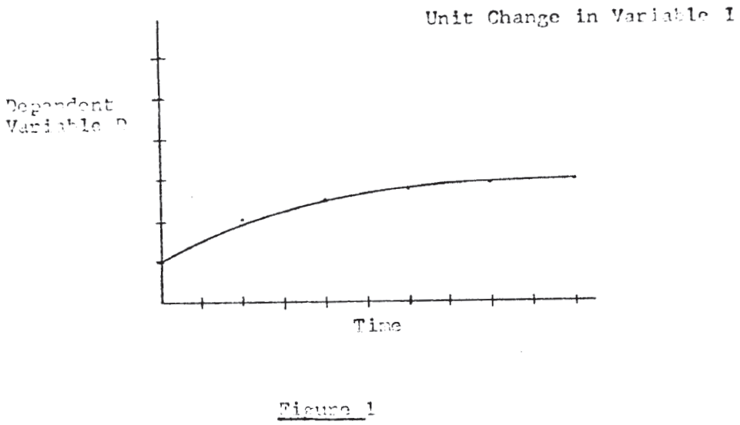
If a two unit change is made in independent variable I, then the same response is obtained from D except that the change in amplitude is multiplied by 2. This is demonstrated in Figure 2.
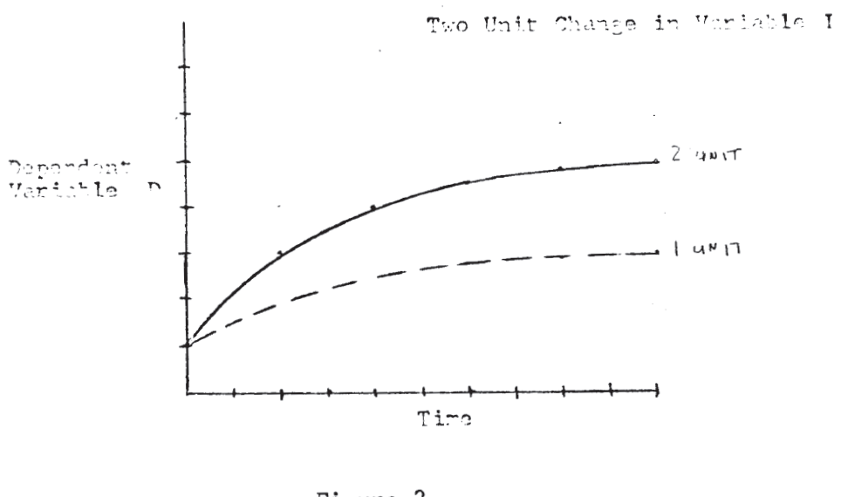

-page 5-
For a linear system the principle of superposition applies and this is demonstrated in Figure 3.
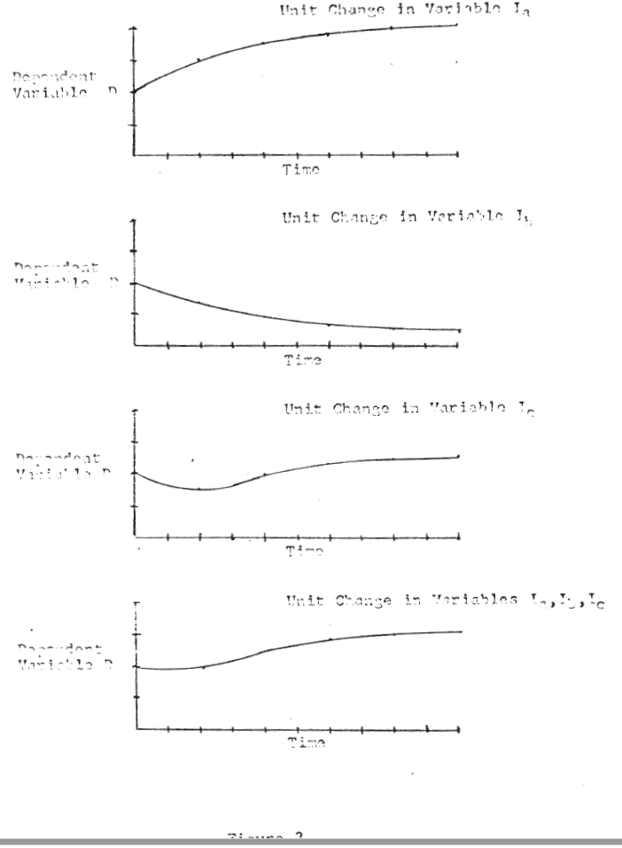

-page 6-
Let the numerical subscript on the dependent variable D represent the value of D at some discrete time interval after the change in the independent variables. The change in value of D at ant time interval may be deternmined by a set of linear algebraic equations if the change in the independent variables are known.
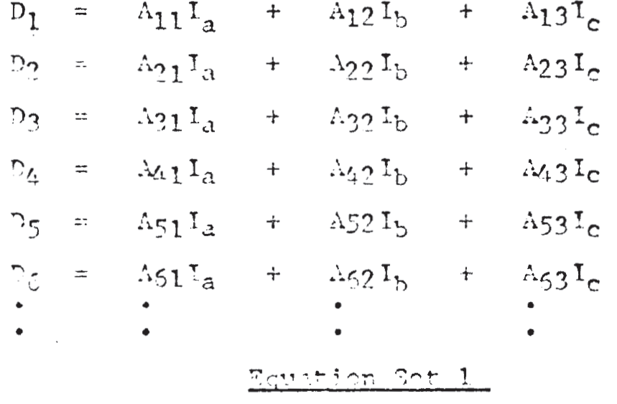
where D₁, D₂, D₃, etc. are for the time intervals 1, 2, 3 etc. , respectively and represent the change n D that result from the change in D that results from the cgange in I_{a}, I_{b} and I_{c}. The coefficients A_{ij} describe the system dynamics and may be determined experimentally by a number of published techniques. The relationship between this approach to describing system dynamics and finite difference differential equations is obvious. The coefficients Aij in the equation are nothing more than the solution of the differential difference equations. It is a simple matter to extend this calculation procedure to more than one dependent variable. For example two dependent variables D_{a} and D_{b}.

-page7-
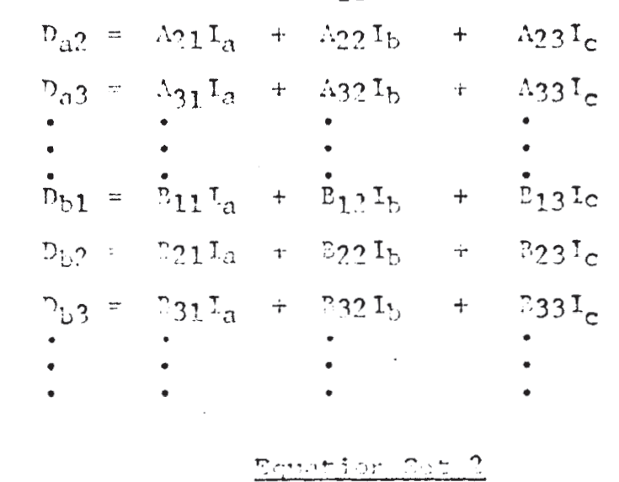
The Change In A Dependent Variable Can Be Expressed As A Change In The Error And A Control Scheme Developed Using The Exact Sample Method To Solve For The Current Value.
The change in the dependent variable D_{a} and D_{b} can be expressed as a change in the error when the set point for each variable is known
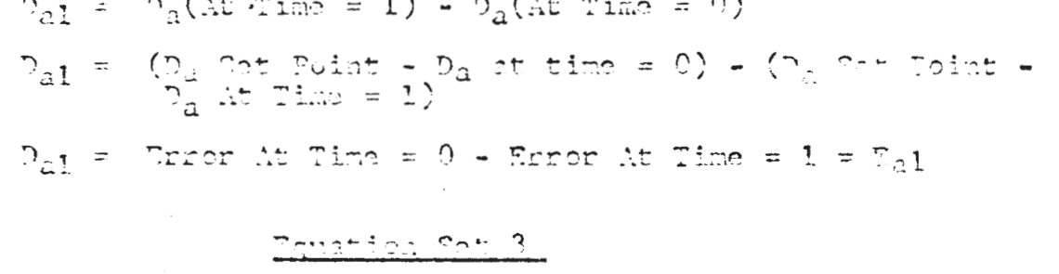
For illustration, assume thata steady state error exists in one of the dependent variables D_{a}. It is also assumed that the most desirable path for the variable to return to the setpoint is known. This is illustrated in Figure 4.

-page8-
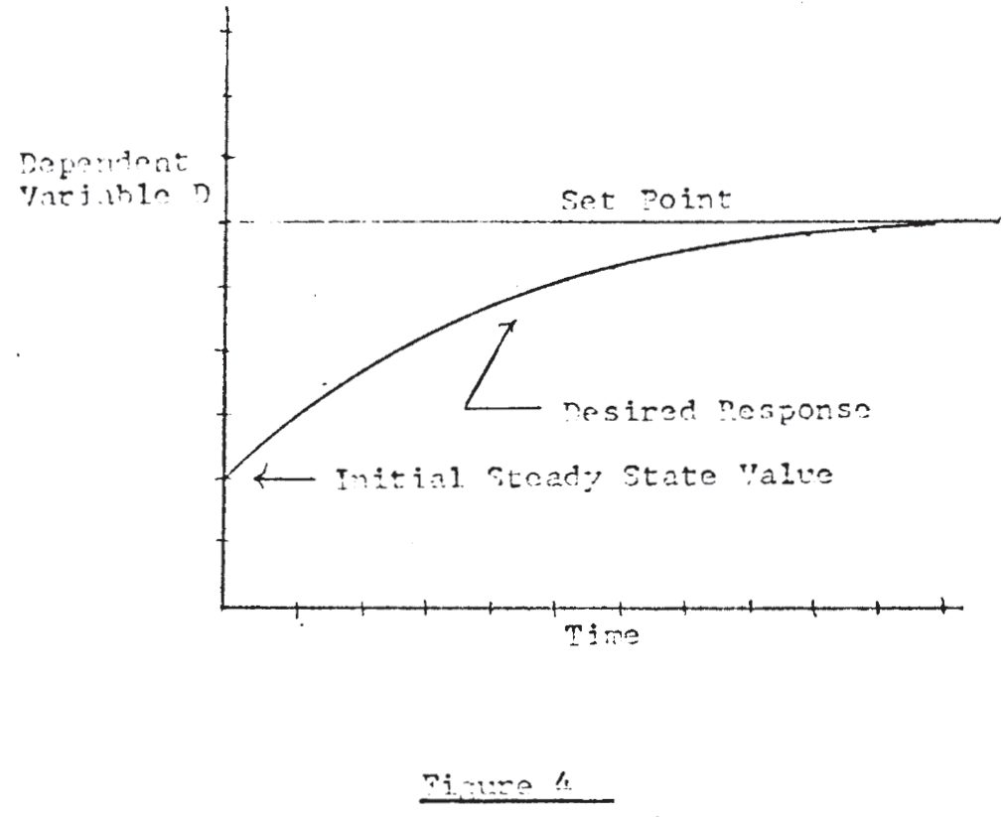

Since the desired change in Da is now known and the coefficients Aij in the dynamic response are known, the best set of moves in the independent variables to accomplish this control response can be determined by the method of least squares. The concept is easily expanded to multivariable control since the change in independent variables determined may influence a number of dependent control variables.

-page9-
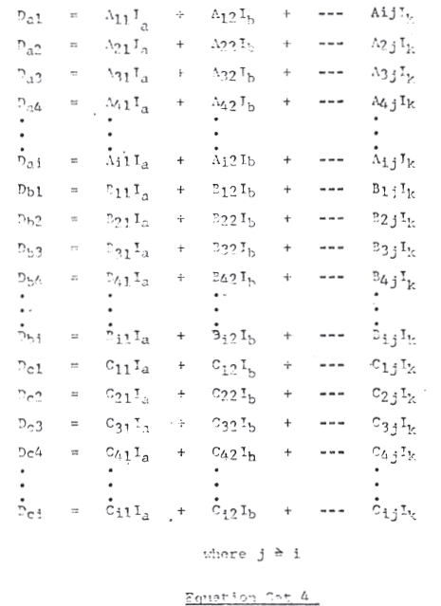
The number of independent variables fix the size of the matrix to be inverted, therefor any degree of accuracy can ne achieved in describing the dynamic response by reducing the length of the time interval.

-page10-
Time Dependent Moves In The Independent Variables May Be Incorporated Into The Control Algorithm.
An additional improvement can be achieved by permitting the independent variables to move in each time interval in the future. For example I_{a0}, I_{a1}, I_{a2}, etc. are moves in the independent variable I_{a} at times 0, 1, 2 respectively.
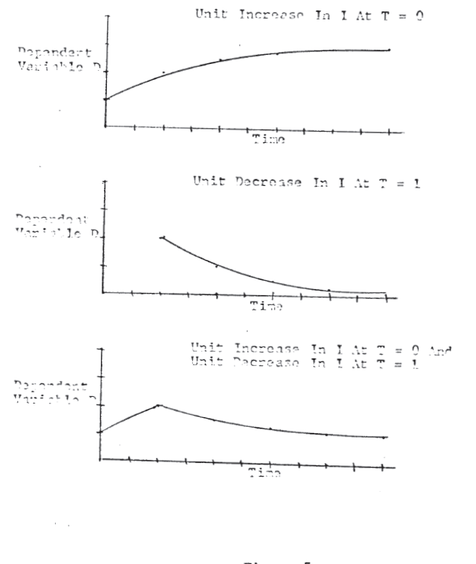
Figure 5

-page11-
The response of the dependent variable D_{a} to changes in one variable I_{a} is shown in Figure 5. The changes in I_{a} are made at time 0 and time 1 and represent a unit increase and decrease, respectively, The addition of this concept to the algorithm adds another dimension to the control since it allows the “planning” of future moves of the manipulated variables. There isn’t any additional dynami information to extend the algorithm to time dependent moves in the independent variable since the dynamic matrix repeats itself. This is illustrated below for 2 independent variables.
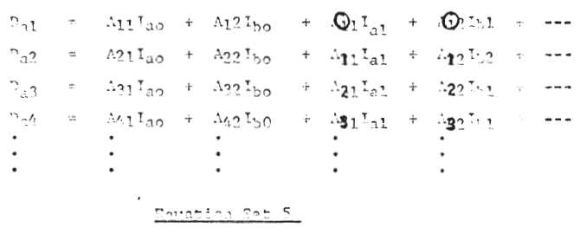
The concept of time varying independent variables is easily extended to more than one dependent variable by analogy to equation set 2 where only one move in each of the independent variable at time zero was shown. For clarification this situation is illustrated below:

-page12-
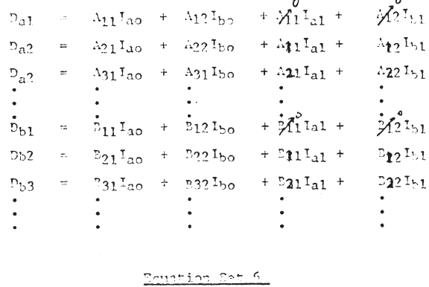

Correction For Errors In The Dynamic Model And Disturbances To The System
The expression in the algorithm for errors in the dynamic predictions and disturbances would be made comparing the predicted error against the actual error. If the actual error is less than the predicted error then there would not be any corrections made in the independent variables. If on the other hand the actual error is greater that the predicted error the discrepancy between the erros would be corrected by moving the independent variables. The use of the least square method of solution in conjunction with the specification of a desired system response represents a practical control algorithm for a multivariable control system. The algorithm would satisfy four of the six desired criterion listed on the first two pages of this letter. The profit criterion is not covered directly with this type of approach; however if the set points were the result of an optimization, this would not be a serious limitation.

-page13-
The method does not provide a technique for recognizing the physical limitations of the independent (manipulated) variables. Although this problem can probably be circumvented by an iterative process, there appears to be a simpler alternative that will be considered next.
Use Of The Linear Programming Algorithm To Solve The Dynamic Equations.
The sum of the moves in each of the independent variable determines the final steady state position of the process. The most desirable steady state is the one which is optimum from the standpoint of the profit functions. On this basis the best set of control moves is the set that culminates in an optimum steady state operation. The linear programming algorithm provides the basis for finding the steady state optimum and also provides a means of constraining the response of the process being optimized when the dynamics are described in the manner presented in the previous paragraph. The beauty of this approach is that by adjusting the allowable error at such interval of time, the convergence of system can be guaranteed. In addition the controlled variable can be allowed to converge in a cyclic manner or in an over damped manner depending on how the limits are set at each time interval. This characteristic permits the control of a system adjacent to the constraints of the process, which is essential if the maximum benefits are to be derived from the control. This principal is illustrated in the next figure.

-page14-
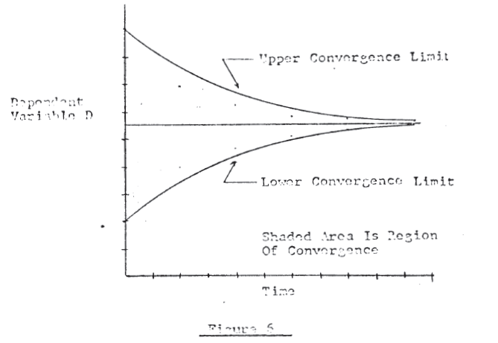
An optimization by definition forces a process to some set of constraints, therefore an algorithm that has an economic motivation must be capable of approaching while not exceeding a constraint on control variable.
The elements in the profit row of the linear programming would be derived from a steady state model of the process as reported by a number of writers in the literature.
The control algorithm proposed in this letter is the result of a number of years of studying and searching for a practical method of controlling multivariable systems. The criterion listed for the control algorithm are not just desirable but necessary if a computer is to successfully control a chemical process at an optimum condition. The conventional control theory in text books fails miserable short of these criterion, therefore I believe this proposal of mine is worth persuing. To the best of my knowledge the approach has not

-page15-
been proposed or attempted before and although my experience with process control at Shell cannot be disassociated from my technical background, I can say without hesitation that it does not resemble any technique now being used by Shell or under development by Shell.
Your comments, even if you do not agree with my points would be appreciated.

