Selection of Controlled Variables for a Natural Gas to liquids (GTL) Process

Mehdi Panahi, Sigurd Skogestad*
Department of Chemical Engineering, Norwegian University of Science and Technology (NTNU), 7491 Trondheim, Norway

Abstract
The aim of this work is to select the best individual or combined controlled variables (CVs) for a natural gas to hydrocarbon liquids (GTL) process based on the idea of self-optimizing. The objective function is to maximize the variable income of the plant and two modes of operation are studied. In mode I, where the natural gas flowrate is given, there are three unconstrained degrees of freedom (DOFs) and the corresponding individual self-optimizing CVs are selected as (i) CO₂ removal in fresh synthesis gas (syngas), (ii) CO mole fraction in fresh syngas and (iii) CO mole fraction in recycle tail gas from the Fischer Tropsch (FT) reactor. This set of CVs gives a worst-case loss of 1393 USD/hr. Adding one, two and three measurements and controlling measurements combinations, decrease the worst-case loss significantly; to 184, 161 and 53 USD/hr, respectively. In mode II, the natural gas flowrate is a degree of freedom and it is optimal to increase it as much as possible to maximize profit. The variable income increases almost linearly until the oxygen flowrate becomes active. Practically, this is the maximum achievable income. Theoretically, it is possible to increase the natural gas flowrate to improve the objective function, but this results in “snowballing” with large recycle flowrates to the FT reactor because its volume is the limitation.
Keywords: Fischer-Tropsch, Plantwide control, Optimal operation, Operational regions, Snowball effect
  - Introduction
For large natural gas reservoirs, converting natural gas to transportable liquid fuels (GTL) is economical when the target markets are further away than approx. 2500 km from the resources. Figure 1 shows the gas commercialization options and situation of GTL processes comparing to other possibilities of transportation, converting or usages.

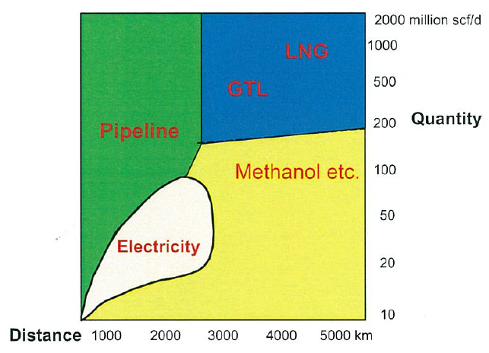
Figure 1. Gas commercialization options and situation of GTL processes¹

In this paper, optimal operation of a GTL process is considered using the top-down part of general plantwide control procedure of Skogestad². We want to operate the plant economically efficient in presence of unexpected disturbances. The main issue is “which variables should be controlled?” To select the best controlled variables, the self-optimizing method is applied. “Self-optimizing control is when we can achieve an acceptable loss with constant setpoint values for the controlled variables (CVs) without the need to reoptimize when disturbances occur^{2”}. This means that we use off-line optimization and analysis to obtain a control structure that can use constant setpoint policy for the CVs. This may completely remove the need for a real time optimization layer (RTO) for updating the setpoints when disturbances occur. However, at least theoretically, we will need to accept a small loss in objective cost compared to the case when RTO is used. By using measurement combinations, the loss can often be decreased significantly and from an engineering point of view close to zero. Based on the loss magnitude one can decide on using individual or combination of measurements as self-optimizing CVs.
In general, a different set of self-optimizing variables need to selected in each operating region (set of active constraints) and in this paper we consider two modes of operation. In mode I, the feedrate to the process is given and in mode II, the feedrate is adjusted to get the maximum possible throughput.
The steps of the self-optimizing method are as follows.
Step 1: Define the objective function and constraints
Step 2: Identify degrees of freedom (DOFs) for optimization
Step 3: Identify important disturbances
Step 4: Optimization for these disturbances
Step 5: Identification of candidate controlled variables (CVs)
Step 6: Selection of CVs
In section 3, the self-optimizing steps are followed in details for the GTL process to select the best controlled variables. The UniSim commercial simulator is used for modeling the process.
  - Process description
GTL processes include three main steps (see Figure 2) to convert natural gas to a range of liquid fuels. In the synthesis gas (syngas) unit, natural gas is reacted with oxygen and steam to “syngas”, a mixture of CO and H_{2.}. This is further converted to a range of liquid hydrocarbon fuels by the highly exothermic Fischer-Tropsch (FT) reactions.
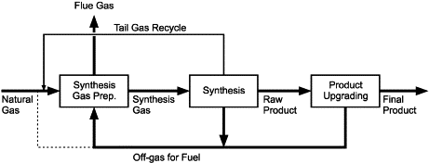
Figure 2. Simple flowsheet of GTL process³
The FT hydrocarbon products include mostly paraffins and olefins, in the range from light (methane) to heavy hydrocarbons (wax). In the final step, the heavier products are upgraded to clean fuels and the lighter hydrocarbons are recycled back to the syngas unit or used as fuel inside the plant.
The GTL flowsheet, process model and nominal optimal data is taken from our previous work⁴ where more details are given. In the current paper, we nominally assume a 3 bar pressure drop between the syngas unit and FT reactor⁶. The syngas unit is assumed to operate at 30 bar (no pressure drop for individual equipment is assumed). The pressure drop is simulated using a valve (see V-1 in Figure 3) with variable pressure drop as a function of flowrate. Figure 3 shows the process flowsheet with nominally optimal data. The syngas step consists of a pre-reformer, fired heater and auto-thermal reformer (ATR), which is claimed to be the best way for syngas production⁵. The other main units are the CO₂ removal for the syngas stream and the FT reactor, which in our case is a Cobalt based slurry bubble column rector (SBCR).
Fired heater and pre-reformer
Fresh natural gas and recycled hydrocarbons from the FT unit are mixed and preheated in the fired heater to 455°C⁶ and then enter the pre-reformer. In the pre-reformer, all heavier hydrocarbons are converted by reaction with steam to syngas. The methanation and shift reactions are assumed to be in equilibrium in the pre-reformer⁷. The advantage of the pre-reformer is that one avoids cracking in the subsequent ATR. The outlet of the pre-reformer is further heated in the fired heater to 675°C and then enters the ATR. To control the temperatures of the outlet streams of the fired heater, we use by-pass streams (not shown in the flowsheet in Figure 3), which can be viewed as control degree of freedom. In addition to preheating several streams, the fired heater produces superheated medium pressure (MP) steam which generates electric power for the oxygen plant and for the recycle compressors (compressors I and II in Figure 3).

Auto-thermal reformer
The following reactions take place in the ATR⁸:
Oxidation of methane: (1)
Steam reforming of methane: (2)
Shift Reaction: (3)
Figure 3. GTL flowsheet with data for optimal nominal point (mode I)

The outlet of the ATR is more than 1000°C, and the heat is used to generate steam. The syngas is then further cooled to separate out associated water. In the next unit, the CO₂ content is reduced. This unit is not modeled in detail, but amine absorption/stripping could be an option. The prepared syngas, which we call the fresh syngas, has a H₂ to CO ratio of around 2 to 2.1. The exact ratio is decided by optimization.

Fischer Tropsch (FT) reactor
The volume of the FT reactor is assumed 2000 m³ and gas holdup is 40%⁶. The cooled FT reactor operates at 27 bar and 210°C. The FT reactions are highly exothermic and an advantage of slurry reactors is their excellent heat removal properties. By controlling the boiling water pressure, the reactor temperature can indirectly be controlled. A compressor (Compressor II in the flowsheet) was added in the FT recycle loop to compensate for the assumed 2 bar pressure drop in the FT reactor.
The highly exothermic FT reactions are described by Yates and Satterfield reactions⁹.
(4)
where .The products are paraffins and olefins. Methane formation is also unavoidable. We use the proposed reaction rates of Iglesia et al¹⁰ for Cobalt based FT reactions to simulate the slurry bubble column FT reactor (SBCR).
(5)
(6)
The details of the reaction rates and reactor simulation are given in our previous work⁴. The following lumps are assumed to describe the FT products: C₁, C₂, LPG (C₃-C₄), Gasoline/Naphtha (C₅-C₁₁), Diesel (C₁₂-C₂₀) and Wax (C₂₁₊). Light ends (mostly C₁ and C₂) are either recycled to the syngas unit or purged to be used as fuel for the fired heater. The ASF model is used to describe the distribution of the products.
(7)
Here is the weight fraction of hydrocarbons () and α is the chain growth probability. Figure 4 illustrates the meaning of chain growth probability.
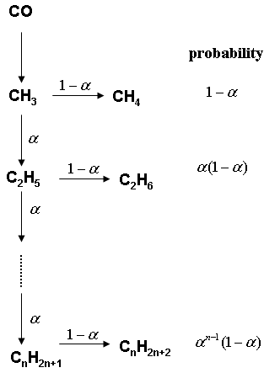
Figure 4. Probability of the chain growth to hydrocarbons in FT reactions¹

As Figure 4 shows, the selectivity to hydrocarbons is a function of the chain growth probability. The factor α is a function of the hydrogen to carbon monoxide ratio. In previous work we discussed these dependencies⁴ and showed that how significance is this ratio. We use the function proposed by Yermakova and Anikeev¹¹ and modified by Song et al¹² to calculate chain growth probability:
(8)
Here, and are mole fractions in the FT reactor and T is reactor temperature (K).
In the next section, we apply the self-optimizing method² to select the best individual and combined self-optimizing CVs for this process.
  - Top-down analysis for operation of the GTL process
We perform the analysis in two modes of operation; in mode I, the natural gas feed flowrate is given (disturbance) and in mode II, the natural gas feed flowrate is a degree of freedom for optimization.
    - Mode I: natural gas flowrate is given
The steps of the top-down analysis are as follow.
      - Step 1. Define the objective function and constraints
We define variable income (profit) as the objective function to be maximized.
Variables income = sales revenue – variable cost (9)
Variable cost=cost of raw materials + cost of energy + cost of CO₂ removal (10)
The prices for raw materials, products and other costs are given in Table 1⁴. Note that we did not include cost for energy. In addition, no credit was assumed for steam generated in the process (MP steam in boiler after ATR, LP steam in FT reactor) but we expect that should not affect our control structures. Since there is much extra steam in the plant, therefore the required energy for regenerating of solvent in CO₂ removal unit can be easily supplied. Anyway, we have included 50 USD/ton CO₂ in the optimization.

Table 1. Assumed prices cost⁴
Raw materials:
- natural gas:0.5 USD/MMBtu
- water and steam: 0
- oxygen: oxygen is supplied by the ASU unit and we assume that the GTL plant supplies the required steam for the oxygen plant. The price we need to pay decreases somewhat with increased oxygen usage; USD/kg (11)
Energy: 0
CO₂ removal: 50 USD/ton CO₂
Products:
- LPG (C₃-C₄) = 0.9 USD/kg
- Gasoline/Naphtha (C₅-C₁₁) = 0.73 USD/kg
- Diesel (C₁₂-C₂₀) = 0.71 USD/kg
- Wax (C₂₁₊) = 0.63 USD/kg

The inequality constraints are as follows.

- Feed syngas molar ratio H₂O/C ≥ 0.3 to ensure soot free conditions. Carbon in this ratio includes fresh and recycled hydrocarbons. Note that Holdor Topsøe reports soot free operations at even lower values⁵ but we choose 0.3 as the lower bound.
- Inlet temperature of ATR (outlet of fired heater) ≤ 675°C. The reason for this limit is piping material constraint¹³.
- Outlet of ATR ≤ 1030°C. This temperature is an average of several ATR temperatures reported by Holdor Topsøe¹⁴ which ensures soot free operation.
- To avoid convergence problem, for simulation purposes, purge ratio of tail gas is bounded at 3% although the optimal is lower value at around 2%. The purpose of the purge stream is to get rid of the nitrogen entering in the fresh natural gas feed.
- In addition, there are capacity constraints on the variable units; fired heater (duty +40% compared to nominal), CO₂ removal unit (+20% feedrate), oxygen plant (+20% oxygen flowrate).
The equality constraints, most of which were explained in process description are:
- Fresh natural gas + recycle hydrocarbons temperature to pre-reformer is kept at 455°C,
- Steam temperature to pre-reformer is kept at 455°C,
- Oxygen feed temperature to ATR is kept at 200°C,
- Feed enters the syngas unit at 30 bar. Note that the pressure of the fresh streams are set in other units which are outside our flowsheet boundary,
- Fresh Syngas from ATR (after passing the boiler) is cooled down to 38°C for separation of water content,
- Syngas enters into the FT reactor at 210°C,
- Boling water pressure (cooling medium of FT reactor) is kept at 12.5 bar (low pressure, LP steam). This gives a gradient of 20°C between FT desired temperature (210°C) and the coolant (190°C).
- FT products are cooled down to 30°C in a 3-phase separator to separate liquid fuels, water and tail gas,
- Recycle tail gas to FT reactor is compressed to 27 bar,
      - Step 2. Identify degrees of freedom (DOFs) for optimization
There are 15 main steady-state operational degrees of freedom which can be selected to be:
- H₂O (superheat steam) feedrate to pre-reformer (this can be viewed also as the ratio H₂O/C),
- Superheat steam bypass in fired heater,
- Natural gas feedrate as fuel (make up) to the fired heater,
- Natural gas + recycle hydrocarbons bypass in fired heater,
- Oxygen feedrate to ATR,
- Oxygen bypass in fired heater,
- Cooling duty for water removal from fresh syngas,
- CO₂ removal,
- Pre-heater duty for FT reactor,
- Steam (LP) flowrate for cooling FT reactor,
- 3-Phase separator cooling duty for separation of FT products,
- Recycle ratio to FT reactor, which is the percentage of recycled tail gas that enters the FT reactor. The rest is recycled back to the syngas unit (pre-reformer),
- Compressor II duty (the recycle tail gas flow to FT reactor),
- Recycle tail gas purge ratio,
- Compressor I duty (the recycle tail gas flow to syngas unit),
      - Step 3. Identification of important disturbances
The main disturbances (d) are natural gas feedrate, natural gas composition, natural gas price and FT “kinetic parameter”. In addition, the value of all active constraints may be considered as disturbances. We determine the maximum expected value for each disturbance in step 6.
      - Step 4. Optimization
We first did the optimization for the nominal case using the “Mixed method” in UniSim. This method tries to combine the advantage of global optimization of the BOX method and the efficiency of SQP method. Initially, it uses the BOX method with a very loose convergence tolerance and then switches to the SQP method to locate the final solution with the desired tolerance¹⁵. Figure 3 shows the optimal nominal flowsheet. Table 2 shows the optimal nominal values of some of the important parameters. Carbon efficiency, defined in this table is the ratio of mole carbon of produced hydrocarbons to mole carbon in feed natural gas including the required natural gas as fuel in the fired heater.
We find three active constraints during optimal nominal operation;
- the outlet temperature of the fired heater is active at the maximum (675°C),
- the outlet temperature of the ATR is active at the maximum (1030°C),
- purge ratio is active at the specified minimum which is to purge 3% of the tail gas.
Since change at any of these active constraints has a significant effect on objective function value⁴, we included all of them as disturbances during analysis.

Table 2. optimal nominal values
 |  | CO₂  Removal | Recycle  ratio to FT | Purge of  tail gas |  |  | CO conversion |  | H₂ conversion |  |  | Carbon  Efficiency | Objective function  (USD/hr)
 |  |  |  |  |  |  | per pass | overall | per pass | overall |  | Carbon  Efficiency | Objective function  (USD/hr)
0.6010 | 0.5233 | 75.73% | 73.79% | 3% | 2.1 | 2.03 | 85.74% | 95.50% | 89.93% | 96.92% | 0.87 | 74.59% | 49293

We have 15 steady-state degrees of freedom, 9 equality constraints and 3 active constraints which each needs one degree of freedom for control. Therefore, we have 3 (=15-9-3) remaining unconstrained degrees of freedom.

Table 3. possible pairings of steady-state degrees of freedom with equality/active controlled variables
Degree of freedom (DOF) Controlled variable (CV)
1- Superheat steam bypass in fired heater Superheat steam temperature to pre-reformer

2- Natural gas feedrate as fuel (make up) to Outlet temperature of the fired heater (active
the fired heater constraint)

3- Natural gas + recycle hydrocarbons Natural gas + recycle hydrocarbons feed bypass in fired heater temperature to pre-reformer

4- Oxygen feedrate to ATR ATR outlet temperature (active constraint)

5- Oxygen bypass in fired heater Oxygen feed temperature to ATR

6- Cooling duty for water removal from Separator temperature
fresh syngas

7- Pre-heater duty for FT reactor FT reactor inlet temperature

8- Steam (LP) flowrate for FT reactor cooling Steam drum pressure

9- 3-phase separator cooling duty 3-phase separator temperature

10- Compressor II duty (the recycle tail gas Compressor II outlet pressure
flow to FT reactor),

11-Recycle tail gas purge ratio, Purge ratio (active constraint)

12- Compressor I duty (the recycle tail gas Compressor I outlet pressure
flow to syngas unit),

Unconstrained CVs in mode I
There are many ways to pair the constraints with the degrees of freedom (inputs), but with the suggested pairings in Table 3, we are left with the following unconstrained degrees of freedom:
u₁: Feed H₂O/C,
u₂: CO₂ removal % before FT reactor
u₃: Recycle ratio to FT reactor
The objective is now to select the best three self-optimizing CVs to pair with these DOFs. Note that the actual choice of unconstrained degrees of freedom (u₁, u₂, u₃) does not really matter and we would obtained equivalent results with other choices, although the matrices G^{y}, G_{d}^{y}, J_{uu} and F in the subsequent analysis would be different.
      - Step 5. Identification of candidate controlled variables
We consider 18 candidate measurements including the three unconstrained degrees of freedom (actually, all the 15 DOFs could have been considered, but we only consider these 3):
- O₂/C (y₁)
- Feed H₂O/C = u₁ (y₂)
- CO₂ removal% = u₂ (y₃)
- recycled tail gas ratio to FT reactor = u₃ (y₄)
- H₂/CO in fresh syngas (y₅)
- H₂/CO in tail gas (y₆)
- H₂/CO into FT reactor (y₇)
- H₂ mole fraction in fresh syngas (y₈)
- CO mole fraction in fresh syngas (y₉)
- CH₄ mole fraction in fresh syngas (y₁₀)
- H₂ mole fraction in tail gas (y₁₁)
- CO mole fraction in tail gas (y₁₂)
- CH₄ mole fraction in tail gas (y₁₃)
- H₂ mole fraction into FT reactor (y₁₄)
- CO mole fraction into FT reactor (y₁₅)
- fresh syngas flowrate (y₁₆)
- tail gas flowrate to syngas unit (y₁₇)
- tail gas flowrate to FT reactor (y₁₈)

We have 18 candidate measurements and one needs to select 3 individual measurements, CV=Hy where H is the selection matrix. Therefore there are possible single measurement candidate sets. The self-optimizing method is applied in the next step to choose the best set.
      - Step 6. Selection of CVs
To find the best set of CVs, we applied the “exact local method”¹⁶, which gives the maximum loss imposed by each candidate set in presence of disturbances and measurement noise. The set with the minimum worst-case loss is the best. Expressions (12)-(15) give the mathematical formulation of calculating loss.
(12)
(13)
where the optimal sensitivity (F) can be obtained analytically from (14) or numerically by re-optimizing the process from (15).
(14)
(15)
In (12), (M) is the maximum singular value of matrix M, is Hessian of the objective function with respect to unconstrained DOFs, is the gain of the selected measurements from the inputs, is the expected magnitude of the disturbances, is implementation error, is second derivative of objective function with respect to DOFs and disturbances and is gain from disturbances to the selected measurements. It is worth knowing that Frobenius norm, which gives the average loss could be used instead of worst-case loss, but both methods give the same results¹⁷.
We consider 7 disturbances (d) with the following maximum expected magnitude (included in the diagonal matrix, ):
d₁(N.G. flowrate):10%,
d₂(N.G. hydrocarbons composition):10%, change in hydrocarbons composition is balanced with change in N₂ composition in natural gas flow stream,
d₃(fired heater outlet temperature):30°C,
d₄(ATR outlet temperature):40°C,
d₅(FT reactions rate constant):10%,
d₆(purge ratio):15%,
d₇(N.G. price):10%
The implementation error (measurement noise) for the candidate measurements is assumed to be (included in the diagonal matrix,); compositions: 0.1%, flowrates: 10%, split ratios: 15%.
Individual measurements as CVs
A branch and bound algorithm¹⁸ is applied to find the best set of single measurements with the minimum worst-case loss. Table 4 shows the five best sets with their corresponding worst case loss. The smallest loss is obtained by controlling the CO₂ removal (y₃) in CO₂ removal unit, the CO mole fraction in the fresh syngas (y₉) and CO mole fraction in the tail gas (y₁₂).
Table 4. Five best set of individual self-optimizing CVs in the optimal nominal case
(Mode I of operation)
no. | Sets |  |  | Loss (USD/hr)
1 | y₃: CO₂ removal | y₉: CO mole fraction  in fresh syngas | y₁₂: CO mole fraction  in tail gas | 1393
2 | y₃: CO₂ removal | y₂: H₂O/C | y₆: H₂/CO  in tail gas | 1457
3 | y₃: CO₂ removal | y₂: H₂O/C | y₅: H₂/CO  in fresh syngas | 1698
4 | y₃: CO₂ removal | y₆: H₂/CO  in tail gas | y₅: H₂/CO  in fresh syngas | 2594
5 | y₁₀: CH₄ mole fraction  in fresh syngas | y₆: H₂/CO  in tail gas | y₅: H₂/CO  in fresh syngas | 2643

We pair the CVs of the best set with the corresponding close-by manipulated variables:
CV1 = CO mole fraction in outlet of the ATR (y₉) is controlled using u₁ = Feed H₂O/C. CV2 = CO₂ removal% (y₃) is controlled using u₂= CO₂ removal
CV3 = CO mole fraction in tail gas (y₁₂) is controlled using u₃ = recycle tail gas ratio to the FT reactor. The CV2 “pairing” seems strange, but it follows because we have not modeled in detail the CO₂ unit, so the input (u₂) is actually a CV (y₃). The demonstrated control loop just figures out that CO₂ removal percentage is controlled internally by the CO₂ removal plant. Manipulating of recycle amine in case that amine absorption/stripping system is applied will be one possibility to control the CO₂ removal.
Measurement combinations as CVs
As the loss of the best individual sets of measurements in Table 4 is fairly high (compared to the objective function value in the optimal nominal point), we consider measurement combinations as CVs, CV=Hy where H is a “full matrix” in terms of the selected measurements, to get a smaller loss¹⁹. The optimal H is obtained by solving the following optimization problem.
(16)
where . An analytical solution¹⁹ for (16) is: .

A partial branch and bound algorithm²⁰ is applied to find the best set of CVs with more measurements than 3. Figure 6 and Table 5 show the results of Solving (12) and (16) for different number of measurements.
The results show that by having 4 measurements the loss decreases significantly from 1393 USD/hr to 184 USD/hr and by having 5 and 6 measurements the loss decreases further to 161 USD/hr and 53 USD/hr respectively. By combining 7 measurements the best worst-case loss is 17 USD/hr, which is almost zero from a practical point of view. Measurement y₃ (CO₂ removal) is always included, but the other measurements in the optimal set varies.

Figure 5. Possible control structure for mode I of operation (red lines are by-pass streams)

Figure 6. Minimum worst-case loss with different number of measurements (mode I)

Table 5. Optimal measurement combinations (CVs) with corresponding losses (mode I)

no. measurements Optimal CVs worst-case loss (USD/hr)
3
1393

4
184

5
161

6
53

7
17

    - Mode II: Natural gas feed is a degree of freedom for optimization
From an economical point of view with the given prices, it is optimal to increase the amount of natural gas feed as much as possible to get more profit. As mentioned earlier, the following maximum capacity constraints are included:
- Duty of fired heater: +40% compared to nominal in mode I
- Feedrate to CO₂ removal unit: +20%
- Oxygen feedrate: +20%
We didn’t include any upper bound on the compressor duties. This is because in mode I the nominal compressor duties (compressor I: 0.47 MW, compressor II: 0.55 MW) are small compared with the duty of the fired heater (energy duty: 328.6 MW), so we may consider basing the design capacity for the compressors on the mode II operation.
The profit is shown as a function of the feedrate in Figure 7. In addition to the oxygen flowrate, outlet temperature of fired heater (at maximum), outlet temperature of ATR (at maximum) and purge ratio (at minimum) are also active, which they are the same active constraints as the nominal case. The profit increases almost linearly with the natural gas flowrate (see Figure 7) up to the point when the first capacity constraint is reached, which is when the oxygen flowrate reaches its maximum (point A in Figure 7). At this point the increase in natural gas feedrate is +23.18% (compared to the nominal point I). The reason why it does not increase completely linearly is because of the fixed volume of the FT reactor which implies that the optimal values of the intensive variables change somewhat.
The feedrate can be increased further to +33.32% (point B in Figure 7), at which we reach the bottleneck where a further increase gives infeasible operation. Figure 8 shows the optimal flowsheet at the maximum throughput. Table 6 summarizes the optimal values of the main parameters. However, note from Figure 7 and Table 8 that although the profit increases by +21.0% from the nominal point to point A, it only has a very small further increase to +21.6% in point B. Thus, in practice, operating point A may actually be the optimal, because in point B the compressor work is about twice as large as in point A. The compressor work is included in our economic optimization, but the minor operational economic benefit in point B may not justify the extra capital costs of a larger compressor. Also, there are other operational disadvantages with large variations in the recycle flow (“snowballing”) and there is also the issue of less effective use of resources in point B since the purge flow is large. Nevertheless, we choose to work with operating point B for the further control studies.
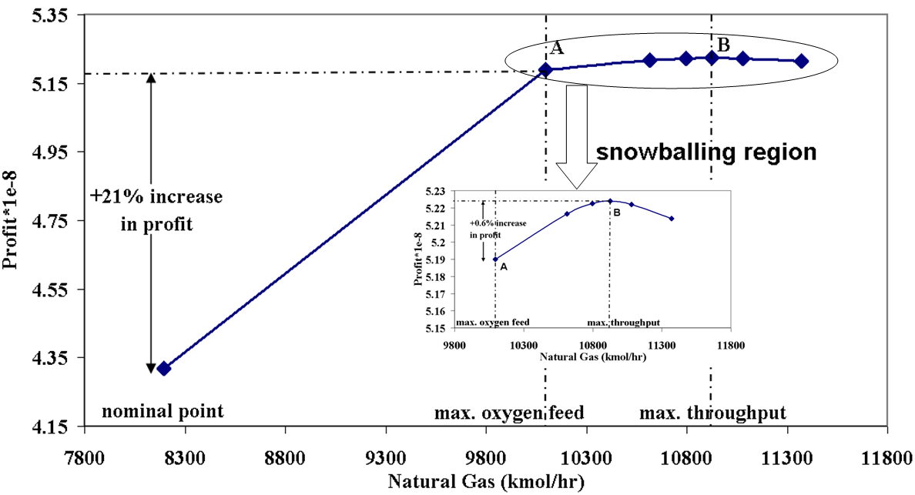
Figure 7. Optimal profit as function of natural gas flowrate
Point A: near max. profit (recommended operating point), Point B: max. achievable profit (max throughput)

Figure 8. GTL flowsheet with data for maximum throughput (mode II, point B)
Figure 9 shows that as the feed natural gas feedrate increases, CO and H₂ conversions decrease and purge flowrate and the recycle increase, all because of the constant volume of FT reactor. This is snowballing effect²¹ which should be avoided. Therefore, the FT reactor volume may be viewed as the bottleneck of the process. Actually, the bottleneck for operation is the active constraints, but in terms of redesign it may be better to increase the reactor volume.

Table 6. Optimal values at three operating points
 | Feed | into ATR | CO₂  Removal | Recycle  ratio to FT | Purge of  tail gas |  |  | CO conversion |  | H₂ conversion |  |  | Carbon  efficiency | Compressor II (duty, MW) | Objective function  (USD/hr)
 |  |  |  |  |  |  |  | per pass | Overall | per pass | overall
opt. nominal | 0.6010 | 0.5233 | 75.73% | 73.79% | 3% | 2.1 | 2.03 | 85.74% | 95.50% | 89.93% | 96.92% | 0.8707 | 74.59% | 0.55 | 49293
max. oxygen (A) | 0.5357 | 0.5160 | 76.80% | 90% | 3% | 2.092 | 1.91 | 67.08% | 94.14% | 74.705 | 95.88% | 0.8692 | 74.30% | 2.15 | 59246
max. throughput  (B) | 0.4084 | 0.5040 | 76.04% | 97.13% | 3% | 2.095 | 1.80 | 51.25% | 94.79% | 60.69% | 96.39% | 0.8701 | 74.31% | 5.06 | 59634

Unconstrained CVs in Mode II (point B)
In mode II, there are 16 DOFs because the natural gas feedrate gives one extra compared to mode I. At the optimal point (point B), there are 4 active constraints and the same 9 equality constraints as in mode I. The extra active constraint compared to mode I is the maximum oxygen flowrate. Since it then cannot be used to control the ATR exit temperature (active constraint) as we did in mode I, we select to use the natural gas feedrate to control the ATR temperature. The other pairings for control of the constraints are as for mode I.
We are then again left with 3 unconstrained degrees of freedom which are the same as in mode I: H₂O/C, CO₂ removal % and recycle ratio to FT. The self-optimizing analysis is repeated to find the best set of CVs. Compared to case I, we add the maximum oxygen flowrate as a disturbance (d₈:5%).
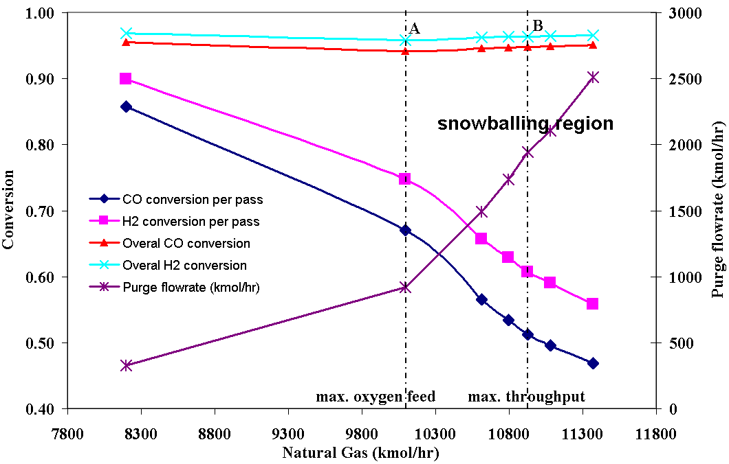
Figure 9. Optimal values of CO, H₂ conversion (single pass and overall) in FT reactor and purge flowrate as function of natural gas feedrate

Individual measurements
By applying the exact local method we find the best individual measurements. The best five sets are presented in Table 7. In mode II, two of the unconstrained degrees of freedom are found to be self-optimizing CVs (u₁=H₂O/C and u₂=CO₂ removal). The best third CV is the ratio H₂/CO into FT reactor, which should be paired with the only remained degree of freedom, which is recycle tail gas ratio (u₃). The resulting control structure is shown in Figure 10. Note that the objective of this work is to select controlled variables (CVs) and the shown pairings with the manipulated variables (MVs) is only a suggestion. By comparing the best individual measurement sets for the two modes of operation we find one common set, which is the third set in Tables 4 and 7, and interestingly, we see that two measurements; y₃ (CO₂ removal) and y₅ (H₂/CO in fresh syngas) have almost the same setpoint values (see the optimal values in Table 6). The setpoint of the third measurement, H₂O/C, changes from 0.6010 in the nominal case to 0.4084 in the maximum throughput case (point B).
Figure 10. Possible control structure for mode II of operation

Table 7. Five best sets of individual self-optimizing CVs in the maximum throughput case (Mode II, point B)
no. | Sets |  |  | Loss (USD/hr)
1 | y₃: CO₂ removal | y₂: H₂O/C | Y₇: H₂/CO  Into FT reactor | 3022
2 | y₃: CO₂ removal | y₂: H₂O/C | Y₆: H₂/CO  in tail gas | 3316
3 | y₃: CO₂ removal | y₂: H₂O/C | Y₅: H₂/CO  in fresh syngas | 3495
4 | y₃: CO₂ removal | y₂: H₂O/C | y₁₇: tail gas  flowrate to syngas unit | 4179
5 | y₃: CO₂ removal | y₉: CO mole fraction  in fresh syngas | y₁₅: CO mole fraction  Into FT reactor | 4419

In the “snowballing” region between operating points A and B, one can view the H₂O/C setpoint as throughput manipulator (TPM). As mentioned, from a practical point of view, it may be better to operate the plant closer to point A. This may be achieved from increasing the setpoint for H₂O/C from 0.4084 (point B) to 0.5357 (point A).

Measurement combinations as CVs
As an alternative to individual measurements, we consider also combinations of CVs in mode II. Figure 11 and Table 8 illustrate the results. By combining 4, 5, 6 and 7 measurements, the worst-case loss decreases significantly to 520, 153, 112 and 61 USD/hr respectively.
Figure 11. Minimum worst-case loss with different number of measurements (mode II)

Table 8. The best set of combination measurements and their corresponding losses in comparison with the best individual measurements set (mode II)
no. of the best set of the minimum
measurements combinatorial CVs worst-case loss
(USD/hr)
3
3022

4
520

5
153

6
112

7
61

  - Conclusions
The steady-state top-down part of the general plantwide control procedure was applied for selection of the best controlled variables (CVs) for GTL process in two modes of operation. In mode I, the natural gas feedrate is given and in mode II, the natural gas feedrate is degree of freedom for optimization in order to achieve the maximum possible profit. The transition from mode I to mode II occurs when the oxygen flowrate reaches its maximum. In mode II, when the oxygen flowrate saturates (point A), the recycle flowrate to the FT reactor increases significantly as we further increase the feedrate towards the optimal point B. The purge flow and compressor II duty also increase. This snowballing effect should be avoided. In addition, the economic benefit of increasing the feedrate is small, therefore it may be better in practice to operate closer towards point A.
In both mode I and II of operation, we have three remaining unconstrained steady-state degrees of freedom and among the best corresponding individual measurement CV sets, we found for both modes two CVs with almost the same setpoint value (H₂/CO in fresh syngas and CO₂ removal%) and a third one (H₂O/C feed) where the setpoint decreases from 0.6010 (nominal case) to 0.4084 (maximum throughput, point B) and this choice gives a simple transition. In mode II, the setpoint of the steam to carbon feed ratio (H₂O/C) can be chosen as the throughput manipulator (TPM) in the “snowballing region” between points A and B, and by reducing its value we can move closer to point A, where snowballing is avoided.
Use of combinations of measurements reduces significantly the worst-case loss. In both modes, we reach almost zero loss by combining 7 measurements.
References

(1) GTL-Workshop (2010). "Introduction to GTL Technology, Pre-Symposium Workshop." Organized by Gas Processing Center and Shell Company Doha, Qatar

(2) Skogestad, S. (2004). "Control structure design for complete chemical plants." Computers & Chemical Engineering 28(1-2): 219-234

(3) Rostrup-Nielsen, J., I. Dybkjaer and K. Aasberg-Petersen (2000). "Synthesis gas for large scale Fischer-Tropsch synthesis." American Chemical Society, Division of Petroleum Chemistry, Preprints 45(2): 186-189

(4) Panahi, M., A. Rafiee, S. Skogestad and M. Hillestad (2011). "A Natural Gas to Liquids (GTL) Process Model for Optimal Operation." Accepted for publication in Industrial & Engineering Chemistry Research Journal, DOI: 10.1021/ie2014058

(5) Aasberg-Petersen, K., T. S. Christensen, C. Stub Nielsen and I. Dybkjær (2003). "Recent developments in autothermal reforming and pre-reforming for synthesis gas production in GTL applications." Fuel Processing Technology 83(1-3): 253-261

(6) Schanke, D. and J. Sogge (2010). Personal communication, Statoil, Research center/ Trondheim

(7) Christensen, T. S. (1996). "Adiabatic prereforming of hydrocarbons -- an important step in syngas production." Applied Catalysis A: General 138(2): 285-309

(8) Aasberg-Petersen, K., J. H. Bak Hansen, T. S. Christensen, I. Dybkjaer, P. S. Christensen, C. Stub Nielsen, S. E. L. Winter Madsen and J. R. Rostrup-Nielsen (2001). "Technologies for large-scale gas conversion." Applied Catalysis A: General 221(1-2): 379-387

(9) Yates, I. C. and C. N. Satterfield (1991). "Intrinsic kinetics of the Fischer-Tropsch synthesis on a cobalt catalyst." Energy & Fuels 5(1): 168-173

(10) Iglesia, E., S. C. Reyes and S. L. Soled (1993). Reaction-Transport selectivity models and the design of fischer-tropsch catalysts. Computer-aided design of catalysts.Eds P. C. J. Becker E. Robert 199-257

(11) Yermakova, A. and V. I. Anikeev (2000). "Thermodynamic Calculations in the Modeling of Multiphase Processes and Reactors." Industrial & Engineering Chemistry Research 39(5): 1453-1472

(12) Song, H.-S., D. Ramkrishna, S. Trinh and H. Wright (2004). "Operating strategies for Fischer-Tropsch reactors: A model-directed study." Korean Journal of Chemical Engineering 21(2): 308-317

(13) Bakkerud, P. K. (2009). Personal Communication

(14) Dybkjær, I. and T. S. Christensen (2001). Syngas for large scale conversion of natural gas to liquid fuels. Studies in Surface Science and Catalysis.Eds J. J. S. E. Iglesia and T. H. Fleisch, Elsevier. Volume 136: 435-440

(15) UniSim (2008). UniSim Design Honeywell Company. R380

(16) Halvorsen, I. J., S. Skogestad, J. C. Morud and V. Alstad (2003). "Optimal Selection of Controlled Variables†." Industrial & Engineering Chemistry Research 42(14): 3273-3284

(17) Kariwala, V., Y. Cao and S. Janardhanan (2008). "Local Self-Optimizing Control with Average Loss Minimization." Industrial & Engineering Chemistry Research 47(4): 1150-1158

(18) Kariwala, V. and Y. Cao (2009). "Bidirectional branch and bound for controlled variable selection. Part II: Exact local method for self-optimizing control." Computers & Chemical Engineering 33(8): 1402-1412

(19) Alstad, V., S. Skogestad and E. S. Hori (2009). "Optimal measurement combinations as controlled variables." Journal of Process Control 19(1): 138-148

(20) Kariwala, V. and Y. Cao (2010). "Bidirectional Branch and Bound for Controlled Variable Selection Part III: Local Average Loss Minimization." IEEE Transactions on Industrial Informatics 6(1): 54-61

(21) Luyben, W. L. (1994). "Snowball effects in reactor/separator processes with recycle." Industrial & Engineering Chemistry Research 33(2): 299-305

* Corresponding author. Tel.:+47 73594154; fax.:+47 73594080 E-mail address: skoge@ntnu.no

