MIQP FORMULATION FOR OPTIMAL CONTROLLED VARIABLE SELECTION IN SELF OPTIMIZING CONTROL

Ramprasad Yelchuruª, Sigurd Skogestad^{b}
^{a,b} Department of Chemical Engineering

Norwegian Science and Technological University, Trondheim, 7032
Corresponding Author’s E-mail: skoge@chemeng.ntnu.no

ABSTRACT

Optimal operation of process plants plays a key role in productive and profitable plant operation. In order to facilitate the optimal operation in the presence of process disturbances, the optimal selection of controlled variables plays a vital role. In this paper, the optimal controlled variable selection is reformulated as a convex QP for a given measurement subset and we present a Mixed Integer Quadratic Programming methodology to select controlled variables c=Hy as the optimal linear combinations of fewer/all measurements of the process. The proposed method is evaluated on a toy test problem and on an evaporator case study with 10 measurements.

Keywords: Optimal operation; selection of controlled variables; measurement combination; plantwide control; Mixed Integer Quadratic Programming

- INTRODUCTION
To enhance the productivity and profitability of the process plants, optimal operation is very important. In the presence of disturbance to facilitate the optimal operation, the optimal control structure selection is important. The decision on which variables should be controlled, which variables should be measured, which input variables should be manipulated and which links should be made between them is called control structure selection. Usually, control structure decisions are based on the intuition of process engineers or on heuristic methods. This does not guarantee optimality and makes it difficult to analyze and improve the control structure selection proposals.
This paper considers the selection of controlled variables (CVs) associated with the unconstrained degrees of freedom. We assume that the CVs cs are selected as a subset or combination of all available measurements y. This may be written as
c=Hy where ny ≥ nc;
ny: number of measurements, nc: number of CVs = number of unconstrained DOFs.
where the objective is to find a good choice for the matrix H. In general, we also include inputs (MVs) in the available measurement set y.
Skogestad and coworkers have proposed to use the steady state process model to find “self-optimizing” controlled variable as combinations of measurments. The objective is to find ‘H’ such that when the CVs are kept at constant set points, the operation gives acceptable steady state loss from the optimal operation in the presence of disturbances.
The theory for self-optimizing control (SOC) is well developed for quadratic optimization problems with linear models. This may seem restrictive, but any unconstrained optimization problem may locally be approximated by this. The “exact local method” of Halvorsen et al. (2003) handles both disturbances and measurement noise. The problems of finding CVs as optimal variable combinations (c=Hy, where H is a full matrix) are found to be difficult to solve numerically (Halvorsen, 2003), but recently it has been shown that it may be reformulated as a quadratic optimization problem with linear constraints (Alstad et al., 2009).
The problem of selecting individual measurements as controlled variables (so ‘H’ contains ‘nu’ number of columns with ‘1’ and rest of the columns are zero, mathematically ‘HH^{T} = I’) is more difficult. The maximum gain rule (Halvorsen et al., 2003) may be useful for prescreening but it is not exact. Kariwala and Cao (2009) have derived effective branch and bound methods for the exact local method. Even though these methods simplify the loss evaluation for a single alternative, it requires evaluation of every feasible alternative to find the optimal solution. As the number of alternatives increase rapidly with the process dimensions, resorting to exhaustive search methods to find the optimal solution is computationally intractable. This motivates the need to develop efficient methods to find the optimal solution.
We consider three interesting problems related to finding ‘H’:
- Selection of CVs as best individual measurements (select ‘n = nc’ measurements)
- Selection of CVs as combination of all (‘ny’) measurements.
- Selection of CVs as combination of best subset of ‘n’ measurements. Where
We consider the solution of these problems when applied to the exact local method formulation of Halvorsen et al. (2003). Problem 2 is the easiest one, Problems 1 and 3 involve structural decisions (discrete variables) and are therefore more difficult to solve. Nevertheless, from a practical point of view Problems 1 and 3 are important as it is not wise to use more measurements than necessary to get an acceptable loss.
To solve Problem 1, Cao and Kariwala (2008) has developed bidirectional branch and bound methods to find the best individual measurements as CVs using minimum singular value criterion. To solve Problem 2 Alstad et al. (2009) has reformulated the self optimizing control problem as a quadratic optimization problem and developed analytical solution to find best measurement combinations as CVs. To solve Problem 3, Kariwala and Cao (2009) developed bidirectional branch and bound methods to find best subset of measurements. The methods developed by Kariwala and Cao (2009) exploit the monotonic property of objective function in SOC problem and these methods are of limited/no use if the objective functions are not monotonic.
In this paper we propose a different method to solve Problems 1 and 3 by reformulating the exact local method problem formulation as a Mixed Integer Quadratic Programming (MIQP) problem. The MIQP formulation is simple and can easily be extended to other cost functions. The developed methods are evaluated on a toy problem and on an evaporator case study with 10 measurements, 2 unconstrained degrees of freedom. The developed MIQP methods for SOC are generic and can easily be evaluated for any system.
- EXACT LOCAL METHOD
The “exact local method” formulation from Halvorsen et al. (2003) and its optimal solution from Alstad et al. (2009) are reviewed. We want to operate the plant close to optimal steady state operation, by using available degrees of freedom. The steady state cost function J(u_{all},d) is minimized for any given disturbance d. The possible process parameter variations are also included as disturbances. Few of the available degrees of freedom u_{ac} are used to implement “active constraints” optimally, so that u contains only the remaining unconstrained steady state degrees of freedom.
The “reduced space” unconstrainted optimization problem then becomes
(1)
In this work we want to find a set of nc = nu controlled variables c, or more specifically optimal measurement combinations
c = Hy (2)
such that a constant set point policy (where u is adjusted to keep c constant) yields optimal operation (Eq. 1), at least locally. With a given d, solving Eq. (1) for u gives J_{opt}(d) , u_{opt}(d) and y_{opt}(d) . In practice, presence of implementations errors and changing disturbances makes it impossible to have u = u_{opt}(d) and results in deviation from optimal operation and this deviation is quantified as loss. The resulting loss (L) is defined as the difference between the cost J, when using a non-optimal input u, and J_{opt}(d) as in Skogestad and Postlethwaite (2005):
L = J(u,d) - J_{opt}(d) (3)
The local second-order accurate Taylor series expansion of the cost function around the nominal point (u*; d*) can be written as
(4)
where ∆u = (u - u*) and ∆d = (d - d*), nu and nd are sizes of ∆u and ∆d. For a given disturbance (∆d = 0), the second-order accurate expansion of the loss function around the optimum (J_{u} = 0) becomes
where (5)
In this paper, we consider a constant set point policy for the controlled variables which are chosen as linear combinations of the measurements as in Eq. (2).
The constant set point policy implies that u is adjusted to give c_{s}=c+n where n is the implementation error for c. Here we assume implementation error is caused by the measurement error i.e. n = H*ny. Now we want to express the loss variables z in terms of d and ny when we use a constant set point policy.
The linearized (local) model in terms of the deviation variables is written as
(6)
(7)
whereand and for a constant set point policy (∆c_{s} = 0) (Halvorsen et. al. 2003) (8)
The F in Eq. (8) is the disturbance sensitivity matrix from disturbances d to measurements y at optimal operating points and can be evaluated directly from optimal process operating data. For illustration, select the process operating data close to optimal operation for the possible process disturbances ∆d and for these disturbances ∆y^{opt} are known and disturbance sensitivity matrix F can be calculated directly. And this obviates the need to calculate,and. The magnitudes of the disturbances d and measurement noise n^{y} are quantified by the diagonal scaling matrices W_{d} and W_{n}^{y} respectively. And we write
(9,10)
and by introducing the magnitudes of ∆d and n^{y}, the loss variables z in Eq. (3) can be written as (11)
where (12,13)
(14)
Using the Eq.s (12), (13), (14) and (5) the loss can be rewritten as
(15)
The loss in Eq. (15) can be minimized with H as the decision variable. Similar to Halvorsen et.al. 2003 the norm of d’, n^{y’} is chosen to be constrained by , and the opitmization problem is formulated to minimize the worst case loss and average loss as in Kariwala and Cao (2008).
(16,17)
For these SOC problems Kariwala et.al. (2008) proved that the combination matrix H that minimizes the average loss in Eq. (17) is super optimal and in the sense that the same H minimizes the worst case loss in Eq. (16). Hence solving the optimization problem in Eq. (17) is considered in the rest of the paper. The scaling factor does not have any effect on the solution of the Eq. (17) and hence it is omitted in the problem formulation.
Lemma 1: The problem in Eq. (17) may seem non-convex, but it can be reformulated as a constrained quadratic programming problem (Alstad et al., 2009).
(18)
Proof: From the original problem in Eq. (17) the optimal solution H is non-unique. If H is a solution then H₁ = DH is also a solution as for any non-singular matrix D of nu x nu size. This means the objective function is unaffected by the choice of D. One implication is that HG_{y} can be chosen freely. We can thus make H unique by adding a constraint, for example. More importantly this simplifies the optimization problem in Eq. (17) to optimization problem shown in Eq. (18). End proof
The problem in Eq. (18) is a constrained quadratic programming problem in measurement combination matrix H. We can further simplify the constrained quadratic programming problem Eq. (18) as follows.
(19)
(19a) (19b) (19c)
As the constraints in 3 formulations are equality constraints the lagrange multipliers can take any –ve or +ve at optimal point.
Let YY^{T} = F_{n};
KKT conditions for these formulations
(20)
(20a) (20b) (20c)
The formulations in Eq. (19a,19b) are exactly the same as H₁ = DH and for any non-singular matrix D of nu x nu size. And the KKT conditions of Eq. (20b, 20c) are same as premultiplying first KKT condition of Eq. (20c) with D^{T}D results in first KKT condition of Eq.(20b) as lagrange multiplers can take either +ve or –ve values in equality constrained problems and the 2nd KKT condition for (20b,20c) are same. For equality constrained QP the solution satisfying the KKT conditions is the optimal solution, the formulations in Eq. (19b,19c) gives same optimal point even though the objective function values in Eq. (19b,19c) are different. And by selecting (i) , (ii) ; Q any non-singular matrix, then Eq. (19c) results in
(21)
(21a) (21b)
This formulations in Eq. (21a, 21b) are very useful reformulations of the non-convex problem in eqaution (17) as it obviates the need for second derivative (J_{uu}) calculation of the economic objective function J and HG_{y} can be chosen as any non-singular matrix and still the reformulated problem gives a solution to the non-convex problem in Eq. (17).
We further reformulate the problem in (18) by vectorizing the decision matrix H to a vector x as described in Alstad et al., (2009). First X is introduced as. The matrices X and are split into vectors as and we further introduce the long vectors as below

and the large matrices
As and as and as

the constraint can be written as

.In summary, the optimization problem (18) for finding the optimal H can be written as a constrained quadratic programming problem in the variables X_{δ} as follows. Note here that X_{δ} is a stacked vector of all the columns in X or H^{T}.
(22)
- MIXED INTEGER QUADRATIC PROGRAMMING
The Mixed Integer Quadratic Programming (MIQP) approach provides a different method to solve Problems 1 and 3 described in introduction. Note here that Problem 1 and Problem 2 may be considered as special cases of Problem 3. The main advantages with the MIQP formulation are that these are simple, easily extendable and exact.
We start from the formulation given in (22) to find the optimal loss for the exact local method. Then we address this best measurement subset selection problem by formulating the problem in Eq. (19) as a MIQP problem as described below. Let be binary variables and let rest of the variables be the same as in Eq. (19). For the chosen measurement subset in the ny measurements, the decision variables associated to that binary variables are chosen to be bounded in a range of -M to M. And these bounds are formulated as big-M constraints. Thus the MIQP problem with big-M constraints can be written as in Eq. (23).

whereand (23)

and n is the measurement subset size.
In MIQP formulations, selection of a higher value for M in big-M constraints guarantee optimal solution, when bounds on decision variables are unknown. But higher M requires increases computational time in finding the optimal solution. Hence to find the suitable M value in finding optimal solution in an acceptable computational time, the Q matrix in Eq. (21) can be chosen to have smaller entities to use smaller M values in MIQP formulation in Eq. (23). For example, if MIQP requires M value of 1000 for HGy = Q ; then M value of 10 is sufficient for HGy = Q₁ (i.e. Q₁=0.01*Q); so M, Q can be chosen to reduce the computational time. But caution needs to be taken as very small entities of Q results in small entities in optimal H and the CPLEX solver tolerances may creep in solving the MIQP problem. Then MIQP problem in Eq. (23) is solved for different values of n between nu to ny. Later, the optimal measurement subset size n can be selected for the concerned process.
Lemma 2: The best individual measurements in exact local method (Problem 1) can be obtained from the MIQP problem formulation (Eq. 20) solution for measurement subset size equal to nc.
Proof: As mentioned in the proof of Lemma 1, if H is a solution then H₁ = DH is also a solution for any non-singular matrix D of size nuxnu as . Hence the objective function is unaffected by the choice of D.
Let H_{nc} be the optimal solution to this MIQP problem (Eq. 20) for best nc measurements combination matrix. Now by choosing and we find the best indiviual measurements H_{im}.(Solution to Problem 1) End proof
Application to toy test problem. To illustrate the problem formulation, consider the toy problem of Halvorsen et a.l. (2003) which has two inputs , one disturbance d and two output measurements . The cost function is
; where the outputs depended linearly on u , d as with At the optimal point we have and J_{opt}(d) = 0.
Both the inputs and outputs are included in the candidate set of measurements y. For the example, the steady gain matrix from y to u (G^{y}), steady disturbance gain matrix from y to d (), hessian of cost function with u, d, and disturbance, noise weight matrices ,used ar
The resulting optimal sensitivity matrix is computed as follows
These matrices are used to get the stacked vector X_{δ}, J_{δ}, G_{δ}^{T}and Y_{δ} and the associated matrices in MIQP formulation in Eq. (20) are

4. RESULTS

4.1 Toy problem

The minimized loss function with the number of measurements used as CVs (i.e. the measurement combinations) is shown in Figure 1. From Figure 1, the loss is minimized as we use more number of measurements to find the CVs as the combinations of measurements. And the reduction in loss is very small when we increase the measurement subset size from 3 to 4. Based on the Figure 1, we can conclude that using CVs as combinations of 3 measurement subset is optimal for this toy problem.
4.2 Evaporator Case study
The evaporator case study and the associated data are directly taken from Kariwala et al., 2008. More information on the process description and associated model can be found in Kariwala et al., 2008. This evaporator process has 10 candidate measurements. Note that we included the inputs in the candidate measurements for this case study. We formulated the MIQP problem for the evaporator case study with 10 measurements to find the 2 CVs as the combinations of 10 measurements.
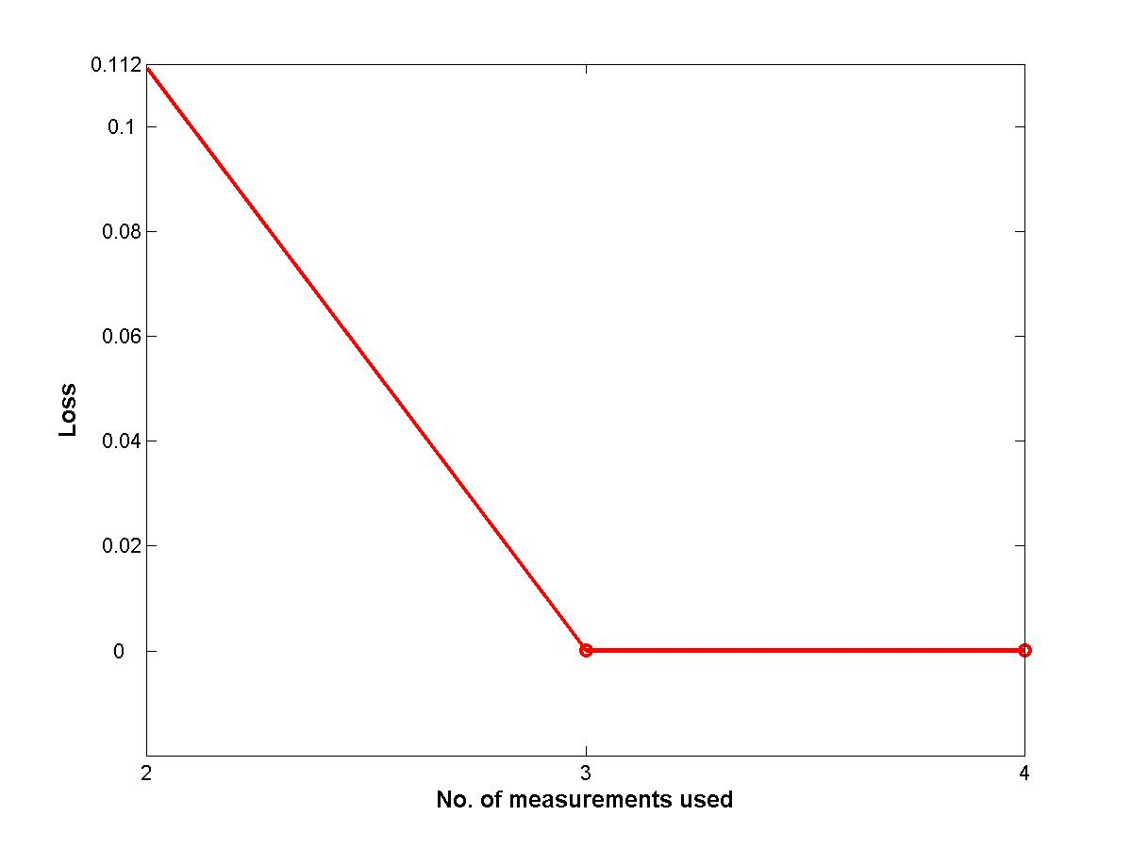
Figure 1. Optimal average loss with best measurement combinations vs no. of measurements used.
Candidate measurements are y = [P₂ T₂ T₃ F₂ F₁₀₀ T₂₀₁ F₃ F₅ F₂₀₀ F₁]; u = [F₂₀₀ F₁];
An MIQP is set up for this distillation column with an M value of 10 in big-M constraints in Eq. (20) and . We solved the MIQP to find the CVs as the combinations of best measurement subset size from 2 to 10. The IBM ILOG CPLX solver is used to solve the MIQP problem. The same problem is solved by downwards branch and bound, partial bidirectional branch bound methods of Kariwala and Cao (2009). The computational times (CPU time) taken by MIQP, Downward BAB, PB³ method and exhaustiv|e search method are tabulated in Table 1. Note that exhaustive search is not performed and an estimate of CPU time assuming 0.01 s for each evaluation is tabulated. From Table 1, it can be seen that the MIQP finds optimal solution in 5 times faster than exhaustive search methods in computational (CPU) time. For this case study MIQP, PB³, Downwards BAB methods find the same measurement subsets within few secs. MIQP methods are 2-3 times slower than PB³, Downwards BAB methods. In conclusion, even though the MIQP methods are not computationally attractive to that of Downwards BAB and PB³ methods; MIQP based methods are acceptable as these optimal CVs selection problems are performed offline. Despite these, MIQP method is valuable as the method is simple and can easily be extended to any quadratic cost functions to find optimal CVs in SOC framework. The minimized loss function with the number of measurements used for CVs (i.e. the measurement combinations) is shown in Figure 2. From Figure 2, it can be seen that the loss decreases rapidly when the number of measurements increased from 2 to 3, and from 3 loss decreases very slowly. Based on the Figure 2, we can conclude that using CVs as combinations of 3 measurements subset is optimal for this 10 measurement evaporator case study. MIQP formulations are easy than the BAB methods and structural constraints such as selection of certain type of measurements can be done easily.
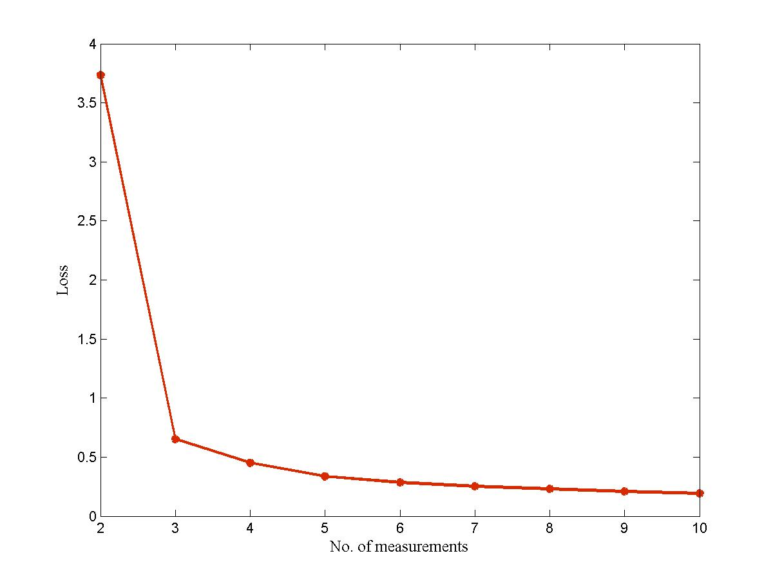Figure 2. Optimal average loss using MIQP method with best measurement combinations vs no. of measurements used.
No.  Meas | Optimal  Measurements | Loss | MIQP  cpu time (sec) | Downwards BAB  cpu time (sec) | PB3  cpu time (sec) | Exhaustive Search  cpu time (sec)
2 | [F₃ F₂₀₀] | 3.7351 | 0.0938 | 0.0781 | 0.0600 | 0.45
3 | [F₂ F₁₀₀ F₂₀₀] | 0.6501 | 0.1406 | 0.0000 | 0.1406 | 1.2
4 | [F₂ T₂₀₁ F₃ F₂₀₀] | 0.4515 | 0.1250 | 0.0313 | 0.0313 | 2.1
5 | [F₂ F₁₀₀ T₂₀₁ F₃ F₂₀₀] | 0.3373 | 0.2188 | 0.0000 | 0.0313 | 2.52
6 | [F₂ F₁₀₀ T₂₀₁ F₃ F₅ F₂₀₀] | 0.2857 | 0.1406 | 0.0000 | 0.0313 | 2.1
7 | [P₂ F₂ F₁₀₀ T₂₀₁ F₃ F₅ F₂₀₀] | 0.2532 | 0.1094 | 0.0313 | 0.0000 | 1.2
8 | [P₂ T₂ F₂ F₁₀₀ T₂₀₁ F₃ F₅ F₂₀₀] | 0.2296 | 0.1250 | 0.0000 | 0.0781 | 0.45
9 | [P₂ T₂ F₂ F₁₀₀ T₂₀₁ F₃ F₅ F₂₀₀ F₁] | 0.2100 | 0.0938 | 0.0000 | 0.0000 | 0.1
10 | [P₂ T₂ T₃ F₂ F₁₀₀ T₂₀₁ F₃ F₅ F₂₀₀ F₁] | 0.1936 | 0.0000 | 0.0313 | 0.0000 | 0.01
* Note that exhaustive search is not performed and an estimate of CPU time assuming 0.01 s for each evaluation.
Table 1. Comparsion of computation times of MIQP, Downwards BAB, PB3 and exhaustive search methods

4.3 Evaporator case study with structural constraints
For this evaporator case study there are 3 temperature measurements, 6 flow measurements and 1 pressure measurement. If the plant operation management decides to procure only 3 (1 pressure, 1 temperature, 1 flow) sensors, 5 (1 pressure, 2 temperature, 2 flow) sensors then these can easily be incorporated as structural constraints in MIQP formulations, whereas it might take some effort to incorporate these structural constraints in Downwards BAB, PB³ based methods. For the case of 5 (1 pressure, 2 temperature, 2 flow) sensors the MIQP formulation is
(24)
then the optimal loss with these structural constraints as choosing 1 pressure, 2 temperature, 2 flow sensors is 0.5379 and the optimal measurements are [P₂ T₂ F₂ F₁₀₀ T₂₀₁] where as the loss without any structural requirement is 0.3373 and the optimal measurements are [F₂ F₁₀₀ T₂₀₁ F₃ F₂₀₀]. Note that the optimal measurement subset found with these structural constraints as (2 temperature, 1 pressure, 2 flow sensors) is different than any 5 optimal sensors.
5. CONCLUSIONS
Optimal CV selection as measurement combinations to minimize the loss from the optimal operation is solved. The CV selection problem in self optimizing control framework is reformulated as a QP and CVs selection as combinations of measurement subsets is formulated as an MIQP problem. The calculation of second derivative (J_{uu}) of the cost function can be difficult/restrictive for many processes in the exact local method of SOC. The reformulated problem in this paper obviates the J_{uu} requirement and aids in wide applicability of SOC based exact local method.. The developed MIQP based methods are easier compared to the bidirectional branch and bound methods reported in literature to find the CVs as combinations of measurement subsets. And MIQP methods cover wider spectrum of quadratic based objective functions whereas bidirectional branch and bound methods are limited to objective functions with monotonic properties. MIQP based methods takes slightly longer time than bidirectional branch and bound methods, but this is acceptable as the optimal CV selection problem is an offline task. The easiness to incorporate few structural constraints in MIQP formulations is discussed with an example, where as incorporation of structural constraints take some time and effort in Downwards BAB, PB³ methods .
REFERENCES
- Skogestad, S., Plantwide control: the search for the self-optimizing control structure. Journal of Process Control, 10(5), 487 - 507.
- Halvorsen, J., Skogestad S., Morud J.C., and Alstad V., Optimal selection of controlled variables. Industrial Engineering and Chemistry Research, 42, 14, 3273 – 3284, 2003
- Kariwala, V. and Cao Y., Bidirectional branch and bound for controlled variable selection. Part II: Exact local method for self-optimizing control, Computers and Chemical Engineering, 33, 8, 1402 – 1414, 2009
- Kariwala, V., Cao, Y. and Janardhanan, S., Local self-optimizing control with average loss minimization, Industrial Engineering and Chemistry Research, 47, 1150 – 1158, 2008
- Skogestad S. and Postlethwaite I., Multivariable Feedback Control: Analysis and Design. John Wiley & Sons, Chichester, UK, 2nd edition, 2005.
- Alstad V., Skogestad S., Hori E.S., Optimal measurement combinations as controlled variables, Journal of Process Control, 19, 138 – 148, 2009.
- Cao Y. and Kariwala V., Bidirectional branch and bound for controlled variable selection Part I. Principles and minimum singular value criterion, Computers and Chemical Engineering, 32, 2306 – 2319, 2008.
- Skogestad S., Dynamics and control of distillation columns – A tutorial introduction. Trans. IChemE Part A, 75:539-562, 1997
- Brookes, M., “The Matrix Reference Manual”, online http://www.ee.ic.ac.uk/hp/staff/dmb/matrix/intro.html, 2005

Brief Biography of the Presenter

Provide the biography of the presenter in less than 10 lines. This will be used for introducing the speaker during the symposium, and also will be useful for readers of papers on the CD.

Yelchuru Ramprasad was born in Nellore, Andhra Pradesh, India. He took his bachelors degree in Chemical Engineering Department at NIT, Warangal, India (1998 - 2002) and masters degree in Chemical and Environmental Engineering Department at NUS, Singapore (2002 - 2004) . Later he worked for Research & Technology team in Honeywell Technology solutions lab in Bangalore (2004 - 2007). Currently he is pursuing his PhD (from Jan 2008) in Norwegian Science and Technological University (NTNU) in Trondheim, Norway. His research interests are plant-wide control structure selection, MPC, control theory development, multivariate statistical methods, biomedical process control, controller performance monitoring, process and performance monitoring of batch processes.

