Steady State Simulation for Optimal Design and Operation of a GTL Process
Mehdi Panahi, Sigurd Skogestad, Ramprasad Yelchuru
Chemical Engineering Department, Norwegian University of Science and Technology (NTNU), 7491, Trondheim, Norway

Abstract
This study of gas to liquid (GTL) production uses an authothermal reformer (ATR) for synthesis gas production and a slurry bubble column reactor (SBCR) with Cobalt catalyst for the Fisher-Tropsch (FT) conversion to liquid fuels. The well-known Satterfield kinetics are used for the FT reactor; the remaining reactions are simulated assuming thermodynamic equilibrium. The process also includes high-pressure CO₂ removal. Important process parameters, which are subject to optimization, include feed rates of water and oxygen, inlet ATR temperature and recycle flows. In addition to determining the process and equipment design, optimization is used to find the controlled variables. The aim is to identify “self-optimizing variables” that indirectly give close-to-optimal operation with constant setpoints, in spite of disturbances.

Keywords: Gas to liquid process, Optimization, Plantwide control, Self-optimizing control, Process control,
  - Introduction
Synthesis Gas
Unit

Natural Gas
Liquid Fuels
Fischer-Tropsch
Reactor

Upgrading
Unit

Water
Oxygen

Fig. 1- Main parts of GTL process

The GTL process in Fig.1 has 3 main steps (i) production of synthesis gas (syngas), (ii) Fischer-Tropsch (FT) reactor and (iii) upgrading units. (Fig.1). In the syngas unit, a mixture of hydrogen and carbon monoxide is produced and is sent to the Fischer-Tropsch (FT) reactor for converting to liquid fuels. The syngas and FT units make up almost 85% of total investment cost of the plant. In our work, our focus is on these two units.

This paper focuses on the optimal operation of such plants so that we can capture in practice the benefits in terms of energy savings and productivity that are predicted when designing the process. Skogestad (2004) has proposed a systematic method for designing the control structure of a complete chemical plant. The first step of this procedure is the selection of controlled variables (self-optimizing control) which is the focus of this paper.
  - Conceptual design of a GTL process
    - Feed data:
Natural gas feed is assumed at the following conditions:
Flow rate: 8195 , Pressure: 73.5 bar, Temperature: 40 °C
Composition:
Nominal feed rates of water and oxygen (see Fig. 1): ,
    - Syngas unit
In GTL processes, there are different routes for syngas production from natural gas, including Auto Thermal Reforming (ATR), steam reforming, partial oxidation of methane and CO₂ reforming. ATR is a combination of steam reforming and oxidation of methane. It is claimed to be the best route for syngas production (Bakkerud, 2005) and has been selected for this study.

To avoid the potential problem that the ATR works as a steam cracker, producing olefins from higher hydrocarbons in the feed, an adiabatic pre-reformer is introduced. Here, the temperature is 350-550°C and all higher hydrocarbons are converted (Aasberg-Petersen et al, 2001) according to the following reactions:
Complete conversion reactions (endothermic, so energy is needed):
Equilibrium reactions:
In our case, natural gas and water are preheated to 455°C and fed to the adiabatic pre-reformer. In spite of the exothermic equilibrium reactions the overall reactions are endothermic and the outlet temperature is about 416°C.

The pre-reformer outlet stream is mixed with recycled flue gas from the FT unit and heated in a fired heater to 675 before entering the adiabatic authothermal reformer (ATR). Oxygen is preheated to 200 and is also fed to the ATR. The ATR is the main reactor in producing the synthesis gas and the following three main reactions take place:

Oxidation of methane (exothermic):
Steam reforming of methane (endothermic):
Shift Reaction (exothermic):
Because of the large heat generated by combustion in reaction (6) the net reactions are exothermic, and the outlet temperature of the ATR is about 1000 ºC.

A high-pressure CO₂ capturing process with MDEA as an absorbent is used to remove most of the CO₂ from the syngas. A mixture of hydrogen and carbon monoxide is the main product of ATR and a ratio of around 2-2.3 is desired to have maximum conversion to liquid fuels in the subsequent FT reactor (see Fig. 2). To set this ratio, a small amount of CO₂ is recycled to the ATR. This avoids that too much CO is shifted to CO₂ according to reaction (8).

    - FT reactor
The syngas is sent to the FT reactor. The FT synthesis with cobalt catalyst produces mostly n-alkanes and 1-alkenes. The FT reaction and kinetics using cobalt catalyst was taken from Satterfield and Yates (Yates and Satterfield, 1991). The main reaction is
The a and b are temperature-dependent constants; a representing a kinetic parameter and b an adsorption coefficient (Table1). The amount of cobalt catalyst is 392.2 (based on data from Sehabiague et al, 2008).

Table 1- Kinetic parameter for FT reaction
Reactor Temperature (°C)
240 | 75.76 | 11.61
220 | 53.11 | 22.26

The product distribution of the hydrocarbons “(–CH2-)_{n}” are assumed to follow an Anderson-Schulz-Flory (ASF) distribution to methane, alkanes and alkenes, which can be expressed as:
Here, W_{n} is the weight fraction of hydrocarbon molecules containing n carbon atoms. α is the chain growth probability, which is determined by the catalyst and the process conditions. for C₁ and C₂₊ were set to 0.45 and 0.85, respectively (Fox III and Tam 1995). is the selectivity to olefins which is approximately 4 (Ahón et al 2005). Cobalt is not very active for the water gas shift reaction so the shift reaction is negligible. In total, 59 reactions (to CH₄ and to alkanes and alkenes with number of carbons from 2 to 30) were modelled in a CSTR (SBCR) reactor.

The FT reactions are highly exothermic and the generated heat in the reactor is removed by boiling water at high pressure to generate steam. The FT products at 227 ºC are then cooled to 50 ºC and separated in a 3-phase separator (water, liquid fuels and flue gas). The flue gas, mostly unreacted H₂ and CO, is recycled (90%) to the FT reactor, some (9%) is recycled to the ATR reactor, while about 1% is purged.

The effect of reactor volume on liquid fuels production is shown in Fig. 3. From this figure, it can be observed that a volume greater than about 2200 m³ does not significantly increase liquid fuel production, so the reactor volume was selected to be 2200 m³. The final process flowsheet is shown in Fig. 4. All units were modelled using the Unisim flowsheet simulator.

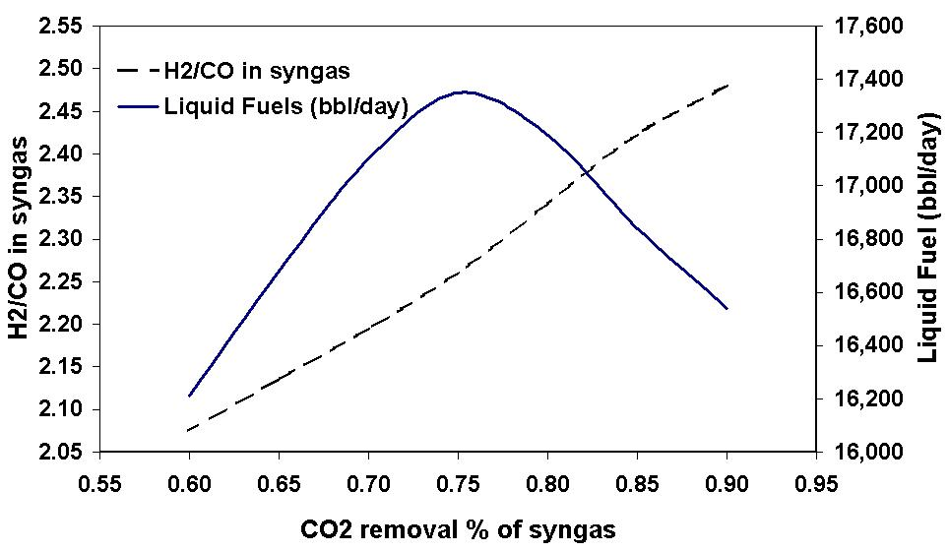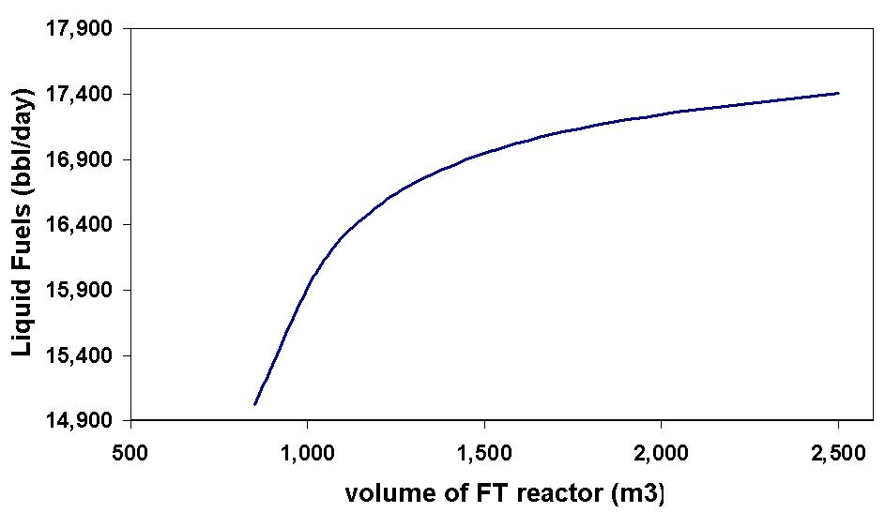

Fig. 2- Effect of %CO₂ removal on (1) H₂/CO in syngas and (2) production of liquid fuels
Fig.3- Liquid fuels production as function of volume of FT reactor

Fig. 4- Process flowsheet for GTL process
  - Optimal operation and Self-optimizing control
With a given process design the objective is now to study operation and we use the procedure of Skogestad (2004). One important step is to perform optimization to find optimal conditions of the process for various disturbances.

Step 1: Define the objective function
We consider the case where the product price of the liquid product (fuel) is high so it is optimal to maximize the yield. Hence, the objective function is defined as:
Maximize the liquid fuels production with a given feed rate of natural gas.

The following operational constraints should be satisfied:
(a) The ratio should be larger than 0.3 to avoid soot formation in the ATR.
(b) The fired heater exit temperature should not exceed 675 ºC due to limitations on construction material. (Bakkerud, 2009)

    - Step 2: Degrees of freedom (DOFs)
With a given natural gas feed rate we identify seven degrees of freedom that can be used for optimizing the objective. These were here selected to be:
1- Water feed rate (u₁)
2- Oxygen feed rate (u₂)
3- Exit temperature of fired heater (u₃)
4- Fraction CO₂ removed in the CO₂ capturing plant (u₄)
5- Amount of CO₂ recycled to the ATR (u₅)
6- Amount of flue gas recycled to FT reactor (u₆)
7- Amount of flue gas recycled to the ATR (u₇)

Optimization with respect to these 7 degrees of freedom was performed using the SQP algorithm in UniSim to find the optimal nominal operating point.

Optimal objective function (liquid production): 17,315 bbl/day

There is 1 active constraint (exit temperature of fired heater); leaving 6 unconstrained degrees of freedom at the optimum. The optimal values for the 7 degrees of freedom are as follows
u₁(H₂O) = 6025 kmol/hr ()
u₂ (O₂) = 5803 kmol/hr ()
u₃ (exit temperature of fired heater) = 675 °C (active constraint)
u₄ (CO₂ removal %) = 77.8
u₅ (recycled % of removed CO₂) = 1.34
u₆ (recycled % of flue gas to FT reactor) = 88.69
u₇ (recycled % of flue gas to ATR) = 91.53

The active constraint (exit temperature of fired heater) should always be controlled, but it is not clear how we should use the remaining 6 unconstrained degrees of freedom. Preferably, we would like to find 6 variables that give close-to-optimal operation with constant setpoints (“self-optimizing” control). To look for potential self-optimizing variables, we may reoptimize the process for different disturbances and look for variables with a small optimal variation. Based on this we may suggest potential CVs, and we can then test alternatives by considering the economic loss when they are kept constant.

    - Step 3: Disturbances
We consider 4 major disturbances for the GTL process:
1- flowrate of natural gas (±10%)
2- composition of hydrocarbons in natural gas (-10%)
3- change in FT kinetics (±10% in kinetic parameter a),
4- change in exit temperature of fired heater (±25 °C)

Reoptimizing the process for different disturbances show that the constraint on the exit temperature of the fired heater always remains active. This means that 6 CVs associated with the 6 unconstrained DOFs need to be identified.
To keep control simple, we first try whether we can keep some of the original DOFs (u₁-u₇) constant at their nominal optimal value and achieve near-optimal operation with small loss in the presence of different disturbances and also implementation errors (which is when we are not able to keep the DOFs constant). The ideal case is when the loss is small so there is no need to reoptimize any of DOFs in presence of disturbances or implementation error.

      - First disturbance: Change in flowrate of natural gas
The flowrate of natural gas is allowed to change ±10%. Fig.5 shows the value of reoptimized objective function when we let to all the six unconstrained DOFs vary (solid line), The dotted line shows the value if we keep all DOFs constant at their optimal nominal points. We see that if the flowrate of natural gas increases by 10%, then the simple policy with constant DOFs gives a 20.6% loss in liquid fuel production, which is not acceptable. We also considered the optimal variation in the six DOFs, and found that the largest variation was in the oxygen flowrate (Fig. 6). This suggests that we may attempt to let the other DOFs be constant. Indeed, we see from the dashed line in Fig. 5 that if we keep all DOFs (u_{i}) at their optimal nominal points, except for the oxygen flowrate, then we have an acceptable loss (1.3%) in the worst case. However, there are other disturbances, so it is too early to conclude that we can keep all these DOFs constant.

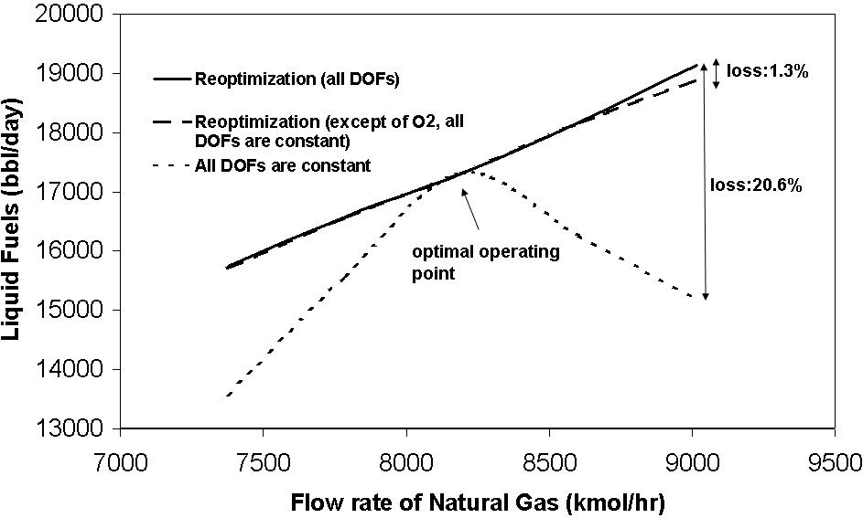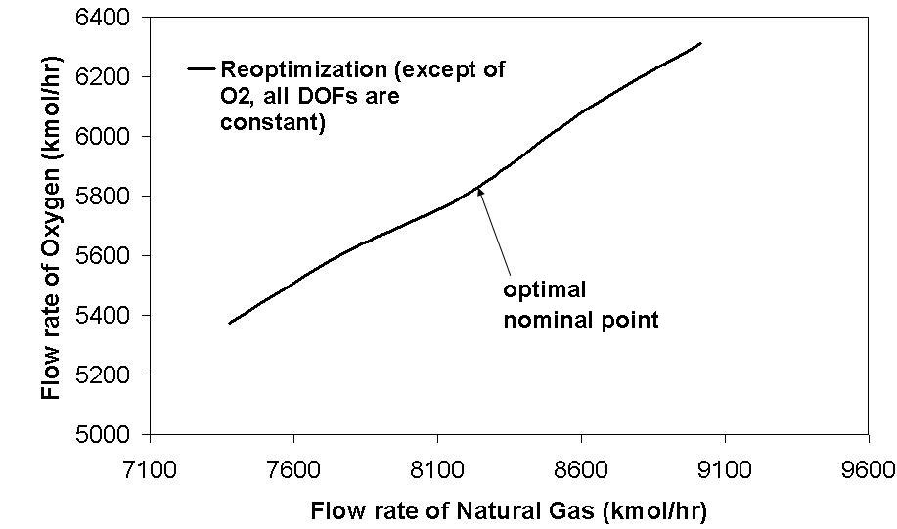

Fig. 5- Effect on operation of changes in flowrate of natural gas feed.
Fig. 6- Relation between reoptimized oxygen flowrate and natural gas flowrate

      - Second disturbance: Change in composition of hydrocarbons in feed
The same method was applied to the second disturbance, which is an increase in the N₂ contents in the range from 0.6% to 10%. The results in Fig.7 show that the effect of this disturbance is quite small. In the worst case, the fuel production loss is 3.3%. If we allow for reoptimization of the O₂ feed rate (Fig. 8) then the loss is almost zero (Fig. 7).

      - Third disturbance: Model mismatch in kinetic parameter of FT reactions
This disturbance is not important. Fig.9 shows that a ±10% change in the kinetic parameter a gives a loss of less than 1% even with all DOFs kept constant.

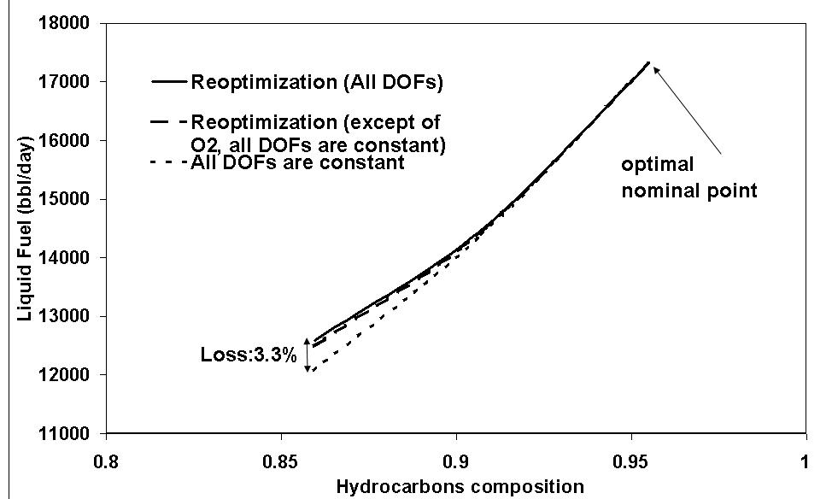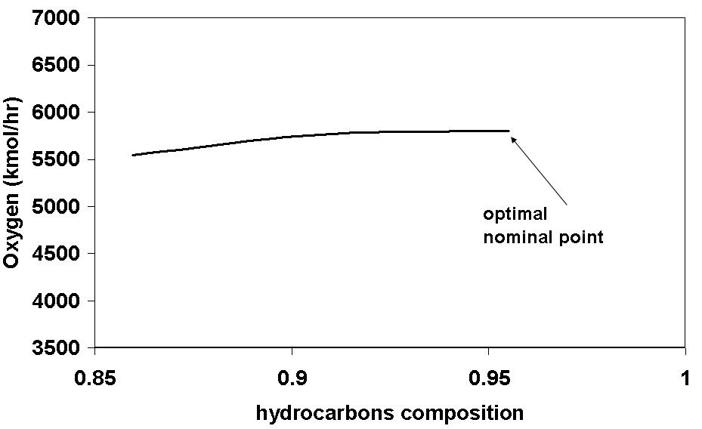

Fig. 7- Effect on operation of changes in feed composition
Fig. 8- Relation between reoptimized oxygen flowrate and composition of hydrocarbons in feed

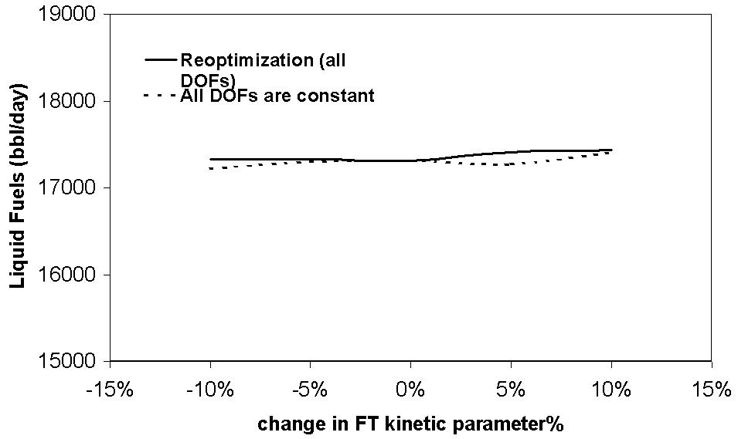
Fig. 9- Effect on operation of change in FT kinetic parameter a

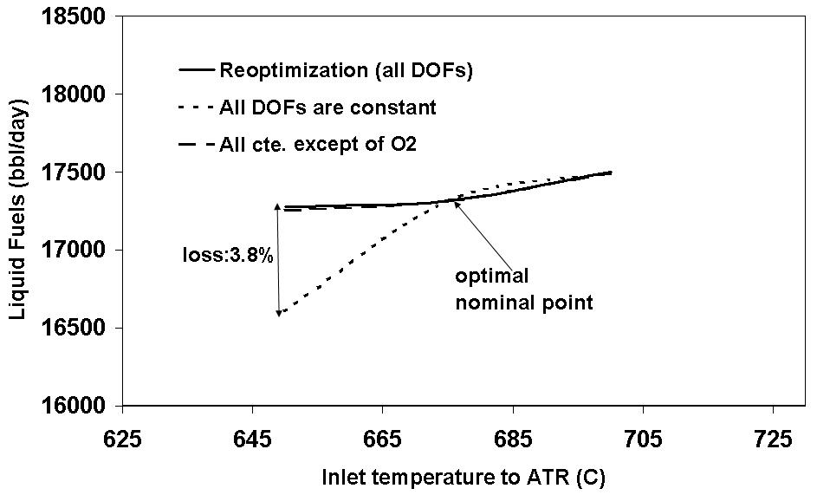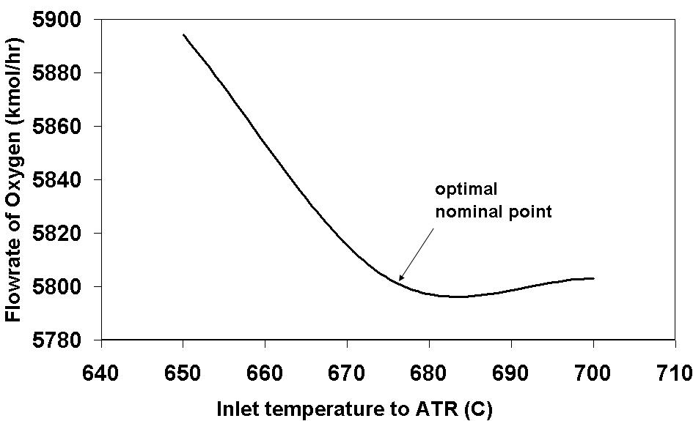

Fig. 10- Effect on optimal operation of changes in change to exit fired heater temperature to ATR

Fig. 11- Relation between reoptimized flowrate of oxygen and exit fired heater temperature

      - Fourth disturbance: Change in fired heater exit temperature
Fig. 10 shows that if the fired heater exit temperature decreases by 25 ºC, without reoptimizing, the fuel production loss is 3.8%. If we reoptimize the oxygen feedrate, the loss is almost zero. The reoptimized flowrate of oxygen is shown in Fig. 11.
Table 2- Summary of losses for various disturbances
no. | disturbance | worst case of  each disturbance |  | Loss (%), if all DOFs  are constant except  of O₂ flowrate
no. | disturbance | Change from  nominal point | Loss  (%) | Loss (%), if all DOFs  are constant except  of O₂ flowrate
1 | Flowrate natural gas | +10% | 20.6 | 1.3
2 | Inlet temperature to ATR | -25 ºC | 3.8 | 0.1
3 | Hydrocarbons in the feed | -10% | 3.3 | 0.8
4 | Kinetic FT parameter a | +5% | 0.8 | -

Table 3- Effect of CV implementation error on objective function (loss)
CVs | Implementation error | Loss (%)
Recycled flue gas % to ATR (u7) | -15% | 13.55
H₂O feedrate (u1) | -10% | 1.9
Recycled flue gas % to FT (u6) | -15% | 0.51
CO₂ removal% (u4) | -5% | 0.21
Recycled CO₂% to ATR (u5) | -15% | 0.02

The results for all four disturbances are summarized in Table 2. It seems that we can always keep all the DOFs constant, except of the O₂ feedrate. However, in addition to disturbances, we should also examine the effect on the objective function of the implementation errors in the selected controlled variables, for example caused by measurement errors. From Table 3 we see that objective function is sensitive to implementation errors in recycled flue gas to ATR (u₇) and H₂O feedrate (u₁), while its sensitivity to the other CVs (u₄, u₅, u₆) is negligible. Note that the implementation error in the active constraint (u₃) has already been considered as a disturbance, while we have already decided that the oxygen feedrate (u₂) should not be kept constant.

In summary, we still have 3 unconstrained DOFs (flowrate of oxygen u₂, flowrate of water u₁ and recycled flue gas to ATR, u₇) for which we have not identified good (self-optimizing) controlled variables. Some potential candidates are: H₂/CO ratio at ATR outlet, temperature at ATR outlet, methane contents in flue gas, oxygen/hydrocarbon feed ratio and water feedrate. For the last two “open-loop” policies one may need good flow measurements to reduce the implementation error. The selection of the best variables will be the subject of future work.
  - Conclusion
The UniSim process simulator was used to simulate and optimize a GTL plant. A rule of thumb for GTL is that for every 10,000 SCF (=282.6 Sm³ =11.953 kmol) of natural gas, approximately 1 bbl (=159 liter) of fuel is produced (Patel, 2005). In our case study, we produce 17,315 bbl/day from 8195 kmol/hr natural gas, which is 5.23% higher than the rule of thumb. In the synthesis gas part, the optimal ratios of oxygen and water to methane at the nominal operating point were, and a good volume of the FT reactor was found to be 2200 m³.

There are 7 operational degrees of freedom (DOFs): Feed rates of oxygen and water, exit temperature of fired heater, flue gas recycle to ATR and FT, CO₂ removal rate and recycled CO₂ to ATR). By optimizing the operation for various disturbances, we found that 1 of the DOFs is always needed to satisfy an active constraint at the fired heater exit temperature. Furthermore, we found that 3 of the original DOFs can be kept constant at their optimal nominal values (flue gas recycle to FT, CO₂ removal rate, recycled CO₂ to ATR) when there are disturbances, so these are good self-optimizing variables. Further work is needed to find good controlled variables for the remaining 3 unconstrained DOFs (, and recycled flue gas to ATR).

References
Aasberg-Petersen, K., J.-H Bak Hansen, T. S. Christensen, I. Dybkjaer, P. Seier Christensen, C. Stud Nielsen, S. E. L.Winter Madsen and J. R. Rostrup-Nielsen, 2001, Technologies for large-scale gas conversion, Applied Catalysis A: General 221, 379-387.

Aasberg-Petersen, K., T. S. Christensen, C. Stud Nielsen and I. Dybkjær, 2003, Recent developments in authothermal reforming and pre-reforming for synthesis gas production in GTL applications, Fuel Processing Technology, 83, 253-261.

Ahón,V. R. , Jr. E. F. Costa, J. E.P. Monteagudo, C.E. Fontes, Jr. E. C. Biscaia, P. L. C. Lage, 2005, A comprehensive mathematical model for the Fischer-Tropsch synthesis in well-mixed slurry reactors, Chemical Engineering Science, 60, 677-694.

Bakkerud, P. K., 2009, Personal commiunication.

Bakkerud, P. K., 2005, Update on synthesis gas production for GTL, Catalysis Today, 106, 30-33.

Fox III , J. M. and S. S. Tam, 1995, Correlation of slurry reactor Fischer-Tropsch yield data, Topics in Catalysis, 2, 285-300.

Patel, B., 2005, Gas Monetization: A Techno-Economic comparison of Gas-To-Liquid and LNG, 7th World Congress of Chemical Engineering, Glasgow.

Sehabiague, L., R. Lemonie, A. Behkish, Y. J. Heintz, M. Sanoja, R. Oukaci, B. I. Morsi, 2008, Modeling and optimization of a large-scale slurry bubble column reactor for producing 10,000 bbl/day of Fischer-Tropsch liquid hydrocarbons, Journal of the Chinese Institute of Chemical Engineers, 39, 169-179.

Skogestad, S., 2004, Control Structure Design for Complete Chemical Plants, Computers and Chemical Engineering, 28, 219-234.

Yates, I. C. and C. N. Satterfield,1991, Intrinsic Kinetics of the Fischer-Tropsch Synthesis on a Cobalt Catalyst, Energy & Fuels, 5, 168-173.

