Self-Optimizing and Control Structure Design for a CO₂ Capturing Plant
Mehdi Panahi, Mehdi Karimi, Sigurd Skogestad, Magne Hillestad, Hallvard F. Svendsen
Department of Chemical Engineering, Norwegian University of Science and Technology(NTNU), 7491 Trondheim, Norway

Abstract
Capturing and storing the greenhouse gas carbon dioxide (CO₂) produced by power plants could play a major role in minimizing climate change. In this study a post-combustion CO₂ capture plant using MEA is designed, simulated, and optimized using the UniSim process simulator. The focus of this work is the subsequent optimal operation and control of the plant with the aim of staying close to the optimal operating conditions. The cost function to minimize is the energy demand of the plant. It is important to identify good controlled variables (CVs) and the first step is to find the active constraints, which should be controlled to operate the plant optimally. Next, for the remaining unconstrained variables, we look for self-optimizing variables which are controlled variables that indirectly give close-to-optimal operation when held at constant setpoints, in spite of changes in the disturbances. For the absorption/stripping process, a good self-optimizing variable was found to be a temperature close to the top (tray no.4) of the stripper. To validate the proposed structure, dynamic simulation was done and performance of the control structure was tested.

Keywords: Process control, Optimal operation, Plantwide control, Controlled variable selection
  - Introduction
Aqueous absorption/stripping with aqueous solvents such as MEA has been used effectively for removing acid gases (CO₂ and H₂S) from natural gas, oil refineries, power plant flue gas and the production of ammonia and synthesis gas. Fig. 1 shows a typical flow diagram of the process for a simple reboiled stripper. The system consists of two columns: the absorber, in which the CO₂ is absorbed into an amine solution via a fast chemical reaction, and the stripper, where the amine is regenerated and then sent back to the absorber for further absorption. Prior to CO₂ removal, particulates, sulfur dioxide, and NO_{x} are removed from the flue gas. The flue gas from the power plant is typically cooled before the absorber from 150 to 55 °C (its adiabatic saturation temperature) or to 40 °C if cooling water is used.
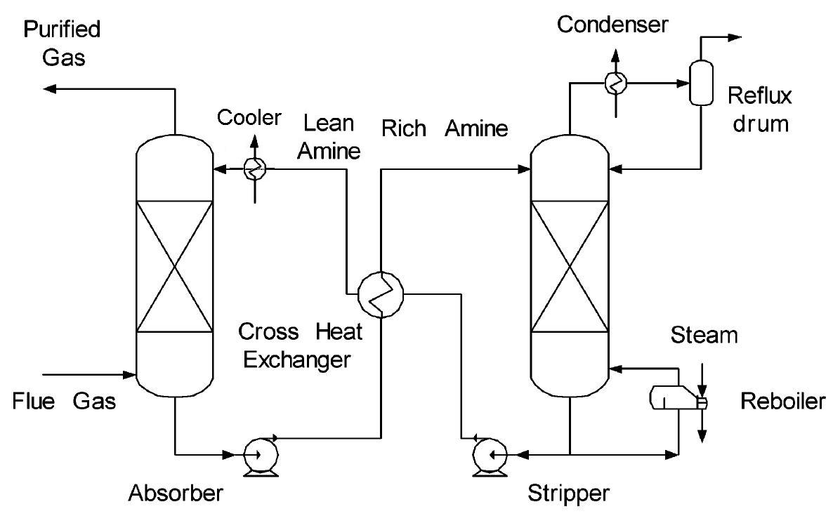
Fig. 1- Typical absorber/stripper process for CO₂ capture

One problem with using MEA as a solvent is the high cost of operation. This is simply due to the excessive energy requirement for solvent regeneration, which contributes about 70 per cent of the process utility cost. In fact, the energy consumption in the CO₂ capturing plant is estimated to be 15-30% of the net power production of a coal-fired power plant. A lot of work have been done to reduce energy consumption of CO₂ units, but little has been done on studying how this can be implemented in practice when the process is subjected to disturbances. This is the aim of the present study where we focus on selecting good controlled variables which can be kept at constant setpoints without the need to re-optimize when disturbances occur. To select the controlled variables we look for self-optimizing control, one may use the stepwise procedure of Skogestad (Skogestad, 2004). The plant was modelled using the UniSim flowsheet simulator from Honeywell using the amine package for the thermodynamic calculations.
  - Self-optimizing control of a CO₂ capturing plant
    - Step 1: Define objective function and constraints
In the CO₂ plant there are operational costs related to the two utilities: Steam (heat) for the reboiler of stripper and electricity (power) for driving the pumps. To avoid using prices we convert the heat to equivalent thermodynamic work (power). We assume that the temperature of steam in reboiler () is 10°C higher than reboiler temperature and steam condenses at 40°C in the turbine (). The total equivalent work for the plant (the objective function) is then
(1)
Where and . The efficiency of the imagined Carnot cycle (heat pump) that generates heat from power is assumed to be 75% .
The constraints are:
- Environmental requirement: Capture 90% of CO₂.
- Temperature of lean solution to the absorber is 51°C (to get a good operation of the absorber).
- Because of the MEA degradation problem, pressure should be less than 2 bar. Stripper top pressure is therefore kept at 1.8 bar.
- The stripper condenser temperature should be as low as possible and is here assumed to be at 30°C.
    - Step 2. Determine DOFs for optimization
We have 9 valves (Fig.2) which give 9 dynamic degrees of freedom. However, there are 4 levels (2 in stripper, 1 in absorber, 1 surge tank) that need to be controlled and since these levels have no steady state effect, the number of degrees of freedom (DOFs) for steady-state optimization is 5.

EMBED Visio.Drawing.11
Fig. 2- Process with 9 dynamic DOFs (valves)

    - Step 3. Identification of important disturbances
The main disturbances are the feed (flue gas) flow rate and its composition. In addition all active constraints should be considered as disturbances.
The objective function is defined as the energy per kg of removed CO₂ (which is a good objective for a given feedrate, but for cases where we would like to maximize the amount of treated gas), so small variations in the CO₂ recovery constraint have a small influence on the objective function. In practice, the inlet temperature of lean solution is around 51°C and even if it changes in the range 40-60°C has no effect on the energy consumption. The only equality constraint that may have significant affect on the objective function is change in pressure of the stripper.
Finally, we consider three main disturbances. (table 1)

Table 1- Main disturbances
Disturbance |  | Nominal | Change
d1 | Gas flowrate | 219.3 kmol/hr | ±5%
d2 | Gas composition | CO₂: 0.1176, N₂: 0.7237,O₂: 0.0502, H₂O: 0.1085 | ±5%
d3 | Stripper pressure | Top: 180 kPa, Bottom: 200 kPa | +10 kPa

    - Step 4. Optimization (nominally and with disturbances),

To control the 4 equality constraints we need 4 DOFs and we need 4 DOFs to control 4 levels then we have one degree of freedom left for optimization, N_{opt.free} = 9 – 4 – 4 = 1.

Objective function: min. $W_{\text{eq}}$
Subject to: The four constraints in section 2.1 and:

5. 0.005 ≤ CO₂ fraction in bottom of stripper ≤ 0.05.

At the nominal operating (no disturbances) point we get:
Optimal objective function: $W_{\text{eq}}$= 640.5
CO₂ composition in the bottom of stripper = 0.0227 (so the optimum is unconstrained).

    - Step 5. Identification of candidate controlled variables.
The remaining unconstrained DOF could for example be selected as the reboiler duty. However, rather than keeping it constant, it may be better to use it to control some other variables (CV), and we consider two alternatives:
1. Tray temperature at some stage in the stripper column.
2. CO₂ composition in the bottom of the stripper.

    - Step 6. Evaluation of loss
For evaluation and initial screening of the candidate controlled variables we use the maximum scaled gain rule (Skogestad and Postlethwaite, 2005).

    - Procedure for scalar case:
1. Make a small perturbation in each disturbances di and re-optimize the operation to find the optimal disturbance sensitivity for each candidate CV, $\frac{∂{Δy}_{\text{opt}}}{∂d_{i}}$,where ${Δd}_{i}$ denotes the expected magnitude of disturbance i. From this we compute the overall optimal variation (here we choose the 2-norm):
${Δy}_{\text{opt}}=\sqrt{\sum_{i}{{\left(\frac{∂{Δy}_{\text{opt}}}{∂d_{i}}\text{.}{Δd}_{i}\right)}^{2}}}$ (2)
2. Identify the expected implementation error n for each candidate controlled variable y (measurement).
3. Make a perturbation in the independent variables u (in our case u is reboiler duty) to find the unscaled gain (G),
$G=\frac{Δy}{Δu}$ (3)
4. Scale the gain with the optimal span where n is implementation error to obtain for each candidate output variable y:
$\text{Span} y ={Δy}_{\text{opt}}+n$ (4)
The scaled gain is then:
$\left|G^{'}\right|=\frac{\left|G\right|}{\text{Span} y}$ (5)
The worst-case loss L_{wc} = J(u,d)−Jopt(u,d) (the difference between the cost with a constant setpoint and re-optimized operation) is then for the scalar case:
(6)
Where $J_{\text{uu}}=\frac{∂^{2}J}{∂u^{2}}$ is the Hessian of the cost function J. In our case J = $W_{\text{eq}}$.
Note that does not matter for selecting CVs in the scalar case.
By using a Matlab script interfaced with Unisim, the scaled gains were found for different candidate CVs. The results are shown in table 2.

Table 2- Scaled gain for different candidate CVs
Candidate CV | Scaled gain | Candidate CV | Scaled gain
CO₂ composition | 0.2463 | Temp. Gain Tray 11 | 0.1358
Temp. Gain Tray 1 | 0.0203 | Temp. Gain Tray 12 | 0.151
Temp. Gain Tray 2 | 0.056 | Temp. Gain Tray 13 | 0.108
Temp. Gain Tray 3 | 0.1276 | Temp. Gain Tray 14 | 0.0788
Temp. Gain Tray 4 | 0.2845 | Temp. Gain Tray 15 | 0.0614
Temp. Gain Tray 5 | 0.2693 | Temp. Gain Tray 16 | 0.0499
Temp. Gain Tray 6 | 0.2279 | Temp. Gain Tray 17 | 0.0409
Temp. Gain Tray 7 | 0.1913 | Temp. Gain Tray 18 | 0.0334
Temp. Gain Tray 8 | 0.1632 | Temp. Gain Tray 19 | 0.0264
Temp. Gain Tray 9 | 0.1446 | Temp. Gain Tray 20 | 0.0200
Temp. Gain Tray 10 | 0.1332

From table 2, the best candidate CV is found to be the temperature on tray no. 4. The CO₂ composition has also a good (high) scaled gain but it is still ranked 3rd after temperature of tray no.5. To validate the proposed controlled variable, dynamic simulation were performed in the next step.
  - Dynamic simulation
To switch to the dynamic mode in the UniSim simulator, sizing of the equipments and pressure flow specification was done. There is some discrepancy between the steady- state and dynamic models which seems to be caused by a difference in the thermodynamic models used by UniSim for two modes. The main effect is that recycle amine flow between the columns is smaller, which results in a smaller objective function () in the dynamic case. For our purposes this does not matter very much and the relative order of the control structures remains the same.

All control loops were implemented and tuned individually using the SIMC method. (Skogestad, 2003) The final control structure with 9 feedback loops is shown in Fig.3 for the proposed case where the CV is stripper tray temperature no.4. The paring of the loops is quite obvious in this case and is based on minimizing the effective time delay from inputs to outputs. The reboiler duty is used as the MV to control tray temperature no. 4.

Fig. 3- Process flowsheet with control loops

Fig. 4a shows the performance of the proposed structure. This can be compared to the case where bottom temperature (tray no.20) is controlled (Fig. 4b) which results in larger losses, especially at steady-state for the pressure disturbance (disturbance 6).

As expected the losses are also small if we control the CO₂ composition in the bottom of stripper. (Fig. 4c). However, temperature control is much easier, faster and cheaper than composition. Therefore, control temperature of tray no.4 that we found by self-optimizing concept is the best controlled variable.
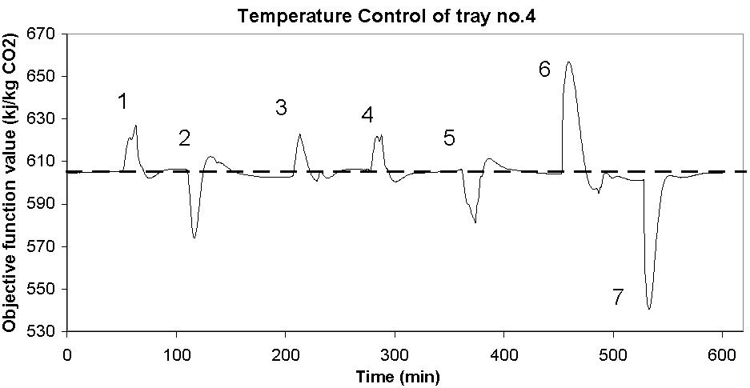
(a)
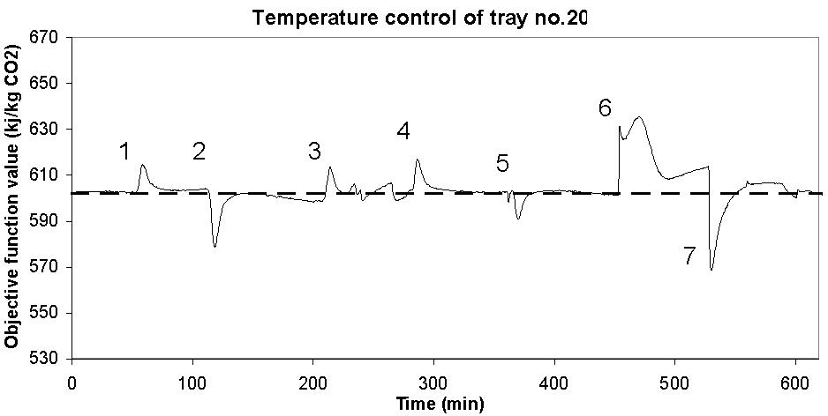
(b)
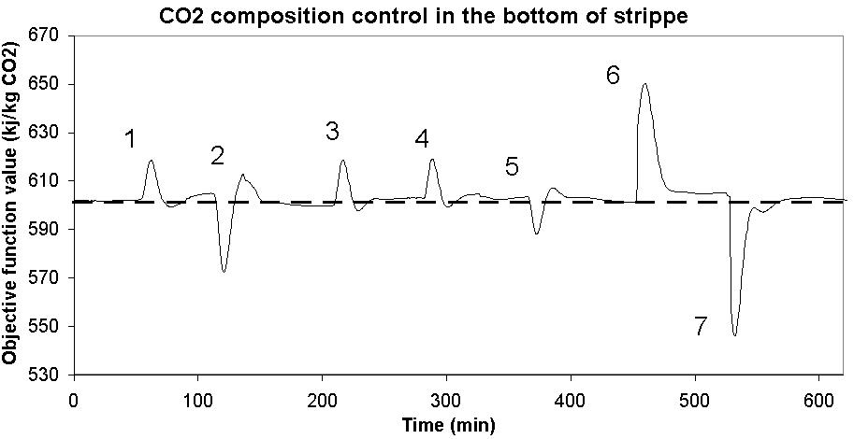
(c)
Fig. 6- Objective function () in presence of disturbances 1) d1:+5% change from base case, 2) d1:-10%, 3) back to base case 4) d2:+5% change from base case 5) back to base case, 6) d3:+10 kPa, 7) back to base case. Arrows indicate cases with large steady-state losses.
  - Conclusion
A self-optimizing concept control structure was designed for a post-combustion CO₂ capturing plant. The losses are small which means that it is not necessary to re-optimize the process when different disturbances occur. The plant has 9 dynamic degrees of freedom; 4 of them were used to control equality constraints and 4 of them were used for level control. We found the temperature close to the top (tray no. 4) of the stripper to be a good CV for the remaining unconstrained degree of freedom.
  - References
Grainger, D ., M-B. Hägg, 2008, Techno-economic evaluation of a PVAm CO₂-selective membrane in an IGCC power plant with CO₂ capture. Fuel, 87, 1, 14-24

Jassim, M. S., G. T. Rochelle, 2006, Innovative Absorber/Desorber Configurations for CO₂ Capture by Aqueous Monoethanolamine, Ind. Eng. Chem. Res., 45, 2465-2472

Jensen, J. B., S. Skogestad, 2008, Optimal Operation of Refrigeration Cycles, PhD thesis

Skogestad, S., 2004, Control Structure Design for Complete Chemical Plants, Computers and Chemical Engineering, 28, 219-234

Skogestad, S., 2000, Plantwide control: The search for the self-optimizing control structure, Process Control, 10, 487-507

Skogestad, S., I. Postlethwaite, 2005, Multivariable Feedback Control Analysis and Design, 2nd edition

Skogestad, S., 2003, Simple analytic rules for model reduction and PID controller tuning, Process Control, 13, 291-309

