A simple dynamic model for control design and analysis of severe slugging

Espen Storkaas and Sigurd Skogestad,

Department of Chemical Engineering
Norwegian University of Science and Technology,
N7491 Trondheim, Norway

Abstract

A novel simple dynamic model of a pipeline-riser system at riser slugging conditions is proposed. The model covers the stable limit cycle known as riser slugging, and even more importantly for control purposes, predicts the presence of the unstable but preferred stationary flow regime that exists at the same boundary conditions.

The model has only three dynamic states, namely the holdups of gas and liquid in the riser and the holdup of gas in the upstream pipeline. The most important adjustable parameters are the "valve constant" for the flow of gas into the riser and two parameters describing the fluid distribution in the riser.

The model has been fitted to data both from an OLGA test case and experiments. In all cases there is good agreement with the reference data. The model has been further verified by showing that its controllability predictions are almost identical to those of a more detailed two-fluid model based on partial differential equations.

Introduction

One of the major challenges associated with multiphase pipeline-riser systems is the occurrence of an undesirable flow regime known as riser slugging. It is characterized by liquid accumulation in the bottom of the riser (the riser base). Eventually, the liquid blocks the pipeline, stopping the flow of gas and initiates the slug cycle. The prerequisite for this to occur is a relatively low pipeline pressure and/or a low gas flow rate. Riser slugs are often long, and thus associated with severe pressure oscillations. Another commonly used name for riser slugging is severe slugging, especially when the liquid fills up the entire riser.

One approach to avoid riser slugging is to reduce the opening of the topside choke valve and by that increasing the pressure drop over the valve (e.g., Sarica and Tengesdal, 2000).. However, this will lead to an increased pressure in the entire pipeline and may reduce the oil recovery. Thus, avoiding riser slugging by (stationary) choking is not an economically optimal solution.

Active feedback control is an alternative approach to avoid or remove riser slugging in pipeline-riser systems. It was first proposed by Schmidt et al. (1979) and later by Hedne and Linga (1990) but did not result in any reported implementations. More recently there had been a renewed interest in control-based solutions, both as simulation studies, experimental work and actual implementations, as reported by Hollenberg et al. (1995), Courbot (1996), Henriot et al. (1999), Havre et al.(2000), Havre and Dalsmo (2002), Skofteland and Godhavn (2003), Kovalev et al. (2003) and Storkaas et al. (2003). Using active control to stabilize an unstable operating point has several advantages. Most importantly, one is able to operate with even, non-oscillatory flow at a pressure drop that would otherwise give severe slugging. This will in turn lead to less need for topside equipment, higher production rates, higher oil recovery and less wear and tear on the equipment.

To design efficient control systems, it is advantageous to have a good model of the process. When obtaining a “good” model for control purposes, it is important to keep the control objective and its associated timescale (bandwidth) in mind. One should only include those physical phenomena that are significant at the relevant timescales in the model. This allows one to use simpler models for control purposes than for more detailed simulations. Storkaas and Skogestad (2005) found that the magnitude of the unstable poles for the (industrial-size) system investigated was around 0.005-0.01 s⁻¹. This means that the relevant timescale for stabilizing the flow in a pipeline-riser system is in the order of minutes. Based on that timescale, physical phenomena whose dominant dynamical behavior is in the order of a few seconds can be regarded as instantaneous. The timescale of the problem also allows us to use spatially average values for distributed physical properties when the spatial dynamics are to fast to be relevant.

In Storkaas and Skogestad (2005), a distributed two-fluid model with two partial differential equations (PDEs) was used to show that simple control systems could be used to stabilize the unstable stationary flow regime that exists at the same boundary conditions as riser slugging in pipeline-riser systems. It was also shown that the model used probably was unnecessarily complex for performing controllability analysis and controller design, and that a simpler model could be utilized.

The goal of this paper is to develop a simpler model for pipeline-riser systems at riser slugging conditions that is tailor-made for control purposes. The resulting model is based on the three-state model developed by Jansen et al. (1999) for gas lift well control.

Model Description

The conventional multiphase flow models use distributed conservation equations and are developed to cover the behavior of two-phase flow in pipelines over a wide range of pipe geometries, flow regimes and boundary condition. The aim here is a simpler model that predicts the following important characteristics of the riser slugging system (in order of importance):

- the presence of the desired (but naturally unstable) “smooth” stationary solution (flow regime) at the same boundary conditions as those corresponding to riser slugging
- the dynamic behavior of this flow regime (i.e. the nature of the transition from smooth flow to riser slugging)
- the stability of this flow regimes as function of choke valve opening
- the amplitude/frequency of the oscillations of fully developed riser slugging

Note that one for control purposes is more interested in the desired (but normally unstable) “smooth” flow regime than the undesired (but naturally occurring) riser slugging (which in dynamic systems terms is a stable limit cycle). A parallel to this can be found in everyday life; if one wants to learn how to ride a bike (and thus design a control system for this), one is more interested in how the bike behaves when riding along the road (the desired unstable operating point) than on how it behaves when it lies on the ground (the undesired stable operating point, similar to undesired slug flow).

Assumptions
The model is based on the setup depicted in Figure 2.1 and Figure 2.2.

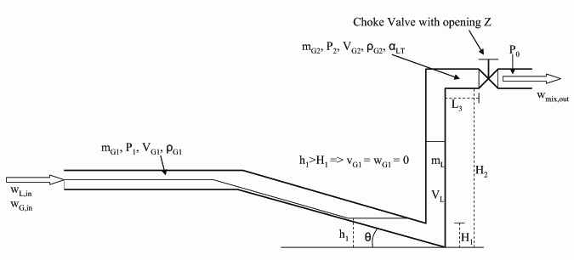
Figure 2.1: Simplified representation of riser slugging
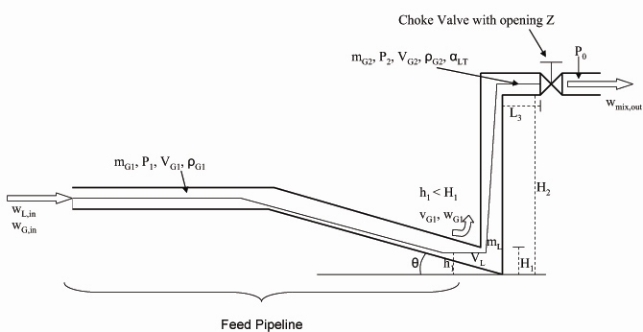
Figure 2.2: Simplified representation of desired flow regime

The main assumptions are:
- The liquid dynamics in the upstream feed pipeline are neglected by assuming constant liquid velocity in this section.
- Constant gas volume V_{G1} in the feed pipeline. This follows from assumption A1by neglecting the liquid volume variations due to variations in the liquid level h₁ at the low-point.
- Only one dynamical state (m_{L}) for liquid holdup in the riser section. This state includes both the liquid in the riser and in the low-point section (with level h₁)
- Two dynamical states for gas holdup (m_{G1} and m_{G2}), occupying the volumes V_{G1} and V_{G2}, respectively. The gas volumes are "connected" by a pressure-flow relationship in the low-point.
- Ideal gas behavior
- Stationary pressure balance over the riser (between pressures P₁ and P₂)
- Simplified valve equation for gas and liquid mixture leaving the system at the top of the riser
- Constant temperature

Model fundamentals

The model has three dynamical states, as stated by assumptions A3 and A4:
- mass of liquid m_{L} in the riser and around the low-point
- mass of gas m_{G1} in the feed section
- mass of gas m_{G2} in the riser

The corresponding mass conservation equations are

Based on assumptions A1- A8, Figure 2.1 and Figure 2.2, the computation of most of the system properties such as pressures, densities and phase fractions are then straightforward.

Some comments:
- The stationary pressure balance over the riser A6 is assumed to be given by

.
Here, $\bar{ρ}$ is the average mixture density in the riser. The use of a stationary pressure balance is justified because the pressure dynamics are significantly faster than the time scales in the control problem. For long pipelines, it might be necessary to add some dynamics (i.e. time delay) between the pipeline pressure P₁ and the measured pressure if the pressure sensor is located far from the riser.

- The boundary condition at the inlet (inflow w_{G,in} and w_{L,in}) can either be constant or pressure dependent.
A simplified valve equation for incompressible flow is used to describe the flow through the choke valve,

If a more accurate description of the flow out of the system is needed, the Sachdeva model (Sachdeva et al., 1986) can be used.

- The most critical part of the model is the phase distribution and phase velocities in the riser. The gas velocity is based on an assumption of purely frictional pressure drop over the low-point and the phase distribution is based on an entrainment model. This is discussed in more detail below.

The entire model is given in detail in appendix A. A Matlab version of the model is available on the web (Storkaas, 2003).

Relationship between gas flow into riser and pressure drop
When the liquid is blocking the low point (h₁ > H₁ in Figure 2.1), the gas flow w_{G1} is zero.

When the liquid is not blocking the low point (h₁ < H₁ in Figure 2.2), the gas will flow from V_{G1} to V_{G2} with a mass rate. From physical insight, the two most important parameters determining the gas rate are the pressure drop over the low-point and the free area given by the relative liquid level ((H₁-h₁)/H₁) at the low-point. This suggests that the gas transport could be described by a valve equation, where the pressure drop is driving the gas through a "valve" with opening (H₁-h₁)/H₁. Based on trial and error, it is proposed to use the following "valve equation":

where $f_{1}=\hat{A}\left(H_{1}−h_{1}\right)/h_{1}$ and $\hat{A}$ is the gas flow cross-section at the low-point. Note that $f_{1}=\hat{A}\left(H_{1}−h_{1}\right)/h_{1}$ is approximately quadratic in the "opening" $\left(H_{1}−h_{1}\right)/h_{1}$.

Separating out the gas velocity with $w_{G1}=v_{G1}ρ_{G1}\hat{A}$ yields

Entrainment equation
The final important element of the model is the fluid distribution in the riser. This distribution can be represented in several ways. One approach is to use a slip relation to relate the liquid velocity to the gas velocity and use the velocities to compute the distribution. This is similar to the approach used in a drift flux model (Zuber and Findlay, 1965). Several unsuccessful attempts were made to derive a model based on this approach.

Another approach, which was found to successful, is to model directly the volume fraction of liquid (α_{LT}) in the stream exiting the riser. The liquid fraction will lie between two extremes:
- $α_{\text{LT}}=α_{\text{LT}}^{}$ when the liquid blocks the flow such that there is no gas flowing through the riser (v_{G1}=0). In most cases with liquid blocking only gas exits the riser (see Figure 2.1) and $α_{\text{LT}}^{}=0$. However, eventually the entering liquid may cause the liquid to fill up the riser and $α_{\text{LT}}^{}$ exceeds zero. For more details, see appendix A.
- α_{LT} = α_{L} when the gas velocity is very high such there is no slip between the phases. Here α_{L} is the average liquid fraction in the riser.

The transition between these two extremes should be smooth as illustrated in Figure 2.3. The transition is assumed to depend on a parameter q as represented by the thequation

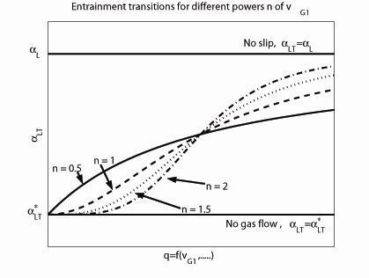
Figure 2.3: Transition between no and full entrainment

The parameter n is used to tune the slope of the transition. The parameter q in is yet to be determined. Note that the entrainment of liquid by the gas in the riser is somewhat similar to flooding in gas-liquid contacting devices such as distillation columns. The flooding velocity is equal to the terminal velocity for a falling liquid drop and is given by

Flooding with large entrainment occurs when the gas velocity v_{G1} is larger than v_{f}. A reasonable choice is therefore to set q as the ratio between v_{G1} and v_{f}. Actually, the square of the ratio was chosen, $q=k{\left(v_{G1}/v_{f}\right)}^{2}$ and introducing v_{f} from gives

where $K_{3}=k/k_{f}^{2}$is used as a tuning parameter. Equation combined with produces the transition depicted in Figure 2.3. The tuning parameter K₃ will shift the transition along the horizontal axis.

Tuning Procedure
The model has four tuning parameters: K₁ in the choke valve equation, K₂ in the internal gas velocity equation, and K₃ and n in the entrainment model. In addition, some of the physical parameters are sometimes adjusted to fine-tune the model. These physical parameters include the average molecular weight of the gas, M_{G}, and the upstream gas volume, V_{G1}.

The tuning of the model will depend on the available data. Accurate field data for the real system is obviously the best alternative, but is rarely available. A simple way to obtain data is to generate them from a more detailed model, for example using a commercial simulator such as OLGA. In this work an OLGA model has been used to generate data for a wide range of choke valve openings Z.

The analysis of a riser slugging system in Storkaas and Skogestad (2005) shows that the transition from the stable flow regime to riser slugging is through a Hopf bifurcation. This implies that the system must have a pair of purely complex eigenvalues (poles) at this point. This fact removes one degree of freedom in the stationary solution (the zero solution of equations , and ) of the model at the bifurcation point. In addition, for a stationary flow regime to exist, the gas must flow through the low-point separating the two gas volumes V_{G1} and V_{G2}. For the gas to flow, the height h₁ must be less than H₁ (Figure 2.2 and eq. ). This will impose a restriction on the remaining three degrees of freedom at the bifurcation point.

The proposed tuning strategy is to identify the bifurcation point from the reference data and use two measurements (for example the upstream pressure P₁ and the topside pressure P₂) to fix two degrees of freedom in the stationary solution of the model. The Hopf bifurcations discussed above removes another degree of freedom. Fixing the stationary value of h₁ in the interval 0<h₁<H₁ allows us to find K₁, K₂, K₃ and n from the stationary solution of the model. Finally, the physical properties M_{G} and V_{G1} as well as the value used for h₁ can be adjusted to get an acceptable fit of pressure levels, amplitudes, and frequencies for other valve openings.

Note that due to the lumped nature of the model, variations along the feed pipeline are not included. This means that the model must be tuned to data from a specified point in the feed pipeline.

Model verification
For verification, the model is fitted to experimental data from a medium scale loop (15 m riser) and to the OLGA test case (300 m riser) used in Storkaas and Skogestad (2005). Sivertsen and Skogestad (2005) have also fitted the model to experimental data from a miniloop (1 m riser) with good results.

Experimental Tiller data
The experimental data were obtained from recent experiments performed by Statoil at a medium scale loop at the SINTEF Petroleum Research Multiphase Flow Laboratory at Tiller outside Trondheim, Norway. The loop consists of a 200 meters long slightly declining feed pipeline entering a 15 meters high vertical riser with a control valve located at the top. The fluids used are SF₆ for the gas and Exxsol D80 (a heavy hydrocarbon) for the liquid. After the riser the mixture enters a gas-liquid separator with an average pressure of 2 bar. The inflow into the feed pipeline is pressure dependent. More information on these experiments can be found in Skofteland and Godhavn (2003), Fard et al. (2003) and Godhavn et al. (2005).
.
The experimental data consist of four data points for non-oscillatory flow, where one is for stable flow, one is the bifurcation point and the last two point are for stabilized (open-loop unstable) operation. In addition, data for riser slugging with 100% open choke valve are available. The experimental data are represented by the dots in Figure 4.4, where the two dots at Z=100% represent the maximum and minimum pressure in the slug cycle.

As seen in Figure 2.1, we were able to obtain a very good fit with our simplified model to the experimental results using the tuning procedure described in section 3. The model parameters from the tuning are given in Table 1. More importantly, the controllers designed based on the simplified model reproduced the stability results confirmed experimentally. In fact, the optimized controller tunings found using the model matched the ones found to be optimal from the experimental work.

The inflow mechanism seems to have little influence on the controllability. An analysis of the model gives the same general controllability findings and local (linear) behavior as for the simulated OLGA test case with constant inflow studied (Storkaas and Skogestad, 2005). The only major difference is that, as expected, the low-frequency gain associated with flow measurements at the outlet is larger when the inflow is pressure dependent. However, the low-frequency gain is still low, so the controllability problem remains.

Table 1 : Parameteres identified to fit experimental Tiller data

Parameter | Value | Unit
K₁ | 0.0014 | m⁻²
K₂ | 2.81 | -
K₃ | 16.7 | s²/m²
n | 1.75 | -
Upstream Gas Volume V_{G1} | 0.80 | m³
Molecular Weight Gas M_{G} | 146.1 | kg/kmole
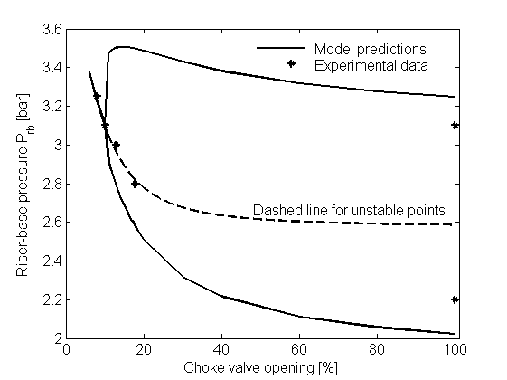
Figure 4.4: Bifurcation diagram for the Tiller experimental data

Simulated OLGA test case
The test case for riser slugging OLGA, also studied in Storkaas and Skogestad (2005), is used as a second verification case. The case geometry and nomenclature is shown in Figure 4.5 and Figure 4.6. The relationship between the nomenclature used in the model (Figure 2.1/Figure 2.2) and the nomenclature used for the physical system depicted in Figure 4.5 are given in Table 2.

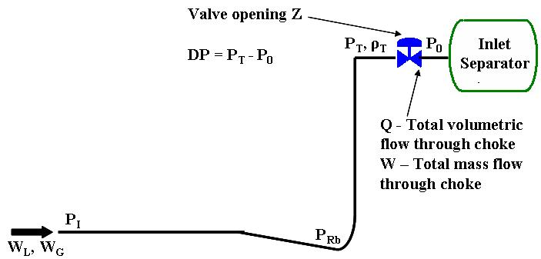
Figure 4.5: Nomenclature used for the pipeline riser system

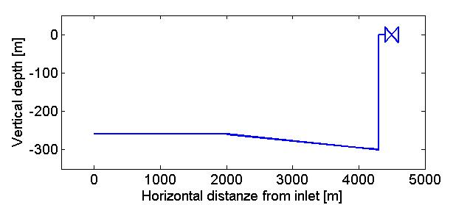
Figure 4.6: System geometry for OLGA test case

Table 2: Nomenclature for physical system and model.
Description | Physical system (Figure 4.5) | Model (Figure 2.1 and 2)
Topside pressure | P_{T} | P₂
Riser-base pressure* | P_{Rb} | P₁
Inlet pressure* | P_{I} | P₁
*Both these pressures are represented by P₁ in the model.

Model Tuning
The model was tuned as outlined in section 3 and resulted in the parameters given in Table 3. The reference data was from OLGA simulations consisted of data both for riser slugging and for the stable and unstable regions of the stationary flow regime. The unstable stationary operation points were obtained using the OLGA Steady State Processor. The bifurcation point were identified to be at a valve opening of Z=13%, and the corresponding values for the inlet pressure P_{I} and pressure drop over the valve DP=P_{T}-P₀ were used to tune the model.

Table 3 : Parameters identified to fit the simulated OLGA data

Parameter | Value | Unit
K₁ | 0.0054 | m⁻²
K₂ | 6.84 | -
K₃ | 0.11 | s²/m²
n | 2.3 | -
Upstream Gas Volume V_{G1} | 12.64 | m³
Molecular Weight Gas M_{G} | 20.6 | kg/kmole

Comparison with OLGA reference data and two-fluid model
In Figure 4.7 and Figure 4.8, the bifurcation diagrams for the inlet pressure P_{I} and the topside pressure PT predicted by the simplified 3-state model are compared to the OLGA reference data and to the data from the PDE-based two-fluid model used in Storkaas and Skogestad (2005). For each model, the solid lines represent operation with constant valve opening (without control). Riser slugging is represented by two solid lines, and the system is oscillating between the maximum and minimum pressure levels indicated in the bifurcation diagrams. The dashed lines indicate the unstable stationary flow regime.

Figure 4.7 and Figure 4.8 shows that the simplified model gives an excellent fit to the OLGA reference data for the desired, non-oscillatory flow regime. The amplitude of the riser slugging is also predicted with good accuracy. Figure 4.7 shows that the simplified model actually gives the correct pressure drop over the pipeline-riser system, whereas the more complicated PDE-based model predicted the pressure drop to be about 5% too high. The pressure drop over the choke valve in figure Figure 4.8 fits the reference data for the stationary flow regime for both models while there are some minor deviations for the riser slugging regime.

The slug frequency is not included in the bifurcation diagram, but simulations show that the simplified three-state model predicts a slug frequency that, compared to the OLGA simulations, is about 10-20% too high for low-to-medium range valve openings and up to about 50% too high for large valve openings. The higher frequency probably comes from neglecting the liquid dynamics in the feed section. This is not surprising since we have in this case tuned to achieve a good fit for the amplitude, and when the upstream gas volume is
fixed, we cannot fit both frequency and amplitude simultaneously.

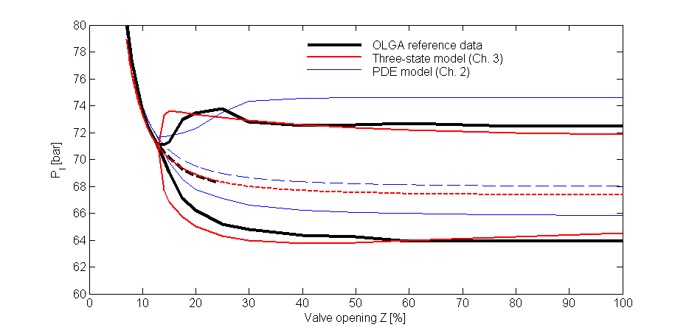
Figure 4.7 : Bifurcation diagrams for the simulated OLGA case : Inlet pressure P_{I}

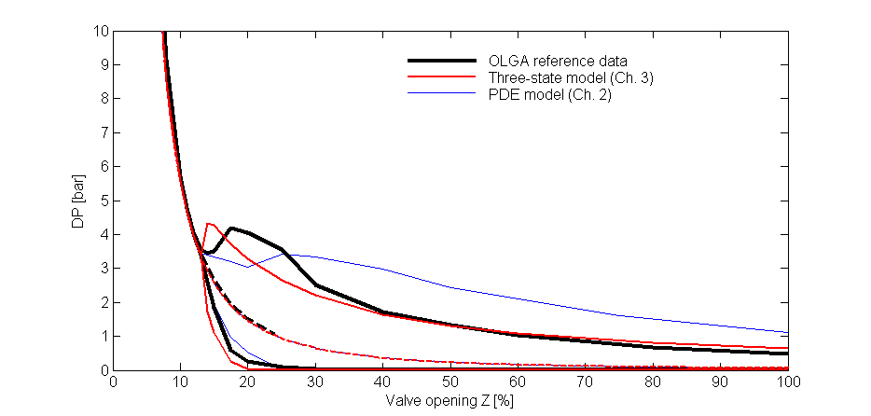
Figure 4.8: Pressure drop over choke valve DP

Control properties of model
To further verify the model, we first investigate the open-loop step responses for the OLGA test case for the 3-state model and compare these with the two fluid model from Storkaas and Skogestad (2005) and with OLGA. We then compare the local (linear) behavior and the controllability results for the simplified model and two-fluid model at a valve opening of Z = 30%. We generally find an excellent agreement with the significantly more complicated models, which is based in quite different modeling assumptions. This further shows that the simple 3-state model is excellent for control purposes.

Open-loop step response
Figure 5.9 shows the simulated step response to a step from Z = 10% to Z = 12% at t=0 for the simple 3-state model, the two-fluid model used in (Storkaas and Skogestad, 2005) and OLGA. The step responses give us some insight into the dynamic behavior of the different measurement alternatives.

We observe the following for the 3-state model:
- The oscillations have a frequency that is similar to OLGA, which indicates that the imaginary parts of the poles responsible for the oscillatory behavior have almost the same magnitude.

- An effective time delay of about 10s is missing in the response for y = P_{I}

- The effective time delay in y = DP, which is caused by unstable (RHP) zero dynamics, is 1-2 minutes. This is similar to the two-fluid model, but shorter than in OLGA. Also, the inverse response in the 3-state model has a shape that is consistent with real RHP-zeros, whereas the other two responses are indicative of complex RHP-zeros.

- The response for y = Q is very similar to the two other models.

Frequency response comparison
Figure 5.10 shows the Bode plot with the valve opening Z as input and the inlet pressure P_{I} as output for the simplified model (solid lines) and the two-fluid model from Storkaas and Skogestad (2005) (dashed lines). P_{I} was identified in Storkaas and Skogestad (2005) as a good candidate for stabilizing control. The step responses in the previous section show that a time delay of about 10 seconds is missing in the simplified 3-state model. The time delay is due to pressure wave propagation through the pipeline.
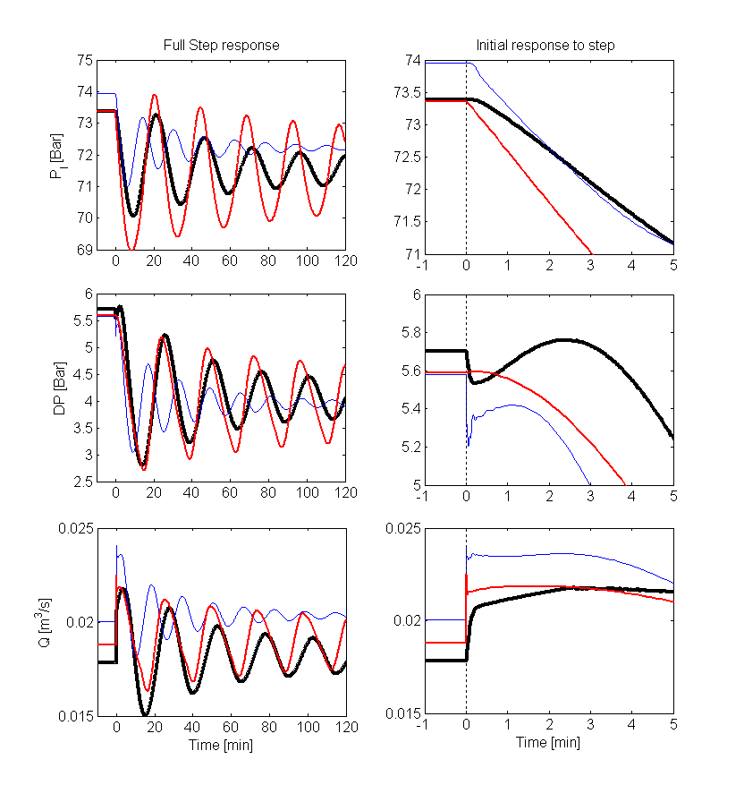
Figure 5.9 Open-loop step response with simple 3-state model (normal lines), two-fluid model (thin lines) and OLGA(thick lines)
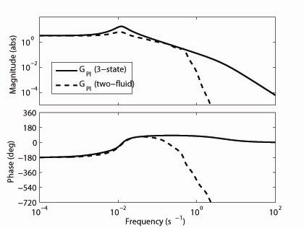
Figure 5.10 : Response from u=Z to y=P_{I}, Comparison of frequency responses for simplified (solid) and two-fluid model (dashed).
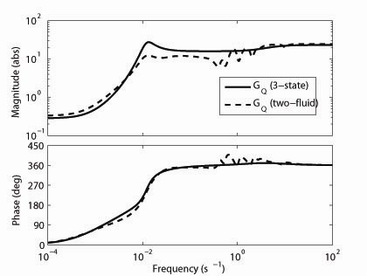
Figure 5.11: Response from u=Z to y=Q, Comparison of frequency responses for simplified (solid) and two-fluid model (dashed).

Time delay manifests itself in a Bode plot as a drop in the phase and is evident in the lower part of Figure 5.10 : Response from u=Z to y=PI, Comparison of frequency responses for simplified (solid) and two-fluid model (dashed). For a time delay of about θ = 10 s, the phase should theoretically drop about 57º at ω = 1/ θ = 0.1 and drop sharply after this. This is consistent with the phase behaviour of the two-fluid model. Note that this delay may easily be added to the simplified model to improve its behaviour. Another difference is a drop in the process gain (magnitude) for high frequencies in the two-fluid model. This drop in gain is a dampening effect that occurs due to the dynamics in the feed line which is not included in the simplified model. However, this damping occurs
at higher frequencies than the desired bandwidth of the control problem, and the model deviation is therefore not important. A third difference is that the simplified model has a higher gain in the frequency range around the instability. The reason for this is not clear, and we make no claim as to which model gives the right representation of the gain. Figure 5.11 shows the Bode plot with the valve opening Z as input and the volumetric flow through the choke valve Q as output. The differences are small, except for a higher gain around the frequency of the instability. Figure 5.12 shows the corresponding responses for disturbances in liquid feed (W_{L}), gas feed (W_{G}) and downstream pressure (P₀). As above, the deviations between the simplified model and the two-fluid model can be explained by the difference in feed-line dynamics.
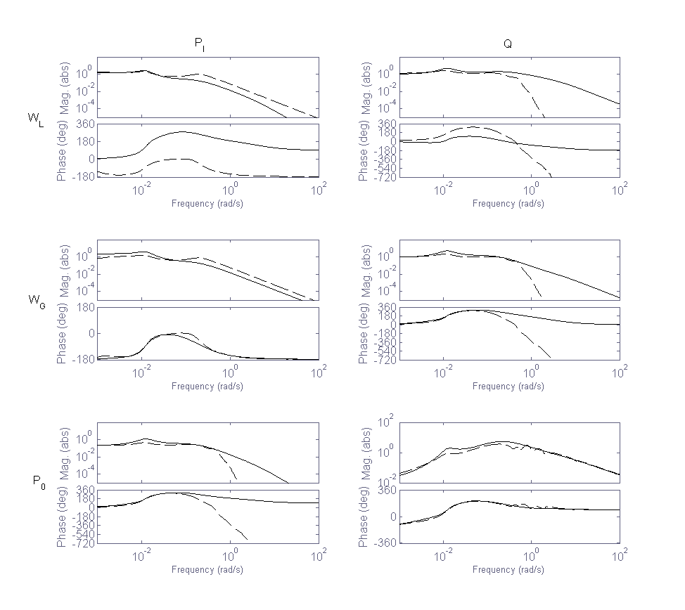
Figure 5.12 Comparison of disturbance frequency responses for 3-state (solid) andtwo-fluid model (dashed). Left column: y=P_{I}, right column: y=Q. First row: d1=W_{L}, second row: W_{G}, third row: d₃=P₀.

Controllability analysis

Storkaas and Skogestad (2005) considered as candidate measurements for stabilizing control of the pipeline-riser system the following measurements:

- input pressure P_{I}
- riser-base pressure P_{Rb},
- pressure drop over the choke valve DP=P_{T} – P₀ (or equivalently, the topside pressure P_{T} since P₀ is constant),
- density in the top of the riser ρ_{T} ,
- mass flow rate through the choke valve w_{out}
- volumetric flow rate through the choke valve, Q=w_{out}/ ρ_{T}

For these candidate measurements Storkaas and Skogestad (2005) used the linearized two-fluid PDE model to compute the lower bounds on the closed-loop transfer functions S, T, KS, SG, KSG_{d} and SG_{d}. The lower bounds serve both as measures of the achievable performance (e.g. the lower bound on KSG_{d} give the minimum input usage due to disturbances) and a as robustness indicators (e.g. SG is a measure of the sensitivity toward inverse additive uncertainty). Values significantly higher than unity for any of the lower bounds on the closed loop transfer functions are indications of controllability problems. The pole vectors were also computed as a tool for measurement selection. The controllability analysis concluded that the inlet or riser-base pressures were the best measurement candidates. The flow-rate Q and W were also found to be good candidates, but only in an inner loop in a cascade controller due to poor properties at low frequencies.

To compare, we here compute the same bounds for the simple 3-state model, except that we omit the riser-base pressure P_{Rb} from the analysis since in the simplified model, P_{Rb} ≈ P_{I}. Tabel 1 and Tabel 2 summarize the controllability results for the two models at valve openings Z = 17.5% and Z = 30%. The bounds on the closed-loop transfer functions and the pole vectors are computed as described in Storkaas and Skogestad (2005). Although there are some differences between the two models, the conclusion is as before; we should preferably control the inlet pressure P_{I} , and if that measurement is not available, we should use the volumetric flow Q or the mass flow W in an inner loop in a cascade controller.

One trend is that the value for min_{K} ||KS||∞ (that is, the minimum peak for |KS|) is lower for the simplified model than for the PDE-based two-fluid model. This is consistent with the difference in peak gains observed form the Bode plots.

For the measurement alternatives DP and ρ_{T}, which both have unstable zeros, the value for M_{S,min} = M_{T,min} are lower for the simplified model than for the PDE-based model from Storkaas and Skogestad (2005). The reason is the difference in the location of the unstable zeros, which are also given in the tables. For y = DP, the simplified model has real unstable zeros, whereas the PDE model has a pair of complex unstable zeros that lie closer to the complex pair of unstable poles. This is consistent with the shape of the inverse responses in Figure 5.9.

Tabel 1 : Controllability data for the operating point Z=17.5 %. Unstable poles at p=0.0007±0.0073i for simplified model and at p=0.0014±0.0085i for PDE-based model.
 |  |  |  |  |  | Minimum preaks
Measurement | Value | Scaling | Smallest RHP-zero | Pole vector ^{b} | |G(0)| ^{b} | |S|=|T| | |KS| | |SG| | | KSG_{d}| | |SG_{d}|
P_{I}[bar](3-state) | 69.35 | 1 | - | 0.49 | 19 | 1 | 0.01 | 0 | 0.06 | 0
P_{I}[bar](PDE) | 70 | 1 | 99 | 0.36 | 18.9 | 1.0 | 0.03 | 0.0 | 0.06 | 0.0
DP[bar](3-state) | 1.91 | 1 | 0.018 | 0.21 | 17.7 | 1.1 | 0.02 | 5.9 | 0.06 | 1.37
DP[bar](PDE) | 1.92 | 1 | 0.01±0.01i | 0.21 | 17.6 | 1.6 | 0.04 | 17.1 | 0.08 | 0.95
ρ_{T}[kg/m³](3-state) | 464 | 50 | 0.0045 | 0.35 | 1.4 | 1.2 | 0.01 | 27.4 | 0.06 | 2.25
ρ_{T}[kg/m³](PDE) | 432 | 50 | 0.016 | 0.28 | 1.5 | 1.4 | 0.03 | 28.6 | 0.07 | 1.60
w_{out}[kg/s](3-state) | 9 | 1 | - | 0.64 | 0 | 1 | 0.01 | 0 | 0.06 | 0
w_{out} [kg/s](PDE) | 9 | 1 | - | 0.59 | 0 | 1 | 0.02 | 0 | 0.06 | 0
Q[m³/s](3-state) | 0.0194 | 0.002 | - | 0.42 | 1.5 | 1 | 0.01 | 0 | 0.06 | 0
Q[m³/s](PDE) | 0.0208 | 0.002 | - | 0.51 | 1.8 | 1 | 0.02 | 0 | 0.06 | 0

Tabel 2 : Controllability data for the operating point Z=30%. Unstable poles at p=0.0038±0.0115i for simplified model and at p=0.0045±0.0108i for PDE-based model.
 |  |  |  |  |  | Minimum preaks ª
Measurement | Value | Scaling | Smallest RHP-zero^{b} | Pole vector ^{b} | |G(0)| ^{b} | |S|=|T| | |KS| | |SG| | | KSG_{d}| | |SG_{d}|
P_{I}[bar](3-state) | 68 | 1 | - | 0.31 | 3.4 | 1 | 0.11 | 0 | 0.31 | 0
P_{I}[bar](PDE) | 68.7 | 1 | 98.1 | 0.30 | 3.3 | 1.0 | 0.30 | 0.0 | 0.35 | 0.005
DP[bar](3-state) | 0.68 | 0.5 | 0.016 | 0.17 | 6.3 | 1.9 | 0.25 | 15.1 | 0.31 | 5.8
DP[bar](PDE) | 0.66 | 0.5 | 0.01±0.01i | 0.17 | 6.1 | 4.3 | 0.62 | 16.8 | 0.97 | 5.5
ρ_{T}[kg/m³](3-state) | 459 | 50 | 0.0045 | 0.34 | 0.26 | 1.5 | 0.13 | 4.4 | 0.38 | 2.0
ρ_{T}[kg/m³](PDE) | 427 | 50 | 0.015 | 0.27 | 0.27 | 2.6 | 0.64 | 14.6 | 0.55 | 4.7
w_{out} [kg/s](3-state) | 9 | 1 | - | 0.73 | 0 | 1 | 0.06 | 0 | 0.31 | 0
w_{out} [kg/s](PDE) | 9 | 1 | - | 0.63 | 0 | 1 | 0.17 | 0 | 0.32 | 0
Q[m³/s](3-state) | 0.0196 | 0.002 | - | 0.47 | 0.28 | 1 | 0.09 | 0 | 0.31 | 0
Q[m³/s](PDE) | 0.0211 | 0.002 | - | 0.59 | 0.33 | 1 | 0.17 | 0 | 0.32 | 0.002

Conclusions

A very simple model of riser slugging suitable for controller design and analysis has been developed. The model has three states and is based on ’phenomenological’ modelling that includes the major characteristics of the system. The major characteristics of the riser slugging systems are the stability of the flow as a function of choke valve position, the nature of the transition to instability (Hopf bifurcation), the presence of an unstable steady-state solution and the amplitude of the oscillations. It should be stressed that it is more important for the model to describe the (desired) steady state flow regime than the (undesired) slug behavior.

The model is very simple, and some of the equations and assumptions may seem unusual or even questionable. Nevertheless, the model fits nicely data both from an OLGA test case and from medium-scale experiments. The experience is that the simplified model is easier to fit to experimental data than the more detailed two-fluid PDE models. Importantly, a controllability analysis shows the same results for a two-fluid PDE model and the simple three-state model. The model has also been used for controller design in Storkaas (2005).

The model is available on the web (Storkaas, 2003).

Acknowledgments
Thanks to John-Morten Godhavn and the Statoil Research Centre for providing the experimental Tiller data used to verify the simplified three-state model.

References
Courbot, A. (1996), ‘Prevention of severe slugging in the Dunbar 16“ multiphase pipeline’,
Offshore Technology Conference, May 6-9, Houston, Texas.

Fard, M., Godhavn, J.-M. and Sagatun, S. (2003), ‘Modeling and slug control within
OLGA’, Submitted to SPE Journal.

Godhavn, J.-M., Mehrdad, P. F. and Fuchs, P. (2005), ‘New slug control strategies, tuning
rules and experimental results’, Journal of Process Control (15), 547–577.

Jansen, B., Dalsmo, M., Nøkleberg, L., Havre, K., Kristiansen, V. and Lemetayer, P. (1999), ’Automatic control of unstable gas lifted wells’, SPE Annual Conference and Exhibition in Houston, Texas. SPE 56832.

Havre, K. and Dalsmo, M. (2002), ‘Active feedback control as a solution to severe slugging’,
SPE Production and Facilities pp. 138–148. SPE 79252.

Havre, K., Stornes, K. and Stray, H. (2000), ‘Taming slug flow in pipelines’, ABB review
4, 55–63.

Hedne, P. and Linga, H. (1990), ‘Suppression of terrain slugging with automatic and manual
riser choking’, Advances in Gas-Liquid Flows pp. 453–469.

Henriot, V., Courbot, A., Heintze, E. and Moyeux, L. (1999), ‘Simulation of process to
control severe slugging: Application to the Dunbar pipeline’, SPE Annual Conference
and Exhibition, Houston, Texas. SPE 56461.

Hollenberg, J., de Wolf, S. and Meiring, W. (1995), ‘A method to supress severe slugging in
flow line riser systems’, Proc. 7th Int. Conf. on Multiphase Technology Conference.

Kovalev, K., Cruickshank, A. and Purvis, J. (2003), ‘The slug suppression system in operation’, Offshore Europe 2003, Aberdeen, UK. SPE 84947.

Sachdeva, R., Schmidt, Z., Brill, J. and Blais, R. (1986), ‘Two phase flow through chokes’.
SPE 15657.

Sarica, C. and Tengesdal, J. (2000), ‘A new teqnique to eliminating severe slugging in
pipeline/riser systems’, SPE Annual Technical Conference and Exibition, Dallas,
Texas. SPE 63185.

Schmidt, Z., Brill, J. and Beggs, H. (1979), ‘Choking can eliminate severe slugging’, Oil and
Gas Journal pp. 230–238.
Sivertsen, H. and Skogestad, S. (2005), ‘Anti-slug control experiments on a small scale twophase loop’, Escape’15, Barcelona, Spain, 29 May - 1 June 2005.

Skofteland, G. and Godhavn, J.-M. (2003), Suppression of slugs in multiphase flow lines
by active use of topside choke - field experience and experimental results, in ‘Proc. of
MultiPhase ’03, San Remo, Italy, 11-13 June 2003’.

Storkaas, E. (2003), Matlab source code. Available at home page of S. Skogestad.
http://www.nt.ntnu.no/users/skoge/software/storkaas/

Storkaas, E. (2005), Stabilizing control and Controllability: Control solutions to avoid slug
flow in pipeline-riser systems, PhD thesis, Norwegian University of Science and Technology.

Storkaas, E. and Skogestad, S. (2005), ‘Controllability analysis of a two-phase pipeline-riser
system at riser slugging conditions’, Submitted to IEEE Transactions on Automatic
control.

Storkaas, E., Skogestad, S. and Godhavn, J.-M. (2003), A low-dimensional model of severe
slugging for controller design and analysis, in ‘Proc. of MultiPhase ’03, San Remo,
Italy, 11-13 June 2003’.

Zuber, N. and Findlay, J. (1965), ‘Average volumetric concentration in two-phase flow systems’, Journal of Heat Transfer 87, 453–468.

A1 Model equations

This appendix contains the set of equations that constitutes the simplified model of a pipeline-riser
system at riser slugging conditions that was developed in this paper. The model assumptions are given in the paper. The model is implemented in Matlab and the model files are available at the web Storkaas (2003).

Conservation Equations

Calculation of state dependent internal variables

Flow equations

Geometric equations at lowpoint

Notation

Symbol | Descripton | Unit | Remarks
 | Mass of gas in volume i |  | State variable
 | Mass of liquid |  | State variable
 | Gas volume i |  | V_{G1}=const
 | Volume occupied by liquid
 | Volume of liquid in riser
 | Total volume in riser |  | Constant
P_{1,} P_{I}, P₂, P_{T,} P_{RB} | Pressure (see Table 2)
 | Pressure after choke valve |  | Disturbance
DP = P_{T} – P₀ | Pressure drop choke valve
Z | Valve Position |  | Input
 | Gas density
 | Liquid density |  | Constant
 | Average density in riser
 | Density upstreams valve
 | Gas velocity at lowpoint
 | Liquid velocity through choke valve
 | Internal gas mass flowrate
 | Gas mass flowrate through choke valve
 | Liq. Mass flowrate through choke valve
 | Average liq.frac. in riser, volume basis | -
 | Liq.frac. upstreams valve, volume basis | -
 | Liq.frac. upstreams valve, mass basis | -
 | Liquid height at or upstream lowpoint | m
 | Height at lowpoint | m | Constant
 | Height of riser | m | Constant
r | Radius of pipe | m | Constant
 | Area in horizontal plane, V₁ | m² | Constant
 | Cross section area, V₂ | m² | Constant
 | Gas flow area at lowpoint | m²
 | Length of horizontal top section | m | Constant
 | Feed pipe inclination | rad | Constant
 | Gas Constant |  | Constant
 | Spesific gravity |  | Constant
 | System Temperature | K | Constant
 | Molecular weight of Gas |  | Constant
 | Mass rate of gas into system |  | Disturbance
 | Mass rate of liquid into system |  | Disturbance
 | Choke valve constant | - | Tuning parameter
 | Gas Flow constant | - | Tuning parameter
 | Friction parameter | - | Tuning parameter
 | in the friction expression | - | Tuning parameter

Present affiliation: ABB, Oslo
Correspondence author
Parts of this work was presented at the Multiphase '03 conference in San Remo, Italy (Storkaas et al., 2003)
Want these small
Want these large

