Minimum Energy for the four-product Kaibel-column

Ivar J. Halvorsen, SINTEF, Norway and Sigurd Skogestad, NTNU, Norway

AIChE Annual meeting 2006, paper 216d

Introduction

For a four-component feed, Kaibel (1987) proposed a single dividing wall column (DWC) with two side-streams. We will show that an analytic minimal energy expression for the Kaibel-arrangement is straightforward to deduce based on the methods presented by Halvorsen (2001). The expression is very similar to the expression for the 3-product Petlyuk column. Minimum energy for the generalized n-product Petlyuk arrangement is given in Halvorsen (2001), Halvorsen and Skogestad (2003). Halvorsen introduced the V_{min}-diagram, and this tool is also suited to illustrate the performance of a Kaibel column.

Compared to the conventional 3 column direct split sequence, the Kaibel column can be built in a single shell, making it very interesting in terms of capital cost savings. In addition it performs quite well in terms of energy savings too. As an example, the potential energy savings are 33% compared to the direct sequence for an equimolar 4-component mixture with relative volatilities of 6:4:2:1.

We will show how the methods can be used to compare a number feeds for a set of alternative arrangements. The feed may contain any number of components that are split into four products with both sharp and non-sharp splits between each product.
ABCD
CD
A
AB
B
D
C
ABCD
CD
A
B
D
C
AB
C1
C21
C2x
C22
DWC
Equivalent

Column section arrangement

Figure 1 The Four Product Kaibel Arrangement

Minimum energy expression

We consider a 4-component feed (F) with the components A (light), B, C and D (heavy). The feed with composition vector z and liquid fraction q shall be separated into 4 pure products. We assume infinite number of stages, constant pressure, constant molar flow and constant relative volatilities ($α$) referred to a reference component (typically the heavy D). Thus $α_{A}>α_{B}>α_{C}>α_{D}$

The objective of this study to obtain the minimum vapour flow requirements for the Kaibel-arrangement as shown in Figure 1. The prefractionator (C1) performs a sharp AB/CD split. The succeeding “main column” performs the A/B-split in the top (C21) and the C/D-split in the bottom (C22). The middle section (C2x) between the B and C outlet is actually operated at full reflux (V=L) without any net transport of components since the B/C split is already obtained in the prefractionator. The minimum vapour flow requirement in the main column is given by the highest requirement from the A/B or the C/D-split.
ABCD
A
B
D
C
AB
ABC
BCD
CD
BC
ABCD
CD
A
AB
B
D
C
ABC
BCD
BC
In a single shell with multiple dividing walls
Basic Column sections and interconnections
Figure 2. The Petlyuk Arrangement extended to four products.

Before deriving the overall minimum vapour flow for the Kaibel column let us consider the extended Petlyuk arrangement shown in Figure 2. Here, the minimum energy is given by the requirement to perform the most difficult of the three splits: A/BCD, AB/CD or ABC/D as if that split should be performed in a single column (Halvorsen 2001). This requires that every internal column in the arrangement is operated at its preferred split (Stichlmair 1989).

However, in the Kaibel-arrangement the prefractionator is not operated at the preferred split, but performs a sharp AB/CD split. The minimum vapour flow rate (V_{min}) at the top of the prefractionator is then higher and can be expressed analytically by the Underwood (1948) expression:

$\frac{V_{T\text{min}}^{{\text{AB}}/{\text{CD}}}}{F}=\frac{α_{A}z_{A}}{α_{A}−θ_{B}}+\frac{α_{B}z_{B}}{α_{B}−θ_{B}}$ (1)

Here $θ_{B}$is the middle common Underwood (1948) root found from the feed equation:
$\frac{α_{A}z_{A}}{α_{A}−θ}+\frac{α_{B}z_{B}}{α_{B}−θ}+\frac{α_{C}z_{C}}{α_{C}−θ}+\frac{α_{D}z_{D}}{α_{D}−θ}=1−q$ (2)
The common Underwood roots obey: $α_{A}>θ_{A}>α_{B}>θ_{B}>α_{C}>θ_{C}>α_{D}$

Note that when the prefractionator is operated at minimum energy for AB/CD split, the middle root ($θ_{B}$) is the only active root. To find the actual Underwood root in the top and in the bottom sections we must return to the defining Underwood equation (e.g., Halvorsen 2001). In the top, only component A and B occur, thus

$V_{T\text{min}}^{{\text{AB}}/{\text{CD}}}=\frac{α_{A}w_{A}}{α_{A}−φ}+\frac{α_{B}w_{B}}{α_{B}−φ}$ Here $w_{A}=z_{A}F$and $w_{B}=z_{B}F$ (3)

In the bottom, we have similarly only component C and D travelling downwards:
$V_{T\text{min}}^{{\text{AB}}/{\text{CD}}}−(1−q)F=\frac{α_{C}w_{C}}{α_{C}−ψ}+\frac{α_{D}w_{D}}{α_{D}−ψ}$ Here $w_{C}=−z_{C}F$and $w_{D}=−z_{D}F$ (4)

The interesting roots are $φ_{A}$ in the top and $ψ_{C}$ in the bottom. (Note that $α_{A}>φ_{A}>θ_{A}>α_{B}$ and $α_{C}>θ_{C}>ψ_{C}>α_{D}$.) Due to the full thermal coupling these roots carry over from the prefractionator (C1) and become the common Underwood roots in columns C21 and C22 respectively as shown by Halvorsen (2001).

Thus, the minimum vapour flow rate in the top of the Kaibel column (C21) is given by:

$V_{T\text{min}}^{C\text{21}}=\frac{α_{A}w_{A}}{α_{A}−θ_{A}^{C\text{21}}}=\frac{α_{A}w_{A}}{α_{A}−φ_{A}}$ (5)

Similarly, in the bottom of C22:

$V_{B\text{min}}^{C\text{22}}=\frac{α_{D}w_{D}}{α_{D}−θ_{C}^{C\text{22}}}=\frac{α_{D}w_{D}}{α_{D}−ψ_{C}}$ (6)

Thus, the overall minimum vapour flow for the Kaibel arrangement in terms of the overhead vapour flow is (for simplicity we use D as reference and thereby:$α_{D}=1$):

$\frac{V_{T\text{min}}^{\text{Kaibel}}}{F}=\text{min}(\frac{V_{\text{min}}^{C\text{21}T}}{F},\frac{V_{\text{min}}^{C\text{22}B}}{F}+(1−q))=\text{min}(\frac{α_{A}z_{A}}{α_{A}−φ_{A}},\frac{z_{D}}{ψ_{C}−1}+(1−q))$ (7)

The calculations are simple and exact for infinite number of stages. With the assumption of constant relative volatilities and constant molar flows, the solution for the Underwood roots requires a polynomial root solver, but the rest are simple rational expressions. No iterations are required.

The minimum vapour flow for the Kaibel arrangement can never come down to the minimum energy for the extended four-product Petlyuk column. This is because the prefractionator is operated above the preferred split, and that introduces an irreversible loss that cannot be recovered in the succeeding columns.

Numerical Example

In Table 1 six different arrangements are compared. There are many more combinations possible. The Petlyuk- and the Kaibel arrangements have the prefractionator ends fully thermally coupled to the succeeding columns. V_{min} is given in molar flow rate and in per cent referred to the conventional direct split sequence.

 | Configuration | V_{min} | Savings | First column/ prefractionatior | Second separation | Third separation
1 | Four product extended Petlyuk | 1.38 | 50% | C1:ABC/BCD | C21:AB/BC  C22:BC/CD | C31:A/B  C32:B/C  C33:C/D
2 | Kaibel column | 1.83 | 33% | C1:AB/CD | C21:A/B  C2x:B/C  C22:C/D
3 | Three product Petlyuk+ conventional B/C | 1.98 | 28% | C1: A/BC/D | C2: B/C
4 | Prefractionator+  single main column | 2.34 | 15% | As Kaibel, but with condenser &reboiler in prefractionator | C21:A/B  C2x:B/C  C22:C/D
5 | Prefractionator+  2 separate columns | 3.04 | -11%  (loss) | As Kaibel, but with condenser &reboiler | C21:A/B  Isolated from  C22:C/D
6 | Conventional direct sequence (3 columns) | 2.75 | 0%  (reference) | C1:A/BCD | C2:B/CD | C3:C/D
7 | Conventional indirect sequence with liquid overhead (3 columns) | 3.50 | -27%  (loss) | C1:ABC/D | C2:AB/C | C3:A/B
Table 1 Comparison of minimum energy for 4-product separation sequences.
Feed data: F=1, α=[6 4 2 1], z=[0.3 0.2 0.2 0.3], q=1.

Observe that the Kaibel-arrangement consumes more energy than the full extended Petlyuk arrangement, but also that it performs better than the other more conventional arrangements (4-7) that do not use full thermal coupling. It also performs better than a combination of a 3-product Petlyuk column combined with a conventional binary column for the last split (3).

The V_{min}-diagram

The solution is simple to illustrate in the V_{min} –diagram in Figure 3. Recall from the work of Halvorsen and Skogestad (2003) that the peaks P_{AB}, P_{BC} and P_{CD} represent minimum energy for sharp product splits of the original mixture. Each peak is related to each of the common Underwood roots ($θ_{A},θ_{B},θ_{C}$). The highest peak (here P_{AB}) represents the minimum energy for the Petlyuk arrangement. For a Petlyuk arrangement, the prefractionator performs the “easy” split between components A and D, and the remining components are split such that we operate at the preferred split, which is at P_{AD}. However, in a Kaibel-arrangement the prefractionator performs the more difficult split between components B and C. For the Kaibel column we must compute the new peaks P'_{AB} and P'_{CD} that are determined by the actual Underwood roots ($φ_{A},ψ_{C}$), see equations (5) and (6). The minimum energy in the Kaibel arrangement is given by the highest of the new peaks (here P'_{AB}). It is obvious from this diagram that the Kaibel arrangement always consumes more energy than the full Petlyuk arrangement since P'_{AB} > P_{AB}, P'_{CD} > P_{CD} and trivially: P'_{AB} > P_{BC} and P'_{CD} > P_{BC}. It is also simple to see that the difference between Kaibel- and Petlyuk-arrangements can become small when peak P_{BC} is quite low. This is illustrated by the additional results in Figure 4.

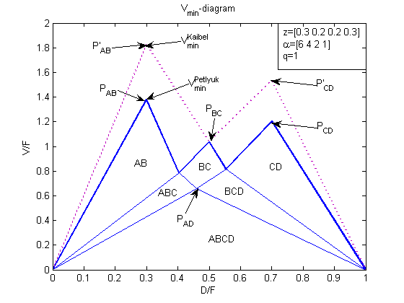
Figure 3 V_{min} diagram for the four component feed

To get a rough approximation of P'_{AB} and P'_{CD}, just consider the two lines P_{AD}P_{AB} and P_{AD}P_{CD} and the corresponding two parallels through P_{BC} and se how these parallels intersects the verticals straight above P_{AB} and P_{CD.} (This is not shown in the figure.)
Thus, the V_{min} –diagram, based only on the feed data, can give a good picture of the performance of the Kaibel column even without doing the detailed calculation.

The left and right peaks represent the minimum vapour flow in the upper an lower part of the Kaibel column respectively. The highest peak determine the energy demand.

Additional examples

In Figure 4 a set of V_{min}-diagrams is shown where the feed properties is varied from the basic example given in Figure 3. (α=[6 4 2 1], z=[0.3 0.2 0.2 0.3], q=1)
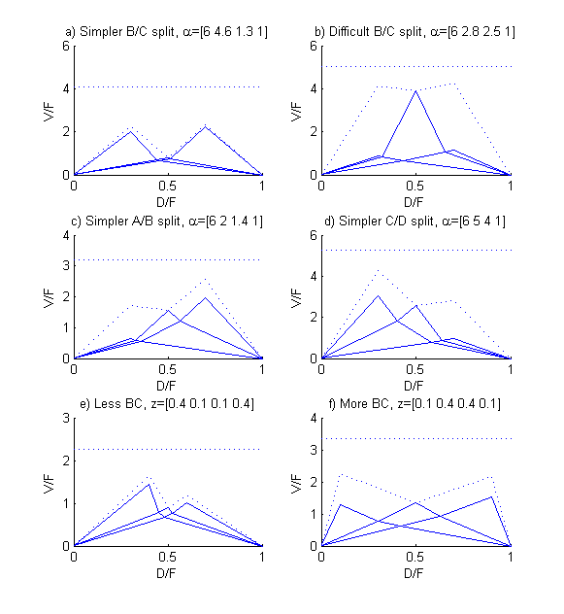
Figure 4 V_{min}-diagram for different feed properties. The peaks representing the Kaibel column are shown dashed. The dashed horisontal line above each diagram represents the vapour flow in the best conventional configuration.

Note that the peaks representing the Kaibel arrangement (dashed) are always above the ones representing the full 4-product Petlyuk arrangement (solid). However, the Kaibel arrangement also has significantly lower vapour flow than a conventional arrangement (the dashed horizontal line) for all the examples.

The peak P_{BC} is small if the relative volatility between B and C is smaller than the ones between A/B and C/D, an also if the feed fraction of B+C is small compared to A and D.

Note that in case a) when the B/C split is simple (compared to A/B and C/D) and in case e) where the amount of B and C in the feed is small, the Kaibel column comes very close in performance to the full 4-product Petlyuk arrangement.

In case b), c) and d) where the peaks are very different, this will give a corresponding large difference in vapour flow in the upper and lower part of a Kaibel column. Thus, another arrangement may be more practical in those cases.

Conclusion

It is shown that it is straightforward to find the analytic expression for minimum energy of the Kaibel-arrangement based on the calculation methods for the generalized Petlyuk arrangement. These are again based on the classical Underwood equations.

The result is simple to illustrate in the V_{min}-diagram. From the basic V_{min}-diagram based on the four-component feed, it is easy to assess the vapour requirement in a Kaibel column without doing the detailed calculation.

The energy savings by a Kaibel column can be over 30%. It is also attractive for capital cost savings compared to conventional 3-column arrangements since these can be replaced with a single shell and a single re-boiler and condenser. A full Petlyuk arrangement for four components will always save some more energy, but will not be very realistic to use in a real plant due to much higher complexity.

It is straightforward to use this analysis for more than four feed components, with both sharp and non-sharp purity specifications for the four products.

References

Kaibel G., Distillation Columns with Vertical Partitions, Chem. Eng. Technol., 1987, Vol. 10, pp 92-98.

Halvorsen, I. J., Minimum Energy Requirements in Complex
Distillation Arrangements. Dr. Ing. Thesis, NTNU, 2001:43.
Available from the web page of Sigurd Skogestad, Department of
Chemical Engineering, NTNU (http://www.nt.ntnu.no/users/skoge/publications/thesis/2001_halvorsen/)

Halvorsen I.J., Skogestad S,. Minimum Energy Consumption in Multicomponent Distillation. 3. More Than Three Products and Generalized Petlyuk Arrangements. Ind. Eng. Chem. Res. 2003, 42, 616-629

Stichlmair, J (1988). Distillation and Rectification, Ullmann's Encyclopedia of Industrial Chemistry, B3, 4-1-4-94, 1988, VCH.

Underwood, A.J.V (1948), Fractional Distillation of Multi-Component Mixtures. Chemical Engineering Progress, Vol. 44 no. 8, 1948.

Appendix – The Underwood roots

The actual Underwood roots ($φ$) in the top section (subscript T) of a two-product distillation column with a N-component feed are defined as the solution of:
$V_{T}=\sum_{i}{\frac{α_{i}w_{i}}{α_{i}−φ}}$ (A1)

Similarly, the Underwood roots ($ψ$) in the bottom (subscript B) is defined as the solution of:
$V_{B}=\sum_{i}{\frac{α_{i}w_{i}}{α_{i}−ψ}}$ (A2)

By subtracting these two equations we obtain the feed equation:

$V_{T}−V_{B}=(1−q)F$ (A3)

Here w_{i} is the net transport rate of component i in the upwards direction. V is the vapour flow rate and $α_{i}$ is the relative volatility referred to a reference component (usually the heavy key).

Underwood showed that for minimum energy operation corresponding roots in the top and bottom coincide. Thus, these common roots ($θ$) can be found directly from the feed equation. For N components there are N-1 common roots with values between the relative volatilities.

In any operating point of the column, we denote a common root as an active root when the actual roots have coincided to the actual roots ($φ_{i}=θ_{i}=ψ_{i}$). This occurs when there are any components that are distributed to both products. With reference to the V_{min}-diagram for the four-component example in Figure 4, $θ_{A}$ is active in region AB, ABC and ABCD. The root $θ_{B}$ is active in region BC, ABC, BCD and ABCD and finally $θ_{c}$ is active in region CD, BCD and ABCD. The lines in the diagram are boundary lines where one component is exactly at the limit of being distributed to both products.

