Abstract

Ziegler and Nichols published their famous paper “Optimum settings for automatic controllers” in 1942. Based on Ziegler and Nichols experience with the transient for many types of processes they developed a method for tuning of closed-loop response. In the literature there are still discussed whether they used a controller with a configuration in accordance with the cascade or the parallel form. The question was examined through literature study and by reproduction of the simulations Ziegler and Nichols presented in their paper. A series of simulations was carried out and the results pointed out that Ziegler and Nichols tunings was most likely for an ideal PID controller. Coughanowr and Koppel have derived a transfer function for the Taylor Fulscope controller Ziegler-Nichols had been using when developing their tunings. According to that function for infinite baffle-nozzle gain, Ziegler and Nichols tunings could not be applied strictly to a Taylor Fulscope controller. A more complex controller transfer function with finite gain would be on a modified cascade form. Ziegler-Nichols also used a mechanical differential analyzer at MIT to simulate processes at a higher speed. Transfer function for a PID controller had to be implemented on the analyzer and a PID controller on the ideal form would most probably have been applied to the differential analyzer. It was according to the experimental results and references in the literature concluded that Ziegler-Nichols tunings are for ideal controller

Performance values reflect controller stability and robustness. Different PID controller tunings were judged by the performance values Integral Absolute Error (IAE), computed for the process output, and Total Variation (TV), computed for the process input (controller output). Ziegler-Nichols tunings gave a generally fast but a more unstable response. This was evident by low values for integral absolute error (IAE) and higher values for total variation (TV). Skogestad’s tunings gave in general somewhat slow response. This corresponded in higher IAE values and lower TV values. It was concluded that Skogestad’s tunings offered the best stability and robustness of the reviewed tunings.

1. Introduction 1
2 Theory 2
2.1 Ziegler-Nichols Tuning rules 2
2.1.1 Z-N controller settings 2
2.1.2 Controlled process in the Ziegler-Nichols article 3
2.2 2.2 Controller configuration 6
2.2.1 Taylor Fulscope, a pneumatic PID-Controller 8
2.3 Cascade PID- Controller 11
2.4 Literature references for Ziegler- Nichols’ pneumatic PID controller 12
2.5 Integrated Absolute Error, IAE, and Total Variation, TV. 13
3 Results 14
3.1 An approximate to Z-N’s process example 14
3.2 Simulation results 15
3.2.1 Deadtime process 16
3.2.2 Process with integrating action and deadtime 16
3.2.3 Processes with deadtime, integrating action and a first-order transfer function. 17
3.2.4 Processes with deadtime and a second-order transfer function 19
3.3 Performance criteria for controllers 26
3.3.1 Pure dead time process 27
3.3.2 Integrating process 27
3.3.3 Process examples 28
4 Discussion 30
4.1 The PID controller of Ziegler and Nichols. 30
4.1.1 The preliminary evaluation of processes 30
4.1.2 Settings and simulation results for PID-Controllers 30
4.1.3 The Taylor Fulscope Controller and related topics 32
4.2 Performance criteria for controllers 34
5 Conclusion 35

Appendix

Introduction

Ziegler and Nichols published their famous paper “Optimum settings for automatic controllers” in 1942. The tuning rules were developed after numerous simulations with the pneumatic Taylor Fulscope controller. It is however some disagreement in the literature if this pneumatic controller was really working according to an ideal or a cascade PID (proportional-integral-derivative) controller transfer function. The effect of this confusion is important when considering the derivative action added to the PI-controller. The main objective of this report is to try to answer the question regarding which form represents the pneumatic controller (cascade or ideal). The question is to be examined through literature study and by trying to reproduce the simulations Ziegler and Nichols presented in their paper.

Controller performance is an important subject to investigate. Different performance values reflect the controller stability and robustness. PID-controller performances for different controller tunings are to be tested. The integral Absolute Error (IAE), i.e. deviation from the set point, is to be calculated for the process output. Total Variation (TV) for the process input (controller output) was the second performance criteria that were to be calculated. Performances for Skogestad’s tunings are to by compared with other well known tuning rules.

Theory

Ziegler-Nichols Tuning rules
In 1942 Ziegler and Nichols, who were engineers for a major control hardware company in the United States (Taylor Instruments Co), proposed tuning rules for the ”Optimum settings for automatic controllers”. Based on their experience with transient for many types of processes they developed a method for tuning of closed-loop response, this implied keeping the controller in the closed loop as an active controller in automatic mode. The principal control effects found in PID-controller where examined and practical names and units proposed for each effect. They suggested that ultimate controller gain, K_{cu}, and ultimate period, P_{u}, where to be obtained from a closed-loop test of the actual process, and not from a study of frequency responses. The basis for proportional, sensibility, adjustment was a reduction of amplitude at a 1:4 rate. The basic steps in determining the controller setting are described in the next section.

Z-N controller settings
- When the process is in steady state within the normal level of operating, the integral and the derivative modes of the PID-controller are removed leaving only the proportional control. On some controllers, this might require setting the deviate time to its minimal value and the integrating time to its maximum value.
- Disturb the system by adding an increasing value of proportional gain to the controller, until the system response with a sustained constant oscillating output. The corresponding K_{c} is denoted as the ultimate gain, K_{cu}, and the period of oscillation is the ultimate period, P_{u}.
- The Ziegler-Nichols tuning rules, given in Table 2.1, are then used to set the controller parameters for a Proportional (P)-, a Proportional-integral (PI)- or a Proportional-integral-derivative (PID) - controller.

Table 2-1 Controller settings with reference to Z-N
Type of controller | K_{C} | τ_{I} | τ_{D}
Proportional (P) | 0.5 * K_{U} | - | -
Proportional-integral (PI) | 0.45 * K_{U} | $$\frac{P_{U}}{1\text{.}2}$$ | -
Proportional-integral-derivative (PID) | 0.6 * K_{U} | $$\frac{P_{U}}{2}$$ | $$\frac{P_{U}}{8}$$

The Z-N tuning rules are given in the table above. The tunings and variations of them are frequently used in the industry because they are simple to implement

Controlled process in the Ziegler-Nichols article
It was stated that a paper cowering laboratory and field data and developed mathematical relations were not to be presented in their article. They considered most important that the information were available for use by persons interested in the application of automatic-control instruments. The article therefore included only a single illustrative example. For this example effects of load disturbance and different controller settings were shown.

The controller gain in the paper was referred to as the proportional-response sensitivity, or only sensitivity. The applied controller had a range of gain from 1000 to 1 psi per inch, as the output pressure change per inch of the tracker pen travel. The tracker pen speed was 0.625 min per plot unit The adjustment of the gain affects primarily the stability of control. The “ultimate sensitivity, K_{CU}” was obtained by disturbing the process by altering the controller gain until the output had a sustained oscillation.

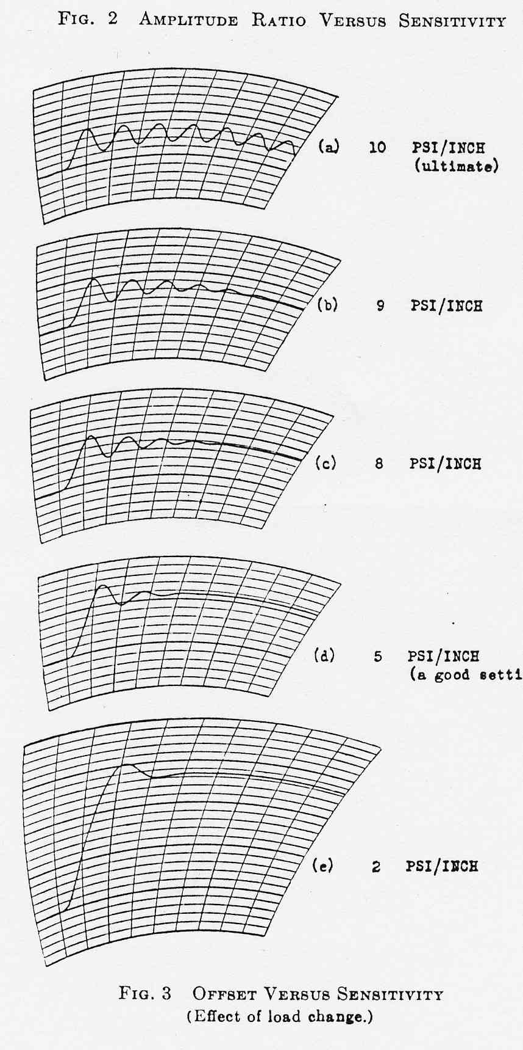
Figure 2-1 Offset versus sensitivity. Effect of load change.

The amplitude ratio 1:4 corresponded to a controller gain, K_{C}, equal ½ * K_{CU}, which was the recommended setting for a P-controller according to Z-N. This was evaluated for load change when a P-controller was applied to the process. The process response had an increasing offset from the set point with a decreasing value for K_{C} lower than the K_{CU}, as seen in Figure 2-1. At K_{CU} the response was a sustained oscillation with period Pu.

The period of oscillation (P_{u}) at the stability limit, produced a good index of required integration time, τ_{I}. The P_{u} of the process was 0.8 min, see Figure 2-1, and the optimum setting for a PI-controller was according to Z-N K_{C} = 0.45*K_{CU} and τ_{I} = P_{u} /1.2. Integration time, τ_{I}, was inverse the denoted reset rate in the article. The gain was reduced compared with the P-controller, because otherwise the amplitude ratio would have been increased markedly.
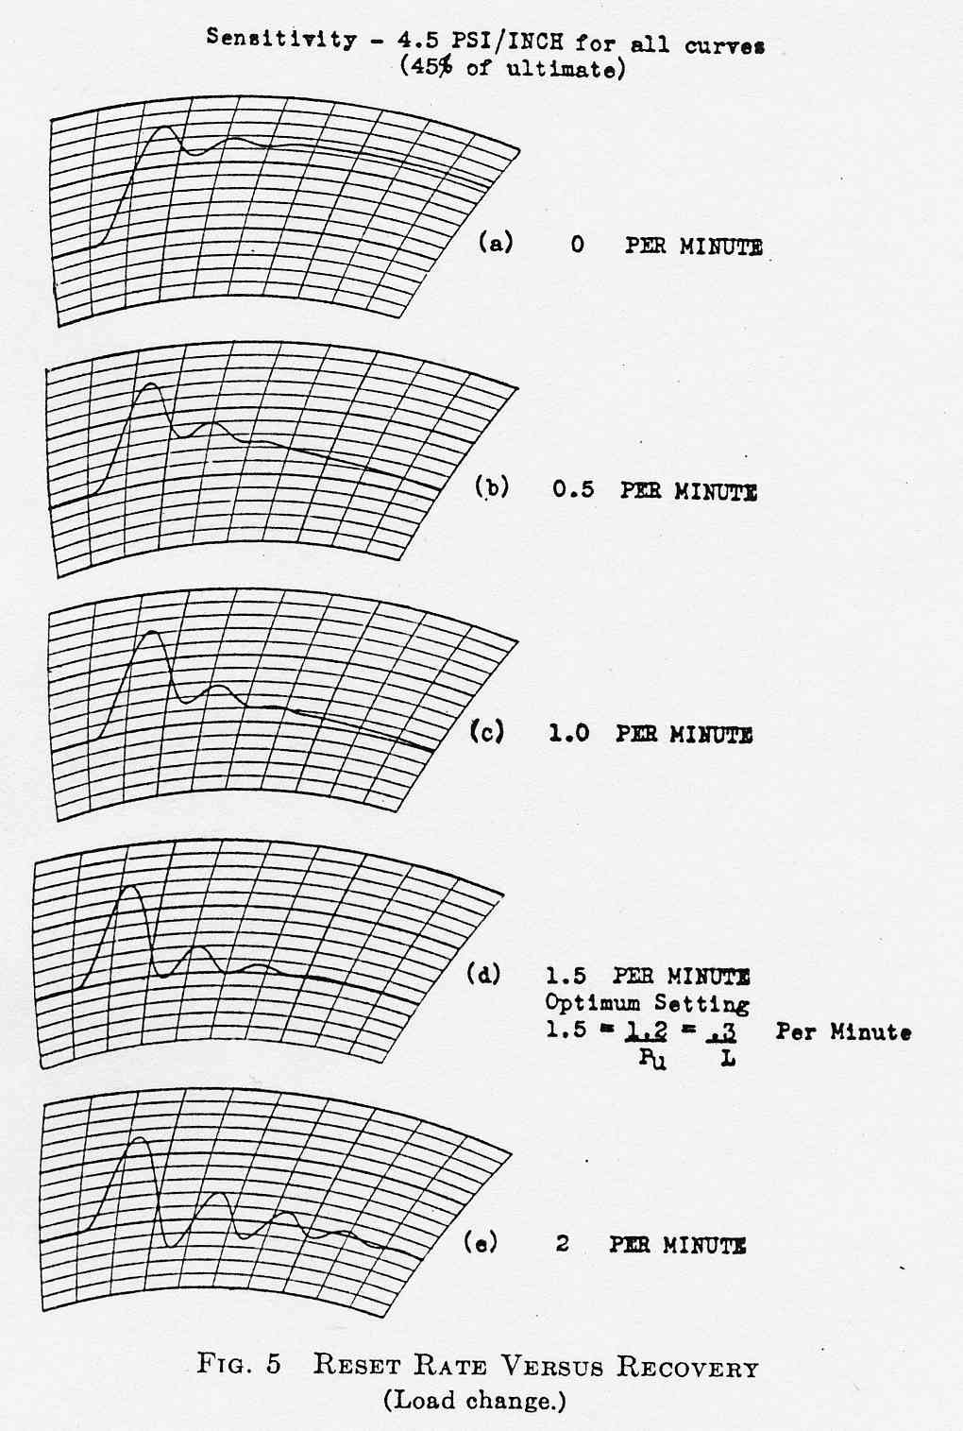
Figure 2-2 Reset-rate versus recovery. Load change.

The derivative action part of the controller was introduced in the last experiment for the closed-loop example. τ_{D} or pre-act-time improved the controller performance for this example. The optimum τ_{D} was reported to be (for further details Error: Reference source not found).

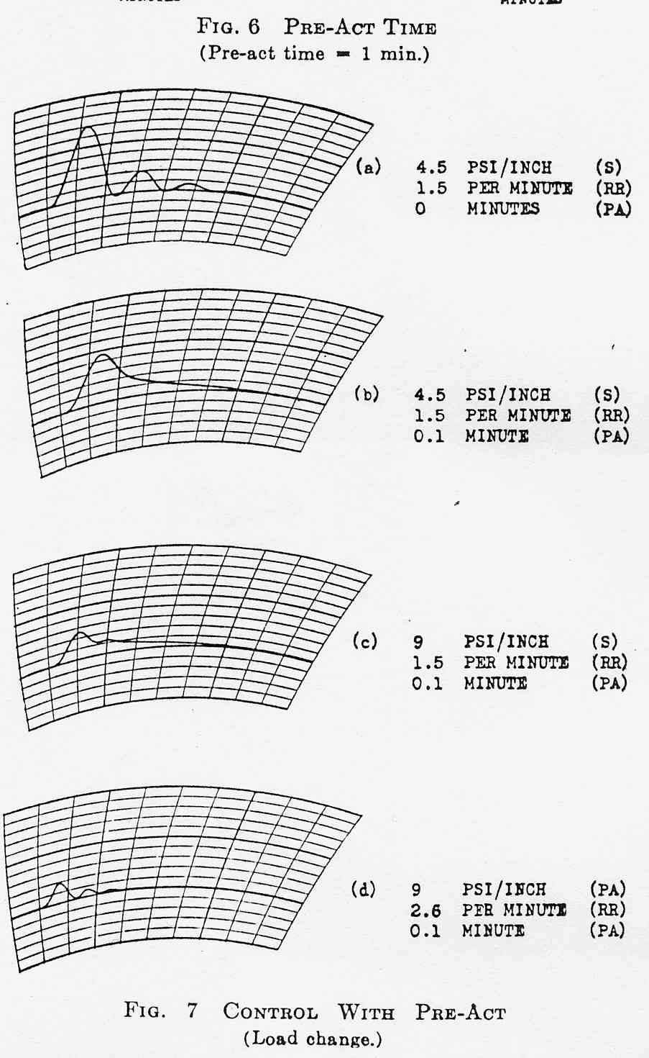
Figure 2-3 PID-Controller. Load change.
A supplementary piece of information in the paper was that when the gain, integral and derivative action used in the last example in the paper (Figure 2-3):
- The maximum deviation form the set point was cut 71 percent T,
- the period of oscillation was reduced by 43 percent,
- and the time required for the oscillation to die out was halved.

2.2 Controller configuration
The industrial pneumatic PID-controllers, which were used at the time Ziegler and Nichols wrote the paper on simple tuning rules, had mainly two different setups. The ideal (or parallel) and the cascade (or series) arranged PID-controllers, with general transfer functions show in the next equations and in the figures.

- An ideal PID-Controller:
Equation 2-1 Ideal PID-controller.
An ideal PID – controller was however physically unrealizable. Commercial controllers approximated the ideal behavior by using transfer functions of the following forms, with α typical between 0.05-0.1:

- Cascade transfer function for a pneumatic PID-controller.
Equation 2-2 Pneumatic cascade PID-controller
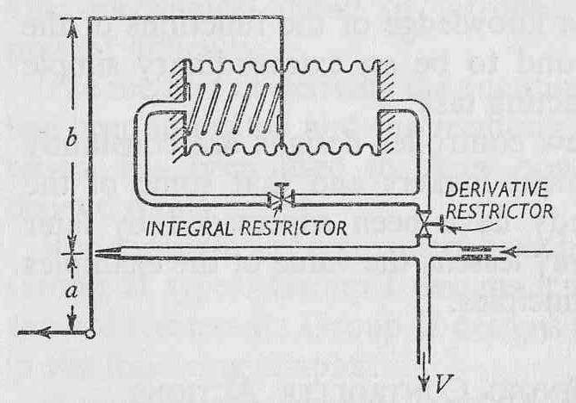
Figure 2-4 Series/Cascade -coupled PID-controller
The restrictors shown in the figure were placed after one another, i.e. the controller was on the cascade form.

- Ideal (1) transfer function for a pneumatic PID-controller.
Equation 2-3 Pneumatic ideal (1) PID-controller

- Ideal (2) transfer function for a pneumatic PID-controller .
Equation 2-4 Pneumatic ideal (2) PID-controller
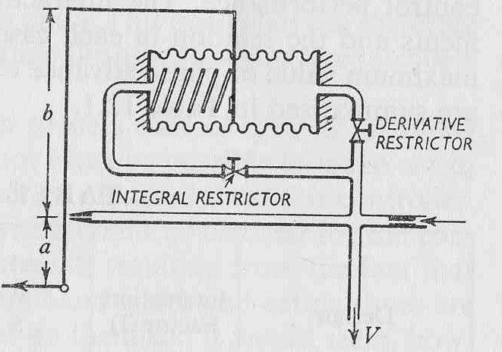
Figure 2-5 Parallel-coupled pneumatic PID-controller

The first industrial PID controllers were of the interacting type. These were designed to solve a process control problem, and not a particular mathematical as today’s PID controllers . The principal design differences between the two controller setups, are placement of the derivative and integrating functions in series or parallel, which brought about different kind of interaction between the modes. The result of the interaction was that in real pneumatic controllers the proportional, integral and derivative parts produced actions that differed from those of a completely ideal controller, which would have had no interaction between the modes. This is described in detail in the follow text, mainly through function analysis of a pneumatic PID controller.

Taylor Fulscope, a pneumatic PID-Controller
Transfer function for a three-mode controller (Figure 2-6) was compared with the previous ones descried earlier. The Taylor Fulscope was a PID controller with interacting controller parts. The functional behavior of the Fulscope controller has been described in several publications , , , , and is described in the follow section. The main components in the controller is the baffle-nozzle system, bellows, resistances and the relay ( see Figure 2-6).
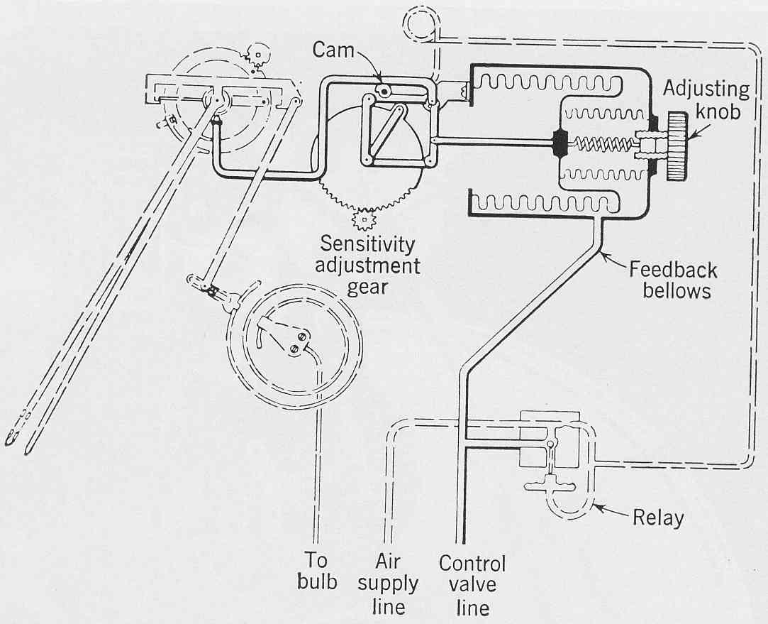
Figure 2-6 The Taylor Fulscope controller
A schematic diagram for the same controller is presented in Figure 2-7. This arrangement has the integral and derivative action restrictors in parallel.

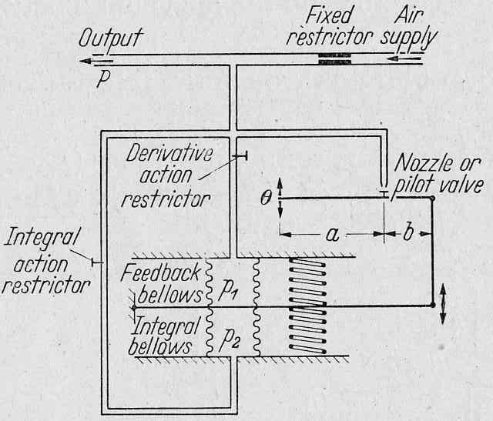
Figure 2-7 A schematic diagram

The parameters in the diagram and equations are described below:
- p is controller output pressure.
- c is the amplification factor relating a small flapper movement to a large change in output pressure.
- a and b are the relative effect of movement of the deviation and feed-back linkages.
- g is the spring constant of the feed-back bellows.
- θ is the distance between the nozzle and the flapper, or the error detecting device.
- p₁ and p₂ represent bellow pressures.
- τ₁ is the time-constant of the derivative action restrictor and the space surrounding the bellows in the drum.
- τ₂ is time constant of the integral action restrictor and feed-back bellows.

The differential equations for the Taylor are shown in the following equationsError: Reference source not found,Error: Reference source not found.
Equation 2-5
After the equation was rearranged and with the assumption c>>1, which is equivalent to stating that c approaches infinite or an infinite baffle-nozzle gain, this gave an equation that was similar to an ideal controller.
Equation 2-6 Taylor Fulscope
The Equation 2-6 gives an ideal controller when inserted for the following parameters.
Equation 2-7 Taylor Fulscope on the “ideal” form

For the intermediate frequencies, the response is that of an ideal controller, except that the gain, derivative time, and the reset time differ from the dial settings Error: Reference source not found. They are K_{C}, τ_{I} and τ_{D} and given in the Equation 2.2-5. The dial controller settings are therefore only nominal values. The effective values may differ from the nominal values by as much as 30%, because off the interactions among the modes Error: Reference source not found. The effect of the interaction on the controller gain could be even larger, since the gain is increased by a factor of about
(τ₁ + τ₂)/(τ₁ -τ₂). This can be denoted as an interaction factor, I, according to an approximated ideal formula:
Equation 2-8
According to the equation, as τ₁ approaches τ_{D}, the gain approaches infinity. When τ₂ is greater than τ₁ the denominator term containing affecting the gain becomes negative, indicating unstable behavior. This instability arises because the pressure in the reset (derivative) bellows changes more rapidly than the pressure in the feedback bellows.
The interaction factor (τ_{I} + τ_{D})/(τ_{I} -τ_{D}) becomes infinite and therefore the gain of the controller becomes infinite Error: Reference source not found. The controller would in such situations behave as a 2-step (on/off) action controller when τ_{I} = τ_{D}. This must clearly be avoided if the controller is to be operated as a continuous 3-action controller. It should in accordance with the facts above be emphasized that the interacting character of such controllers means that they have to be calibrated for different derivative and the integrating tasks.

Cascade PID- Controller
The instability arising from too much derivative action in a parallel controller can be avoided by putting the derivative and integral resistances in series Error: Reference source not found. The two resistances and capacities form a dead-end interacting system, or a “series arrangement”, as illustrated in Figure 2-4.

Aikman and Rutherford Error: Reference source not found have derived a transfer function and the corresponding blended parameters for such a controller.
Equation 2-9 Cascade PID
The interaction factor, I, has become greater than that with parallel feedback, but the controller is stabile for all derivative times. This is because the controller gain stays finite for τ_{D} = τ_{I}. Generating proportional, integrating and derivative signals separately and then combining the signals would have eliminated the interaction factors which parallel and cascade old fashion controllers have. A fully ideal controller would have required a more complex pneumatic controller, but in such cases an electrical instrument with ideal response would be installed nowadays.

Literature references for Ziegler- Nichols’ pneumatic PID controller
Several authors have discussed the pneumatic controller Z-H used to regulate processes and thereby derived their tuning rules for industrial controllers. In the next part, some of the views will be introduced.

PID controllers were at the time Z-N did their experimental work of the interacting according to Shinskey Error: Reference source not found. He states that the Z-N used a single stage pneumatic controller, which was on some sort of cascade form, when they developed their tuning rules. This affected the proportional action (P) . The P_{effective} differed from the action a non-interacting controller in the following way according to Shinskey:
$P_{\text{eff}}=\frac{P}{(1+\frac{τ_{D}}{τ_{I}})∗(1−\frac{τ_{D}}{τ_{I}})}$Equation 2-10 Effective Proportional action
This was a serious limitation to that controller. Setting τ_{D} = τ_{I} forced the proportional gain to maximum, and setting τ_{D} > τ_{I} reversed the action for the controller. Because of this, Ziegler and Nichols kept the ratio τ_{D}/τ_{I} = ¼ stated Shinskey.

Connell argued that Z & N were obliged to promote the “ideal” Taylor Fulscope controller (section 2.2.1), which had the reset and derivative needle valves in parallel. Applying the same position to the two needles valves would make the controller go into on-off control. This equal setting the ratio integrating to derivative action equal to one other (see previous section dealing with the same matter). SeborgError: Reference source not found has also pronounced the ideal controller configuration for the controller used by Ziegler and Nichols.

The story of the development work and simulator tests on the Fulscope 100 by Ziegler and Nichols is cover in “Modern Control Started with Ziegler-Nichols Tuning”. Ziegler did preliminary tests of the PID-Fulscope controller using the demonstration room in the factory. It consisted of a series of tanks and capillaries to simulate a multicapacity system for a “typical” process to control pressure. The system offered slow data collection so they rented out the differential analyzer at MIT, to increase number of simulated processes.

Integrated Absolute Error, IAE, and Total Variation, TV.
IAE is an object or a performance criterion, which can be used to determining the best curve hence the controller tuning which produces the best curve function Error: Reference source not found. The design criterion used by Ziegler and Nichols was the ¼ amplitude decay ratio for closed loop response. This is often judged to be too oscillatory by plant operating personnel and only the two first peaks of the closed-loop response are considered. IAE (below) is a controller design relation based on a performance index that considers the entire closed-loop response.
$\text{IAE}=\int{\left|e\right|\text{dt}}$ Equation 2-11 Integral of absolute values of the error
Total Variation, TV, is also a performance criterion for closed-loop response, but in contrast to the IAE, the objective for TV is to measure the total variation in the controller output signal, u.
$\text{TV}=\sum{\left|u_{i}−u_{i−1}\right|}$ Equation 2-12

Results

An approximate to Z-N’s process example
Ziegler and Nichols have in their paperError: Reference source not found a single illustrative example. The controller setup, cascade or parallel, was to be found. The first goal of this experimental part was therefore to establish a model of the process though a transfer function, which had the same behavior as the process example in the paper. This could subsequently make it possible to determine the controller setup.

In accordance with the procedure in section 2.1.1 the ultimate gain and period of the resulting sustained oscillation, referred to as ultimate period, P_{u}, was given in the paper. One parameter for the process was therefore known. The ultimate period was 48 seconds, and this was used to establish possible transfer functions for the described process. A routine (minbode.m in Appendix D) programmed in Mathlab® calculated among other values the exact phase angle for transfer functions. One could then at the phase crossover frequency, ω₁₈₀, determine the ultimate period, $P_{U}=\frac{2π}{ω_{\text{180}}}$.
It was also known that the process had deadtime, roughly estimated by Ziegler and Nichols to be 12 seconds. The known foundation for experiments and comparisons was then a process with deadtime, process output from Ziegler and Nichols shown in section 2.1.2 and the value for ultimate period. The controller setups (cascade and parallel) that were investigated are displayed in the two next figures. A difference in controller output and performance would only occur when the three controller modes were in action. The cascade setup was used in simulations with P- and PI-controllers.

Figure 3-8 Block diagram for a cascade control system in Simulink®..

Figure 3-9 Block diagram for parallel control system in Simulink®..

Simulation results

Table 3-2 Symbols used in this section were:
Descriptions | Symbol | Unit
Ultimate period | P_{u} | Second
Deadtime | θ | Second
Ultimate gain | K_{U} | -
Controller gain | K_{C} | -
Integral time constant | τI | Second
Derivative time | τI | Second

The load disturbance occurred 10 seconds after simulation was started, and was magnitude a unit. The process transfer function was simulated in Simulink®, a dynamic system simulation tool in Mathlab®, with proportional, proportional-integral and proportional-integral-derivative controllers according to ZN-experiments.

Deadtime process
$G_{1}(s)=e^{−θS}$Equation 3-13 (G = Process transfer function)

Table 3-3 Process 1, simulation parameters and results.
 | Process parameter
Simulation Num. | θ | P_{u} | K_{U}
1 | 12 | 48 | 0.1309

The ultimate period and gain could also have been calculated through the follow equations:
$\begin{aligned}ω_{\text{180}}:−\frac{π}{2}−π⋅θ=−π,ω_{\text{180}}=\frac{π}{2}⋅\frac{1}{θ} \\ \text{GM}=1⇒K_{U}=\frac{π}{2}⋅\frac{1}{θ}\end{aligned}$ Equations 3-14
The result for the simulation was that a pure delay process was not comparable with the process Z-N controlled.

Process with integrating action and deadtime
$G_{\text{S2}}=\frac{1}{s+ε}e^{−θS},ε=\frac{1}{τ}$ Equation 3-15
Table 3-4 Process 2, simulation parameter and results
 | Process parameter |  | Results
Simulation Num. | θ, sec | τ, sec | P_{u}, sec | K_{U}
1 | 12 | infinite | 48.00 | 0.1389
2 | 12 | 100 | 45.8717 | 0.1373
3 | 12 | 20 | 40.1104 | 0.1644
4 | 12 | 10 | 36.0471 | 0.2010
5 | 14 | 30 | 48.2899 | 0.1343

The transfer function was evaluated within a range for the process parameters. Some of the results are presented in the table above. Figure 3-10 shows the results for
K_{C} = K_{U} . 0.45 which were compared with the results from Z-N (Figure 2-2). The process had, as seen from the simulations, too little oscillatory behavior and too short period.
Figure 3-10 Simulation results Process 2.

Processes with deadtime, integrating action and a first-order transfer function.
$G_{3}(s)=\frac{1}{s}⋅\frac{1}{τ_{1}s+1}e^{−θS}$ Equation 3-16
The number of possible solutions was increasing with the complexity of the transfer function. Table 3-5 shows some tested parameter, and the ultimate values for the process, at 12-second deadtime.
Table 3-5 Results from calculations in Mathlab.
 | Process parameter |  | Ultimate values
Simulation Num. | θ, sec | τ₁, sec | P_{u}, sec | K_{U}
1 | 12 | 0.01 | 48.0400 | 0.1308
2 | 12 | 0.5 | 49.9974 | 0.1259
3 | 12 | 1.0 | 51.9807 | 0.1218
4 | 12 | 5 | 66.6909 | 0.1041
5 | 12 | 10 | 82.1466 | 0.0963

The first parameter, which the process should have fulfilled, was the ultimate period (48s). The period for sustained oscillation was the most accurate and useful information given in the paper for the preliminary search. Feasible solutions were screened, by using the minbode.m routine in Mathlab, for ranges of deadtimes and time constants, τ₁. Results for some of the feasible points after the calculations are in Table 3-6.
Table 3-6 Sample results from calculations in Mathlab
 | Process parameter |  | Ultimate values
Simulation Num. | θ, sec | τ₁, sec | P_{u}, sec | K_{U}
1 | 6 | 7.5 | 47.6578 | 0.1854
2 | 7 | 6 | 48.3885 | 0.1646
3 | 8 | 4.4 | 47.9661 | 0.1512
4 | 10 | 2 | 47.8231 | 0.1358
5 | 11 | 1 | 47.9774 | 0.1321

Figure 3-11 Process simulation results for P-Controller

The controller parameters were set according to experiments in the paper:
P-controller: K_{C} = 0.45*K_{U} and PI-controller: K_{C} = 0.45*K_{U}, τ_{I} = P_{U}/1.2 and τ_{D} = 0
Figure 3-12 Process simulation results for PI-Controller
Results from simulations (1-5) were only in some agreement with the results that ZN obtained in their process example. The crossover did not occur in Ziegler and Nichols experiments.

Processes with deadtime and a second-order transfer function
$G_{4}(s)=\frac{1}{τ_{1}s+1}⋅\frac{1}{τ_{2}s+1}e^{−θS}$ Equation 3-17
The number of possible solutions was further increased by the introduction of another first order transfer function. The assumed process dynamic in this section was a second order transfer function. The feasible region was therefore to be truncated by some assumptions. The derivative action used in the last part of Ziegler and Nichols experiments, remarkably improved the controller performance in PID- setup. The derivative part was assumed to be almost equal to the deadtime, because this could result in a canceling of this term. A selection of the promising parameters for the transfer function resulting from the evaluation of period and simulations are presented in
Table 3-7.

All the parameters for the transfer function were simulated with P and PI- controller actions in accordance with the experiments performed in the article (P-controller: K_{C} = 0.45*K_{U} and PI-controller: K_{C} = 0.45*K_{U}, τ_{I} = P_{U}/1.2 and τ_{D} = 0).
Table 3-7 Parameters for the 2.order transfer function.
 | Process parameter |  |  | Ultimate values
Simulation Num. | θ, sec | τ₁, sec | τ₂, sec | P_{u}, sec | K_{U}
1 | 6 | 14 | 25.5 | 47.8314 | 7.3174
2 | 6 | 11.5 | 37 | 47.8478 | 8.984
3 | 7 | 9 | 35 | 47.9281 | 7.2628
4 | 7.5 | 8.5 | 30 | 48.0073 | 6.0607
5 | 8 | 7.5 | 32 | 48.4974 | 5.9462
6 | 8 | 7 | 35 | 48.0890 | 6.3437
7 | 8.5 | 6.5 | 29.5 | 47.8298 | 5.2625
8 | 8.5 | 7 | 25.5 | 47.8098 | 4.7518
9 | 9 | 5 | 38.5 | 47.7629 | 6.1788
10 | 9 | 5 | 40 | 47.9502 | 6.379
11 | 9 | 6 | 27 | 47.9335 | 4.6788
12 | 10 | 4 | 34 | 47.9882 | 5.1504
13 | 10 | 4.5 | 27 | 47.8756 | 4.2759
14 | 11 | 2.5 | 39 | 47.7993 | 5.4978
15 | 12 | 2 | 30 | 48.1570 | 4.1751

The simulation results for the parameters given in Table 3-7 resulted in a reduction of the feasible region for possible solutions to the transfer function (deadtime [8 10], τ₁ [5 7.5] and τ₂ [30 40] (see appendix A). Parameters given for simulations 5 to 10 gave the most promising outputs when compared with Z-N’s measured process output (see Figure 2-3 and Figure 3-13). These values were therefore used in the closing simulations, for cascade and the two ideal setups for PID-controllers. The PI-controller actions were as described above.

Figure 3-13 Results for parameters 5 to 10.
Parameters for Process 4 used in the simulations above, were then simulated with the 3 considered controller transfer functions. The sets of parameters were renumbered from 1 to 5. Knobs setting for the 3 controllers are the same as described by Ziegler and Nichols in their 3-mode controller experiment (see Figure 2-3).

Table 3-8 Controller settings for PID experiments.
Experiment Num. | Controller settings
Experiment Num. | K_{C} | τ_{I} | τ_{D}
1 | 0.45 * K_{U} | P_{U} /1.2 | P_{U} /8
2 | 0.90 * K_{U} | P_{U} /2.08 | P_{U} /8

The two experiments listed above were simulated for each of the controllers and graphical presentations of the results are shown in the following parts.

Ideal (1) PID Controller. Transfer function for an ideal PID controller
.
Figure 3-14 Ideal(1) PID Controller. Experiment Num.1.

Figure 3-15 Ideal (1) PID-Controller. Experiment Num. 2

Ideal (2) PID Controller (page 7). Transfer function for an ideal PID controller stated by Seborg et al Error: Reference source not found
Figure 3-16 Ideal(2) PID Controller. Experiment Num.1

Figure 3-17 Ideal (2) PID-Controller. Experiment Num.2

Cascade PID controller (see page 7)
Figure 3-18 Cascade PID-Controller. Experiment Num.1
Figure 3-19 Cascade PID-Controller. Experiment Num.2
Simulation results from the ideal(1 ) PID-controlled processes gave responses that were in agreement with the results from Z-N. Tests with wider a controller setting area, i.e. used ZN-tunings as circa specification because of the reported difficulties setting the interacting control modes, but this just slightly improved the result conformities. Calculations were done iterative in Mathlab, by using the improvement effect of derivative action added compared with PI-action as convergence criteria.

Performance criteria for controllers
There exist different tuning rules for controller settings and some of these tunings were applied to the processes in this section. The equations and the tuning rules are the same as those found in Skogestad’s “Probably the best simple PID tuning rules in the world”. The tunings rules used were SIMC, IMC, ZN, Aströms and Tyreus-Luyben. The performance values Integrated Absolute Error, IAE, and Total Variation, TV, for controllers with different tunings were calculated.

Tuning rules and the derivation of the corresponding controller parameters for simulated processes can be found in SkogestadError: Reference source not found except of ZN PID tunings. The applied controller was on the cascade form and processes were regulated with P-, PI and PID-controllers. The processes were simulated in Simulink, and IAE and TV were calculated in Mathlab by using the script IAEandTV.m (see Appendix B). A set point change and a load change were disturbances for the processes. IAE was calculated for process output (y) and TV was calculated for process input (u).

Ziegler and Nichols tuning rules were assumed to be valid for a controller on the ideal form. Coefficient for a cascade-controller had to be calculated from coefficient for the ideal form . Primed values are for the cascade form. According to ZN-PID tunings the ratio τD/τI was equal ¼ and thereby canceled the last term in the equation below.
Equations 3-18

Seven process examples were simulated. Integral absolute error, IAE, and total variation, TV, were calculated from the resulting process input (controller output) and output. Results from simulation outputs are shown in Appendix C. The set point change was a unit, ys, and the input load disturbance, du, was of magnitude 0.5 if no other is specified for the process.

Pure dead time process
$G_{1}(s)={\text{ke}}^{−θS}$ Equation 3-19 Time delay process

Tunings | K_{C} . k | K _{I}. k . θ | IAE  (set point) | IAE (load) | TV (set point) | TV (load)
SIMC (τ_{c} =θ) | 0 | 0.5 | 2.17 | 1.07 | 1.08 | 0.54
Astrom (M_{s} = 1.4) | 0.16 | 0.47 | 2.13 | 1.05 | 0.84 | 0.50
Astrom (M_{s} = 2.0) | 0.26 | 0.85 | 1.54 | 0.75 | 1.18 | 0.72
ZN | 0.45 | 0.27 | 3.72 | 1.84 | 1.05 | 0.75
Table 3-9 Process 1 Tunings and performance values

Integrating process
$G_{2}(s)=k'\frac{e^{−θS}}{s}$ Equation 3-20 Integrating process with time delay.
Table 3-10 Process 2- Tunings and performance values
Tunings | K_{C} . k’.θ | τI / θ | τD / θ | IAE (set point) | IAE (load) | TV  (set point) | TV (load)
SIMC (τ_{c} =θ) | 0.5 | 8.00 |  | 3.92 | 8.00 | 0.72 | 0.78
IMC | 0.59 |  |  | 2.10 | infinite | 0.73 | 0.62
Astrom  (M_{s} = 1.4) | 0.28 | 7.00 |  | 5.77 | 13.75 | 0.43 | 0.82
Astrom  (M_{s} = 2.0) | 0.49 | 3.77 |  | 4.21 | 4.58 | 1.06 | 1.07
Tyreus-Luyben | 0.49 | 7.32 |  | 3.95 | 7.47 | 0.72 | 0.79
ZN-PI | 0.71 | 3.33 |  | 3.93 | 2.79 | 2.14 | 1.44
ZN-PID | 0.47 | 1 | 0.25 | 3.05 | 1.79 | 1.87 | 1.39

Process examples

$$G_{3}(s)=\text{20}\frac{(−0\text{.}3s+1)(0\text{.}\text{08}s+1)}{(2s+1)(1s+1)(0\text{.}4s+1)(0\text{.}2s+1)(0\text{.}\text{05}+1)^{3}}$$
Table 3-11 Processes 3, tunings and performance value.
Tunings | K_{C} . k | τI | τD | IAE  (set point) | IAE (load) | TV  (set point) | TV (load)
SIMC- PI | 0.85 | 2.50 | 0 | 3.57 | 1.49 | 1.05 | 0.63
SIMC- PID | 1.30 | 2.00 | 1.2 | 2.65 | 0.77 | 1.81 | 0.74
ZN-PID | 1.28 | 1.33 | 1.33 | 2.80 | 0.57 | 3.21 | 1.11

$$G_{4}(s)=k\frac{1}{(τ_{0}s+1)^{4}}$$

Table 3-12 Processes 4, tunings and performance value
Tunings | K_{C} . k | τI / τO | τD / τO | IAE  (set point) | IAE (load) | TV  (set point) | TV (load)
SIMC-PI | 0.30 | 1.50 |  | 5.59 | 2.70 | 0.85 | 0.55
SIMC-PID | 0.50 | 1.50 | 1.00 | 4.32 | 1.59 | 0.82 | 0.58
ZN-PI | 1.80 | 5.24 |  | 4.68 | 1.47 | 4.64 | 1.35
ZN-PID | 1.20 | 1.57 | 1.57 | 3.30 | 0.75 | 3.02 | 1.17

$$G_{5}(s)=\frac{1}{(s+1)(0\text{.}2s+1)(0\text{.}\text{04}s+1)(0\text{.}\text{008}s+1)}$$
Table 3-13 Process 5, tunings and performance values.
Tunings | K_{C} | τI | τD | IAE (set point) | IAE (load) | TV (set point) | TV (load)
SIMC-PI | 3.72 | 1.10 |  | 0.45 | 0.59 | 4.43 | 2.82
SIMC-PID | 17.90 | 1.00 | 0.22 | 0.26 | 0.11 | 38.50 | 5.18
Astrom-PI (M_{s}=2.0) | 4.13 | 0.59 |  | 0.58 | 0.31 | 7.46 | 4.09
ZN-PI | 13.61 | 0.47 |  | 0.58 | 0.31 | 7.46 | 4.09
ZN-PID | 9.07 | 0.14 | 0.14 | 0.39 | 0.06 | 43.96 | 8.24

Remark: Ziegler-Nichols tunings on a PI-controller would have led to instability.
$$G_{6}(s)=\frac{(0\text{.}\text{17}s+1)^{2}}{s(s+1)^{2}(0\text{.}\text{028}s+1)}$$

Table 3-14 Process 6, tunings and performance values.
(Load disturbance of magnitude 2)

Tunings | K_{C} | τI | τD | IAE  (set point) | IAE (load) | TV  (set point) | TV (load)
SIMC-PI | 0.296 | 13.52 |  | 6.54 | 91.53 | 0.44 | 3.35
SIMC-PID | 1.397 | 2.894 | 1.33 | 1.91 | 4.17 | 5.57 | 6.41
Aström  (M_{s} = 2.0) | 0.47 | 7.01 |  | 5.24 | 30.02 | 1.04 | 4.68
ZN-PID | 1.923 | 0.905 | 0.905 | 3.41 | 2.66 | 19.36 | 14.81

ZN’s PI- tunings gave an unstable response, i.e. increasing amplitudes, if it were applied to the controller.

Discussion

The PID controller of Ziegler and Nichols.

The preliminary evaluation of processes
Based on Ziegler and Nichols experience with the transient for many types of processes they developed a method for tuning in closed-loop. They suggested that ultimate controller gain, K_{cu}, and ultimate period, P_{u}, where to be obtained from a closed-loop test of the actual process. They published their paper in 1942, but in the literature there are still discussed whether they used a controller with a configuration in accordance with the cascade or the parallel form.

Trough finding a process model matching the one Ziegler and Nichols were controlling, one should have had a good start point for investigating different controller transfer functions. The simulation results in the previous chapter gave reasons for some notes. Implementations of the oscillation results were done only with the means of visual interpretation. This was however judged to give enough accuracy, because transferring the plotted results from ZN to data output could only be done at low precession. The dead time process, Process 2 and Process 3 were tested, but gave too little oscillatory movement when comparing with the results from ZN. Adding more dynamical behavior through a 2.order transfer function with dead time (process 4, p.20) was therefore an approach to the transfer function for Z-N’s process. Numerous variations in transfer function parameters, i.e. dynamical responses, were tested and compared with ZN’s. Presented process responses for parameters 5 to 10 in Table 3-7 were judged comparable to experimental example in the paper.

Settings and simulation results for PID-Controllers
Figure 3-14 to Figure 3-19 showed simulation results for the different PID-controllers. Results from the first experiment for the cascade controller agreed visual with the corresponding ZN results (Figure 2-3). The second experiment on the other hand had response not in agreement. The output oscillated with some amplitude decrease around zero, rather than having a ¼ amplitude reduction ratio, which was the aim in Ziegler-Nichols tuning rules and also the result from their experiment.

The ideal pneumatic PID-controller (Ideal-2) equation proposed by Seborg et al.Error: Reference source not found, had simulation results far from the Ziegler-Nichols’. Experiment 1 gave considerable amplitude decrease, but the second experiment gave an unstable response with increasing amplitude. The unsuitability was an effect of the major difference between this controller and the two other. Ideal-2 controller brought along an extra term in the derivative part. (Equation 2-4)
An increase of the proportional gain to 90 % of the ultimate gain, which was the case for the last experiment, would almost denote a doubled proportional action for this type of controller. The controller gain was therefore brought higher than the corresponding gain margin permitted for closed loop stability.

Simulation results for closed loop response for the Ideal (1)-controller distinguished itself in the aspect of approximating the ZN -process and thereby the controller transfer function. The Ideal (1) was the controller equation with most resemblance to a completely ideal controller. Visual interpretations of results were earlier considered accurate enough. Ziegler-Nichols gave however for the PI- and PID-experiments the effect of adding derivative action (see chapter. 2.1.2). The effect of adding derivative action for the control of Process 4 was a 38 percent reduced deviation from the set point (ZN had 71 percent) and period of oscillation was reduced by 26 percent (ZN reported 43 percent). The process could therefore be sub-optimal and/or the almost ideal transfer function did not represent the reel one used by Ziegler-Nichols. Other parameters than presented in this report were also tested in the 2.order transfer function with dead time. This was done iteratively with a fixed increment on the parameter within wide ranges, but gave poor result improvements. An optimizing problem could have been formulated, but this would then have required an effective solver, which integrated both Mathlab-scripts and a Simulink-model, and the solver had to handled constraints. Higher order transfer function could then have been investigated effectively if this was formulated. The lack of accuracy in ZN’s reported data and the true controller equation would still cause problems.

The Taylor Fulscope Controller and related topics
According to the article “Modern Control Started with Ziegler-Nichols Tuning Error: Reference source not found, Connell Error: Reference source not found and others, Ziegler and Nichols were using the Taylor Fulscope controller when they developed their tuning rules. The choice of controller was obvious because they both worked for Taylor Instrument Companies, and were actively participating in finding application for the controller.

Ziegler-Nichols tuning rule for PID-control is to have τI = 4 .τD, and this is assumed to be for an ideal controller:

Comparing the ideal equation with the one derived for Taylor Fulscope controller; Equation 2-6
and inserted for τI = 4 .τD, this would eventually mean having τ1 = τ2. The actual gain would at this point approach infinity and the response would be unstable. If instead one tried setting τ2 = 4 .τ1 the corresponding effective time constants would have be τD = 25/4.τI. The ratio 25/4 differs considerable from Ziegler-Nichols tuning rules presented in the paper. Ratio value for their last experiment in the paper was τD = 3.85.τI, and consequently the controller settings should have led to instability. This aspect stands in contrast to what ZN reported, which was a considerable improved control performance. The simple Taylor Fulscope equation had also some resemblance with a controller on the cascade form. The difference was the interaction term for the controller gain, which could lead to infinite gain. If the equation above was assumed to be correct, a cascade controller setup should have been a good approximation to the controller transfer function.

The equation for Taylor Fulscope controller was derived for infinite baffle-nozzle gain. Infinite gain is however not physically realizable. An equation describing the controller should perhaps take a limited gain in to count. Hougen derived an equation for a pneumatic parallel PID-controller with finite gain. Deriving a transfer function with finite gain for the Taylor Fulscope controller gave results agreeing with Hougen’s results. The function complexity was increased, and thereby the reducing the ease to compare it with an ideal PID controller transfer function.
Equation 4-21 PID transfer function from Hougen
Where τa and τb are dependent on both τ1 and τ2.
Equation 4-22 PID transfer function from C&K
The equation above was derived from the book of Coughanowr and Koppel Error: Reference source not found, by using nomenclature and assumptions from their derivation of PI- and PD-equations for the Taylor Fulscope controller. As earlier noted are these equations more difficult to handle than the simpler one with infinite baffle-nozzle gain, the constants in the denominators have to be calculated after experimental work according to Hougen. The transfer functions shown above maybe less restrictive to τD/τI ratios, and thereby not have the strange limitation that their own tunings could not be applied to the Taylor Fulscope controller.

Pneumatic controllers depart from the “theoretical” ideal controller. Ziegler-Nichols used the differential analyzer at MIT to speed up data collection from simulated processes Error: Reference source not found. The analyzer consisted of mechanical integrators that solved differential equations. A PID controller could be utilized on this device through differential equations. The controller could then be ideal, only limited by the machine accuracy and mechanical limits. A mathematical analysis of the functional behavior of the pneumatic PID-controller was yet to be done at that time. Implementing a PID controller on the analyzer would therefore have had more similarities with an ideal equation than a pneumatic controller.

Performance criteria for controllers
Set point changes or load changes were the process disturbances. The integral absolute errors for the process outputs, y, and total variation were depending on applied tuning rules to the controllers. The controller gain, KC, given from the different controller settings was varying considerably from setting to setting. Ziegler-Nichols tunings had in most cases the highest KC values. Increasing the controller gain leads to a larger change in the controller output. Increasing the gain to a certain limit can lead to response instability, causing overshoots and oscillation if the process is disturbed. An effect of the high-controller gain from ZN-tuning is relatively low IAE values, but on the other hand the controller output tends to oscillate with corresponding higher values for total variation, TV (see Table 3-9 to Table 3-14). Skogestad’s settings have relatively low KC values and hence slower response also observed by Holm et al., but do not have the same problem with robustness and stability. Aström’s settings gave controller gain in the mid-area compared with ZN’s and Skogestad’s settings.

The offset from set point is reduced at different rates for the tunings. ZN’s tunings have relatively small integral time constants and therefore a faster response to error. As for the high-gain, a small integral time reduces the stability (see figures in Appendix C). This would easily be seen in a Bode-diagram by the lowered gain and phase margins. The IAEs for set point and load changes were small, but because the controller output often oscillated a higher total variation was reached. Skogestad’s settings had in general higher τI’s and with those had somewhat slower response to error, but the stability was kept. Skogestad’s rules gave small IAEs for set point changes. At load disturbance the integral absolute errors were slightly larger because of the slower response. Derivative action in the controller adds sensitivity to the direction of the error, and generally reduced the overshot and IAE. For Skogestad’s tunings the process output tends to oscillate for processes with small time constants, because of the slower response, with corresponding higher TV as in example Process 5.

Conclusion
Based on the results from the simulations of different processes with controllers on the cascade and ideal forms, a conclusion could be drawn. Simulations with a controller on the ideal (1) form (Equation 2-3) gave results that were agreeing with Ziegler-Nichols results in the paper. The two other tested controller settings gave results that were not corresponding to ZN’s results. Ziegler and Nichols tunings are therefore most likely for an ideal PID controller. They were running simulations on the Taylor Fulscope controller, and several authors have done functional analysis of this pneumatic controller. Coughanowr and Koppel derived a transfer function for the Taylor instrument, but according to that function with infinite gain, Ziegler and Nichols tunings could not be applied to the Fulscope controller. Transfer function with finite gain should therefore be considered if a true picture of the pneumatic controller is sought. The transfer function would then be a more complex interaction function, which would be difficult to transpose to an ideal equation. Ziegler-Nichols used a differential analyzer at MIT to simulate processes at a higher speed. Transfer function for a PID controller had to be implemented on the analyzer and a PID controller on the ideal form would most probably have been applied to the differential analyzer. Depending on the true transfer function for the Taylor Fulscope controller, tuning results from MIT could only been used on the pneumatic device after translating them. An accurate translation would be troublesome without knowing the Fulscopes transfer function. There are according to mentioned aspects reasons to believe that the tuning rules are for ideal controller, and were mainly worked out on a mechanical differential analyzer. Verifying this statement could be done in an extension to this report. A functional analysis of the Taylor Fulscope controller should be done. The easiest way to verify this conclusion is to run experiments where Ziegler-Nichols tunings are applied to the Taylor Fulscope controller.

Different tunings for PID-controllers for were judged by performance criteria, Ziegler-Nichols tunings gave a generally fast but unstable response. This was evident by the low values for integral absolute error (IAE) for the process output, and the higher values for total variation (TV). Skogestad’s tunings gave in general somewhat slower but more stable response. This corresponded in higher IAE values and lower TV values.

_______________________________
Sigurd Myhre Hellem Trondheim, 26.11.2001
Literature Citations

Ziegler, J.G. and Nichols, N.B., Optimum settings for automatic controllers, American Society of Mechanical Engineers (64), (pp 759-768), Nov. 1942.
Seborg, D.E., Edgar, T.F.and Mellichamp, D.A., Process Dynamics and Control, Wiley, 1989.
Shinskey, F.G., Process Control Systems (Application, Design and Tuning), McGraw, 4.ed., 1996.
Tustin, A., Automatic and Manual Control (paper A.R. Aikman and C.I Rutherford: The Characteristic of Air-operated Controllers ), Butherworths Scientific Publications, 1952.
Young, A.J., An Introduction Process Control System Design, Longmans, 1955.
Harriott, Process Control, McGraw-Hill, 1964.
Coughanowr, D.R, and Koppel, L.B., Process systems analysis and control, McGraw-Hill, 1965.
Connell, B., Process Instrumentation Applications Manual, McGraw-Hill, 1996.
Blickley, G.J., “Modern Control Started with Ziegler-Nichols Tuning”, Control Engineering, (pp. 11-17) 2.ed., Oct. 1990.
Skogestad, S., Probably the best simple tuning rules in the world, submitted to Journal of Process Control, July 3, 2001.
Aström, K.J., Automatic Tuning of PID, Instrument Society of America, 1988.
Hougen, J.O., Measurements and Control Applications, 2.ed, 1997.
Holm, O. and Butler, A, Robustness and Performance Analysis of PI and PID Controller Tunings, NTNU, Nov 15,1998.

