Extended version of paper “Plantwide control: Towards a systematic procedure” from ESCAPE 12 symposium, Haag, May 2002.
This version (03 June 2002) has been submitted for publication in Comp.Chem.Engng.

Control structure design for complete chemical plants
Sigurd Skogestad
Norwegian University of Science and Technology (NTNU)
Department of Chemical Engineering, 7491 Trondheim, Norway

Abstract

Control structure design deals with the structural decisions of the control system, including what to control and how to pair the variables to form control loops. Although these are very important issues, these decisions are in most cases made in an ad-hoc fashion, based on experience and engineering insight, without considering the details of each problem. In the paper, a systematic procedure for control structure design for complete chemical plants (plantwide control) is presented. It starts with carefully defining the operational and economic objectives, and the degrees of freedom available to fulfill them. Other issues, discussed in the paper, include inventory and production rate control, decentralized versus multivariable control, loss in performance by bottom-up design, and recycle systems including the snowball effect.

1. Introduction
A chemical plant may have thousands of measurements and control loops. In practice, the control system is usually divided into several layers, separated by time scale, including (see Figure 1)

- scheduling (weeks)
- site-wide optimization (day)
- local optimization (hour)
- supervisory (predictive,advanced) control (minutes)
- regulatory control (seconds)

We here consider the lower three layers.
The local optimization layer typically recomputes new setpoints only once an hour or so, whereas the feedback layers operate continuously. The layers are linked by the controlled variables, whereby the setpoints are computed by the upper layer and implemented by the lower layer. An important issue is the selection of these variables.

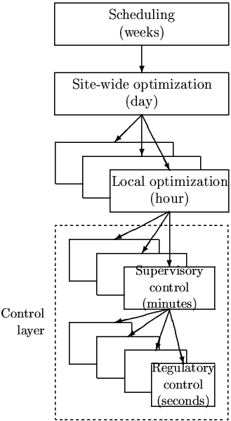

Figure 1: Typical control hierarchy in a chemical plant.

Control structure design deals with the structural decisions that must be made before we start the controller design, and involves the following tasks (Foss, 1973); (Skogestad and Postlethwaite, 1996):
- Selection of manipulated variables m (``inputs'')
- Selection of controlled variables (``outputs''; variables with setpoints)
- Selection of (extra) measurements (for control purposes including stabilization)
- Selection of control configuration (the structure of the overall controller that interconnects the controlled, manipulated and measured variables)
- Selection of controller type (control law specification, e.g., PID, decoupler, LQG, etc.).

Control structure design for complete chemical plants is also known as plantwide control. In practice, the problem is usually solved without the use of existing theoretical tools. In fact, the industrial approach to plantwide control is still very much along the lines described by Page Buckley in 1964 in his chapter on Overall process control.. The realization that the field of control structure design is underdeveloped is not new. Alan Foss (1973) made the observation that in many areas application was ahead of theory, and stated that
“The central issue to be resolved by the new theories is the determination of the control system structure. Which variables should be measured which inputs should be manipulated and which links should be made between the two sets? There is more than a suspicion that the work of a genius is needed here, for without it the control configuration problem will likely remain in a primitive, hazily stated and wholly unmanageable form. The gap is present indeed, but contrary to the views of many, it is the theoretician who must close it.”
A recent review of the literature on plantwide control can be found in Larsson and Skogestad (2000). In addition to Page Buckley and Alan Foss, important contributors in this area include George Stephanopoulos and Manfred Morari (1980- ) (synthesis of control structures), William “Bill” Luyben (1975- ) (“snowball effect”), Ruel Shinnar (1981- ) (“dominant variables”), Jim Douglas and Alex Zheng (1985- ) (hiearchical approach) and Jim Downs (1991- ) (Tennessee-Eastman challenge process).

This paper is organized as follows. First, we present an expanded version of the plantwide control design procedure of Larsson and Skogestad (2000). A systematic approach to plantwide control starts by formulating the operational objectives. This is done by defining a cost function J that should be minimized with respect to the N_{opt} optimization degrees of freedom, subject to a given set of constraints. In reminder of the paper we go through the procedure step by step with special emphasis on:

- Degree of freedom analysis
- Selection of controlled variables
- Inventory control
- Loss in performance by bottom-up design

Finally, we discuss recycle systems and the so-called snowball effect.

2. Procedure for control structure design for chemical plants

The proposed design procedure is summarized in Table 1. In the table we also give the purpose and typical model requirements for each layer, along with a short discussion on when to use decentralized (single-loop) control or multivariable control (e.g. MPC) in the supervisory control layer. The procedure is divided in two main parts:

- Top-down analysis, including definition of operational objectives and consideration of degrees of freedom available to meet these (tasks 1 and 2)
- Bottom-up design of the control system, starting with the stabilizing control layer (tasks 3, 4 and 5 above)

The procedure is generally iterative and may require several loops through the steps, before converging at a proposed control structure.

Table 1: A plantwide control structure design procedure

STEP | Comments, analysis tools and model requirements
I. TOP-DOWN ANALYSIS:
- DEFINITION OF OPERATIONAL OBJECTIVES
Identify operational constraints, and preferably identify a scalar cost function J to be minimized.
- MANIPULATED VARIABLES AND DEGREES OF FREEDOM  Identify dynamic and steady-state degrees of freedom (DOF) | May need extra equipment if analysis shows there are too few DOFs.
- PRIMARY CONTROLLED VARIABLES:  Which (primary) variables c should we control?  - Control active constraints  - Remaining DOFs: Control variables for which constant setpoints give small (economic) loss when disturbances occur. | Steady-state economic analysis:  - Define cost and constraints  - Optimization w.r.t. steady-state DOFs for various disturbances (gives active constraints)  - Evaluation of loss with constant setpoints
- PRODUCTION RATE:  Where should the production rate be set?  (Very important choice as it determines the structure of remaining inventory control system.) | Optimal location follows from steady-state optimization (step 3), but may move depending on operating conditions.
II. BOTTOM-UP DESIGN:  (With given controlled and manipulated variables) |  | Controllability analysis: Compute zeros, poles, pole vectors, relative gain array, minimum singular values, etc.
- REGULATORY CONTROL LAYER.  - Stabilization  - Local disturbance rejection  Purpose: “Stabilize” the plant using single-loop PID controllers to enable manual operation (by the operators)  Main structural issue: What more should we control?  - Select secondary controlled variables (measurements) y₂  - Pair these with manipulated variables m, avoiding m’s that saturate (reach constraints) | 5.1 Pole vector analysis (Havre and Skogestad, 1997) for selecting measured variables and manipulated inputs for stabilizing control.  5.2 Partially controlled plant analysis. Control secondary measurements (v) so that the layer above (or the operators) can handle the effect of disturbances on the primary outputs (c).  Model: Linear multivariable dynamic model. Steady state usually not important.
6. SUPERVISORY CONTROL LAYER.  Purpose: Keep (primary) controlled outputs c at optimal setpoints c_{s}, using unused manipulated variables and setpoints v_{s} for regulatory layer as degrees of freedom (inputs).  Main structural issue: Decentralized or multivariable control?  6a. Decentralized (single-loop) control  Possibly with addition of feed-forward and ratio control.  - May use simple PI or PID controllers.  - Structural issue: choose input-output pairing  6b. Multivariable control  Usually with explicit handling of constraints (MPC)  - Structural issue: Size of each multivariable application | 6a. Decentralized:  Preferred for noninteracting process and cases where active constraints remain constant.  Pairing analysis: Pair on RGA close to identity matrix at crossover frequency, provided not negative at steady state. Use CLDG for more detailed analysis  6b. Multivariable:  1. Use for interacting processes and for easy handling of feedforward control  - Use MPC with constraints handling for moving smoothly between changing active constraints (avoids logic needed in decentralized scheme 5a)  Model: see 5
7. OPTIMIZATION LAYER  Purpose: Identify active constraints and compute optimal setpoints c_{s} for controlled variables.  Main structural issue: Do we need real-time optimization (RTO)? | Model: Nonlinear steady-state model, plus costs and constraints.
8. VALIDATION | Nonlinear dynamic simulation of critical parts

Model requirements

In the control layers (step 5 and 6) we need a linear multivariable dynamic model. Since we are controlling variables at setpoints using feedback, the steady-state part of the model is not important (except for controller design with pure feedforward control). In the optimization layer (steps 3 and 7) a nonlinear steady-state model is required. Dynamics are usually not needed, except for batch processes and cases with frequent grade changes. For modeling, we need to distinguish further between the cases of

- Control structure design (this paper): “Generic” model sufficient
- Controller design (tuning of controllers): Specific model needed

Since a good control structure is generally insensitive to parameter changes, it follows that a “generic” model is generally sufficient for our purpose. This is a model where the structural part is correct, but where all the parameters may not match the true plant in question. A first-principle theoretical model, based on material and energy balances, that covers the whole plant is usually recommended for this. For the control system design in case 2 (which is not the concern of this paper) we need a ``specific” model, for example, based on model identification. Here it is usually sufficient with a local model for the application in question with emphasis on the time scale corresponding to the desired closed-loop response time (of each loop), or, if on-line tuning is used, we may not need any model at all.

Why not a single big multivariable controller?

Most of the steps in Table 1 could be avoided by designing a single optimizing controller that stabilizes the process and at the same time perfectly coordinates all the manipulated variables based on dynamic on-line optimization. There are fundamental reasons why such a solution is not the best, even with tomorrows computing power. One fundamental reason is the cost of modeling and tuning this controller, which must be balanced against the fact that the hierarchical structuring proposed in this paper, without much need for models, is used effectively to control most chemical plants.

Definition of operational objectives and constraints (step 1)

The operational objectives must be clearly defined before attempting to design a control system. Although this seems obvious, this step is frequently overlooked. Preferably, the operational objectives should be combined into a scalar cost function J to be minimized. In many cases J may be simply selected as the operational cost, but there are many other possibilities. Other objectives, including safety constraints, need to formulated as constraints.

Selection of manipulated variables and degree of freedom analysis (step 2)

Degree of freedom analysis. We start with the number of dynamic or control degrees of freedom, N_{m} (m here denotes manipulated), which is equal to the number of manipulated variables. N_{m} is usually easily obtained by process insight as the number of independent variables that can be manipulated by external means from step 1 (typically, the number of adjustable valves plus other adjustable electrical and mechanical variables). Note that the original manipulated variables are always extensive variables.
Next, we must identify the N_{opt} optimization degrees of freedom, that is the degrees of freedom that affect the operational cost J. In most cases the cost depends on the steady state only, and N_{opt} equals the number of steady-state degrees of freedom N_{ss.} To obtain the number of steady-state degrees of freedom we need to subtract from N_{m}

- N_{0m} = the number of manipulated (input) variables with no steady-state effect (or more generally, with no effect on the cost). Typically, these are “extra” manipulated variables used to improve the dynamic response, e.g. an extra bypass on a heat exchanger.
- N_{0y} = the number of (output) variables that need to be controlled, but which have no steady-state effect (or more generally, no effect on the cost). Typically, these are liquid levels in holdup tanks.

and we have

N_{ss} = N_{m} – (N_{0m} + N_{0y})

Example 1. The integrated distillation process in Figure 2 has N_{m}=11 manipulated variables (including the feedrate), and N_{0y} = 4 liquid levels with no steady-state effect, so there are N_{ss} = 11 - 4 = 7 degrees of freedom at steady state.

Example 2. Heat is transferred from the hot process side to cooling water in a heat exchanger. The flow of cooling water can be manipulated, and there are bypasses on both the cold and the hot side, so there are 3 manipulated valves and thus N_{m} = 3 dynamic (control) degrees of freedom (see Figure 3). However, at least when seen from the process (hot) side, there is only 1 steady-state degree of freedom, which is the amount of heat transferred from the hot to the cold side, so N_{ss} = 1. Thus, there are N_{0m} = 2 of the 3 manipulated variables have no steady-state effect (note that we cannot associate this with two particular valves, as each valve individually has a steady-state effect). However, dynamically there are 3 degrees of freedom, and the bypass flows may be used to improve the dynamic response.

Figure 2. Degrees of freedom for integrated distillation process (Example 1).

Figure 3. Degrees of freedom for heat exchanger with bypasses (Example 2).

Sometimes it can be difficult to obtain the number of steady-state DOFs by “valve counting” and identifying variables with no steady-state effect. One may then instead use Table 2 which list for the typical number N_{ss} of (operational) steady-state degrees of freedom for some process units.

Example 1 (continued). From Table 2 we have that the heat-integrated distillation process in Figure 2 has 7 steady-state degrees of freedom (1 feedrate, 3 heat exchangers, 2 distillation columns (reflux splitters), and 1 sidestream). (3 steady-state DOFs with fixed pressures and feedrate and no sidestream). This agrees with the counting of valves.

Table 2. Typical number of steady-state degrees of freedom for some process units

- each external feedstream: 1 (feedrate)
- splitter: n-1 (split fractions) where n is the number of exit streams
- mixer: 0
- compressor, turbine, pump: 1 (work)
- adiabatic flash tank: 1 (0 with fixed pressure)
- liquid phase reactor: 1 (volume)
- gas phase reactor: 1 (0 with fixed pressure)
- heat exchanger: 1 (duty or net area)
- distillation column excluding heat exchangers: 1 (0 with fixed pressure) + number of sidestreams

Comments:
- At steady state the feedrate to each unit must equal the flowrate from the upstream unit, so only external (“fresh”) feedstreams are counted.
- If there are equality specifications on some of these variables, e.g. the liquid reactor volume is fixed, then it usually most convenient to delete it is as a degree of freedom (alternatively, one may leave it as a degree of freedom, and later in the analysis include the specification as an “active constraint”).
- Dynamically there are more degrees of freedom. For example, with a fixed feed a typical distillation column including reboiler and condenser has 5 dynamic (control) degrees of freedom (reflux, bottom product, distillation product, reboiler duty, and condenser duty). At steady-state there are only 3 degrees of freedom, because two degrees are consumed to control the reboiler and condenser levels that have no steady-state effect. Treating the reboiler and condenser separately we are then down to 1 degree of freedom for a distillation column (as listed above).
- Note that the heat exchangers for a distillation column (condenser and reboiler) are here counted separately. This makes it easier to deal with heat-integrated columns. However, a distillation column must of course include a reboiler and condenser, so looking at a column in isolation without these units is a bit misleading, and is the reason for the strange claim above that a column with fixed pressure has 0 degrees of freedom at steady state – it would be more correct to say that specifying pressure removes a degree of freedom (and indirectly specifies the condenser duty, whereas the reflux split remains a degree of freedom).

Example 3. A distillation column system can more generally be viewed a combination of heat exchangers and splitters.
- A regular two-product column system has 4 steady-state degrees of freedom (feedrate, reflux split and two heat exchangers) (2 with fixed pressure and feedrate).
- A three-product Petlyuk distillation column (double wall column) has 7 steady-state degrees of freedom (feedrate, two heat exchangers, a reflux split, a sidestream split, a liquid return split, and a vapor return split) (5 with fixed pressure and feedrate).

Example 4. For the reactor-distillation-recycle process in Figure 9 we have from Table 2 that there are from N_{ss} = 5 degrees of freedom at steady state (1 fresh feedrate, 1 reactor holdup, 1 distillation column , 2 heat exchangers). Alternatively, using “valve counting” we have N_{m}= 7 (F₀, F, B, D, L, Q_{B}, Q_{c}), N_{y0} = 2 (M_{d}, M_{b}) (note that the reactor volume does have a steady-state effect) and N_{ss} = N_{m} – N_{0y} = 7 – 2 = 5. With fixed pressure there are 4 steady-state DOFs for this process.

The optimization is generally subject to constraints, and at the optimum many of these are usually ”active”. The number of ``free'' (unconstrained) degrees of freedom that are left to optimize the operation is then N_{opt} – N_{active}. This is an important number, since it is generally for the unconstrained degrees of freedom that the selection of controlled variables (task 1 and step 3) is a critical issue.

Comment on manipulated variables. In most cases there are few options when it comes to manipulated variables. A degree of freedom analysis should be used to check that there are enough DOFs to meet the operational objectives, both at steady state (step 2) and dynamically (step 5). If the DOF analysis and/or the subsequent design shows that there are not enough degrees of freedom (either for the entire process or locally for dynamic purposes), then degrees of freedom may be added by adding equipment. This may, for example, involve adding a bypass on a heat exchanger, or adding an extra heat exchanger or a surge tank.

Note that it is not only the number of variables that is important, but also their range. If a manipulated variable saturates, then it is effectively lost as a degree of freedom. For example, for the heat exchanger in Figure 3, one may need the bypasses on both sides because each bypass by itself is too small to reduce the heat transfer by the desired amount.

5. What should we control? (steps 3 and 5)
A question that puzzled me for many years was: Why do we control all these variables in a chemical plant, like internal temperatures, pressures or compositions, when there are no a priori specifications on many of them? Intuitively, we need to control the “dominant” variables for the process. The answer to this question is that we first need to control the variables directly related to ensuring optimal economic operation (these are the primary controlled variables in step 3):

- Control active constraints
- Select unconstrained controlled variables so that with constant setpoints the process is kept close to its optimum in spite of disturbances and implementation errors. These are the less intuitive ones, for which the idea of self-optimizing control (see below) is very useful.

In addition, we need to control variables in order to achieve satisfactory regulatory control (these are the secondary controlled variables, see step 5):

- Control unstable/integrating liquid levels (these are usually obvious). This consumes steady-state degrees of freedom since liquid levels have no steady-state effect (but this has already been taken into account in the degree of freedom analysis).
- Stabilize other unstable modes, for example, for an exothermic reactor (these are also usually quite obvious). This involves controlling extra local measurements, but does not consume any degrees of freedom, since the setpoints for the controlled variables replace the manipulated inputs (valve positions) as degrees of freedom.
- Control variables which would otherwise “drift away” due to large disturbance sensitivity (these are sometimes less obvious). This involves controlling extra local measurements, e.g. a tray temperature in a distillation column, and also does not consume any degrees of freedom.

Here “satisfactory regulatory control” loosely means that the operators will be able to operate the plant manually without too much effort.

Self-optimizing control (step 3)

The basic idea of self-optimizing control was formulated about twenty years ago by Morari et al.(1980) who write that “we want to find a function c of the process variables which when held constant, leads automatically to the optimal adjustments of the manipulated variables.” To quantify this more precisely, we define the (economic) loss L as the difference between the actual value of the cost function and the truly optimal value, i.e. L = J(u; d) - J_{opt} (d) where u = f(c,d).

Self-optimizing control (Skogestad, 2000) is achieved if a constant setpoint policy results in an acceptable loss L (without the need to reoptimize when disturbances occur).

The main issue here is not to find the optimal setpoints, but rather to find the right variables to keep constant. The idea of self-optimizing control is illustrated in Figure 4. We see that a loss results when we keep a constant setpoint rather than reoptimizing when a disturbance occurs.
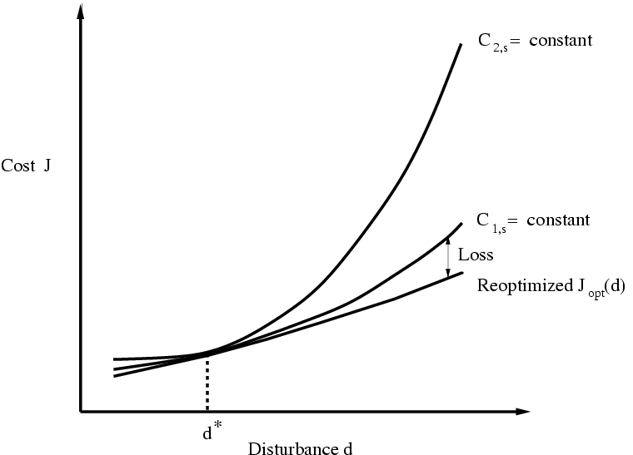

Figure 4. Loss L = J – J_{opt}(d) imposed by constant setpoint policy: There is a loss if we keep a constant setpoint rather than reoptimizing when a disturbance ocuurs. For the case in the figure it is better (with a smaller loss) to keep the setpoint c_{1s} constant than to keep c_{2s} constant.

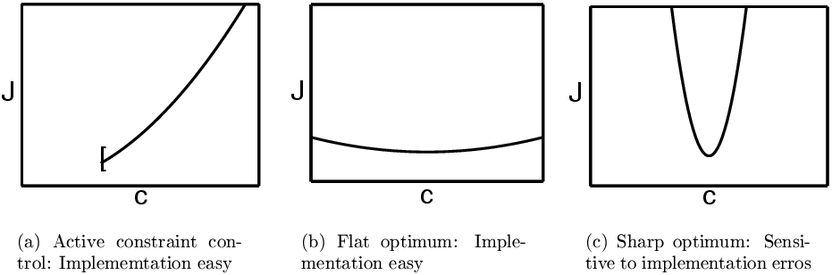

Figure 5. Implementing the controlled variable: Effect of implementation error on cost

An additional concern with the constant setpoint strategy, is that there is always a difference between the setpoint c_{s} and the actual value c due to implementation errors caused by measurement errors and imperfect control. To minimize the effect of the implementation errors, the cost surface as a function of c should be as flat as possible, see Figure 5.

Example sharp optimum. An example of a sharp optimum (Figure 5c) is for high-purity distillation where the controlled variable c is the temperature in the end of the column. In this case even a small change in temperature at the end of the column will imply a large relative change in composition, and thus a large change in cost J for the process.

To select controlled variables for self-optimizing control, one may use the stepwise procedure of Skogestad (2000):

Step 3.1 Definition of optimal operation (cost and constraints)
Step 3.2 Determine degrees of freedom for optimization
Step 3.3 Identification of important disturbances
Step 3.4 Optimization (nominally and with disturbances)
Step 3.5 Identification of candidate controlled variables
Step 3.6 Evaluation of loss for alternative combinations of controlled variables (loss imposed by keeping constant setpoints when there are disturbances or implementation errors)
Step 3.7 Evaluation and selection (including controllability analysis)

Note that except for Step 3.7, this procedure normally requires steady-state information only. The procedure has been applied to several applications, including distillation column control (Skogestad, 2000), the Tennessee-Eastman process (Larsson et al., 2001) and the reactor-recycle process (Larsson et al., 2002).

To identify good candidate controlled variables, c, one should look for variables that satisfy all of the following requirements (Skogestad, 2000):

- The optimal value of c should be insensitive to disturbances
- c should be easy to measure and control (so that the implementation errror is acceptable)
- The value of c should be sensitive to changes in the manipulated variables (the steady-state degrees of freedom). Equivalently, the optimum (J as a function of c) should be flat.
- For cases with more than one unconstrained degrees of freedom, the selected controlled variables should be independent.

At least “locally” (for small disturbances), these requirements may be combined into a single rule (which generalizes requirement 3): Look for variables that maximize the minimum singular value of the appropriately scaled steady-state gain matrix G from u to c (Skogestad and Postlethwaite, 1996) (Skogestad, 2000) . Here u denotes the steady-state degrees of freedom.

If a linearized model is available, then the minimum singular value rule may very useful for eliminating poor candidate variables, but it is a local analysis, and for a final selection one should use the above procedure with evaluation of the loss for larger disturbances.

It is stressed that the issue of selecting appropriate controlled variables c for the unconstrained degrees of freedom is equally important when we use multivariable constrained control (MPC) in the supervisory control layer. The setpoints for the selected controlled variables as well as the active constraints, which may vary with time, are then computed by the steady-state optimization layer and supplied to MPC for implementation.

6. Production rate and inventory control (step 4)

In a chemical plant mass moves through the process, starting up as feeds and ending up as products. The mass balance requires that, at least at steady state, the same flow goes through all units, and this is accomplished indirectly by keeping the total inventory (mass holdup) in each unit approximately constant. The discussion in this section is mainly aimed at liquid (and solid) systems, for which total inventory is not self-regulating so that a control system is required for inventory control. Pressure is an indication of total inventory in gas phase systems, and the self-regulation caused by pressure differences make explicit inventory control less important in most gas phase systems.

Although the total inventory (holdup, level) in a processing unit usually has no or little steady-state effect, it thus needs to be controlled to satisfy the mass balance and maintain stable operation. The bottom-up design of the control system (step 5) therefore usually starts with the design of the (liquid) level control loops. However, one needs to be a bit careful about assigning loops based on local considerations in each unit, because as indicated the level loops are linked together through the transport of mass through the process. Furthermore, level control consumes steady-state degrees of freedom, and determines the initial effect of feedrate disturbances.

There are many possible ways of pairing the level loops, and the basic issue is whether to control the inventory (level) using the inflow or outflow? A little thought reveals that the answer to this question is mainly determined by where in the plant the production rate is set, and that we should control inventory (Buckley, 1964) (see Figure 6c)

- using the outflow downstream of the location where the production rate is set, and
- using the inflow upstream of this location.

- In the direction of flow (given feed rate)
- Opposite flow (given product rate)
- Production rate set inside plant
Figure 6. Inventory control

This justifies why in Table 1 there is a separate step called “Production rate”, because the decision here provides a natural transition from step 3 (top-down economic considerations) to step 5 (bottom-up assignment of individual loops, usually starting with the level loops).

The production rate is commonly assumed to be set at the inlet to the plant, with outflows used for level control (Figure 5a). One important reason for this is probably that most of the control structure decisions are done at the design stage (before the plant is built) where we usually fix the feedrate. However, during operation the feedrate is usually a degree of freedom, and very often the economic conditions are such that it is optimal to maximize production. As we increase the feedrate we reach a point where some flow variable E internally in the plant reaches its constraint E_{max} and becomes a bottleneck for further increase in production. In addition, as we reach the constraint we lose a degree of freedom for control, and to compensate for this we have several options:

- Reduce the feedrate and “back off” from the constraint on E (gives economic loss).
- Use the feedrate as a manipulated variable to take over the lost control task (but this usually gives a very “slow’’ loop dynamically because of long physical distance). To avoid this slow loop one may either:
- Install a surge tank upstream of the bottleneck, and reassign its outflow to take over the lost control task, and use the feedrate to reset the level of the surge tank, or:
- Reassign all level control loops upstream of the bottleneck from outflow to inflow (which may involve many loops).

All of these options are undesirable. A better solution is probably to permanently reassign the level loops (as indicated in option 4). We then have the following rule:

Identify the main dynamic (control) bottleneck (see definition below) in the plant by optimizing the operation with the feedrate as a degree of freedom (steady state, see step 3). Set the production rate at this location.

The justification for this rule is that the economic benefits of increasing the production are usually very large (when the market conditions are such), so that it is important to maximize flow at the bottleneck. On the other hand, if market conditions are such that we are operating with a given feed rate or given product rate, then the economic loss imposed by using a outer cascade loop to adjust the production rate at the bottleneck (somewhere inside the plant, see Figure 11 for an example) is usually zero, as deviations from the desired feed or production rate can be averaged out over time, provided we have storage tanks for feeds or products. However, one should be careful when applying this rule, as also other considerations may be important, such as the control of the individual units (e.g. distillation column) which may be affected by whether inflow or outflow is used for level control.

We have here assumed that the bottleneck is always in the same unit. If it moves to another unit, then reassignment of level loops is probably unavoidable if we want to maintain optimal operation.

Note that we here have only considered changes in operating conditions that may lead to bottlenecks and thus to the need to reassign inventory (level) loops. Of course, other active constraints may move and the best unconstrained controlled variable (with the best self-optimizing properties) may change, but the reconfiguration of these loops is usually easier to handle locally.

MPC in regulatory control layer

The above discussion assumes that we use single-loop controllers in the regulatory control layer (which includes level control), and that we want to minimize the logic needed for reassigning loops. An alternative approach, which overcomes most of the above problems, is to use a multivariable model-based controller with constraints handling (MPC), which automatically tracks the moving constraints and reassigns control tasks in an optimal manner. This is many ways a more straightforward approach, but such controllers are more complex, and their sensitivity to errors and failures is quite unpredictable, so such controllers are usually avoided at the bottom of the control hierarchy.

Another alternative, which is more failure tolerant, is to implement a MPC system on top of a fixed single-loop regulatory control layer (which includes level control). As shown in Theorem 1 (below) this gives no performance loss provided we let the multivariable controller have access also to the setpoints of the lower-layer regulatory controllers (including the ability to dynamically manipulate the level setpoints). The regulatory layer then provides a back-up if the MPC controller fails, but under normal conditions does not affect control performance.

Definition of bottleneck

Consider a given objective function, given parameters, given equipment (including given degrees of freedom) and given constraints (including quality constraints on the products). A unit (or more precisely, an extensive variable E within this unit) is a bottleneck (with respect to the flow F) if
- With the flow F as a degree of freedom, the variable E is optimally at its maximum constraint (i.e., E= E_{max} at the optimum)
- The flow F is increased by increasing this constraint (i.e., dF/dE_{max} > 0 at the optimum).
A variable E is a dynamic( control) bottleneck if in addition
- The optimal value of E is unconstrained when F is fixed at a sufficiently low value
Otherwise E is a steady-state (design) bottleneck.

Remarks on definition:
- Typically, F is the flowrate of the main feed or main product.
- Most of the information required to identify bottlenecks follows from the optimization with various disturbances in step 2.
- The fact that an extensive variable is at its maximum constraint does not necessarily imply that it is a bottleneck, because we may have that dF/dE_{max} = 0 (e.g., this may happen if the variable E is a cheap utility).
- In many cases F is also the objective function to be maximized, and the values of dF/dE_{max} are then directly given by the corresponding Lagrange multipliers.
- We may in some cases have several bottlenecks at the same time, and one should then identify the main bottleneck. In a preliminary analysis, this may be selected as the variable with the largest value of E_{max}⋅dF/dE_{max}. (i.e. with the largest relative effect on the flowrate).
- The location of the bottleneck may move with time (i.e., as a function of other parameters)
- The concept of “bottleneck” is clearly of importance when redesigning a plant to increase capacity. It is also important in terms of operation and control, because the main bottleneck is the variable that should be operated closest to its constraint.
- Steady-state bottlenecks may be important in terms of design, but need normally not be considered any further when it comes to deciding on a control structure (as they should always be kept at their maximum). Examples of possible steady-state bottleneck variables are reactor volumes and heat exchangers areas.
- A control policy based on fixing intensive variables is not steady state optimal for systems with bottlenecks.

Comment: Life cycle approach

As noted above, the process and control system design is usually based on considering a few base case designs with given feedrates, whereas in practice the plant is often operated with feedrate as a degree of freedom. Thus, one fails to consider the entire plant life cycle when designing the plant. Also, during design with a given feedrate F, optimizing the profit P is equivalent to maximizing P/F (since F is given). On the other hand, during operation with the feedrate as a free variable, we will increase the feedrate until dP/dF=0, so we get (P/F)_{operation} < (P/F)_{design}. Thus, unless we take a life cycle approach, we will use the raw materials and energy less effectively than we designed for.

Several external feeds

If the process has more than one external feed, then the largest feedstream or the sum of the feedstrams is normally used for total inventory control, whereas the other feedstreams are used for inventory control of individual components.

Purge streams

Purge streams may be required to avoid accumulation of intermediate trace components that have no “natural” way out of the process and are not removed by reactions.

7. Regulatory layer (step 5)

The regulatory control layer consists of SISO control loops, usually of the PID kind. The main objective is to “stabilize” the plant. We have here put stabilize in quotes because we use the word in an extended meaning, and include both modes which are mathematically unstable as well as slow modes (“drift”) that need to be “stabilized” from an operator point of view. The controlled variables for stabilization are measured output variables y₂, and their setpoints y_{2s} may be used as degrees of freedom by the layers above. More generally, the objective of the regulatory control layer is to locally ccontrol secondary measurements (y₂), so that the effect of disturbances on the primary outputs (y₁=c) can be handled by the layer above (or the operators). In the regulatory control layer we generally avoid using manipulated variables that may saturate, because otherwise control is lost and reconfiguration of loops is required.

Figure 7. Selection of secondary controlled variables y₂

The main structural issue in the regulatory layer is to determine which extra (secondary) variables y₂ to control in order to stabilize the process and achieve local disturbance rejection (see Figure 7). A good secondary controlled variable (measurement) usually has the following properties:

- The variable is easy to measure
- The variable is easy to control using one of the available manipulated variables (the manipulated variable should have a “direct”, fast and strong effect on it)
- For stabilization: The unstable mode is “quickly” detected in the measurement (use pole vectors for a more detailed analysis)
- For local disturbance rejection: The variable is located “close” downstream of an important disturbance (use partial control analysis for more details).

Except for cases where we do final control in the regulatory control layer, no degrees of freedom are lost as the setpoints c_{s} for the locally controlled variables remain degrees of freedom for the layer above. This assumes that also the setpoints for the liquid levels remain as degrees of freedom.

The “unstable’’ modes are very often related to inventory in each unit. This includes both the overall inventory (total mass) as well as the inventory of individual components.

- For liquid phase systems, overall inventory in each unit is stabilized by controlling liquid level.
- For gas phase systems, overall inventory (pressure) is controlled in selected units, but in many units it is left uncontrolled (floating), for example, to minimize pressure drop.
- For both gas and liquid phase systems, the inventory of individual components may need to be stabilized. Usually, this involves controlling a composition, or a derived property such as temperature. For example, in a distillation column, a temperature controller is often used to stabilize its otherwise drifting composition profile. Note that we do not need to control the inventory of all components, as there may be only one unstable mode associated with the “drift” of many components. Also, control of a single measurement may stabilize several unstable modes.

As already discussed, the design of the regulatory layer (or more precicely, the assignment of control loops in the regulatory control layer) usually starts by determining where to set the production rate (step 4), and then assigning the stabillizing liquid level loops. For the other unstable modes a pole vector analysis (Havre and Skogestad, 1997) may be useful. It requires a linearized model, and to minimize the required input usage, the rule is to select for stabilizing control measured variables and manipulated inputs corresponding to large elements in the pole vectors.

The next step is to assign inner loops for local disturbance rejection as part of a cascade control system. The objective is to control secondary measurements (v) so that the effect of disturbances on the primary outputs (c) can be handled by the layer above (or the operators).

Partial control

To analyze this in more detail the concept of partial control is very useful, and the objective is to minimize the magnitude of the partial control gain, P_{d1} (see below), which gives the effect of the disturbances on the primary outputs (c) with the secondary (regulatory) loops closed. The results in this section are from Skogestad and Postlethwaite (1996) and Havre and Skogestad (1996). We here use the terms “lower layer”, “inner loops” and “secondary loops” as synonyms for the regulatory control layer. The “primary” control system is the same as the supervisory control system.

Let the overall process model be y = G u + G_{d} d. We partition the manipulated inputs u and the measured outputs y into two sets,

y = [y₁ y₂], u=[u₁ u₂]

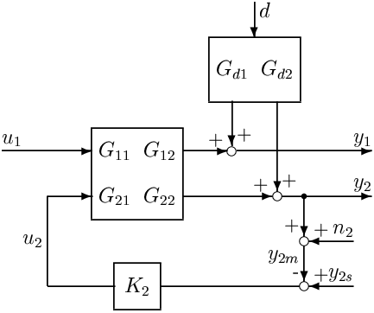

Figure 8. Partial control of the secondary variables y₂

where y₁ denotes the primary outputs (c), y₂ the secondary outputs (v), u the inputs (m), u₂ the inputs used in the secondary layer, and u₁ denotes the unused inputs. The plant model G is partitioned correspondingly,

y₁ = G₁₁ u₁ + G₁₂ u₂ + G_{d1} d
y₂ = G₂₁ u₁ + G₂₂ u₂ + G_{d2} d

By closing the lower-layer (inner) loops involving u₂ and y₂,

u₂ = K₂ (y_{2s} – y₂ – n₂),

we obtain, as seen from the (supervisory) layer above, a partially controlled system with y_{2s} (the setpoints for the locally controlled variables y₂) and u₁ (the unused input) as degrees of freedom. The transfer function for the partially controlled system is

y₁ = P₁ u₁ + P_{r1} (y_{2s}-n₂) + P_{d1} d

where P₁ = G₁₁ – G₁₂ K₂ (I + G₂₂ K₂)⁻¹ G₂₁,
P_{d1} = G_{d1} – G₁₂ K₂ (I + G₂₂ K₂)⁻¹ G_{d2},
P_{r1} = G₁₂ K₂ (I + G₂₂ K₂)⁻¹.

The lower layer is assumed to be much faster than the upper layer, so for a preliminary analysis when selecting secondary controlled variables y₂ we may assume that y₂ is perfectly controlled (let K₂ → ∞, or equivalently set y₂ = y_{2s} – n₂) and we get

P₁ = G₁₁ – G₁₂ G₂₂⁻¹ G₂₁,
P_{d1} = G_{d1} – G₁₂ G₂₂⁻¹ G_{d2},
P_{r1} = G₁₂ G₂₂⁻¹

We should then

- select to control secondary variables y₂ such that P_{d1} = G_{d1} – G₁₂ G₂₂⁻¹ G_{d2} is small (at least at higher frequencies beyond the bandwidth of the primary control system).

It is recommended to plot the magnitude of the elements in P_{d1} as a function of frequency, and if the variables are appropriately scaled then “small” means less than 1 (Skogestad and Postlethwaite, 1996). If we want to use the reference r₂ as a degree of freedom to control the primary outputs y₁, then P_{r1} = G₁₂ G₂₂⁻¹ should be (sufficiently) large (also at steady-state). If r₂ is not a degree of freedom in the primary control layer, then it may be viewed as a disturbance and P_{r1} = G₁₂ G₂₂⁻¹ should be small. If we want to use the unused inputs u₁ as a degree of freedom to control the primary outputs y₁, then P₁ = G₁₁ – G₁₂ G₂₂⁻¹ G₂₁ should be (sufficiently) large (also at steady-state).

8. Supervisory control (step 6)

The purpose of the supervisor control layer is to keep the (primary) controlled outputs c at their optimal setpoints c_{s}, using as degrees of freedom the setpoints v_{s} in the regulatory layer and any unused manipulated inputs. Which variables to control and their setpoints are determined by the optimization layer above. Note that the variables to control may change if the active constraints change.

For the supervisory control layer, the first structural issue is decide on whether to use decentralized or multivariable control. Note that there is usually some decentralization, that is, there is often a combination of several multivariable and single-loop controllers.

Decentralized single-loop control is the simplest. It is preferred for noninteracting process and cases where active constraints remain constant. Advantages with decentralized control:

+ Tuning may be done on-line
+ No or minimal model requirements
+ Easy to fix and change

Disadvantages:

- Need to determine pairing
- Performance loss compared to multivariable control
- Complicated logic required for reconfiguration when active constraints move

The decision on how to pair inputs (y_{2s}, u₁ ) and outputs (c), and this is often done based on process insight. In more difficult cases a RGA-analysis may be useful, and the rule is pair such that the resulting transfer matrix is close to identity matrix at the crossover expected frequency, provided the element is not negative at steady state. For a more detailed analysis one should also consider disturbances, and compute the closed-loop disturbance gain (CLDG) (Skogestad and Postlethwaite, 1996). One disadvantage with decentralized control is that it may require reconfiguration of loops (with complicated logic) if the active constraints change

Multivariable control is preferred for interacting processes and for processes with changes in active constraint. For the cases where the constraints may change, one needs a multivariable controller with explicit constraint handling (e.g., MPC). This avoids the need for logic, and gives a smooth transition between active constraints. Advantages with multivariable constrained control (MPC):

+ Coordinated control for interactive processes
+ Easy handling of feedforward control
+ Easy handling of changing constraints with no logic required and smooth transition between active constraints

Disadvantages:
- Requires multivariable dynamic model
- Tuning may be difficult
- Less transparent
- Reliability problem: “Everything goes down at the same time”

The optimization in step 2 with various disturbances may be used to set up a table of possible combinations of active constraints, and multivariable constrained control (MPC) should be used if a structure with single-loop controllers will require excessive reconfiguration of loops.

Optimization (step 7)

The purpose of the optimization is to identify the active constraints and recompute optimal setpoints c_{s} for controlled variables.

In addition to deciding on which unconstrained variables to control (see step 3), the main structural issue is to decide if it is necessary to use real-time optimization (RTO), or if manual optimization is sufficient. With RTO new setpoints are typically computed about every hour or so, after the steady-state model has been adjusted to match the current conditions. Real-time optimization (RTO) is costly in the sense that it requires a detailed steady-state computer model to be maintained and continuously updated. If the active constraints do not change, and we are able to find good self-optimizing controlled variables, then RTO gives little benefit and should not be used. There are also situations where the active constraints do change, but where the operators may be able to identify and implement the required changes.

Validation (step 8)

After having determined a plantwide control structure, it may be necessary to validate the structure, for example, using nonlinear dynamic simulation of critical parts.

11. Discussion. Bottom-up design (steps 5-7): Any loss in control performance?

We have here assumed that the control system is designed bottom-up starting with the lower regulatory control layer, involving the inputs u₂ (denoted m earlier) and the outputs y_{2.} Does this hierarchical decomposition into control layers impose any loss on the overall achievable control performance in terms of the primary outputs y₁ (denoted c earlier)?

The answer is “no” provided we have full access to the lower (secondary; regulatory) layer from the upper (primary; supervisory) control layer:

Theorem (Larsson and Skogestad, 1998). The closing of a lower-layer (partial) control system, involving the manipulated input u₂ and the measured and controlled variable y₂, introduces no new control limitations (e.g., in terms of RHP-zeros) provided
- The setpoints y_{2s} (for y₂) are available as a degrees of freedom at the next layer.
- The measurements y₂ are available at the next layer
- The controller interconnecting y₂ and u₂ is minimum phase and stable (but may have integrators).

The proof is trivial because under these conditions we can just invert away the controller K₂ used in the lower layer. Although the theorem is trivial, it has some important practical significance in terms of multivariable control (MPC). It tells us that the presence of the lower-layer control system imposes no limitations on the overall control performance, provided we at the next layer use a multivariable controller with full access to the measurements (y₂) and setpoints (r₂) used in the lower layer.

However, in many practical cases, we want to use a simpler control system, and we may impose limitations by (A) improper pairing, or (B) use of inner cascade loops that actually amplify disturbances.

A. Improper pairing. Assume that we do not have access to r₂ when controlling y₁. For example, this is the situation if we do “final control” in the lower layer, i.e. y₂ is actually a “primary” output. (Alternatively, this is the situation if we use decentralization within the supervisory control layer, and design the single-loop controllers sequentially).

In this case pairing on a negative steady-state RGA-element will impose a fundamental limitation in terms of the control of y₁. More precisely, if

- the pairing between u₂ and y₂ corresponds a negative steady-state RGA-element (in the RGA of G),
- G₂₂ has no RHP-zero, and
- we use integral control in K_{2,}

then closing the inner loop involving u₂ and y₂ will introduce a RHP-zero in the resulting transfer function P₁₁ from u₁ to y₁ (Shinskey 1979, Bristol 1966, Grosdidier and Morari, 1985, Jacobsen, 1999). The effect of the RHP-zero is less severe (moved to higher frequencies) as we tighten the control in the inner loop (Jacobsen, 1999, Larsson, thesis 2000).

Note: There are also other reasons for avoiding pairing on negative steady-state RGA-elements, including ensuring failure tolerance and allowing for independent tuning (DIC).

B. Improper cascade control. Assume that the outputs y₂ are “secondary” outputs (extra measurements) which we choose to control in order to stabilize the plant or improve local disturbance rejection. This is a standard cascade control system. In this case the set u₁ is empty, and the layer above uses the setpoints r₂ in order to control the “primary” outputs y₁.

In this case, the main purpose of the lower-layer control system is to improve the control of y₁, but if improperly designed, it may make the situation worse. For example, if we had a case where originally the disturbance had no effect on the output (G_{d1} = 0), then the closing of a lower-layer loop may introduce sensitivity to the disturbance (with P_{d1} = G_{d1} – G₁₂ K₂ (I + G₂₂ K₂)⁻¹ G_{d2} nonzero).

12. Application: Reactor-recycle process the snowball effect

We here will apply the above procedure, with emphasis on the selection of controlled variables, to the reactor-recycle process in Figure 9, but let us first start with a discussion of the so-called snowball effect.
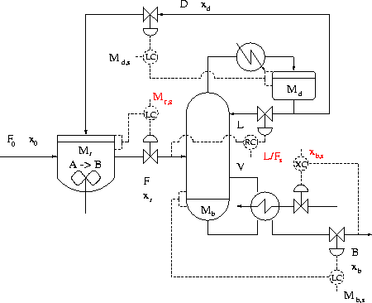
Figure 9 . Reactor with recycle process with control of recycle ratio (L/F), M_{r} (maximum reactor holdup), and x_{B} (given product composition).

Snowball effect

Luyben (1993) introduced the term ``snow-ball effect’’ to describe what can happen to the recycle flow in response to an increase in fresh feedrate F₀ for processes with recycle of unreacted feed (see Figure 9). Although this term has been useful in pointing out the importance of taking a plantwide perspective, it has lead to quite a lot of confusion.

To understand the problem, let us first consider the ``default'' way of dealing with a feedrate increase, which is to keep all the intensive variables (compositions) in the process constant, by increasing all flows and other extensive variables with a steady-state effect in proportion to F₀. This is similar to how one scales the production rate when doing process simulation, and is the idea behind the ``balanced'' control structures of Wu and Yu (1996). Specifically, this requires that we keep the residence time M_{r}/F constant, that is, we need to increase the reactor holdup M_{r} in proportion to the reactor feedrate F.

However, changing the reactor holdup (volume) during operation is usually not possible (gas phase reactor), or at least not desirable, since for most reactions it is economically optimal to use a fixed maximum reactor volume in order to maximize per pass conversion (i.e., reactor holdup is a steady-state bottleneck, see above). To increase conversion (in response to an increase in feedrate F₀) one may instead increase the concentration of reactant by recycling unreacted feed. However, the effect of this has limitations, and the snowball effect occurs because even with infinite recycle the reactor concentration cannot exceed that of pure component. In practice, because of constraints, the flow rates do not go to infinity. Most likely, the liquid or vapor rate in the column will reach its maximum value, and the result of the snowballing will be a breakthrough of component A in the bottom product, that is, we will find that we are no longer able to maintain the product purity specification (x_{B}).

To avoid snowballing Luyben et al. (1993, 1994) and Wu and Yu (1996) propose to use the “default” approach with a varying reactor holdup, rather than a “conventional” control structure with constant holdup. Their simulations show that a variable holdup policy works better, which is not surprising as the reactor in effect works as a large surge tank which dampens feedrate changes. However, their simulations are strongly misleading, because in the “conventional” structure they fix the reactor holdup at a value well below the maximum value used in the varying holdup structures. In fact, the lowest value of the recycle D for a given value of F₀ is when the reactor holdup M_{r} is at its maximum, so the conventional structure with maximum holdup is actually better in terms of avoiding snowballing.

Luyben has furthermore suggested as a general rule to avoid snowballing to “fix a flow in each recycle loop”, but this rule seems to have little basis. For example, for the reactor-recycle process this would lead to control structures that can only handle very small feedrate changes (see below).

In summary, the “snowball effect” is a real operational problem if the reactor is “too small”, such that we may encounter or get close to cases where the feedrate is larger than the reactor can handle. The “snowball effect” makes control more difficult and critical, but it is not a control problem in the sense that it can be avoided by use of control. Rather, it is a design problem that can be easily avoided by installing a sufficiently large reactor to begin with.

Control structure design with given feedrate

We here consider the reactor recycle-process in Figure 9. The degrees of freedom analysis (Step 2) was performed earlier (Example 4).

Step 3.1. The operational cost function J to be minimized, or equivalently the profit function P to be maximized, is

P = - J = p_{B} B - p_{F0} F₀ – p_{V} V – p_{D} D

where p_{B} [$/kg] is the product price, p_{F0} [$/kg] the feedstock price, p_{V} [$/kg] is the energy cost (sum of price for reboiling and condensing) and p_{D} is the recycle cost (sum of cost for pumping and preprocessing the recycle stream). With a given feedrate and negligible recycling costs, the economic objective is then to minimize energy usage (i.e., minimize boilup V).

Step 3.2. From Example 4 there are, with fixed pressure, 4 degrees of freedom at steady state, including the external feedrate F₀. With a fixed feedrate F₀, there are 3 steady-state degrees of freedom.

Step 3.4 (active constraints). Optimization with respect to the three degrees of freedom, give that M_{r} should be kept at its maximum (to maximize conversion), and that the product composition x_{B} be kept at its specification (overpurifying costs energy). These two variables should then be controlled (active constraint control). This makes the Luyben structure and the two balanced structures of Wu and Yu (1996) economically unattractive, at least from a steady-state point of view.

Step 3.5 (unconstrained DOFs). There is one unconstrained degree of freedom left, and the issue is to decide which variable we should select to keep constant. Alternatives are, for example, the amount of recycle D or F (“Luyben rule”), composition x_{D} (conventional structure), reflux L, reflux ratios L/D or L/F, etc.

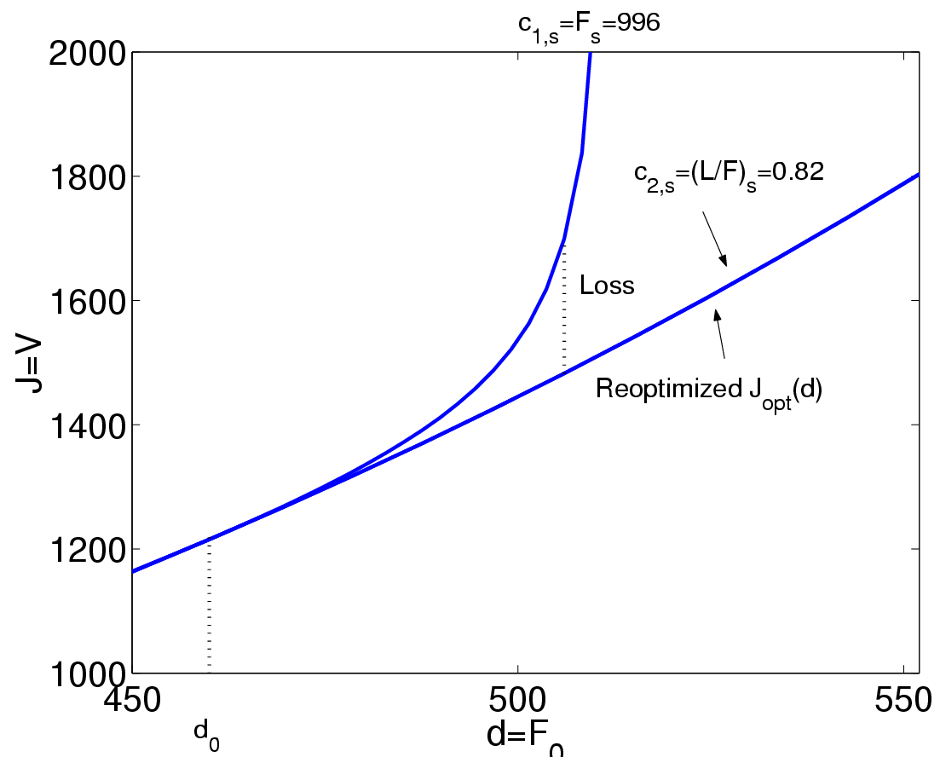

Figure 10. Selection of controlled variable for the reactor-recycle process: The loss imposed by controlling c₁₌ L/F is much smaller than when controlling c₂=F.

Step 3.6 (evaluation of loss). Larsson et al. (2002) evaluated the energy loss imposed by keeping these constant when there are disturbances in F₀ and found that x_{D} and L/F were good choices for the unconstrained controlled variable, whereas F, D or L were poor choices. This is illustrated in Figure 10 for L/F and F. In fact. keeping D or F constant (Luyben rule) yields infeasible operation for relatively small feedrate disturbances and confirms the results of Wu and Yu (1996). This is easily explained: As the feedrate F₀ is increased, we must with constant F=F₀+D reduce the recycle D to the reactor. Therefore light component A will accumulate in the distillation column and operation becomes infeasible. In terms of the loss, control of top composition x_{D} is slightly better than control of the reflux ratio L/F. However, the “two-point” distillation column control problem, involving control of both of bottom (x_{B,} active constraint) and top (x_{D)} compositions, is known to be difficult due to strong two-way interactions. In conclusion, it is therefore recommended to control L/F.

Step 4. The feedrate is here assumed to be set at the inlet (see more about this below).

Step 5 (regulatory loops). One possible choice for the regulatory control loops are shown in Figure 9. Note that with a given feedrate, the outflows are used to control level in the reactor and in the distillation column.

Step 6 (supervisory control layer). The proposed decentralized structure of the supervisory control layer is also shown in Figure 9.

Variable feedrate and bottleneck

In practice, the feedrate may be a degree of freedom, and the production rate should be set at the bottleneck.

Step 4 (where to set production rate). For this plant the reactor holdup is a steady-state (design) bottleneck, whereas the column capacity (V_{max}) is the dynamic (control) bottleneck. Thus, if it is likely that the plant will be operated under conditions where we want to maximize production, then we should probably use a control structure where the production rate is set at the column bottleneck (V), and inventory control should use inflow upstream of this location

Step 5 (regulatory loops). A possible control structure is to use the feedrate F₀ to control the reactor level, the column feed F to control bottom composition, and the boilup V to set the production rate. For the case with a given feedrate F₀ one could adjust F₀ to its to its given value with a cascade flow controller with Vas the degree of freedom, see Figure 11.
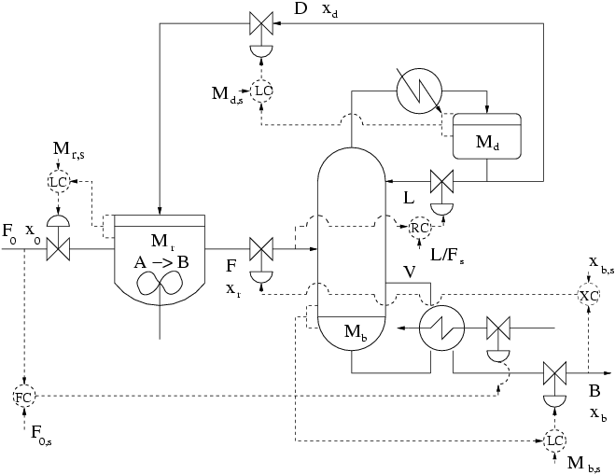
Figure 11. Control structure for case with variable feedrate with production rate set at the bottleneck (vapor boilup V). For the case with a given feedrate, a cascade flow controller (lower left) is used to set F_{0,s}.

Additional case studies

The design procedure described in this paper has been applied to numerous case studies, several of which are found in the thesis by Larsson (2000).

- Larsson et al. (2002) and Govatsmark et al. (2002): Selection of controlled variables for reactor, separator and recycle process (Steps 1, 2 and 4 plus some on Steps 5 and 6)
- Larsson and Skogestad (1999) and Engelien et al. (2002): Optimization and selection of controlled variables for heat-integrated distillation columns (Steps 1, 3 and 4)
- Larsson et al. (2001): Selection of controlled variables for the Tennessee-Eastman process with focus on how to eliminate poor candidate variables (Steps 1 and 3). (The control system design in this paper was included to show that the proposed controlled variables are workable, but otherwise do not follow the steps in Table 1. For example, there is no thorough analysis on where to locate the throughput manipulator (step 4)).
Skogestad (2000): Optimization (moving active constraints as a function of feedrate) and selection of controlled variables for a propane-propylene distillation column (Steps 1, 3 and 4).

13. Conclusion
The proposed plantwide control design procedure in Table 1 has two main parts:

I. Top-down analysis to identify degrees of freedom and primary controlled variables (look for self-optimizing variables).
II. Bottom-up analysis to determine secondary controlled variables and structure of control system (pairing).

There are many outstanding research issues related to filling in more detailed procedures in Table 1 on what to do in each step of the procedure. For example, more work is needed in order to understand how to decompose and coordinate the layers of the control system.

References

Bristol, E.H., 1966, “On a new measure of interaction for multivariable control systems”, IEEE Trans. on automatic control, 133-134.

Buckley, P.S., 1964. Techniques of process control. Wiley.

Foss, A.S., 1973, “Critique of chemical process control theory”, AIChE Journal, 19, 209-214.

Grosdidier, P. and M. Morari, 1985, “Closed-loop properties from steady-state gain information”, Ind.Eng.Chem.Res., 24, 221-235.

Havre, K. and S. Skogestad, 1996, ``Input/output selection and partial control,'' IFAC World Congress, San Francisco, July 1996, M, 181-186.

Havre, K. and S. Skogestad, 1998, ``Selection of variables for regulatory control using pole vectors”, Proc. IFAC symposium DYCOPS-5, Corfu, Greece, 614-619.

Jacobsen, E.W., 1999, “On the dynamics of integrated plants - non-minimum phase behavior”, J. Proc. Control, 9, 439-451.

Larsson, T. and S. Skogestad, 1998, ``Limitations imposed by lower layer control configurations '', AIChE Annual Meeting, Miami Beach, 16-20 Nov. 1998

Larsson, T. and S. Skogestad, 1999, ``Control of industrial heat integrated distillation columns'', AIChE Annual Meeting, Dallas, 1-5 Nov. 1999.

Larsson, T., 2000. Studies on plantwide control, Ph.D. Thesis, Norwegian University of Science and Technology, Trondheim.

Larsson, T. and S. Skogestad, 2000, “Plantwide control: A review and a new design procedure”, Modeling, Identification and Control, 21, 209-240.

Larsson, T., K. Hestetun, E. Hovland and S. Skogestad, 2001, “Self-optimizing control of a large-scale plant: The Tennessee Eastman process’’, Ind.Eng.Chem.Res., 40, 4889-4901.

Larsson, T., M.S. Govatsmark, S. Skogestad and C.C. Yu, 2002, “Control of reactor, separator and recycle process’’, Submitted to Ind.Eng.Chem.Res.
Luyben, W.L. 1993. “Dynamics and control of recycle systems. 2. Comparison of alternative process designs.” Ind. Eng. Chem. Res. 32, 476-486.
Luyben, W.L. 1994. “Snowball effect in reactor/separator processes with recycle”. Ind. Eng. Chem. Res. 33, 299-305.
Morari, M., G. Stephanopoulos and Y. Arkun 1980. “Studies in the synthesis of control structures for chemical processes. Part I: Formulation of the problem. Process decomposition and the classification of the control task. Analysis of the optimizing control structures.” AIChE Journal 26, 220–232.

Shinskey, F.G., 1979, Process control systems, Mc-Graw Hill

Skogestad, S. and I.Postlethwaite, 1996, Multivariable feedback control, Wiley.
Skogestad, S. (2000). “Plantwide control: The search for the self-optimizing control structure”. J. Proc. Control 10, 487-507.
Wu, K.L. and C.-C. Yu (1996). “Reactor/separator process with recycle. 1.Candidate control structure for operability”. Computers. Chem. Engng., 20, 1291-1316.

