SEPARATION OF TERNARY HETEROAZEOTROPIC MIXTURES IN THE CLOSED MULTIVESSEL BATCH DISTILLATION COLUMN

Stathis Skouras and Sigurd Skogestad

Norwegian University of Science and Technology, NTNU, Trondheim, Norway

A multivessel batch distillation-decanter hybrid is proposed for the separation of ternary heterogeneous azeotropic mixtures. The column is operated as a closed system and the products are accumulated simultaneously at the vessels during one such ‘total reflux’ operation. Two ternary azeotropic mixtures of Serafimov’s topological class 1.0-2 were studied. Simulated results for the first system verify the feasibility of the novel process in separating heterogeneous azeotropic mixtures. Results for the second mixture further justify the potential of the proposed distillation-decanter hybrid in separating close boiling temperature systems by the addition of a heavy heterogeneous entrainer.

INTRODUCTION

Much attention has been given lately to a novel batch distillation column configuration usually called ‘multi-effect batch distillation system’ (Hasebe) or ‘batch distillation column with a middle vessel’ (Davidyan, Barolo, Warter) or ‘middle vessel column’ (Cheong, Rodriguez-Donis) or ‘multivessel batch distillation column’ (Wittgens, Skogestad, Hilmen).

The novel column configuration was first mentioned by Robinson and Gilliland¹ in 1950, but the use of such a column for the separation of binary and multicomponent mixtures was not analysed until 1970, independently by Bortolini and Guarise² and Treybal³. The interest on this column configuration was renewed after the work of Hasebe et al.⁴ and since then the complex batch column is often appears in the related literature.

The middle vessel column (MVC) is a combination of a batch rectifier and a batch stripper. The column has both a rectifying and a stripping section and therefore it is possible to obtain a light and a heavy fraction simultaneously from the top and the
bottom of the column while an intermediate fraction may also be recovered at the middle vessel. Three modifications of the MVC have been suggested in the literature. One with a liquid bypass, where the liquid stream from the rectifying section bypasses the middle vessel and enters the stripping section, one where both liquid and vapour streams from the top section enter the middle vessel and one with a vapour bypass from the bottom section to the top section of the column. In our work we use the vapour bypass modification as shown in Figure 1a.
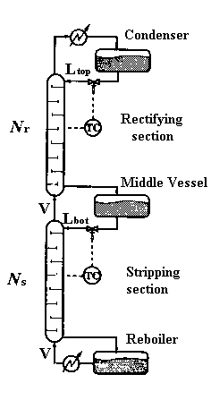
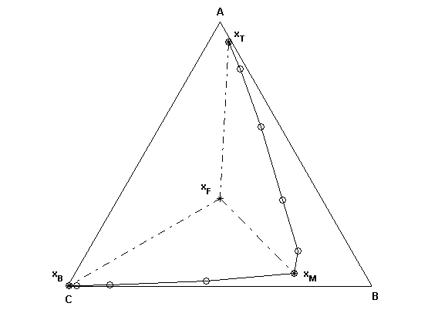

Figure 1: a) Middle vessel batch column (MVC). b) Steady state column profile (solid line with open circles) and material balance triangle (dashed lines)

Until recently most of the work on the MVC was for ideal or constant relative volatility systems. Hasebe et al.⁴⁻⁶ studied some characteristics of the column and presented simulation results for binary and ternary mixtures. They also proposed the total reflux (closed) operation of such a column. Davidyan et al.⁷ presented a rigorous mathematical analysis of the MVC and tried to describe the dynamic behaviour of the column. Meski and Morari⁸ provided a limiting analysis of a mathematical model for the MVC under the assumptions of negligible holdup on the trays and constant molar flows. Barolo et al.⁹⁻¹⁰ performed experiments in a continuous column modified in order to resemble the MVC. They implemented different control configurations and also discussed the effect of some operating parameters on column performance. For the closed operation of the MVC, a feedback control structure, based on temperature controllers, has been proposed by Skogestad et al.¹¹. The feasibility of this simple control strategy was demonstrated both by simulations and experiments by Wittgens et al.¹². A constant relative volatility quaternary system was studied and at the end of the process four pure products were accumulated at the vessels.

The first who tried to study the performance of the MVC in the separation of azeotropic mixtures was Safrit et al.¹³⁻¹⁴. They studied the case of extractive batch distillation in the MVC, with a heavy entrainer added continuously at the top of the column. Warter et al.¹⁵ and Hilmen et al.¹⁶ also studied the performance of extractive batch distillation in the MVC and reported some advantages of the novel process over conventional batch extractive distillation. In a series of three excellent papers Cheong et al.¹⁷⁻¹⁹ developed a mathematical model in order to study the qualitative dynamics of the MVC when it is used to separate multicomponent azeotropic mixtures. The theoretical insights from the analytical tools developed, were also verified by simulations. Warter et al.²⁰ has showed simulated results for the separation of binary azeotropic mixtures by using homogeneous entrainers. They showed ways to cross the distillation boundaries by placing the feed at the concave side of the boundary and by manipulating the vapour flows at the two sections of the column. In that way all three original components can be recovered. Hilmen²¹ provided also simulated results on the closed multivessel batch distillation of ternary homogeneous azeotropic mixtures when the control strategy proposed by Skogestad et al.¹¹ was implemented. In a recent work Rodriguez-Donis et al.²² provided simulated results when heterogeneous entrainers were used instead. In this case a decanter should be combined with the MVC for doing the liquid-liquid split (distillation-decanter hybrid process).

Our work addresses the same issue namely, heterogeneous azeotropic batch distillation on a distillation-decanter hybrid, but the MVC will be operated at total reflux or better as a closed system since total reflux is only achieved as we approach steady state. The main advantage of the closed MVC is the simplicity of operation, since no product change-overs are required but rather pure products are accumulated at the vessels at the end of the process. Additionally, the ‘total reflux’ operation utilises the maximum attainable separation in the column and is especially advantageous for high purity separations. Finally this operating mode allows us to make direct use of the distillation lines or residue curves, thus extracting valuable information about the possible products at the vessels as we reach steady state.

The correspondence between the distillation lines and the steady state column profile is simple and straightforward. ‘The steady state vessel product compositions of a closed multivessel batch distillation column are connected by a distillation line with the given number of equilibrium trays. In addition the material balances must be satisfied’(Hilmen²¹). At steady state the material balances for the closed MVC can be written as:

M_{F} = M_{T} + M_{M} + M_{B}

M_{F} x_{F} = M_{T} x_{T} + M_{M} x_{M} + M_{B} x_{B} ⇒

M_{M} (x_{F} - x_{M}) = M_{T} (x_{T} - x_{F}) + M_{B} (x_{B} - x_{F})

The above material balances reveal that the vessel holdups must obey the so-called lever rule. In addition the vessel compositions must lie on the same distillation line because total reflux is reached at steady state. As also noted by Hilmen²¹ ‘the feasible region of vessel compositions in the MVC are enclosed by the feed distillation line and the borders of the current feed distillation region and by the material balance triangle connecting the unstable node, the stable node and one of the saddles of the current feed distillation region’, as shown in Figure 1b.
- MODEL

The dynamic model for the middle vessel column used in our simulations consists of:
- Overall and component mass balances
- Vapour-liquid equilibria²³ modeled by UNIQUAC equation and liquid-liquid equilibria²⁴⁻²⁵ based on experimental data
- Indirect level control at the vessels with P temperature controllers, as proposed by Skogestad¹¹, for step 1 of the process. Direct level control at the decanter with a PI level controller for step 2 of the process

The model is based on the following assumptions:
- Staged distillation column sections (N_{r} and N_{s} stages at the rectifying and stripping section, respectively)
- Equal constant molar vapour flows at both sections of the column (simplified energy balances)
- Constant molar liquid holdup on all stages, negligible compared to the holdup on the vessels (neglecting liquid dynamics)
- Negligible vapour holdup
- Perfect mixing and equilibrium on all stages
- Ideal vapour phase
- Constant pressure at P = 1.013 bar

All simulations were performed in Matlab^{® 26} by using the integration routine ODE15s.

3. RESULTS

Methanol – Water – 1-Butanol (System 1)
The first mixture to be studied is Methanol – Water – 1-Butanol. Water and 1-butanol exhibit a heterogeneous azeotrope and an immiscibility gap over a limited region of ternary compositions exists (Figure 2a). The stability of the stationary points of the system is also shown on this figure. One distillation boundary, running from methanol (unstable node) to the binary heteroazeotrope (saddle) divides the composition space in two regions, thus limiting the feasible products under distillation. For example, a feed F placed on the left feed region will provide the unstable node (methanol) as a top product, the saddle (binary heteroazeotrope) as a middle vessel product and the stable node (1-butanol) as a bottom product, provided that we have enough stages at each column section.

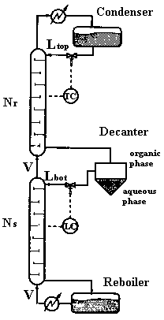
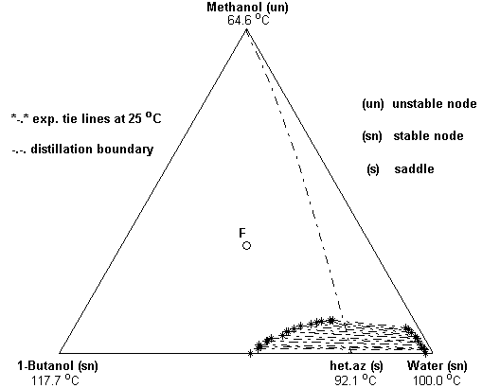

Figure 2: a) Azeotropic mixture of Serafimov’s topological class 1.0-2.
b) Middle vessel batch distillation – decanter hybrid

Water is impossible to be taken as a product in this column since it belongs to a different distillation region and the distillation boundary can not be crossed under total reflux. Therefore not all three original components can be separated simultaneously in one closed operation of the middle vessel column. That is, for example, the case for homogeneous azeotropic mixtures as mentioned by Hilmen²¹. However, the fact that the azeotrope accumulated at the middle vessel is heterogeneous provides a straightforward way of overcoming the azeotropic composition and cross the distillation boundary, namely by decantation. In this way the column can be operated in both distillation regions and all three components can be recovered at the vessels in one closed operation. Thus, a distillation-decanter hybrid seems like a promising alternative.

Our aim is to show that the middle vessel batch column with a decanter taking the place of the middle vessel provides a feasible way of separating heterogeneous azeotropic mixtures. The proposed novel process can be seen in Figure 2b. The closed operation of such a hybrid column certainly simplifies the process since ‘the column runs by itself’ and exhibits advantages over other operating techniques as, for example, the ‘steering the middle vessel’ technique proposed by Cheong et al.¹⁷⁻¹⁹ and implemented for heterogeneous azeotropes by Rodriquez-Donis²².

The operating procedure followed in our simulations is:
Step 1. Start up: Built up the composition profile at the column. No decantation is performed during this step.
Step 2. Decantation: Decantation starting. One of the immiscible phases is refluxed back in the column. Final products are accumulated at the vessels at the end of this step.

Our simulations for system 1 showed the following patterns
Step 1. The feed (x_{F}) is placed at the left feed region. The composition profile at the column is built up. The final products at the vessels can be easily predicted by checking the stability of the singular points in this feed region. Since methanol is the unstable node of the region, it appears at the top vessel. The saddle heteroazeotrope is accumulated at the middle vessel while 1-butanol appears at the bottom vessel, as the stable node of the region. Figure 3a illustrates Step 1 of the process and shows the evolution of the compositions at all vessels. The steady state liquid profile at the column and the final products at the vessels(x_{T}, x_{M}, x_{B}) are also depicted at the figure.

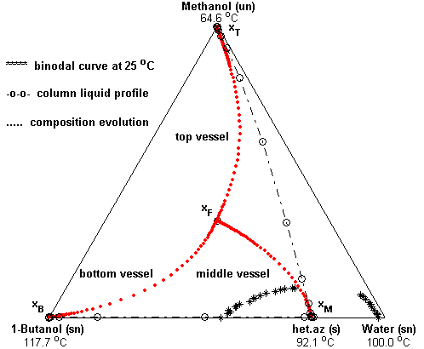
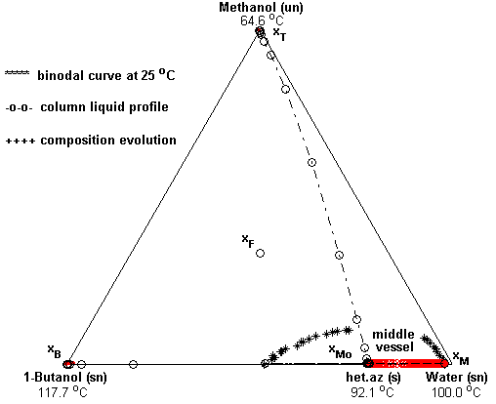

Figure 3: Separation of the system Methanol – Water – 1-Butanol. a) Step1 b) Step 2

Step 2. The heteroazeotrope accumulated at the middle vessel consists of two immiscible liquid phases, one rich in water (aqueous phase) and one rich in 1-butanol (organic phase). If we decant the two phases and reflux the organic phase back in the column, the 1-butanol previously ‘trapped’ in the azeotrope is stripped down in the column and is accumulated at the bottom vessel. At the same time, the aqueous phase is accumulated at the middle vessel while the methanol stays at the top of the column. So all three original components can be recovered at the vessels at the end of the process.

Our simulations show that this is the case. Figure 3b exhibits how the middle vessel is getting enriched in water. The water composition at the middle vessel starts at the heteroazeotropic point (x_{Mo}=0.782) and ends up at the composition of the aqueous phase determined by the liquid-liquid experimental data (x_{M}=0.98). The 1-butanol, contained in the heteroazeotrope, is now refluxed back in the stripping section of the column and enters the bottom vessel. At the end pure methanol is collected at the top vessel (x_{methanol}≈1), water at the middle vessel (x_{Water}=0.98) and pure 1-butanol at the bottom (x_{1-Butanol}≈1). The corresponding recoveries are r_{Methanol}≈100%, r_{Water}≈100%, r_{1-Butanol}=95.8%. All simulation data, initial conditions and steady state results are presented at the Appendix.

Acetone – Water – Toluene (System 2)
System 1 is rather a literature example and it was chosen in order to verify the feasibility of the proposed middle vessel-decanter hybrid in separating heteroazeotropic mixtures. The decanter performs the wanted liquid-liquid split of the heteroazeotrope, while the stripping section further purifies one of the components forming the azeotrope. However, someone can claim that this separation can be also performed in a common batch rectifier-decanter hybrid and that the rectifying section in our column performs a separation (methanol-water) which is of not particular interest and difficulty. We will show now that the proposed process provides further advantages compared to a batch rectifier-decanter hybrid by presenting an example where the rectifying section is performing a more interesting and difficult separation.

One such example is the system Acetone – Water – Toluene. Acetone with high purity is difficult to be recovered from its aqueous solutions since the binary system exhibits a tangent pinch at molar fractions of acetone greater than 0.95. Such close boiling temperature systems are of great industrial interest and their separation by normal distillation becomes uneconomical because high number of trays and high reflux ratios are necessary.

The common practice is to add a third component (entrainer) in the system, which acts preferentially with one of the original components and eases the separation. Toluene can be used as such a suitable entrainer in our case. Toluene is heavier than both acetone and watew and forms a heterogeneous azeotrope with water. The mixture exhibits an immiscibility gap over a wide range of ternary compositions. There is one distillation boundary running from acetone to the heteroazeotrope as can be seen at figure 4. The system belongs to Serafimov’s class 1.0-2 like system 1.

The procedure followed in our simulations was the same as for system 1.
Step 1. The initial feed (x_{F}) was placed at the left feed region where acetone is the unstable node (top vessel), toluene is the stable node (bottom vessel) and the heteroazeotrope is a saddle and therefore it is accumulated at the middle vessel. The stripping section performs the binary separation water-toluene and therefore the azeotropic composition is reached at the middle vessel. The rectifying section is devoted to the binary separation acetone-water and therefore the steady state liquid profile at the top section follows the distillation boundary (Figure 5a). The distillation boundary touches asymptotically the acetone-water vertex at high acetone concentrations, which verifies the difficulty of the separation (tangent pinch) at the top of the column. Therefore more stages are required at the rectifying section of the column than at the stripping section.

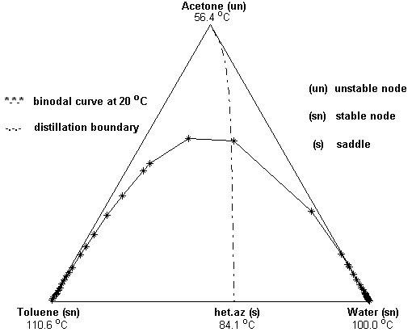
Figure 4: The system Acetone – Water –Toluene (Serafimov’s class 1.0-2)

Step 2. After building up the composition profile at the column we start decanting the two immiscible liquid phases at the middle vessel. The entrainer rich (organic) phase, containing a very small amount of water (see experimental binodal curve), is refluxed back in the column. The aqueous phase, which is almost pure water, is accumulated at the middle vessel (Figure 5b). At the end of the process the aqueous phase is collected at the middle vessel (x_{M}=0.995). The top vessel contains acetone (x_{T}=0.988) and the entrainer (toluene) is collected at the bottom vessel (x_{B}≈1). The corresponding recoveries are r_{Acetone}=100%, r_{Water}=86%, r_{Toluene}=97.3%. Detailed steady state results are given at the Appendix.
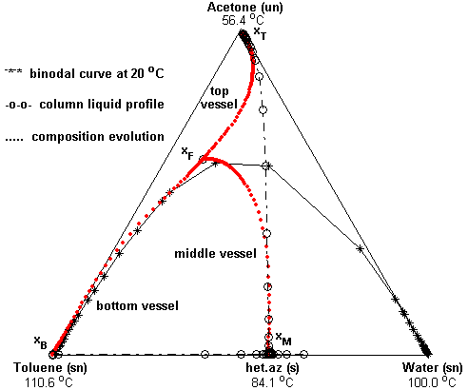
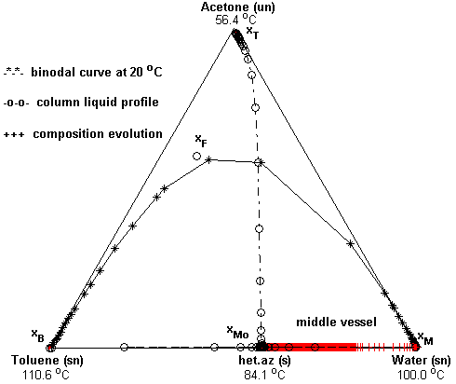

Figure 5: Separation of the system Acetone – Water – Toluene. a) Step 1 b) Step 2
4. FUTURE WORK

More heterogeneous azeotropic ternary systems will be investigated at the middle vessel distillation-decanter hybrid. The following systems exhibiting one heteroazeotrope will be a subject of future research.

Ethyl acetate – Water – Acetic Acid (Serafimov’s class 1.0-1a)
Acetic acid and water form a tangent pinch and high purity acetic acid is difficult to be recovered from its aqueous solutions. The addition of a light heterogeneous entrainer eases the separation. One such entrainer can be ethyl acetate. The corresponding distillation lines map modeled by UNIQUAC along with the stability of the stationary points is shown at figure 6a. We ignore for the moment the heterogeneous composition region and the peculiarities the distillation lines exhibit inside this region. There is no distillation boundary and the binary heteroazeotrope between water and ethyl acetate is the unstable node of the system. Thus, it will appear at the top of the column. The bottom product will be acetic acid (stable node). Depending on the feed composition the middle vessel product can be either ethyl acetate or water (saddles). If we place the feed at the right bottom feed region then pure water accumulates at the middle vessel. The heteroazeotrope at the top vessel is decanted and the aqueous phase is refluxed back in the column. Thus the top vessel is steadily enriched in ethyl acetate (until the point determined by the liquid-liquid equilibrium), while the middle vessel is enriched in water. Acetic acid remains at the bottom of the column because of low volatility. At the end of the process three pure products are accumulated at the vessels.

Water – Acetic Acid – Butyl Acetate (Serafimov’s class 1.0-1b)
In this case a heavy heterogeneous entrainer (butyl acetate) is added in the original binary mixture of water-acetic acid. The corresponding ternary phase diagram is shown at figure 6b. There exists again no distillation boundary. Water forms a heterogeneous azeotrope with butyl acetate. This heteroazeotrope is the unstable node of the system and appears at the top of the column. Butyl acetate is accumulated at the bottom and with the right placement of the feed acetic acid is possible to be collected at the middle vessel. A decanter on the top ‘breaks’ the heteroazeotrope and the entrainer rich phase is refluxed back in the column. Thus, the butyl acetate previously ‘trapped’ at the top vessel is now running down the column and enters the bottom vessel. At the end of the process the aqueous phase is collected at the top, acetic acid at the middle vessel and the entrainer at the bottom vessel.

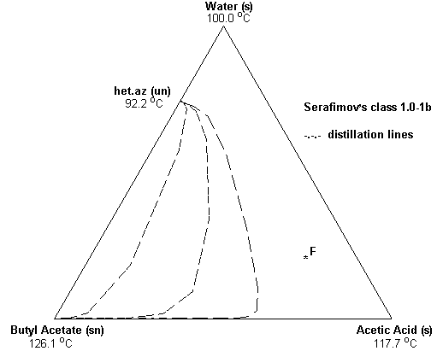
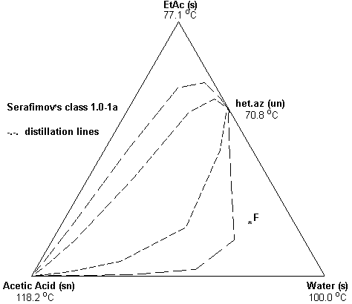

Figure 6: a) The system Ethyl Acetate – Water – Acetic Acid
b) The system Water – Acetic Acid – Butyl Acetate

5. CONCLUSIONS

Two heterogeneous azeotropic systems, both classified at Serafimov’s topological class 1.0-2, were presented at this work. The feasibility of their separation at the closed middle vessel batch distillation-decanter hybrid was investigated by simulations in Matlab.

The results for the mixture methanol-water-1-butanol (system1) proved the feasibility of the proposed novel process. The heteoazeotrope formed by water and 1-butanol was ‘broken’ by decantation, while distillation was used in order to achieve further purification of the original components. At the end of the process three pure components were accumulated at the vessels.

Results for the system acetone-water-toluene further justified the potential of the novel hybrid process. The column was used for the separation of a close-boiling temperature (tangent pinch) mixture by using a heavy heterogeneous entrainer and three pure products were accumulated at the vessels at the end of the process.

Azeotropic systems classified at Serafimov’s topological class 1.0-2 can be separated at the novel column, simultaneously in one closed operation. Future work will investigate the possibility of separating other classes of azeotropic mixtures, like for example systems belonging to Serafimov’s topological class 1.0-1a and 1.0-1b.

6. NOTATION

M | Liquid holdup (kmol)
x | Liquid compositions
r | Recoveries
1,2 | Process steps

Subscripts

F | Feed
T | Top vessel
M | Middle vessel
B | Bottom vessel
r | Rectifying section
s | Stripping section

7. LITERATURE CITED

- Robinson, C.S., Gilliland, E.R., (1950). “Elements of Fractional Distillation”. Vol. 4., McGraw Hill, New York
- Bortolini, P., Guarise, G.B., (1970). “A New Method of Batch Distillation (in Italian)”. Quad. Ing. Chim. Ital., 6, 1-9
- Treybal, R.E., (1970). “A Simple Method of Batch Distillation”, Chem, Eng., 77, 95-98
- Hasebe, S., Abdul Aziz, B., Hashimoto, I., Watanabe, T., (1992). “Optimal Design and Operation of Complex Batch Distillation Column”. Proceedings IFAC Workshop on Interactions between Process Design and Process Control, London (UK), September 1992, Perganon Press: Oxford, U.K
- Hasebe, S., Kurooka, T., Hashimoto, I., (1995). “Comparison of the Separation Performances of a Multi-Effect Batch Distillation system and a Continuous Distillation System”. Proc. IFAC Symp. DYCORD+ ’95, Elsingore, Denmark, Pergamon press, 249-254
- Hasebe, S., Noda, M., Hashimoto, I., (1999). “Optimal Operation Policy for Total Reflux and Multi-Effect Batch Distillation Systems”. Comp. Chem. Eng., 23, 523-532
- Davidyan, A.G, Kiva, V.N., Meski, G.A, Morari, M., (1994). ”Batch Distillation in a Column with a Middle Vessel”. Chem. Eng. Sci., 49 (18), 3033-3051
- Meski, G.A., Morari, M., (1995). “Design and Operation of a Batch Distillation with a Middle Vessel”. Comp. Chem. Eng., S19, S597-S602

- Barolo, M., Guarise, G.B., Ribon, N., Rienzi, S.A., Trotta, A., Macchieto, S., (1996a). “Some Issues in the Design and Operation of a Batch Distillation Column with a Middle Vessel”. Comp. Chem. Engng, 20 (Suppl.), 37-42
- Barolo, M., Guarise, G.B., Ribon, N., Rienzi, S.A., Trotta, A., Macchieto, S., (1996b). “Running Batch Distillation Column with a Middle Vessel”. Ind. Eng. Chem. Res., 35 (12), 4612-4618
- Skogestad, S., Wittgens, B., Litto, R., Sørensen, E., (1997). “Multivessel Batch Distillation”, AIChe J, 43 (4), 971-978
- Wittgens, B., Litto, R., Sørensen, E., Skogestad, S., (1996). “ Total Reflux Operation of Multivessel Batch Distillation”. Comp. Chem. Engng, S20, S1041-S1046
- Safrit, B.T., Westerberg, A.W., Diwekar, U., Wahnschafft, O.M., (1995). “Extending Continuous Conventional and Extractive Distillation Feasibility Insights to Batch Distillation”. Ind. Eng. Chem. Res., 34, 3257-3264
- Safrit, B.T., Westerberg, A.W., (1997). “Improved Operational Policies for Batch Extractive Distillation Columns”. Ind. Eng. Chem. Res., 36, 436-443
- Warter, M., Stichlmair, J., (1999). “ Batchwise Extracrive Distillation in a Column with a Middle Vessel”. Comp. Chem. Eng. Suppl., S915-S918
- Hilmen, E.K., Skogestad, S., Doherty, M.F., Malone, M.F., (1997). “Integrated Design, Operation and Control of Batch Extractive Distillation with a Middle Vessel”, Presented at AIChe Annual Meeting, Los Angeles, CA, November 1997
- Cheong, W., Barton, P.I., (1999a). “Azeotropic Distillation in a Middle Vessel Batch Column. 1. Model Formulation and Linear Separation Boundaries”. Ind. Eng. Chem. Res., 38, 1504-1530
- Cheong, W., Barton, P.I., (1999b). “Azeotropic Distillation in a Middle Vessel Batch Column. 2. Nonlinear Separation Boundaries”. Ind. Eng. Chem. Res., 38, 1531-1548
- Cheong, W., Barton, P.I., (1999c). “Azeotropic Distillation in a Middle Vessel Batch Column. 3. Model Validation”. Ind. Eng. Chem. Res., 38, 1549-1564
- Warter, M., Stichlmair, J., (2000). “ Batch Distillation of Azeotropic Mixtures in a Column with a Middle Vessel”, ESCAPE-10 Proceedings, Elsevier Science B.V., 691-696
- Hilmen, E.K., (2000). “Separation of Azeotropic Mixtures: Tools for Analysis and Studies on Batch Distillation Opeartion”, PhD Thesis, Norwegian University of Science and Technology, Norway
- Rodriguez-Donis, I., Gerbaud, V., Joulia, X., (2001). “Middle Vessel Heterogeneous Batch Distillation of an Azeotropic Mixture”, European Symposium on Computer Aided Process Engineering 11, Elsevier Science B.V., 499-2001e
- Gmehling, J., Onken, J., (1977). “Vapour-Liquid Equilibrium Data Collection”. DECHEMA Chemistry Data Series, Frankfurt am Main
- Sørensen, J.M., Arlt, W., (1980). “Liquid-Liquid Equilibrium Data Collection”, DECHEMA Chemistry Data Series, Frankfurt am Main
- Gmehling, J., Menke, J., Krafczyk, J., Fischer, K., (1994). “Azeotropic Data”, VCH, Oldenburg / FRG
26. The Math Works, Inc., (2000). “MATLAB 6.0”, www.mathworks.com

APPENDIX

Table 1: Simulation data and initial conditions

System 1: Methanol – Water – 1-Butanol
Feed composition | x_{F0} = [1/3, 1/3, 1/3]
No. of trays per section | N_{r} = 25, N_{s} = 15
Initial charge | M_{F} = 5.385 kmol
Initial condenser holdup | M_{T0} = 0.035 kmol
Initial middle vessel holdup | M_{F0} = 5.000 kmol
Initial reboiler holdup | M_{B0} = 0.250 Kmol
Trays holdup (constant) | M_{i} = 1/300 kmol
Vapor flow (constant) | V = 5 kmol/h
System 2: Acetone – Water – Toluene
Feed composition | x_{F0} = [0.6, 0.1, 0.3]
No. of trays per section | N_{r} = 65, N_{s} = 25
Initial charge | M_{F} = 5.385 kmol
Initial condenser holdup | M_{T0} = 0.035 kmol
Initial middle vessel holdup | M_{F0} = 5.000 kmol
Initial reboiler holdup | M_{B0} = 0.250 Kmol
Trays holdup (constant) | M_{i} = 1/300 kmol
Vapor flow (constant) | V = 5 kmol/h

Table 2: Simulation results

System 1: Methanol – Water – 1-Butanol

Step 1 | Condenser | Middle Vessel | Reboiler
Holdup (kmol) | 1.778 | 2.240 | 1.267
X_{Methanol} | 1.000 | 0.000 | 0.000
X_{Water} | 0.000 | 0.782 | 0.000
X_{1-Butanol} | 0.000 | 0.218 | 1.000
Recovery (%) | - | het.az | -

Step 2
Holdup (kmol) | 1.778 | 1.819 | 1.688
X_{Methanol} | 1.000 | 0.000 | 0.000
X_{Water} | 0.000 | 0.980 | 0.000
X_{1-Butanol} | 0.000 | 0.020 | 1.000
Recovery (%) | 100 | 100 | 95.8

System 2: Acetone – Water – Toluene

Step 1 | Condenser | Middle Vessel | Reboiler
Holdup (kmol) | 3.285 | 0.750 | 1.250
X_{Acetone} | 0.988 | 0.000 | 0.000
X_{Water} | 0.012 | 0.575 | 0.000
X_{Toluene} | 0.000 | 0.425 | 1.000
Recovery (%) |  | het.az

Step 2
Holdup (kmol) | 3.285 | 0.457 | 1.543
X_{Acetone} | 0.988 | 0.000 | 0.000
X_{Water} | 0.012 | 0.995 | 0.000
X_{Toluene} | 0.000 | 0.005 | 1.000
Recovery (%) | 100 | 86.0 | 97.3

Keywords: | Azeotropic mixtures
 | Heterogeneous azeotropic mixtures
 | Heterogeneous azeotropic distillation
 | Distillation-decanter hybrid
 | Hybrid processes

