Minimum energy and entropy requirements in
multicomponent distillation

Ivar J. Halvorsen¹ and Sigurd Skogestad

Department of Chemical Engineering, Norwegian University of Science and Technology, N7491 Trondheim, Norway.
1) Currently at SINTEF Electronics and Cybernetics, N-7465 Trondheim, Norway
Email: Ivar.J.Halvorsen@sintef.no, Sigurd.Skogestad@chembio.ntnu.no

ABSTRACT

In the evaluation of minimum energy consumption (1st law) we here also discuss minimum entropy production, or lost work (2nd law). This leads us to the reversible Petlyuk arrangement. However the total required heat supply is higher in this case than for the typical (adiabatic) Petlyuk arrangements, but there is a potential for further reduction by use of internal heat integration. This principle can also be applied to general arrangements (not only reversible) and we compare set of alternative distillation arrangements for a given feed example. We also conjecture that the generalised extended adiabatic (not reversible) Petlyuk arrangement require less energy than any other adiabatic arrangement at constant pressure when we consider configurations without internal heat integration. The simple Vmin-diagram is shown to be very useful in evaluating alternative arrangements, including the use of double-effect (dual pressure) heat-integrated schemes.

INTRODUCTION

What is the minimum energy requirement for separating a given multi-component mixture by distillation? This is a fundamental question of significant practical importance, yet it remains unsolved even for the case of ideal mixtures, at least when we consider the practical case with adiabatic column sections. However, we conjecture that, with constant pressure and without internal heat integration, the generalised extended adiabatic (not reversible) Petlyuk arrangement requires less energy than any other adiabatic arrangement. The energy requirement is then easily computed as the being equal to the most difficult binary split (Halvorsen 2001). The minimum energy requirement when we allow for internal heat exchange remains unknown.
However, minimum energy (1st law) is by itself not sufficient as a measure, because also the quality (temperature) of the energy matters. Specifically, we prefer a process where the energy may be supplied at a low temperature and cooling may be supplied at a high temperature. To take this into account, we also consider the entropy production or lost work (2nd law).
This leads us to the reversible Petlyuk arrangement described by Grunberg (1956), Petlyuk et. al. (1964 and 1965) and Fonyó (1974ab). An overview is also found in the textbook by King (1980). A characteristic of the reversible distillation column is that some of the heat is supplied continuously along the bottom (stripping) sections and removed along the top (rectifying) sections.
We here consider the separation of ideal mixtures for which we may assume constant relative volatility and constant molar flows and for the entropy calculations we also assume equal heat of vaporisation and negligible liquid volume compared to the gas volume. We assume infinite number of stages because this provides a lower bound on the energy requirement for ideal mixtures. In practice with a finite number of stages, the actual energy requirement may be about 10% higher. With these simplifying assumptions, analytic expressions for minimum energy and for the relative entropy production have been derived for several important distillation configurations (Halvorsen 2001). A review of the most important expressions is given in the following Error: Reference source not foundsection.

Minimum Energy and Entropy Calculations

The term adiabatic column section, as used by Petlyuk et. al. (1964), denote a column section with no heat exchange along the section. In non-adiabatic sections we can supply or remove heat continuously at any stage in the section. A reversible section is an infinite non-adiabatic section where the heat is supplied or removed in a way that eliminates mixing irreversibility between neighbouring stages. In a column arrangement we put together a number of sections, reboilers and condensers. Sections may be directly (fully thermally) coupled, by two-way liquid and vapour streams or may be coupled via condensers or reboilers. The Minimum energy is the minimum required external heat supply to reboilers and to non-adiabatic column sections. We use the total requirement for vaporisation or vapour flow as a measure of the energy requirement.

Entropy Production (2nd law)

From the 2nd law of thermodynamics the total entropy change for any natural process must be greater than zero (ΔS_{total}=ΔS_{sur} +ΔS ≥ 0). For separation of ideal mixtures into pure products, the entropy change on the process side (ΔS) is equal to the negative of the entropy of mixing N_{c} pure compounds at constant pressure and temperature (x here denotes the feed mole fraction):
$ΔS=R\sum_{i=1}^{N_{c}}{x_{i}\text{ln}(x_{i})}$ (1)
The entropy change in the surroundings (ΔS_{sur}) depends on the actual process, and can be calculated from:
${ΔS}_{\text{sur}}=−\oint{\frac{\text{dQ}}{T}}$ or ${ΔS}_{\text{sur}}=−\sum_{j}{\frac{Q_{j}}{T_{j}}}$ (2)
where dQ is the actual heat transferred at system temperature T. The integral has to be taken around the system boundaries where heat transfer to the surroundings occur. The summation on the second expression is used when the heat is supplied or removed at discrete temperature levels (Q_{j} at T_{j}), for example in a reboiler and a condenser.

For a reversible process the total entropy change ΔS_{total} is zero, or ΔS_{sur} = -ΔS. A normalized measure of entropy production is then the relative entropy production, defined here as:
$S_{r}=\frac{{ΔS}_{\text{total}}}{\left|ΔS\right|}=\frac{{ΔS}_{\text{sur}}+ΔS}{\left|ΔS\right|}$ (3)

It can be shown (Halvorsen 2001) that with the simplifying assumptions used in this paper (constant relative volatility, constant and equal heats of vaporization), the temperature-composition-pressure relationship (T-x-P) for a multicomponent mixture (see also Petlyuk (1964) for a binary mixture) is given by:
$\frac{1}{T}=\frac{R}{λ}\text{ln}(\frac{P_{\text{ref}}}{P}\sum_{i}{α_{i}x_{i}})+\frac{1}{T_{b,\text{ref}}}$ (4)

Here T_{b,ref} is the boiling point for the reference component at the reference pressure P_{ref}., λ is the molar heat of vaporisation, which is assumed equal for all components, and the universal gas constant R=8.31 [JK⁻¹mol⁻¹)].
Now we consider a column (or just a section) with constant molar vapour flow (V) and known composition and pressure in the top (T) and bottom (B). Then equation (2Error: Reference source not found) combined with (4Error: Reference source not found) gives:
${ΔS}_{\text{sur}}=λV(\frac{1}{T_{T}}−\frac{1}{T_{B}})=\text{RV}\text{ln}(\frac{P_{B}\sum{α_{i}x_{i,T}}}{P_{T}\sum{α_{i}x_{i,B}}})$ (5)

Note that this expression is independent of the heat of vaporisation, the boiling point temperatures and the absolute pressure. The component properties are solely described by the relative volatility parameter (α). In the case of constant pressure and sharp separation between a binary mixture of components L and H, (5Error: Reference source not found) is simplified to:

${ΔS}_{\text{sur}}=\text{RV}\text{ln}α_{\text{LH}}$ (6)

The entropy production in adiabatic Petlyuk arrangements can also be found by the expression for single adiabatic sections. For the ternary case (Figure 4Error: Reference source not foundc or 4d), given by the vapour flows and temperatures in the reboiler (B) condenser (T) and the sidestream stage (S), we obtain from (5Error: Reference source not found):

${ΔS}_{\text{sur}}=λ\left(V_{B}(\frac{1}{T_{S}}−\frac{1}{T_{B}})+V_{T}(\frac{1}{T_{T}}−\frac{1}{T_{S}})\right)=R\left(V_{B}\text{ln}α_{\text{BC}}+V_{T}\text{ln}α_{\text{AB}}\right)$ (7)

In the typical Petlyuk arrangement (Figure 4Error: Reference source not foundc), the vapour flow is constant from the bottom to the top of the arrangement. The required flow V=max(V_{T},V_{B}). Then ${ΔS}_{\text{sur}}=\text{RV}\text{ln}α_{\text{AC}}$ (where $\text{ln}α_{\text{AC}}=\text{ln}α_{\text{AB}}+\text{ln}α_{\text{BC}}$). Note that ΔS_{sur} (or S_{r}) is always lower for the modified arrangement with possibilities to supply or remove heat at the sidestream stage (Figure 4Error: Reference source not foundd) since: $\text{max}(V_{B},V_{T})\left(\text{ln}α_{\text{BC}}+\text{ln}α_{\text{AB}}\right)≥\left(V_{B}\text{ln}α_{\text{BC}}+V_{T}\text{ln}α_{\text{AB}}\right)$.

Minimum Energy (1st law)

Even thought the net heat supply is zero ($\oint{\text{dQ}=0}$) it is useful to distinguish between heating (dQ>0) and cooling (dQ<0). We write dQ=dQ_{H}+dQ_{C}. where the heating dQ_{H} is the positive part of dQ and the cooling dQ_{C} is the negative part of dQ. Note that the total heat supply equals the total cooling and is given by:

$Q_{H}=\oint{{\text{dQ}}_{H}=−Q_{C}=−}\oint{{\text{dQ}}_{C}}$ (8)

This is a useful measure from an energy point of view (1st law). Ideally we want to have both ΔS_{total} small (small lost work, i.e. good 2nd law performance) and small Q_{H} (small total heat supply, i.e good 1st law performance). The ideal separation process with a minimum value of Q_{H} is a reversible process with all the heating at the highest temperature (T_{H}) and all the cooling at the lowest temperature (T_{L}). The vaporisation rate (V) is related to the heat by Q_{H}= λV where λ is the heat of vaporization. For an ideal reversible process working between two temperature levels we obtain we from (2Error: Reference source not found):
$V_{\text{rev}\text{,min}}=\frac{Q_{H\text{min}}}{λ}=\frac{−ΔS}{λ(\frac{1}{T_{L}}−\frac{1}{T_{H}})}=\frac{−ΔS/R}{\text{ln}α_{\text{LH}}+\text{ln}\frac{P_{H}}{P_{L}}}$ (9)
Note that for constant pressure and sharp binary split, the relative volatility is the only required physical property.

Minimum Energy for Extended Petlyuk Arrangements

For the generalised (adiabatic) Petlyuk arrangement Halvorsen (2001) showed that the minimum energy requirement for separation of a feed mixture of N_{c} components into N_{c} pure products is given by:
$V_{\text{min}}^{\text{Petlyuk}}=\underset{j}{\text{max}}\sum_{i=1}^{j}{\frac{α_{i}z_{i}F}{α_{i}−θ_{j}}}$ , $j∈\left\{1,N_{c}−1\right\}$ (10)
Here θ_{j} are the N_{c}-1 common Underwood roots (Underwood 1948) found from (q is liquid fraction in the feed (F) and z is the feed composition):
$\sum_{i=1}^{N_{c}}{\frac{α_{i}z_{i}}{α_{i}−θ}}=1−q$ (11)
To illustrate the vapour requirements in a Petlyuk Arrangement, the V_{min}-diagram presented by Halvorsen (2001) is very useful. The diagram shows how the distribution of the feed components depend on the two degrees of freedom in a single two-product column. Figure 1 shows an example for a ternary (ABC) mixture. We choose the overhead vapour flow (V=V_{T}) and the distillate product flow (D=V-L) as the two degrees of freedom. The straight lines, which are at the boundaries when a component is at the limit of appearing/disappearing (distribute/not distribute) in one of the products, can be computed directly by Underwood’s method. The two peaks (P_{AB} and P_{BC}) give us the minimum vapour flow for sharp split between A/B and B/C. The point P_{AC}, however, is at the minimum vapour flow for sharp A/C split and this occurs for a specific distribution of the intermediate B, known as the “preferred split” (Stichlmair 88). The whole diagram can be constructed from these three points. For a real mixture, this may be done by 3 simulations with a rigorous simulator (e.g. Hysys), configured with a relative large number of stages (e.g. N=4N_{min}).

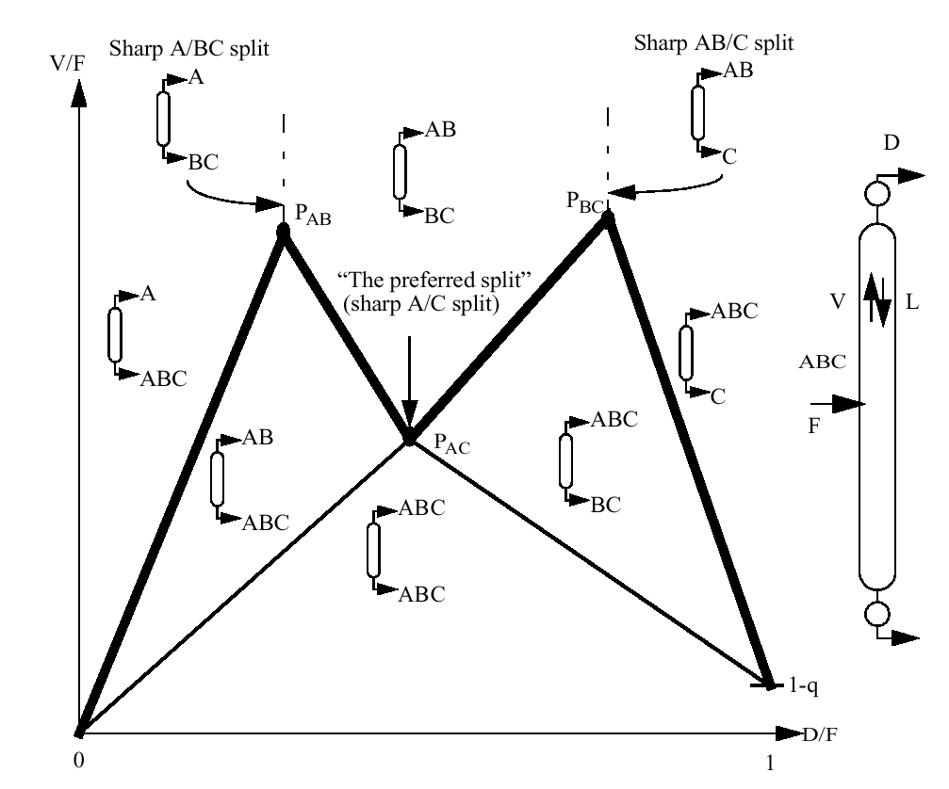
Figure 1: The V_{min}-diagram shows the distribution regions for the feed components as a function of V/F and D/F in an ordinary two-product column. The highest peak is then the minimum vapour flow for a Petlyuk arrangement.

Interestingly, as shown by Halvorsen (2001) the V_{min}-diagram, that originally shows the behaviour in a single two-product column, also contains all the required information for minimum vapour flow in every section of the integrated Petlyuk column (See Figure 4c).

Minimum vapour flow for the Petlyuk column is simply given by the highest peak (P_{BC}). Equation (10) is the exact analytical expression for this vapour flow. Note that this is exactly the same as the minimum vapour flow for the most difficult binary split (A/B or B/C). In addition, the preferred split ( P_{AC}) gives us the minimum vapour flow requirement for the prefractionator column, and the difference between the two peaks is the difference in minimum vapour flow requirements above and below the sidestream stage. In the example below, this is utilised in the configuration in Figure 4d to improve the 2nd law performance for the Petlyuk arrangement by adding or removing heat at the sidestream stage (which is an intermediate temperature) corresponding to the difference in vapour flow between these two peaks.

The V_{min}-diagram can be constructed for any number of feed components, and Halvorsen (2001) showed that the minimum vapour flow is given by the highest peak also for generalised "Petlyuk" arrangements extended to any number of products. Non-sharp product split specifications and aggregate products can also be handled.

The Best Adiabatic Arrangement without internal heat exchange

It has been conjectured (Halvorsen 2001) that the adiabatic Petlyuk arrangement, where all the heat is supplied in the bottom reboiler at the maximum temperature, requires minimum energy (V_{min}) compared to any other adiabatic distillation arrangement (without internal heat exchange). However, no proof has been found in the literature (Petlyuk 2000), except for the ternary case (Fidkowski and Krolikowski 1987). Figure 2Error: Reference source not found illustrates the result from Halvorsen (2001) that the direct (full thermal) coupling minimise the total vapour flow through the cross-sections above or below a column junction. Thus by replacing any junction with something else than a direct coupling, the vapour requirement has to increase somewhere in the arrangement. However, this is a conjecture since it has not been generally shown for all possible column arrangements.
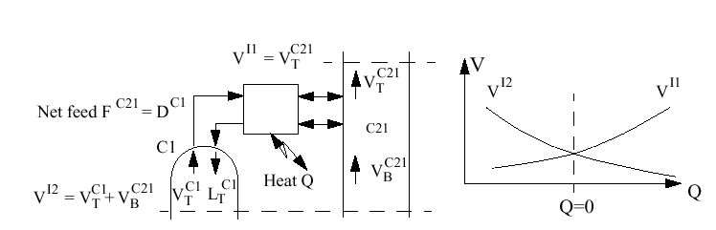
Figure 2: General column interconnection junction. The direct (full thermal) coupling minimise the flow through the intersections I1 or I2 for zero external heat exchange.

Vapour Flow in Reversible "Petlyuk" Arrangements

The sources of irreversibility in a distillation process come from mixing of fluids with different composition and temperature. This may happen at the feed stage, in the top or bottom when fluid is returned to the column, and also inside the column when there is a composition difference between neighbouring stages. In adiabatic distillation, there will always be a set of stages inside the column sections with significant composition differences resulting in irreversible inter-stage mixing, even with infinite number of stages.
To obtain reversible operation we consider infinite non-adiabatic sections. We assume that at any stage (n), there is a local pinch zone with constant composition (i.e. x_{n}=x_{n+1}) such that we obtain reversible mixing between neighbouring stages. Then the material balance for component (i) at an arbitrary stage is given by:
${\text{Vy}}_{i}−{\text{Lx}}_{i}=w_{i}$ (12)
Note that the net component flow w_{i} is always constant inside any type of section. From (12) we get the requirement for vapour flow through the stages. In the top:
$V_{T}=\frac{w_{i}−x_{i}D}{y_{i}−x_{i}}$ (13)
Note that this expression is valid for any component (i). The net product flows are trivially given by $D=V_{T}−L_{T}=\sum{w_{i,T}}$in the top and $B=L_{B}−V_{B}=−\sum{w_{i,B}}$in the bottom.
For each internal column in the arrangement, the net product flows (w_{i}) and minimum vapour flow through the feed stage (subscript F) can be computed in the same way as for ordinary columns, where a pinch zone is assumed across the feed stage. This implies that the feed component distribution and vapour flow through the feed stage in the reversible column is the same as in the prefractionator of the adiabatic Petlyuk column. Just as in the Petlyuk arrangement, only one component is removed in the top and one in the bottom in each internal column. To compute the vapour flow in the succeeding columns to the prefractionator, we need to compute the pinch-zone composition in the junction. Interestingly, along a reversible section the mole fraction of an arbitrary component (i) depends linearly of the composition of the one to be removed. Assume component (k) is the heavy component and is to be removed in the top. Then:
$x_{i}=x_{i,F}\left(\frac{1−x_{k}}{1−x_{k,F}}\right)$ => $x_{i,T}=x_{i,F}\left(\frac{1}{1−x_{k,F}}\right)$ (14)
Combined with the vapour-liquid equilibrium y=f(x) all the variables in equation (13) is now known, and the vapour flow profile can be computed. For x_{k}=0, equation (14) also gives the composition in the top of the prefractionator, which is identical to the feed stage composition in the succeeding column. The procedure may then be repeated for any number of succeeding columns in a general multicomponent system.

TERNARY SEPARATION EXAMPLE

To illustrate the results we consider the energy requirement, given in terms of the total produced vapour rate per unit feed V/F and the entropy production, given in terms of the relative entropy production S_{r}=ΔS_{total}/ΔS where ΔS is the entropy change for the process (entropy of mixing for feed), and ΔS_{total} is the total entropy production when a particular process is applied.

We consider the separation of an equimolar saturated liquid ternary feed with constant relative volatility (α=[4;2;1] between the components A, B and C). From (1) the entropy change of the process is ΔS = 8.31⋅ ln (1/3) = -9.13 J/K mol. With all external heat supplied at the boiling point of the heavy component (C) and all external cooling supplied at the boiling point of the light component (A), the theoretical minimum energy requirement for a reversible process separating this mixture is from (9) V/F = - ln (1/3) / ln 4 = 0.793, but achieving this value requires reversible distillation plus the use of heat pumps.

The considered distillation configurations are shown in Figures 3,4 Error: Reference source not foundError: Reference source not foundand 5Error: Reference source not found Figure 3Error: Reference source not found shows two-column configurations where one of the feed components is separated as a pure product in the first column. Figure 4Error: Reference source not found and 5Error: Reference source not found show prefractionator arrangements, where the first column performs a sharp A/C split while the intermediate B is distributing to both products. Figure 5Error: Reference source not found shows prefractionator arrangements with internal heat integration. The results are briefly discussed below and are summarised in Table 1Error: Reference source not found.
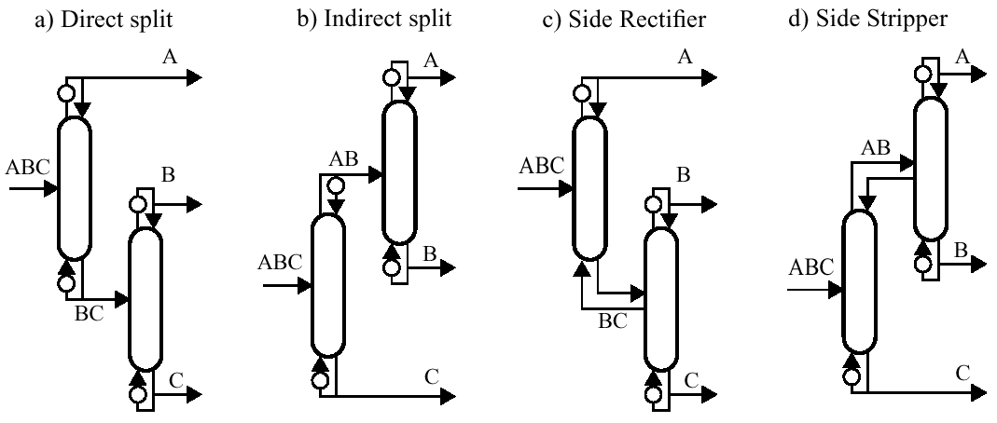
Figure 3: Conventional two-column configurations for separation of ternary mixtures. No internal heat integration is applied.

Let us first consider the conventional “direct split” arrangement with two two-product columns (Figure 3Error: Reference source not founda). Here we take in the first column A as the top product and the remaining mixture of B/C as the bottom product. The second column separates B and C, and we get B in the top and C in the bottom. The total energy requirements in the two column reboilers is V/F=2.072 and the entropy production is S_{r}=0.59. Some energy reduction may be achieved with the “indirect split” (Figure 3Error: Reference source not foundb) where we in the first column take C as the bottom product and A/B as a vapour top product. The second column separates A and B. Here V/F=2.032, but the entropy production is higher, S_{r}=1.21, because the temperature difference between heat supply and cooling is larger. The directly coupled side rectifier and side stripper performs better in terms of minimum energy (both have V/F=1.882), but the direct split configuration has still lower entropy production (Table 1Error: Reference source not found).

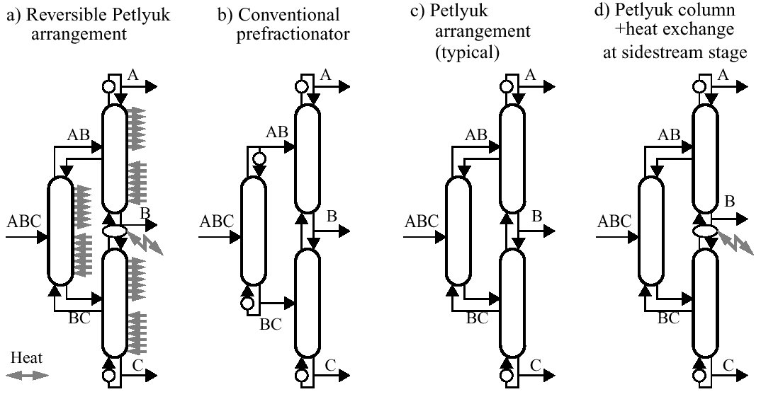
Figure 2: Prefractionator arrangements (three two-product columns) for separation of ternary mixtures. No internal heat integration is applied.

The fully reversible arrangement shown in Figure 4Error: Reference source not founda is ideal in therms of entropy production (Sr=0.0), but the total amount of heat supplied in the reboiler and along the bottom sections of the three internal columns (V/F=1.667) is higher than for the other prefractionator arrangements in Figure 4Error: Reference source not found. However, much of the heat is supplied at lower temperatures. The conventional prefractionator arrangement in Figure 4Error: Reference source not foundb is also interesting since it may approach the Petlyuk column in terms of minimum energy (V/F=1.556) and the entropy production, (S_{r}=0.63) is approaching the result by the direct split configuration (Figure 3a).
The adiabatic directly coupled Petlyuk column with a single reboiler as shown in Figure 4Error: Reference source not foundc achieves V/F=1.366. This is more than 30% energy reduction compared to the conventional direct split configuration and the Petlyuk column is the best adiabatic arrangement in terms of energy (Halvorsen 2001). However, the entropy production remains high, S_{r}=0.72, because all the heat is supplied at the highest temperature (boiling point of component C) and all the cooling is at the lowest temperature (boiling point of component A). However, in this case, the vapour requirement above the sidestream is lower than below, so we may take out some heat at the intermediate boiling point (component B) by condensing some vapour at the sidestream stage and thereby reduce the entropy production to S_{r}=0.54. Thus, the modified Petlyuk arrangement in Figure 4Error: Reference source not foundd performs better than the direct split configuration (Figure 3Error: Reference source not founda) also in terms of entropy production.
To further reduce the energy requirements we must allow for internal heat exchange. For example (Figure 5Error: Reference source not foundb), for this specific mixture we may in the Petlyuk column preheat the feed with the sidestream product and achieve V/F=1.181 and Sr=0.49.
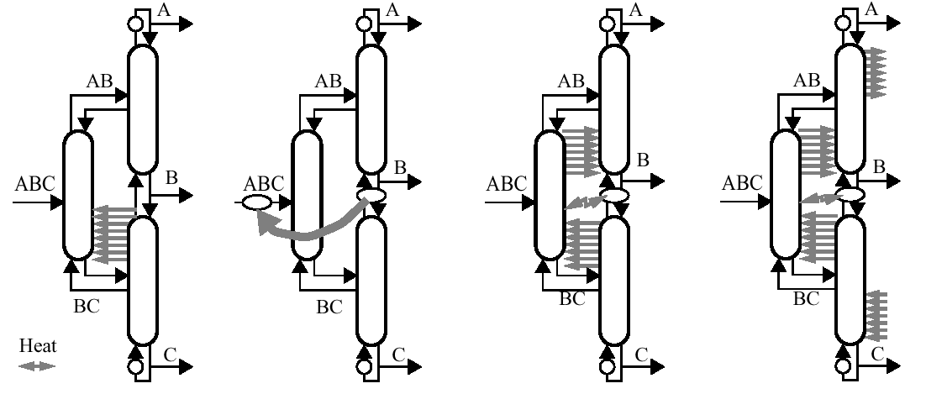
Figure 5: Directly coupled ternary arrangements where internal heat integration is used to reduce both external heat supply and loss of separation work.
To significantly reduce the energy consumption further we must allow for non-adiabatic sections with continuous heat exchange. For example, for this specific mixture, if we allow for heat exchange between the middle four sections in the Petlyuk column (Figure 5Error: Reference source not foundc), then we may achieve V/F=1.000 and S_{r}=0.26. A practical case, which is more realistic, is a Dividing Wall Column (DWC) where we allow heat exchange across a part of the dividing wall (equivalent to Figure 5aError: Reference source not found). In the given example, heat transfer below the sidestream is achievable and with ideal heat transfer the vapour supply an be reduced to V/F=1.22 but with S_{r}=0.54. Lestak et al. (1994) considered heat transfer across the wall for a given case, and it was found that it could be beneficial to allow for heat transfer along a part of the dividing wall and insulate the other part. But the overall reduction in heat input was found to be small.
To achieve further reductions let us again consider the reversible distillation process in Figure 4Error: Reference source not founda where the entropy production is zero, S_{r}=0. We may introduce internal heat pumps (not shown) so that all external heat supply is at the highest temperature. According to equation (9) we may in this way reduce the external energy requirement to V/F=0.793, which is the theoretical minimum for the separation of this mixture by distillation at constant pressure.

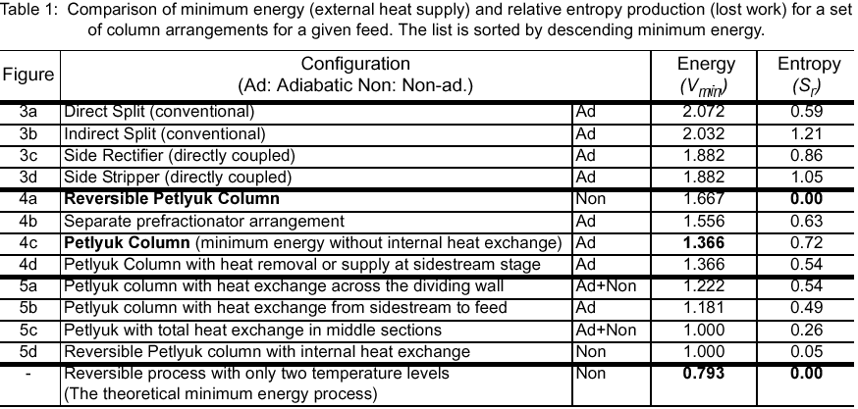

Operation at Several Pressure Levels - Double Effect Columns

In all the examples above we have considered constant pressure, and thereby the same temperature range given by the boiling points of the most heavy and light components. By increasing the temperature range, e.g. by operating at several pressure levels, it is possible to reduce the external energy requirement further.
Figure 6 shows the result for the same feed as in the example above for two types of double effect columns. For the direct split (Figure 3a) we can with a double-effect heat integration reduce V/F from 2.072 to 1.072, and for the prefractionator configuration (Figure 4b) reduce V/F from 1.556 to 0.778. Note that these values for the double effect configurations are directly obtained from the Vmin-diagram. Here the pressure levels are adjusted to the ideal case of zero temperature difference in the internal heat exchangers. The relative entropy production (S_{r}) is the same as for the corresponding configuration without internal heat exchange.
However, note that in the double effect configurations all the heat is supplied at the highest temperature and is removed at the lowest temperature, and, more importantly, that the temperature ranges for are wider than for the cases with a single constant pressure. Thus, the vapour flows are not directly comparable since the minimum energy target for an ideal reversible process (equation 9) also decreases with increasing temperature range. It may be better to compare the ratio V_{min}/_{Vrev,min}. For the case study we find that V_{min}/_{Vrev,min} is 1.63 for both of the two double effect configurations, which is still better than the ratio of 1.72 for the Petlyuk configuration with a single pressure.

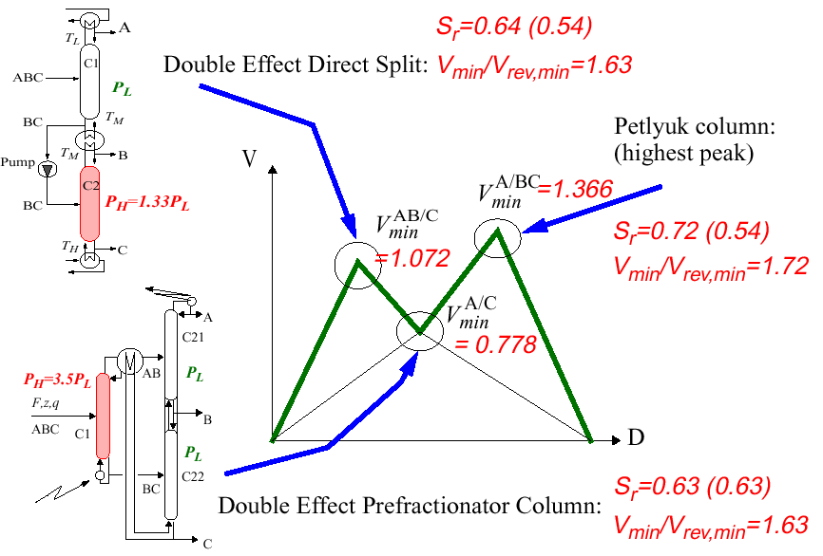
Figure 6: The V_{min}-diagram is very effective for assessing double-effect arrangements. (The numbers in brackets are for cases when additional external heat is supplied/removed in the internal heat exchangers or at the sidestream stage in the Petlyuk column to obtain minimum vapour in every individual column section).

CONCLUSION

Reversible distillation gives valuable insight in the energy requirement for multicomponent distillation. However, even if the reversible arrangement is optimal with respect to entropy production or lost work (2nd law), we may have irreversible (adiabatic) systems with less energy consumption (1st law). Without considering any internal heat exchange, the adiabatic Petlyuk arrangement seems to achieve less minimum energy requirement than any other distillation system.
Internal heat exchange can be used for further reduction of the minimum external energy (heat supply). Heat exchange can be applied in any system where the temperature ranges where we need heat supply overlaps temperature ranges where heat is available. Thus, it can be applied for the ideal reversible arrangement as well as for the adiabatic Petlyuk column and also for conventional column arrangements. With a given total temperature range, the minimum energy target can be defined by a theoretical reversible distillation process where all the energy is supplied at the highest temperature and removed at the lowest temperature.

The simple Vmin-diagram has been shown to be very powerful in evaluating alternative distillation arrangements.

REFERENCES

- Fidkowski, Z. and Krolikowski, L. (1987). Minimum Energy Requirements of Thermally Coupled Distillation Systems. AIChE Journal, Vol. 33, No. 4.
- Fonyó, Z. (1974a). Thermodynamic analysis of rectification I. Reversible model of rectification. Int. Chem. Eng, Vol. 14, No 1, pp 18-27
- Fonyó, Z. (1974b). Thermodynamic analysis of rectification. II. Finite cascade models. , Int. Chem. Eng, Vol. 14, No 2, pp 203-210
- Grunberg, J.F. (1956). The reversible separation of multicomponent mixtures. Proceedings of the 1956 Cryogenic Engineer-ing Conference, Boulder, Colorado
- Halvorsen, I.J. (2001). Minimum Energy Requirements in Complex Distillation Arrangements. NTNU Dr. ing. Thesis, NTNU 2001:43. Available from http://kikp.chembio.ntnu.no/thesis/download/2001/halvorsen/
- King. C.J. (1980). Separation Processes, McGraw-Hill 1980, 2nd edition.
- Lestak, F., Smith, R., Dhole, V.R. (1994). Heat transfer across the wall of dividing wall columns. Trans. IChemE, Vol. 72, Part A, September 1994.
- Petlyuk, F.B., Platonov, V.M., Girsanov, I.V. (1964). The design of optimal rectification cascades. Khim. Prom. No. 6, 45 (445-453)
- Petlyuk, F.B., Platonov, V.M., Slavinskii, D.M. (1965). Thermodynamically optimal method for separating multicomponent mixtures. Int. Chem. Eng. Vol. 5, No. 3, pp 555-561
- Petlyuk, F.B. (2000), Personal communication.
- Stichlmair, J. (1988), Distillation and Rectification, Ullmann's Encyclopedia of Industrial Chemistry, B3, 4-1 - 4-94, 1988
- Underwood, A.J.V. (1948), Fractional Distillation of Multi-Component Mixtures. Chemical Engng. Progr. Vol. 44, no. 8.

