Plant-wide disturbance assessment with an application on a paper making process

Di Zhang*, Hui Cheng, Sirkka-Liisa Jämsä-Jounela
* Helsinki University of Technology, Laboratory of Process Control and Automation, Department of Biotechnology and Chemical Technology, P.O.Box 6100, 02015, Finland
( e-mail:dizhang@cc.hut.fi).
Abstract: Control performance assessment for a single control loop has been well established. However, the methods developed for the single control loop are not adequate to make diagnosis for the whole plant, because the control loops and equipments are interacting with each other. Several methods for the plant-wide disturbance detection and diagnosis are available, but they are mostly concentrated on a particular type of disturbance. In this paper, the methodology for the plant-wide disturbance assessment is proposed, in which the plant-wide disturbance detection and root cause diagnosis are integrated together. A case study on a paper making process is presented and finally the results are discussed.
Keywords: Plant-wide disturbance assessment; disturbance detection; root cause diagnosis; paper making process; control performance assessment.

1. INTRODUCTION
Early detection and diagnosis of occurrence of an abnormal event in an operating plant helps to avoid low product quality, high manufacturing costs and maintain process safety. For this purpose, single-input-single-output control loop performance assessment and benchmarking techniques have been developed and well established. However, in a typical industrial plant, there are hundreds of control loops and equipments working together, and they are interlinking instead of being isolated from each other. Therefore methods have been developed lately for the plant-wide range disturbance detection and root cause diagnosis. A review on the available methods for both plant-wide disturbance detection and root cause diagnosis is given by Thornhill and Horch (2007). In addition, the limitations of some methods applied for the plant-wide oscillation disturbance detection and diagnosis are summarized by Tangirala et al. (2007).
In this paper, a general plant-wide disturbance assessment methodology is proposed for integrating the existing methods on plant-wide disturbance detection and root cause diagnosis into a coherent system. The methodology is illustrated on a paper making case study implemented in the APROS Paper simulator.
The paper is organized as follows: reviews on the plant-wide disturbance detection and root cause diagnosis are given in section 2. The methodology on the plant-wide control performance assessment is proposed in section 3. In section 4, this methodology is applied on a case study of a paper making process. Finally, section 5 shows the results of the case study and conclusions are given in section 6.
2. PLANT-WIDE DISTURBANCE DETECTION AND ROOT CAUSE DIAGNOSIS
2.1 Plant-wide Disturbance Detection
Plant-wide disturbance detection is applied to detect the disturbed variables among all the variables along the whole plant. The available plant-wide disturbance detection methods can be classified based on the feature of the disturbance. Three groups of the methods can be identified: oscillating disturbance detection methods, oscillating and non-oscillating disturbance detection methods and the methods for non-stationary disturbance detection.
The oscillation disturbance detection methods include the time-domain methods, the auto covariance function (ACF) methods and the spectral peak detection methods. Examples of the time-domain methods are presented in Hägglund (1995) and Salsbury and Singhal (2005). In Hägglund (1995) the integrated absolute error (IAE) based method monitors the IAE value of the control error between successive zero crossings of the control error to decide the presence of oscillation. In Salsbury and Singhal (2005), the poles in an Auto-Regressive Moving Average (ARMA) process are estimated by using a higher-order crossing such that the conjugate pairs of poles can be transferred to the damping ratio values in order to detect the presence of oscillatory modes in the signal. Miao and Seborg (1999) present an ACF based method where the sample autocorrelation coefficients of the measured output and the damping ratio are calculated as the oscillation index. In Thornhill et al. (2003), a method utilizing the zero-crossings of the filtered ACF is presented and used in the detection of the multiple independent oscillations present in a plant. As a benefit of this approach, the effect caused by white noise can be reduced. Also the peak features of the dominant frequency components hidden in the spectral of the perturbed controller outputs can be extracted to aid the oscillation detection.
Oscillating and non-oscillation disturbance detection methods are mainly spectral methods. In Thornhill et al. (2002), a method based on the spectral principal component analysis is proposed, where the measurements with similar long-term deviations are classified according to their power spectra to the groups even though there is the time delay between measurements. In Xia and Howell (2005), a detection method on the basis of the independent component analysis is proposed to isolate multiple sources of plant-wide oscillations. In Xia et al. (2007), a method based on a non-negative spectral decomposition is provided and used to extract non-negative spectral peaks and to map multiple oscillatory sources onto the most appropriate control loops. In Tangirala et al. (2007) the non-negative matrix factorization method is proposed for oscillation detection with the application on the image analysis and document clustering. Another method based on the power spectral correlation map developed in Tangirala et al. (2005) is used for plant-wide oscillation detection. In addition a simple clustering algorithm to group variables with similar power spectral shapes was developed. Jiang et al. (2006) propose a spectral envelope method for detecting and classifying process measurements with the similar spectral features.
For the non-stationary disturbance detection, a commercial Wavelet analysis tool Time2Wave is proposed in Matsuo et al. (2003). The plant-wide disturbance detection methods are summarized by a family tree in Fig.1 provided by Thornhill and Horch (2007).
2.2 Root cause diagnosis
Root cause diagnosis is used to locate the cause which leads to the plant-wide disturbance or unsatisfied performance. The root cause diagnosis methods can be classified into non-linear cause methods and linear cause methods.
The non-linear root cause diagnosis methods include non-linear time series analysis, limit cycle, and valve diagnosis methods. In Choudhury et al. (2004) a non-linear time serials method is proposed, which uses the bicoherence to detect the presence of the non-linearity in the process data. In Zang and Howell (2004), the correlation dimension and maximal Lyapunov exponent are combined with knowledge of the harmonic propagation of plant-wide oscillations to locate the source of the non-linearity. In Srinivasan et al. (2005), a method on the base of identification of the Hammerstein model of the system is proposed and used for diagnosing stiction. For the limit cycle methods, a method on the base of harmonics is provided in Zang and Howell (2007), where a bi-amplitude ratio is proposed to quantify harmonic attenuation or amplification as the oscillation propagates. The valve diagnosis methods can be grouped according to the existence of the intervention. The methods without intervention include: in Horch (1999) and Kano (2004). In Horch (1999), the cross correlation between control input and process output is calculated and used to diagnose external oscillatory disturbance and stiction in control valves. In Kano (2004), the waveform shape of the simulated data generated by using the model is compared with that of the operating data that suffers from valve stiction. An example of the intervention methods is proposed by Choudhury et al. (2005), which is used for confirming the.stiction valves. The non-linear diagnosis methods mainly diagnose the problems caused by control valves with excessive static friction, on-off and split-range control, sensor faults, process non-linearities and slugging flows.
The linear diagnosis methods mainly include tuning methods and interaction or structural methods. For the tuning methods, overall loop performance index (OLPI) is provided in Xia and Howell (2003), which uses a variance index to localize a single fault in a multi-loop arrangement. The loop with the largest OLPI value is marked as the most probable loop containing the root cause variable. The variance index method can also be used for the interaction/ structural diagnosis. For the interaction or structural methods, the causal diagraph method diagnoses the root cause of the deviation detected in the evolution of the variables of a plant. With this method, the primary fault and the fault propagation path can be identified as shown in Cheng et al. (2008). Another causal digraph method is provided in Bauer and Thornhill (2008), which used a cross correlation function to identify the disturbance propagation path. In Bauer et al. (2004) the propagation path of the disturbance is identified in a causal digraph using the transfer entropy method, which can measure directionality of the variation with respect to time. The linear diagnosis methods mainly diagnose the problems caused by poor controller tuning, controller interaction and structural problems. The root cause diagnosis methods are shown in the family tree in Fig 2 provided by Thornhill and Horch (2007).

Fig. 1. Family tree of the plant-wide disturbance detection methods by Thornhill and Horch (2007)

Fig. 2. Family tree of methods for data-driven plant-wide root cause diagnosis by Thornhill and Horch (2007)
3. METHODOLOGY FOR PLANT-WIDE DISTURBANCE ASSESSMENT
The methodology for plant-wide disturbance assessment proposed is this paper contains disturbance detection and root cause diagnosis. An overall picture of the methodology is shown in the upper flowchart in Fig. 3.
Firstly, data which includes measurements, set-points and reference data, is collected. Secondly, disturbance detection is carried out. The disturbance detection methods summarized in section 2 are shown in the middle of Fig. 3.If more than one variable are detected as being disturbed, they are grouped according to the similar dynamic behaviour. Thirdly, the root cause diagnosis is applied to the groups respectively, since the root cause variable in each group must be among the group members. The initial step for the root cause diagnosis is the disturbance type identification. Then the corresponding methods are selected from the family tree shown in the end of Fig. 3. If it is a linear cause, two groups of methods are available, tuning diagnosis and interaction/structural diagnosis. For the plant-wide approach, the focus is more on the interaction/structural diagnosis, and a causality method has been developed for this approach. On the other hand, if it is a non-linear cause, there are three groups of methods for this branch, valve diagnosis methods, limit cycle methods and non-linear time series analysis methods.
4. CASE STUDY ON A PAPER MAKING PROCESS
4.1 Testing Environment
In this work, the plant-wide process control assessment has been applied on a part of the paper making process implemented in the APROS (Advanced Process Simulation Environment) simulator developed by VTT, Technical Research Centre of Finland. The process chosen is the formation part of the paper making process which begins with the pulp slush. The pulp slush is distributed across the width of the machine and lengthwise of the sheet in the head box. Next the pulp slush is deposited onto a moving screen. Web is formed in the former and a wire section dewaters the pulp. The web is further dewatered and compressed in the wet press section. Finally, the web is dried to a temperature-moisture content range in the drying section.
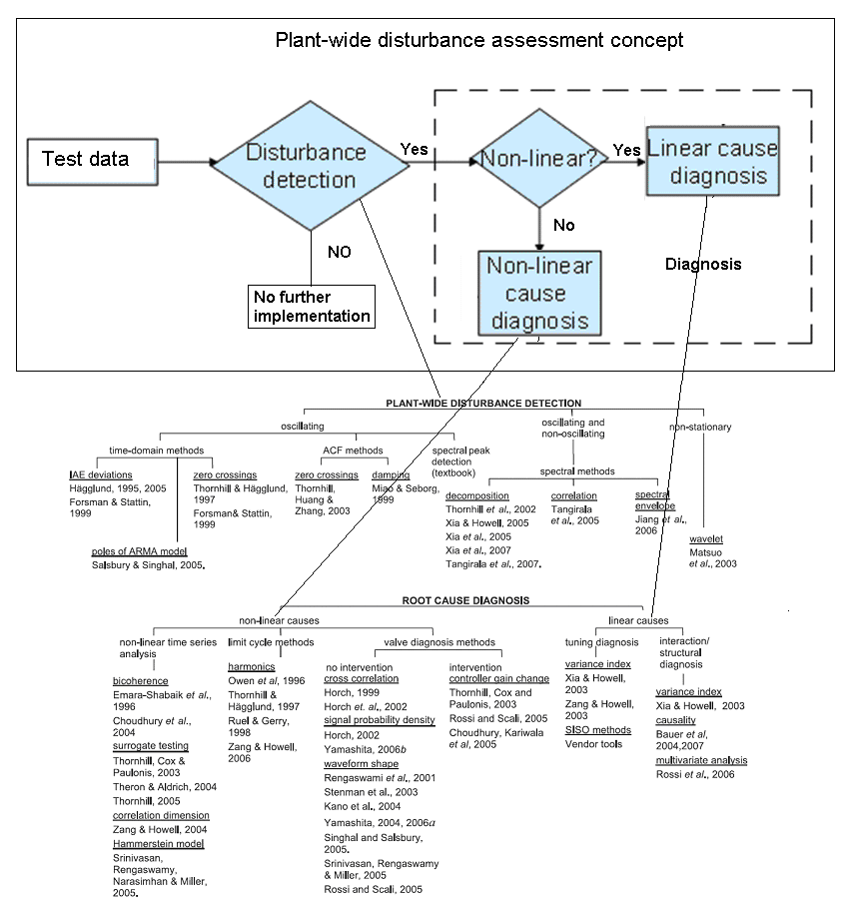
Fig. 3. General plant-wide disturbance assessment
4.2 Plant-wide Disturbance Assessment for the Paper Making Process
The plant-wide process assessment procedure begins with detecting the plant-wide disturbance, after which the disturbed variables are grouped. For this case study, oscillation is under concern and the IAE and ACF method are used for disturbance detection.
If the IAE result is bigger than a threshold, it can be taken as a disturbance instead of noise. And if the disturbance happens more frequently than a boundary value, it is detected as oscillation. The variables with oscillation are grouped according to the oscillation frequency and power spectra frequency is in use. The linearity identification is applied on the grouped variables and one non-linearity index mentioned by Choudhury et al. (2004) is in use. The existence of non-linearity in a system can be decided by the Gaussian test and the nonlinearity test. If the signal is non-Gaussian it goes through another test to determine its linearity. The nonlinearity index (NLI) is provided as shown in (1).
$\text{NLI}\overset{}{=}|b\hat{i}c_{\text{max}}^{2}−(b\hat{\bar{i}}c^{2}+2σ_{{\text{bi \{}\hat{c}}^{2}})|$ (1)
where $\text{bic}$ is the bicoherence and $σ_{b\hat{i}c^{2}}$is the standard deviation of the estimated squared bicoherence and $b\hat{\bar{i}}c^{2}$is the average of the estimated squared bicoherence. The signal generating process can be assumed to be linear if the value of the NLI is approaching zero. If the process is identified as linear, the root diagnosis path presented by Bauer and Thornhill (2007) is applied to find the disturbance propagation path and to build the causal diagraph. In case the propagation path is simple, for example, the path has a linear form, the root case variable can be obtained immediately when the causal diagraph is formed.
For the complex cases, the following steps are proposed. The transfer functions between each pair of the related variables are identified and the defined causal diagraph is built. The fault free data can be used to identify the transfer functions between the related variables indicated by the preliminary causal diagraph. Then the transfer functions achieved are added to the preliminary causal diagraph to build the defined causal diagraph. The root cause diagnosis is implemented through the global and local residual calculations. The secondary and preliminary faults are then distinguished and the root cause variable is indicated.
The overall procedure for the proposed plant-wide process control concept is shown in Fig. 4 in the case of the linear root cause.
5. RESULTS
5.1 Disturbance Detection
For the case study, the basis weight valve is under concern. The poor performance of the basis weight valve can affect the web dry basis weights along the whole paper making process. The seven variables related to this process is selected for plant-wide process monitoring as described in Table 1 and shown in Fig. 5.
Ten thousand observations of the seven variables are used with the sampling time being one second. Three thousand observations are shown in Fig. 6, data of each variable are mean centred and scaled to unit standard deviation. ACF for each variable is calculated, IAE and ACF methods are applied and the oscillation feature can be visualized. The lower plot in Fig. 6 shows the spectra frequency features presenting that all the seven variables have a similar power spectra. The most obvious plant-wide disturbance is the oscillation with a frequency of 0.0033$s^{−1}$ which affects all the seven variables.
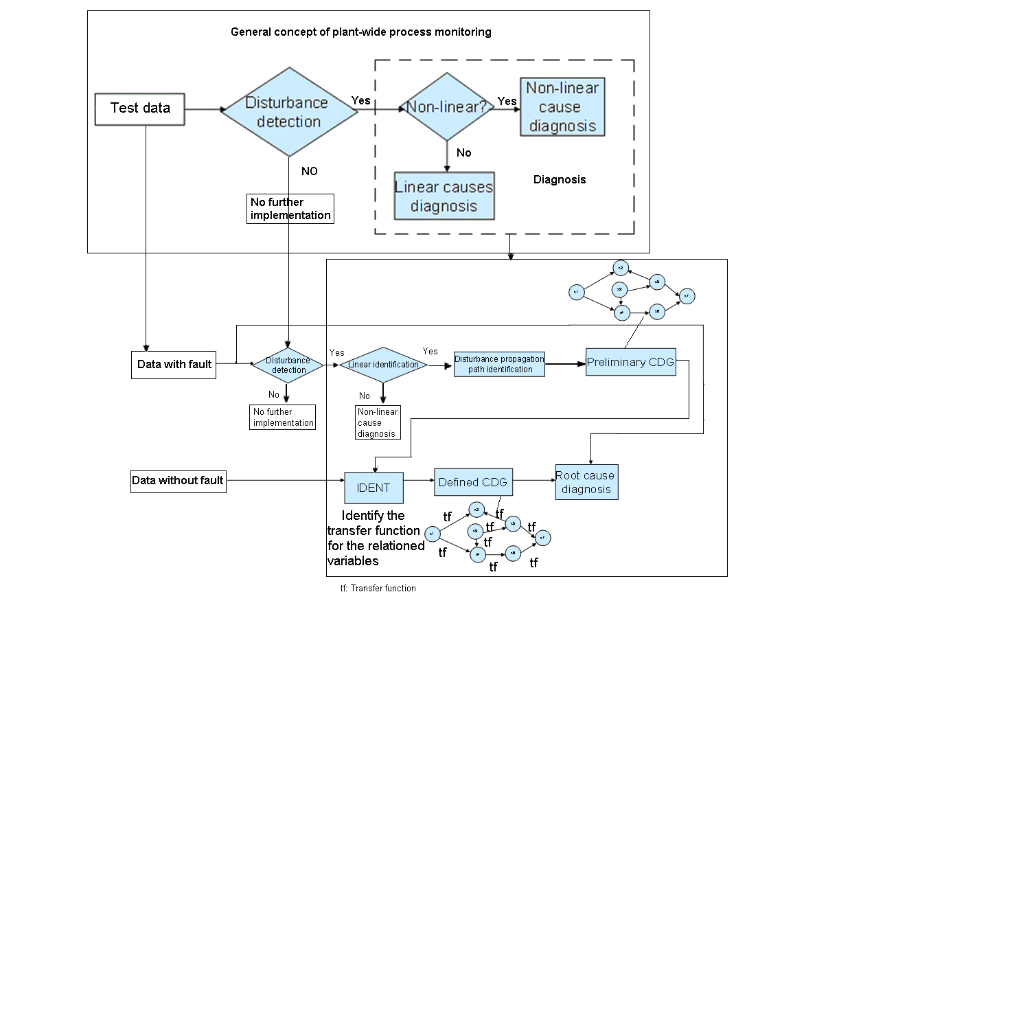
Fig. 4. Flowchart for the proposed methodology
5.2 Root cause diagnosis
Fig. 7. shows the squared bicoherence calculated for V1 (basis weight valve opening) in the case study. The symbols f1 and f2 represent frequency, and the unit is $s^{−1}$. It can be seen that around the frequency of 0.0033$s^{−1}$which is the frequency of the oscillation detected in the disturbance detection part, the values of the squared bicoherence do not vary much. And all the other variables have similar plots. When the squared bicoherence is almost constant, the index is close to zero. Hence the signal generating process is confirmed to be linear.
The Cross-correlation function (CCF) method for propagation path identification provided by Bauer and Thornhill (2007) is applied for root cause diagnosis. The time delays of each pair of variables are calculated, and the initial causality matrix of the case study is formed accordingly. It is shown as:
$Λ=\left[\begin{matrix}− & \text{51} & \text{52} & \text{52} & \text{61} & \text{64} & \text{95} \\ & − & 1 & 1 & \text{10} & \text{13} & \\ & & − & 0 & \text{10} & \text{10} & \\ & & & − & 9 & \text{12} & \\ & & & & − & 3 & \\ & & & & & − & \\ & \text{49} & \text{50} & \text{50} & 5 & \text{62} & −\end{matrix}\right]$ (2)
For example, from the matrix, the value in the row one and the column three is the time delay of V3 (web dry basis weight after the former) relative to V1 (basis weight valve opening), which means V3 is 52 seconds later than V1. And also after the correlation testing and directionality analysis, all the seven variables are indicated as correlated and each direction index is bigger than the threshold.
Table 1. Description of the chosen variables for plant-wide process monitoring.
Variables | Description | Unit
V1 | basis weight valve opening | 0-1
V2 | web dry basis weight after the head box | $$g/{m^{2}}$$
V3 | web dry basis weight after the former | $$g/{m^{2}}$$
V4 | web dry basis weight after the press section | $$g/{m^{2}}$$
V5 | web dry basis weight after the first 3 drying group | $$g/{m^{2}}$$
V6 | web dry basis weight after the 4th drying group | $$g/{m^{2}}$$
V7 | web dry basis weight after the 5th drying group | $$g/{m^{2}}$$

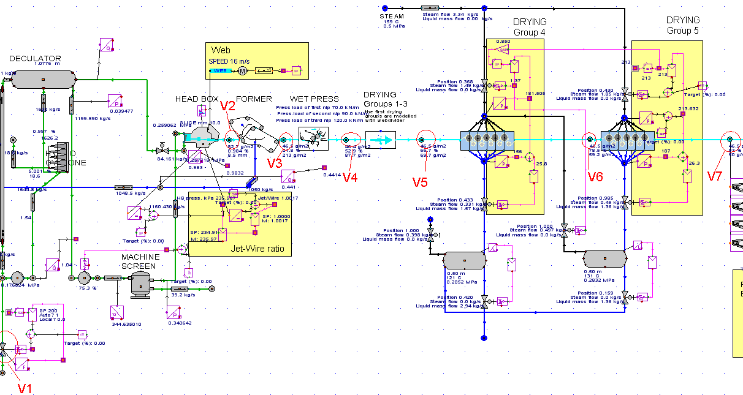
Fig. 5. Seven variables are marked with circles in a paper making process of the APROS simulator interface.

.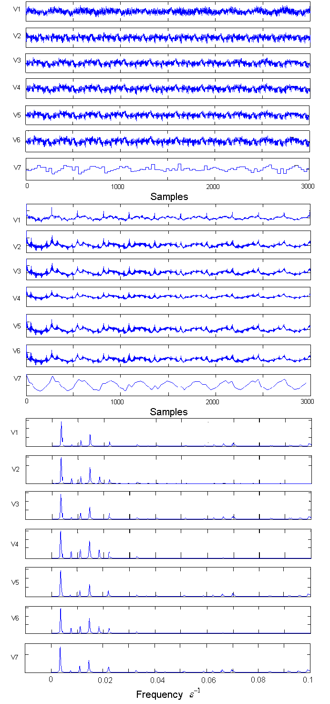
Fig. 6. Data set. Upper panel: time trends. Middle panel: ACF. Lower panel: power spectra.
Fig. 7. Bicoherence calculation for V1.

After consistency checking, V7 is deleted and the final causality matrix is given as:
$Λ=\left[\begin{matrix}− & \text{51} & \text{52} & \text{52} & \text{61} & \text{64} \\ & − & 1 & 1 & \text{10} & \text{13} \\ & & − & 0 & \text{10} & \text{12} \\ & & & − & 9 & \text{12} \\ & & & & − & 3 \\ & & & & & −\end{matrix}\right]$ (3)
The verified causality matrix achieved thus has six entries above the main diagonal and six in the first row. For the values in the first row, they increase one by one, thus the causal graph should be like a string of beads as shown in Fig. 8. From the causal diagraph, V1 is most likely to be the root cause variable. V1 is the basis weight valve opening, thus the root cause might be related to the valve.
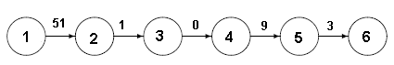
Fig. 8. Causal diagraph of the case study.

6. CONCLUSIONS
In this paper, the plant-wide disturbance assessment methodology integrating disturbance detection and diagnosis has been proposed and tested on the paper making process provided by APROS. After the whole implementation procedure, the plant-wide disturbance in the form of oscillation is detected and the candidate root cause variable is found. The result is correct according to the initial setting, since the plant-wide disturbance is formed by adding noise to V1, the basis weight valve opening. Thus it indicates the proposed concept can work well for the plant-wide disturbance assessment in a simple case. The results provide a promising beginning for the later improvements in this area although there are still some challenges.
ACKNOWLEDGEMENTS
The authors gratefully acknowledge VTT for making available the APROS simulator.

REFERENCES
Bauer, M and Thornhill, N.F. (2008). A practical method for identifying the propagation path of plant-wide disturbances, Journal of Process Control, 18, 707-719.
Bauer, M., Thornhill, N. F. and Meaburn, A. (2004). Specifying the directionality of fault propagation paths using transfer entropy. DYCOPS 7 conference, Boston, July 5–7, 2004.
Cheng, H., Nikus, M., and Jämsä-Jounela, S.L. (2008). Fault diagnosis of the paper machine short circulation process using novel dynamic causal digraph reasoning, Journal of Process Control, 18, 676-691.
Choudhury, M.A.A.S., Kariwala, V. and others (2005). Takada, H., & Thornhill, N.F., A simple test to confirm control valve stiction, IFAC World Congress, Praha.
Choudhury, M.A.A.S., Shah, S.L. and Thornhill, N.F. (2004). Diagnosis of poor control loop performance using higher order statistics, Automatica, 40, 1719–1728.
Hägglund, T. (1995). A control-loop performance monitor, Control Engineering Practice, 3, 1543-1551.
Horch, A. (1999). A simple method for detection of stiction in control valves, Control Engineering Practice 7, 1221-1231.
Jiang, H., Choudhury, M. A. A. S. and others (2006). Detection and diagnosis of plant-wide oscillations via the method of spectral envelope. In Proceedings of the IFAC-ADCHEM 2006, Gramado, Brazil, April 3–5.
Kano, M., Maruta, H. and others (2004). Practical model and detection algorithm for valve stiction, DYCOPS 7, Boston.
Matsuo, T., Sasaoka, H., and Yamashita, Y. (2003). Detection and diagnosis of oscillations in process plants. Lecture Notes in Computer Science, 2773, 1258–1264.
Miao, T. and Seborg, D.E. (1999). Automatic detection of excessively oscillatory feedback control loops, IEEE Conference on Control Applications, Hawaii 1999, 359-364.
Salsbury, T.I. and Singhal, A. (2005). A new approach for ARMA pole estimation using higher-order crossings, Proceedings of American Control Conference, Portland, 4458-4463.
Srinivasan, R., Rengaswamy, R. and Miller, R. (2005). Control loop performance assessment. 2. Hammerstein model approach for stiction diagnosis, Industrial & Engineering Chemistry Research, 44, 6719-6728.
Tangirala, A.K., Kanodia, Jitendra and Shah S.L. (2007). Non-negative matrix factorization for detection of plant-wide oscillations, Industrial and Engineering Chemistry Research , 46 , 801-817.
Tangirala, A.K., Shah, S.L. and Thornhill, N.F. (2005). PSCMAP: A new measure for plant-wide oscillation detection, Journal of Process Control, 15, 931-941.
Thornhill, N.F and Horch, A. (2007). Advances and new directions in plant-wide controller performance assessment, Control Engineering Practice, 15, 1196-1206.
Thornhill, N.F., Huang, B. and Zhang, H. (2003). Detection of multiple oscillations in control loops, Journal of Process Control, 13, 91-100.
Thornhill, N.F., Shah,S.L. and others (2002). Spectral principal component analysis of dynamic process data, Control Engineering Practice, 10, 833-846.
Xia, C., Zhang, J. and Howell, J. (2007). Isolation of whole-plant multiple oscillations via non-negative spectral decomposition, Chinese Journal of Chemical Engineering, 15, 353-360.
Xia, C. and Howell, J. (2005). Isolating multiple sources of plant-wide oscillations via spectral independent component analysis, Control Engineering Practice, 13, 1027-1035.
Xia, C. and J. Howell (2003). Loop status monitoring and fault localization, Journal of Process Control, 13, 679-691.
Yamashita, Y. (2006). Diagnosis of oscillatory process control loops, SICE-ICASE International Joint Conference, Bexco, 1882-1885.
Zang, X. and Howell, J. (2004). Correlation dimension and Lyapunov exponents based isolation of plant-wide oscillations, DYCOPS 7, Boston.
Zang, X. and Howell, J. (2007). Isolating the source of whole-plant oscillations through bi-amplitude ratio analysis, Control Engineering Practice, 15, 69-76.

