Commissioning of Nonlinear Model Predictive Controllers
to a new Polypropylene Plant

Staffan Haugwitz¹, Erik Wilsher², Kai Hofsten³, Ketil S. Andersen³,
Øyvind Moen³ and Bjørn Glemmestad³

¹Advanced Process Control group, Borealis AB, SE-444 86 Stenungsund, Sweden.
(Staffan.Haugwitz@borealisgroup.com)

²Prediktor AS, N-1601 Fredrikstad, Norway

³Advanced Process Control group, Borealis A/S, N-3960 Stathelle, Norway

Abstract: This paper reports on the commissioning of nonlinear model predictive controllers (NMPC) to the reactors in Borealis new polypropylene plant in Burghausen, Germany. The polypropylene is processed in three continuous reactors in series, to allow various product qualities. The NMPC controllers, developed by Borealis since 1994, use 1st principle models to predict the future behaviour of the plant and utilizes a SQP optimization algorithm to find optimal input values. The paper ends with process data from the new plant showing the performance of the NMPC controller.

Keywords: Nonlinear model predictive control, polymerization, reaction control, optimization, modelling, polypropylene

1. INTRODUCTION


Plastics are all around us. Our everyday life depends on products made of plastics. Today, plastics are used in more and more applications, to decrease weight, thus also to decrease the environmental load and to increase flexibility in production. Polypropylene is used for plastic bottles, food containers, medical equipment and various packaging materials. If you see this symbol, then you know it is made of polypropylene.

This paper will describe the commissioning of the advanced process control system (APC) at the new Borealis polypropylene (PP) plant in Burghausen, Germany. In this case, the APC is built around three nonlinear model predictive controllers (NMPC), one for each polymerization reactor. Borealis was the first company in the world to implement NMPC for polymerization control, see Hillestad and Andersen (1994). Today, it is practice in Borealis to implement this technology on all new polymer plants. Currently, there are 12 plants running NMPC in closed loop, that is, 70 % of the total number of plants.

The introduction of model predictive control (MPC) in the chemical industry has been very successful, see for example Qin and Badgwell (2003). Various MPC systems have been applied to solve many industrial control problems with great success. One of the main reasons for the success is that the MPC systems are able to handle constraints on both input and output variables and resolves the problem with time delays, inverse response and coupling between variables in a natural way. Perhaps the most important factor of its success is the fact that MPC is a unified way of doing control - constraints, delays, inverse response etc. Nonlinear MPC is a more recent development, due to the computational complexity when solving non-convex optimization problems. In polymerization control, the process nonlinearities when changing product grades require the use of nonlinear models to achieve acceptable performance.

The paper is organized as follows. Section 2 contains a process description of the Borstar technology developed for polyethylene and polypropylene production. Section 3 defines the operational and control objectives associated with the production. Section 4 presents the control structure and the control algorithm used. Section 5 discusses the different steps in commissioning the NMPC in the newly built plant. Section 6 presents process data from the real plant to illustrate the performance of the controllers. The paper ends with some conclusions in Section 7.

Figure 1: Simplified flow scheme of the Borstar propylene technology. The three reactors allow a very flexible product range.

2. PROCESS DESCRIPTION

This paper is focusing on the PP6 plant in Burghausen, Germany. It is a polypropylene plant based on Borealis proprietary process technology Borstar. The main components in the plant are the three reactors connected in series, see Figure 1. The monomer (the raw feed), here propylene, is fed first to a loop reactor, where the polymerization occurs in a mix of liquid propylene and solid PP particles, called slurry. The catalyst feed is pre-processed in a small prepolymerization reactor before it is fed into the loop reactor. The second reactor is a gas-phase fluidized-bed reactor (GPR), where the bed of catalyst and solid particles is fluidized from below by propylene gas to produce more polypropylene. The last reactor is also a gas-phase reactor, but it is only used for some specific polymer grades. One example is block co-polymers, Instead of forming the polymer chains with propylene molecules only, co-polymers consist of two different monomers, propylene and ethylene in the same polymer chain. The purpose is to improve the thermal and mechanical properties of the product. When ethylene is added, this can be viewed as adding rubber into the plastics. This means that the plastics will become less brittle and will not break as easily. One application of this product is for example car bumpers. When producing block co-polymer, ethylene is fed to all three reactors, but most of that feed goes to the third reactor to increase the ethylene content.

The main advantage with the Borstar technology is that with these three reactors, it is possible to very precisely compose different polymer grades. Each reactor will produce polymer chains with its own unique property and by combining the three reactors and varying the reaction rate in each reactor, polymers with various properties can be produced. One example is the molecular weight of the polymer. High molecular weight gives strong physical properties, but low molecular weight simplifies the

moulding of the plastic components. Traditionally, the polymerization occurs in one single reactor, and the molecular weight distribution has a classic bell-shaped form, see Figure 2. With the Borstar technology, the molecular weights from the first two reactors lead to a so-called bimodal distribution, giving both good physical properties and simple processing during the moulding phase. Each product grade is a detailed recipe on exactly what properties the polymer in each reactor should have and what relation there should be between the reactors. To follow this recipe, there is a strong need for advanced process control, to ensure consistent quality with maximum production rate.

Figure 2: Molecular weight distribution for unimodal and bimodal polymer products. From van Brempt (2003).

3. PROCESS AND CONTROL OBJECTIVES

The main objective is to produce polymer with desired quality. A second objective is to maximize the production rate or minimize the cost of production. There are two main quality variables, the Melt Flow Index, which is a measure of the molecular weight, and the ethylene content in the polymer. Therefore, these two variables are used as controlled variables (CV) for all three reactors. The Melt Flow Index is difficult to calculate and lab measurements are only available every few hours, hence the hydrogen concentration may be used as alternative controlled variable. The production rate is also an important CV for all three reactors. In particular, the fraction of each reactor’s rate of the total rate is very important as it directly affects the properties of the end product. Finally, the total mass of polymers is also a controlled variable in the loop reactor. This is similar to controlling the density in the reactor.

The operators provide the NMPC system with setpoints to these controlled variables.

Figure 3: The shaded area represents the controller consisting of an estimator, a nonlinear process model and an optimization algorithm.

There is a NMPC controller for each reactor, to simplify the calculations and to allow for increased flexibility. Each controller downstream has access to the values of the manipulated variables of the controllers upstream, to enable feed-forward control actions. In addition, there are numerous measured disturbances included in the model so their effect on the CVs can be compensated for.

4. CONTROL STRUCTURE AND DESIGN

The manipulated variables of the NMPC controller are implemented as setpoints to the DCS system. This cascade structure allows the plant to be operated in DCS mode without the NMPC being on-line.

The NMPC controller has been entirely developed within Borealis and is called OnSpot. It includes an estimator, a process model and a control algorithm, see Figure 3. The estimator uses measurements to update the states and adapt model parameters to compensate for plant/model mismatch, thus achieving integral action. The process model is based on 1st principles, for example mass and chemical balances. The optimization in the control algorithm is solved using sequential quadratic programming (SQP), see e.g. Gill et al (2005). The following cost function is used
$μ=\int_{0}^{T}{\left(\sum_{i}{{w_{i}\left(y_{i}−y_{\text{ref},i}\right)}^{2}}+\sum_{j}{p_{j}({Δu}_{j})^{2}}\right)}\text{dt}$
where y_{i} is the controlled variable, y_{ref,i} is the desired setpoint, Δu_{j} is the control action and w_{i} and p_{j} are the weighting factors. There are hard rate and absolute constraints on the manipulated variables. Constraints on other process variables are implemented as soft constraints.

The process is sampled every minute. The prediction horizon may range from 1 to 8 hours. To reduce the computational complexity, blocking factors are used in the control trajectories and the prediction horizon. The model contains approximately 30 – 70 states. The computational time on an average PC is around 0.1 – 5 seconds.

5. COMMISSIONING

The first part of the design phase is to gather information about the new plant to construct a physical model describing the necessary gains and dynamics. The modelling is non-trivial, especially the reaction kinetics are hard to capture satisfactorily to achieve acceptable closed-loop performance.

It is also important to determine what to include in the model and what to exclude. There may exist very detailed models for various components, but as long as they cannot be verified with on-line measurements, they should be used with caution. Defining, testing and verifying the model represent the main work load during the commissioning.

After the modelling, the NMPC is integrated with the DCS system and process database of the plant, for example by setting appropriate tag names and writing application specific routines for communication.

During the first months of operation, the plant runs in DCS mode to tune all basic control loops and to test all process equipment. Meanwhile, the physical model is verified with recorded process data to improve the accuracy of the model. When the model can predict the process behaviour close enough, the first test of the NMPC in closed loop control begins.

Another very important part of the commissioning is to educate the operators and plant engineers, and to make them comfortable working with the APC system. It is really important that they understand the logics and behaviour of the APC system. To maintain the benefits with the APC system, it is essential that the operators are supported on a regular basis by local APC engineers.

6. PROCESS DATA FROM BURGHAUSEN

The NMPC controller for the first reactor, the Loop reactor, started in May 2008.
Figure 4 shows process data from the Loop reactor during 40 hours of operation. The plot considers the two most important CV’s, the solid mass, y_ms2, (closely related to the density) and the production rate, y_r2. They are extra interesting as they are tightly coupled. Increased solids lead to increased production rate and vice versa with a nonlinear behaviour. The green trend at y_r2 is the measured production rate and the purple trend is the production rate estimated by the NMPC.
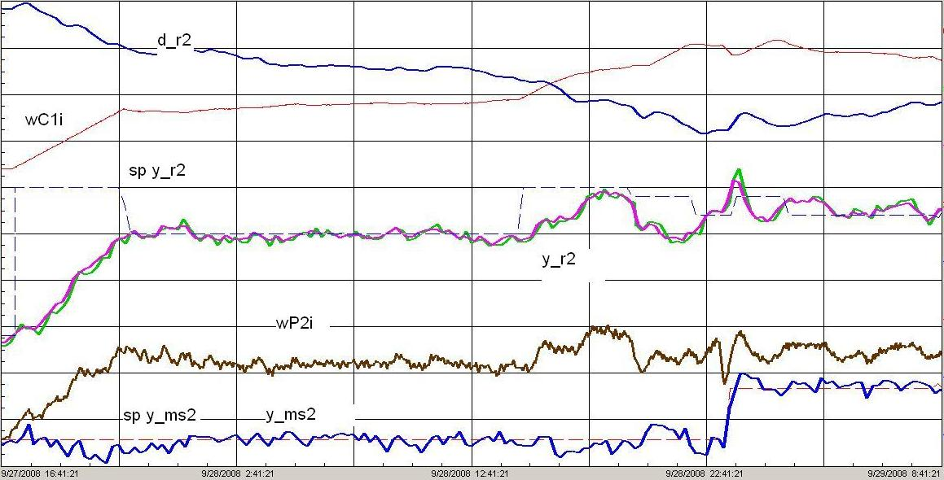
Figure 4: Process data from closed loop control using NMPC
The plot is divided into a grid with 8 time frames, each 5 hours long. In the first phase, the operator has increased the setpoint (sp y_r2) for production rate and the controller subsequently increases the catalyst feed (wC1i). The catalyst feed is at its limits of the maximum rate of change. Meanwhile, the propylene feed (wP2i) is also increased to maintain a constant mass of solids (y_ms2) inside the reactor, i.e. a constant density.

In the following three time frames, the production rate and the solid mass are quite stable. However, during this time the catalyst activity is slowly decreasing. This is recognized by the estimator of the NMPC controller, see the top line (d_r2) in Figure 4, which represents the estimated catalyst activity. To keep the production rate at the setpoint, the controller slowly increases the catalyst feed to compensate for the decreased catalyst activity.

In the fifth time frame, the setpoint of the production rate is once again increased, with a subsequent increase in the catalyst feed. However, in the sixth time frame the production rate suddenly decreases. This is due to a reduction in the hydrogen feed, which was a result of too high H2 concentration in a lab sample. The reduced H2 feed decreases the reaction rate and the controller increases the catalyst feed even more.

In the seventh time frame, the operator increases the setpoint for the solid mass, (sp y_ms2), i.e. increasing the density. The controller decreases the propylene feed for a short moment to bring up the total mass of solids inside the reactor. This also causes a temporary increase in the production rate before the controller

manage to compensate with a somewhat lower catalyst feed.

To summarize, the NMPC controller shows great performance in tracking the setpoints given by the operator and maintaining the process at stable conditions despite unmeasured disturbances such as decreasing catalyst activity. Furthermore, the figure shows how important it is to have multivariable controllers to better handle processes with strong interactions.

7. CONCLUSIONS

In this paper, a brief report on the commissioning of NMPC controllers to a polypropylene plant has been presented. The three reactors in the Borstar process technology allow a very large range of product qualities. Each reactor is controlled using a NMPC controller based on 1st principles models and a SQP optimization algorithm. Process data from the new plant shows that the controller succeeds in tracking the setpoints from the operator as well as keeping the process at the setpoints despite various measured and unmeasured disturbances.

ACKNOWLEDGMENTS

The first author would like to thank Bjørn Glemmestad, Ketil Strand Andersen, Erik Wilsher, Kai Hofsten and Øyvind Moen for their guidance and support.

REFERENCES

van Brempt, W., P. van Overschee, T. Backx and Ø. Moen (2003) “Plantwide economical dynamic optimization: application on a Borealis Borstar process model” In proceedings of ADCHEM, Hong Kong

Gill, P. E., W. Murray and M. A. Saunders (2005) “SNOPT: An SQP Algorithm for Large-Scale Constrained Optimization” SIAM Review, 47, pp. 99—131

Hillestad, M and K. S. Andersen (1994) ”Model Predictive Control for Grade Transitions of a Polypropylene Reactor.” In proceedings of ESCAPE’4, Dublin

Qin, S. J. and T. A. Badgwell (2003): ”A survey of industrial model predictive control technology.” Control Engineering Practice, 11, pp.733—763

