Enhancing the Understanding and Insights of Students and Industry Operators in Process Engineering Principles via Immersive 3D Environments
Christine Nortonª, Ian Cameronª, Caroline Crosthwaiteª, Nicoleta Balliu^{b}, Moses Tade^{b}, David Shallcross^{c}, Andrew Hoadley^{d}, Geoff Barton^{e}, John Kavanagh^{e}.
ªChemical Engineering, The University of Queensland, St Lucia, Qld 4072, Australia
^{b}Chemical Engineering, Curtin University of Technology, Perth, WA 6001, Australia
^{c}Department of Chemical and Biomolecular Engineering, The University of Melbourne, Parkville, Vic 3010, Australia
^{d}Chemical Engineering, Monash University, Clayton, Vic 3800, Australia
^{e}Department of Chemical and BiomolecularEngineering, The University of Sydney, Sydney, NSW 2006, Australia
Abstract
This work differentiates itself from most educational based multimedia resources by catering for two distinct audience groups. The first group is undergraduate process engineering students in a number of Australian institutions, whereas the second group represents operational staff at the industrial facilities covered by the interface. This presents challenges in pedagogy, educational pitch, industrial relations and project management.
The learning environment is based around spherical imagery of real operating plants coupled with interactive embedded activities and content. This Virtual Reality (VR) learning tool has been developed by applying aspects of relevant educational theory and proven instructive teaching approaches. Principles such as constructivism, interactivity, cognitive load and learner-centred design have been central considerations when constructing and structuring this resource. Structural challenges include determining a framework for the basic environment, the repository for the VR and activities, as well as the development of a learning platform arrangement to support self-directed learning in the interface. Some of the system’s current functionality is demonstrated through snapshots of the screen configuration. Future developments within the interface are revealed.

Keywords: 3D virtual reality, immersive learning environment, process engineering
  - Introduction
This project addresses the parallel needs of university and industry through delivery of a set of virtual process plants embedded with training and learning resources.
Within university, current undergraduate engineering students in chemical, process and related disciplines often lack industry exposure. Opportunities for providing visual context for process theory in real operating systems are increasingly less accessible to students. Costs, litigation concerns as well as logistic constraints make both plant operators and university staff hesitant to conduct large scale plant tours. Additionally, a significant reduction of most industry-based work experience placements in Australia means students have less opportunity to see process engineering in practice. This therefore leaves a significant gap in the conceptual understanding of the current process engineering undergraduate.
For university students, this interface brings the real plant to the user through a set of virtual reality (VR) immersive environments. These environments enhance insight and understanding by providing:
- A real engineering context within the different plants
- Relevant activities and information pieces embedded within the VR imagery
- An exploratory platform to discover and investigate at the individual’s own pace. [1]
In industry, there is a genuine need to establish effective operational training resources which deliver a consistent message to operations and engineering staff. With round the clock operations in most process plants, there is also a desire to provide a learning platform which is accessible and available 24 hours a day. A learning structure which reduces the requirement for trainer supervision, without diluting the key learning outcomes, provides industry with undeniable cost and training benefits.
Industrial staff can utilize the environments to:
- Provide the basis for general site inductions
- Conduct operator training on specific equipment
- Shed light on the pieces of process equipment generally regarded as “black boxes” by process operators.
Through application of this learning tool, industry is given the opportunity to provide a level of consistency in their operator training, through an easily accessible platform, which does not require intense supervision or support.
The application of VR technology in this setting supports visualization of systems in a sphere which is not intrusive on the operational plant but offers experiential learning opportunities without risk of serious consequences. With its modified view of reality, users are allowed to explore beyond traditional boundaries into pieces of equipment and their operation. Immersion in the VR leads to a sense of “being there” which is associated with genuine psychological learning benefits. Within this setting, users are able to direct their own learning in a style espoused in constructivist philosophies and by learner-centred practices. The visual strengths offered by VR are strongly aligned with the learning preferences of the users and support easy translation of the dynamic content into imagery suitable to the audience.
A prototype VR system commenced development at The University of Queensland during 2005 [1]. The development of this VR immersive environment prototype system and the on-going associated activities has been supported by BP Refinery (Bulwer Island) Brisbane, Australia. BP currently uses the system for site familiarization and for shutdown training for complex turbine drives and pump systems. The project team has received feedback from key stakeholders regarding this prototypic environment and is currently in the process of modifying the environment to improve usability and add the increased functionality requested. Development of a second immersive environment covering Coogee Energy’s methanol plant based in Victoria, has commenced. Other industry sectors showing interest include: water treatment, minerals processing, petrochemicals and paper manufacture. These may result in the addition of more industrial applications to the interface to create a library of VR immersive environments.
  - Pedagogy
    - Educational theory and practices
Educational theory behind such multimedia applications has not been developed as rapidly as the technological capacity to build it. Often the design of such resources is driven by the technical potential rather than validated educational theory. In an attempt to circumvent this complication, we have attempted to base the design and development decisions on educational theory and proven practices.
    - Developing educational resources
Some key principles of structuring a multimedia resource include:
- When presenting information, knowledge accessed, processed, interpreted and constructed by the individual is more likely to be embedded than that which is force-fed.
- Teaching not only becomes an activity of presenting knowledge concepts and relationships but is also an act of supporting, motivating and guiding learners. This model of instruction means education needs to help learners collect tools to become better self-directed learners rather than solely teach facts and figures [2].
- Applying a constructivist model, whereby the student is given access to cognitive tools which extend their learning potential beyond their abilities - in effect, scaffolding their ability to accumulate and process knowledge. These tools also assist by supporting cognitive processing, sharing cognitive load or allowing users to visualise, analyse, interpret, rationalise and develop information [3].
- Employing user-centred design philosophies as practiced in the development of Human-Computer Interfaces (HCI). In educational resource development, the end-user is effectively the learner, who is generally regarded as a content and user novice. Principles of user-centred design have to be modified to make allowances for this difference in experience. This gives rise to learner-centred design philosophies [4].
- Prototyping and usability testing of the resource with the learners during development to compensate for their lack of involvement in the design phase.
    - Basic environment structure
To encourage self-directed exploratory research of the interface, a menu structure embedded in the VR has been selected for the base level environment structure. In investigating the VR interface, a learner can highlight all equipment with content or activity links associated with them. When the piece of equipment is selected, a right-click of the mouse accesses a description of that piece of equipment, learning resources associated with it or its system and a search page (Figure 1). The search engine offers the ability for learners to follow links to learning resources classified by system variables such as portion of the unit covered, difficulty, subject area and learning objectives. Similarly a user can search through keywords to discover equipment, its features and location within the VR.
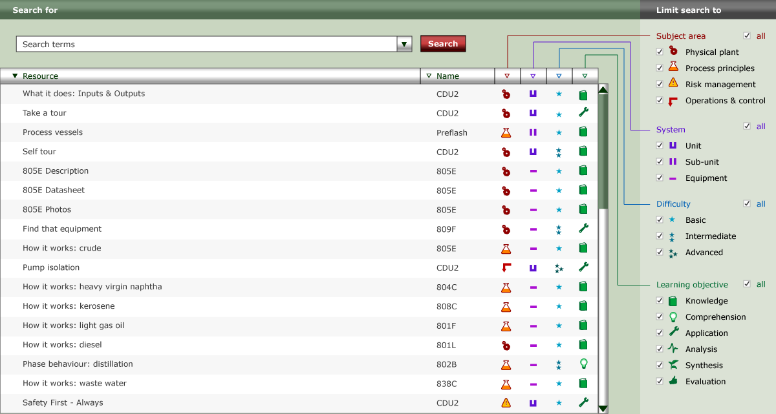
Figure 1 Search page
This structure offers the best utilization of the immersive environment’s visual strengths. It also alleviates a menu structure, accessed external to the VR, with a branching structure with a number of unpopulated categories. In applying this structure, we are supporting functionality requested by students in usability surveys.
    - Learning platform options
When a set of immersive environments has been developed, each employing the basic environment structure, we will look at ways to coordinate the environments into a self-directed learning platform characterized by an innovative technology format. Three over-arching learning platform arrangements considered in more detail for this work, which encapsulate key aspects of educational theory and the principles of constructivist e-learning environments include:
- Concept Mapping
- Educational Games
- Problem Based Learning
  - Learning Resources
Some of learning applications available in the immersive environment covering Crude Unit Number 2 (CDU2) at BP Refinery (Bulwer Island), Brisbane are introduced in the following sections.
    - Take a tour
Users are initially able to take a fully guided and narrated tour to move around the plant to any place of interest. This provides a context for other learning activities.
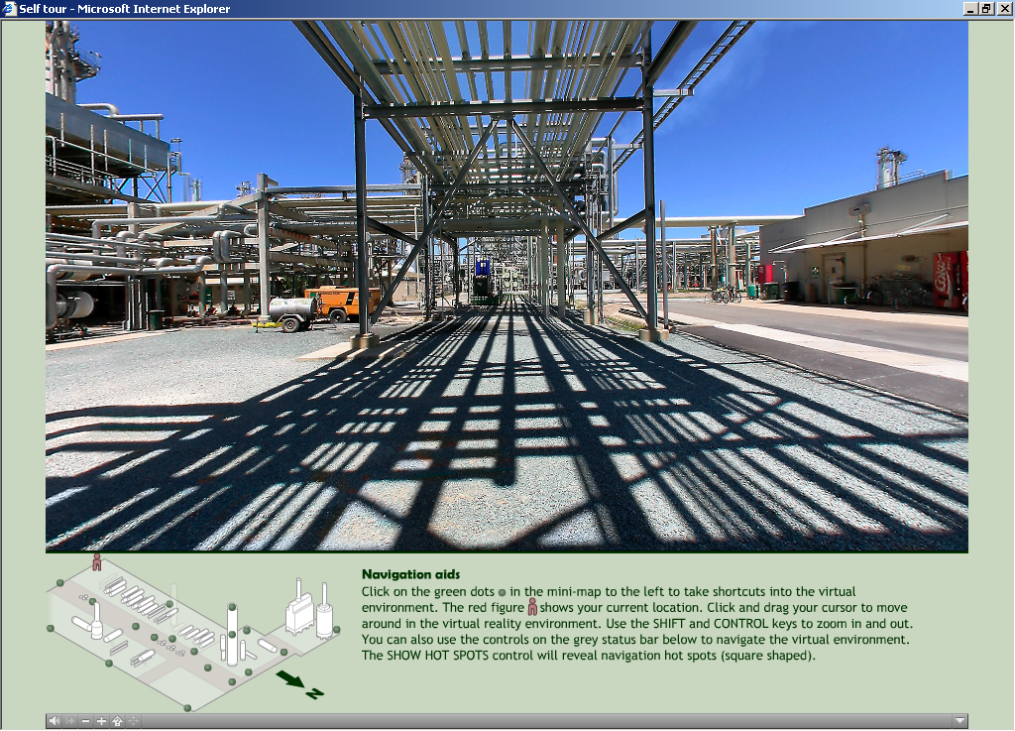
Figure 2 Take a guided tour
    - Distillation phase behaviour
An informative animation explores the distillation hydrodynamics (Figure 3).
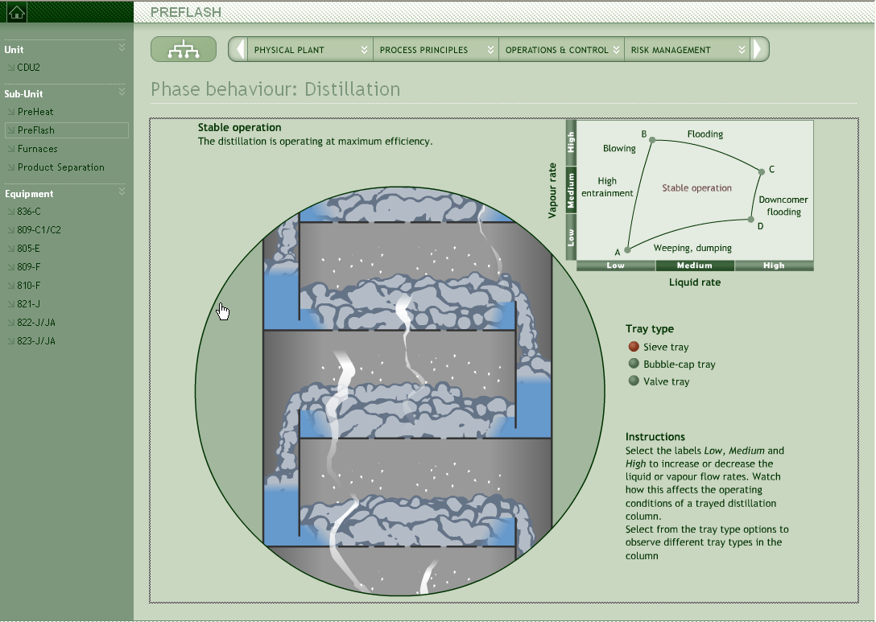
Figure 3 Distillation phase behaviour
Within this activity a user can manipulate vapour and gas flows and tray type and see the effects that this has on liquid-vapour contact regimes. Dynamic models of distillation have been formulated to enable students to manipulate key system variables and assess responses. These are still to be linked to the VR.
    - Pump isolation
In this activity, pictured in Figure 4, the user performs a pump shutdown by mimicking all the actions required within the VR environment. By turning valves, securing spare pumps and opening drains, the user appreciates the detail required by the procedure and the critical importance of each step. They are also able to realize the checking mechanisms and the regimented correctness facilitated by the GRAFCET procedure structure.
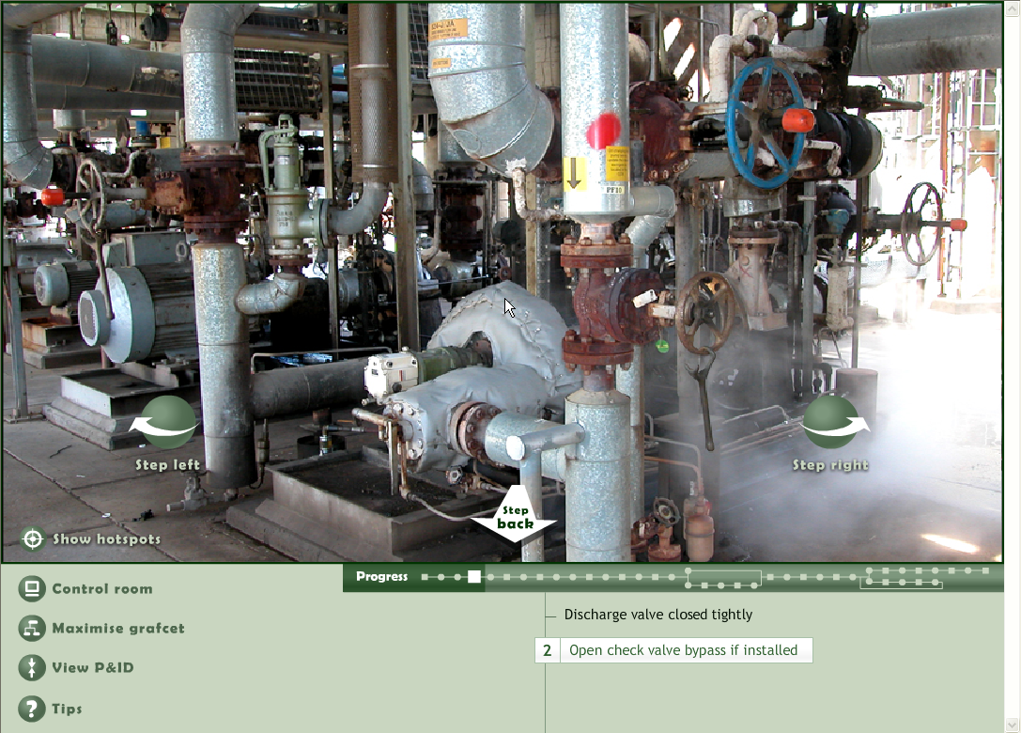
Figure 4 Pump isolation activity
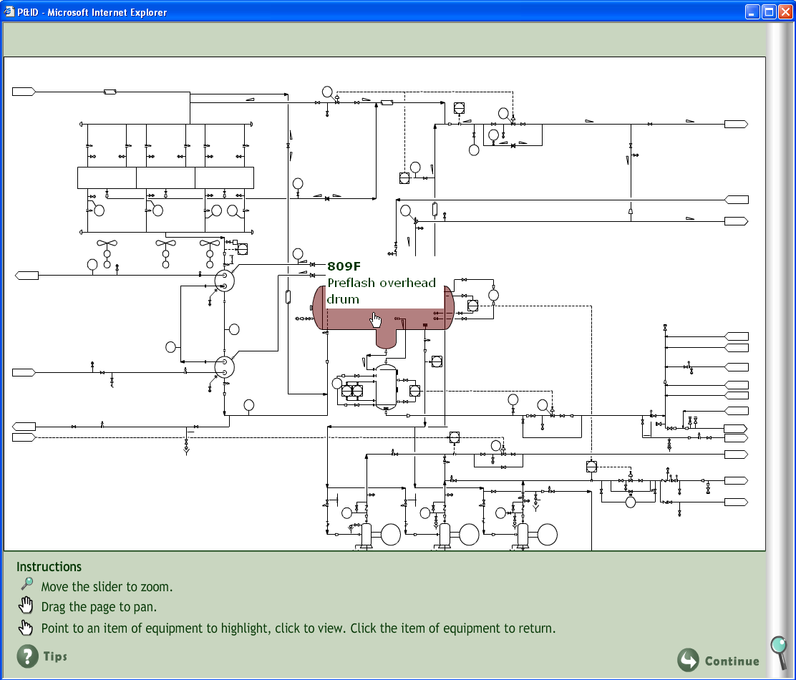
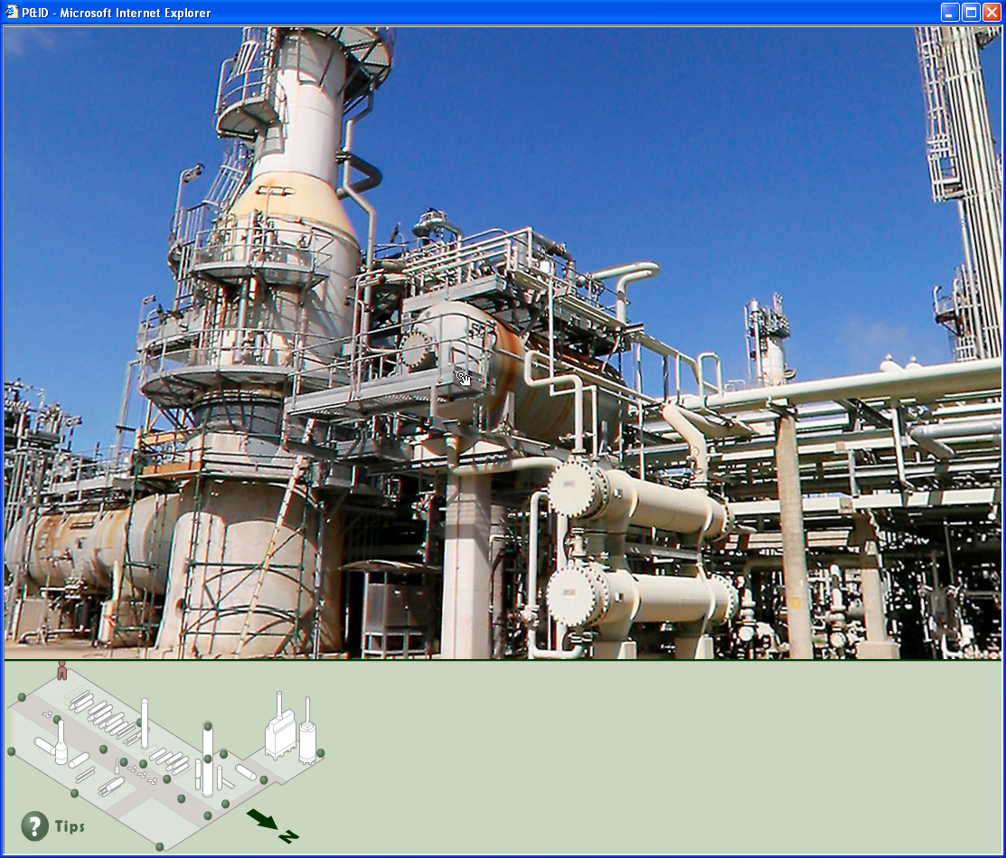
  - Future Developments
    - Activities under construction
We will continue to enhance the virtual process plant covering CDU2 with the addition of several new activities. Some of the new activities include:
- A Wonder-why tour which explores the design of specialized equipment, layout arrangements, piping configurations and design choices and then questions students about their rationale and basis. Design and performance calculations are possible.
- Risk management activities including an explosion simulation (Figure 5) which looks at the role of confinement in explosion impacts.
- Pinch analysis of the preheat exchanger train in an attempt to determine the underlying design assumptions made.
- A flow-sheeting exercise in which students generate the process flow diagram from a process description.
- Performing mass and energy balances over a heat exchanger network to determine the cause of product quality issues.
- A GRAFCET formulation activity in which a written procedure to shutdown a heat exchanger is transformed into a GRAFCET diagram.
- The generation of a temperature versus enthalpy chart describing the passage of kerosene through the distillation column from the flash zone to the draw off point.
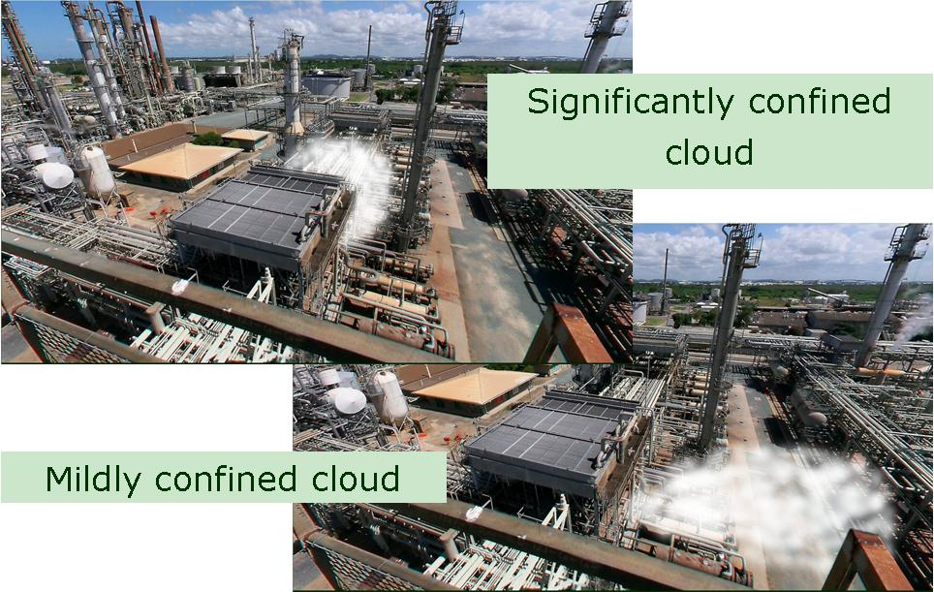
Figure 5 Explosion simulation case
  - Conclusion
The learning resource has been well received by student groups, lecturers and course coordinators, industry operators and industry management. Lecturers at the University of Queensland and partner institutions are already applying the resource to aid learning in key control and unit operations courses. BP Refinery (Bulwer Island) has utilized pump isolation exercises to train new operators in basic operating procedures and provided access to the interface for all other operations personnel. Management personnel within the BP Major Hazards group have identified applications in visualizing the extent of hazardous incidents. The more exposure the system gets in industry and universities, the more applications are discovered for the resource and so momentum around its use is generated and expanding rapidly.
  - Acknowledgements
We gratefully acknowledge the contributions of the multimedia and instructional design staff at the Teaching and Educational Development Institute (TEDI) at the University of Queensland.
We thank those in the Learning and Development Group at BP Refinery (Bulwer Island), Brisbane for their keen interest and support in the development of this system.
Financial support for this project has been provided by The Carrick Institute for Learning and Teaching in Higher Education Ltd, an initiative of the Australian Government Department of Education, Science and Training and The University of Queensland.
References
[1] I.T. Cameron et al., 2005, An Immersive Learning Environment for Process Engineering using Real VR. in CHEMECA Conference (Sept). Brisbane.
[2] U. Nulden, 2001, e-ducation: research and practice. Journal of Computer Assisted Learning. 174: p. 363-375.
[3] K. Sedig, S. Rowhani, and H.-N. Liang, 2005, Designing interfaces that support formation of cognitive maps of transitional processes: an empirical study. Interacting with Computers. 174: p. 419-452.
[4] S. Blythe, 2001, Designing online courses: user-centered practices. Computers and Composition. 184: p. 329-346.
[5] M. Hegarty, 2004, Dynamic visualizations and learning: getting to the difficult questions. Learning and Instruction. 143: p. 343-351.

