Simulation of a PEMFC-super capacitor hybrid system
S. Sailler^{a,b}, F. Druartª, D. Riu^{b}, P. Ozilª
a: LEPMI, UMR 5631, 1130 rue de la piscine 38402 st martin d’hères Cedex
b: G2Elab, UMR 5269, BP 46, Domaine universitaire, 38402 st martin d’hères Cedex
Abstract
Nowadays, fuel cell systems seem to be a good alternative to fossil energies, in order to reduce greenhouse effect gas production. However, fuel cells behavior is governed by various physicochemical phenomena. Thus fuel cell implementation in electrical system is difficult, this is due to fuel cell complex electrical behavior and low voltage. Moreover, static converters working at such low voltage range present unsatisfactory efficiency. To avoid designing oversize fuel cell stack due to consumption peak, we combine fuel cell with storage device, so peaks are assumed by the super capacitor. In this work, authors have studied an hybrid system combining a PEMFC fuel cell stack and a super capacitor. In order to predict system performances, simulations were carried out using Matlab-Simulink. The system is composed of fuel cell stack, super capacitor and two DC/DC converters. On one hand, converts aim is to bring a constant system’s output voltage and, on the other hand, to request storage when fuel cell response is insufficient. In order to provide high quality electrical signal, we constrain an output voltage maximum variation less than 1V. The command loops of converters have to be determined in order to improve system control. Several control laws can be used, e.g. hysteresis control loops for current control and a PI corrector were adopted to control output voltage. To design control laws, the fuel cell stack is described as a constant voltage source in serial association with a resistance, the super capacitor is assumed as a constant voltage source. The simulated system is composed of a 500W PEMFC stack (operating voltage: 12V) and a 52F super capacitor (operating voltage: 15V). Transient behaviors are studied under several loads operating conditions. We studied a 25% increase from nominal power. Results show that super capacitor assumes power peaks and maintain output voltage at 24V. Moreover, despite their simplicity, control loops and PI corrector permit good control output voltage.
Keywords: hybrid system, control laws, fuel cell, super capacitor.
  - Introduction
Time simulations of electrical systems are classically a power tool to design such systems. However, the simulation of systems integrating fuel cells is a difficult task as they are characterized by an electrical non-linear behavior and a low rated voltage (Palma et al, 2006). Moreover, these fuel cells need a power electronics interface in order to adapt to standard load voltage and storage devices are usually associated to fuel cells to provide power in case of power limitations.
Thus, in this article, the authors propose a tool of simulation of hybrid electrical generators based on fuel cell and electrical storage like super capacitors. Firstly, an improved modeling of fuel cell is proposed taking into account mass and charge transfer. This new model is compared to current equivalent circuit of fuel cell based on a simple voltage source with a resistance (Thounthong et al, 2006). It must be noticed that non-linear domains of fuel cell I-V curves are not considered in this simple equivalent circuit. In a second part, design and control loops are characterized and simulated on a system formed by a 500 W PEMFC associated with a 52F super capacitor, which supply a 24 V DC isolated network
  - Electrical models for hybrid systems
    - Super capacitor model
Super capacitor is modeled by an ideal current source to simplify calculations. However, a power limitation is introduced in order to take into account the load state of this storage device (1350W).
    - DC/DC converter model
Two DC/DC boost converters (Dang et al, 2006) are used in order to increase output voltage of fuel cell and storage to 24V DC. The converter associated to fuel cell is controlled to maintain load voltage to 24 V ± 1V, while the other allows to request storage power in case of fuel cell insufficiency.
Boosts models are based on exact formulations according to switching conditions (Choe et al, 2007).Such models allow to compute electrical quantities like load voltage and input current to command angle of switches. Fuel cell models
      - Static electrical model
In electrical engineering, fuel cells can be simply modeled as a constant voltage source in serial association with a resistance. Sometimes, this resistance is variable in order to take in account the non linear variation of the voltage (Thounthong et al, 2006). The classical model is equivalent to a linear regression of the polarization curve:
$$\text{Ucell}=U_{\text{oc}}−R×I$$
Where R is the ohmic losses and U_{oc} the open circuit voltage, I the current.
      - Dynamic model: Transfer function model.
The transient fuel cell response to a current step could be assumed equal to a first order system response:
$$\frac{U}{I}(p)=\frac{K}{1+τ×p}$$
Where K is the gain of the system, p the Laplace operator and τ the time constant, but theses parameters don’t have physical interpretation.
      - Phenomenological model
This more complete model allows to take into account cathode electrochemical phenomena. It is based on Fick diffusion law and Butler-Volmer equations.
Then a PEM fuel cell consists of two electrodes with a thin layer of catalyst in contact with a plastic membrane separating gas supply chambers (see figure 1).
Only the cathode side was studied in this work. The Fick equations allow us to describe this diffusion of O₂ and H₂O in the gas diffusion layer (GDL). Based on diffusion on the GDL, the dynamic behavior of this layer is obtained from the mass-balance equation:
$ε^{\text{GDL}}\frac{∂c_{i}}{∂t}=−\frac{∂N_{i}}{∂y}$ (1)
Where ε^{GDL} is the porosity of the gas diffusion layer, c_{i} the mole concentration in the pore and N_{i} the flux governed by Fick law:
$N_{i}=−D_{i}^{\text{eff,AL}}\frac{∂c_{i}}{∂y}$ (2)
Where D_{i}^{eff,AL} is the effective diffusion coefficient.
In the gas diffusion layer, the over-potential is assumed constant.
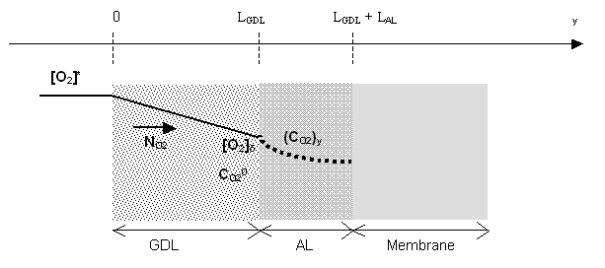
Figure 1: PEMFC cathodic side
The behavior of an active layer in a gas diffusion electrode can be described from the classical macro-homogeneous model for active layer (Springer et al., 1993). Here, the model defined by Bultel et al., 2002 is extended to include the dynamic charging processes of the electrical double layer occurring in parallel to the faradaic charge transfer processes. The equation of continuity for oxygen species in the electrolyte can be written classically for a porous medium as:
$ε^{\text{AL}}\frac{∂c_{i}}{∂t}=D_{i}^{\text{eff,AL}}\frac{∂^{2}c_{i}}{∂y^{2}}−a_{e}\frac{j_{\text{f,c}}}{n_{i}F}$ (3)
This equation is also written for water mass balance as:
$ε^{\text{AL}}\frac{∂c_{i}}{∂t}=D_{i}^{\text{eff,AL}}\frac{∂^{2}c_{i}}{∂y^{2}}+a_{e}\frac{j_{\text{f,c}}}{n_{i}F}$ (4)
Where ε^{AL} is the active layer porosity, n_{i}, the total number of electron involved in the reaction, F, the Faraday’s constant and a_{e}, the catalyst surface area per unit volume of active layer. The gas permeation and water flux through the membrane are also assumed negligible in our study. The faradaic current density (j_{f}) referring to the oxygen reduction at the cathode (c) is described by the Butler-Volmer equation (Bultel et al., 2002). In order to obtain the equation for the potential drop in the active layer, the continuity equation which describes the transformation of ionic species into electronic current via faradic processes and the double layer charging, must be taken into account. They lead to the charge balance equation :
$a_{e}C_{\text{dl}}\frac{∂η}{∂t}=κ^{\text{eff}}\frac{∂^{2}η}{∂y^{2}}−a_{e}j_{\text{f,c}}$ (5)
Where C_{dl}, is the double layer capacitance and κ^{eff}, the effective ionic conductivity of the active layer, η the over-potential.
The mass and charge balance equations can be solved numerically in respect of the following boundary condition : at the gas channel | gas diffusion layer interface (y=0), the ionic current density is zero while at the membrane-active layer interface (y=L_{GDL}+L_{AL}), and the ionic current density (i_{s}) is constant equal to total current density:
$i_{s}\left(y=0\right)=−κ^{\text{eff}}\frac{\text{dη}}{\text{dx}}\left(y=0\right)=0$ and $i_{s}\left(y=L_{\text{GDL}}+L_{\text{AL}}\right)=−κ^{\text{eff}}\frac{\text{dη}}{\text{dx}}\left(y=L_{\text{GDL}}+L_{\text{AL}}\right)=i$ (6)
Oxygen concentration at the gas channel | diffusion layer interface is assumed equal to gas channel concentration. At the membrane | active layer interface, we consider that the oxygen flux is equal to zero. This is due to the fact that no water was experimentally observed at the anode.
$c_{i}\left(y=0\right)=c_{\text{i,0}}$ and $N_{i}\left(y=L_{\text{GDL}}+L_{\text{AL}}\right)=0$ (7)
For water mass balance, due to the fact that experimentally, the fuel cell produce liquid water, we consider that the concentration at the gas channel | gas diffusion layer is equal to the saturation vapor pressure. At the membrane | active layer interface, the water flux is considered equal to zero.
$c_{i}\left(y=0\right)=c_{\text{i,0}}$ and $N_{i}\left(y=L_{\text{GDL}}+L_{\text{AL}}\right)=0$
Then the Fuel Cell voltage could be written as :
$$\text{Ucell}(t)=U_{\text{oc}}−R×i(t)−η_{c}(t,i)$$
Where U_{oc} is the open circuit voltage, R the ohmic losses and η_{c} the cathodic over potential.
      - Fuel cell stack model comparison
In a first time,simple elctrical and transfert function models have been identified from experimental polarization curves for a 500 W 16 cells fuel cell stack. This stack is composed of Paxitech ® membrane electrode assembly and UBzM ® body. Then, it can be observed on figure 2.a that phenomenological model better fits experiments. Moreover, transfer function model does not fit the experiment response as this model has been identified for only one operating point. That show the transfer function model limitation.

a) 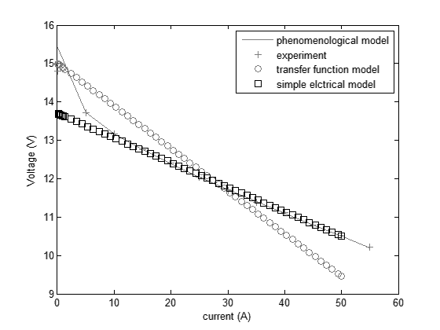 | b)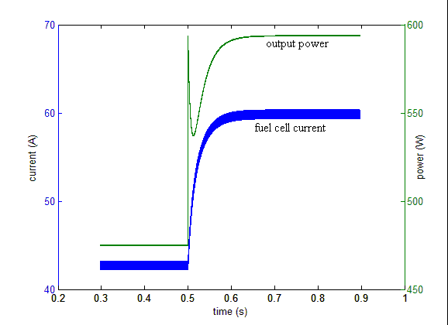
Figure 2: fuel cell response: a) I-V curves, b) power demand step
In figure 2.b the response of fuel cell and DC-DC converter is represented. We could see that the fuel cell associated with the DC-DC converter is insufficient to provide enough energy. That’s why hybridation with super capacitor was studied.
  - DC-DC converter control loops.

The fuel cell converter (A) is controlled to provide output Voltage (Vs=24V). Assuming an ideal current response –instantaneous fuel cell current response compared to converters response– this voltage control loops is then equivalent to a power control loops which can be characterized by a first order response (Séguier et al, 1987). Then a simple Proportional Integrative (PI) (1) regulator is sufficient to control this converter.
Super capacitor converter (B) is controlled to provide the gap of power (Ps) between load demand and fuel cell supply. A simple Proportional regulator (2) is also used to control this converter. Control loops are illustrated on figure 3.
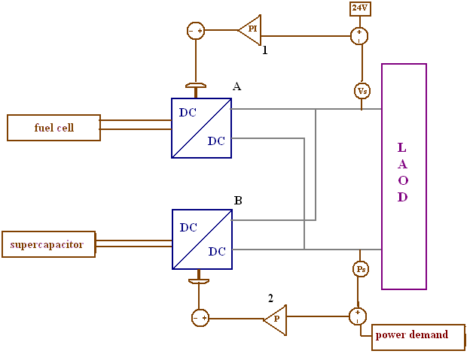
Figure 3: system control loops
  - Hybrid system simulations.
The authors have simulated the hybrid system behavior using fuel cell models presented above. Then, figures 4.a and 4.b present current responses for simple electrical model and function transfer model. The power demand step appears at t=0.7s.
First of all we can observe that the super capacitor influence the fuel cell starting behavior. Moreover, we could see difference between the two models. The simple elctrical model have a faster response time. This is due to the fact that this model has an instantaneous response. So only converter time limitation are taking into account. In figure 4.b, we introduce transfer function model to take into account fuel cell dynamic behavior. This change fuel cell time response, but, error on fuel cell voltage introduce error on system response.
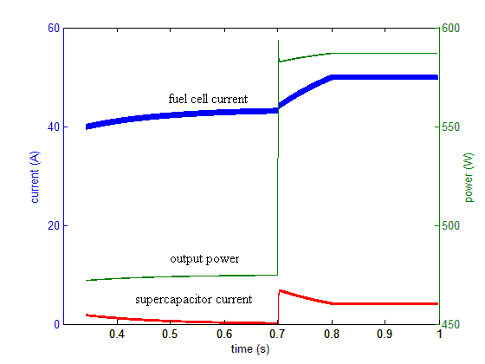  a) | 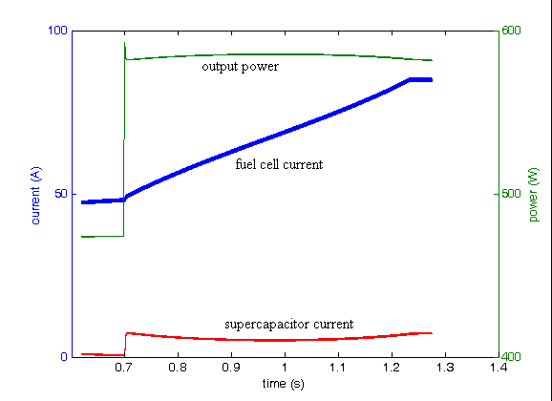  b)
Figure 4: hybrid system response: a) simple electrical model; b) transfer funciton model.
In fact, the function transfer function could be improved if we take into account the current dependence of K and τ parameters. Moreover we can see that for both models, the super capacitor current do not reach zero, this is due to the fact that the power demand is too important.
  - Conclusion.

In this work, we have studied different fuel cell models in order to use them in electrical system simulator. If we are only interested in steady-state behavior, a phenomenological model or a simply electrical model appears to be sufficient and reliable. Besides, transfer function of fuel cell is more accurate for time transient modeling.
The authors have also simulated a hybrid electrochemical system which control electrical flows between PEMFC, storage device and load thanks to a simple control loop structure.
Prospects of this work focus mainly on the development of an experimental demonstrator in order to validate and complete these first results. Works on modeling are also carried out to use a dynamic equivalent model based on half-order systems (Usman et al, 2006).

References.

Y. Bultel et al., 2002, Modeling impedance diagrams of active layers in gas diffusion electrodes: diffusion, ohmic drop effects and multistep reactions, Journal of Electroanalytical Chemistry, 527, 1-2, 143-1550.
S.-Y. Choe et al, 2007, Integrated modeling and control of a PEM fuel cell power system with a PWM DC/DC converter ,Journal of power sources, 164, 614-623.
W. Choi et al, 2006, Development of an equivalent circuit model of a fuel cell to evaluate the effects of inverter ripple current, Journal of Power Sources, 158, 2, 1324-1332
D.B. Dang et al, 2006, New high power-high ratio non isolated, DC-Dc-boost converter For fuel cell applications, Power Electronics Specialists Conference. PESC '06. 37th IEEE, 1-7
L. Palma et al, 2006, Design Considerations for a Fuel Cell Powered DC-DC Converter for Portable Applications, Applied Power Electronics Conference and Exposition, 2006. APEC '06. Twenty-First Annual IEEE
G. Séguier et al, 1987,Les convertisseurs de l’électronique de puissance, technique et documentation-Lavoisier
T.E. Springer et al., 1993, Modeling and experimental diagnostics in polymer electrolyte fuel cells, Journal of the Electrochemical Society, 140, 12, 3513-3526.
P. Thounthong et al, 2006, Test of a PEM fuel cell with low voltage static converter, Journal of Power Sources, 153, 1, 145-150
M. Usman Iftikhar et al, 2006, Dynamic modeling of proton exchange membrane fuel cell using non-integer derivatives, Journal of Power Sources, 160, 2, 1170-1182

