Simulation of process related safety limit of alkoxylation reactors
Sven Degenkolbe, Mattthias Süßmuth, Werner Witt
Lehrstuhl Anlagen- und Sicherheitstechnik, Brandenburgische Technische Universität Cottbus, Burger Chaussee 2, 03044 Cottbus, Germany
Abstract
The alkoxylation process is a polymerization reaction of fatty substances and epoxides, which has a high risk because of the reaction’s high heat and the properties of chemicals. Semi-batch reactors are commonly used for this reaction. In the reactor, the base reactant (e.g. fatty alcohols), the catalyst (e.g. sodium-methylate) and nitrogen as inert gas are charged at first. Then the second reactant (e.g. ethylene oxide EO) is dosed. The rate of dosing depends on the size of the reactor, catalyst, temperature and the concentration limit (accumulation limit/safety limit) of the dosed component. As during reaction operating conditions change (e.g. liquid level), it is important that the safety limit is known. In this article, a simulation tool that calculates the process related safety limit of the alkoxylation reaction is presented. Until now, the calculation is based mainly on the reactor’s mass and heat balance. In order to allow a predictive simulation, thermodynamic equilibrium calculation is realized through the group contribution method “Predictive Soave-Redlich-Kwong (PSRK)”.

Keywords: reactor, ethoxylation, alkoxylation, simulation, safety limit
  - Introduction
Alkoxylation reactors are one of the most used reactors and have high risk potential. The alkoxylation process is a reaction of fatty substances and epoxides. The high risk is a result of the reaction’s high heat and the use of toxic chemicals. In the case of a failure (e.g. loss of cooling), a runaway reaction may occur, leading to an instant rise of pressure and temperature. However, it is possible to assure a safe operation through the implementation of constructive and operational measures. Constructive safety equipment (relief devices such as safety vents or burst discs) or process control and shut down systems (limiting of the concentration) are used [1, 3, 4].

Although the safety system design is normally based on assumptions and/or simple models, a more detailed consideration has a the potential to increase process efficiency and safety. Furthermore, the knowledge of the maximum allowed concentration of EO (safety limit) is fundamental [2]. On the basis of a disturbance simulation, a computer program was developed to calculate the safety limit of the maximum accumulated EO concentration during operation.
  - Architecture of the simulation tool
The simulation tool consists of a graphical user interface (GUI) with a database and the simulation program. Data is entered using the GUI and stored in the database. The dynamic simulation program calculates the process state variables with respect to time. The database ensures different simulation studies to be easily handled. The primary focus is the effects analysed related with the assumption made and/or operation conditions. In the second step the effects of failure scenarios will be integrated.

    - Simulation program
The simulation program is based on a modular design principle (Fig. 1) and is written in the open source interpreter language Octave. Based on a batch reactor containing liquid and vapor phase the simulation program solves a system of differential and algebraic equations of mass-, energy balance, and phase equilibria.

The alteration of product properties against the alkoxylation rate is accounted for by using group contribution methods. For phase equilibrium calculation Predictive Soave-Redlich-Kwong (PSRK), UNIFAC and Henry models are implemented.

In addition to the safety function, the simulation of normal operation provides the concentration of accumulated EO, as well as the operating pressure profile. These parameters depend significantly on the temperature profile and dosing rate.

To simulate the safety limit, the following conditions are assumed:
- complete mixing of reactor content,
- adiabatic system,
- thermodynamic equilibrium within the reactor content.

Figure 2 depicts the basic flowchart of the safety limit calculation. It is based on a runaway reaction simulation. Within the calculation the accumulated EO is varied until the maximum allowed pressure is reached. Commercially available dynamic simulation software, e. g. Aspen Plus/Dynamics or Chemcad, provide only the simulation of runaway reaction or the normal operation. An automated simulation of the safety limit function (maximum allowed EO concentration) is not possible. The maximum allowed accumulation of EO as a function of time can be expressed via both the concentration-based safety limit function and pressure-based safety limit function.

Figure 1. Modular concept of the simulation program

Figure 2. Flowchart of safety limit calculation procedure

      - Validation of runaway reaction simulation
To validate the runaway reaction simulation, experiments under adiabatic condition were performed in the PhiTec II calorimeter. Fig. 3 shows experimental and simulation data. The most important parameters are start pressure/temperature, maximum pressure/temperature, and end pressure/temperature. The values of these parameters almost match. Within the assumed constraints (e.g. thermodynamic equilibrium) the simulation provides good results.
Figure 3. Experimental data and simulation of runaway reaction (EO-Decanol)
The deviations in dynamics of the temperature and pressure profile are not relevant for the safety limit calculated.

    - Structure of graphical user interface (GUI) and database
The main function of GUI is the storage of needed data in a database, and it also makes the simulation program easier to use. The data is divided into master and application data. The master data includes construction parameters for reactors and the reactant properties e.g. structural groups. The group contribution values and the binary interaction parameters are saved in the master dataset. The application data includes recipe, chemical reaction description, and operating data. The reactor data and reactant properties only have to be specified only once. In the recipe dataset the reactants have to be defined. In operating data a reactor dataset is combined with a recipe/reaction dataset.

Once all of the master data is created, it can be used in the application data. After the reaction is defined and substances are added to the recipe, combining a reactor with a recipe/reaction dataset can create a new operating data record. Thus it is easy to change the recipe for the chosen reactor.

Before starting a simulation the reactor, operating dataset and phase equilibrium model must be chosen. Next, the user interface generates the input data files for the simulation program and starts calculation. The relevant results are presented in tables and diagrams according to the user’s needs. The presentation of the simulation results is focused on the main user group, being the design engineer, safety expert and production manager.
  - Example
Based on a recipe containing ethylene oxide and decanol a calculation of the safety limit function for the reactor PhiTec II will be shown (other input data see Fig. 4).

Figure 4. Basic input parameters for simulation
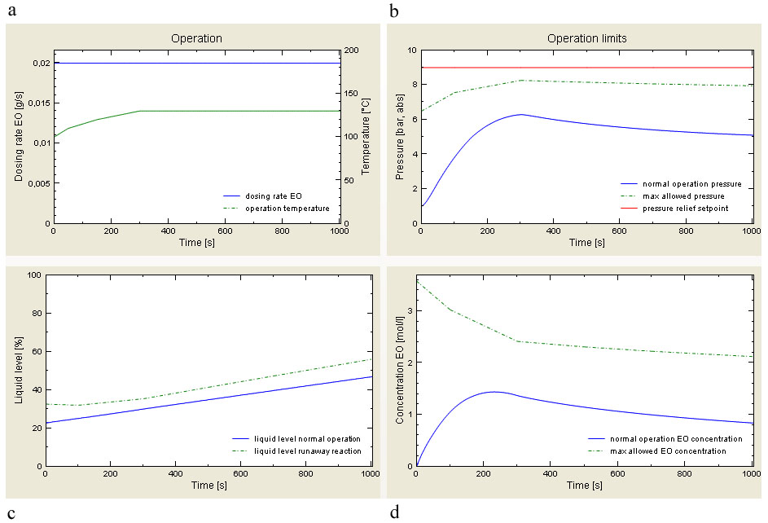Figure 5. Program screen shot of the results presentation

With this data a dynamic simulation of safety limit function was performed. The simulation results are presented in Fig. 5. Diagram (a) shows operating data (EO dosing rate and operation temperature), while the other three diagrams contain normal operation data (line) and the safety limit functions (dashed line). Diagram (b) shows the pressure curves of normal operation (line), maximum allowed operating pressure (dashed line; pressure based safety limit function), and maximum pressure e.g. relief valve set point pressure (line at 9 bar). Diagram (c) shows the liquid level for normal operation (line) and maximum liquid level for runaway reaction (dashed line). Diagram (d) shows accumulated EO concentration for normal operation (line) and maximum allowed EO concentration (dashed line; concentration based safety limit function).

Due to the low liquid level and the low EO accumulation the effects of a runaway reaction at the start of the operation are small. Thus it is possible to start with a high EO dosing rate. During the operation, both the liquid level and the accumulated EO concentration increase. Hence a higher EO dosing rate have to be reduced. Due to the changing product properties (increasing chain length) and rising temperature, the process conditions becomes less critical. The distance between the normal operation and the critical conditions increases (see Fig 5 b and d after 400s). For our example, this indicates an optimization potential at the end of the operation (e.g. increasing of EO dosing rate).
  - Conclusion
The dynamic simulation of safety limit functions vs. changing process conditions has the capability to provide detailed insight into the process. This knowledge can be used to increase safety (identification of critical process steps) as well as process intensification without affecting safety.
The next step in improving of runaway reaction simulation would be the integration of liquid-vapor mass transfer resistance model. Furthermore the effect of thermal mass of the reactor (Phi-factor) would be considered.

  - Acknowledgement
The authors would like to thank the Deutsche Forschungsgemeinschaft (DFG) for their financial support.

  - List of symbols

T Temperature
P Pressure
t Time

References

[1] J.Schmidt, H. Giesbrecht, 1997, Absicherung von Semi-Batch-Reaktoren gegen unzulässige Drücke, Verfahrenstechnik und Chemieingenieurwesen Jahrbuch 1997, VDI-Verlag, Düsseldorf, 233-249

[2] R.Fröhlich, 2003, Zur allgemeingültigen Festlegung der sicherheitstechnischen Betriebsgrenzen von Alkoxylierungsreaktoren, Dissertation, BTU Cottbus, Germany

[3] G. Deerberg, 1997, Zur sicherheitstechnischen Beurteilung von Semibatch-Prozessen mit Gas/Flüssigkeits-Systemen, Dissertation, Fraunhofer IRB Verlag, Stuttgart

[4] W. Witt, P.-M. Weimspach, G. Deerberg, K. Schwarze, S. Schlüter, A. Steiff, 1995, Beherrschng kritischer Reaktionen in Mehrphasensytemen durch technische Maßnahmen, Abschlussbericht zum BMBF-Forschungsvorhaben

