Structural optimization of sustainable chemical process flowsheets under uncertainty
Gonzalo Guillén-Gosálbezª, José A. Caballero^{b}, Laureano Jiménezª
a Department of Chemical Engineering, Universidad Rovira i Virgili, Av. Països Catalans 26, 43007 Tarragona, Spain
b Department of Chemical Engineering, University of Alicante, Ap. Correos 99, 03080 Alicante, Spain
Abstract
This work addresses the environmentally conscious design of chemical processes under uncertainty in the inventory of emissions released during the plant operation. Given a superstructure of process flowsheet alternatives, the objective is to find the set of solutions that represent the optimal compromise between cost and environmental performance. The environmental impact is measured through the Eco-indicator 99, which incorporates the recent advances made in Life Cycle Assessment (LCA). The design task is mathematically formulated as a bi-criterion stochastic MINLP that simultaneously accounts for the minimization of cost and environmental impact. The stochastic model is reformulated into its scenario-based deterministic equivalent, which includes a set of representative scenarios of the uncertain input data that are generated through Monte-Carlo sampling. The strategy presented is applied to a case study (hydrodealkylation of toluene), for which the set of trade-off solutions in terms of cost and environmental criteria is computed.

Keywords: process synthesis, LCA, sustainability, uncertainty.
  - Introduction
In the past decade there has been a growing awareness of the importance of incorporating environmental concerns along with traditional economic criteria within the optimization procedure. This has led to the development of a new generation of tools that assist in the design of sustainable chemical processes. A key issue of these strategies is how to capture the environmental concerns into a quantitative indicator capable of supporting objective environmental impact assessments. In this regard, Life Cycle Assessment (LCA)[1] has recently become the preferred tool to evaluate process alternatives from an environmental point of view. This has been motivated by the holistic perspective that it adopts, which includes the entire life cycle of the product, process or activity.

Unfortunately, the application of LCA is hampered in practice by the high degree of uncertainty brought about by several factors. Despite the importance of explicitly incorporating the main sources of uncertainty that affect the LCA analysis, the majority of the studies made so far are deterministic. These approaches assume nominal values for the uncertain parameters and do not provide any control on the variability of the environmental performance in the space of uncertain parameters.
This work addresses the optimal design of sustainable chemical processes under uncertainty in the inventory of emissions. The approach presented takes advantage of the complementary strengths of stochastic mathematical programming and LCA in a similar way as was done before by other authors[2,3] for the deterministic case. In our framework, LCA is used to assess the process alternatives from an environmental perspective, whereas stochastic MINLP techniques are employed to generate feasible alternatives to the problem and find the best ones in terms of economic and environmental criteria.
  - Problem statement
Given is a superstructure which embeds a set of potential structural alternatives of a chemical process. Given are also a time horizon, the demand of the final products, the cost of the raw materials, utilities and equipment units, and the prices of final products. The environmental data required to perform the LCA analysis, which include the uncertain parameters (i.e., emissions released per unit of reference flow) are also provided. The problem then consists of selecting the set of flowsheet configurations and associated operating conditions that represent the optimal trade-off between cost and environmental impact over the entire time horizon.
  - Proposed approach
The synthesis problem with environmental concerns under uncertainty in the inventory of emissions can be formulated as a stochastic multi-objective mixed integer non linear problem, which can be translated into its scenario-based deterministic equivalent bi-criterion MINLP as follows:
In (P1), the continuous variables x represent the flows, operating conditions and design variables. The binary variables y denote the potential existence of process units. The non-linear performance and sizing equations correspond to h(x,y) = 0, while the inequality constraints g(x,y) ≤ 0 represent the design specifications.

The objective function includes two terms. The first one is the total cost, which comprises the cost of the process equipments, the raw materials and utility costs and also the by product sales revenues. The second one is the environmental performance under uncertainty. Its calculation requires the definition of a continuous variable d_{s}, which represents the total emissions associated with the plant operation, and a parameter θ_{s}, which denotes the value of the emissions released per unit of reference flow. Both terms have a subscript s that indicates the specific scenario for which they are defined. Notice that the environmental performance is affected by the uncertainty in the inventory of emissions whereas the cost of the process is insensitive to this source of uncertainty. The solution of (P1) is given by the Pareto optimal set of flowsheet configurations and associated operating conditions. These solutions can be calculated with any multi-objective optimization method suitable for MINLPs.
    - Environmental impact assessment
In the approach presented the environmental performance is assessed through the Eco-indicator 99[4], which reflects the current state of the art in LCA methodology and application. The LCA methodology comprises four phases:
1) Goal and scope definition. In this phase, the system boundaries and the impact categories are identified. In this work we perform an analysis from the “cradle to the gate”, in which the downstream processes such as secondary processing, product-use and disposal are neglected. This analysis covers the 11 impact categories defined in the Eco-indicator 99.
2) Inventory analysis. This phase provides the total emissions associated with the main process (Life Cycle Inventory). These are calculated from the inputs and outputs of materials and energy and the emissions released per unit of reference flow.
3) Impact assessment. Here the emissions are translated into a set of environmental impacts that are aggregated into three damage categories. For each damage category d, the damage in scenario s (DAM_{ds}) is given by the emissions EM_{bs} of those chemicals that have a negative impact in the damage category (i.e., those compounds that belong to the set ED_{b}) and the associated damage factors (α_{bd}).
Finally, the Eco-indicator 99 in scenario s is calculated by making use of normalization (β_{d}) and weighting (ω_{d}) factors that allow to aggregate the impacts into a single metric.
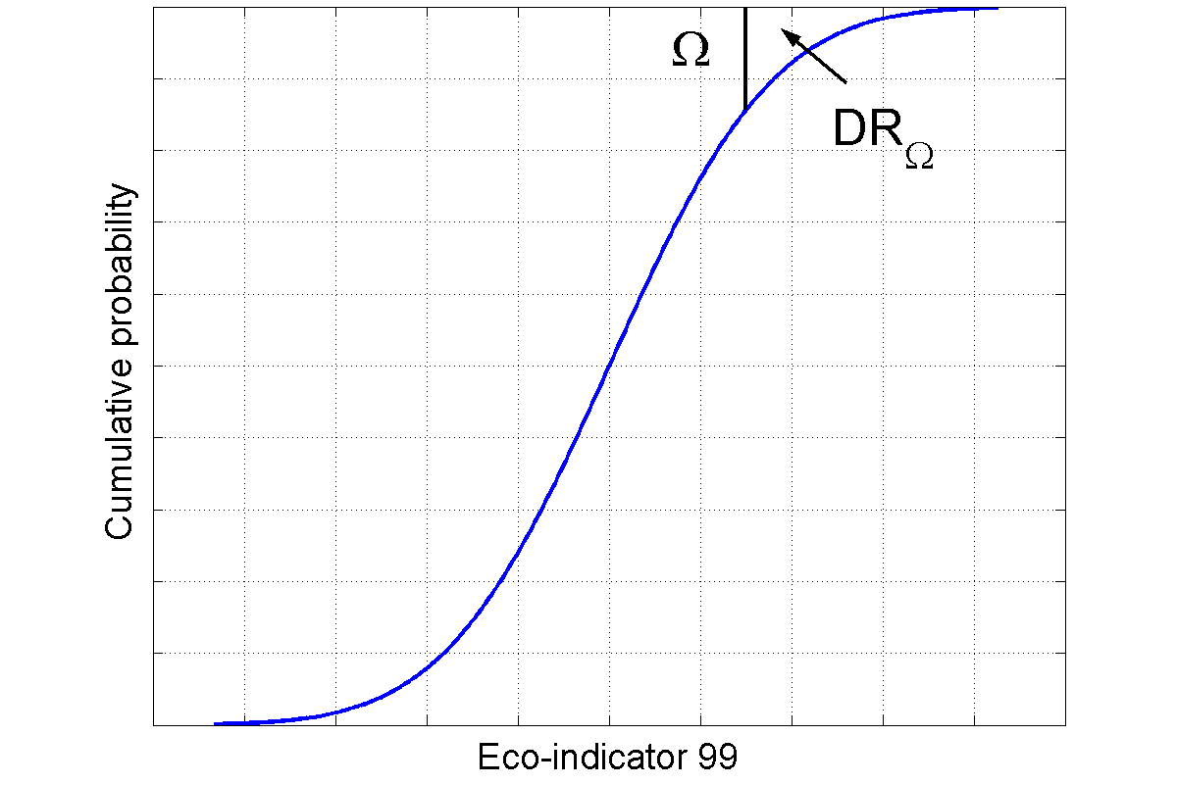
Figure 1. Environmental downside risk
An important issue in the proposed approach is how to measure the environmental performance in the space of uncertain parameters. In this work, we propose to make use of the downside risk, which was originally proposed by Eppen et al.[5], to manage the environmental impact under uncertainty. We name the new metric as environmental downside risk, and use the following equations to calculate its value:
The environmental downside risk represents the integral of the cumulative probability function of the environmental impact from a specific target level omega to infinity. Thus, this metric is given by the area above the probability curve of the Eco-indicator 99 from Ω to infinity (see Figure 1). The target level Ω represents the environmental limit that should not be exceeded. The downside risk can be easily determined from the probability of each scenario s (prob_{s}) and the auxiliary positive continuous variables δ_{Ωs}, whose definition is enforced via equations (4) and (5).
4) Interpretation. Finally, in the fourth phase the results are analysed and a set of recommendations for the system are formulated. In our case, this involves performing a post-optimal analysis of the trade-off solutions in order to identify the best one according to the decision-makers’ preferences and the applicable legislation.
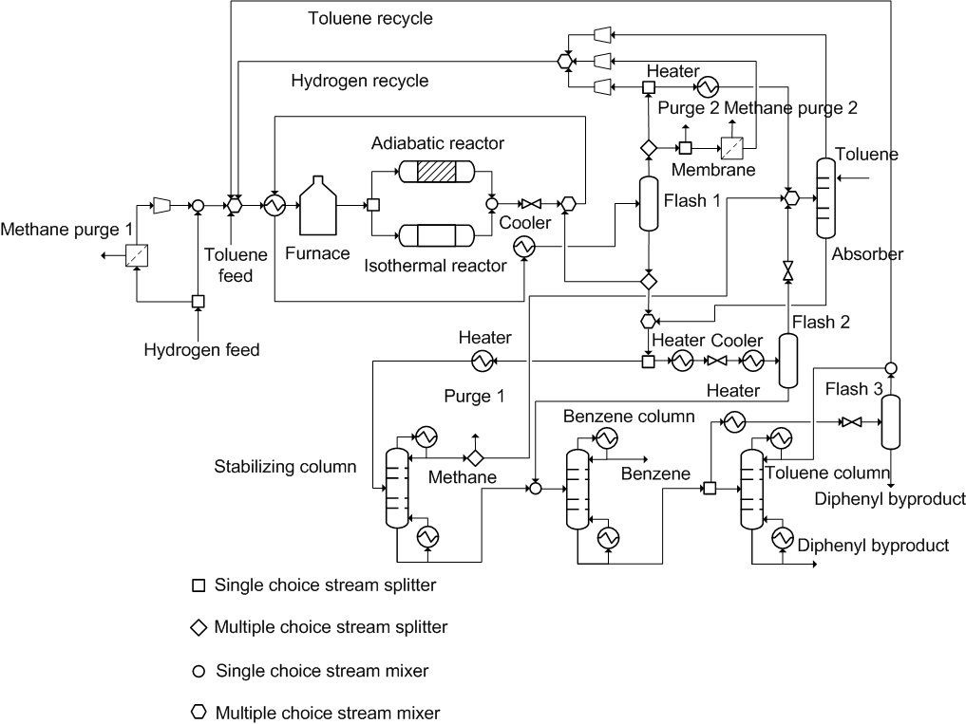
Figure 2. Superstructure for hydrodealkylation of toluene process.
  - Case Study
Our methodology is applied to a well known design problem (i.e., hydrodealkylation of toluene). The superstructure of alternatives and all the associated data have been taken from the work of Kocis and Grossmann (1989)[6] (see Figure 2). Furthermore, the environmental loads associated with the generation of raw materials, electricity and steam have been retrieved from the Ecoinvent database, which is integrated with the Simapro software[7]. A standard deviation of 10% has been assumed for all the emissions per unit of reference flow of activity (i.e., generation of raw materials and energy). We consider 50 equiprobable scenarios that are generated through Monte Carlo sampling, assuming that the input data follow Gaussean distributions with known mean and standard deviation. The target level is set to 4·10⁸ Eco-indicator 99 points.
    - Results& discussions
The design task is formulated as a bi-criterion MINLP that contains 825 constraints, 810 continuous variables and 13 binary variables. The trade-off solutions are calculated through the ε-constraint method[8]. Each single-objective problem is implemented in GAMS and solved with DICOPT. The NLP and MILP subproblems are solved with CONOPT and CPLEX, respectively.

The trade-off solutions of the problem are shown in Figure 3. As can be seen, there is a clear compromise between both objectives, since a reduction in the downside risk can only be achieved at the expense of an increase in the cost. Notice that each point of the curve corresponds to a chemical process flowsheet operating under certain conditions. The first point of the curve is the minimum cost solution, whereas the last one represents the least environmentally harmful solution (i.e., the one with the lowest environmental downside risk). Figure 4 depicts the probability functions of the Eco-indicator 99 associated with the extreme solutions of the curve. It can be observed how the cumulative probability curve is shifted to the left when the downside risk is minimized, thus reducing the probability of causing high environmental impacts. For example, the minimum downside risk solution does not exceed the target level in any scenario, whereas the minimum cost one violates the environmental limit in 12 % of the scenarios considered in the analysis.
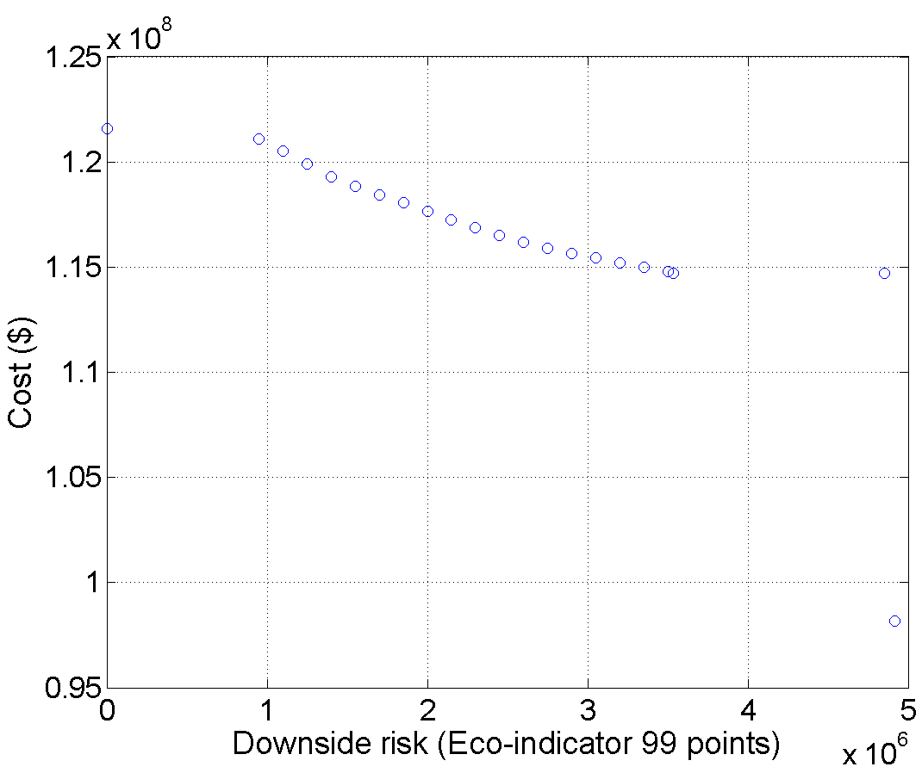 | 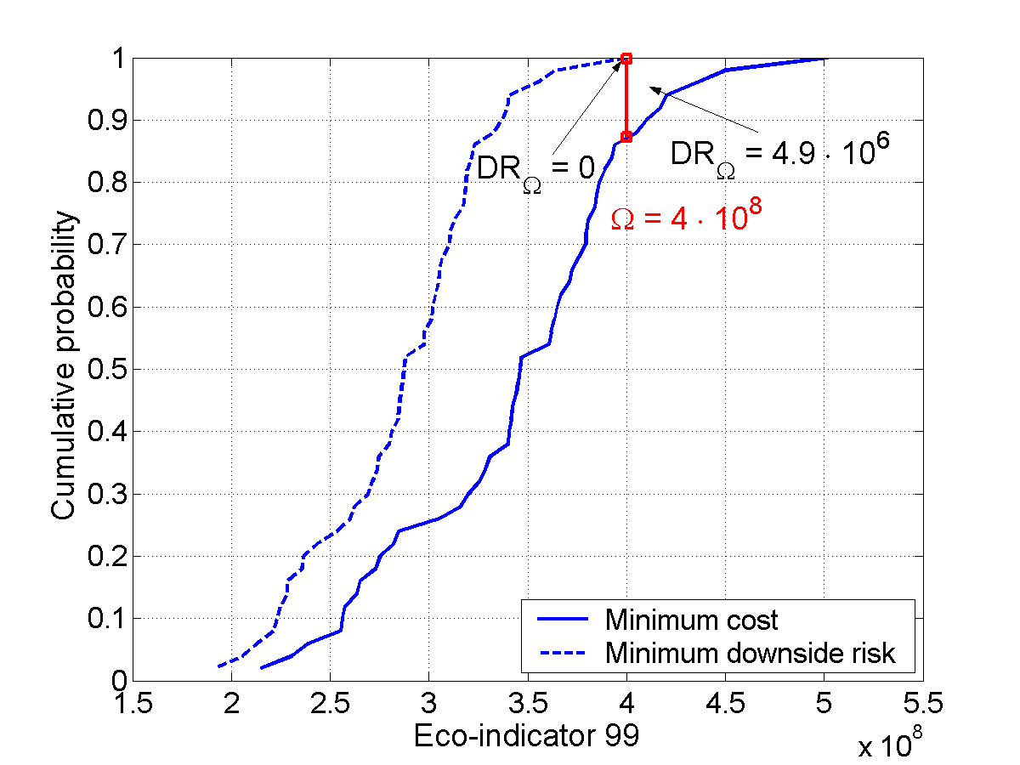
Figure 3. Trade-off solutions. | Figure 4. Cumulative probability curves.
Figure 5 depicts the expected value of the environmental impacts that are included in the Eco-indicator 99 for each of the extreme solutions. In this case the main impacts are: (3) respiratory effects on humans caused by inorganic substances, (4) damage to human health caused by climate change and (11) damage to resources caused by extraction of fossil fuels. Note that some impacts have a negative sign, since the model takes into account the possibility of obtaining environmental savings through the recovery of the heat generated in the combustion of the by-products.
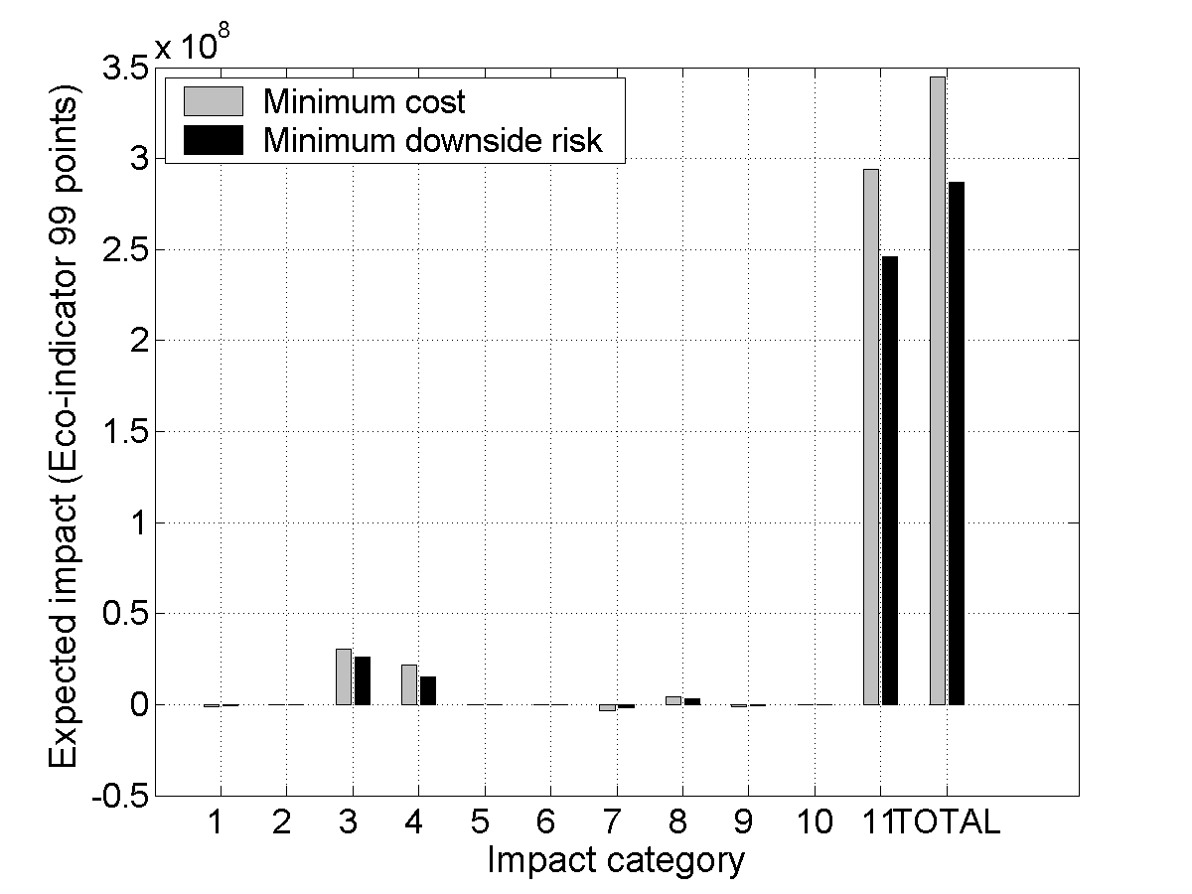
Figure 5. Impact categories of Eco-indicator 99.
Upon analysis of the structural features of the trade-off solutions, which are not given here due to space limitations, one can see how the downside risk is reduced by decreasing the raw materials consumption. Table 1 shows the materials balance associated with the extreme solutions. As can be seen, the solution with minimum cost consumes more raw materials, since their extra cost is compensated by the energy savings from the combustion of the by-products. On the other hand, in the more sustainable alternative, the raw materials consumption is reduced in order to minimize the emissions associated with their generation, which constitutes the most significant source of impact. Furthermore, the extreme solutions lead to different structural flowsheet configurations. Specifically, both of them choose the isothermal reactor, the stabilizing column, the second flash and the membrane in the purge. The differences lie in the membrane in the input stream and in the absorber. The membrane is selected in the minimum cost solution, but does not appear in the solution with minimum downside risk. On the other hand, the absorber is included in the solution with minimum downside risk, but not in the minimum cost solution. The use of the absorber allows to recover the benzene lost in the flash separator, which increases the efficiency of the process and thus reduces the consumption of raw materials.
Table 1. Materials balance of the extreme solutions.
Stream (kmol/min) | Hydrogen | Methane | Benzene | Toluene | Diphenyl
Input¹ | 3.05 | 0.03 | 0 | 3.93 | 0
Output¹ | 0 | 3.94 | 2.20 | 0.02 | 0.86
Input² | 2.51 | 0.03 | 0 | 2.92 | 0
Output² | 0 | 2.91 | 2.14 | 0.03 | 0.38
1 Minimum cost solution, 2 Minimum downside risk solution.
  - Conclusions and Future Work
This work has proposed a novel framework for the design of sustainable chemical processes under uncertainty in the inventory of emissions. Our strategy relies on the combined use of LCA and stochastic mathematical programming. The design task with environmental concerns has been formulated as a bi-criterion mixed integer non-linear problem (MINLP) accounting for the minimisation of the cost and the environmental downside risk. The proposed approach has been applied to a case study (hydrodealkylation of toluene) for which the set of trade-off solutions has been computed. Future work will focus on incorporating other sources of uncertainty that affect the LCA analysis.
References
[1] Consoli, F. et al., 1993, Guidelines for life-cycle assessment: a "code of practice", SETAC (Society of Environmental Toxicology and Chemistry), Pensacola, FL, USA.
[2] Azapagic, A. and Clift, R, 1999 Computers and Chemical Engineering 10, 1509-1526.
[3] Hugo, A., Pistikopoulos, E. N, 2005, Journal of Cleaner Production, 13, 1471-1491.
[4] The Eco-indicator 99, 2000, A damage oriented method for life cycle impact assessment. Methodology Report and Manual for Designers", Technical Report, PRe Consultants, Amersfoort, The Netherlands.
[5] Eppen, G. D.; Martin, R. K.; Schrage, L. Operations Research 1989, 37,517-527.
[6] Kocis, G. R. and I. E. Grossmann, 1989, Computers and Chemical Engineering, 13, 797-819.
[7] SimaPro 6 LCA software, 1998, The Netherlands (www.pre.nl/simapro/default.htm).
[8] Haimes, Y. Y., Lasdon, L. S., Wismer, D. A, 1971, IEEE Transactions on Systems, Man and Cybernetics, 1, 296-297.

