Fundamental aspects to improve risk potential assessment of chemical process industry
Ranzan Nª, Witt W^{b}
ªDepartment of chemical engineering, University of engineering and technology Lahore,Pakistan
^{b}Lehrstuhl Anlagen-und Sicherheitstechnik,Brandenburgische Technische Universitat,Cottbus,Germany
Abstract
The amount of work and time to perform a powerful qualitative safety/risk analysis and a quantitative safety/risk analysis (risk potential study) are approximately same. Analysis of failure statistics, past accident analysis, field experiments, process behaviour and careful definition of objectives of quantitative safety/risk analysis supports risk potential study. In this paper, fundamental aspects of safety/risk analysis and a semi quantitative methodology (risk potential study) based on Extended HAZOP is presented. Plant specific numerical rating of consequence class (C) for each individual type of risk (financial, personnel (workers and public) etc.) and frequency class has been developed and used in Extended Hazop. Hazop decision matrices of each risk (financial, personnal etc.) are formulated to rank the scenarios in different risk potential categories. Similar risk potential scenarios are clustered to generate modification proposals to optimize the safety/risk. Two example case studies taken from chemical process industry are used for the illustration of the methodology.

Keywords: Extended HAZOP, Hazop decision matrix, Distillation column unit, Batch reactor
  - Introduction
Safety/risk is the art and science of developing and understanding of the risk (financial, personnel, environment) which fundamentally different from many other activities of chemical process engineering [1]. This analysis can be sorted into two principle groups: 1) qualitative, 2) quantitative. Though both academic researchers and practicing engineers have number of techniques for quantitative safety/risk analysis [2]. But qualitative Hazard and operability study (HAZOP) integrated with risk potential matrix, based on experience of the expert team when judging the risks associated with their facilties and activities, is still the most popular method used in chemical processing industry. The most common arguments presented in its support and against quantitative safety/risk analysis are: 1) we do not have quality failure rate data, 2) we do not have accurate mathematical models to predict accident phenomenon and their effects, 3) we do not have enough time to quantify all aspects, 4) completeness and reproducibility of results in quantitative safety/risk analysis can never be gurranted. But we have the opinion that the amount of work and time to perform a powerful qualitative safety/risk analysis and a quantitative safety/risk analysis (risk potential study) are approximately same. Table 1 gives the fundamental aspects to be considered for qualified safety/risk analysis. Analysis of failure statistics, past accident analysis, field experiments, process behaviour and careful definition of objectives of analysis supports risk potential study. In this contribution, methodology for risk potential assessment of chemical processing industry is explained with the help of two case studies.

Table 1. Fundamental aspects of safety/risk analysis
No. | Fundamental Aspects | Answers/solutions
1 | Plant & process information for safety/risk analysis | Plant documentation, Commercial data bases, Field experiments etc.
2 | Hazard identification | Past accident analysis, Hazop, PHA etc.
3 | Frequency estimation | Analysis of failure statistics, Fault tree analysis, Event tree analysis etc.
4 | Consequence analysis | Disturbance simulation, Event tree analysis, Effect estimation models, Damage estimation models, Past accident analysis
5 | Risk presentation | Risk contour, F-N curves, Risk potential matrix
6 | Acceptable risk criteria | Standards, Company and/or state policies
7 | Optimization | Cost benefit analysis, Multiobjective optimization
8 | Completeness | FMEA, Check lists, Detailed disturbance simulation
9 | Quality | Experts & use of computer supported tools
  - Methodology
The important steps of the methodology presented for the risk potential assessment of the chemical process industry and safety/risk optimization for potential scenarios are as follow:
1) Based on plant specific scenarios a numerical rating of consequence class (C) from 0-8 (lowest to highest) for each individual type of risk (financial, personnel (workers and public) and environmental) is developed (see table 2).
2) Based on past historic data basis, failure statistic analysis and generic failure date of components, numerical rating of frequency class from 0-9 (highest to lowest) for occurring a scenario/event is also developed.
3) Identification of plant sections for intensive analysis based on short cut consequence analysis such as release estimates.
4) Identification of hazards and/or weak points in design using Extended Hazop in which physical effects such as increase in level results to increase in pressure etc. and risk (financial, personnel and environmental) related consequence of each scenario will be documented separately (see details in [3]). Event tree analysis and fault tree analysis are used within Extended Hazop to establish the consequence and frequency class.
5) Keeping in view the analysis objectives, the completeness of Extended Hazop is ensured by qualified checklists and simulating various disturbances.
6) Extended Hazop results are transferred from Hazop worksheets to Hazop decision matrices of each risk (financial, personnel etc.). Within Hazop decision matrices, the scenarios are ranked in different risk potential categories.
7) Clustering of similar risk potential scenarios to generate modification proposals for optimization of safety/risk.
8) Justification of each modification proposal (if necessary) considering life cycle related cost modeling and/or presenting risk using risk contours.

Table 2. Numerical rating of different individual risk consequences
Financial damage (€) | Health (personnel) damage | Environmental damage | Score
F1 ~ <10 | H1~ no complaint of injury | E1~ no impacts | 0
F2 ~ 10¹ - 10² | H2~ 1 complaint of injury | E2~ nuisance effect | 1
F3 ~ 10² - 10³ | H3~1 person mild injured or 10 complaints | E3~ 10 complaints or local news | 2
F4 ~ 10³ - 10⁴ | H4~ 1 visit doctor or 10 mild injured or 100 complaints. | E4~ 100 complaints or front page local news | 3
F5 ~ 10⁴ - 10⁵ | H5~1 hospitalized or 10 visits doctor or 100 mild injured or local news | E5~>100 complaints or major local news or small national news | 4
F6 ~ 10⁵ - 10⁶ | H6~1 permanent disable or 10 hospitalized or 100 visits doctor or 100 mild injured or national news | E6 ~ national news or short term non complai- -nce of regulation | 5
F7 ~ 10⁶ - 10⁷ | H7~ 10 permanent disabilities or 100 hospitalized or 1000 visits doctor or international news | E7 ~ Major national news or extended non compliance & notice of violation (NOV) likely | 6
F8 ~ 10⁷ - 10⁸ | H8~ 1 fatalities or 100 permanent disabilities or >100 hospitalized or inter national news | E8~ significant long term non compliance & NOV is certain or international news | 7
F9 ~ >10⁸ | H9~ 10 or more fatalities | E9~ Regulatory action including fines certain | 8
  - Case Studies
    - Example 1
A distillation column unit (see ref. 4 for process details) from a chemical plant is taken as first example. Figure 1 shows a simplified process diagram. The separation targets (mass %) are: Distillate: Water < 10 Bottoms: acetone<0.22; methanol<2; acidity < 3. The area around the plant is open fields (rural condition). Weather conditions (Stability factor “F”) and wind speed (1.5m/s) as low as possile that results in smallest value of dispersion coefficients are selected. It is assumed that 10 workers are present, which are not distributed uniformly, on the land in area of 100 square meters around the column under study. The situation of overpressure in column is studied.
A number of Extended HAZOP worksheets
are formulated. Table 3 gives the list of
plausible causes identified in the Extended
HAZOP worksheets. The physical effects
and risk related consequences of the
plausible causes identified during
Extended HAZOP are analyzed by
disturbance simulation and event
tree analysis. It is not possible to
simulate the scenarios such as foaming,
fouling etc. with commercial simulation
tools like Aspen dynamics.
Scenarios such as less steam flow rate,
more feed flow rate etc. can be simulated not Fig. 1. Simple process diagram
only to evaluate control structures (small disturbances) but also for safety examination (large disturbances). Figure 2 shows the disturbance simulation results for plausible casue 2.1.

Table 3. Scenarios or possible causes identified in Extended HAZOP
Possible causes ID | Description
1.1 | Too less or loss of cooling capacity in head condenser and/or cooler
1.2 | More direct steam flow or High steam temperature
1.3 | Too much feed or HC slipping
1.4 | Fouling of base pipe work or wrong valve position of bottom line
1.5 | Too much reflux flow
2.1 | Restriction/blockage of vent line plus pressure rise
3.1 | More cooling capacity in head condenser and/or cooler
3.2 | Less or loss of reflux flow due to pump failure
4.1 | Restriction in bottom outlet valve or base pipe work
4.2 | Foaming
5.1 | Column bottom by pass valve fail open
5.2 | Rupture of pipe (column bottom outlet)
6.1 | Faulty level measurement of reflux drum

Risk potential matrix for each individual type of risk is formulated and only potentially dangerous scenarios are further investigated. Figure 3 shows the financial, personnel and environmental risk contour along with risk factors for the catastrophic consequence in case of scenario 2.1. Keeping in view the analysis objectives and evaluating risk potential matrices, five safety related alternatives from simple pressure SS-A: alarm system, SS-B: Remote shutdown system, SS-C: Non redundant PLC shutdown system, SS-D: Relay logic shutdown system and SS-E: PLC TMR shutdown system to deal overpressure situation is generated and evaluated. Figure 4 shows the results of optimization proposal. SS-C seems to be best option and also confirmed by multicriteria decision analysis method-Promethee.
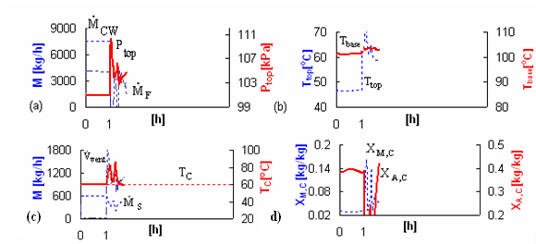

Figure 2. Disturbance simulation for plausible cause 2.1
Financial risk 4.5 m² 6176 $/y
Personal risk 11.5 m² 109200 $/y
Environmental risk contour 78 m² 9712 $/y
Figure 3 Risk contours for the catastrophic consequence for scenario 2.1
Figure 4 Optimization proposal evaluation results
    - Example 2
Ethoxylation of fatty alcohols is performed in industry for production of surfactants & polyglycols. A semibatch reactor [see ref. 5 for process details] process for ethoxylation of fatty alcohols is studied as second example. This process has high operational risk potential because of exothermic reaction and hazardous properties of ethylene oxide. For example in case of operational failures such as loss of cooling may cause the run away reaction to occur which leads to an instant increase of temperature and pressure. The simulation tool for ethoxylation developed in our chair [6] is used for calculation of safety limits and support of extended HAZOP to identify hazards. The simulations results are validated by experiments in the PhiTec II calorimeter. Figure 5 shows the simulation results for the disturbance of loss of cooling water.
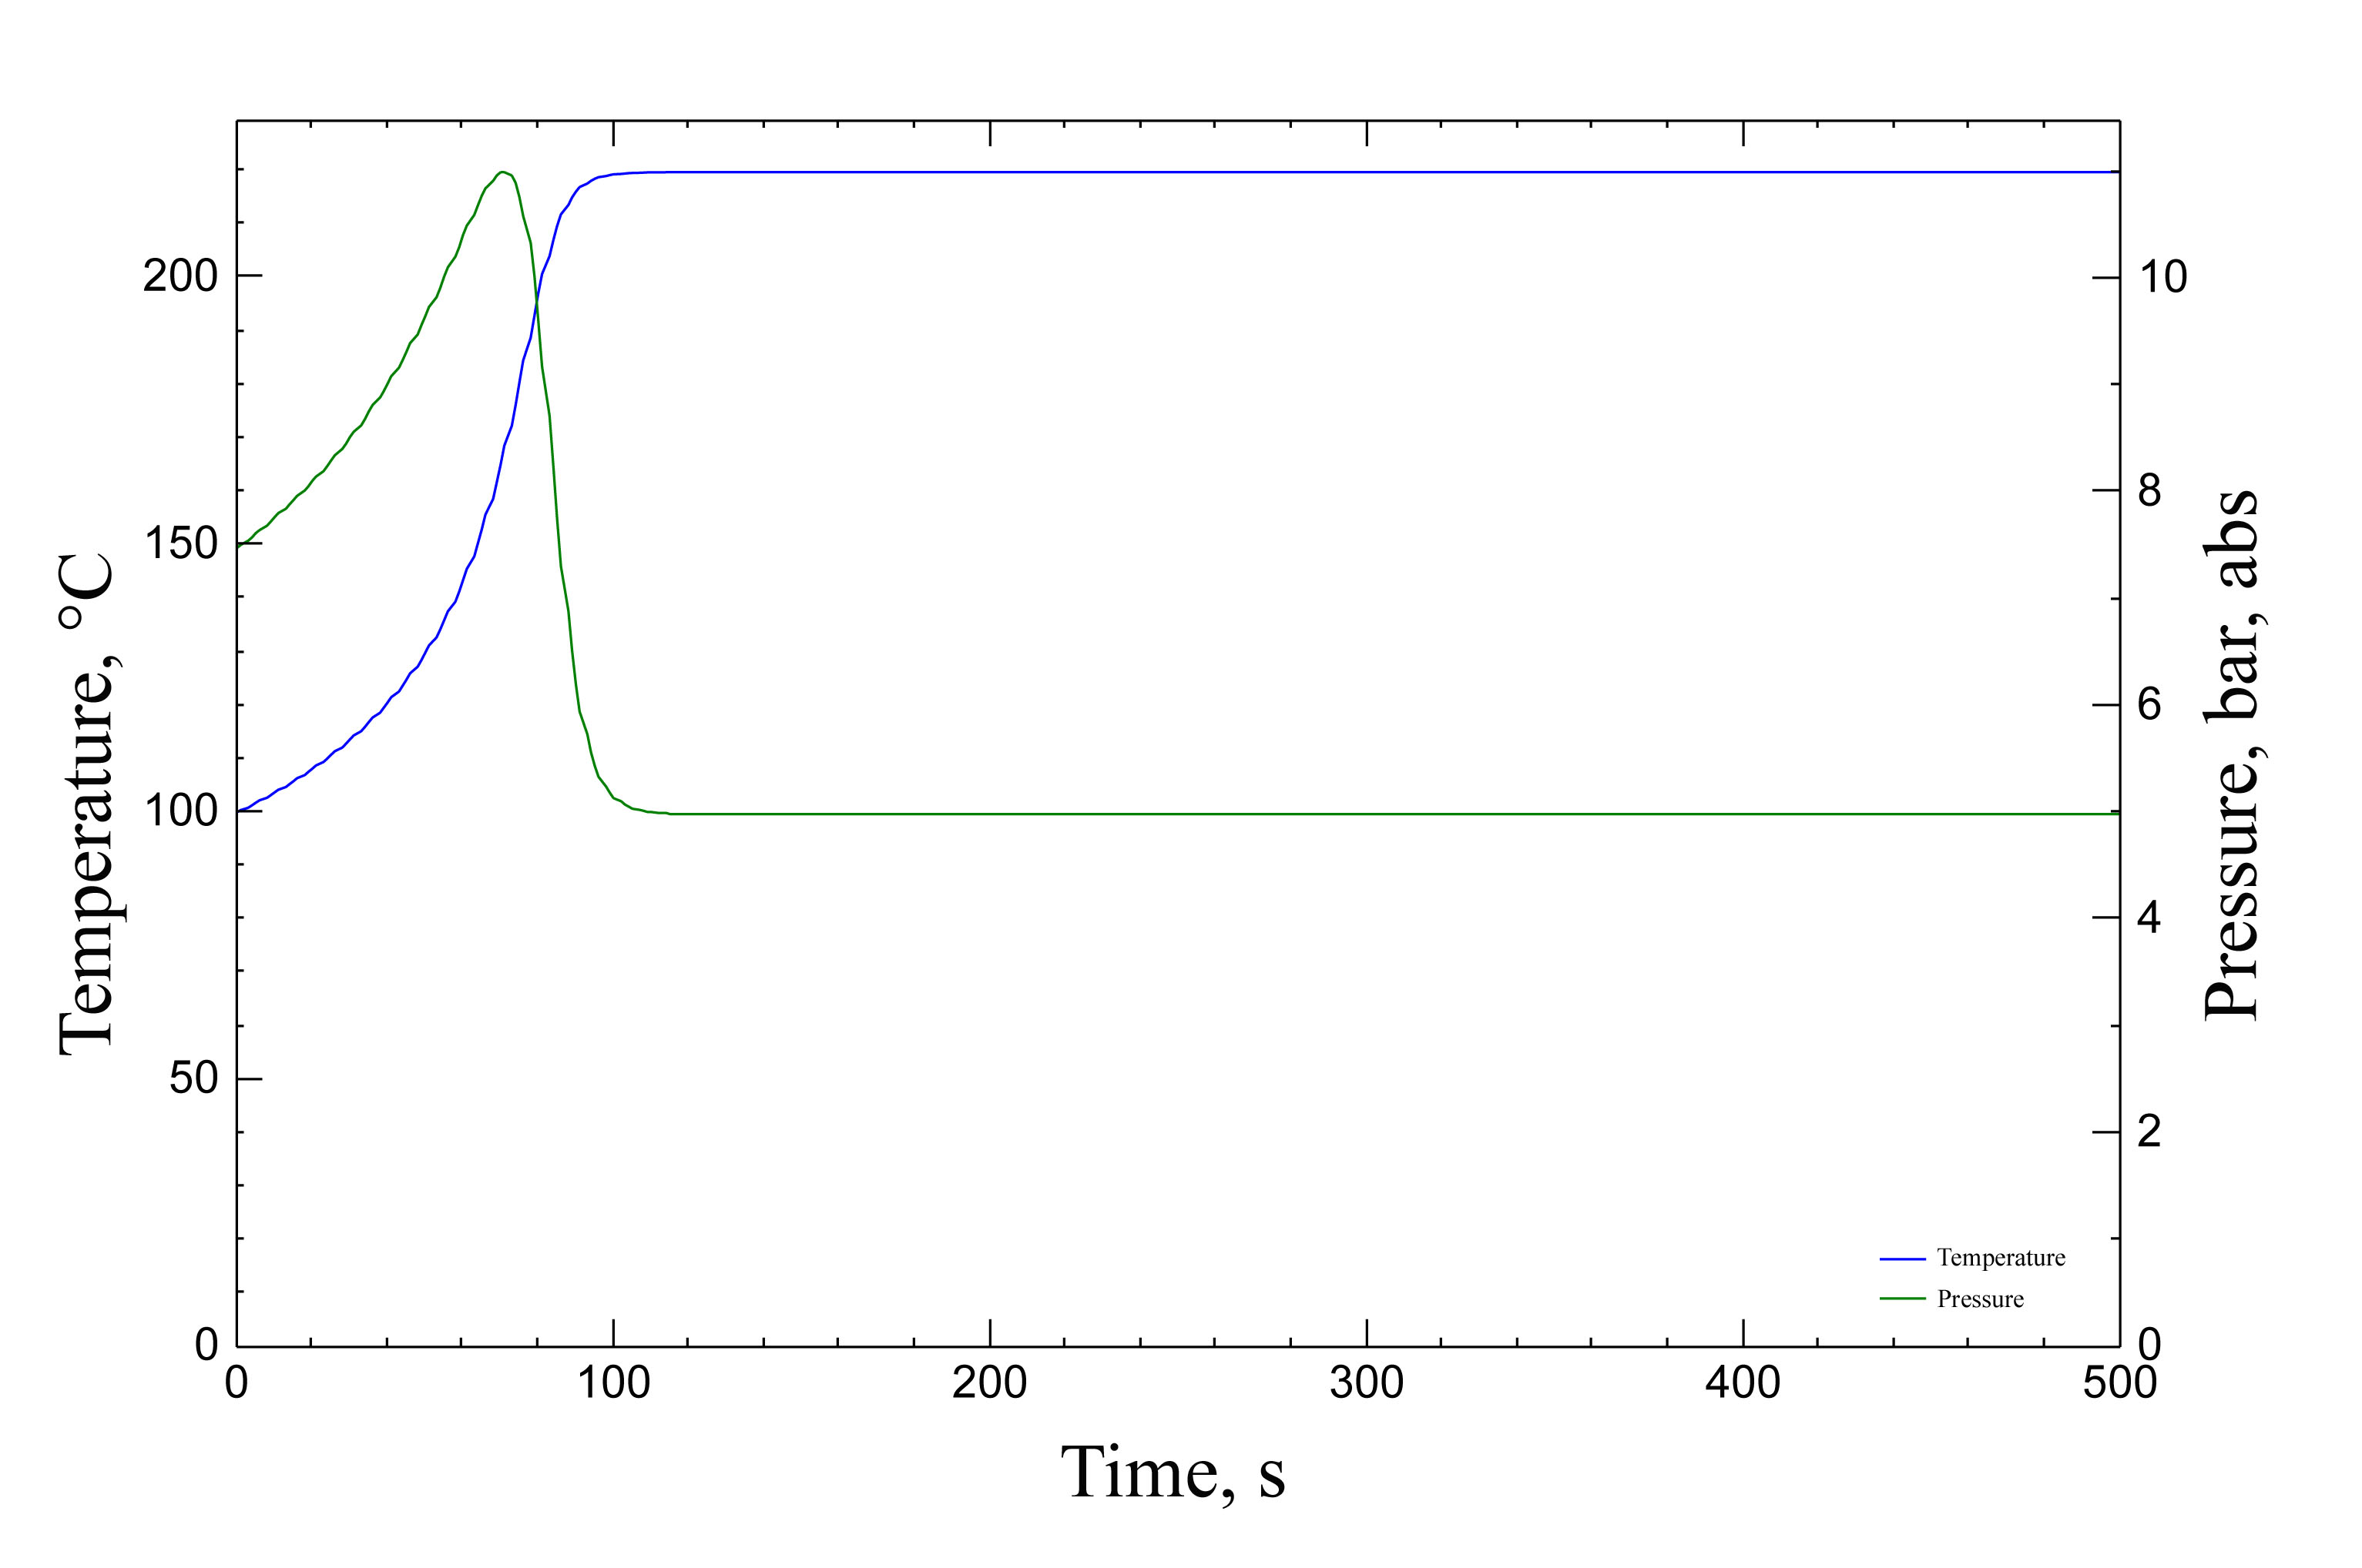
Figure 5 Simulation results for run away reaction due to loss of cooling
Major hazards identified are: 1) Overheating of EO feed pump, 2) Reverse flow of contaminated EO, 3) Run away reaction, 4) Deflagration in reactor and 5) EO emission.
  - Conclusion
A semi quantitative methodology presented for risk potential assessment of chemical processing industry proves a good tool for safety optimization and process design.
References
- Arendt, J.S. and Lorenzo, D.K. “Evaluating process safety in the chemical industry-A user’s guide to QRA” CCPs, New York, 2000.
- CCPS-Center for Chemical Process Safety: “Guide lines for Hazard Evaluation Procedures, CCPs” American Institute of Chemical Engineers”, New York ,(1992)131-151
- Ramzan, N.; Compart, F.; Witt, W., process safety progress, 26(1), (2007) 35-42
- Ramzan, N., Compart, F., Witt, W., Process safety progress, 26(3), (2007)248-257.
- Deerberg, G.; Schlüter, S.; Steiff, A.; Witt, W.,Chem. Eng. Sci.51 (11), (1996) 3113-3118
- Degenkolbe, S., Sussmuth,M.,Witt, W., submited for presentation in 18th ESCAPE (2008)

