Integrated Decision Support Tool for Pharmaceutical Product Development
Ankur Jain^{b}, Pavan Kumarª, Girish Joglekarª, Leaelaf Hailemariamª, Pradeep Sureshª, Chunhua Zhaoª, Kenneth R. Morrisª, Gintaras V. Reklaitisª, and Venkat Venkatasubramanianª
ªSchool of Chemical Engineering, Purdue University, 480 Stadium Mall Drive, West Lafayette, IN 47907, USA
^{b}Enterprise Optimization, United Airlines, Chicago, IL, 60007, USA

Abstract
In this work a Java based execution engine is developed to provide the decision support tool for pharmaceutical product development based on an ontology based knowledge representation model. This paper presents the detailed design and architecture of this execution engine, which uses the knowledge encoded in the guideline ontology, and accesses several other ontologies to retrieve information and store the results and recommendations. The execution engine executes the various steps in a guideline which specify the details of the decision making process. Although illustrated in the context of pharmaceutical product development, the proposed approach can be applied to support other product, process and equipment design decision processes which rely on multiple knowledge sources.

Keywords: Ontology, Knowledge Modeling, Decision Support System, Pharmaceutical Product Development
  - Introduction
A number of decision support tools have been proposed and developed in the past two decades to capture the knowledge and support the complex decision making process involved in pharmaceutical product development¹. Most of these systems employ a knowledge representation which is based on a specific tool. This makes it difficult to share the knowledge across different tools and applications and to use it in an integrated manner. In our previous work^{2,3} an application independent knowledge representation model has been developed in the form of an ontology, which is called a guideline ontology. The guideline ontology has the generality to be able to represent decision trees, heuristics and rules as guidelines. A number of guidelines were developed to capture the knowledge used in decision making in pharmaceutical product development. In order to provide decision support, a Java based execution engine is developed for the implementation of guidelines. The execution engine provides decision support based on the knowledge represented in the guidelines. The execution engine also interacts with three other ontologies: (a) material ontology², (b) product development state ontology⁴ and (c) mathematical model ontology².

The paper is organized as follows. Section 2 provides a brief summary of the guideline ontology and its structure. The detailed design and architecture of the execution engine is presented in Section 3. Section 4 provides the details of a case study and the results demonstrating the application of decision support tool. Section 5 summarizes the approach used in this work and discusses its benefits.
  - Guideline Ontology
The guideline ontology^{2,3,4} models decision trees, heuristics and rules in the form of guidelines. The guidelines are represented in the form of ontology using Web Ontology Language⁵ (OWL) and developed using Protégé⁶ as the ontology editor. A guideline models procedural knowledge, which mainly consists of decision logic, information look up and evaluation of decision variables.
    - Structure of Guideline Ontology
The guidelines are created based on GLIF⁷ (GuideLine Interchange Format), a specification developed for structured representation of clinical guidelines. Classes and attributes in the guideline ontology constitute the guideline representation model and the instances in the guideline ontology constitute the knowledge of a specific domain. Based on the GLIF specification, each guideline is represented as an instance of the Guideline class. The details of the decision making process of a guideline are specified as an instance of Algorithm class. An Algorithm instance consists of instances of seven type of basic steps linked together to form a flowchart (Figure ‎1).

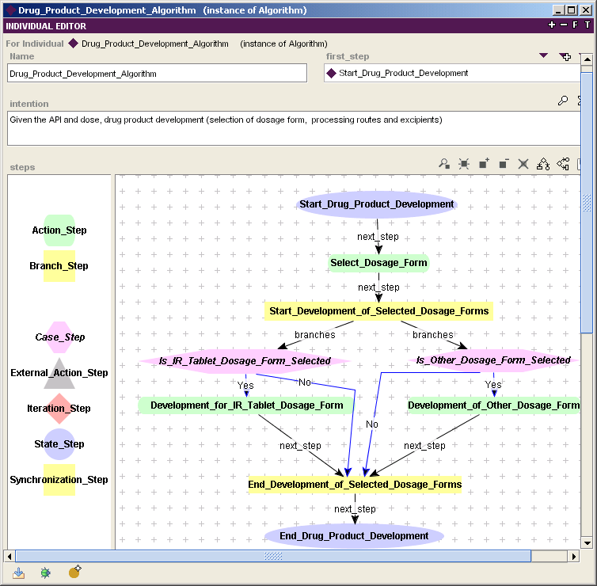
Basic Steps
Purpose of Guideline
Guideline Details

Figure 1. Algorithm and Basic Steps of a Guideline
A step can be one of the following types: (1) state step which is used to specify the state of product development in the specific context of a guideline’s application; (2) decision step which represents a decision point; (3) action step which represents a domain specific action or a link to a subguideline; (4) branch step which is used to initiate multiple steps in parallel; (5) synchronization step which is used to coordinate concurrent steps or steps with arbitrary execution order; (6) iteration step which is used to execute a set of steps multiple times; and (7) external action step which is used to perform the actions outside the scope of guidelines.
  - Execution Engine
In order to provide the decision support for pharmaceutical product development, an execution engine has been developed for the implementation of guidelines. The execution engine uses the knowledge in the form of guidelines and the information stored in an ontology-based information repository to provide the decision support. Section 3.1 explains the higher level architecture of the execution engine and how different ontologies are used by the execution engine. It also includes details about tools and technologies used in the development of the execution engine. Section 3.2 describes the details of how the execution engine is used to execute the guidelines.
    - Architecture of Execution Engine
The execution engine uses the knowledge encoded in the guideline ontology, and accesses several other ontologies to retrieve the information and store the recommendations as they are being made. Ontologies are accessed by the execution engine using Protégé-OWL API (Application Programming Interface)⁸. The execution engine is developed in the Java programming language using the Eclipse 3.1 development environment⁹. Figure ‎2 outlines the overall architecture of the execution engine. The guideline ontology and the other ontologies were developed independent of the execution engine and can also be accessed or used by other tools and applications.

Execution Engine
Developed in Java using Eclipse
Based on Guideline Ontology
Material Ontology
Product Development
State Ontology
Guideline Ontology
Mathematical
Model Ontology
User Interface
Get Development State Details
Update Development State
Access Material Properties
Access Mixing Rules for Mixture Properties
Access Knowledge Stored as Guidelines

Figure 2. Architecture of Execution Engine and Interaction with Different Ontologies
As shown in Figure 2, to obtain the details about the development state of the product to which guidelines are being applied, the execution engine is linked to the product development state ontology. After the decisions are made by the execution engine, they are sent to the product development state ontology and stored there. In order to make the decisions, the execution engine also needs to get the values of properties used in decision step expressions. The execution engine accesses these properties from an information repository based on the material ontology. The details about which material and what properties to access are provided by the guidelines themselves. For accessing the mixture properties that are not available in the material ontology, mathematical models are used. Mathematical models which are represented as mathematical model ontology are also accessed directly by the execution engine. A user interface is developed for the decision support that provides the user with the functionalities to execute and browse the guidelines.
    - Execution of Guideline
This section describes the details of the execution of specific steps of a guideline. In order to execute the guideline steps, execution engine needs to: (a) interpret all the details (classes and attributes) of guideline ontology, and (b) implement the guideline steps (instances) in guideline ontology during runtime. The first task of interpreting the details of guideline ontology is achieved by creating a mapping of all the classes and attributes in guideline ontology to corresponding Java classes. Next, to enable the use of guidelines details and other components for execution implementation, further details are added to the execution engine. Both of these steps are independent of the guideline instances and as new guidelines are being added no changes are required in the engine.

To create the mapping, Java classes are created corresponding to all the classes in the guideline ontology. Protégé 3.1 provides the feature – Generate Protégé-OWL Java Code⁸ – to create these classes automatically from an ontology. For each attribute of classes in ontology, Generate Protégé-OWL Java Code also creates several Java methods to access and manipulate those attributes. However, the code which is generated automatically does not provide all the details on how to use these Java classes and methods in the execution engine. For example, to specify the messages displayed on the user interface or to link the execution engine with the user interface, further details need to be added to these Java classes. To add these details, a set of new classes are created which inherit the details of classes created automatically and include the details that can be added manually. This provides a better organization of classes and eliminates the need of manually updating the Java classes if the guideline ontology is modified. Apart from the classes corresponding to those in the guideline ontology, several other classes are created to facilitate the execution of guidelines. They are used for initiating the execution by displaying the user interface, obtaining the values of development state and guidelines, and performing the other tasks associated with the guideline execution.

During runtime, Protégé-OWL API is used to access the guideline ontology from the Java execution engine as shown in Figure 3. Protégé-OWL API is an open-source Java library for OWL, which provides classes and methods to load and save OWL files, to query and manipulate OWL data models, and to perform reasoning⁸. Protégé-OWL API provides the access to instances in the guideline ontology by creating a Guideline OWLModel object (Figure 3).

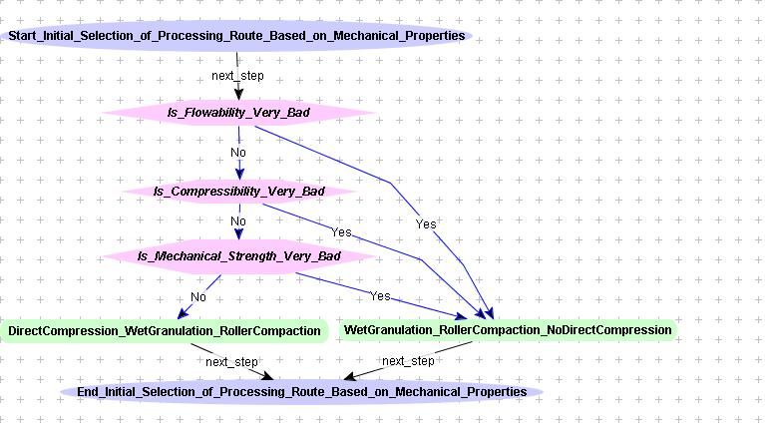
Guideline Execution Engine
User Interface
Using Protégé- OWL API
Details of Decision Making
Guideline Ontology
Guideline
OWLModel
Display Guidelines
Guideline Execution
Figure 3. Execution Engine Accessing Guideline Ontology During Runtime
Creating an OWLModel object is the first step for the execution of guidelines. The user interface accesses this object to display the list of guidelines and their details. As the execution of a specific guideline starts, the following tasks are executed:
Start Algorithm: The first task is to start the execution of the algorithm which contains all the basic steps for a guideline. Apart from displaying some messages, it involves obtaining the first step of the algorithm which is always a state step.
Execution of State Step: To execute the state step, first, the details of the product development state are obtained. Following that, the next step after the state step is obtained and executed.
Execution of Action Step: An action step has multiple functions including invoking a subguideline and obtaining the value of material property or updating development state. To invoke the subguideline, it sends the control to the first step of the subguideline along with the required details about the product development state. To update the product development state, it invokes the assignment action.
Execution of Decision Step: For the execution of a decision step, first, values of all the properties required to make the decision are obtained from material ontology using a get data action. After obtaining the property values, the expression used in decision criterion is evaluated using a parser⁴. The expression result is then compared with the condition value for different options for the decision step and the first decision option for which the condition value matches the expression result is selected as the next step.
Execution of Branch and Synchronization Steps: A branch step has multiple next steps corresponding to different branches. Execution of all the branches starts in parallel. A branch terminates when it encounters the synchronization step. As soon as all the branches finish execution, control goes to the next step of the synchronization step.
Execution of External Action Step: The external action step is used to perform the actions outside the scope of guidelines. When an external action step is encountered, the guideline execution is paused. The user performs the desired tasks using any other tools and updates one or more ontologies except the guideline ontology. As the guideline execution is resumed by the user, the engine obtains the updated information from the other ontologies, and proceeds to the next step.
Execution of Iteration Step: The iteration step is used to execute a sequence of steps multiple times, each time with a different set of input or condition. To execute the iteration step, first the list of iteration conditions is obtained. Then, the sequence of steps, which is encoded as a separate subguideline is executed multiple times, each time with different input or condition. Once the execution is completed for all the conditions and inputs, control goes to the next step of iteration step.
  - A Case Study
The execution engine along with the knowledge representation model provides a decision support tool which can be effectively used to capture and use the knowledge in decision making in pharmaceutical product development. As a case study, the decision support tool is used in the context of developing formulation of a drug substance and guidelines are used to select the processing route and excipients to manufacture the formulation for Cycloserine. Cycloserine is a MDRTB (multi-drug resistance tuberculosis) drug with a dose of 250 mg and immediate release solid dosage form as desired dosage form. As a first step, the state of Cycloserine product development is represented as an instance in product development state ontology. Then a set of guidelines are applied to identify one or more feasible processing routes for manufacturing the formulation. These guidelines selected roller compaction as a feasible processing route, and eliminated direct compression and wet granulation based on the poor flowability and poor chemical stability, respectively, of Cycloserine. Based on the physical and chemical properties of Cycloserine, the guidelines identified that flowaid and lubricant are the required excipient roles in the formulation. To identify the potential candidates for each excipient role, first, mixture properties of excipient candidate and Cycloserine are calculated using the mixing models represented in the form of mathematical model ontology, and then evaluated using excipient selection guidelines. Based on the flow property, guidelines identified that Trical (Tribasic Calcium Phosphate) or Cabosil (Colloidal Anhydrous Silica) can be used as flowaid and Magnesium Stearate or Talc (Magnesium Silicate Monohydrate) can be used as lubricant.
  - Summary
The execution engine is developed independent of the specific knowledge in the guideline ontology. The execution engine depends on the classes and attributes in the guideline ontology, and it is independent of instances in the ontology. This means as new knowledge is added to the guideline ontology as instances, no change is required in the execution engine. Domain experts in pharmaceutical product development do not need to know the implementation details of execution engine as they use it. All the information required to execute the guidelines, which is represented in the form of other ontologies (material ontology, mathematical model ontology and product development state ontology), is directly accessed by the execution engine. All the ontologies in this work are represented in OWL and execution engine is developed in Java; and they do not depend on the choice of editor (Protégé/Eclipse) or OWL API (Protégé-OWL). The knowledge modeling approach and execution engine developed in this work are based on a knowledge representation which is independent of system or inference engine that uses the knowledge. The knowledge representation model and guidelines can also be used for other applications and readily integrated with other tools. The same approach can be applied to several areas in chemical engineering and other engineering domains.

References
1. C. Zhao, A. Jain, L. Hailemariam, P. Suresh, P. Akkisetty, G. Joglekar, V. Venkatasubramanian, G.V. Reklaitis, K. Morris, & P. Basu, 2006, Towards Intelligent Decision Support for Pharmaceutical Product Development, Journal of Pharmaceutical Innovation, Sep-Oct, 23-35
2. V.Venkatasubramanian, C. Zhao, G. Joglekar, A. Jain, L. Hailemariam, P. Suresh,P. Akkisetty, K. Morris, & G.V., Reklaitis, 2006, Ontological Informatics Infrastructure for Pharmaceutical Product Development and Manufacturing, Computers & Chemical Engineering, 30, 10-12, 1482-1496
3. C. Zhao, A., Jain, L. Hailemariam, G. Joglekar, V. Venkatasubramanian, G.V. Reklaitis, & K. Morris, 2006, A Unified Approach for Knowledge Modeling in Pharmaceutical Product Development, in: 16th ESCAPE and 9th International Symposium on Process Systems Engineering, 21B, Marquardt, W., & Pantelides, C. (Eds.), Elsevier, 1929-1935
4. A. Jain, 2007, An Ontological Framework for Knowledge Modeling and Decision Support for Pharmaceutical Product Development, Ph.D. Dissertation, Purdue University, West Lafayette, IN, USA
5. W3C, 2004, Web Ontology Language Overview, W3C Recommendation. Available online at: http://www.w3.org/TR/owl-features/
6. Protégé, url. http://protege.stanford.edu/
7. M. Peleg, A. Boxwala, S. Tu, D. Wang, O. Ogunyemi, and Q. Zeng, (2004), Guideline Interchange Format 3.5 Technical Specification. Available online at: http://www.glif.org
8. Protege-OWL API, url. http://protege.stanford.edu/plugins/owl/api
9. Eclipse, url. http://www.eclipse.org/

Corresponding author: venkat@ecn.purdue.edu

