Management and reuse of mathematical models in chemical industries with MOVE
Lars von Wedelª
ªAixCAPE e.V., Intzestrasse 1, 52072 Aachen, Germany, vonwedel@aixcape.org
Abstract
Mathematical process modeling is a powerful tool, but model development is often a complex task. It is therefore surprising that solutions for systematically maintaining, archiving, and reusing mathematical models are not widely accepted. As a consequence, the efforts invested into model development are often not properly exploited. Further, repeated work might lead to inconsistent results if different modeling assumptions are applied. A systematic approach to managing mathematical models is therefore a beneficial support of modeling development in chemical engineering companies. This contribution motivates the need for systematic management, archival, and reuse of mathematical models in chemical industries and sketches requirements that a possible solution must fulfill in order to be successfully applied in order to support an engineer along his daily modeling work.
Keywords: Knowledge management, modeling, database, library.
  - Introduction
Model-based methods are nowadays frequently used in chemical industries for delopment and optimization of production processes. Formal analysis of these models with numerical methods improves the quality of the process development and may lead to e.g. reduction of production cost, increase of capacity or energy efficiency, or improvements in the product quality.
Although the effort to develop such models is regarded to be rather high, solutions for systematically maintaining, archiving, and reusing mathematical models are not widely accepted. This is partly due to lacking awareness, partly due to the fact that technical solutions tailored to companies’ work processes are not available. Typically, models are used over and over for the same production process, not only in order to achieve a continuous improvement in product quality and cost, but also because external factors such as cost of raw material and energy as well as product prices are constantly changing.
Hence, reuse of mathematical models can contribute significantly to a reduction of cost and development time of projects making use of model-based methods. In addition, reusing existing models instead of developing new ones from scratch ensures that information is consistently applied throughout several projects. Various scenarios for reusing different aspects of models come to mind:
- The development of new models for process equipment can be simplified if models for underlying transport phenomena, material properties, or complex geometries are available from a structured library and can be aggregated rather than reinventing them over and over again.
- During process design it is easier to refine a less detailed model rather than to develop a new one from scratch. For example, a linear model of the process steps involved can be extended to use rigorous models based on approximately the same model structure. In such a procedure, the results of the simpler model can be used in order to simplify initializing the more complex one.
- For a capacity extension project, it will be desirable to have those models available which have been used for process design (probably a couple of years ago). The model can be adapted and extended to analyze the projected modifications to the process.
- If a process cannot be operated properly, it is desirable to perform control system analysis or design based on a dynamic model. If such a model does not exist, important information such as the model structure or reaction kinetic parameters can be reused from existing steady-state models.
When talking to engineers concerned with modeling in chemical companies it becomes obvious, that models developed for a certain project are usually not stored in a central place. Only results derived through simulation or optimization are passed on. The files belonging to a mathematical model remain with the modeler and are not available for use by others in subsequent projects. As engineers usually develop a number of models which may differ in parameter values, complexity, the assumptions made during the modeling process, process structure, etc., a model development effort usually results in many variations of the final model. When the work on a model is to be continued, it is often difficult (even for the author) to determine the version with which final results were generated.
This contribution discusses how this situation can be improved by model management which comprises organizational means and adequate tool support. Chapter 2 presents more general ideas about model management. Chapter 3 introduces a system entitled MOVE (Model Organization and Versioning Environment). Chapter 4 explains experiences made from introducing the system into departments in which engineers frequently use model-based approaches. Chapter 5 concludes the contribution and briefly discusses future work.
  - Model management
    - Benefits
An important effort to reduce cost and improve speed of the process explained above is to reuse models already developed and thereby avoid part or all of the development effort for a new model. In software engineering, which suffers from problems similar to those in process modeling (Jarke, Marquardt, 1997), the dividend paid by every $1 spent on software reuse has been estimated to be as high as $30 over a four-year period (Capers, 1994).
Benefits can be gained on various levels of granularities. Models of material behavior, i.e. property models and reaction data, can be reused if the same compunds are considered in a different context.
However, reusing these modeling concepts requires a technical means for storing and retrieving models in a structured library to make them easily accessible for reuse. In addition, organizational measures must be taken in order to ensure that relevant models are made available in a timely manner and kept up to date with in this library. As opposed to previous approaches aiming at model reuse, this contribution is based on models developed for commercial modeling environments that are in widespread use in chemical companies, rather than trying to introduce new tools and corresponding modeling languages.
    - Requirements
Basically, four major use cases should be considered by a model management system (von Wedel, 2004). These functions must be technically accessible to all possible users of the system. Concrete access rights to these functions may vary for individual persons.
- Import model: Importing a model means feeding it into the model management system. The model shall then be permanently stored by the system in order to make it available over the long term. The import should comprise not only the original model files (the model implementation) specific to a certain process modeling tool, but also documentation or other files (e.g. measurement data).
- Browse models: It shall be possible to browse the models stored in the system. Alternative sorting criteria should help the modeler not to loose orientation. Models could be organized by business units and projects for example in order to allow some basic structuring.
- Search models: Besides browsing a large set of models, it shall also be possible to perform a direct search, e.g. given model name, author name, or creation date. In addition, models could be tagged with keywords which can also be used for searching, similar as in an internet search engine.
- Retrieve model: Retrieving a model means that, after it has been found by browsing or searching, it is obtained from the repository in its original form.
    - Realization
The above mentioned requirements can be realized by a number of technical solutions. A known realization is the use of a dedicated directory hierarchy on a file server, but this approach lacks functions to actively support model import (e.g. ensuring consistency of the imported files), browsing models (because only one sorting criteria can be used and must be fixed in advance) or searching models (which is limited to a simple textual search).
  - MOVE – A web-based model management system
    - Overview
The approach described in this contribution is to develop a tailored web-based system to support the above stated requirements. The system is called the Model Organization and Versioning Environment, or MOVE for short. Such a web-based system has the advantage of being easy to install and maintain because only one instance of the system is actually deployed on a single server that is accessible to all possible users.
    - Architecture
A framework has been used as the basis of MOVE in order to simplify the development of the system. The framework consists of a web application server called Zope (Zope Foundation, 2007) and a content management framework called Plone (Plone Foundation, 2007). Zope comprises an object-oriented database and manifold means to publish objects from this database in terms of HTML web pages which are generated from suitable templates. The combination of Zope and Plone as the underlying basis for the system provides full text searching capabilities and means for controlling access to different groups of people. As an example, access to information about models from a business units can be restricted partially or completely to corresponding employees.
    - The MOVE Metamodel
At the heart of MOVE is a metamodel which is a homogeneous representation of the modeling concepts of common process modeling tools. The metamodel comprises concepts such as model, chemical substances, reaction kinetics, blocks and their parameters etc. in order to represent information of a mathematical model. The actual data (instances) of these concepts are stored in the database and constitute the model library. All functions such as searching, browsing and web page generation rely on this metamodel. In addition, a folder concept is available for structuring the overall set of models into several layers. Folders may be introduced for business units, product groups, plants, subordinate plant sections, or specific projects, for example.
    - Model Import
The function of importing a model must achieve two things. First, it must add the original model files to the model library so that users can retrieve them later. Second, the contents from these model must be read and translated into corresponding concepts of the metamodel. This import is activated by uploading a file archive (extension .zip) which contains the model input file itself and various other files relevant for the model.
In general, the import functions are realized as separate modules tailored to various process modeling tools. These modules are launched from the central MOVE system when a user imports a model into the library. The output from these modules is a fragment of XML which is a direct representation of the metamodel and is easily added to the database.
Such modules have been developed for commerical simulators such as AspenPlus (Aspentech, 2007) and Pro/II (SimSci-Esscor, 2007) or in-house simulators. The AspenPlus import module reads an AspenPlus input file (extension .inp) and translates it into the XML representation mentioned above. The Pro/II import module launches an instance of Pro/II and uses its application programming interface for reading the model contents.
    - Browsing the model library
Browsing the MOVE system starts at the top level model library folder. Each folder consists of models and possibly further folders. The information displayed for a model is split into various categories. The overview represents general information such as the name, the modeling tool employed, the corresponding organizational unit, author, a description and is shown in Figure 1.
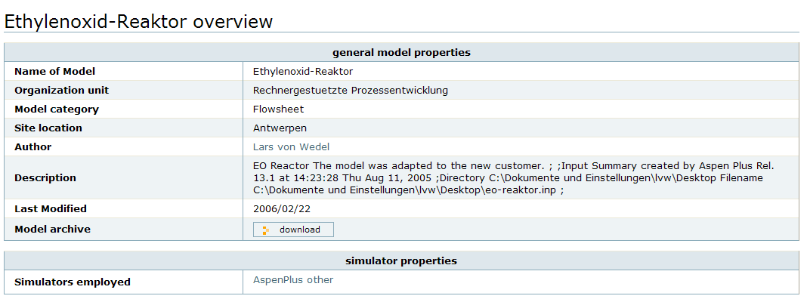
Figure 1: Overview page for a process model
The thermodynamics category represents information about the chemical substances occurring in the model (including name, formula, and cas number) as well as information regarding the emplyoed thermodynamic models (such as Unifac) and the databases from which parameters for these models originate. An example of this category is shown in Figure 2.
Additional categories display the unit operation models of which e.g. a flowsheet consists together with their parameters and a history which shows the various revisions that have been created for a model.
It should be noted that many elements in these category views are hyperlinks to other concepts of the metamodel which have associated views themselves. As an example, selecting the hyperlink of a chemical component as shown in Figure 2 will take the user to a page that lists all models that contain water. Likewise, selecting a link to a certain process modeling tool (such as AspenPlus) will display a page listing all models developed using a particular release of AspenPlus.
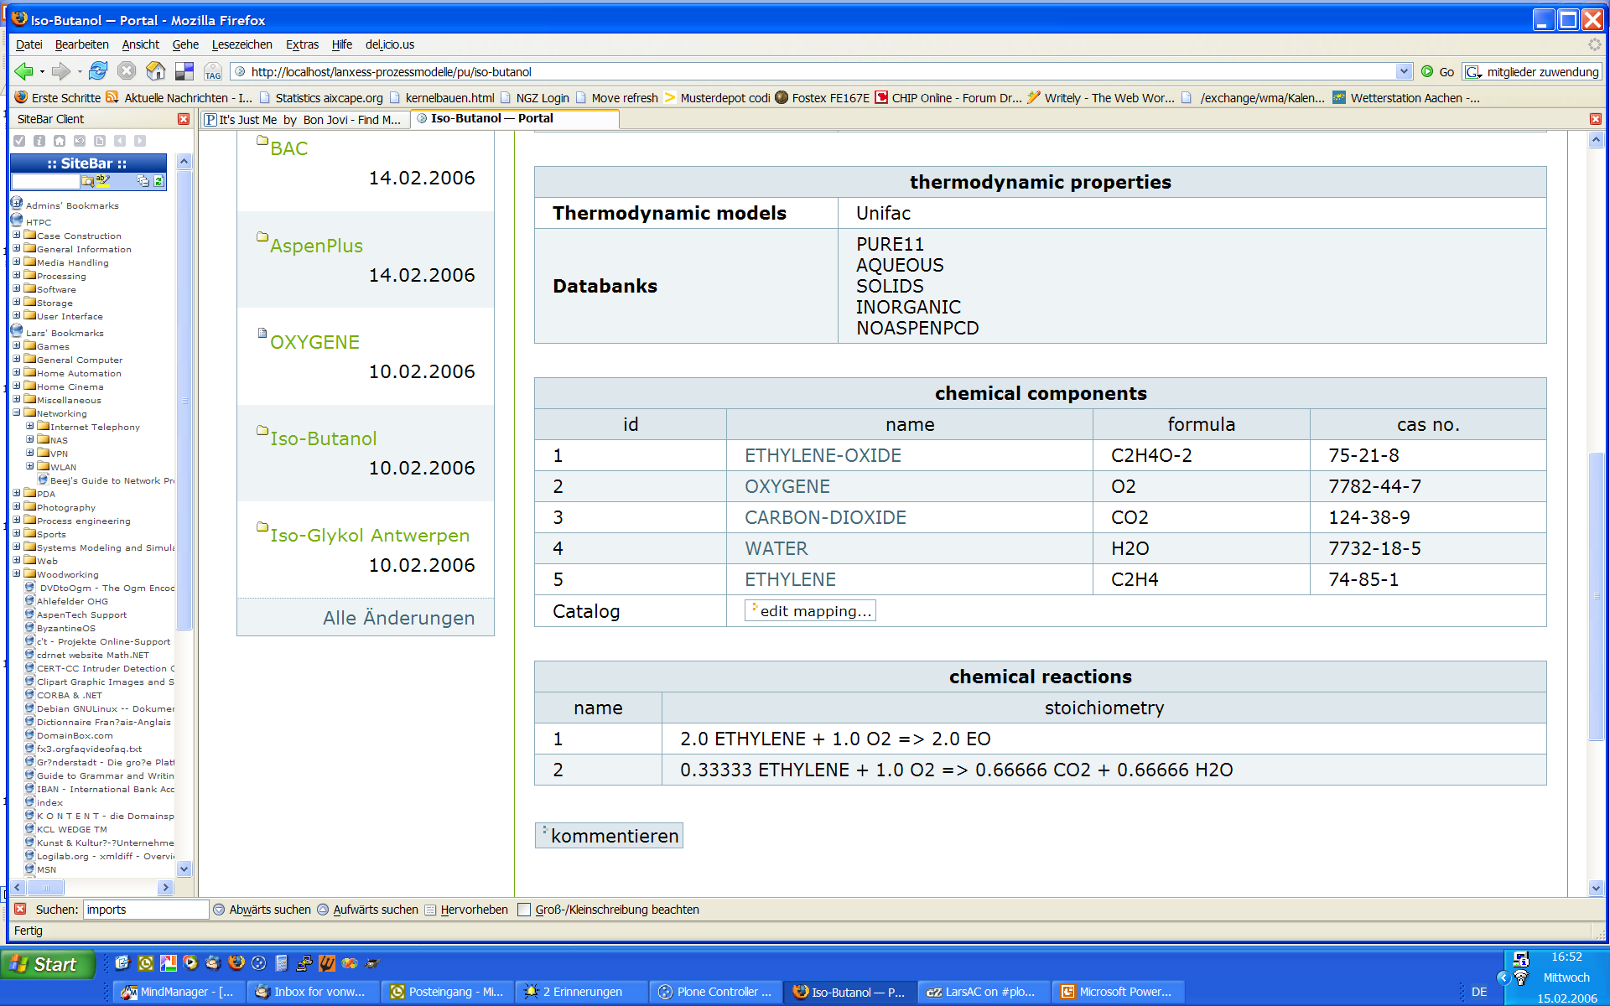
Figure 2: Thermodynamics page for a process model
    - Searching models
Currently, the searching capabilities in MOVE are limited to the full text search provided by the underlying framework. The use of the full text search is simplified because many concepts are made available by unique names during import. As an example, the search term water will always identify the substance known as water, regardless whether the model developer has chosen water, wasser, eau, or H2O as a user identifiers in AspenPlus.
    - Retrieving models
In order to retrieve a model, the user can select a download link on the overview page which will permit to download a zip archive of the model files as they were imported. The user is then able to continue work on the model by extracting the zip archive. An update of the model can be submitted to the MOVE system as a new release and will appear as part of the history category of a model. All revisions of a model from the past are accessible at any time.
  - Introducing model management in chemical engineering companies
When introducing a model mangement approach into a department or company it is necessary to decide several things in advance. First of all, the structure of the model library must be agreed upon. Most companies the author was in touch liked to see a representation of their business units and plants as the primary means for structuring the model library. Further, it must be discussed how access rights are granted to which groups of employees. A basic requirement is that users from a central engineering service group have access to all models in the catalog whereas employees in the various business units should only be able to have access to models assigned to their business unit.
The actual setup of the system is quite simple. MOVE is quickly installed computer in the intranet and usually secured by using HTTP over a secure socket layer SSL. The major part of the actual installation is to set up the basic catalog structure in terms of business units and plants and to register the various users. This overall effort is easily achieved during an afternoon session.
During the actual use of the system there are different approaches for maintaining the catalog. Some companies prefer to have one or two people responsible for maintenance, whereas others evenly distribute maintenance across all users. Maintenance tasks comprise e.g. adding new users or restructuring the business units according to changes of the company organization.
An important aspect of the introduction of model management is to have a positive attitude on sharing and reuse. It has been reported in the past, that knowledge management systems have not been used properly because users were afraid to make their knowledge available to others. One reason often mentioned is that users are concerned to publish erroneous or unsatisfactory results. In companies where departments are separate profit centers people have even uttered concerns to help a foreign profit center by disclosing information created in their own department. A helpful approach would be to integrate the use of the model library with financial compensations in order to make the benefit of provision and use of models transparent.
  - Conclusion
The system MOVE presented supports departments or companies in maintaining a structured library of process models regardless of the tools that were used to develop these models. Import modules translate model input files from various proprietary formats into a common metamodel. This metamodel is used for web page generation and searching functions.
The system can therefore contribute to a model management (or knowledge management, in more general) strategy. The system is currently in use in several chemical companies where individual departments are exploring functionality and possible extensions. Extensions might eventually lead to a modeling portal, a web-based system comprising all kinds of information related to process modeling such as tutorials, documentation, etc.
References
M. Jarke, W. Marquardt, 1996, Design and evaluation of computeraided process modeling. In Proceedings of the First International Conference on Intelligent Systems in Process Engineering (ISPE ’95), J. Davis, G. Stephanopoulos, and V. Venkatasubramaniam, Eds., no. 312 in AIChE Symposium Series. CACHE Publications, pp. 97–109.
J. Capers, 1994, Software challenges: Economics of software reuse. IEEE Software 27, 7 (July), 106–107.
Von Wedel, 2004, An Environment for Heterogeneous Model Management in Chemical Process Engineering, Dissertation, RWTH Aachen, available online at http://darwin.bth.rwth-aachen.de/opus3/volltexte/2004/844/
Plone Foundation, 2007, Plone, http://www.plone.org, Project web page.
Zope Foundation, 2007, Zope, http://www.zope.org, Project web page.
AspenTech Inc., 2007, AspenPlus, http://www.aspentech.com/products/aspen-plus.cfm, Product web page.
SimSci-Esscor Inc., 2007, PRO/II, http://www.simsci-esscor.com/us/eng/products/productlist/proII/default.htm, Product web page.

