CAPE Methods and Tools for Systematic Analysis of New Chemical Product Design and Development
Merlin Alvarado-Morales,ª Naweed Al-Haqueª, Krist V. Gernaey^{b}, John M. Woodley^{b}, Rafiqul Ganiª
ªCAPEC, ^{b}BioEng, Department of Chemical and Biochemical Engineering, Technical University of Denmark, DK-2800 Kgs. Lyngby, Denmark
Abstract
This paper highlights the use of CAPE methods and tools for systematic analysis of chemical product-process development. Through a conceptual case study involving the production of four chemical (intermediate) products via a second-generation biorefinery route, the steps of analysis and the need for, as well as the use of, CAPE methods and tools are highlighted.

Keywords: Chemical product, Process design, Property model, CAPE, Biorefinery
  - Introduction

Conventionally, computer-aided process engineering (CAPE) has been concerned with the development and solution of problems related to chemical process design, control and operation through systematic computer-aided techniques. The oil and gas industry, the petrochemical industry and to some extent, the chemical industry have been the traditional users of the methods and tools, including software, from the PSE/CAPE community. Problems related to process optimization, process integration and process synthesis/design are currently solved through knowledge-based methods as well as mathematical optimization techniques. To date systematic (and/or computer-aided) methods and tools have been developed and applied successfully to solve many industrial problems. However, future applications will not only demand CAPE methods and tools, but also require new tools and models. This is well illustrated by the application of CAPE to the second generation of biorefinery concept discussed in this paper.

As resources decrease and demand for products in terms of quantity (as well as quality) increase, it is necessary to continuously develop better and significantly improved chemical-based products in order to satisfy the needs of the modern society. On the other hand as Gani and Grossmann (2007) noted, we continually face the questions ⎯which of our current products should be replaced, which products will we need for the future and how do we search for sustainable alternatives? In addition we can ask whether it will be possible for the CAPE/PSE community to provide and develop the necessary methods and tools to address these problems, or can the methods and tools currently available be used to solve these problems? These questions can be addressed through the formulation and solution of integrated product-process design problems that can be viewed as new opportunities and challenges for CAPE/PSE. In particular, the areas of energy and sustainability clearly provide new challenges and opportunities. One example is the shift towards renewable resources with respect to energy, most notably through the increasing use of biomass as a renewable energy source, which requires addressing processes that have quite different characteristics than the traditional petrochemical processes in as much as the reactions are only mildly exothermic and take place at relatively moderate temperatures and pressures. Furthermore, the separations tend to involve highly dilute aqueous systems.

The objective of this paper is to highlight the use of CAPE methods and tools in the different stages of the design and development of chemical products and their sustainable production. In particular, some of the design and development issues related to the production of important intermediate chemicals from alternative renewable resources are analyzed.
  - Chemical product-process development

The design of chemical products and their sustainable production involves analysis of the product-process needs; generation of process alternatives (for a specified product); evaluation of the product-process performance; final selection and validation of the product-process (Gani, 2004). Systematic model-based methods and tools can be applied at every step, depending on the availability of appropriate models. Consider, for example, an intermediate chemical (product) that can be produced from a range of renewable resources. A pre-analysis of the product qualities and its characteristics, defines the process needs. Even though a product may be obtained through many processing routes, the objective must be to identify those that are sustainable. Here, algorithms that can quickly generate and evaluate processing alternatives are needed together with a set of performance criteria and product-process specifications. Product-process specifications help to identify the set of feasible alternatives, while more sustainable alternatives can be identified by using sustainability metrics and/or life cycle assessment as the set of performance criteria. The main supporting CAPE tools are: modelling tools (models need to be generated, tested, and validated before use, as an example: MoT); property tools (truly predictive but reliable calculations are needed: ProPred, TML); process synthesis/chemical synthesis (generation of flowsheet and molecules/mixture alternatives: ProCAFD, ProCAMD); design tools (driving force based design of operations: PDS); process simulation (for verification/analysis of design: PROII® and ICAS); databases (database of chemicals, reactions, enzymes, etc., are always useful to have: CAPEC database). As a proof of concept case study, the development of four intermediate chemical products and their corresponding processes is highlighted below. The objective is to identify four intermediate chemical products that can be produced from renewable resources, which may be corn, straw, and/or lignocellulose. The methods and tools listed above, ICAS (Gani et al., 1997), MoT, ProPred, TML, ProCAMD, ProCAFD, PDS, CAPEC-database (Gani, 2002), and PROII® have been used in the case study. The same methods and tools can also be used for product-process development in pharmaceutical, food, and agrichemical industries.

    - Product-process analysis: biorefinery

Considering the concept of a biorefinery ⎯ a facility that integrates biomass conversion processes and equipment to produce chemicals, fuels and power - the four chemical products can be identified from multiple products that are commonly attributed to a biorefinery. A biorefinery might, for instance, produce one or several low-volume (but high-value) chemical products as well as low-value (but high-volume) products such as intermediate chemicals and/or liquid transportation fuel, while generating electricity and process heat for its own use. The high-value products enhance profitability while the high-volume products may also enhance profitability by producing other high value chemicals in the product supply chain, or, as fuel helping to meet increasing energy needs. In addition, the power production reduces over-all production costs and avoids greenhouse-gas emissions. Based on the above discussion, four chemical products (as listed in table 1) have been selected.
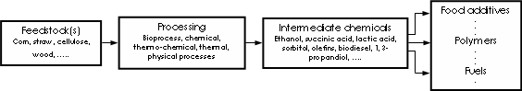
Figure 1. Basic principles of a biorefinery.
An interesting feature for the four selected chemical products is that they can be produced from the same source – that is, conversion of glucose, which can be produced from corn, straw or lignocellulose (see Figure 1). The product palette of a biorefinery not only includes the products produced in a petroleum refinery, but also in particular products that are not accessible in petroleum refineries. For instance, furfural and 5-hydroxymethyl-furfural (HMF) are interesting by-products from lignocellulose feedstock biorefinery. Furfural is the starting material for the production of nylon 6,6 and nylon 6.

    - Setting of targets for product-process design

The first step is to evaluate a base case design and define targets for generation of more sustainable alternatives. In this way, an analogy may be drawn with computer aided molecular design (CAMD), where molecules matching a set of target properties are identified. In this case, using the same principle, process flowsheets matching a set of design targets (improved sustainability metrics) will be analyzed. Figure 2 shows a simplified version of the flowsheets for the conversion of corn as the raw material to produce the four chemical products listed in table 1 (the detailed flowsheet for each product can be obtained from the authors).
Figure 2. Simplified flowsheet for the production of bio-based chemicals from corn.
Figure 2 also shows the results of a mass balance based on the amount of products obtained per kg of raw material (in this case, corn) and the amount of water used in the principle processing steps using collected data from the open literature. Based on this mass balance and an added energy balance, a cost analysis for the 4-products biorefinery has been performed. The results are summarized in table 1. It can be noted that the three high value products have an acceptable rate of return while the low value product is not economically feasible for the production rates listed in table 1. This means that the targets for more sustainable design alternatives should be focused on production of ethanol for this biorefinery. From figure 2 it can be seen that economic feasibility of the process for ethanol can be improved through higher product yields and/or more efficient product recovery.

Table 1. Cost analysis of 4-products biorefinery
Product | Production (kg/h) | Profit ($)/kg | Payback time (yr) | Price ($/kg)
Lactic acid | 1271.23 | 0.042 | 6 | 1.10
1, 3-propandiol | 1256.76 | 0.058 | 4.1 | 1.34
Succinic acid | 1226.67 | 0.043 | 7.4 | 1.10
Ethanol (corn) | 1135.25 | 0.019 | 11.62 | 0.75
Ethanol (lignocellulose) | 18557.0 | -0.166 | - | 0.75

As the reactor effluents are dilute aqueous solutions of the product, recovery is not straightforward. Furthermore, separation by distillation is both difficult and expensive because of the ethanol-water azeotrope. In this work, we have considered alternative product recovery strategies for ethanol and succinic acid (to identify another alternative to crystallization for product recovery). The option of increased product yield in the reaction is beyond the scope of this work as it involves the design/selection/testing of new catalysts or enzymes.

    - Generate-test design alternatives

The traditional succinic acid recovery method is based on precipitation and crystallization technology. However, the recovery of succinic acid by this process is costly and complex. From an analysis of succinic acid-water binary mixture, it is clear that solvent-based separation is an option worth considering, for example liquid-liquid extraction (LLE). ProCAMD (Harper and Gani, 2000) has been used to find solvents for LLE of succinic acid from water. Figure 3(a) shows the LLE driving force diagram for succinic acid-water-solvent (butyl acetate and propyl acetate) on a solvent free basis. From figure 3(a) it can be seen that between the two solvents that have been identified, butyl acetate is better as it provides a larger driving force. For the case of ethanol purification, we are highlighting the process with lignocellulose as the raw material (see bottom row of table 1). The product stream from the fermentation stage is a mixture of ethanol, cell mass and water. In this stream, ethanol (produced from lignocellulosic biomass) has concentrations that are lower (less than or equal to 5 wt %) than ethanol produced from corn. To obtain anhydrous ethanol, the first step is to recover ethanol from the product stream of the fermentor. The product (37 wt % ethanol) is then concentrated to obtain anhydrous ethanol (more than or equal to 99.5 wt %). Here also we can employ the driving force concept (Gani and Bek-Pedersen, 2000) to investigate the different separation techniques. From figure 3(b) it can be seen that it is impossible to obtain anhydrous ethanol in a single distillation column (curve 1).Therefore, solvent-based or hybrid separation processes are necessary. By solvent-based distillation using ethylene glycol (curve 2) or ionic liquid (curve 4), it is possible to achieve the desired purity.
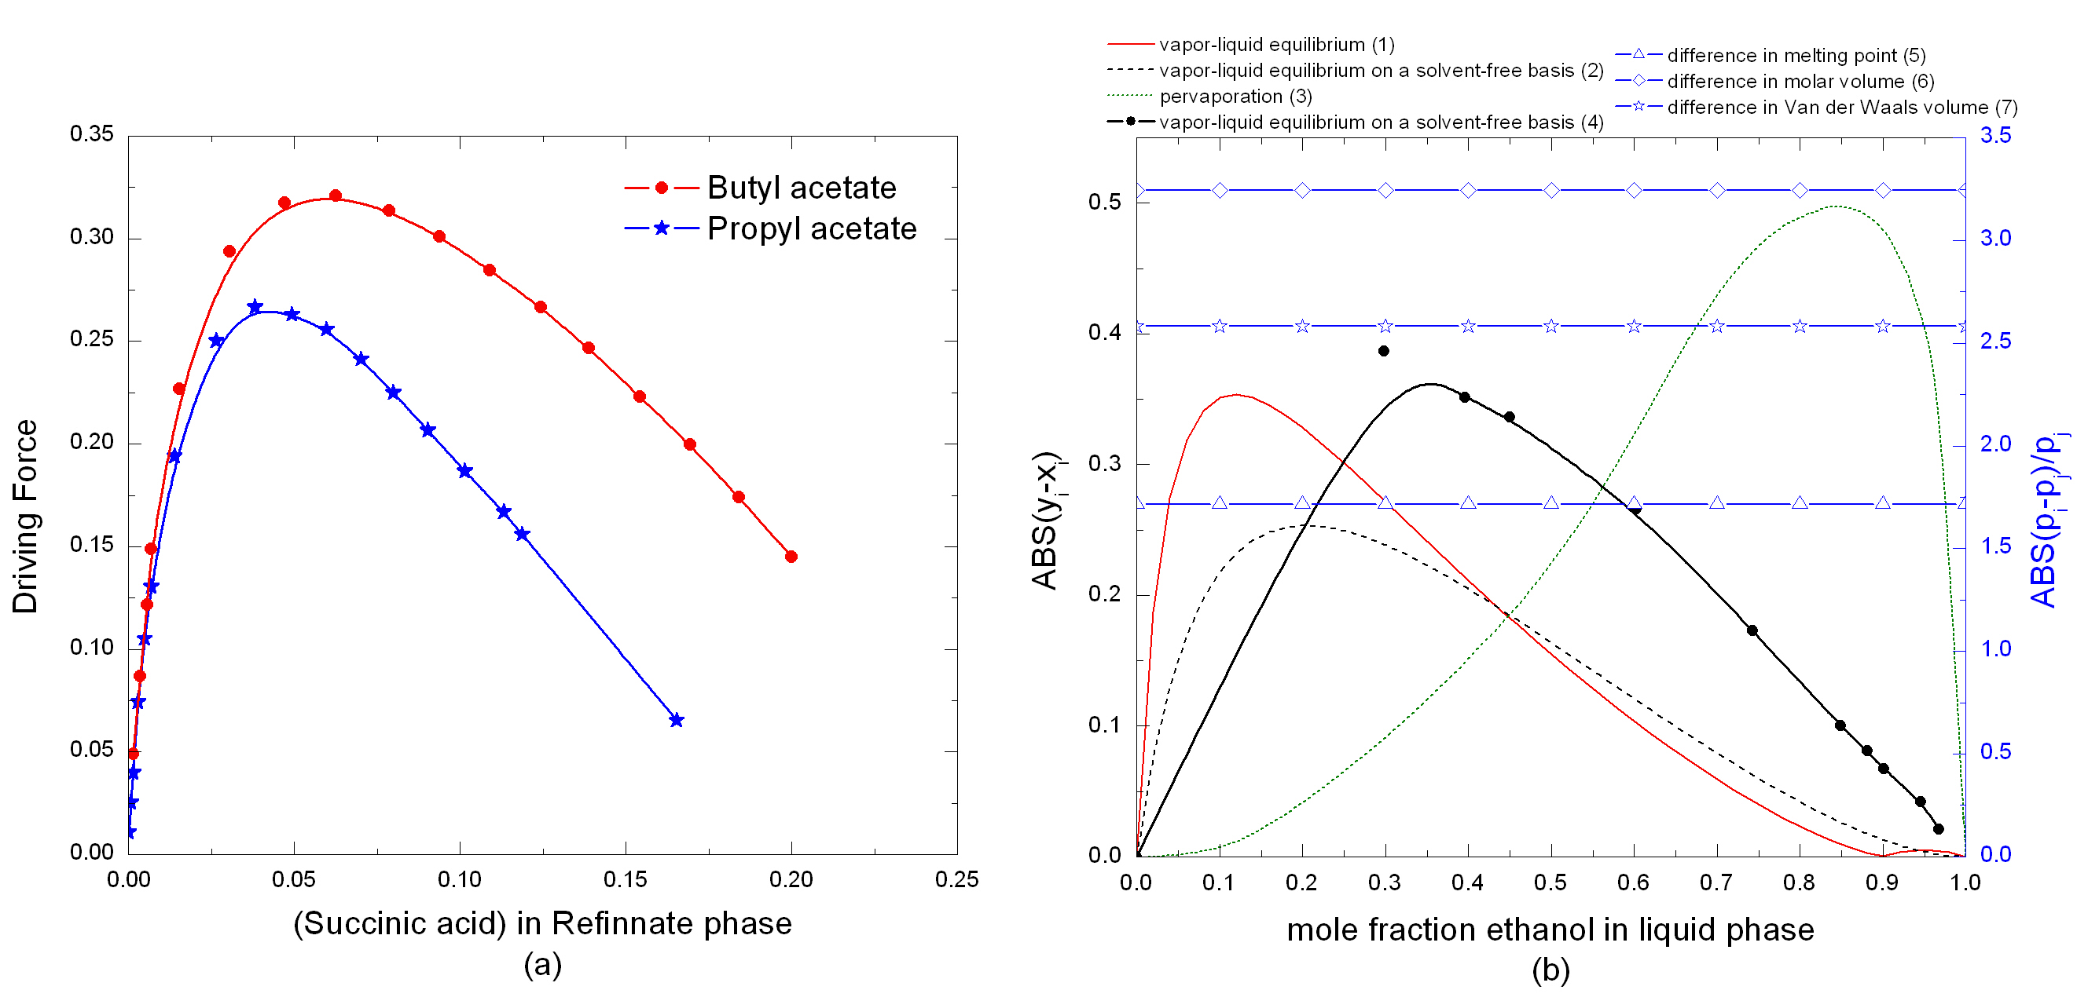
Figure 3. (a) Solvent-free driving force curves for succinic acid-water mixture based on LLE. (b) Curves for driving force as a function of composition (curves 1-4) and as constants (curves 5-7) for ethanol-water mixture.
Distillation followed by pervaporation is also a feasible (curves 1 and 3) separation process. As reported by Seiler et al. (2004) compared with the organic solvent-based separation which uses ethylene glycol (curve 2), a saving in overall heat duty of 24% can be achieved by using ionic liquid [EMIM]⁺[BF4]⁻ (curve 4). This can be very quickly verified through the driving-force based process group contribution approach for flowsheet synthesis and simulation (d’Anterroches, 2005). From table 1, it can be seen that the ethanol from lignocellulosic biomass has a negative profit value. However, with the ionic liquid based distillation process, an improvement to the profit (-0.099 $/kg) can be achieved. This however is still not enough to produce a positive profit, indicating there are costs related to pretreatment and water-use that also need to be targeted (note that the purification step counts for only about 30 % of the total operating cost).

    - Final selection and validation

From the above analysis, it is clear that applying solvent-based liquid-liquid extraction for recovery of succinic acid and ionic liquid based ethanol purification will lead to lower operating costs without increasing the environmental impact. In addition, the use of resources would be improved through better and more efficient solvents. Thus, these alternatives will improve sustainability metrics related to waste, environmental impact and economics. The final optimal design, however, is not possible to obtain until the production rates for each of the four products are simultaneously optimized. Note that as listed in table 1, the production rate of ethanol is not particularly high, due to imposed constraints on the availability of biomass as the raw material. The flowsheet of a biorefinery could reach a high degree of compactness by using process intensification and specifically bio-reactive separations. For example, in the bioethanol production process, where enzymatic hydrolysis is applied, different levels of process integration are possible. In Consolidated BioProcessing (CBP) all required enzymes are produced by a single microbial community in a single reactor. CBP would appear the logical endpoint in the development of biomass conversion technology. Application of CBP implies no capital or operating costs for dedicated enzyme production (or purchase), reduced diversion of substrate for enzyme production, and compatible enzyme and fermentation systems (Hamelinck et al., 2005). Here the major challenge for the CAPE community is how to provide meaningful and useful simulation and optimization tools for modeling these complex systems that in turn require integration with data-intensive experimentation.
  - Conclusions

One of the greatest challenges for the future is to use renewable raw materials in an efficient way. The biorefinery concept enables the structuring of the technology needed to ensure efficient biomass conversion to fuels and chemicals (as shown in the example here). There are still some unsatisfactory parts within the lignocellulosic feedstock biorefinery (LCF), such as the utilization of lignin as fuel, adhesive or binder, its pretreatment and hydrolysis steps. In principle, a biorefinery is not only able to produce a variety of chemicals, fuels and intermediates or end-products, but can also use various types of feedstocks and processing technologies to produce products for the industrial market. The flexibility of its feedstock use is the factor of first priority for adaptability towards changes in demand and supply for feed, food, and industrial commodities (Kamm and Kamm, 2004). The integration necessary to provide the optimal blend of fuels and chemicals is complex and CAPE methods and tools are essential to achieve this goal. As exemplified here, a major contribution has been to reduce the time and resources to obtain the analysis/design results. In particular a key opportunity for the CAPE community is that it can play the role of the integrator (Gani and Grossmann, 2007). That is, develop systematic solution approaches that combine methods and tools from different sources into flexible, reliable, and efficient problem specific systems. This will not only require the development and adaptation of current systems, but in many cases will also require the development of entirely new approaches and advanced modelling tools.
References
L. d’Anterroches, 2005, Process Flow Sheet Generation & Design through a Group Contribution Approach, PhD thesis, Technical University of Denmark
R. Gani and I. E. Grossman, 2007, Process Systems Engineering and CAPE ⎯ What Next ?, 17TH ESCAPE Proceeding Book, Bucharest, Romania 24, 1-5
R. Gani, 2004, Chemical product design: challenges and opportunities, Computers and Chemical Engineering, 28(12), 2441-2457
R. Gani, 2002, ICAS documentation. CAPEC, Technical University of Denmark
R. Gani, E. Bek-Pedersen, 2000, Simple new algorithm for distillation column design, AIChE Journal, 46(6), 1271-1274
R. Gani, G. Hytoft, C. Jaksland, A. K. Jensen, 1997, Integrated Computer Aided System (ICAS) for integrated design processes, Computers and Chemical Engineering, 21(10), 1135-1146
C. N. Hamelinck, G. van Hooijdonk, A. P.C. Faaij, 2005, Ethanol from lignocellulosic biomass: techno-economic performance in short-, middle- and long-term, Biomass and Energy, 28(4), 384-410
P. M. Harper, R. Gani, 2000, A multi-step and multi-level approach for computer aided molecular design, Computers and Chemical Engineering, 24(2), 677-683
B. Kamm, M. Kamm, 2004, Principles of biorefineries, Applied Microbiology and Biotechnology, 64(2), 137-145
M. Seiler, C. Jork, A. Kavarnou, W. Arlt, R. Hirsch, 2004, Separation of azeotropic mixtures using hyperbranched polymers or ionic liquids, AIChE Journal, 50(10), 2439-2454
PROII User’s Guide (2006). Simulation Sciences Inc, Brea, USA.

