Improvement of the production process of leached optical fibers in a technological and organizational context
Daniëlle T. Stekelenburgª, Zofia Lukszoª, Jeff Lowe^{b}
ªDelft University of Technology, P.O. Box 5015, 2600 GA Delft, The Netherlands
^{b}SCHOTT North America Inc., Southbridge, USA.
Abstract
Many contemporary products are relatively small-volume high-value added items which are generally produced in batch production processes. These types of processes are becoming more and more important as markets change quickly and require markets to adapt. Batch-wise production provides the necessary flexibility to respond to these changes. This research project focuses upon complex batch processes with high quality demands which are hard to meet.
The production of leached optical fibers at SCHOTT North America Inc (SCHOTT) is examined to identify, apply and test a method which is generally applicable for improving and stabilizing the yield of complex batch processes. The fibers produced at SCHOTT are used in health care and must satisfy strict quality requirements. The yield of fibers meeting the quality standards varies greatly and it is unknown which factors determine the yield and the extent of their influence. The company-dedicated goal of this research was to assist the plant of SCHOTT in implementing and executing a quality improvement process. Existing literature offers little support to the organizational aspect of quality improvement trajectories. Therefore specific attention is paid to the organizational consequences of implementing an improvement process.
In this research, response surface methodology is successfully applied to identify causal relationships between factors that impact production process performance and the yield. The optimal settings of these factors are then defined through the use of a regression model. The regression model that is used incorporates the factors of influence on product quality and their relative importance to the production of leached optical fibers at SCHOTT. The same technique can be applied to other production processes. Lastly, an implementation plan is defined to guide organizations towards successful implementation of improvement measures. In order to successfully execute this quality improvement trajectory, a guideline for managing such processes is proposed and applied.

Keywords: Response surface methodology, design of experiments, optimization, quality management, organization.
  - Introduction
Leached optical fibers are used in health care (in endoscopes) to guide images from inside the body of a patient to a screen. This is accomplished by bouncing the image within the fiber from the point of origin to the screen where it is ultimately displayed. This is demonstrated by Figure 1.
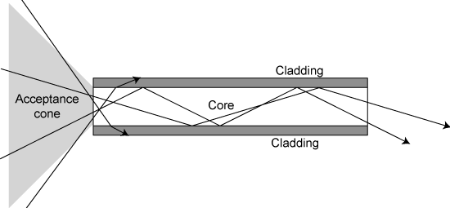
Figure 1 Transmission of light in an optical fiber

The overall production process consists of three main steps: drawing the fiber rods, leaching the fiber bundles and sheathing and inspecting the end product. The focus of this research was on the first sub-process, the rod-stage.


Figure 2 Multi-multi fiber
Fibers are made from a bar of core glass and two cladding-tubes around it. This cladding, which consists of glass that has a lower refraction index than the fiber, protects the fibers and keeps the signal that needs to be transported inside. Fiber rods are drawn in three steps. The first draw produces mono fibers. These fibers are then assembled for the second draw which creates multi fibers. In the third draw, multi-multi fibers are produced. These multi-multi fibers consist of thousands of fibers which resemble a honeycomb when viewed through a microscope. See Figure 2.
The leached optical fiber production process is order-based. Batches of fibers are produced according to the specific wishes of the customer and quality requirements are demanding. The yield of the fiber rods is very low and unpredictable, as many rods do not meet the quality requirements. Process knowledge is limited throughout the fiber optics industry and it is unknown which factors influence the quality of the fiber rods at this stage of production. There is a large financial incentive to improve the yield by limiting production losses at the fiber rod stage. Nonetheless, despite low yield and financial losses, leached optical fibers remain a very profitable business.
  - Research question and methodology
The objective of this article is to identify how the production process of leached optical fibers at SCHOTT North America may be improved. To find improvement strategies the following research question is answered:
What are optimal settings, both functionally and organizationally, for the process conditions to improve the yield of leached optical fibers with respect to the current situation?
To answer this question, response surface methodology (RSM) is employed (Myers, 2002). In the production process of leached optical fibers the relationship between the yield and the independent factors influencing the process performance is unknown. RSM is particularly suitable for optimizing the performance of production processes where process knowledge is limited. The first step in the response surface methodology is to determine a function that describes the response through analyzing the factors of influence. RSM employs experimental design and multiple regression methods. This approach permits the study of multi-variable interactions. Experimental design refers to experimental methods used to quantify the relationship between factors (x₁, x₂, x₃,…) affecting a process and the output of that process (y) in a well-structured approach.
Figure 3 presents a schematic representation of a full-factorial design for three factors. Three factors x₁, x₂, x₃ are varied at two levels: low (corresponds to “-1”) and high (corresponds to “+1”) with respect to a nominal (zero) situation, which results in 8 experiments. A factorial design with k factors, each varied at two levels in such a way that all the settings of every factor appear in all possible combinations with settings of other factors, is called a 2^{k} factorial design, whereby 2^{k} indicates the number of experiments to perform.

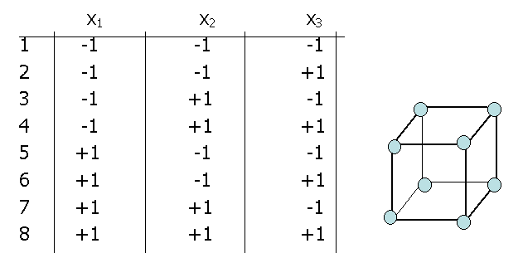
Figure 3 Example of full factorial design of experiments for three factors

Accordingly RSM is very suitable to estimate the response of the production process of leached optical fibers to the input factors. The second step in RSM consists of an analysis of the validity of the model. The final step of an RSM project specifies the relationship between factors in the production process which can be then used for the optimization of the performance of the system by determining the optimal settings of the process parameters (Verwater-Lukszo, 1998). However, knowing the optimal process settings is not enough. Concrete improvement measures need to be formulated to address organizational complexity. Current system improvement tools often do not include this part of the improvement process. To address that deficiency this article investigates both the definition of the improvement measures and the way they should be implemented in a complex organization.
  - Modeling and optimization of leached optical fiber production
This section describes two steps of the RSM approach: model formulation and optimization.
    - Model formulation
Using RSM, a regression model has been estimated. The purpose of the regression model is twofold. On the one hand, the model is focused upon identifying those factors which influence the quality of the fiber rods. On the other hand, the regression model will be used to define the optimal settings of the factors of significant influence.
Through interviewing and monitoring employees a list of 25 possible factors of influence was previously identified (Stekelenburg, 2007). The Design of Experiment portion of RSM is a structured, organized method for determining the relationship between factors of influence and the output of that process. Fractional factorial design is one of the most widely used methods for process improvement. Screening experiments employ a linear regression model to reduce influencing factors. If we can assume that certain higher-order interactions are negligible, a fractional factorial design involving fewer runs than the well-known factorial design can be used to obtain information on the main effects and low-order interactions (Montgomery, 2004).
In this project the estimated ultimate regression model has an explained variance of 72% which is fairly high for an industrial process. The final model of yield y consists of 13 factors and 13 significant interaction effects:

$$y=β_{0}+\sum_{i=1}^{\text{13}}{β_{i}}x_{i}+\sum_{i=1}^{\text{13}}{}\sum_{j>i}^{\text{13}}{β_{\text{ij}}x_{i}}x_{j}+ε$$

The 13 factors influencing response are divided into three groups: easy-to-adjust control variables, not-easy-to-adjust variables and noise factors, which cannot be adjusted by the company. Main factors in the first group include the type of furnace used and the experience level of operators. The second group includes the quality of raw materials, humidity and temperature profiles. The last group addresses the difficulty level of the product which is determined by the quality demands of the customer.
    - Process optimization
To increase the yield of the production process of fiber rods at SCHOTT, the response to the factors that influence the yield must be improved. The non-linear objective function y is optimized for three anticipated noise factor levels. Further, the lower and upper bound on all factors are taken into account. This straightforward optimization results in concrete improvement measures. This research reveals that different furnaces are optimal for different process stages within each difficulty level. Moreover, the optimal performance of the operator was also variable in relation to the difficulty level. To improve yield SCHOTT must also purchase better quality raw materials. It is recommended that suppliers be stimulated to provide consistently higher quality raw material tubes. Further, the humidity in the draw area is an important and currently unstable factor which impacts the product quality. A humidity control system should be implemented to address this variable. Finally, SCHOTT is advised to either implement an advanced temperature control system, or make smart use of ‘natural’ temperature fluctuations in the draw areas by scheduling blanket orders in seasons with the optimal temperature.
  - Quality improvement process
All of the identified improvement measures have consequences for the organization and require effort and commitment from the employees at SCHOTT in order to be successfully implemented. Through observing and conversing with SCHOTT employees many of the general characteristics of the leached optical fiber department were identified. These organizational aspects need to be taken into account when implementing a quality improvement process in the company. Many of the organizational traits identified match features of a professional bureaucracy, as formulated by Mintzberg (Mintzberg, 1992). In order to implement the quality improvement process, the cooperation of the operators is indispensable. However, complete cooperation is often difficult to acquire. It is necessary to develop an environment which facilitates quality improvement processes. By successfully integrating operator and management responsibility, SCHOTT ensured that these parties supported the quality improvement trajectory.
From the experience at SCHOTT and from studying quality principles (ISO 9000:2000, 2000), a guideline is proposed for addressing the management changes necessary for the implementation of a quality improvement process. This guideline, which can be found in Table 1, is focused on SCHOTT. However, it may be applied successfully to quality improvement trajectories in similar professional bureaucracies as many of the challenges will be the same. The four aspects of the proposed guideline will be explained in more detail.
The views of the different parties that are involved should be made to converge in order to create dedication to the quality improvement process. A process approach is very suitable for this goal. A process should be negotiated and designed that guides the quality improvement process for all parties involved. This will serve to reduce interdependencies. Additionally, by establishing a fixed process which the operators agree with will make them less hesitant to committing to changes in their production environment. An external party with experience in designing quality improvement processes may be involved to guide the process negotiation. Aligning the viewpoints and goals of all committed parties is an excellent starting point for a quality improvement process.
The involvement of all parties that are necessary to make the quality improvement process a success should be facilitated. Management must strive to commit the operators to the entire quality improvement trajectory. Management should demonstrate dedication to the process by enhancing their presence which will inspire the goodwill of other parties. This approach will increase the transparency of the production process and provide opportunities to assess individual employee performance. The commitment of all relevant parties to the quality improvement trajectory will speed up the process and enhance results.

Table 1 Guideline for quality improvement trajectories implementation
Guideline | Of who/what? | By who/what? | Quality Principle | Characteristic
Converge views | Operators Management  Other Parties | Process | Customer focus Process approach | Interdependencies Stability of work environment
Involve | Operators  Other Parties | Management | Involvement of people  Process approach | Performance assessment difficult Fear of rationalization Autonomy
Convince | Operators  Other Parties | Management / External Party | Leadership Factual approach to decision making | Fear of rationalization
Support | Operators  Other Parties Process | Management | Continual improvement | Stability of work environment Autonomy Interdependencies

Support is required to facilitate and ensure continuous efforts in the quality improvement process during and after the identification and implementation of the improvement measures. Management should be committed to providing all necessary support to employees who are negatively affected by the changes being made during the quality improvement trajectory.
It is important that the parties involved are supportive of the quality improvement process. This is especially true of the operators who are responsible for making the greatest adjustments. Their endorsement of this method is necessary to prevent frustration of the improvement objectives. In order to involve and acquire the support of the operators, a three step action plan is proposed. This action plan is shown in Table 2.

Table 2 Operator involvement and support action plan
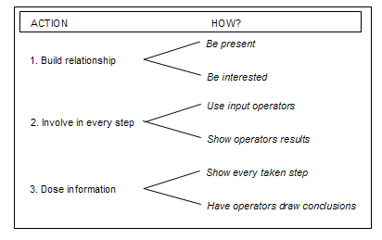

  - Conclusions
Response surface methodology is applied successfully for the optimization of the factors that influence the performance of the production process of leached optical fibers. Functional optimal settings for these variables have been identified. However, response surface methodology does not offer any guidance on the implementation of the improvement measures. A systematic analysis of the organizational complexity at SCHOTT has been performed and an implementation plan has been formulated. The consequences of each improvement measure for the company have been identified; SCHOTT is advised in the use of their position, the financial trade-off of improvement measures and methods for enhancing the dedication of employees of different departments. The steps which need to be taken to ensure successful implementation of the improvement measures are identified, bringing the actual implementation one step closer. In addition, in order to guide the implementation of these types of quality improvement trajectories, an implementation guideline of general application is proposed. These two steps are indispensable for successful process improvement.
References
ISO 9001:2000, Quality management systems – Requirements, ISO,2004.
Mintzberg, H., Structure in Fives, Designing Effective Organizations, Prentice Hall, 1992.
Montgomery, D. C., Design and Analysis of Experiments, Wiley, 2004.
Myers, R.H., D. C. Montgomery, Response Surface Methodology: Process and Product Optimization Using Designed Experiments, Wiley-Interscience, 2002.
Verwater-Lukszo, Z., A Practical Approach to Recipe Improvement and Optimization in the Batch Processing Industry, Computers in Industry, pp. 574-281, 26, 1998.
Stekelenburg, D.T., A brighter view of the fiber world. Yield improvement of complex batch processes with high quality demands, TPM-TU Delft, Delft, 2007.

