Multi-agent Service Composition for Technology Selection
Rafael
^{aToyohashi}

Abstract
This paper proposes an approach to assist engineers in finding processing technologies that can be combined to convert resources into desired products. The approach is by means of a framework for technology composition based on distributed cooperative agents each of which is owned by a technology supplier. The framework is implemented as a computer-aided environment that can be deployed over the Internet in which technology suppliers (technology licensers, research institutions, etc.) advertise their technology capabilities to a processing technology server.

Keywords: service composition, multi-agent systems, technology selection
  - Introduction
Technology selection is concerned with choosing the best mix of technologies from a set of choices so as to satisfy product requirements with a minimum development risk within limited development and production time. Typically, the technology selection requires knowledge of the design and cost models of each technology, something that is not always possible because many technology suppliers keep design and cost calculations confidential. This paper presents a framework for technology composition based on distributed cooperative agents each of which is owned by a technology supplier. The framework is implemented as a computer-aided environment that can be deployed over the Internet in which technology suppliers (technology licensers, research institutions, etc.) advertise their technology capabilities to a processing technology server. In order to carry out the technology selection, the engineer defines the problem in terms of resources (feedstock, service input, etc.), desired outputs, and development constraints. We assume that technology suppliers promote the use of their technologies by allowing potential customers to use their design and simulation software via Web services and the like. Web services are defined as abstract, standardized interfaces to business processes (Srivastava and Koehler, 2003). This way, technology selection can be translated as a service composition problem (Aggarwal, 2004). Service composition is the activity with which new services are created by a assembling a set of already existing elementary services (Rakotoarivelo, 2006). In the case of technologies, once the set of desired technologies have been identified, the user may proceed with a more detailed analysis (such as process design).
Broadly speaking, in order to identify the possible technologies that satisfy the selection requirements two tasks are involved. Namely, service discovery and service composition. Service discovery or matchmaking is the process in which individual technologies can be identified that match a set of requirements. Previous work in the CAPE community include the COGents methodology in which a number of software agents collaborate to configure a process model used in a simulation environment (Braunschweig, et al., 2004; Yang, et al., 2007). Similarly, Batres et al. (2007) propose an architecture in which technology agents evaluate the degree of matching of the search request against technology constraints to identify technology candidate for biomass processing. In the manufacturing domain, Feng (2005) presents a multi-agent system for manufacturing planning which shares similar objectives to those of this paper. However, in those existing approaches, technologies are combined by a single agent. In this paper, we attempt to address the problem of technology selection in terms of service composition carried out by multiple agents. Firstly the methodology is described then the multi-agent environment is explained. Finally, a case study is presented to illustrate the proposed approach.
  - Problem Statement
We formulate the problem as $\left\langle r,p,A,S\right\rangle$, where

$r$ represents consumed resources
$p$represents desired final products
$A$ is a set of agents each of which has the ability to provide a technology
$S$ The solution $S$is a set of technologies $s_{0}\text{.}\text{.}\text{.}s_{n}$such that $r⊆R$, $r⊆\text{in}(s_{0})$, $\text{in}(s_{j})⊆∪_{i=0}^{n}\text{out}(s_{i})$, and $p⊆P$, $p⊆∪_{i=0}^{n}\text{out}(s_{i})$. Each technology in $S$ consumes resources $\text{in}(s_{i})$that are transformed into outputs $\text{out}(s_{i})$.
  - Methodology
A simplified algorithm of the methodology is shown in Figure 1. Firstly, the user specifies the project requirements in terms of project location, technology maturity (development, commercial availability) and other preferences. This is done on the Technology Selection Agent (TSA). TSA then finds potential technology service providers (technology agents) that match the project requirements. Technology agents may decline participating in further interactions with the TSA based on its compatibility with other suppliers, and technical or commercial interests.
Subsequently, TSA specifies the resources to be converted and submits a message to available technology agents. If a technology agent determines that the design is possible then it proceeds to generate a report that is sent to the TSA. If the technology agent can process the resources then a new service is created and stored in the solution memory of TSA. If the resources to be converted are the output of an existing service in the solution memory of the TSA, a new service has to be found and connected downstream. If the solution memory isi empty, the service is stored as the first service in the solution.

1: procedure initiate():
2: TSA ← this.Agent()
3: r ←getResourcesToBeTransformed()
4: projReqs ← getProjectRequirements()
5: for $A_{i}∈A$ do
6: send(EVALUATE_PROPOSAL, projReqs, TSA) to $A_{i}$
7: end for

8: behavior when received(PROPOSAL_CHECKED, result, E)
9: TSA ← this.Agent()
10: r ←getResourcesToBeTransformedForThisProposal
11: if result is true then
12: insert E into matchingAgents
12: send(FIND_POSSIBLE_OUTPUTS, r, E)
13: end if

14: behavior when received(CONSIDER_DESIGN, t, canProcess, output, E)
15: TSA ← this.Agent()
16: s ← find a solution in solutionTable such that feed is s.output
17: r ←getResourcesToBeTransformedForThisProposal
18: if canProcess is true then
19: newService ← (t, E, r)
20: if s is null
21: create a solution s initialized with newService
22: insert s in solutionTable
23: else
24: copy solution and insert copy in solutionTable to store partial designs
25: s.connectService(newService)
26: end if
27: end if
28: for $A_{i}∈A$do
29: send(EVALUATE_PROPOSAL, technologyReqs, TSA) to $A_{i}$
30: end for

31: behavior when received(EVALUATE_PROPOSAL, reqs, sender)
32: E ←this.Agent()
33: q ← getAvailabilityConstraints()
34: result ← check(q)
35: send(PROPOSAL_CHECKED, result, E) to sender

36: behavior when received(FIND_POSSIBLE_OUTPUTS, feed, sender)
37: E ←this.Agent()
38: c ← getTechnologyConstraints()
39: canProcess ← check(c, feed)
40: output ← getOutput()
41: send(CONSIDER_DESIGN, thisTechnology, canProcess, output, E) to
sender
Figure 1. Service composition algorithm
  - System implementation
Agents communicate through the network by exchanging messages using a shared knowledge representation (ontologies) encoded in the Web Ontology Language (OWL) (W3C, 2004). Information about the classification of the technology, the kinds of objects in the inputs and outputs, as well as the physical quantities in the constraints and cost is represented using classes and relationships defined in these ontologies. Classes and properties of things such as substances and processes are defined by means of extending an upper ontology. The upper ontology defines domain-independent concepts such as physical objects, activities, mereological and topological relations, classes and relations for physical quantities (Batres, 2007).

The constraints of the technologies are encoded in CLIF (Common Logic Interchange Format) which is a simplified and updated version of the knowledge representation language known as KIF (Knowledge Interchange Format). Evaluation of the constraints is done by means of inferences using first-order logic reasoners.

For example, the following is a constraint for a pick-and-place technology that require a printed-circuit board length of less than 250 mm.

<constraint_code>
(and (rdf:type ?x qua:board) (qua:length ?x ?l)
(qua:millimeter ?l ?mm) (pq:content ?mm ?value)
(less_than ?value 250))
</constraint_code>

Each technology-agent stores information on technology maturity, constraints and simple algebraic equations. Information on the technology such as maturity is encoded in OWL. Constraints and equations are encoded in CLIF. Constraints are ranked in terms of importance and relevance to the particular agent. In addition, constraints can sepecify separately those items that are required by the constraint. For example, if a high rank constraint (a must-satisfy constraint) of a given technology agent A allows only customers in a given geographic region and the TSA has not submitted that information, technology agent A may ask TSA to provide the missing information. We use copies of a single agent code for all the technolgoy agents but this is not strictly required. In order to express the agent’s information, all agents have copies of upper and domain ontologies that can be retrieved from an Internet agent.

The technology selection environment was programmed in Java using the JADE (Java Agent DEvelopment Framework) library for distributed agent applications (JADE, 2007) and the JTP (Java Theorem Prover) inference system (Fikes2003). The agent platform can be distributed across computers and other Java-enabled machines. It also provides tools for monitoring and configuration of the agents.
Messages are encoded in FIPA ACL (Agent Communication Language). An ACL message contains a number of parameters such as performative, sender, receiver, content, language and ontology. Specifically, the technology selection environment implements the request, query-ref and inform performatives.

Constraints are evaluated using JTP (Java Theorem Prover) which is a reasoning system that can derive inferences from knowledge encoded in the OWL language. JTP is composed of a number of reasoners that implement algorithms such as generalized modus ponens, backward-chaining, and forward chaining and unification (Fikes2003). JTP translates each OWL statement into a CLIF sentence of the form (PropertyValue Value Predicate Subject Object). The inference engine is also used for determining the degree of matching between the requirements and the constraints of both the technology agents and the TSA.

When the TSA agent sends a message to a technology agent to evaluate an input, the technology agent momentarily asserts the resources as facts in the knowledge base of JTP. Subsequently, the equipment agent checks the requirements against the technology constraints by performing queries to the knowledge base.
  - Application example
As an application of the proposed methodology, we consider a design problem from the electronics industry. The objective is to assess the technology options that can produce printed circuit boards (PCBs). Printed circuit board assembly consists of attaching electronic components to the Printed wiring boards (PWB). A printed wiring board is the physical structure that holds together the various electronic components of a printed circuit board. For this particular example, the methodology has been augmented to take into account cost and cycle-time evaluation so that are used to rank the results.

The targeted annual volume of product is 30000 units with 15 technology agents. For this example, we assume that there are 260 working days per year, each day having two eight-hour shifts. The TSA requires the use of lead-free solder alloys in the soldering technology.
The requirements of the TSA are specified in a XML file and read by the TSA agent. The user can inititate the composition process and the message exchange takes place until all the feasible alternatives have been created. The user has the option to select the best choice (currently in terms of cost).

To confirm this TSA asks the soldering agent whether the corresponding soldering technology supports lead-free alloys. This is done by sending a message with a premise containing the technology instance sent by the technology agent and and the query of the lead-free alloys. This is equivalent to asking the question “Does the instance that you send me allows me to use lead-free alloys?”.
A sample query is as follows. Note that for the question to be complete, an owl:allValuesFrom query is also submitted.

(and (rdf:type pcb:tech4935 ?techClass)
(rdfs:subClassOf ?techClass ?restr)
(owl:onProperty ?restr ecm:participation)
(owl:someValuesFrom ?restr pcb:lead_free_alloy))

To test the additional requirement, we have configured a technology agent for hand soldering that uses SnAgCu as soldering alloy. To simplify the query the domain ontology classifies SnAgCu as a subclass of lead_free_alloy.
The resulting manufacturing system is composed of is composed of three technologies: solder paste on screen, automatic pick and place and hand soldering as shown in Figure 2.

  - Conclusions
In this paper we have described an agent-based approach for preliminary technology selection. Technologies are managed by distributed agents that have constraints and technology maturity information. This approach has been tested for a PCB production problem. Nevertheless, there are several issues that will require additional research and development. The current approach produces linear processes, so improvements are needed in order to manage material recycles. Ongoing work consider the use of numeric measures on the positive or negative impact of the technology. An interesting issue is the selection of tech-nologies that are not yet mature. In this concern, aspects such as the amount of funding to complete the development should be taken into account. We are currently, evaluating approaches for local evaluation of partial designs so as to ensure that the service composition is completed in polynomial time.
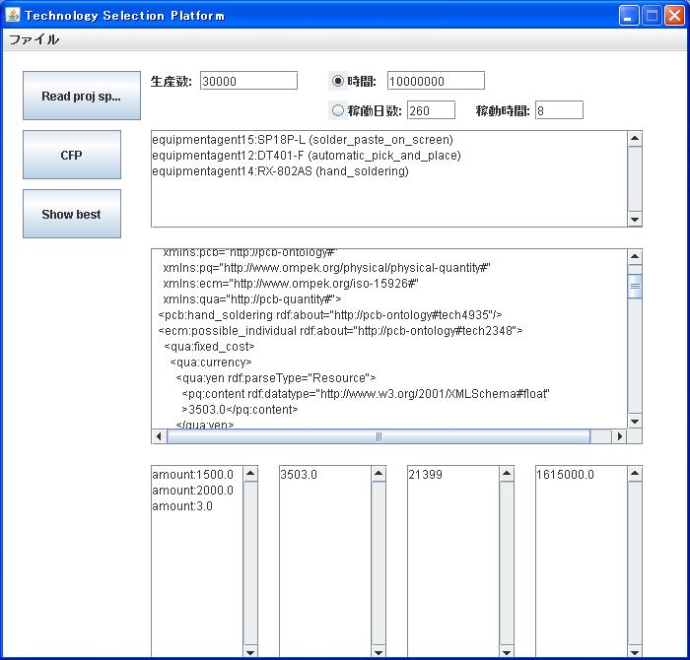
Figure 2. Results of the service composition

References
R Aggarwal, Constraint Driven Web Service Composition in METEOR-S, proceedings of IEEE SCC (2004)
R. Batres and Y. Naka, A Matchmaking Environment for rhe Selection of Biomass Processing Technologies, proceedings of PSE Asia (2005)
R. Batres, M. West, D. Leal, D. Price, M. Katsube, Y. Shimada, T. Fuchino. An upper ontology based on ISO 15926. Comp. & Chem. Eng., 31, No. 5-6 (2007) 519–534
B. Braunschweig, E. Fraga, Z. Guessoum, W. Marquardt, O. Nadjemi, D. Paen, D. Piñol, P. Roux, S. Sama, M. Serra, I. Stalker, A. Yang. CAPE Web Services: The COGents way. ESCAPE-14 (2004)
S. C. Feng, Preliminary design and manufacturing planning integration using web-based intelligent agents. J. Intelligent Manufacturing, 16, (2005) 423–437
R. Fikes, J. Jenkins, and F. Gleb, JTP: A System Architecture and Component Library for Hybrid Reasoning. Proceedings of the SeventhWorld Multiconference on Systemics, Cybernetics, and Informatics. Orlando, Florida, USA, July 27–30 (2003)
JADE, Java Agent DEvelopment Framework. [Online] Available at http://www.cselt.it (2007)
T. Rakotoarivelo, Distributed Discovery and Management of Alternate Internet Paths with Enhanced Quality of Service, PhD Thesis, The University of New South Wales (2006)
B. Srivastava and J. Koehler, Web service composition - current solutions and open problems, ICAPS 2003 Workshop on Planning for Web Services (2003) 28–35
W3C. OWL Web Ontology Language Overview, W3C Recommendation, [Online] Available: http://www.w3.org/TR/owl-features/ (2004)
A. Yang, A Multi-Agent System to Facilitate Component-based Process Modeling and Design, Personal Communication (2007)

