A graphical approach for hazard identification
Rafael
^{aToyohashi}
^{bNational}
^{c}

Abstract
This paper presents a method for the identification of hazard scenarios that explicitly represent much of the information that is otherwise not available with other methods. The proposed method is based on the concept of “hazard scenario graphs” or HSG which is a graphical representation of the chains of activities and events (the causal links between the root cause and the final consequences), as well as participating entities using a shared and common understanding that can be communicated between members of the team and implemented in computational knowledge bases.

Keywords: hazard scenarios, knowledge reuse, causality
  - Introduction
During the design or modification of process plants, engineers use hazards analysis techniques such as HAZOP and FMEA to identify potential problems that if unattended could end in explosions and other consequences (hazard scenarios). For example, in HAZOP studies, engineers start with deviations of the design intent to identify failures and malfunctions (causes). Then for each cause there is a scenario that ends in a hazard (consequence). Subsequently, the result of the analysis is used by the plant engineers in order to improve the safety of the design. Also, during a hazard analysis, engineers can review previous hazards analysis results from similar plants. Heino et al. (2002) point out that most of the information obtained during hazard analysis can be useful to plant operation personnel if presented in a friendly manner.
Broadly speaking, tools that support HAZOP can be grouped into categories: tools that are used to record and document a study and tools that automate the study (Smith and Harrison, 2002). Tools in the first category provide facilities that help to transcript the study generic as an alternative to spreadsheets. With tools in this category, parts of the hazardous scenario are not captured when the scribe records the two extremes of the scenario, namely the initial causes and the final consequences. The second problem is in the representation of hazard analysis information as the text format used in the tool limits the subsequent use of the information. For example, references about the equipment where a consequence occurs are written in the consequence itself. This is error-prone and can cause inconsistencies with other engineering tools.
Venkatasubramanian et al. (2000) presented a review of tools in the second category. For example, HAZID can retrieve data from an electronic P&ID and generate a full detailed HAZOP report. Automated tools are based on a qualitative models of process units that predict outcomes from changes in the process variables from unit to unit. Tools in this category have a formal representation of the equipment and their behaviors with which a detailed scenario can be obtained. However, as the hazard identification method is predefined, users cannot use the tools for other methods such as FMEA or user-defined hazard identification methods.
The approach presented in this paper is an alternative approach to HAZOP and FMEA and can be integrated with any of those tools.
This paper presents a method for the identification of hazard scenarios that explicitly represent much of the information that is otherwise not available with other methods. The proposed method is based on the concept of “hazard scenario graphs” or HSG which is a graphical representation of the chains of activities and events (the causal links between the root cause and the final consequences), as well as participating entities using a shared and common understanding that can be communicated between members of the team and implemented in computational knowledge bases. HSG is based on ontologies and knowledge representation techniques with which knowledge extraction is possible. The method explicitly represents causality, substances, equipment, physical and chemical transformations, plant operations and personnel, facilitating the integration with other engineering tools such as CAD systems. In addition, a support system was developed to assist engineers in developing and using HSGs. Graph editing and knowledge extraction facilities were developed using knowledge engineering tools (JTP inference engines) and a the JGo graphic package.
Firstly, the hazard scenario graphs are introduced. Then the methodology is explained. Finally, the proposed method is illustrated with the hazard analysis of a DAP (Diammonium Phosphate) production process.
  - Hazard Scenario Graphs
Hazard scenario graphs (HSGs) are visual representations of the sequences or networks of events and activities in a hazard scenario. HSGs are based on concepts defined in the ISO 15926 standard that specifies an ontology for the representation of knowledge about process plants (Batres, 2007). ISO 15926 Part 2 (standardized as ISO 15926-2:2003) specifies a “lingua franca” for long-term data integration, access and exchange. It was developed in ISO TC184/SC4-Industrial Data by the EPISTLE consortium (1993-2003) and designed to support the evolution of data through time. The standard includes the definition of kinds and structures of objects, properties, events, processes and relations which can be used in the integration of material property data, equipment information, maintenance activities, etc. Furthermore, not only does ISO 15926 record the process plant as it exists at an instant but also it does record how the plant changes as a result of normal (e.g. maintenance) or abnormal activities. This is critical during the analysis of contributing causes.

A hazard scenario graph is composed of the following elements from the ISO 15926 standard:

1. Activities. An activity is a possible individual that brings about change by causing an event. Classes of activities include physicochemical processes, plant operations, and abnormal situations. Examples of activity are “Level increasing” and “Closing feed valve”.
2. Events. An event is a possible individual that has zero extent in time, which means that it occurs at an instant in time. Events are shown by ovals. A point in time such as ‘UTC 1999-05-13T16:31:23.56’ is a kind of event.
3. Physical objects. A physical object is a distribution of matter, energy, or both. Examples of physical object are a tank, pump, a stream of material, a person.
4. Participating entities are enclosed by hexagons
5. Causal relations are represented as solid arrows identified by the word “cause of event”. A “cause of event” relation connects an activity with one or more events.
6. Temporal relations (beginning and ending) are represented as solid line with a filled circle identified by either the words “beginning” or “ending”. A temporal relation connects an activity with an event. Physical objects are temporally bounded. For example, the physical object “pump P-01 during normal operation” has a begins when the pump was switched on and ends when a cavitation occurred.
7. The participation relation is represented as a solid line with an empty circle identified by the word “participation”
Causal relations are represented by the cause of event relations. A cause of event indicates that the caused (event) is caused by the causer (activity). Temporal binding relationships are represented by beginning and ending relations. A beginning relation marks the temporal start of an activity or physical objects. An ending relation marks the end of a possible individual. A participation relation is a part-whole relation that indicates that physical objects are resources, instruments, or performers of an activity.

Causality in HSG follows the properties described by Shoham (1988) some of which are listed here:
1. Causality is antisymmetric. A cannot cause B if B is the cause of A
2. Causality is antireflexive. A cannot cause itself.
3. Causes cannot succeed their effects in time. A(s) causes A(t) $⇒$ s t
4. Entities participating in the causal relation have a temporal dimension. For example, explosions, runaway reactions, mixing operations, all have a beginning and an ending. Similarly, a reactor during a runaway reaction has also a beginning and an end. This participating entities are possible individuals in terms of the ISO 15926 standard.
5. Domotor adds the property of transivity (Findler, 1996):
If A causes B and B is the cause of C, then A is also the cause of C. Using the HSG relations this is formalized as follows:$∀a_{1},a_{2}∈\text{activity};∀e_{1},e_{2}∈\text{event}$
$$[(\text{cause_of_event }a_{1}e_{1})∧(\text{beginning }e_{1}a_{2})∧(\text{cause_of_event }a_{2}e_{2})]⇒(\text{cause_of_event }a_{1}e_{2})$$
  - Methodology
Step 1. Define the system boundary. This step is also carried out in HAZOP and its purpose is to specify the parts of the system (plant, recipe, operating procedure, control system, etc.) that are to be analyzed.

Step 2. For each piece of equipment and pipelines in the system boundary identify abnormal activities. Abnormal activities include possible equipment malfunctions, undesired physicochemical phenomena, abnormal operations, external events (impacts, earthquakes). This can be done using FMEA’s fault modes or HAZOP deviations.

Step 3. Identify possible propagation scenarios based on the topology of the plant for each of the abnormal activities. An activity causes an event that is the beginning of another activity.
4. Identify activities and events derived from those found in step 3.
5. For each of the activities or events in step 4, identify the hazards that may result.
6. Rank the scenarios in terms of risk and severity of the hazards
7. Go back to step 3 to continue with the rest of the abnormal activities
8. Go back to step 2 to continue with the rest of the equipment items.

During the construction of the scenario mereological relations can be used to indicate that activities or events occur during the time boundaries of another activity. For example, an “abnormal” no-flow situation in a pipe can only occur when material is flowing in that pipe.
  - Example
The following example is from the CCPS book series (CCPS, 1992). This is a process in which ammonia and phosphoric acid react to form diammonium phosphate (DAP), a nonhazardous product. The DAP flows from the reactor to an open-top storage tank. Low ratios of phosphoric acid/ammonia result in an off-specification product, but the reaction is safe. If both amounts of ammonia and phosphoric acid increase, the rate of energy release may accelerate, resulting in increase in temperature and pressure and reactor failure. If too much ammonia is fed to the reactor, unreacted ammonia may flow into the DAP storage tank, causing ammonia release and consequently personnel exposure.
Figure 1. Schematic diagram of the DAP example

Step 1. The system boundaries are the same as the limits of the schematic diagram shown in Figure 1.

Step 2. The next step is to identify the abnormal activities for each of the equipment items. For the ammonia storage tank, the abnormal activities are as follows: equipment malfunctions include gasket and packing failures, no flow of ammonia in and out the tank; undesired physicochemical phenomena include corrosion, erosion, level above the safety limits, level above the safety limits; abnormal operations include inadequate maintenance. External events include external impacts.

Step 3. For this example, the scenarios resulting from corrosion are investigated.

The resulting HSG is shown in Figure 2. Among other things, engineers can search not only in one scenario but in a group of scenarios, which done with the use of inference algorithms. For example, if we are interested in finding the causes of ammonia release, the computer environment will dynamically integrate several scenarios to create a new scenario that is specific to the causality of ammonia release. This is done using the causality properties described in Section 2. Comparatively, a HAZOP study such as shown in CCPS (1992) would assumed leak as a deviation of storage intent, find the cause as corrosion and conclude that the possible consequence is loss of DAP production. Consequently, the steps in between are omitted in the HAZOP report.
  - HSG Editor
Figure 2. A HSG of the DAP process
The HSG editor is a Java application that allows the construction of HSGs and intelligent queries to retrieve or combine parts of the information. HSGs are created by connecting activities, events, and physical objects that are placed in the editing window in a drag-and-drop fashion. The resulting HSG is internally represented in terms of the ontology concepts and encoded in the OWL language. This enables the knowledge extraction by the inference engine and the integration with other tools.
The editor was developed using the JGo, and Jena libraries. JGo is a Java component for developing graph-related applications and Jena is used to generate OWL objects that are passed to the inference for causality reasoning.
The inference engine (JTP) is an object oriented Modular Reasoning System developed by the Knowledge Systems Laboratory of Computer Science Department in Stanford University (Fikes et al., 2003). By default, JTP is composed of a number of reasoners that implement algorithms such as generalized modus ponens, backward-chaining, and forward chaining and unification. The results of the inference can be shown graphically. For example, Figure 3 shows in red the relations connecting the causes of ammonia release.
  - Conclusions
This paper presented a method that aims at a more efficient use of the hazard analysis knowledge. Specifically, the Hazard Scenario Graph was discussed as a means to describe the causality of the scenario and participating entities a compared to a segment of a HAZOP report. The construction of HSGs is possible by means of tools such as the HSG Editor that allows the user to describe the scenario using drag-and-drop icons augmented with semantic descriptions of causality and participating entities. The user can then discover causal links derived from an activity, event or participating entity selected by the user. Comments gathered from two recognized safety experts tell that the hazard scenario graphs are easy to understand, the distinction between the different elements of the graph allows a clear description of the causation, temporal information, and the substances, equipment, personnel involved. Also because the hazard scenario graph is based on ISO 15926, instances in the graph can be integrated with plant databases such as those containing equipment data. An ontology of activities has been developed and we are planning to integrate it with the editor.

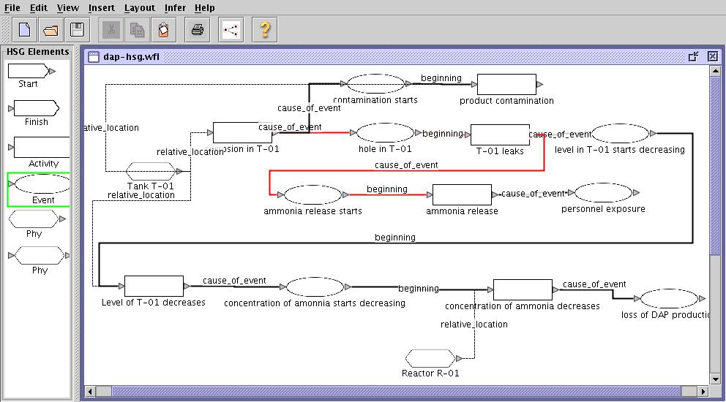
Figure 3. A screendump of the HSG editor.

Acknowledgements. The authors are grateful to Mr. Toshinori Kawabata for the evaluation of the HSG representation.
References
R. Batres, M. West, D. Leal, D. Price, M. Katsube, Y. Shimada, T. Fuchino. An upper ontology based on ISO 15926. Comp. & Chem. Eng., 31, 5-6 (2007) 519–534
CCPS, Guidelines for Hazard Evaluation Procedures, with Worked Examples, AIChE 1992
R. Fikes, J. Jenkins, and F. Gleb, JTP: A System Architecture and Component Library for Hybrid Reasoning. Proceedings of the SeventhWorld Multiconference on Systemics, Cybernetics, and Informatics. Orlando, Florida, USA, July 27–30 (2003)
N. V. Findler, and T. Bickmore, Applied Artificial Intelligence 10 (1996) 455–487
P. Heino, P. Valkokari, K. Rönkkö, E. Kotikunnas and S. Lamberg, Operator Support for Abnormal Situations using Safety and Reliability Knowledge, 15th Triennial World Congress (2002)
Y. Shoham, Reasoning about Change, MIT Press, Cambridge, Massachusetts (1988)
S. P. Smith and M. D. Harrison, Supporting Reuse in Hazard Analysis, DIRC Workshop, London (2002)
V. Venkatasubramanian, J. Zho, and S. Viswanathan, Intelligent Systems for HAZOP Analysis of Complex Process Plants, Comp. & Chem. Eng., 24 (2002) 2291–2302

