Business Process Model for Knowledge Management in Plant Maintenance
Tetsuo Fuchino,ª Yukiyasu Shimada,^{b} Masazumi Miyazawa,^{c} Yuji Naka^{d}
ª Tokyo Institute of Technology, Tokyo, 152-8552, Japan
^{b} National Institute of Occupational Safety and Health, Tokyo, 204-0024, Japan
^{c} Mitsubishi Chemical Corporation, Kurashiki, 712-8054, Japan
^{d} Tokyo Institute of Technology, Yokohama, 226-8503 , Japan
Abstract
The physical state of chemical plants changes with deterioration. The mechanism of deterioration is very complicated and its occurrence and progress speed can not be measured during operation directly. Thus, the maintenance is planned based on the presumption, and the information acquired from inspection and repair is integrated into knowledge in the from of technological standard. This knowledge represents the presumption, and consistency between the technological standard and the results of inspection and repair decides the safety of the plant. In this study, a business process model for knowledge management in plant maintenance is developed, and the system requirement for knowledge management supporting environment is defined.

Keywords: business process model, plant maintenance, knowledge management.
  - Introduction
The plant maintenance aims at restoring the plant which is deteriorated with operation to a desired condition for its safety operation. Therefore, the plant maintenance plays an important role for the life-cycle safety, and proper integrity is required. However, the mechanism of deterioration in chemical plants is very complicated, and its occurrence and progress speed can not be measured directly during operation, generally. Thus, the plant maintenance is carried out by using so called PDCA (Plan, Do, Check, Action) cycle, i.e. the presumption against occurrence and progress speed of deterioration is applied in planning of maintenance, the inspection verifies the presumption, and repair is planed and executed on the basis of further presumption.
On the other hand, there exist huge number of equipment items and pipes to be maintained in a chemical plant, and it is required to maintain them exhaustively and effectively. To satisfy these opposing necessary conditions, the trend of deterioration captured by inspection of equipment units for many years is integrated into knowledge such as causality of deterioration occurrence and progress speed, residual life expectation and so on, and the knowledge is put in the form of technological standard to be applied for the presumption against occurrence and speed of deterioration. Accuracy of the presumption, which effects on safety in operation, greatly depends on the consistency between the technological standard and the results of inspection and repair. However, the technological standard provision form the results of inspection and repair is carried out implicitly, and system requirement for knowledge management in plant maintenance can not be specified properly. The inconsistency between the technological standard and the plant actual state possibly causes serious problem in the lifecycle.
In this study, business process model for knowledge management in plant maintenance is developed under the cooperation of plant maintenance experts in chemical industries in Japan, and IDEF0 (Integration Definition for Function) model [1] to integrate maintenance information into knowledge and technological standard is provided. The system requirement for knowledge management supporting environment in plant maintenance is specified. We have already proposed a business process model for plant maintenance [2], which defined activity from planning to execution of plant maintenance by using IDEF0 model. The proposing business process model here becomes an upper model of the previous one, so that from the lifecycle engineering viewpoint, the previous IDEF0 activity model is extended to include the knowledge management.
  - IDEF0 Activity Model for Lifecycle Engineering
In IDEF0 activity model, the rectangle represents activity, and the arrows describe information. The information is classified into four categories; i.e., 'Input' to be changed by the activity, 'Control' to constraint the activity, 'Output' to be results of the activity and 'Mechanism' to be resources for the activity. The 'Input', 'Control' and 'Mechanism' are fed to left side, top and bottom of the activity respectively, The 'Output' is to go out from right side of the activity. Each activity is developed to sub-activities hierarchically. In this study, a modified PIEBASE template [3], which categorized activities into four types; i.e. 'Manage', 'Do', 'Evaluate' and 'Provide Resources', and two step approach; i.e. (1) generate and define hierarchical structure of activities, (2) provide ICOM (Input, Control, Output, Mechanism) information, which are proposed in the previous study [2], are applied in making IDEF0 activity model.
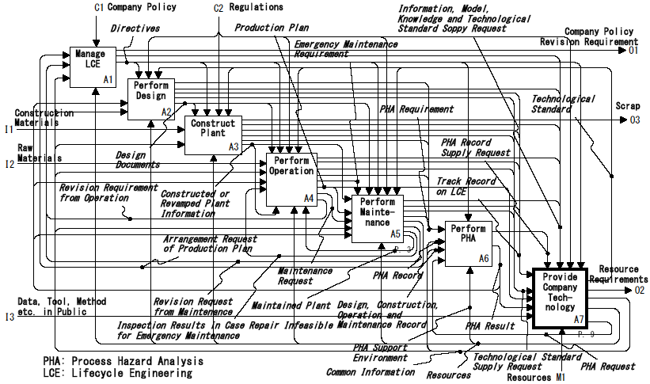
Fig. 1 Perform Lifecycle Engineering
To generalize the maintenance information into knowledge, information from design and operation, which are activities compose plant lifecycle as well as maintenance, is indispensable. Therefore, the top activity of this study should be ‘Perform LCE (Lifecycle Engineering)’, and is developed into seven sub-activities; ‘A1: Manage LCE’, ‘A2: Perform Design’, ‘A3: Construct Plant’, ‘A4: Perform Operation’, ‘A5: Perform Plant Maintenance’, ‘A6: Perform PHA (Process Hazard Analysis)’, and ‘A7: Provide Company Technology’, as shown in Figure 1. The activity model for plant maintenance proposed in the previous study [2] is developed under ‘A5: Perform Plant Maintenance’ activity.
From the view point of lifecycle engineering, information generated in each lifecycle (sub-)activities; i.e. design, construction, operation and maintenance, is to be integrated and shared through the lifecycle. Therefore, the ‘A7’ activity receives the results of lifecycle activities, and outputs knowledge on each lifecycle activity, tools, and technological standards. The respective lifecycle activity performs their engineering on the basis of the technological standard. However, various changes are carried out during the lifecycle, for example it is in such cases as the change of the raw material, the change of the production rate, the change of the product specifications, the change of the product mix, and the change of plant structure (revamp). The effect of such changes is recognized at respective lifecycle activity. Especially in maintenance, A deterioration tendency is likely to change, and the difference between the presumption and the result of inspection would be increased. When this difference spread than the threshold value decided beforehand, the cause is investigated and the change of the technological standard must be required. In Figure 1, this requirement is once fed to ‘A1’ activity, and is informed to the ‘A7’ activity to prevent local inconsistent revision of technological standard.
In the next section, based on the above mentioned consideration of lifecycle engineering, the mechanism of knowledge management for plant maintenance is developed under ‘A7’ activity.
  - Knowledge Management Model for Plant Maintenance
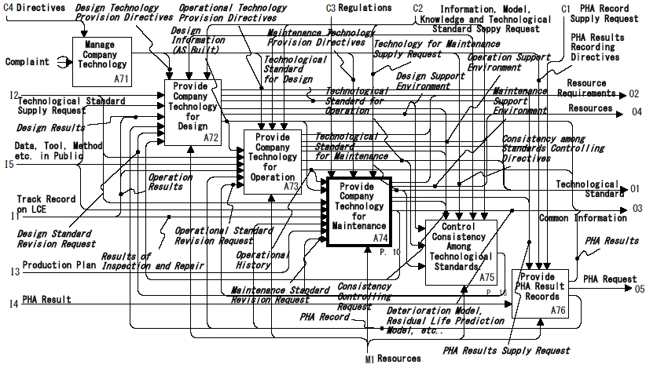
Figure 2. Provide Company Technology
The knowledge and technological standard for respective lifecycle activity are provided separately, because the cycle and timing of performing engineering are different with each other, and these provided standards should be consistent with each other to manage safety through the lifecycle. Thus, the ‘A7’ activity in Figure 1 is developed into six sub-activities as shown in Figure 2. The ‘A72’ to ‘A74’ activities provide technology, knowledge and technological standard to perform design, operation and maintenance. The ‘A75’ controls consistency among technological standards, and if inconsistency is found, then revision requirement for any technological standard is outputted. The occurrence and progress speed of deterioration are influenced by design specification and operational history, and the residual life prediction depends on production plan in future. Therefore, design information, operational log and production plan is fed to ‘A74’ activity in Figure 2.
    - Generation of Technological Standard for Plant Maintenance
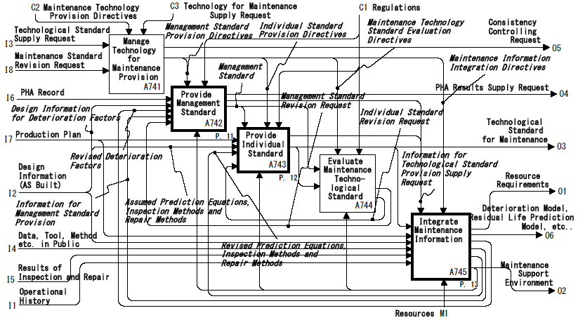
Figure 3 Provide Resources, Knowledge and Technological Standard to Perform Maintenance
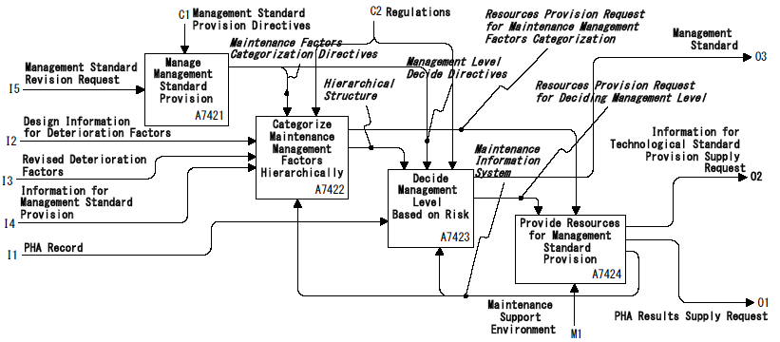
Figure 4 Provide Management Standard for Maintenance
The ‘A74’ activity is decomposed into five sub-activities as shown in Figure 3. There are two types of technological standard for maintenance; i.e. one is technological standard to decide framework of maintenance method, and the other is that to decide the individual maintenance method according to the framework. The former is called ‘management standard’, and the latter is called ‘individual standard’, here. The management standard is provided on the basis of design information in the ‘A742’ activity, and the individual standard is provided in the ‘A743’ activity, on the basis of public information stored in ‘A745’ activity in the beginning. Other than the revision requirement from ‘A75’ activity, when inspection and repair information increases, and knowledge is accumulated in ‘A745’ activity, then a revision is added to the ‘A743’ and/or ‘A742’ activities, if necessary, from ‘A745’ activity.
The ‘A742’ and ‘A743’ activities are developed into four sub-activities as shown Figures 4 and 5 respectively. It is obvious form the ‘A7422’ and ‘A7423’ activities in Figure 4 that the framework, which the management standard is to prescribe, is the relation between deterioration and its causal factors, and the individual standard offers the prediction mechanism and relating methods based on the causal factors for respective equipment items. Therefore, the ‘A745’ activity should receive operational history, design information and results of inspection and repair, and integrate the results of maintenance into the knowledge in the form of the causal factors related to deterioration and the prediction models with related methods.
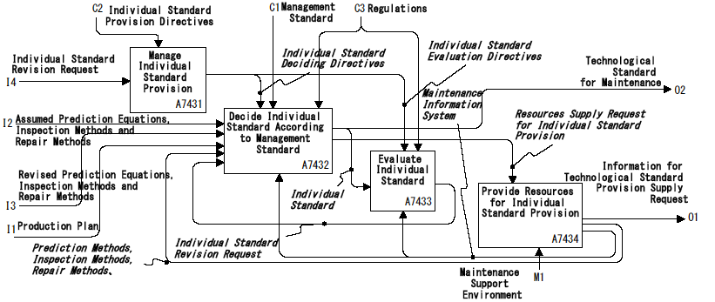
Figure 5 Provide Individual Standard for Maintenance
    - Integration of Maintenance Information into Knowledge
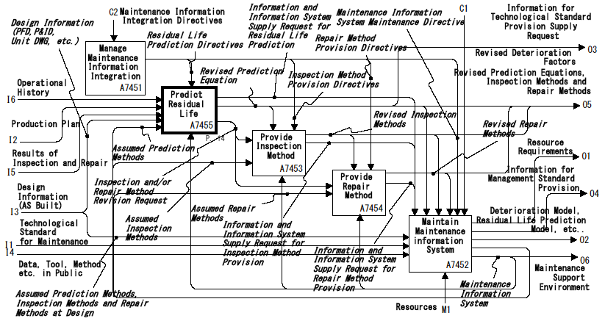
Figure 6 Integrate Maintenance Information into Knowledge
In order to make maintenance plan, three types of knowledge are necessary; i.e. residual life prediction, inspection method and repair method, and these types of knowledge, and the technological standard provided from the knowledge are implemented in the maintenance information system. Therefore, the ‘A745’ activity is developed into five sub-activities as shown in Figure 6. In predicting residual life, the assumed prediction method in design is provided from ‘A7455’ activity in the beginning. According to increase of the inspection and repair information, the parameters in prediction equation are revised. The revised parameters are stored in the ‘A7455’ activity, and it is utilized in prediction next time. When the deviation between predicted and inspected deterioration is increased, diagnosis of the error should be performed. Therefore, the ‘A7455’ is developed into four sub-activities as shown in Figure 7, and the ‘A74554’ activity analysis the reason of the error. There are three types of reasons for the errors; i.e. prediction model, inspection and repair. According to the reason of the error, the proper revision request is fed back to the ‘A743’ and/or ‘A742’ activities.
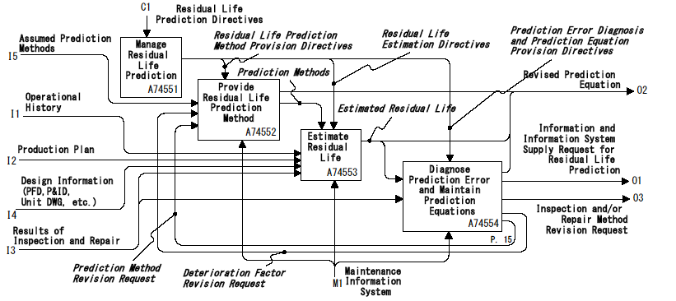
Figure 7 Provide Residual Life Prediction Method
  - Conclusion
In the plant maintenance, the information acquired from inspection and repair is integrated into knowledge, and is put in the form of technological standard. The consistency between maintenance and the technological standard decides safety in lifecycle. In this study, a business process model for knowledge management in plant maintenance is developed, and IDEF0 activity model to manage the consistency explicitly is developed. Consequently, the system requirement for knowledge management supporting environment in plant maintenance can be specified.

Acknowledgements
The authors are grateful to the following plant maintenance experts for their cooperation in modeling; Mr. Sadayoshi Hano (Mitsubishi Chemical), Mr. Kazutaka Hosoda (Fuji Oil), Mr. Kiyoshi Matsuoka (ZEON), Mr. Shizuo Ishizuka (Kashima Oil), Mr. Hitoshi Shinohara (Tokuyama), Mr. Shinji Takagi, Mr. Tatsuo Gamon (Asahi Kasei Chemicals), Mr. Tsuyoshi Takehara (Tonen General Sekiyu)
- References
[1] Federal Information Processing Standards Publications; “Integration Definition for Function Modeling (IDEF0),” http://www.itl.nist.gov/fipspubs/
[2] Fuchino,. T., M. Miyazawa and Y. Naka, “Business Model of Plant Maintenance for Lifecycle Safety,” 17th European Symposium on Computer Aided Process Engineesing - ESCAPE17, Bucharest Romania, Elsevir(2007)
[3] PIEBASE; “PIEBASE Activity Model Executive Summary”, http://www.posc.org/piebase/own

