Support of strategic business decisions at
BASF’s largest integrated production site
based on site-wide Verbund simulation
Stefan Brüggemann,ª Nanette Bauer,ª Eberhard Fuchs,ª Axel Polt,ª Bernhard Wagner,ª Michael Wulkow^{b}
ª BASF AG, 67056 Ludwigshafen, Germany
^{b} CiT-Computing in Technology GmbH, 26180 Rastede, Germany
Abstract
The paper presents a novel large-scale sequential-modular simulation tool for expansion and refinement of Verbund sites with highly-interconnected networks of chemical production and infrastructure plants. The simulation uses a hierarchical model based on the site’s cost centers, plants and unit operation modes which hold the stoichiometry and utility demand of each production step. A semi-automatical interface to the SAP database of the site is used for routinely updating the model with respect to the latest changes regarding structure and recipe parameters. Based on this model the impact of modifications in a single plant, for example a capacity increase, can be analyzed by giving a quantitative prediction of all relevant consequences across the linked value chains of the site. The new simulation tool is used to support strategic business decision making with respect to new investments, capacity adjustments and production planning. In addition, the gathered and consolidated data of the Verbund models are a valuable resource for strategic and operative business units.

Keywords: Simulation, Integrated production, Verbund model, Business decision support, Enterprise resource planning, SAP.
  - Introduction
Verbund is one of BASF’s core competencies: At all major sites, the production plants are connected in a sophisticated complex network which link basic chemicals to specialties along value-adding chains. Byproducts are integrated into subsequent production steps either as a secondary fuel source, or, preferably, as raw materials for other plants (see Kröner et al., 1988, and Lenz et al., 1989). Hence, the Verbund network supports sustainable production by reducing energy and raw material consumption, cuts down logistic costs and allows the jointly use of infrastructure facilities by synergy management. In order to maintain its competitive advantage, BASF continuously cultivates and refines its Verbund structures. However, the high level of integration of the network in which chemical products, side-products, waste fractions and utilities are transferred between and shared by a large number of chemical plants also leads to a high degree of complexity when assessing the impact of strategic business decisions on the Verbund site as a whole. For example, the expansion of a plant for a sales product automatically triggers an increased demand for its respective feedstock intermediates. The resulting make-or-buy decision for these intermediates requires a quantitative prediction of all relevant effects on the other plants of the site as well as the utility systems.
In this contribution, we present some experiences on successfully modeling and simulating BASF’s largest Verbund site worldwide, Ludwigshafen, consisting of more than 200 plants and 8,000 sales products, each processed from several intermediates or raw materials. One of the key challenges is the enormous amount of data which is required to reproduce the network of chemicals, utilities and plants. A new tailor-made simulation software has been developed which provides interfaces to the databases of the site’s procurement and resource planning systems (SAP).
  - Structure and characteristics of the Verbund model
Modern modeling and simulation programs have become indispensable tools for the design and rating of chemical processes. The vast array of different tools can be categorized by the level of detail of the respective models. Figure 1 illustrates this categorization and names some industrially important tools. Plant information systems collect historical measurement data from existing plants. Trend detection and reconciliation features allow a data-driven assessment and rating of single pieces of equipment and the performance of the production process as a whole. Equipment design software targets the sizing and rating of key equipment such as distillation columns or heat exchangers based on thermodynamics, physical property packages and high-detail models for heat and mass transfer as well as fluid dynamics. The use of process simulators such as Aspen Plus has long become state-of-the-art for the design of complete process flowsheets. They allow capturing the interdependence between major pieces of equipment and the influence of recycles. Integrated optimization packages and sizing model libraries assist the identification of cost-optimized operating points (Wiesel et al., 2006).
In principle, the simulation of a complete Verbund site can be regarded as a flowsheet simulation which operates on a very large-scale model encompassing all chemical components, utilities and plants on the site. Regarding the sheer number of components on a single site, which can easily reach several hundred to thousands, it is, however, easy to imagine that standard process simulation tools are not well suited for this task. Instead, BASF decided to create the new custom-made simulation tool SiteMod for site-wide simulation with a highly aggregated model which has been implemented and jointly developed by CiT.
A Verbund model is built up based on a three-level hierarchy which is closely related to the structure of the SAP database of the site. Figure 2 illustrates the structure of the Verbund model with an example. The first level comprises of the plants
Figure 1: Levels of detail in modeling chemical processes
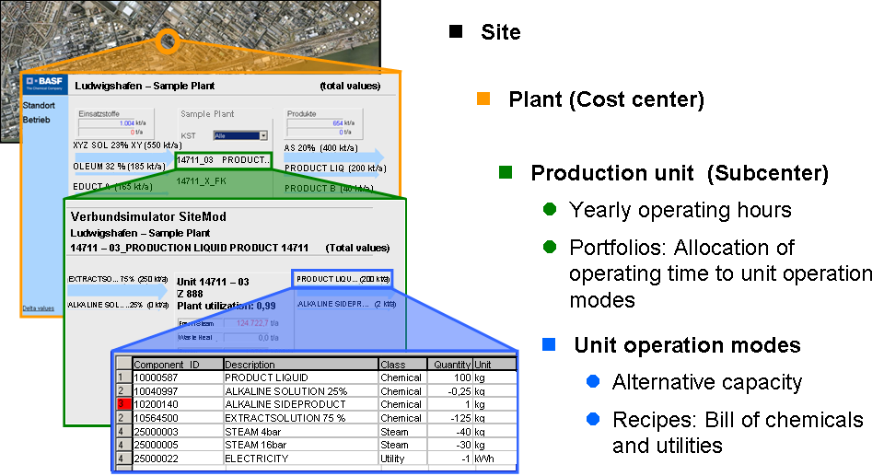
Figure 2: Hierarchical structure of the Verbund model
or, respectively, cost centers on the site. Each plant is subdivided into several production units (cost subcenters) which define an independent chemical production facility, e.g. a single production line of a polymer plant.
The description of the chemical process itself is stored in unit operation modes attached to the production units. The chemistry is given in form of a recipe which balances the input and output streams of the production unit with respect to chemicals and utilities. The example shown in Figure 2 describes the recipe for the production of a liquid intermediate product in the polyamide value chain. Extractsolution 75% is the main raw material. A small quantity of an alkaline side product is formed in addition to the target component. The process requires steam at two pressure levels and a small amount of electricity. Large-scale single-purpose lines, like the one shown here, only have one single operation mode. On the other hand, multi-purpose units can own several competing unit modes. Depending on the type of plant the amount of different unit modes in one unit can grow quite large, e.g. several hundred for compounding and confectioning lines. In addition to the recipe each unit operation mode has a so-called alternative capacity which denotes the maximum yearly production if the production unit is operated with this unit operation mode exclusively.
The amount to which the main product of the unit operation mode is produced is stored in the portfolio of the unit. Using the concept of the alternative capacities the amount of produced material per operation mode can be converted to an operating time. Comparison of the sum of these partial operating times with the total yearly operating time of the unit then yields the level of capacity utilization. In addition, the overall material and energy balances of units and plants can directly be deduced from the portfolios.
  - Integration with the electronic procurement database of the site
The development of Verbund models for site scenarios started in 2002 with the engineering of BASF’s most recent Verbund site in Nanjing. The availability of a tool for site-wide balancing offered a significant contribution to the successful conceptual planning and startup of this new site where the integration of the new plants into several value chains and utility networks was basically derived from the drawing board. In the following years, the concept of Verbund simulation was expanded to the sites in Geismar, Freeport and Antwerp. Up to this point, the models were mainly constructed and maintained by hand. When work started on a Verbund model for BASF’s largest and most diversified site Ludwigshafen in 2004, it soon became apparent that this approach is not suitable anymore. More than 200 plants with over 900 production units, approximately 5,800 main products and a total of around 18,000 different chemical and utility components correspond to an increase of complexity of at least one degree of magnitude in comparison to any of the other sites. In addition to the monstrous task of collecting all relevant information at one point in time, the high rate of modifications with respect to plants, recipes and new products, especially in the specialties and customized polymers sectors, makes it nearly impossible to keep the model up-to-date manually. This claim is probably best illustrated by the fact that in 2007 alone more than 800 new components have been introduced on site.
In order to keep up with the sheer mass of information required for an adequately concise representation of the Ludwigshafen Verbund, SiteMod has been equipped with an interface for data import. The enterprise resource planning database (SAP) of the site is used for the compilation of the raw data. This approach is similar to modern logistics optimization (see Stadtler et al., 2007). Figure 3 shows the software architecture and respective interfaces. As part of its administration and accounting modules, the SAP database contains the current cost center structure and most of the main parameters such as the alternative capacities as well as planned and historical recipes. These parameters are collected in a business warehouse (BW) and extracted to an XML-file which is then imported into a given SiteMod model. A fine-granular parameter blocking mechanism allows to selectively spare certain parameters from being overwritten by the extracted input file.
Currently, a present-state site model is generated and updated on a monthly basis. After importing, the model undergoes a data verification process. The model information is aggregated into cost center reports which are published in a restricted-access intranet database. This database is routinely scanned by a data validation team. In case of doubt this team discusses the respective data with plant management and controlling, whereby inconsistent SAP information is corrected. As a beneficial side effect of the data verification process, plant management and controlling are provided with a web access to a very compact overview of the plants.

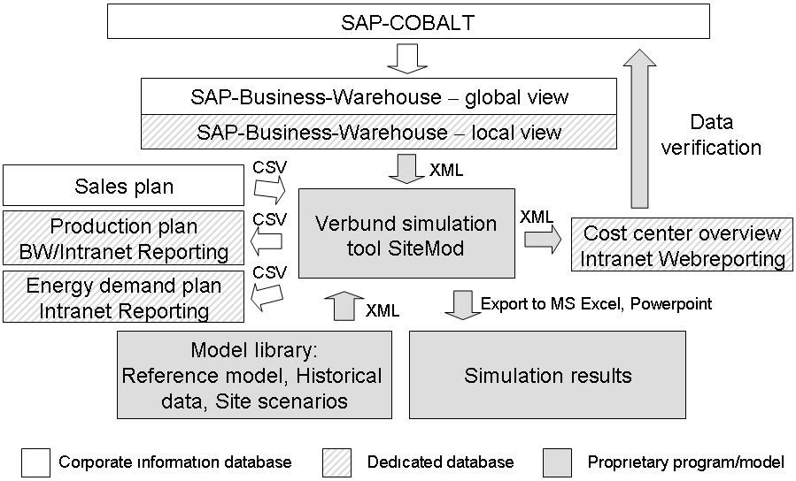
Figure 3: Software architecture and integration with the SAP database
SiteMod also provides additional interfaces for the import of parameter tables, e.g. sales plans for selected components, and the generation of tabular and graphical output for the documentation of different case studies.
  - Calculation and analysis of site scenarios
In principle, Verbund simulation can be used to target either strategic site development scenarios or operative optimization. Historically, the main application is the assessment of the Verbund aspects of investment projects, e.g. new plants or capacity increases in existing plants. This is done in the form of case studies called site scenarios. These case studies target questions such as how the degree of utilization of all upstream plants is affected, if the market prognoses for the related sales products support the planned capacity of an intermediate, or whether there is additional demand for investment in order to supply the required raw materials or utilities. Hence, the scenarios provide important input for the support of strategic business decision making with respect to the investment.
Figure 4 illustrates the application of Verbund simulation for the benchmarking of an investment project. A new site scenario usually starts from a collection of historical information stored in the reference model of the site. This model basically describes the balances of the plants according to the sales and production data of the previous financial year. However, the balances are revised in order to remove effects from singular events such as shortfall of production due to unplanned shutdown, technical problems or raw material shortage. In essence the model, therefore, describes a perfectly operated site. The reference model also contains a set of manually edited parameters and rules which describe constraints on the balances of special components. For example, the demand of some concentrated acid is first covered by re-concentrating available amounts of spent diluted acid before it is synthesized from fresh raw material. Another example is the preferred allocation of production to the most cost-effective of multiple production lines.
In order to create a new scenario the model is augmented with project-specific information, such as new plants and new components with their respective market prognosis. Finally, the model is recalculated by iteratively setting the amounts of production of all unit operation modes in the portfolio of each production unit to a desired target. This target is determined according to the desired sales and the internal demand for the specific component. Rule parameters partition the production in case
Figure 4: Application of Verbund simulation for benchmarking of investment projects
multiple unit operation modes exist for the production of the same component.
A sequential-modular approach has proven to be most suitable for converging the overall site balance out of two reasons. First, it readily supports a step-by-step analysis of the balance changes and, if necessary, adjustment of the rule parameters. Secondly, it allows isolation of singularities and other numerically unwanted effects in the model. For example, singularities frequently arise when component A is not only produced from component B in one unit operation mode but also reprocessed to B in another one. Whereas this situation is perfectly valid for accounting in SAP, it can, depending on the rule parameters, be a major hassle for the simulation.
The resulting balances of the scenario can readily be compared to the reference model or, respectively, to alternate scenarios in form of a Δ-assessment. This assessment shows the changes of the site balance with respect to the overall component balance and the utilization of the plants. Successive scenario calculations can then be used to refine and optimize the integration of productions within the Verbund.
  - Use of Verbund simulation as an operative site information tool
In addition to the economic assessment of investment projects the data in the Verbund model can also be used as a site information tool for midterm operative planning. Based on a five-year sales forecast the corresponding plant portfolios are calculated using the reference model. Where applicable, scheduled capacity increases resulting from debottlenecking and, vice versa, capacity decreases, e.g. from planned turnarounds, are considered. The resulting production plan is published in a SAP BW/Intranet database and provides the plant managers with information on the expected utilization of their plant and, in case of multi-product plants, on the distribution of the product portfolio (cf. Figure 3). Recently, this planning module has been expanded to additionally propose a site-wide forecast of energy and utility consumption.
  - Conclusions and future work
A novel software tool for site-wide balancing of chemicals and utilities has been introduced. The tool enables visualization and refinement of integrated production at a Verbund site based on data from an enterprise resource planning database (SAP). It is used for the economic benchmarking of the site aspects of investment projects. In addition, it is the basis for setting up the midterm operative production and utility forecast of the site. Future work will focus on exploiting the data contained in the Verbund model for additional operative aspects. Ideas range from optimization of product allocation during periods of raw material shortage to the application for tolling purposes. On a long-term scale the extension to multi-site Verbund simulation is targeted.
References
H. Körner, 1988, Optimaler Energieeinsatz in der chemischen Industrie, Chemie Ingenieur Technik, 60, 7, 511-518.
H. Lenz, M. Molzahn and D. W. Schmitt, 1989, Produktionsintegrierter Umweltschutz – Verwertung von Reststoffen, Chemie Ingenieur Technik, 61, 11, 860-866.
H. Stadtler and C. Kilger, 2007, Supply Chain Management and Advanced Planning: Concepts, Models, Software and Case Studies, Springer Verlag, Berlin.
A. Wiesel and A. Polt, 2006, Conceptual steady state process design in times of value based management, Proc. ESCAPE 16, Elsevier, 799-804.

