A generic scientific information management system for process engineering
Sylvie Cauvinª, Mireille Barbieux^{b}, Laurent Carrié^{b}, Benoît Celse^{b}
ªIFP- 1 & 4, avenue de Bois Préau - 92852 Rueil Malmaison, France
^{b}IFP-Lyon, Rond Point de l'échangeur de Solaize, BP3, 69360 Vernaison, France
Abstract
The development of new and innovative refining or petrochemical processes involves various activities ranging from analysis tools development, catalysts or separation agents elaboration, laboratory and pilot tests, models and simulators development. At each step, a huge amount of very valuable and heterogeneous data is collected. It must be exploited by all the actors of a project.
This paper presents the scientific data management system which has been developed in order to deal with this data, therefore enhancing the process development cycle. It focuses on the conceptual foundations which allowed us to reach the aim of having generic applications which are directly configured by the end-user. The system being in use since 2006, feedback and lessons learnt are presented.

Keywords: Scientific data management system, Process development, Databases and Data mining.
  - Introduction and requirements
Developing new industrial refining or petrochemical processes requires a wide range of activities. First of all, catalysts or separation agents are elaborated which involves specific methods of preparation. All the variables such as temperature and duration of calcination, are important. Then many tests are conducted in laboratories in order to estimate the performances of the product which is considered. When this step is successful, more tests are conducted on pilot plants which are units measuring several meters but much smaller than industrial units. These tests cover wide ranges of operating conditions (several kinds of feeds, ranges of pressure and temperature). Collected data is used to build models which will be used to design industrial units and be able to guarantee some yields in specific conditions.
Therefore, collected data is very valuable (a wrong design would lead to huge economic penalties). The set of data is big: a lot of physical analyses are made to get the detailed information that is required, the range of the data must be representative, there is redundancy in the data in order to be able to guarantee its quality. At the same time, the tests being very expensive, the number of experiments and measurements must be restricted to the bare necessity.
As new processes must be developed quicker and quicker to be on time on the market, it is absolutely necessary to deal with the collected data with very efficient tools (Moore 2000). In this paper, we detail the information management system which was set up in our Research and Development Institute. It allows us to optimise the daily work of the process engineers, to optimise the use of the data, to minimise the cost of software development and adaptation, and constitutes an important item of the quality policy.
The system interconnects the experimental devices, data bases, simulation and request tools. All the tools are configured by the end-users, which allows them to use the same tools from one process to another without any further software development. Each data is entered only once, checked manually (using results of the calculations and comparisons between several experimental points), and tracked. Nevertheless, this genericity (or possibility to use the same software for different purposes) involves complexity in the conceptual foundations of the applications.
Figure 1 presents the global organisation of all the devices used and connected. Pilot plants are controlled using the Fix Control System which is connected to iHistorian Software which centralises synthetic values (average, mean, max). On-line and off-line analyses are stored in the LIMS (Laboratory Information Management System) when special chromatography systems are managed by the Galaxie application. The collected data is then transferred in two applications: CataSepa which is dedicated to studies concerning catalyst and separation agents, and B-DEXP which manages pilot plant information. These applications have different aspects: data management, data exploitation with query tools and models connection. Figure 1 also mentions Oleum, an application for managing the location of the products and security aspects (it provides information to B-DEXP) and Correl which is an application dedicated to the elaboration of correlative models using analyses results. Finally, on the catalysts, some information is entered manually in Excel files which are loaded directly in CataSepa.

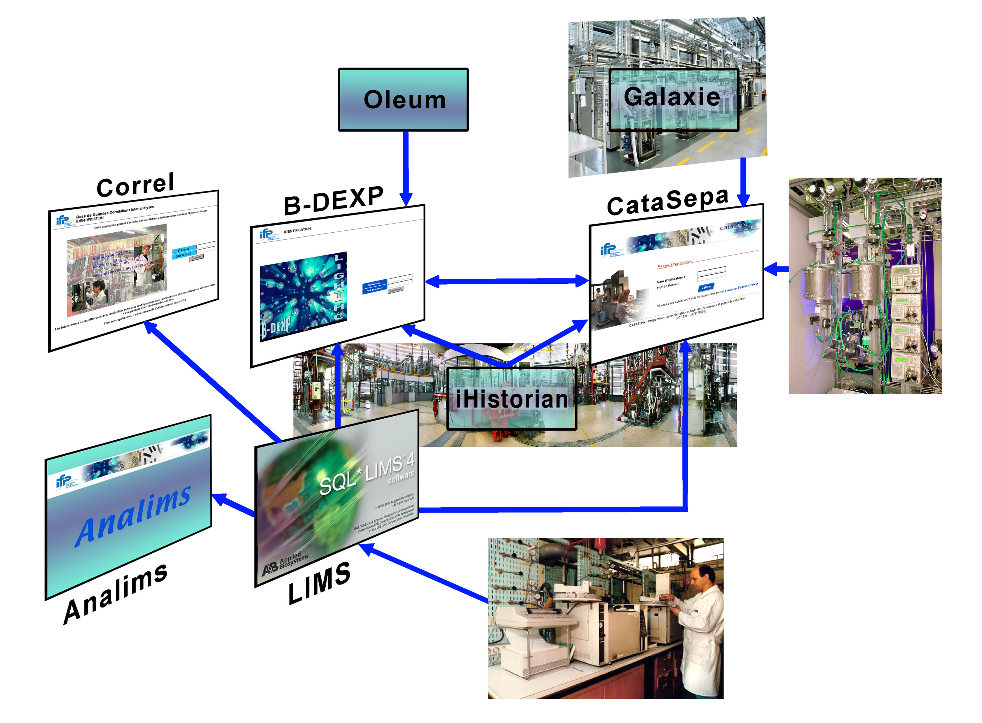
Fig. 1: An interconnected information management system

The paper is organised as follows: Section 2 focuses on the LIMS developed with SQL*LIMS from ABI, using Oracle database, Section 3 focuses on the two applications dedicated to catalyst and process development (CataSepa and B-DEXP) which are distributed Intranet applications developed with Oracle 9i Application Server, Oracle data base, Java and Business Objects, and Section 4 focuses on the lessons learnt.
  - The LIMS application
    - Main functionalities and specificities
The LIMS application manages the submissions and the results of almost all the analyses which are made within the Institute. A submission with its samples follows a complete workflow in the LIMS application from the customer - who generates the submission – to the analysts who enter the results, method by method, and then finally to the customer again when the results are approved.
The standard functionalities of SQL*LIMS software have been adapted to meet the requirements of our process research Institute which are much different from those of the pharmaceutical industry (Kimber 2006).
In particular, due to the fact that tests are conducted in a wide range of conditions, specific functionalities had to be developed. For instance, "frameworks" were made available to manage complex submissions, with multiple samples and numerous analyses, which are frequently used. The "frameworks" are used to generate the new submissions. The development was not easy as it had to take into account the structure of the LIMS. Nevertheless, the database being Oracle, it has been possible to develop such functionalities which make users save a lot of time.
Another important specificity of the application relies in the connections with other tools. The following connections were set-up:
- automatic data entry with IDM LimsLink,
- automatic creation of submissions for on-line analyses,
- connection to the databases CataSepa and B-DEXP (cf. § 2.2),
- connection to the ANALIMS application which generates statistics and quality indicators, using QlikView, a Business Intelligence solution,
- Business Objects module to request the LIMS database, especially for answering questions from the technical assistance.
    - Standard connections
This section focuses on the generic connection between the LIMS and the databases CataSepa and B-DEXP. When a customer generates a submission, he can specify the database where the results have to be inserted, if any. The mechanism is based on an Oracle view, one per database where the results to be transferred are to be "stored".
Every night, a batch is executed (one per client database). It inserts the results into the database. Information is then stored in a journal table in the LIMS database which is used as a filter to generate the view.
    - Use of the application
The LIMS application is in use since mid-2003. It's now fully integrated in the daily work of about 600 persons. A high availability and reliability is therefore required.
About 150 distinct users connect every day to the LIMS.
Concerning the amount of managed data, the number of submissions in a week is quite stable – about 150 – but the number of analyses is increasing: roughly 800 per week in 2006, and 950 per week in 2007.
In order to guarantee good performances, a distributed architecture had to be designed. Specifically, one machine is in charge of the LIMS database, one is in charge of the interactive application, another is in charge of the application dealing only with on-line analyses, and one is in charge of the batch printing system.
  - Catalyst and Process data management
    - Main functionalities and specificities
CataSepa and B-DEXP are two Intranet applications which are used to store information on catalysts (preparation, or characterization) and test results (laboratory test results for CataSepa and pilot plants test results for B-DEXP). As several kinds of catalyses are studied within IFP (adsorbents, solvents, homogeneous catalyses, heterogeneous catalyses), and tests are conducted on different kinds of processes (FCC, HDT, Isomerisation, etc), the applications require a high level of flexibility (cf. 3.2). They allow each group of users:
- to define all the key information to be collected and stored in the database,
- to define calculus in order to calculate test results (selectivity, activity, etc).
All these activities are conducted through configuration screens. No software development is required. Thus, it allows researchers to adapt quickly the application to any change in the way research is conducted.
In order to automate data collection, those applications have been connected through generic links to:
- iHistorian in order to import automatically sensor values
- Chromatographic results (Galaxie) and LIMS results in order to import analyses results (cf. §2.2)
- Pilot Plant in order to create automatically tests (using information stored in the pilot plant controller).
Moreover, specific modules have been developed in order to import/export tests results contained in Excel spreadsheets, and a connection between CataSepa and B-DEXP has been developed in order to be able to use information from one database in the other, especially for calculations and requests.
To obtain such a flexible architecture, a specific Oracle structure has been designed and associated with a specific data base (Data Mart) in order to facilitate Queries (cf. 3.2), the connection of different kind of calculation tools was made available (cf. 3.3) and a standard framework was developed (cf. 3.4).
    - Conceptual foundations
In order to obtain a flexible application, the data base structure is not usual. Each variable of the application is not stored as the column of a table but as rows of a specific table. Then, to add/delete a variable, it is only needed to add/suppress a row without any structure modification of the data base and then of the application.
For example, the following variables are stored for homogeneous catalysis:
- Molecular Formulation
- Ionic Liquid used
when the following variables are used for heterogeneous catalysis:
- Calcination Temperature
- Porous Volume
- Mass
and the following variables are defined for tests in heterogeneous catalysis:
- Pressure (set points, mean value)
- Temperature (set points, mean value)
- Catalyst DRT
- H2/HC
- GC Results
- Activites, Selectivites, Conversion
All the variables are defined for each kind of catalyst, each kind of processes and each kind of application, by the users (who have the configuration profile) themselves.
This architecture is very powerful for flexibility. However, it decreases drastically the possibilities to query the data base. A new data base dedicated to query had then to be developed. Tables are built dynamically (one table per analysis method, preparation method). Each variable is then one column. Each day, data is inserted in the datamart using PL/SQL scripts. This database is then classical and can be easily requested using conventional tools (Business Objects or MS Query).
    - Connecting calculation modules
First of all, users wanted to be able to enter formulas which use data from the database and to store the results which are key variables very often used when requesting the database. A tool was developed to select variables and mathematical functions, to generate the JAVA classes in charge on the calculation (using JAVAcc library), and to create the variable containing the results and insert them in the database. Nevertheless, some calculations relying on others (100 formulas can be defined for one test), a preliminary treatment is organising the calculations. This tool is dedicated to simple calculations such as activities, selectivities, yields.

In other cases, users mainly want to be able to connect existing Fortran or C++ codes. In this case, they can specify the input data, which is sent to an XML file used by the external code, which itself generates an XML file read by the application to create new variables which store the values in the database.
    - Standard framework
In order to reduce development costs, a specific framework following J2EE Design Patterns has been developed in 2000 and used in all our Intranet applications. It is based on the design pattern MVC (Model View Controller). MVC encompasses more of the architecture of an application than is typical for a design pattern. The application is divided in three layers (Burbeck, 1992):
- Model: The '''domain'''-specific representation of the information which the application operates. Domain logic adds meaning to raw data (e.g., selectivity, activity, etc). It uses a persistent storage mechanism (oracle DataBase) to store data.
- View: Renders the model into a form suitable for interaction, typically a user interface element. Multiple views can exist for a single model for different purposes.
- Controller: Processes and responds to events, typically user actions, and may invoke changes on the model.
This module is similar to Struts and Barracuda frameworks but it implements functionalities dedicated to IFP:
- Model layer uses BC4J components provided by Oracle (Muench, 2002).
- View layer uses JSP pages and Oracle taglib provided by BC4J.
- Traces (debug or log) are managed by the framework, as well as user management (login pages, password authentification), and security aspects for database queries.
    - Use of the applications
CataSepa and B-DEXP are used daily since 2006 by about 200 people. Today, about 50 000 catalysts, 5000 tests, 9000 full experiments have been stored. The tools are used for conducting the experiments (for preliminary calculations, data validation) as well as for research (analysis of the data, models and correlations elaboration and validation).
  - Lessons learnt and conclusion
In the past, the situation within the Institute was very heterogeneous. For some processes such as the Reforming process, specific databases were in operation, for others, each engineer had his own Excel files. Many applications were mastered by only one person and nobody else could make it evolve. Each of them being specific, many connection tools were developed in order to put the data in the correct form. Moreover, some data (and some formulas) were defined at different steps of the development cycle. The deployment of the new system solved those problems. Therefore, it increases the quality insurance and optimises the work of the process engineers.
Nevertheless, it involved a lot of work from the different teams in order to define the common use of the data and to configure the applications. The deployment of such a system requires the involvement of everybody in the company, comprising decision makers. Deployed step by step, the system is now fully used in some departments and some configurations are going on in others. It looks very important to develop performing query tools. When dedicated Business Objects reports are made available, the users really benefit from the system and can answer quickly very accurate questions. In the future, it should be examined how data from the different databases can be exploited in order to develop new kinds of processes using existing data, thus minimising the number of tests to be conducted.
Concerning the software aspects, the genericity created some constraints and difficulties. The data model is rather complex and generates complexity for the datamarts and for the calculations. So, a skilled team is required for the maintenance of the applications.
References
R. Moore, 2000, Data Management Systems for Scientific Applications, IFIP conference, Volume 188, Pages 273-284

Kimber M., 2006, Choosing and Using a LIMS, Tessella Support Services PLC, Issue V1.R2.M1, http://www.tessella.com/literature/supplements/pdf/lims.pdf

S. Burbeck, 1992, Applications Programming in Smalltalk-80(TM):How to use Model-View-Controller (MVC), http://st-www.cs.uiuc.edu/users/smarch/st-docs/mvc.html

Steve Muench, 2002, Simplifying J2EE and EJB Development with BC4J, http://www.oracle.com/technology/products/jdev/collateral/tutorials/903/j2ee_bc4j/prnt/j2ee_bc4j.html

www.ifp.fr
www.gefanuc.com
www.gefanuc.com
www.appliedbiosystems.com
www.labtronics.com
www.qliktech.com
www.gefanuc.com
www.varianinc.com

