Troubleshooting and process optimisation by integrating CAPE tools and Six Sigma methodology
Dr. Guido Dünnebier
Bayer Technology Services GmbH, Advanced Process Control, 51368 Leverkusen, Germany
Abstract
The application of state-of-the-art process systems engineering technologies like simulation and optimisation for small scale (life science) processes is limited. The limitation due to the cost-benefit ratio is particularily high when attempting to optimise process operation, in comparison to process design topics.
There is an enormous potential for process systems engineering in the life science area though, since a larger number of smaller improvements is resulting in an enormous economic impact. SixSigma is an established methodology supporting process improvements which originated from american manufacturing industries with a strong focus on statistical methods. It is problem oriented, identifies causes for (operational) problems based on statistical data and economic drivers, and is open to the use of any suitable tool to solve the problems identified.
This contribution discusses the special requirements of process industries and some useful extensions of the Six Sigma toolbox, like establishing multi-variate statistical methods as a standard tool in the Six Sigmal toolbox, and also shows how the identification and priorisation of problems leads to the application of CAPE tools in areas where otherwise the hurdle for their application would have been to high. This is being illustrated using an industrial example from a biotechnological production of pharmaceutical, where the original project scope to stabilise product yield and impurities led to applying advanced control, dynamic simulation and dynamic optimisation in addition to the “low hanging fruits” being related to, e.g., improvements of manual process steps.

Keywords: Process Operations, Dynamic Simulation, Biotechnology, Six Sigma.
  - Introduction
The application of state-of-the-art process systems engineering tools like simulation and optimisation tools for small scale (life science) processes is limited. Even though some areas like scheduling even originated in this sector, most of the model-based methodologies orginating from large scale processes (like refinery, petrochemicals, ..) are by far less often economically applied in small (batch) production units. This is, amongst others, due to the fact that these processes have a different cost-benefit ratio and the processes are more numerous and different in the technologies applied. Commercial modeling, optimization and control technology is dedicated to “classical” gas-liquid processes, whilst the applicability and maturity is limited for life-science processes, including, e.g. solids or biological processes. The limitation due to the cost-benefit ratio is particularily high when attempting to optimise process operation, in comparison to process design topics.
There is an enormous potential for process systems engineering in the life science area though due to the large number of processes present. A potentially large number of smaller improvements is then resulting in an enormous economic impact. There is, on one hand, a significant research need to adapt the well-know techniques for chemical and petrochemical processes to small scale life science processes, delivering customized solutions for batch processes, small scale production and multipurpose plants. On the other hand, the community needs to exploit new workflows to identify the fewer and less obvious opportunities where current tools can well support process improvements in particular in process operations.
This contribution will give a brief introduction in the SixSigma process improvement methodology in the next section, followed by an general introduction of potential applications and an illustrative example of yield optimisation for a biotechnological API (Active Pharmeceutical Ingredient) production in section 3.
  - Six Sigma Process Improvement
Six Sigma is a formalised concept initiated in 1987 by Motorola. It combines project philosophy and cost control with proven methods derived from quality and project management and industrial statistics. Six Sigma is an initiative that aims to reduce errors with a view to improving efficiency. The Six Sigma philosophy is divided into a guideline (or philosophy) for project management, including the commitment of the entire hierarchy and a toolbox of (well known) statistical tools to support process anlysis and data driven decision making. Six Sigma can also be applied solely as a project philosophy, particularly when the commitment to the project goal is already forced by economic needs, and no prejudices exist that could hinder an project approach where the technical solution is not known at the start of the project. The project management philosophy enforces four distinct project phases:
1. Define (D):
After identifying a relevant project on the basis of its economic potential in the pre-project phase, the project goal is specified in this phase (expressed in expected savings), along with nomination of the project team and a time horizon of usually less than a year. The goalt is usually determined by a reduction of process variation towards a stable operation along the demonstrated best practise. Exact limitation of the project is also important if the achievement of success within the stipulated time is to be a realistic possibility (“don’t boil the ocean!”).
2. Measure (M):
The characteristics (e.g. measurements existing or to be introduced) that are relevant to the process in terms of the project goal are defined in the Measure phase and process data is to be collected and its accuracy to be quantified. All decisions are to be based on process data!
3. Analyze (A):
Here, an effort is made to locate root causes for for process variation to be reduced to achieve the required quality characteristics (project goal). The effectiveness of current process control and at whichever σ level one is as a result is determined from the measurements. Result of this phase is also a list of potential improvements ranked by their impact on the project goal.
4. Improve (I):
Modifications are realised in this phase that improve an existing process and, consequently, lead to a higher σ level. These include finding optimum settings, their realisation and the subsequent verification of process improvements. Systematic experiments (statistical test planning) enable quantifying of the effects of the most important process variables; a model is created and improved settings are determined.
5. Control (C):
While success is determined in a typical project on the basis of realisation of process changes, Six Sigma also includes a Control phase. It is not only relevant that the process has been raised to a higher σ level but remains there. This ensures that the effects of improvements are sustained and an improved process does not drop back . This also aids identification of further improvement potential which can be exploited or lead to new projects.
Beside the tools from industrial statistics listed in standard SixSigma handbooks, several tools developed and applied by the CAPE community well fit in this framework when applied to chemical processes. The Six Sigma module principally contains classic statistical methods that originate from a limited number of process variables and, moreover, are only conditionally applicable for strongly correlated variables (e.g. single and multiple regression). Multi-variant methods such as PCA (Principal Components Analysis) and PLS (Partial Least Squares) certainly offer a practical addition in this respect, as they are not only capable of practical processing of correlations, but also provide valuable assistance during data analysis where numerous process variables are involved.
The CAPE community also employs non-statistical methods which can be utilised in Six Sigma projects. In the case of a continuous process with redundant measurements, information on the accuracy of individual process variables can be gained from mass and energy balances over stationary periods of time using data reconciliation
Rigorous process models can generally provide useful service when determining whether the operating status, plant utilisation or use of individual plant components lie within the boundaries of design constraints. In the event of sufficient analogies being detected between the experimental results for the plant and the model simulation, an attempt can also be made to simulate fully-factorial test plans with many factors and factor levels (i.e. an enormous number of “experiments”) and conclusions drawn from this.
More details on the application of SixSigma methodology in the process industry can be found in Bamberg et al. (2007) and NAMUR (2007).
This formal procedure and the tools included within can be applied to any type of process, from discrete manufacturing to business and support processes. It has proven to be very efficient in application where the exact technical solutions are not known beforehand, or when a prioritization between different (potentially costly) technical solutions is not straightforward. To the authors experience, these criteria hold for optimisation of batch process operation, in particular for small scale processes and/or multipurpose plants. The next section illustrates this using an industrial example.
  - Applications
    - General Scope of industrial applications
The industrial applications for troubleshooting of existing batch processes using CAPE technologies can be distinguished into two mayor groups:
1. Improve / Reduce variation of throughput / cycle times / capacity. This is the classical debottlenecking problem where logistic simulation, scheduling and mixed integer optimisation technologies are applied.
2. Variation in quality parameters like impurities or yield. Here mainly data driven technologies like multivariate statistical analysis are usually applied.
The SixSigma methodology is a selection of choice for both groups, since it can be applied if an economically significant variation with unknown root causes appears. It then helps to identify the mayor candidates for potential root causes, prioritize the further actions using the process data and also motivate the application of classical cape tools. First principle modelling is seldom applied for these problems at the first stage since the implementation costs, in particular when physical and chemical property data are scarce, and the building of an expensive model can only be justified economically at a later stage (e.g. after the economical potential of a particular process improvement has be quantified in the course of a SixSigma project).
To illustrate the broad range of potential application, [Klatt, 2007] presented a list of industrial problems from the area of optimisaton of batch process operation from his or his coworkes experience, some of the technologis applied to solve them (without claiming the lists completeness):
1. Improve cycle times and quality for a batch process with solids and raw materials from natural ressources. The problem has been solved by two parallel activities, one using data driven (statistical modelling) leading to a quick implementation, and the other establishing a first principle process model and at a later stage joining these two models.
2. Yield improvement of a chemical API
The problem had been solved by purely data driven (statistical modelling) methods. The improvements implemented concentrated on minor technical modifications of the plant and some manual operational steps.
3. Improve cycle times and quality of multipurpose (Semi)Batch polymer plants
Usually first principle models are not economically feasible in this context, therefore often no systematic optimisation and advacned control, or approaches on a purely data driven basis.
4. Cycle time optimisation for a batch destillation with a reaction.
Since reaction kinetics are only partially known, only a combination of data driven and first principle models (including several experiments) can be applied.
5. Monitoring of the continuous perfusion fermentors for Kogenate production.
Early detection of unnormal operating conditions using dynamic statistical control charts. This is just another illustration of the need of tailormade extended statistical tools for industrial applications in this area. [Warncke, 2007]
The next section describes the yield optimisation for a biotechnological API production in more detail.
    - Biotechnological API production
Biotechnological API (Active Pharmaceutical Ingredient)-processes are often characterised by variation in product yield and impurity levels in fermentation, and varying product yield (and potential impurity excursions) in purification, whilst manufacturing costs tend to be significantly higher than comparable chemical API’s. The reduction of this yield and impurity variation and a quantification of the resin condition in the chromatographic separation where defined as project goals in the definition phase of this extensive SixSigma improvement project at Bayer Healthcare.
Subject of the investigation where both the fed batch fermentation for the production of the API and the purification section including, amongst others, several chromatographic steps. To identify the root causes for the existing process variation in yield and impurities, several statistical tools including multivariate statistics (PCA / PLS) based on all available process data from various sources have been used (see figure 1).
Figure 1: PLS Analysis of process data

The most crucial step in the course of the project was the formulation of process engineering based hypothetical cause-relationships based on the results of the statistical anylsis. These have been developed by combining the statistical results with the experience and sound background knowledge from both production and development.
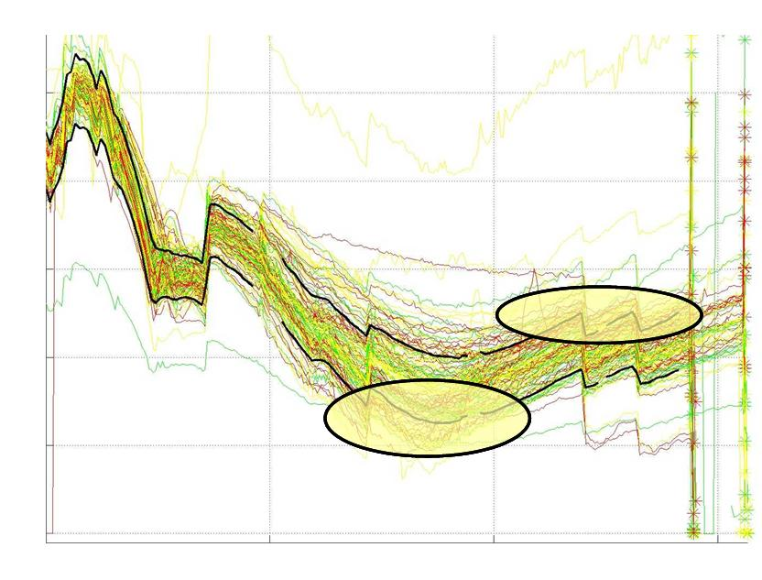
Figure 2: pO2 variation before introduction of control concept

These hypotheses have then, as far as possible, been verified in plant trials and in parallel or in sequence improvements in the production process have then been proposed. Of those, most could be implemented within the current license. Some of these have been of relative simple technical or organisational complexity, but some of them included the usage of advanced control and simulation technologies. The first project included the implementation of an advancd control concept for the dissolved oxygen in the fermentor (Figure 2 shows the variation in this process variable during the previous uncontrolled operation), the second the optimisation of online analyzers to improve the control of the fractionating points during chromatographic separatin (see figure 3, the variation in fractionation time) and the third the use of a dynamic process model and dynamic optimisation to improve the feeding profile during fed batch operation and another one the implementation of statistical process control to monitor the resin quality of several crucial chromatographic columns. The project delivered two mayor beneits: The primary goal was the yield improvement by reducing variation within the process leading to payback times of less than a year, and the second was the, in particular for an established process, significant insight gained during the project.
Figure 3: Concentration profile during chromatographic separation
  - Summary and Conclusions
After introdroducing the SixSigma concept, this contribution motivates how the identification and priorisation of problems leads to the application of CAPE tools in areas where otherwise the hurdle for their application would have been to high. This is being illustrated using an industrial example from a biotechnological production of an API, where the original project scope to stabilise product yield and impurities led to applying advanced control, dynamic simulation and dynamic optimisation in addition to the “low hanging fruits” being related to, e.g., improvements of manual process steps.
To further enforce the implementation of classical CAPE technologies to flexible multipurpose plants, research effert is required to facilitate its use also in case of the unfavourable cost-benefit relationship.

References
A. Bamberg, G. Dünnebier, C. Jaeckle, S. Krämer, J. Lamers, U. Piechottka, 2007, “Six Sigma in der Prozessindustrie”, atp Automatisierungstechnische Praxis, 49(1), p. 42-50
K.U. Klatt, 2007, Presentation on GVC Fachausschuss “Prozess und Anlagentechnik”
NAMUR, 2007, “Six Sigma in Process Industries”, NA119, www.namur.de
M. Warncke, 2007, Dynamic Control Charts for Monitoring Fermentation Processes, BPI Analytical and Quality Summit, San Diego, CA

