A heteronuclear group contribution method for associating chain molecules (SAFT-γ)
Alexandros Lymperiadis, Claire S. Adjiman, Amparo Galindo, George Jacksonª
Centre for Process Systems Engineering, Department of Chemical Engineering, Imperial College London, South Kensington Campus,, London SW7 2AZ, U.K.
Abstract
The SAFT-γ group contribution approach recently proposed by Lymperiadis et al. [JCP, 2007, DOI:10.1063/1.2813894] is extended to model the phase equilibrium of ketones, carboxylic acids and primary amines. The parameters of these new groups have been estimated by regression to pure component vapour-liquid equilibrium data. It is demonstrated that the proposed theory provides an excellent description of the vapour-liquid equilibria for the new chemical families considered, and that the new group parameters can be used in a predictive fashion to obtain the phase behaviour of selected binary mixtures accurately.
Keywords: SAFT, group contribution, heteronuclear segments, equation of state
  - Introduction
A knowledge of the physical properties and phase equilibria of fluid mixtures is essential in the design and optimisation of processes. Most industrial applications involve one or more separation processes (distillation, absorption, crystallization, etc.) where thermodynamic properties are required at early stages of the process design. The experimental data needed to develop thermodynamic models are, however, often scarce for complex and large molecules, and experimental measurements can be extremely costly and time consuming. Predictive thermodynamic models therefore have an important role to play in process design. In addition, in computer aided molecular design (CAMD), where optimal molecules are designed targeting desired sets of properties, the ability to predict physical properties of candidate molecular structures is crucial.
Group Contribution (GC) methods are the most widely used predictive tools in both process and molecular design. The numerous GC thermodynamic models that appear in the literature are based on a wide range of fundamentally different theories (the reader is directed to our recent paper (Lymperiadis et al., 2007) for a more recent review). The UNIFAC group-contribution activity coefficient model of Fredenslund et al. (1975) is probably the most widespread. The GC concept has also been applied within the framework of equations of state (EoS), and has lead to predictive thermodynamic theories such as the PSRK (Holderbaum and Gmehling, 1991), the GC-EoS (Skjøld-Jorgensen, 1988) and the GC-SAFT approach (Tamouza et al., 2004). Other predictive techniques which have received attention include the NRTL-SAC activity coefficient model (Chen and Song, 2004) and the COSMO-RS quantum mechanical technique of Klamt (1995). In a similar spirit, we have recently proposed the SAFT-γ GC method (Lymperiadis et al., 2007). In this paper, we extend its applicability by adding several new groups to the existing parameter table, and demonstrate its predictive capability for highly non-ideal mixtures.
  - Theoretical background
The SAFT-γ GC approch is based on the popular SAFT-VR equation of state (Gil-Villegas et al., 1997). The SAFT-VR EoS is seen to describe accurately the fluid phase behaviour of a wide range of systems, from small strongly-associating molecules, to long-chain molecules and charged systems.
Within the SAFT-γ modelling framework molecules are represented as collections of fused heteronuclear square-well groups (e.g., see the models of propane and 1-propanol depicted in Figure 1). A fused group k is characterised by a hard-core diameter σ_{kk}, a square-well depth ε_{kk} and range λ_{kk}, a key new shape factor parameter S_{k} (which denotes the extent to which each group contributes to the overall molecular properties) and, if appropriate, one or more site types, the number of sites of each type, and the relevant well depth (ε^{HB}_{κκab}) and range (r^{c}_{κκab}) of the associating site-site interaction. The cross parameters (σ_{kl}, ε_{kl}, λ_{kl}, ε^{HB}_{κlab} and r^{c}_{κlab}) for the interactions with other groups l also need to be defined. The cross hard-core diameter σ_{kl} and square-well range λ_{kl} are obtained by simple arithmetic relations while the cross dispersive energy parameter ε_{kl} is fitted to experimental data.
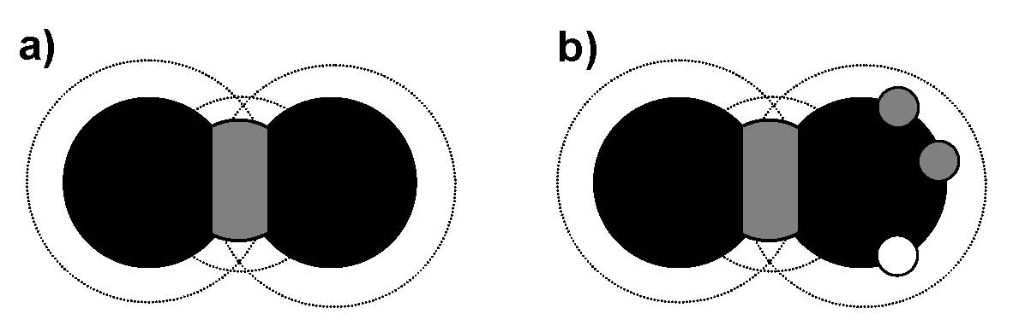
Figure 1: Schematic of the SAFT-γ molecular model for (a) propane and (b) 1-propanol.
As with other SAFT descriptions of the thermodynamic properties, in the SAFT-γ approach the Helmholtz free energy of a mixture of fused heteronuclear model molecules is written as the sum of ideal, monomer, chain and associative contributions, so that
$\frac{A}{{\text{Nk}}_{B}T}=\frac{A^{\text{IDEAL}}}{{\text{Nk}}_{B}T}+\frac{A^{\text{MONO}}}{{\text{Nk}}_{B}T}+\frac{A^{\text{CHAIN}}}{{\text{Nk}}_{B}T}+\frac{A^{\text{ASSOC}}}{{\text{Nk}}_{B}T}$ , (1)
where A^{IDEAL} is the ideal free energy, A^{MONO} corresponds to the residual free energy due segment-segment interactions (note that a group may have more than one segment), A^{CHAIN} takes into account the formation of chains of heteronuclear groups, and A^{ASSOC} corresponds to the residual free energy due to site-site interactions on associating groups. N is the total number of molecules, k_{B} Boltzmann’s constant, and T the absolute temperature. For a detailed description of each of the contributions the reader is directed to the work by Lymperiadis et al. (2007).
  - Estimation of group parameters
The group parameters are estimated from pure component vapour pressure P_{s} and saturated liquid density ρ_{l} experimental data making use of a least-squares objective function. In the parameter estimation procedure, the CH₃ and CH₂ parameters are initially regressed to optimise the description of the n-alkane phase behaviour. These optimal values of the n-alkane group parameters are then transferred to another chemical family so that the parameters of each new group are estimated in a sequential manner. Following this methodology we have obtained (Lymperiadis et al., 2007) the parameters of the CH₃CH group from data for branched alkanes, those for the ACH and ACCH₂ groups from data for n-alkylbenzenes, those for the CH₂= and CH= groups from data for mono- and di-unsaturated hydrocarbons, and those for the OH group from n-alkan-1-ol data. In this work we present the parameters of three additional groups: the parameters for the C=O group, obtained from data for 2-ketones, those for the COOH group, from data for carboxylic acids, and those for the NH₂ group from data for primary amines. The parameters for the new groups investigated are shown in tables 1 and 2.

Table 1. Individual group parameters for the SAFT-γ equation of state. The groups denoted with an asterisk are modelled by more than one identical segment; the C=O group is modelled as two spherical segments, and the COOH group is modelled as three segments one of which has one site of type a. The NH₂ group has two two sites of type a and one of type b.
Group | σ_{κκ}/Å | λ_{κκ} | (ε_{κκ}/k_{B})/K | S_{κ} | (ε^{HB}_{κκab}/k_{B})/K | r^{c}_{κκab}/ Å
CH3 | 3.810 | 1.413 | 252.601 | 0.667 | - | -
CH2 | 4.027 | 1.661 | 240.482 | 0.333
C=O* | 2.787 | 1.782 | 386.833 | 0.482 | - | -
COOH* | 2.806 | 1.538 | 269.285 | 0.644 | 3594.295 | 2.244
NH₂ | 3.908 | 1.527 | 398.872 | 0.472 | 953.630 | 2.637

Table 2. Cross group energy parameters (ε_{κl}/k_{B})/K for the SAFT-γ equation of state.
Groups | C=O* | COOH* | NH₂
CH₃ | 294.070 | 257.515 | 283.840
CH₂ | 207.512 | 283.497 | 308.722
C=O* | 386.833 | - | -
COOH* | - | 269.285 | -
NH₂ | - | - | 398.872

The overall %AADs for all the classes of compounds examined in this and previous (Lymperiadis et al., 2007) are summarised in table 3. The SAFT-γ approach provides an accurate description of the experimental data for the various chemical families over wide ranges of temperatures: the overall %AAD for all compounds is 3.34% for the vapour pressure and 0.92% for the saturated liquid density. The representation of the saturated liquid density is particularly good. The best description of the experimental data is obtained for two of the associating classes of compounds studied: the primary amines, and the 1-alkanols. This is probably due to the dominant effect of hydrogen bonding on the phase equilibria of these substances. The excellent description of the vapour-pressure and coexistence densities for the 2-ketones, carboxylic acids and primary amines is evident from figures 2 and 3.

Table 3. Overall average absolute deviations (%AAD) of vapour pressures P_{s} and saturated liquid densities ρ_{l} within the SAFT-γ framework compared to experiment for all the chemical families included in the database.
Chemical family | No Fitted Compounds | % AAD P_{s} | % AAD ρ_{l}
n-alkanes | 9 | 3.98 | 0.57
branched alkanes | 10 | 2.92 | 0.39
n-alkylbenzenes | 9 | 4.12 | 1.49
alkenes | 19 | 4.78 | 0.74
2-ketones | 8 | 3.47 | 1.14
carboxylic acids | 8 | 3.60 | 1.42
primary amines | 9 | 1.64 | 0.53
1-alkanols | 9 | 2.19 | 1.09
Average % AAD | - | 3.34 | 0.92
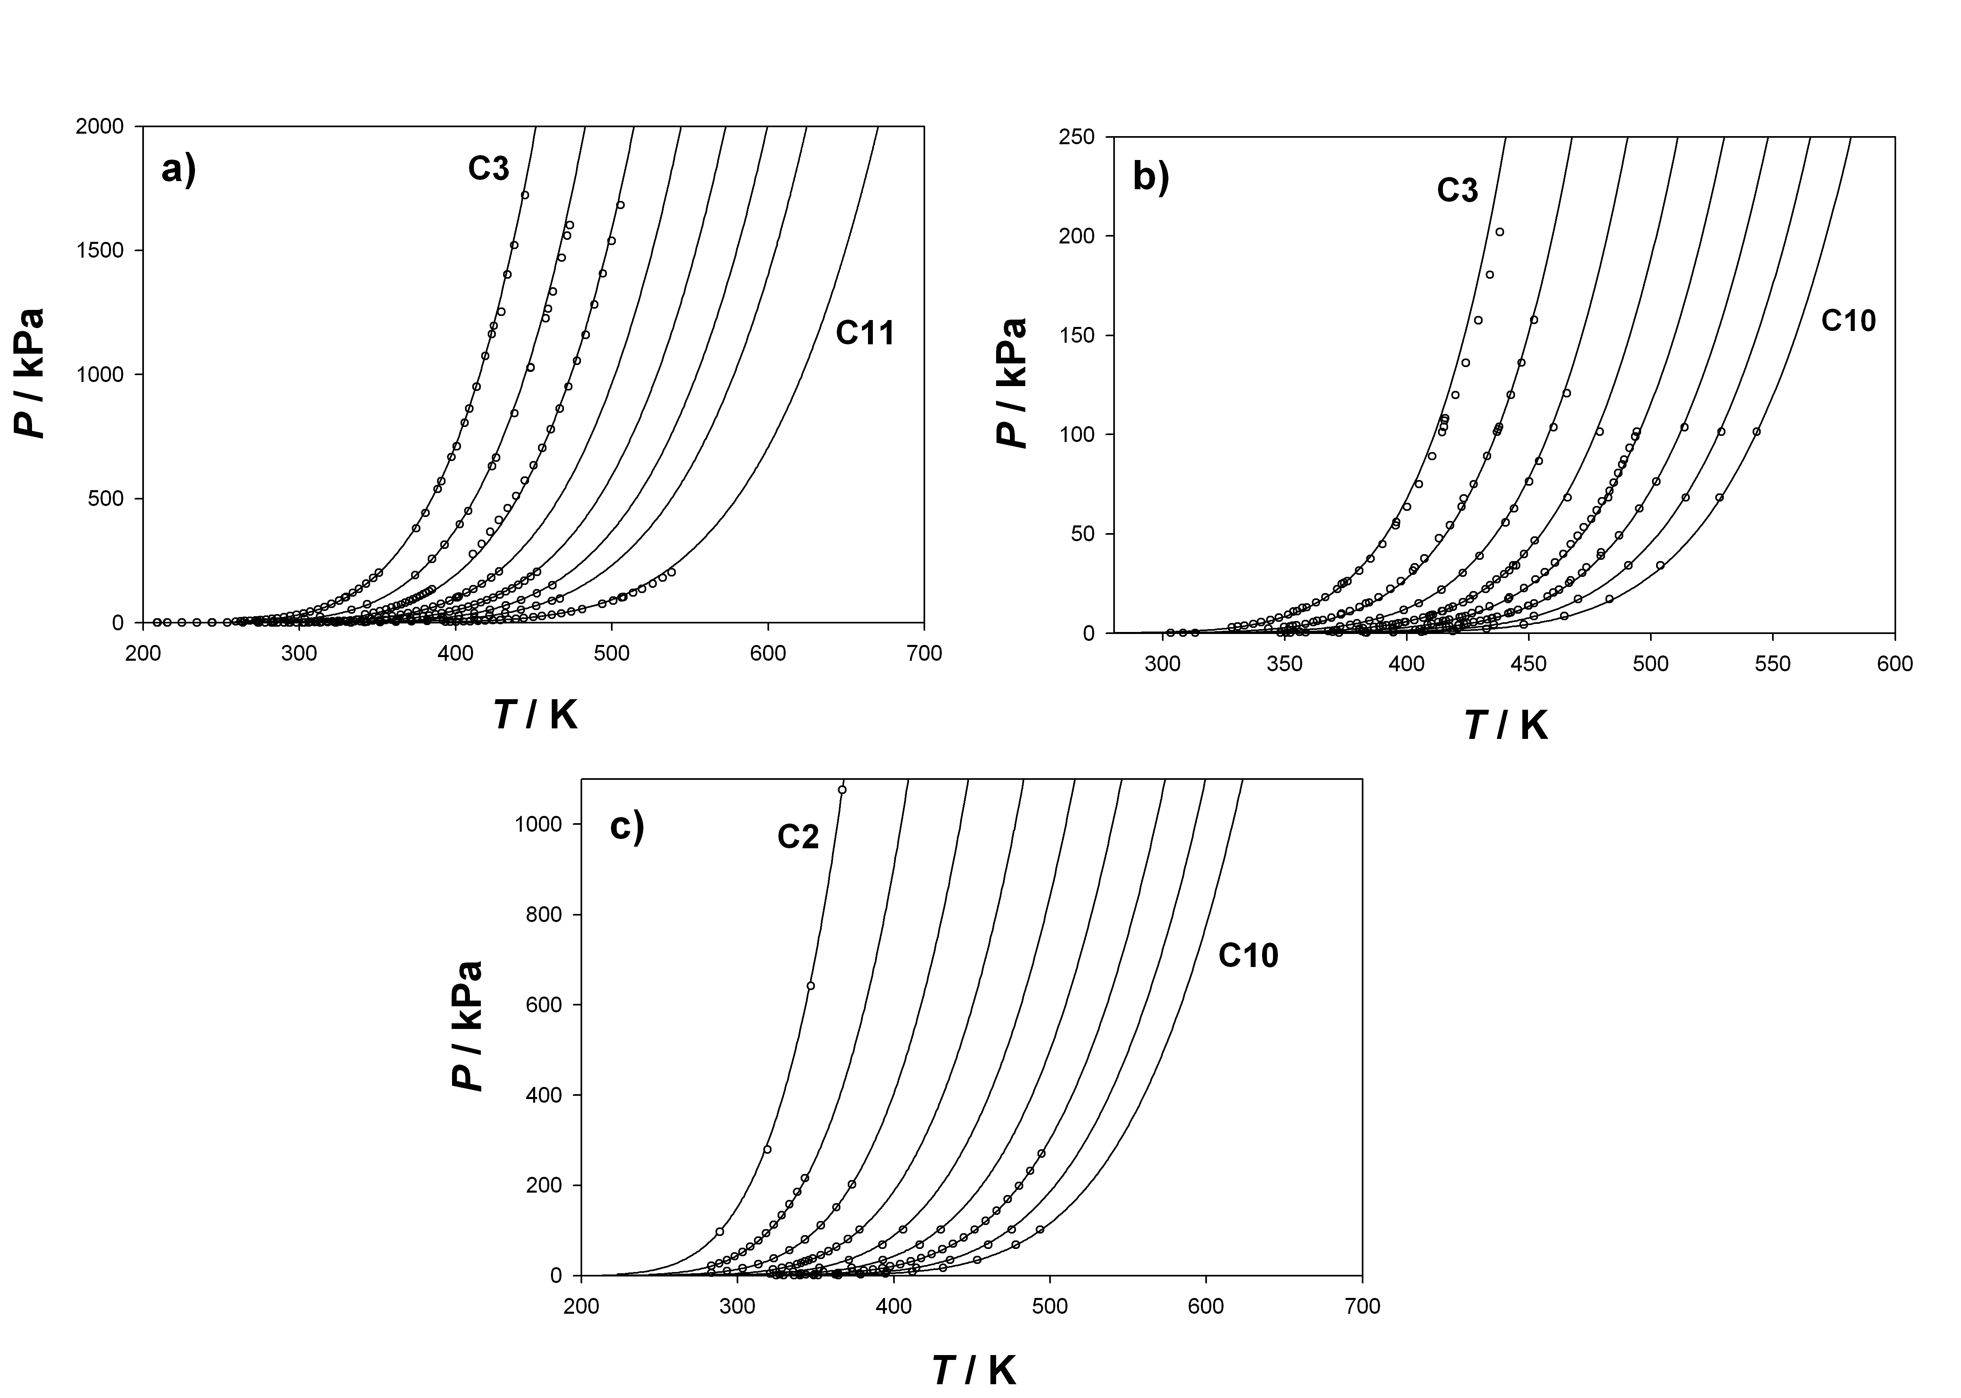
Figure 2: Vapour pressures curves for: a) 2-ketones (propan-2-one to undecan-2-one except decan-2-one), b) carboxylic acids (propanoic acid to decanoic acid), c) primary amines (ethylamine to decan-1-amine). The circles represent the experimental data, and the continous curves the SAFT-γ description.

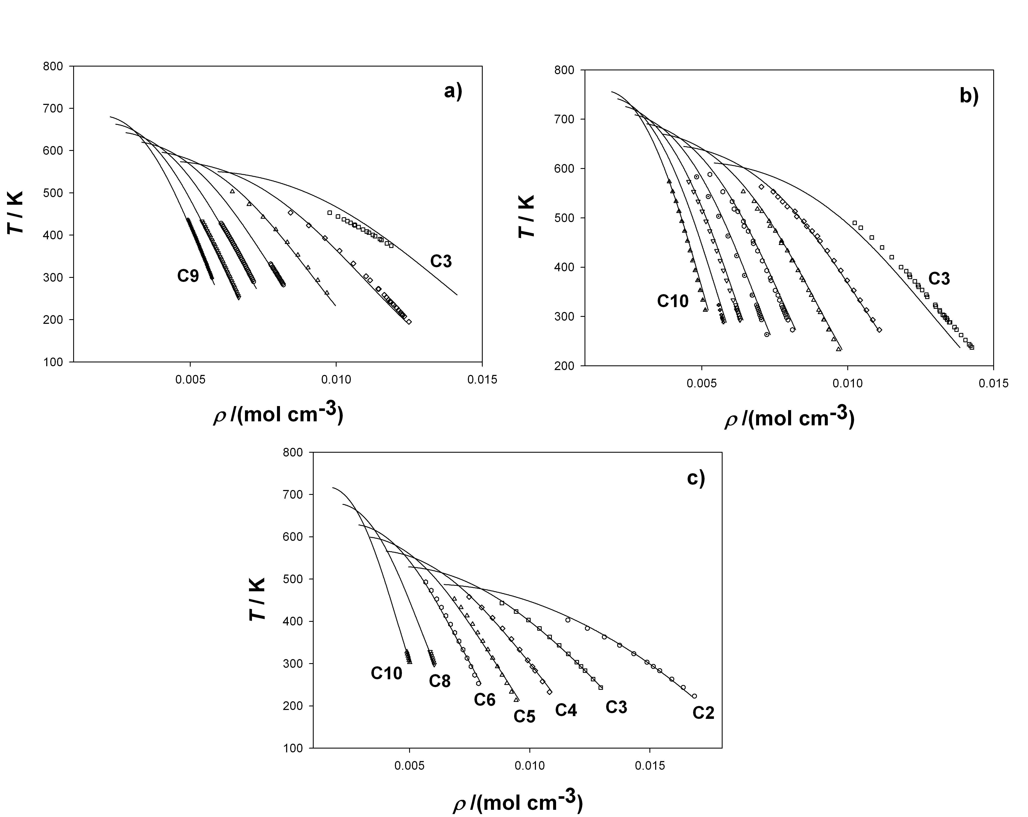
Figure 3: Saturated liquid densities for: a) 2-ketones (propan-2-one to nonan-2-one), b) carboxylic acids (propanoic acid to decanoic acid), c) primary amines (ethylamine to decan-1-amine). The symbols represent experimental data, and the continous curves the SAFT-γ description.
  - Prediction of mixture properties
We examine the predictive capability of the method in describing mixtures of compounds formed from some of the new groups presented by considering the four binary mixtures shown in Figure 4. The advantage of our approach is that the unlike energy parameters between different group types can be estimated from pure component vapour-liquid equilibrium data, without the need for mixture data. Thus, the prediction of the phase equilibria of binary mixtures is a straightforward procedure based on the tabulated parameters. As can be seen in the figure, the SAFT-γ EoS provides an excellent description of the fluid phase behaviour of the mixtures studied.
  - Conclusions
The parameter matrix of the SAFT-γ group contribution EoS is enriched with three new groups: the carbonyl C=O, carboxyl COOH and amino NH₂ groups. It is shown that the approach provides an excellent description of the phase behaviour of the chemical families used to estimate the parameters, and furthermore, that it is capable of predicting accurately the phase behaviour of various classes of binary mixtures comprising the new groups. In future we will be enhancing the applicability range of this promising approach by treating other important groups and we will also investigate the application of the technique for liquid-liquid equilibria (LLE), solid-liquid equilibria (SLE), and solvent design through computer-aided methods.
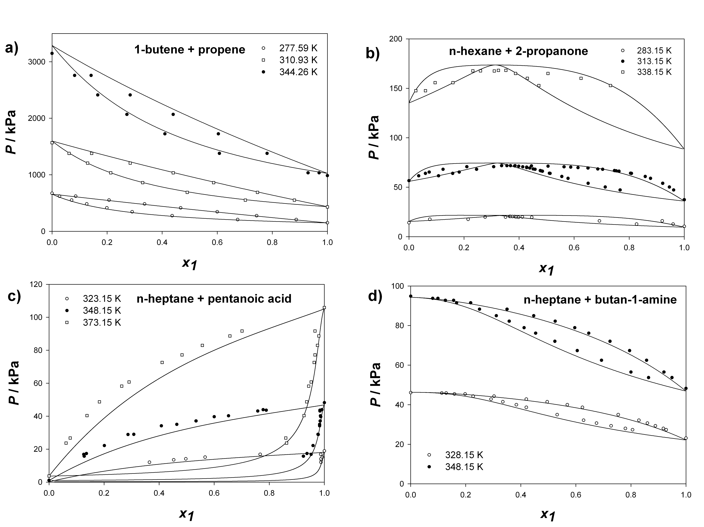
Figure 4: Predicted vapour-liquid equilibria diagrams for selected binary mixtures with SAFT-γ. The symbols represent the experimental data and the continuous curves correspond to the SAFT-γ predictions. The binary mixtures shown are: a) 1-butene + propene where x₁ is the mole fraction of 1-butene, b) n-hexane + propanone where x₁ is the mole fraction of n-hexane, c) n-heptane + pentanoic acid where x₁ is the mole fraction of n-heptane, and d) n-heptane + butan-1-amine where x₁ is the mole fraction of n-heptane.

Acknowledgements
A.L. gratefully thanks Britest and the Engineering and Physical Sciences Research Council (EPSRC) of the UK for the award of a PhD studentship. Additional funding from the EPSRC (GR/N20317, GR/N03358, GR/N35991, GR/R09497, and EP/E016340) is also acknowledged. We would also like to thank P. Crafts from AstraZeneca for useful discussions.

References
A. Lymperiadis, C.S. Adjiman, A. Galindo and G. Jackson, 2007, Journal of Chemical Physics, 127, 234903.
A. Fredenslund, R.L. Jones and J.M. Prausnitz, 1975, AIChE Journal, 21, 1086.
T. Holderbaum and J. Gmehling, 1991, Fluid Phase Equilibria, 70, 251.
S. Skjøld-Jorgensen, 1988, Industrial & Engineering ChemistryResearch, 27, 110.
S. Tamouza, J.P. Passarello, P. Tobaly and J.C. de Hemptinne, 2004, Fluid Phase Equilibria, 222, 67.
C. Chen and Y. Song, 2004, Industrial & Engineering Chemistry Research, 43, 8354.
A. Klamt, 1995, Journal of Physical Chemistry, 99, 2224.
A. Gil-Villegas, A. Galindo, P.J. Whitehead, S.J. Mills, G. Jackson and A.N. Burgess, 1997, Journal of Chemical Physics, 106, 4168.

%AAD is the average percentage error (absolute value) over all data points.

