Operability Analysis and Conception of Microreactor by Integration of Reverse Engineering and Rapid Manufacturing
André L. Jardini,ª Maria Carolina B. Costa,ª Aulus R.R. Bineli,ª Andresa F. Romão,ª Rubens Maciel Filho,ª
ª Department of Chemical Processes, School of Chemical Engineering,
State University of Campinas, 13083-852, Campinas, SP, Brazil
Abstract
The propose of this work is to develop high precision microfabrication facilities using computer aided technologies as Reverse Engineering (RE) and Rapid Manufacturing (RM) process to analyze and design of microreactor. The microreactor is usually a continuous flow reactor in contrast to a batch reactor. The goal of microreactors is the optimization of conventional chemical plants, and also to open the way to research new process technologies and to synthesis of new products. In this work, microreactors fabricated using FDM method (Fused Deposition Modeling), were digitalized, using a 3D scanning, to redesign the object. The widths and thickness of the microchannels produced were analyzed by RE, and alterations and adjusts were performed in redesign strategies for better application. The approaches presented are also fundamental to verify microreactor’s geometry and for modeling/simulation by finite element analysis (FEA), to assure the metrological accuracy of geometry and optimization of process parameters. The integration of RE and RM computer aided technologies to conception and analysis of microreator, has been used to produce several different small scale microchannel devices for chemical processing applications.

Keywords: rapid manufacturing, reverse engineering, microreactors, simulation.
  - Introduction
In this new millennium, much effort has been devoted to developing microdevices for reaction, mixing and separation. The emergence of microreactor generation has been attracting for these application fields. Microreaction technology is sometimes regarded as a key strategy for economic growth, by means of cost and time saving, and for the ecology, by sustainable development and saving of natural resources (Ehrfeld, 2000).
Microreactors are studied in the field of micro process engineering, together with other devices (such as micro heat exchangers, micromixers, microdispersers, and microcombustors) in which physical and chemical processes occur (Watts, 2005).
Microreactors can be used to synthesize material more effectively than current batch techniques or conventional devices. They may involve very efficiently liquid-liquid, gas-liquid and also solid-liquid systems with for example the channel walls coated with a heterogeneous catalyst.
The benefits here are primarily enabled by the mass transfer, thermodynamics, and high surface area to volume ratio environment as well as engineering advantages in handling unstable intermediates (Cordero, 2002; Jahnisch, 2004).

Conventional chemical processing equipment typically holds a relatively large volume of materials and consequently has a relatively large volume to surface area ratio. As a result, different portions of the reactant materials contained within such equipment are exposed to different histories of conditions. In the case of a conventional tank reactor, for example, even when temperature conditions at the walls of the reactor are well controlled, the portions of the reactants that are not in close proximity to the walls of the reactor may experience different temperature histories, especially if a significant temperature gradient exist, which might occur if the chemical reaction is strongly exothermic. In extreme situations reaction rates may accelerate to uncontrollable levels, which may cause safety hazards, such as potential explosions. If, however, the volume to surface area ratio of the processing apparatus is substantially reduced, the degree of control precision of homogeneity of temperature history of the reactants can be substantially improved.
The small characteristic dimensions of microstructured reactors should improve process safety by enhancing heat transfer. Indeed, for exothermic reactions, small dimensions facilitate transfer of heat generated by reaction from the process fluid to the reactor walls. This accelerated heat transfer can prevent hot spot formation and subsequent thermal runway. The combustion of hydrogen, for example, has been operated safety and controlled in the explosive regime in microchannels with diameters of several hundred micrometers, due to enhanced heat transfer (Commenge, 2005).
In this paper, a system of Rapid Prototyping, denominated FDM (Fused Deposition Modeling), is used for microreactor fabrication in ABS (Acrylonitrile Butadiene Styrene) material. FDM system allows building physical objects directly by model in CAD system (Computer aided design) providing very precise control of dimension and design. The flow chart of the rapid design, analysis and optimization of microreactor with microfluidics channels is initially performed in CAD software and constructed in rapid prototyping system is reported in Figure 1. The fluidic properties of microreactors (fluid dynamics, mixing behavior) can be analyze using both experimental measurements and simulations (computational fluid dynamics, CFD). CFD calculations are also used in the design and specification of new microreactor developments. The potential advantages of using a microreactor, rather than a conventional reactor, include better control of reaction conditions, improved safety, and portability.

Figure 1. Flow chart of the rapid design and manufacture of microreactor.
  - Design of Microreactor: CAD Modeling
RM uses Rapid Prototyping (RP) technology to directly produce useable parts from CAD system, and Reverse Engineering (RE) to digitalize the fabricated part aiming optimization and verification of design. The aim of RE is to reproduce a physical object to digital exactly like it is or at least it, as comparison original model. Computer aided systems is the technology concerned with the use of computer systems to assist in the creation and modification of a design. CAD software provides a special kind of file back to the RP system. The generated information for this system can later be exported according to the following formats (IGES, STL, VDA, STEP etc) and imported in the same way by CAE, where the numerical model simulations can be done based on the analyses by finite elements (FEA). The integration these computer aided technologies can be of significance in a process line for fabrication of microreactors applying to control and optimization of chemical processes. In this paper, a FDM system is used for microreactor fabrication in ABS (Acrylonitrile Butadiene Styrene) material. FDM system allows building physical objects directly by model in CAD system (Computer aided design) providing very precise control of dimension and design. Figure 2 shows a cross section of microreactor with microchannels created in SOLIDWORKS software.

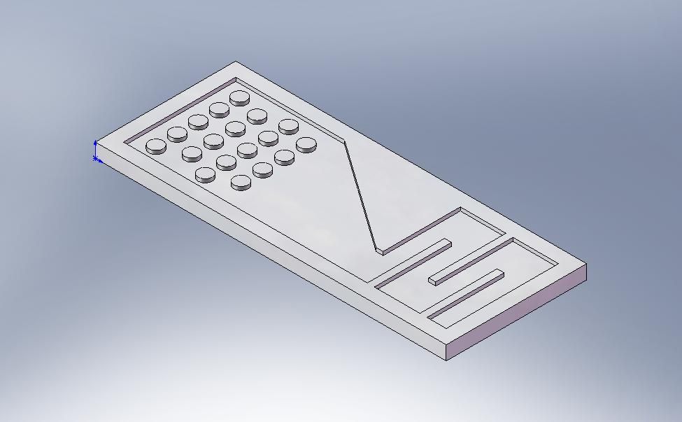
Figure 2. Detailed view of a microreactor created in SOLIDWORKS software.
  - Fabrication of Microreactor
Fabrication of the microreactor by FDM starts with the generation of three-dimensional CAD models (Figure 2) of the microdevice components to be produced. In the FDM process the material filament is transported into the heated chamber by two drive wheels which effects the discharge of the molten material (Figure 3). The data are then converted into the standard FDM file format “STL” and the 3D model is subjected to triangulation, i.e. it is approximated by a structure consisting of triangles. By varying the number of these triangles, the amount of data and the resolution of the FDM component are influenced. These data are used to control FDM head that deposits a ABS filament on a construction platform layer by layer (Fig. 3).

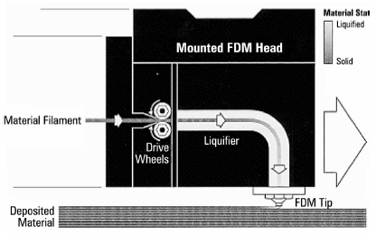
Figure 3. Working principle of the FDM process (Stratasys, 1995).
  - Reverse Engineering
Recent fields of technology innovation related to computer based manufacturing, such as the use of 3D digitizing, are being explored to be integrated in the chain process of industries, for applications as: Reverse Engineering; Quality Control; Differential Inspection; Direct Replication; Detection of Inaccuracies; Redesign of Parts; Manufacturing Tools. The 3D digitizing (Ferreira, 2007) and reconstruction of 3D shapes by RE has numerous applications in areas that include manufacturing, virtual simulation, science, and consumer marketing. This is an actual research and development field that is related to the problem of processing images acquired from accurate optical triangulation (Dorsch, 1994), and is presented as a RE methodology for surface reconstructing from sets of data known as range images.

    - 3D Scanner Digitizer Principle and Application
To perform the RE recurring to a 3D scanning technique an Orcus 3D Scanner (Spatium, 2007) is used that allows the digitizing of objects by taking coordinates on the surfaces at selected points. This device scan without contact using a structured light projection to acquire the surface of the object to be digitized, and CCD cameras capture profile images that by triangulation algorithms generate digital data (Figure 4). Projecting patterns over the object enables triangulation and the collecting of surface data (XYZ) of over One million points per acquisition.

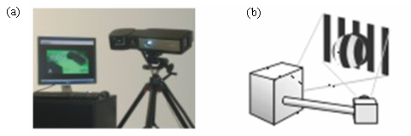
Figure 4. (a) 3D Scanner machine (“Orcus”), (b) 3D Scanner digitiser principle.
The Orcus system, which is a flexible scanning machine, was used to scanning tests for evaluate the accuracy of RM-FDM patterns, and its specification is:

Working area | 2000 x 2000 mm
Resolution | 0.010 mm
Scanning rate | 400.000 points per second

The interface between the 3D Scanner and a digital model was done through Spatium FORM software. For optimum digitalization, three acquisition of microreactor constructed in FDM system, was performed. The software calculates each detected coordinate point and translated that into a 3D virtual space generating a network array of points (points cloud), as shown in Figure 5.


Figure 5. Surface from the digitalized points in Spatium FORM software.
After 3D digitized in Spatium FORM, the next step is to reconstruct the CAD model of the microreactor from the point cloud. The imported point cloud first must be processed in reverse engineering software (Geomagic Studio) to reduce the file size. The points are then wrapped as polygonal surfaces. Certain defects such as holes in the surface must be removed to obtain close manifolds (Figure 6).

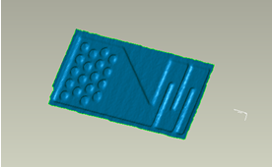
Figure 6. Reconstruction process of the defect microreactor.

A new CAD model is rebuilt from the several points digitized on the RM-FDM surface. This was a RE reconstitution of actual RM-FDM surface that present some diverse coordinates when compared with the original CAD model. The resulting dimensional geometry when compared with the original 3D CAD dimensions allows to control of the metrological accuracy and re-design of the microreactor, as shown in Figure 7.

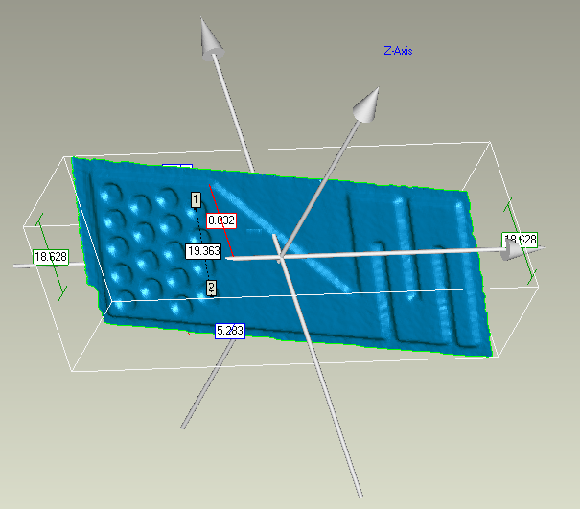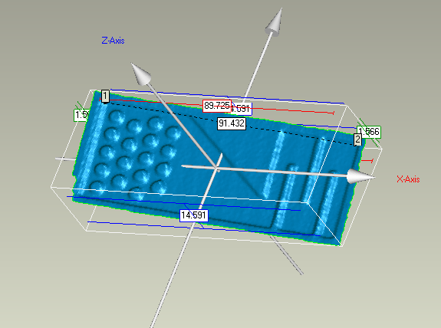
Figure 7. Inspection from RE compared with original CAD.

The CAD data for the microreactor with correspondent resection template is translated into STL file format and imported into the Rapid Prototyping machine (FDM) to fabricate the new microreactor. The STL format is a standard export/import data file for CAD software’s and analyze and simulation software (ANSYS, FEMLAB). This allows transferring design data via the intermediate step of STL from a CAD to another CAD system graphics program.
Finally, the FDM microreactor is directly used in injection molding for the rapid manufacturing for production of the ceramic microcomponents. Ceramic microcomponents are of particular interest for applications in microtechnologies when their good mechanical and tribological properties, their thermal and chemical resistance or special physical, i.e. dielectric or piezoelectric properties, qualify them for uses that can not be covered by polymers or metals.
  - Conclusion
The Reverse Engineering methodology starting from 3D digitizing of physical parts allows to rebuild promptly physical models and to manufacture faster Rapid Prototypes. The Reverse Engineering via 3D digitizing it is a potential methodology to make Virtual Prototyping (VP) models for computer simulation. The computer simulation analysis grant optimized shapes to manufacture improved Rapid Manufacturing. The RE methodology aided by 3D digitizing make available a faster shape metrology control of prototype for foundry by calculating the deviation between 3D digitizing data and 3D CAD model, before manufacturing processes.

  - Acknowledgements
The authors wish to acknowledge the financial support provide by FAPESP (The Scientific Research Foundation for the State of São Paulo).
References
W. Ehrfeld, V. Hessel, H. Lowe, 2000, Microreactors: New Technology for Modern Chemistry, Wiley-VCH, 15.
P. Watts, C. Wiles, 2007, Recent advances in synthetic micro reaction technology, Chem. Communication, 443–467.
J.M. Commeng, L. Falk, J.P. Corriou, M. Matlosz, 2005, Analysis of Microstructured Reactor Characteristics for Process Miniaturization and Intensification, Chem. Eng. Technol., 28, 4.
N. Cordero, 2002, Thermal Modelling of Ohmic Heating Microreactors, Proc. Therminic 2002, Madrid, 173-176.
K. Jahnisch, V. Hessel, H. Löwe, M. Baerns, 2004, Angew. Chem. Int. Ed. 43, 406.
H. Löwe, V. Hessel, and A. Mueller, 2002, Microreactors. Prospects already achieved and possible misuse, Pure Appl. Chem., 74, 12, 2271–2276.
R. Ferreira, I. Leal, N. Alves,, P. Bartolo, 2007, Agile CAD for reverse engineering, Virtual and Rapid Manufacturing, 3, 257-261.
R. Dorsch, G. Hausler, J. Herrmann, 1994, Laser Triangulation: fundamental uncertainty in distance measurement, Appl. Opt. 33, 7, 1306–1314.
Stratasys, 1995, ``FDM1600 User Manual''.

