A Study on Water Transport Phenomena in a Polymer Electrolyte Membrane Fuel Cell with a 2D Steady-state Model
Hyunseok Chung,ª Taejung Ha, ª Sungwoo Cho,ª Chonghun Han ª
ªSchool of Chemical and Biological Engineering, Seoul National University, San 56-1, Shillim-dong, Kwanak-gu, Seoul, 151-742, Korea
Abstract
A two-dimensional, steady state model has been developed to simulate polymer electrolyte membrane (PEM) fuel cells. The model accounts for gas species transport, electrochemical kinetics, charge distribution, and hydrodynamics. The governing differential equations consist of a free-path flow channel, gas-diffusion layer, and catalyst layers for the anode and cathode sides as well as the polymer electrolyte membrane region. A set of governing equations is solved by a finite volume-based fluid dynamics computational algorithm. The correspondence of the simulation polarization curve with the experimental polarization curve is good. The amount of water at the channel outlet is an important aspect of a system that uses fuel cells in vehicles and that cannot be easily supplied with water. Prediction of the amount of water is very important for fuel cell vehicles. From an industrial point of view, the effects of cell geometry, membrane properties, and the humidity of the inlet gas flow are quantitatively analyzed to increase fuel cell efficiency and water management in the fuel cell system.

Keywords: Proton exchange membrane fuel cell, steady-state model, simulation, water transport.
  - Introduction
Proton exchange membrane fuel cells (PEMFCs) are candidates for environmentally friendly power generation applications because they have high energy density and are energy efficient. Most research focuses on single cells and stacks such as membranes, catalysts, and gas-diffusion layers (GDLs). Increasingly, attention has been focused on the design of a PEMFC system. (T. E. Springer et al, 1991, D. M. Bernardi et al., 1991, N. P. Siegel et al, 2003) Detailed analysis of the system is more complex than in single cells or stacks. This is because the rigorous model of the single cell or stack is a complicated solution to the fuel cell system problem. This paper presents a 2D steady-state mathematical model and a simple system model that can be used for the analysis of water content at the channel outlet.
Water content has an important role in PEMFCs. Occasionally, the water content of the outlet gas purge due to temperature difference is omitted at low electrical load levels, but the water content at the channel outlet is important for decreasing the volume of the water tank for the hydrogen recirculation system in a fuel cell vehicle (R. Johnson et al, 2001). This paper proposes a hybrid model based on a cell model and system model to calculate the water content in outlet gas flow.

  - Experiment and model development.
    - Experiment
In order to validate the model, the experiment consisted of PRIMEA® and a parallel serpentine flow field. A constant flow rate was fixed to max current density. During the experiment, the cell temperature was maintained at 65℃, and the humidification condition of inlet gases at the anode and cathode were 100% relative humidity (RH).

    - Model descriptions
In order to develop a recirculation process for the PEMFC system, an adequate balance system model was required. For this reason, a simple system model was developed.(D. M. Himmelblau, 1996, R. B. et al., 1960) The system scheme follows.

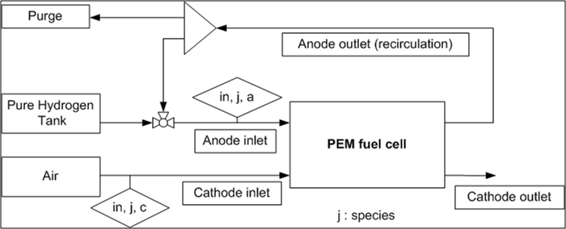

Fig.1. Schematic diagram of the PEMFC system.

The system model follows.
$i=\frac{j×A_{\text{cell}}}{i_{\text{conv}}}$ (Eqn. 1.)
$v_{\text{in},H_{2},a}=\frac{R×T_{\text{air}}}{P_{\text{atm}}}\left(\frac{i}{n(H_{2})F}\right){\text{Stoic}}_{a}$ (Eqn. 2.)
$v_{\text{in},\text{air},c}=\frac{R×T_{\text{air}}}{P_{\text{atm}}}\left(\frac{i}{n(O_{2})F}\right)×{\text{Stoic}}_{c}×{\text{Stoic}}_{\text{air},O_{2}}$ (Eqn. 3.)
${\overset{˙}{m}}_{\text{in},\text{vapor},a}=\frac{P_{\text{atm}}×M_{w}(H_{2}O)×v_{\text{in},\text{vapor},a}}{R×(T_{\text{in},a}+\text{273}\text{.}\text{15})}$ (Eqn. 4.)
${\overset{˙}{m}}_{\text{in},\text{vapor},c}=\frac{P_{\text{atm}}×M_{w}(H_{2}O)×v_{\text{in},\text{vapor},c}}{R×(T_{\text{in},c}+\text{273}\text{.}\text{15})}$ (Eqn. 5.)
$v_{\text{vapor},\text{cell}}=\frac{R×\text{Tcell}}{\left(P_{\text{atm}}+\frac{P_{\text{vapor},c}}{P_{\text{kPa}}}\right)}×\left(\frac{i}{n(H_{2})F}\right)$ (Eqn. 6.)
where Stoica and Stoicc are constants depending on experimental conditions.
The basic assumptions of the 2D steady-state cell model are (i) perfect gases; (ii) laminar flow and incompressible fluids; (iii) contact electrical losses are neglected; (iv) isothermal state. The cell model follows the general governing equations for transport phenomena in PEMFCs:
Mass conservation
(Eqn. 7.)
Momentum conservation
(Eqn. 8.)
(Eqn. 9.)
Species conservation
(Eqn. 10.)
Charge conservation
(Eqn. 11.)
A more detailed description of the cell model can be found in (B. Sunden et al., 2005, P. T. Nguyen et al., 2004). The parameters follow.

Table.1. The parameters used in the PEMFC model

Parameter | Symbol | Value | Unit
viscosity | μ | 1.0e-4 | g/㎝·sec
Porosity in GDL | ε_{GDL} | 0.4 | -
Porosity in Catalyst layer | ε_{CTL} | 0.28 | -

    - Method of solution
The system model can find a solution without difficulty using only a spreadsheet program. In contrast, an analytical solution of the cell model is complex and nonlinear. The cell model was numerically solved using Visual C++ code, based on a finite-volume method and the SIMPLE algorithm (S. K. Um et al., 2000, S. V. Patankar, 1980).

  - Results and discussions
    - Model validation
The experimental data for a single cell can be used for model validation. Fig.1 compares the measured data with the polarization curve prediction. The calculated polarization curve shows good agreement with the experimental performance curve.
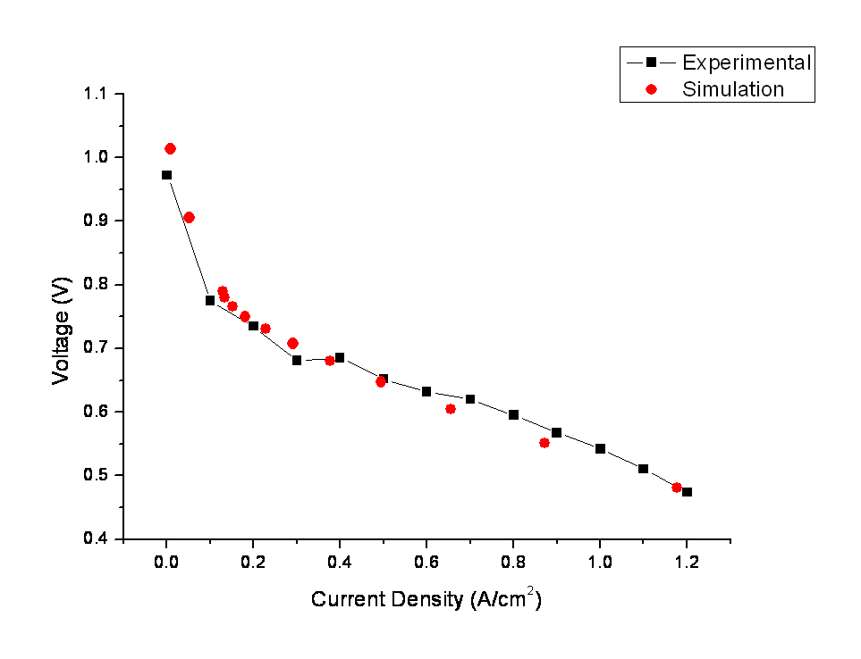
Fig.2. Numerical and experimental performance curves for the test cell.

    - Flow profile in the channel and the GDL
Oxygen mole fraction distribution and hydrogen mole fraction distribution are presented in Fig.3. The results show that oxygen distribution is suddenly decreased through the channel due to high water vapor fraction in the outlet region. Hydrogen distribution is linearly decreased through the channel with no effect from water vapor fraction.
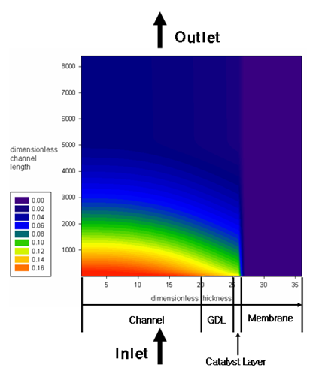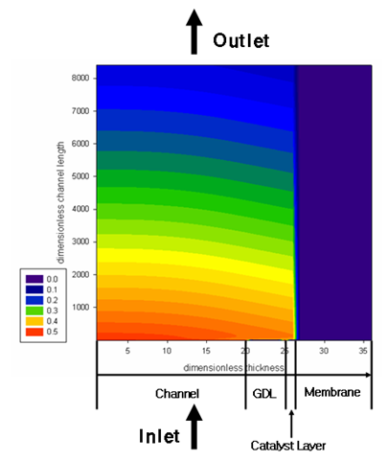
- (b)
Figure.3. (a) Oxygen mole fraction distribution and (b) hydrogen mole fraction in the cathode side for Vcell = 0.605V and Iavg = 0.655 A/㎝2.

    - Water profile in all domains
Fig.4. shows the vapor fraction distribution on the anode side along the gas channel and the GDL for various current densities. The result shows that vapor is well dispersed along the gas channel at a high current density; however, distribution of vapor is not uniform at a low current density due to the absence of the water generation reaction.
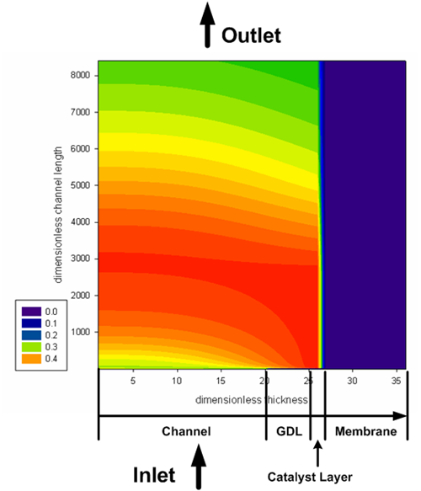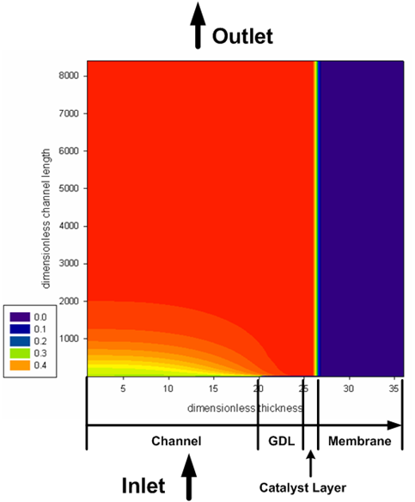
- (b)
Figure.4. Vapor mole fraction distribution in the anode side for (a)Vcell = 0.905V
and Iavg = 0.0520 A/㎝2, (b)Vcell = 0.789V and Iavg = 0.130 A/㎝2.

  - Conclusion
The proposed model has been successfully applied to water content prediction. The amount of water in the outlet gas is the key to increasing system efficiency This simple system model can be extended to the full system of a fuel cell vehicle by applying a thermal control unit and humidifier.

Acknowledgement

This work was supported by the New & Renewable Energy R&D program (2005-N-FC12-P-01-3-040-2007) under the Korea Ministry of Commerce, Industry and Energy (MOCIE). Additional funding was received from the Korea Science and Engineering Foundation through the Advanced Environmental Biotechnology Research Center(R11-2003-006) at Pohang University of Science and Technology. Support was also provided by the Brain Korea 21 Project in 2007.

Appendix A. Nomenclature

c_{f} fixed charge concentration
F Faraday constant (96,485 C mol⁻¹)
H water content ratio
i cell operating current density (A cm⁻²)
j exchange current density (A cm⁻³)
m mass flow rate (g min⁻¹)
P pressure (atm)
p partial pressure (kPa)
R molar gas constant (8.314 J mol⁻¹ K⁻¹)
S source term
T temperature (K)
u x-axis velocity (m s⁻¹)
V humid volume per mass (m³ kg⁻¹)
v y-axis velocity (m s⁻¹)
X molar fraction

Greek letters
ε porosity
η electrode overpotential (V)
ν volumetric flow rate (L min⁻¹)
σ_{m} proton conductivity in the membrane (Ω⁻¹ m⁻¹)
Φ potential (V)

Subscripts
0 initial value
a anode
c cathode
i j species i, j
in channel inlet flow
m membrane
out channel outlet flow
w vapor

References
T. E. Springer, T.A. Zawodzinski and S. Gottesfeld, 1991, Polymer Electrolyte Fuel Cell Model, J. Electrochem. Soc., 138, (8), 2334.
S. V. Patankar, 1980, Numerical Heat Transfer and Fluid Flow, Hemisphere Publishing Corporation.
S. K. Um, C.Y. Wang and K. S. Chen, 2000, Computational Fluid Dynamics Modeling of ProtonExchange Membrane Fuel Cells, J. Electrochem. Soc., 147, (12), 4485.
D. M. Himmelblau, 1996, Basic Principles and Calculations in Chemical Engineering, Prentice-Hall International, Inc.
D. M. Bernardi and M.W. Verbrugge, 1991, Mathematical Model of a Gas Diffusion Electrode Bonded to a Polymer Electrolyte, AIChE J., 37, (8), 1151.
R. B. Bird, W. E. Stewart and E.N. Lightfoot, 1960, Transport Phenomena, John Wiley & Sons, Inc.
B. Sunden, M. Faghri, 2005, Tranport phenomena in fuel cells, WIT Press.
R. Johnson, C. Morgan, D. Witmer, T. Johnson, 2001, Performance of a proton exchange membrane fuel cell stack, Int. J. Hydrogen Energy, 26, 879–87.
N. P. Siegel, M.W. Ellis, D.J. Nelson, M.R. von Spakovsky, 2003, Single domain PEMFC model based on agglomerate catalyst geometry, J. Power Sources 115, 81–89.
P. T. Nguyen, T. Berning1, N. Djilali, 2004, Computational model of a PEM fuel cell with serpentine gas flow channels, J. Power Sources, 130, 149–157.

