MODELING OF HONEYCOMB MONOLITHS BY A TWO-DIMENSIONAL AND MULTI-CHANNEL STRATEGY
Johnny Jimenez, Ferney Silva, Iván Ordóñezª, Ramiro Martínezª
ªUniversidad Industrial de Santander, Car27 Calle9, Bucaramanga, Colombia
Abstract
Single-channel model is good enough to represent the adiabatic conditions of exothermic rections in honeycomb monoliths. In this work, a 2D multi-channel model was developed to observe the behaviour of a circular cross-section of a honeycomb monolithic reactor under different scenarios: 1) a single exothermic (catalytic oxidation of methane) or endothermic reaction (dehydrogenation of methyl-cyclohexane), 2) monolith material (ceramic or metallic) 3) different cell densities (cells per square inch, CPSI) and 4) energy exchange (adiabatic or external heating). Molar and heat balance equations were used to study the effect of each scenario on conversion and temperature of the monolith. The results show that the conversion of the exothermic reaction was favoured in ceramic monolith at adiabatic conditions; while the conversion of the endothermic reaction was favoured when metallic monolith and external heating were used. Additionally, the metallic substrates tend to form more homogeneous radial temperature profiles. For the exothermic reaction the influence of monolith material on the conversion was lightly more important than CPSI while for the endothermic reaction this behaviour was opposite.

Keywords: Monolithic reactor; 2D multi-channel modelling; heat and mass transport.
  - Introduction
The use of honeycomb monolithic reactors has been motivated by a precise control of residence time and low pressure drops, contrary to packed-bed catalytic reactors. These monolithic reactors consist of several straight-channels arranged in a parallel way where the internal walls of each channel have a washcoat of catalyst on their surface (Cybulski and Moulijn, 2006). Usually the monoliths are made out of ceramic or metallic materials depending of thermal properties, chemical durability, etc. (Boger, Heibel et al., 2004). The reactants flow through each channel, interacting chemically with the catalyst on the surface of the walls while the products flows out of the end of each channel. The straight-channel monolithic reactor has been widely studied and modelled by several authors who have considered a great variety of situations of mass and energy transfers; however, most of these studies have been limited to one and two dimensional single-channel modelling under adiabatic (Hayes and Kolaczkowski, 1994, 1999) or isothermal (Tomasic et al, 2004) conditions for exothermic reactions. Kolaczkowski and Worth (1995) proposed a multi-channel 2D model where a monolith of square channels was represented by a structure of rings in non-adiabatic conditions. This model revealed dissipation of heat in radial direction that could be useful in design applications; however, this model was neither validated with experimental work nor with conventional simulators.
In this work, the mass and energy transfers in a honeycomb monolithic reactor when either an exothermic or an endothermic reaction takes place, are analyzed by using a 2D multi-channel model that involves the following situations: insulation or external heating, different types of material as well as different cell density (cells per square inch, CPSI).
  - Multi-channel Modelling
    - Geometry of the 2D multi-channel model
We consider a straight monolith reactor of circular cross-section and channels. We assume that the thickness and shape of both wall channels and washcoat cross-sections are uniform along the length of the reactor. Fig. 1 shows a scheme of geometric model for a 72 CPSI monolith based on information reported in the literature (Liu, Zhao et al., 2005; Ávila, 1998).

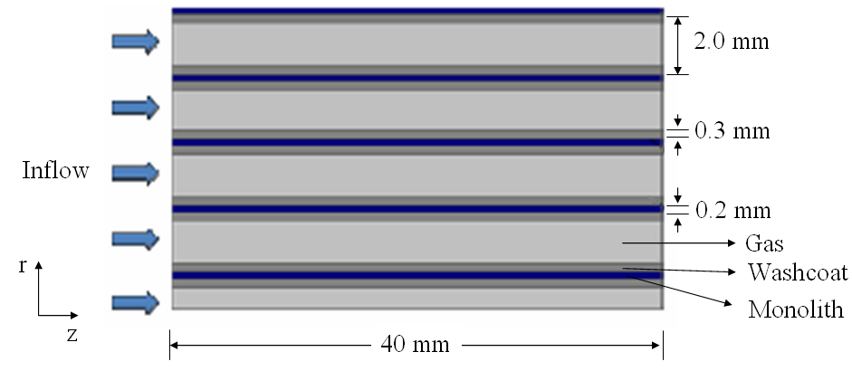
Figure 1. Scheme of the geometric model for a 72-CPSI honeycomb monolith.

    - Reaction kinetics
Depending of information available in the literature, two type of classical kinetic models for heterogeneous catalysis were selected:
1) The exothermic reaction: Oxidation of methane (CH4) on Ni-Al2O3 whose kinetic model is represented by a first order equation (See Eq. (1)) (Zanfir and Gravriilidis, 2003). Several applications and studies on honeycomb monoliths have been reported in the literature for this reaction (Hayes and Kolaczkowski, 1999).
$−r_{{\text{CH}}_{4}}=3x{\text{10}}^{8}\text{exp}\left(−\frac{\text{90000}}{R_{g}T}\right)c_{{\text{CH}}_{4}} \left[\frac{\text{mol}}{m^{3}\text{ s}}\right]$ (1)
2) The endothermic reaction: Catalytic dehydrogenation of methyl-cyclohexane (MCH) on Pt-Al2O3 represented by a Langmuir kinetic model (See Eq. (2)) (Sinfelt et al., 1960). For this reaction there are applications reported only for fixed bed reactors (Jossens and Petersen, 1982).
$−r_{\text{MCH}}=\frac{1\text{.}\text{048}x{\text{10}}^{\text{13}}\text{exp}\left(−\frac{\text{16414}\text{.}5}{T}\right)bR_{g}Tc_{\text{MCH}}}{1+bR_{g}Tc_{\text{CH}}}\left[\frac{\text{mol}}{m^{3}\text{ s}}\right]$ (2)
    - Mathematical model
Table 1 shows a molar and heat balances in steady state applied for the gas phase, catalytic washcoat and monolith walls in each channel. The corresponding boundary conditions are showed in Table 2.

Table 1. Molar and heat balances in each channel of the multi-channel model.
Phase | Molar Balance |  | Heat Balance
Gas (1) | $$\vec{∇}⋅\left(−D_{m,1}\vec{∇}c_{1}+c_{1}\vec{u_{1}}\right)=0$$ | (3) | $$\vec{∇}⋅\left(−k_{1}∇\vec{T_{1}}+{ρC}_{P}T_{1}\vec{u_{1}}\right)=0$$ | (4)
Washcoat (2) | $$\vec{∇}⋅\left(−D_{e,2}\vec{∇}c_{2}\right)=r_{i}$$ | (5) | $$\vec{∇}⋅\left(−k_{2}∇\vec{T_{2}}\right)=ΔH∗r_{i}$$ | (6)
Monolith (3) |  |  | $$\vec{∇}⋅\left(−k_{3}∇\vec{T_{3}}\right)=0$$ | (7)

Table 2. Boundary conditions in each channel of the multi-channel model.
Phase | Molar Balance |  | Heat Balance
Inlet channel | $c_{1,2}=c_{0}$ | (8) | $T_{1,2,3}=T_{0}$ | (9)
Interphase  Gas(1) - Washcoat (2) | $D_{m,1}\vec{∇}c_{1}=r_{i}$ | (10) | $$k_{1}∇\vec{T_{1}}=ΔH∗r_{i}$$ | (11)
Interphase  Monolith(3)–External Boundary |  |  | $T_{3}=T_{W}$ (heating)  $\vec{∇}T_{3}=0$ (adiabatic) | (12)  (13)
Exit channel | $$\vec{∇}c_{1,2}=0$$ | (14) | $$\vec{∇}T_{1,2,3}=0$$ | (15)

where D_{m} is the molecular diffusivity, D_{e} is the effective diffusivity of the catalyst, c is the concentration of limit reactant, u represents the velocity profile, k the thermal conductivity, T the temperature, ρ the molar density, C_{p} molar specific heat, ΔH reaction heat and r_{i} the reaction rate of the substance i (methane (CH₄) or methyl-cyclohexane (MCH)). The initial conditions C₀ and T₀, expressions for D_{e}, D_{m} and the gas properties was taken from the literature (Zanfir and Gravriilidis, 2003; Hayes and Kolaczkowski, 1999). We assumed that the velocity profile is parabolic (maximum velocity = 3.2 m/s) and the external wall temperature T_{W} was set 100 K higher that the inlet temperature T₀ in all cases.

    - Scenarios.
Each reaction shown above was simulated on three different monolith materials (cordierite, stainless steel and copper), two cell densities (72 and 143 CPSI) and two types of energy exchange: adiabatic (0) and external heating (+) conditions (See Table 3). Therefore, twelve scenarios for each type of reaction are obtained. The model of each scenario consisted of a set of partial differential equations coupled to algebraic expressions which were solved by finite elements technique using the software FEMLAB Multiphysics version 2.3.
  - Results and discussion.
Fig. 2 shows the conversion profiles obtained for the exothermic reaction in a monolithic cordierite reactor. The final 72-CPSI reactor conversion is approximately reached at half the axial distance of the 143-CPSI reactor. This denoted that the final conversion of reactant is practically proportional to cell density (CPSI). This occurs because the 143-CPSI reactor has more channels across the same transversal area, which implies proportionally double amount of catalyst per volume that the 72-CPSI reactor. Additionally, this figure shows that the conversion profiles of all channels are equals which demonstrates that the single-channel model is valid when the honeycomb reactor operates at adiabatic conditions for an exothermic reaction.

Table 3. Different scenarios for the multi-channel model of honeycomb monolith.
Type of reaction | Exothermic |  |  |  |  |  | Endothermic
Monolith Material | Cordierite  k₃ = 3 W/m K |  |  |  | Stainless steel  k₃ = 45 W/ m K |  |  |  | Copper  k₃ = 377 W / m K
Cell density | 72 |  | 143 |  | 72 |  | 143 |  | 72 |  | 143
Energy Exchange | 0 | + | 0 | + | 0 | + | 0 | + | 0 | + | 0 | +

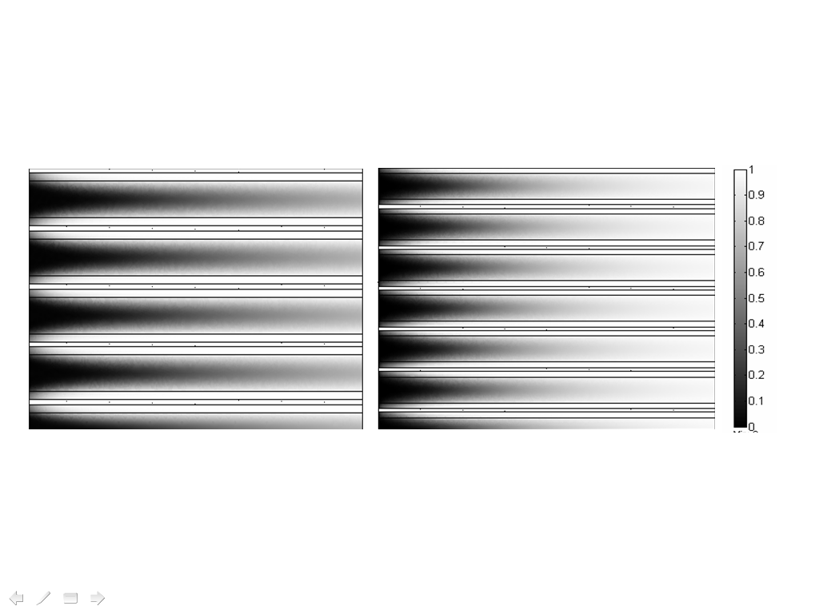
Figure 2. Conversion profiles obtained for an exothermic reaction in a cordierite monolithic reactor at adiabatic conditions.
Fig. 3 shows that the conversion and temperature radial profiles change in the radial direction for the endothermic reaction and these effects are stronger near the most external channel of the monolith. Important temperature differences can be found using different monolith materials and this behaviour influences the reaction rate because the conversion profile has a similar tendency. This demonstrated that this reaction is limited by radial transfer heat in strong way.

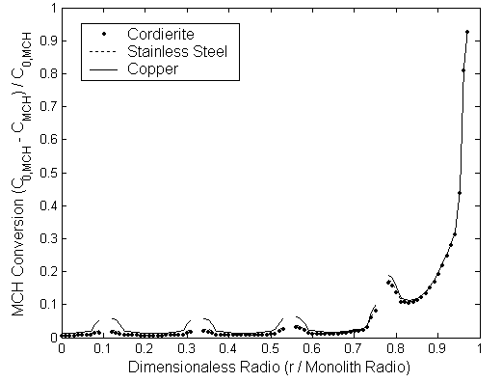 | 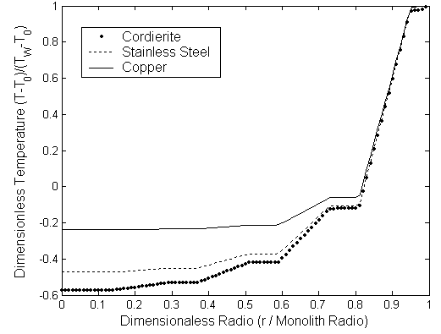
(a) Conversion of Methyl-cyclohexane (MCH) | b) Dimensionless temperature
Figure 3. Radial profile at exit monolith for endothermic reaction on 72 CPSI monolith with external heating.

Fig. 3a shows a better radial behaviour with metallic materials. Fig. 3b shows that material with high conductivity like copper promotes radial temperature profiles more homogenous than the others materials. Therefore, for the endothermic reaction the implementation of metallic materials like copper increase the heat transfer; the energy flows more easily from exterior into the interior of monolith and hence the rate of reaction is favoured. In this case, the MCH conversion at exit was 8.4 % on average, a value higher that in a fixed bed reactor at the same conditions (Sinfelt et al., 1960).
Fig. 4 shows the influence on conversion an temperature profiles of different monolith materials and kind of energy exchange for the exothermic reaction. Clearly a cordierite monolith at adiabatic condition is better to achieve higher conversions of methane. The cordierite (ceramic material) does not promote the heat flow from internal channels to the most external channel of monolith when the exothermic reaction occurs. For this reason, more heat available inside monolith and therefore higher temperatures, reactions rates and reactant conversions can be obtained.

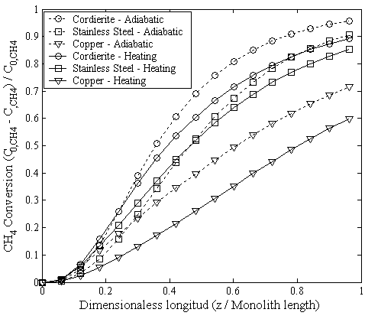 | 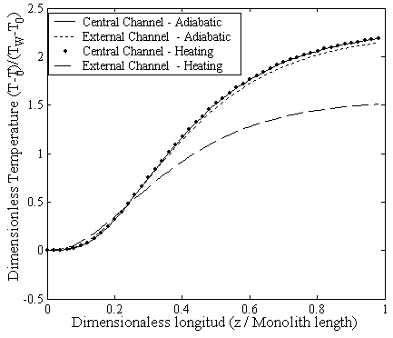
(a) Conversion of methane at different kind of energy exchange | b) Dimensionless temperature of cordierite monolith in different channels.
Figure 4. Axial profiles for the exothermic reaction on 143 CPSI monolith.

Fig. 5 shows a Pareto analysis for the exit conversion. This analysis was developed with the statistic Matlab toolbox to find the relevance of the variables described in Table 3. Fig. 5a shows that for the exothermic reaction the exit conversion is mainly influenced by the monolith material which implies the importance of thermal conductivity. The cell density was also an important variable while the type of energy exchange is insignificant. In spite of the energy exchange is poor significant on exit conversion, for practical proposes, adiabatic conditions will be recommend because will not demand energy cost. Fig. 5b shows an expected tendency of endothermic reactions about of energy exchange since this reaction is highly favoured when a external heating is applied. For endothermic reaction, the cell density was more influencing that thermal conductivity of material and this order of importance was opposite for exothermic reaction.

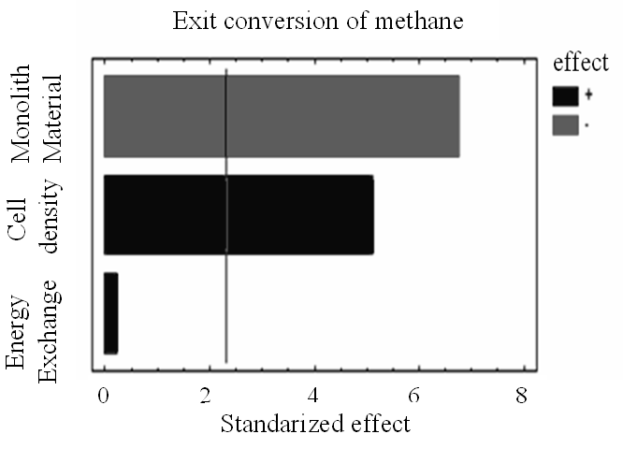 | 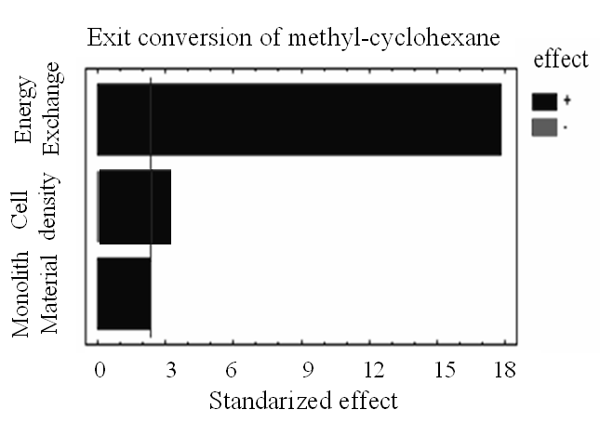
(a) exothermic reaction | b) endothermic reaction
Figure 5. Pareto analysis of exit conversion.
  - Conclusions
For an exothermic reaction in a honeycomb monolithic reactor high conversion can be achieved by increasing the cell density, by using a monolith material of lower thermal conductivity and by operating at adiabatic conditions. On other hand, for an endothermic reaction the most favourable conditions are increasing the cell density, operating with a external heating and using a monolith material of high thermal conductivity. Additionally, the multi-channel model of honeycomb monolith demonstrated that non adiabatic situations can be simulated and this model will permit to explore future applications as endothermic reactions and heating conditions which are not very common actually.
References
Ávila, P., 1998, Utilización de catalizadores monolíticos en procesos de descontaminación ambiental, Instituto de Catálisis y Petroleoquímica, Reverté S.A., Madrid, España, p. 16-14.
Boger T., Heibel A., Sorensen C., 2004, Monolithic catalysts for the chemical industry, Industrial and Engineering Chemical Research, 43, p. 4602-4611.
Cybulski A. and Moulijn J., 2006, Structured catalysts and reactors, Second Edition, Taylor & Francis Group, Boca Raton, USA, p. 21-70.
Hayes, R.E., Kolaczkowski S.T., 1994, Mass and heat transfer effects in catalytic monolith reactors, Chemical Engineering Science, 49, p. 3587-3599.
Hayes, R.E., Kolaczkowski, S.T. ,1999, A study of Nusselt and Sherwood numbers in a monolith reactor, Catalysis Today, 47, p. 295-303.
Jossens, L. W. and Petersen, E. E., 1982, Fouling of a platinum reforming catalyst accompanying the dehydrogenation of methyl-cyclohexane, Journal of Catalysis, 73, p. 377-386.
Kolaczkowski, S.T., Worth D.J., 1995, Modeling channel interactions in a non-adiabatic multichannel catalytic combustion reactor, Catalysis Today, 26, p. 275-282.
Liu, H., Zhao, J. et al., 2005, Conceptual design and CFD simulation of a novel metal-based monolith reactor with enhanced mass transfer, Catalysis Today, 105, p. 401-406.
Sinfelt, J. H., Hurwitz, H., Shulman, R. A., 1960, Kinetics of methyl-cyclohexane dehydrogenation over Pt-Al2O3, The Journal of Physical Chemistry, 64, p. 1559-1562.
Tomasic, V., Gomzi, Z., Znoevic, S., 2002, Reaction and mass transfer effects in a catalytic monolith reactor, Reaction Kinetics and Catalysis Letters, 77, p. 245-253.

