MODELLING OF PRECIPITATION IN TURBULENT FLOW VIA THE JOINT SPECIES-NUMBER DENSITY PDF METHOD
Giovanni Di Veroli, Stelios Rigopoulos
University Of Manchester, George Begg Building, Sackville Street M1 3, UK
Abstract
Precipitation in turbulent flows requires a comprehensive treatment of the Population Balance Equation (PBE) coupled with the chaotic dynamics of turbulent flows. A new approach is presented here where the joint Probability Density Function (PDF) of the number density function and the chemical species’ concentrations is transported. A coupled CFD-Monte Carlo simulations approach is employed for numerical solutions. Application to Barium Sulphate precipitation in a tubular reactor is performed and comparison is made with literature results.

Keywords: Precipitation, Population Balance Equation (PBE), Turbulent flows, Probability Density Function (PDF).

Precipitation processes in turbulent flows are often encountered in the manufacturing of pharmaceuticals, speciality chemicals and other valuable materials. Very often, the desired characteristics of the final product (mechanical strength, rheology, optical properties, etc.) strongly depend on the resulting particle size distribution (PSD). Simulations of reactive precipitation processes can significantly aid in reducing the cost of reactor design and scale-up and in tailoring the product properties to specific applications. Nevertheless, the formulation of models for precipitation in turbulent flows is a complex, interdisciplinary problem that calls for elements from fluid dynamics, chemical engineering and population balance modelling. The presence of turbulence introduces randomness in concentrations values as well as in the PSD. Therefore, even if turbulence is adequately modelled via Computational Fluid Dynamics (CFD), a straightforward Reynolds averaging of the PBE results in a wealth of unclosed terms. Consequently, significant questions pertain as to how the Population Balance Equation (PBE) must be combined with the flow field computations.

The simplest approach ignores randomness at the PBE level ^{[1]} and computes the flow field characteristics via Reynolds averaged models (RANS) whilst the particle size distribution is described via the standard method of moments. Moment methods transform the PBE into a set of equations for the moments of the PSD, therefore reducing its computational cost. By definition, this class of methods does not retrieve the entire PSD; in addition, closure assumptions are needed except for the simplest cases (quadrature assumption is a possible approach for this problem ^{[2]}). In order to combine the flow field computations with the precipitation process, the concept of Probability Density Function (PDF) has been used by several authors. Baldyga et al.^{[3]} used a β-pdf for the mixture fraction, while Marchisio et al.^{[4]} used a Finite Mode-PDF for the composition. Even though the second of these approach seems more flexible, both of them make assumptions at the PDF level and use moment descriptions of the PSD. Others authors (Schwarzer et al.^{[5]}) resolved the flow field using Direct Numerical Simulation (DNS), then attempting to apply Lagrangian particles tracking associated with a finite element discretization of the PSD.

In this work we introduce a modelling framework that overcomes the Reynolds averaged equations closure difficulties, while allowing reaction and crystallisation kinetics of any complexity to be incorporated. The fundamentals of the joint species-number density pdf method have been introduced by Rigopoulos^{[6]}. Here we develop a methodology for coupling the pdf computation to a flow field computed by a CFD code, via a Lagrangian Monte-Carlo stochastic approach. The flow characteristics are computed using a RANS model and the entire PSD of the product (rather than the moments of it) is obtained, while interaction with turbulence is treated by a full PDF approach (rather than a presumed PDF). The method is very flexible and avoids specific assumptions whilst remaining computationally feasible. It also allows estimation of the errors introduced by approximate methods that neglect the fluctuations of Reynolds-averaged terms. The approach is applied to Barium Sulphate precipitation in a tubular reactor.
  - Fundamentals equations and numerical approach
    - General equations

Particulate processes in turbulent incompressible flows are described by the continuity and momentum transport equations for the fluid (Navier-Stokes equations) as well as scalar transport and general population balance equations ^{[6]}. Full treatment of the Navier Stokes equations by Direct Numerical Simulations (DNS) is computationally prohibitive for practical turbulent flows. Therefore, solutions of turbulent flows are achieved through Reynolds Averaged approaches (RANS) or Large Eddy Scales approach (LES), not to be discussed here. RANS approaches provide solutions for average quantities of the turbulent flow using models for treating turbulence, such as the well known k-ε model. The PBE itself expresses the evolution of a distribution of particles through the variation of the number density N(υ). In our context, the PBE could be written:
(1.1)
The number density N(υ) is a continuous entity corresponding to the number of particles of volume υ per unit υ, per unit volume of space. Equation (1.1) describes the evolution of N(υ) due to growth (at a rate G(Y₁, Y₂,, …, Y_{m}, υ)) and due to precipitation of new crystals (at a rate B(Y₁, Y₂,, …, Y_{m}, υ)), as well as the effect of convection with velocity u. The PBE can be discretized for numerical integration. In this case, the PBE is treated exactly without closure assumptions (in contrast with methods of moments where closure is often required). In this work we will employ the scheme of Rigopoulos and Jones ^{[7]}, but it is important to stress that the general features of the following discussion would apply to any other scheme or PBE solving method.

Assuming that the precipitation process does not modify the flow field characteristics, one could obtain the flow characteristics by RANS simulations. Consequently, Reynolds-averaging can be applied to (1.1) leading to an averaged growth contribution $\left\langle ∂\left(G(Y_{1},Y_{2},\text{.}\text{.}\text{.},Y_{m},υ)\text{.}N(υ)\right)/∂υ\right\rangle$ as well as to an averaged nucleation (precipitation) contribution$\left\langle B(Y_{1},Y_{2},\text{.}\text{.}\text{.},Y_{m})\text{.}δ(υ−υ_{0})\right\rangle$. The same remark would apply when averaging the scalar transport equations. Given the random aspect of all variables due to turbulence (all the Y_{k,k=1,m} as well as N(υ) are now random) it has been shown that such averaging lead to a wealth of unclosed terms ^{[6]}. The Probability Density Function (PDF) approach overcomes this problem by allowing exact treatment of these terms.
    - PDF approach

A Probability Density Function f(x,t) describes the probabilistic distribution of a random quantity X. By definition of the PDF, f(x,t).dx is the probability that X lies in the interval [x,x+dx]. Let us define the quantity Φ =( Y₁, Y₂,, …, Y_{m}, N₁, ,N₂,…, N_{n}) where the Y_{k,k=1,m} represents composition (mass fractions or concentrations), while the N_{k,k=1,n} denotes values of the number density N(υ) at its point of discretization υ _{k,k=1,n} (N_{k}=N(υ _{k})). A joint PDF f_{Φ}(φ,t) can be defined, where φ is the analogous of Φ in the PDF sample space. The following equation is obtained for the evolution of f_{Φ} ^{[6]}:
(1.2)
Here summation is implied for variables j (j=1,3), α (α=1,m+n), k (k=1,m) and k’ (k’=1,n). ${\overset{˙}{w}}_{k}$(Y₁, Y₂,, …, Y_{m},) is the rate of reaction of composition Y_{k}. $Γ_{\text{turb}}=ρ⋅\left(C_{μ}/{\text{Sc}}_{t}\right)\left(k^{2}/ε\right)$ is called the turbulent diffusivity while ρ is the density of the fluid and C_{μ} is an empirical constant (C_{μ} = 0.09), Sc_{t} is the turbulent Schmidt number Sc_{t}=0.7; k and ε are the turbulent kinetic energy and the turbulent dissipation rate respectively. C_{mix} is also an empirical constant (C_{mix} = 2) associated with mixing according to the LMSE (Linear Mean Square Estimation) model. The functions G₁ and G₂, as well as B₁, come from the discretization scheme used here, and are given in ^{[6]}. (1.2) is a conservative equation where convection of the f_{Φ} by the mean flow is altered by turbulent diffusion, micromixing and the reactive process. The last two terms of the right hand side of (1.2) represent the reactive part of the process. The major advantage of the PDF approach becomes apparent when we observe that these terms are written in an exact, closed manner. Classical discretization methods are excluded for solving this kind of equation due to the high dimensionality of the PDF transport equation. Solution must therefore be achieved via Monte Carlo simulations.
    - Lagrangian notional particles

Lagrangian Monte Carlo methods for turbulent reactive flows were first introduced by Pope ^{[8]}. In our work, we extend the standard stochastic model to particulate systems. The essence of stochastic models is to simulate a number of stochastic entities whose statistics approximate the quantity we seek to calculate - in this case the pdf f_{Φ}. As the pdf transport equation is of the Fokker-Planck type, it can be shown to be equivalent to a Langevin-type equation for an ensemble of stochastic entities ^{[9]}. In our case the spatial evolution of a stochastic particle is modelled by:
(1.3)
Here, $dw$ is the infinitesimal increment of a Wiener process. The discrete equivalent of $dw$during time step Δt is Δw=Δt^{1/2}•ζ where ζ is a vector of normal random variables. Composition and discretized number density evolutions are modelled by:
${\text{dY}}_{a}=\left[\frac{C_{\text{mix}}}{2}\text{.}\frac{ε}{k}(<Y_{a}>(t)−Y_{a})+\overset{˙}{w}(Y_{1},Y_{2},\text{.}\text{.}\text{.},Y_{m})\right]\text{.}\text{dt}$ (1.4)
(1.5)
These two last equations describe the evolution of the notional particles’ properties. They correspond to the evolution of the pdf in sample space and can be integrated directly. One of the challenges in designing stochastic simulation techniques for pdf formulations is that the transport of the pdf must comply with the Navier-Stokes equations. As the velocity statistics are not included in the pdf, the flow field has to be computed by external means and the results ($Γ_{\text{turb}}$and u as well as Ω=ε/k) matched in every time step with the stochastic simulation of the pdf evolution. Once the flow field is computed, simulation of a large ensemble of notional particles is carried out. Each notional particle carries a set of concentrations and number density values. During a time step, particles first move according to (1.3). Then their composition and PSD are being altered according to (1.4) and (1.5). Note that the average compositions used in (1.4) and (1.5) are estimated locally. During the simulation evolution, particles are sorted into spatial cells and average values are computed for each cell. In fact, even though the spatial evolution of the notional particles is free of any grid structure, the presence of a fixed grid is required to compute the spatial distribution of the sought pdf f_{Φ}. In the present work, the same grid as the one used in the CFD simulations is employed.
  - Simulations results
    - Description

The method is now applied to the simulation of Barium Sulphate precipitation in a tubular reactor. Comparison is made with simulations and experimental results from ^{[4]}. The Reynolds number of the experimental flow set by the authors was about 10,000. A solution of Na₂SO₄ is injected in the central region at a concentration of 34.101 mol/m3 while a solution of BaCl₂ is injected in the outer (annular) region at a same concentration. A particle sizer was used to measure the L₄₃ mean crystal size pipe outlet (L₄₃=m₄/m_{3,} m₄ and m₃ are the 4th and 3rd moments of the size number density). Using a 131∙35 nodes grid, we obtain the flow field characteristics with CFD (Fluent 6.2.16 - standard k-ε model). The grid is very refined near the injection zone where great variations occur. Afterwards, we carry out Monte Carlo simulations. A simple one step reaction describes the precipitation process:
${\text{Ba}}^{2+}+{\text{SO}}_{4}^{2−}→{\text{BaSO}}_{4}↓$ (2.1)
To compare with results from ^{[4]} same kinetics were used. Monte Carlo simulations were performed with 15 notional particles per cell.
    - Results

Figure 1 shows the obtained supersaturation field (S=[BaCl₂][Na₂SO₄]/K_{s}) near the injection zone. The results shown are time averaged. The supersaturation field presents a high peak near injection zone (S ≈ 1600) followed by a sharp decrease and homogenization across pipe radius (S ≈ 300). Once supersaturation homogenizes, it continues to decrease at a slow rate. The first peak of supersaturation corresponds to the forced mixing of streams coming from the central and annular regions. Next, precipitation and growth of particles consume the SO₄²⁻ concentration while the mixing of the flows dilutes it. The consumption, as well as the dilution of Ba²⁺ coming from the annular region does not play a role on this decrease since Ba²⁺ is in great excess. Once the fluid is well mixed and supersaturation is too low for nucleation to be significant, particle growth is the main factor in the slow decrease of the quasi-homogeneous supersaturation. Figures 3 and 4 show the 0th moment and the L₄₃ mean crystal size fields in the pipe. An important number of particles are created near the injection zone where the supersaturation is very high (Fig.3). Beyond this region, the particles are dispersed across the entire pipe. Further, the nucleation rate becomes too negligible for a significant increase in the total number of particles. In contrast, L₄₃ is quite uniform across pipe radius all along the pipe length (Fig.4). The increase is initially high, while later it slows down. Beyond the injection region, the growth of particles is the dominant mechanism for the consumption of supersaturation.

When comparing the M₀th moment and L₄₃ crystal size along the centre line with the simulations of Marchisio et al.^{[4]}, results exhibit good overall agreement (Fig.5-6). Differences between the plots can be explained by uncertainties in parameters, as well as by the different techniques used to handle the population balance (finite element discretization vs. moments approach). Experimental mean crystal sizes were also obtained by those authors at the outlet of the reactor. With our simulations, the entire particles size distribution (PSD) at the outlet of the pipe is obtained (Fig.2). From this PSD we can calculate an equivalent mean size d₄₃=1,55μm. That is comparable to the experimental value of 1,075 μm and to the value of 1,68μm found from the authors’ simulations. Discrepancies with the experimental results can possibly be attributed to the kinetic parameters.
  - Conclusions

A joint PDF approach has been developed, allowing full treatment of the PBE in turbulent flows with any precipitation kinetics. Application to Barium Sulphate precipitation in a tubular reactor (nucleation and growths kinetics taken from a literature article) has been performed. Preliminary results present good agreement. Further applications as well as extension to aggregation and/or breakage mechanisms are intended in a next step.
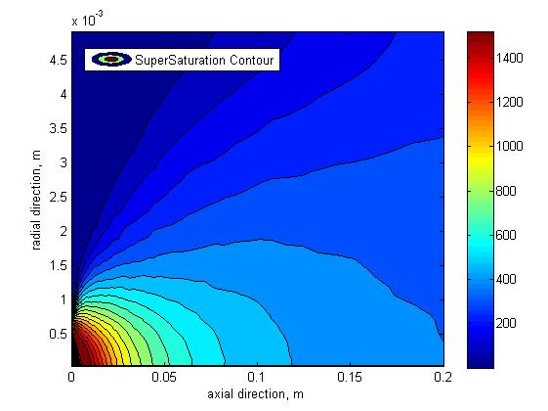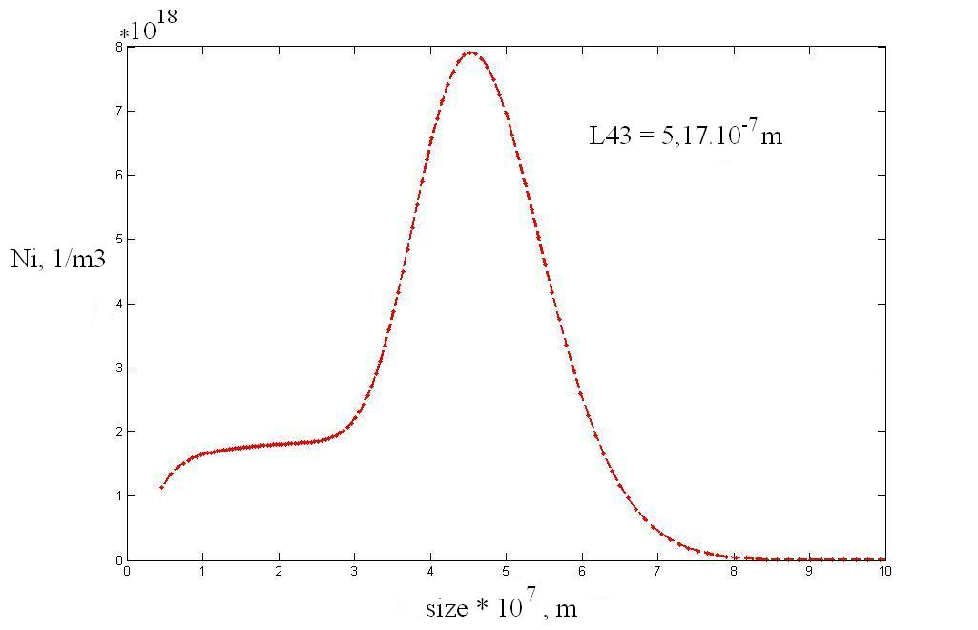
Fig.1 Supersaturation field near the injection zone
Fig.2 Number density distribution at outlet of pipe

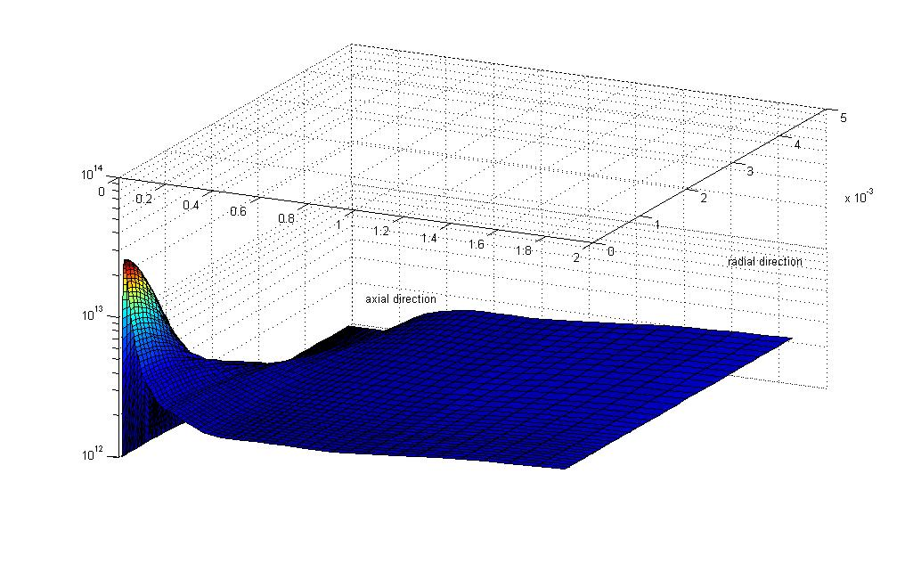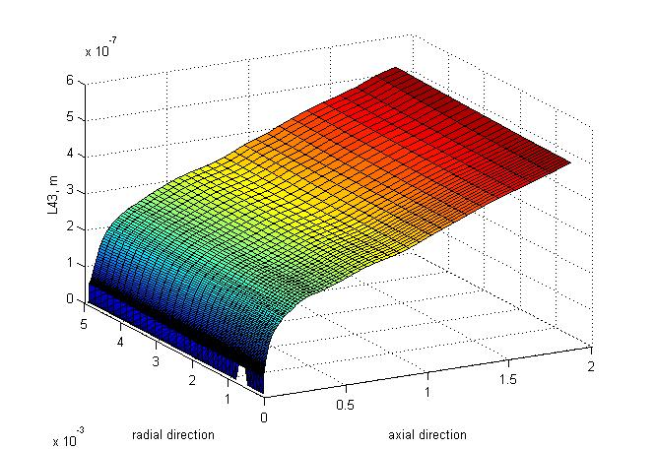
Fig.3 0th moment field
Fig.4 L₄₃ mean size field

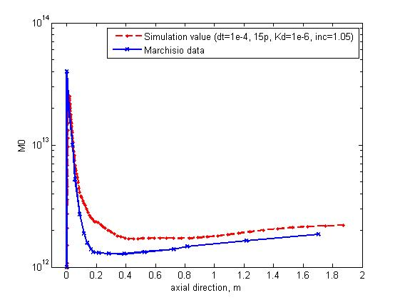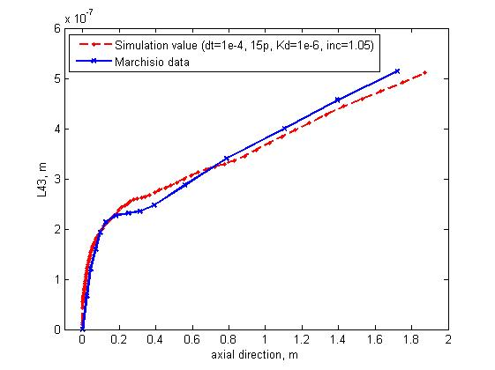
Fig.5 0th moment along center line (our results dashed, ^{[4]} continous line)
Fig.6 L₄₃ mean size along center line (our results dashed, ^{[4]} continous line)

References
- A.A. Öncül et al., (2006), Chem. Eng. Sci. 61(2), pp. 652-664
- R. McGraw, (1997), Aerosol Science and Technology 27 (2), pp. 255-265
- J. Baldyga, W. Orciuch, (2001), Chem. Eng. Sci. 56 (7), pp. 2435-2444
- D.L Marchisio et al., (2001), Ind. Eng. Chem. Res., vol.40, pp. 5132-5139
- H.C. Schwarzer et al.,(2006), Chem. Eng. Sci. 61 (1), pp. 167-181
- S.Rigopoulos, (2007), Chem. Eng. Sci. 62, 6865-6878
- S.Rigopoulos, A.G. Jones, (2003), AIChE Journal 49 (5), pp. 1127-1139
- S.B. Pope, (1981), Combust. Sci. Tech. 25 (5-6), pp. 159-174
- C.W.Gardiner, (2004), Handbook of Stochastic Methods, Third edition, pp.80-115

