An analytical-numerical method for solving a heap leaching problem of one or more solid reactants from porous pellets
Mario E. Mellado, Luis A. Cisternas
Depto. Ing. Química, Universidad de Antofagasta, Antofagasta, Chile and Centro de Investigación Científico Tecnológico para la Minería (CICITEM), Antofagasta, Chile
Abstract
In this paper we present an alternative method based upon analytical and numerical solutions for the ordinary differential and partial differential equations which describe the heap leaching problem of one or more solid reactants from porous pellets. We propose to use analytical solutions for the differential equations which describe rate dissolutions along the pores and the surface of the particles under suitable regularity conditions. Moreover, we propose the use of continuous-discontinuous solutions for the continuity partial differential equations describing balances. All of this, allows to obtain a numerical scheme which is fast and accurate for simulating the heap leaching problem. The model includes the effects of particle scales kinetic factors, heap scales and several operation variables. Finally, numerical experiments are presented.

Keywords: Heap leaching, Differential equations, Analytical and numerical methods.
  - Introduction
Heap leaching is a hydrometallurgical process which has been used since a long time which was originally designed for oxides ores but today have several applications including sulphide ores and caliche minerals. Heap leaching has been a matter of wide research and several mathematical models which allows to simulate, design, optimize and analyze the phenomena have been developed. Some contributions we consider relevant to this work are Andrade, 2004, Bouffard and Dixon, 2001, Bouffard and Dixon, 2006, Cross et. al., 2006, Dixon and Hendrix, 1993ab, Lizama et. al., 2005, Mousavi et. al., 2006, Sheikhzadeh et. al., 2005, Sidborn et. al., 2003, Wu et. al. The main goal of this work is to develop an efficient analytical-numerical scheme for solving the differential equations that describe the heap leaching phenomena.
  - Mathematical framework
Following Dixon and Hendrix, 1993ab, we present a system of Partial Differential Equations (PDE) and Ordinary Differential Equations (ODE) which describes the heap leaching process. The ODE to compute the dimensionless grade of solid reactant within the particle is given by,
(1)
where t is the time, x is the space coordinate, is the Damkohler II number for solid reactant within the particle, dimensionless, is a dimensionless stoichiometric ratio, is the fraction of solid reactant residing on the particle surfaces initially, is the dimensionless reagent concentration and denotes the order of reaction. The ODE to compute the dimensionless grade of solid reactant on the particle surface is given by
(2)
where is the Damkohler II number for solid reactant on the particle surface, dimensionless stands for the dimensionless concentration of the reagent in the bulk solution external to the particle. The continuity equation for is
(3)
together with,
Moreover, it follows that,
where is the ore density [g/cm³], is the ore porosity, is the grade of solid reactant within a particle [mol/g], is the stoichiometric number [mol/mol], is the effective pore diffusivity of reagent A [cm³/cm s], is the reference reagent concentration, is the initial extractable grade of solid reactant [mol/g], is the bulk solution volume fraction, is the heap void fraction and is the superficial bulk flow velocity [cm³/cm² s]. We now replace the dimensionless diffusion time t in all the particular model equations by the dimensionless bulk flow time . The PDE for the dimensionless concentration of dissolved species , is given by
(4)
together with . Here, we have the design parameters,
where R is the particle radius [cm] and Z is the heap depth [cm]. The PDE for the dimensionless bulk concentration of dissolved species is given by,
(5)
The balance equation in the bulk lixiviant is given by,
(6)
The differential equations (1)-(6) complete the ODE-PDE model for the heap leaching process. We use the notion of extraction of reactant from the heap given by
(7)
  - Analytical-numerical scheme for the model problem
Now, we discuss in detail the analyticalnumerical aspects for solving the system (1)-(6). We first concentrate our attention in (1)-(2). Certainly, at a first glance, these equations can not be solved analytically. As we will solve the system of differential equations in an iterative way, we can assume that the functions and have enough regularity. If we assume the latter, the equations (1)-(2) can be solved analytically. Certainly, and considering reaction order for both equations as equal to the unity, we find that,
(8)
and
(9)
It is important to recall that if one need to consider reactions orders and different to the unity, the differential equations can be solved analytically by using the Bernoulli transformation and , respectively. Now we describe our approach for the partial differential equations (3)-(4). We solve these equations with a Crank-Nicholson fully implicit finite difference scheme (Hackbush, 1992). It is very important to note that the matrices generated are sparse, non symmetric and stable. The systems of equations are solved with a preconditioned LU method.
Now we present our approach for the partial differential equations (5)-(6). We solve these equations in an analytical manner. We recall that in the bulk lixiviant of the heap, the mass balance for dissolved species is given by (5). To obtain analytical solutions, we consider the transformation, and . We find that,
(10)
and
(11)
where . By using the same arguments, we find the following analytical solution for equation (6),
(12)
and
(13)
where ,. We note that (10)-(11) is continuous in R² while (12)-(13) is discontinuous when . This discontinuity reveals the important fact that, for, the PDE must be modified in order to have a consistent model. This can be achieved, for instance, by introducing a second order term which allows to have a continuous solution. The discontinuity is just when which suggests the use of this discontinuous solution because the regularizing effect of the algorithm sequence of integrations.

  - Heap leaching with distribution function for different particles sizes
To deal with heap leaching with a distribution function for different particles sizes, we define a dimensionless particle radius as , whereis a reference radius, and making the scaling , , and using the Gates-Gaudin-Schuhmann distribution function of parameter m, the algorithm is as follows: for a space step, solve:
- Given and , obtain by solving

- With obtain and through
- Obtain by solving

.

- Compute and through

and
also,
and
- Compute and store
- Do the same up to Z=1. Then, increase . Once the desired simulation time is reached, stop the iterations.
We use Gauss quadrature for computing E. We note that, even for dense simulations, the main time cost is due to the numerical solution of (3)-(4).
  - Numerical experiments
First, we need to point out that our approach is able to reproduce the results shown in Dixon and Hendrix, 1993ab, by considering the operation conditions indicated there. A complete agreement with that simulations was used to test our computational code. We now present an industry simulation by considering a standard heap leaching process in the north of Chile. We present numerical results for the following situation: :=1.3, :=0.03,:=0.000157,:=0.000157,r:=2.5,:=1.0,:=10^{-6}, :=0.00333, :=0.000157, :=0.03, :=0.03, :=0.000333, z:=1000.0.
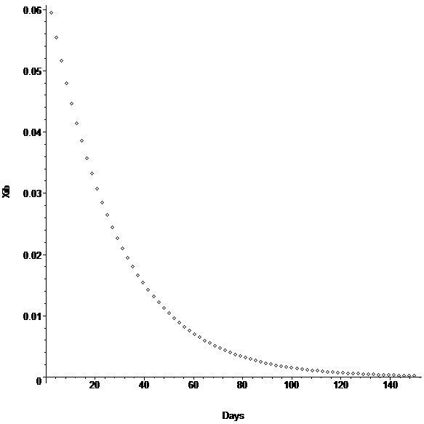
Figure 1. against days.
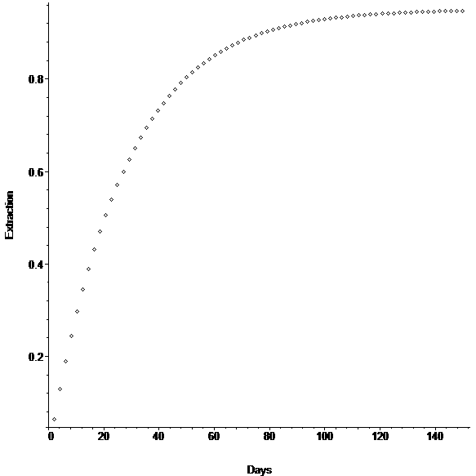
Figure 2. E against days.
The above pictures show an agreement with the industry standard heap leaching process which validates our approach and allows to conclude this simple modification of the numerical algorithm for solving (1)-(6) can produce good results at a low computational effort.
  - Conclusions
An analyticalnumerical approach method for solving the heap leaching problem has been developed. The mathematical theory is consistent and shows the possibility of improvement the model by including, for instance, a second order term in (5). Also, this methodology can be applied to obtain totally analytical models by considering the presented analytical solutions together with analytical solutions for the equations (3)-(4), for instance, by some reasonable simplifications of the differential equations. A complete agreement with industry processes validates our method from the engineering point of view.
Acklowledgments
LC wishes to thank CONICYT for financial support, through Fondecyt Project 1060342.
References
de Andrade Lima, L. R. P., (2004). Brazilian Journal of Chemical Engineering 21, 435-447.
S. Bouffard. & Dixon, D. G., (2001). Metallurgical and Material Transactions B 32B, 763-776.
S. Bouffard, & Dixon, D. G., (2006). Hydrometallurgy 86, 63-71.
M. Cross, Bennett, C. R., Croft, T. N., McBride, D. & Gebhardt, J. E., (2006). Minerals Engineering 19, 1098-1108.
D. Dixon, & Hendrix, J. L., (1993). Metallurgical Transactions 24B, 1087-1102.
D. Dixon, & Hendrix, J. L., (1993). Metallurgical Transactions 24B, 157-168.
W. Hackbusch, (1992). Elliptic Differential Equations. Springer-Verlag.
H. Lizama, Harlamovs, J. R., McKay, D. J. & Dai, Z., (2005). Minerals Engineering 18 , 623-630.
S. Mousavi, Jafari, A., Yaghmaei, S., Vossoughi, M. & Sarkomaa, P., (2006). Minerals Engineering 19, 1077-1083.
G. Sheikhzadeh, Mehrabian, M. A., Mansouri, S. H. & Sarrafi A., (2005). International Journal of Heat and Mass Transfer 48, 279-292.
M. Sidborn, Casas, J., Martinez, J. & Moreno, L., (2003) Hydrometallurgy 71, 67-74.
Wu Ai-xiang, Liu Jin-zhi & Tang Ling-yan, (2007). Applied Mathematics and Mechanics 28, 327-335.

