Modeling of Polyvinyl Acetate Polymerization Process for Control Purposes
Teodora Mitevaª, Rodrigo Alvarez^{b}, Nadja Hvalaª, Dolores Kukanja^{c}
ªJožef Stefan Institute, Jamova 39, SI-1000 Ljubljana, Slovenia
^{b}UPC, Enginyeria Química , Avda. Diagonal 647, Pab. G-2, E-08028 Barcelona, Spain
^{c}MITOL, Sežana, Partizanska cesta 78, SI-6210, Slovenia

Abstract
The research work presented in this paper considers the polymerization process in MITOL factory in Sežana (Slovenia). The challenge is to increase the production rate, while keeping quality parameters at the desired values. For this purpose a model consisting of differential and algebraic equations (DAE) has been already constructed⁷. The model is intended to take over the role of a soft sensor, being able to provide estimates of the given process outputs. In this paper we derive an extended version of the model in order to reach fully predictive capabilities. By using modeling from first principles (energy balance), the dynamics of the temperature is derived as a function of the concentrations of reacting chemicals. The preliminary simulation results based on real plant data, derived in gPROMS environment, are presented.

Keywords: vinyl acetate, control, modeling, gPROMS
  - Introduction
Emulsion polymerization of vinyl acetate is quite a complex chemical process. Efforts have been made to determine the mechanisms of the reaction. Initial estimations of the number of particles and conversion, based upon the Smith and Ewarts’ polymerization model were written by O’ Donnel and Mesrobian¹. Dunn and Taylor² went further and developed many of the theories commonly accepted nowadays. In the literature it is also possible to find a good number of comprehensive models of the vinyl acetate polymerization reaction, gathering the different theories and mechanisms proposed. In 1992, Urquiola et al.^{3,4,5} wrote a series of papers about the polymerization of vinyl acetate using a polymerizable surfactant.
The presented work addresses modeling of a polymerization process in a chemical factory Mitol in Sežana, Slovenia. The problem we have is to design optimal control actions required to reach the final product with specified quality parameters in as short time as possible. The motivation arises from the fact that current batch control is done by following a recipe derived from experience. The large quantities of raw materials and equipment resources involved in the batch prevent us from performing experiments directly on the plant. Therefore we need a good predictive model of the polymerization reaction. The model of Aller et al.^{6,7} was designed to provide estimates of four outputs: conversion, particles size, solids content and viscosity, having the temperature and initial amounts and flow rates of the monomer and initiator as model inputs. The problem appeared that having the temperature as a model input does not allow us to fully optimize the polymerization process and to observe the changes of the temperature, and consequently the process outputs, by supplementing different amounts of monomer and initiator. The sufficient amount of initiator was also difficult to be predicted. In our work we extend the proposed model with energy balance equations and in this way simulate the temperature in the reactor as an additional model state variable. In this way the necessary control actions for shortening the batch duration could be studied.
  - Process description
The modeled reaction is polymerization of vinyl acetate using potassium persulfate (KPS) as initiator and polyvinyl alcohol as protective colloid. The production process is semi batch polymerization. Initial amounts of initiator and monomer are added into the system as well as the whole amount of the polyvinyl alcohol. The reactor is closed and the heating starts. When the temperature of the reactor reaches approximately 70˚C, the operator stops the hot water through the heating jacket (Figure 1). The exothermic reaction and the heat of the remaining water filling the heating coat continue to rise the temperature. After the reactor temperature reaches a certain level, the remaining monomer starts to be pumped into the reactor with a continuous flow of 370 kg/h. The monomer flow rate is controlled by a PID controller acting on the pump. The temperature of the added monomer is the outdoors temperature.

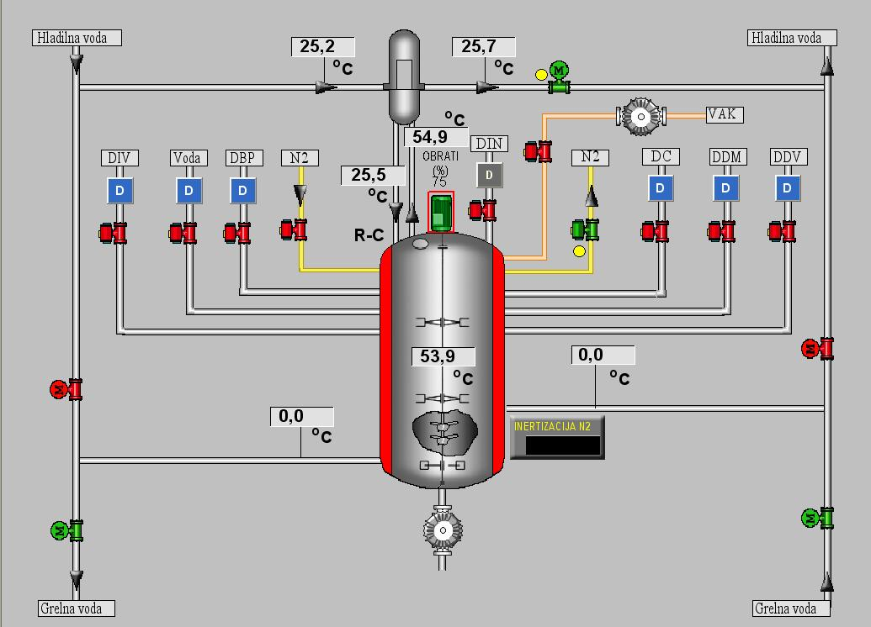
Figure 1. Scheme of polymerization reactor in MITOL

In the beginning of the reaction, the temperature can reach 82˚C, but afterwards, for the product quality reasons, it is necessary to keep the temperature between 75˚-80˚C. Temperature control is performed by manually adding a small amount of initiator every time the temperature decreases. When all the monomer is added into the system, a larger amount of initiator is added in order to terminate the reaction. The temperature is then allowed to increase up to 90˚C. The reaction is considered as finished when the temperature starts to decrease again.
The main variables affecting the duration of the reaction are: the temperature, initial amount of monomer, flow rate of the monomer and the addition of the initiator.
The quality of the product is defined by the following parameters: conversion into polymer, particle size distribution, viscosity and solids content.
  - Temperature model
The current model is based on the previous work of Aller et al.^{6,7}, where the monomer flow rate, initiator addition and the temperature were taken as inputs into the system. The temperature was not estimated by the model. In order to observe the changing of the temperature profile as a result of the change of the initiator addition, we took out the temperature as an input, and rather estimated it from the energy balance model.
The energy balance model is based on reaction heat capacity, and the energy produced and consumed during the reaction. The latter include the following:
- heating of the reactor through the heating jacket,
- producing the heat in the exotermic reaction,
- heating the incoming monomer to the reactor temperature,
- cooling of the reactor by the reflux,
- heat losses to the surrounding.
Reaction heat capacity accounts for the heat capacities of the reactor ingredients, i.e. monomer in the reactor (M), converted monomer (polymer) (M_{conv}), and initial amounts of water (W) and polyvinyl alcohol (PVOH). It is calculated from their mass and specific heat capacities (Cp) according to the following equation
$K_{R}=M{\text{MW}}_{m}{\text{Cp}}_{\text{mon}}+M_{\text{conv}}{\text{MW}}_{m}{\text{Cp}}_{\text{pol}}+W{\text{Cp}}_{\text{water}}+\text{PVOH}{\text{Cp}}_{\text{pol}}$ ()
where MW_{m} is monomer molecular weight [g/mol].
The heating of the reactor through the heating jacket (ΔH_{jacket}) is given by:
${ΔH}_{\text{jacket}}=0\text{.}\text{00018}(T−T_{\text{jacket}})K_{R}$ ()
where T is reactor temperature and T_{jacket} is the temperature in the jacket that is modeled as follows:
${\text{dT}}_{\text{jacket}}/\text{dt}=(0\text{.}\text{00018}K_{R}/4\text{.}\text{18}⋅\text{1000})(T−T_{\text{jacket}})$ ()
The reaction heat produced in the exotermic reaction is proportional to the heat of polymerization (ΔH_{r}) and polymerization reaction rate (r_{pol}) computed with the model of Aller et all.^{6,7}:
$−{ΔH}_{r}r_{\text{pol}}$ ()
The energy needed to heat the incoming monomer to reactor temperature is proportional to the mass of the incoming monomer (computed from moles of incoming monomer Q_{m} and monomer molecular weight MW_{m}), its heat capacity (Cp_{mon}) and temperature (T_{mon}):
$Q_{m}{\text{MW}}_{m}{\text{Cp}}_{\text{mon}}T_{\text{mon}}$ ()
The energy loss by the reflux through the condenser (Q_{cond})is estimated by the flow coming in and out of the condenser (Q_{FC}), its heat capacity (Cp_{Cout}) and temperature of the reflux going through the condenser (T_{Cout}, T_{Cin}). The λ is vaporization heat.
$Q_{\text{cond}}=Q_{\text{FC}}{\text{Cp}}_{\text{Cout}}(T_{\text{Cout}}−T_{\text{Cin}})−Q_{\text{FC}}λ$ ()
$λ=−0\text{.}\text{00281}T_{\text{Cout}}^{2}−0\text{.}\text{32738}T_{\text{Cout}}+\text{408}\text{.}\text{178}$ ()
The heat losses to the surroundings are given by
$Q_{\text{loss}}=C3(T−T_{\text{ext}})$ ()
Where C3 is an adjustable parameter and T_{ext} is the outside temperature.
We have divided the modeled temperature profile in three parts. The first part starts when we close the reactor and start heating it with hot water through the heating jacket, and ends when we stop the hot water and wait till the temperature in the reactor reaches around 80ºC. In that first part there is no heat looses and no flow through the condenser. The energy balance model in the first part is therefore the following:
$K_{R}\frac{{\text{dT}}_{R}}{\text{dt}}+T_{R}\frac{{\text{dK}}_{R}}{\text{dt}}=Q_{m}{\text{MW}}_{m}{\text{Cp}}_{\text{mon}}T_{\text{mon}}−{ΔH}_{r}r_{\text{pol}}−{ΔH}_{\text{jacket}}$ ()
The left side of the eqation accounts for the change in the internal energy of the reactor, which is due to the change of reactor temperature (first term) and the change of its heat capacity (second term).
The second part of the modeled temperature profile starts at the end of the first part and ends at the first initiator addition during the batch. In that part the reactor is no more heated through the heating jacket, the losses are negligible, as well as the flow through the condenser because the reaction has just been started. The energy balance model includes only monomer enthalpy and the reaction heat. The equation is the following:
$K_{R}\frac{{\text{dT}}_{R}}{\text{dt}}+T_{R}\frac{{\text{dK}}_{R}}{\text{dt}}=Q_{m}{\text{MW}}_{m}{\text{Cp}}_{\text{mon}}T_{\text{mon}}−{ΔH}_{r}r_{\text{pol}}$ ()
The energy balance for the third last part of the modeled temperature profile takes into account also the reflux through the condenser and heat losses. The equation has the following form:
$K_{R}\frac{{\text{dT}}_{R}}{\text{dt}}+T_{R}\frac{{\text{dK}}_{R}}{\text{dt}}=Q_{m}{\text{MW}}_{m}{\text{Cp}}_{\text{mon}}T_{\text{mon}}−{ΔH}_{r}r_{\text{pol}}−Q_{\text{cond}}−Q_{\text{loss}}$ ()
Model parameters in equations (2)-(11) were taken from the literature⁸ (MW_{m}, Cp_{pol}, Cp_{mon}, Cp_{out}, ΔH_{r}) or estimated based on real plant data (C3) so that a satisfactory agreement between the process and the model was obtained. The values of model parameters are given in Table I.

Table I Values of model parameters
Parameter | Value
MW_{m} [gmol⁻¹] | 86.09
Cp_{pol} [kJ kg⁻¹ K⁻¹] | 1.77x10⁻²
Cp_{mon} [kJ kg⁻¹ K⁻¹] | 1.77x10⁻²
Cp_{out} [kJ kg K⁻¹] | 1.17
T_{ext} [˚K] | 283.15
ΔH_{r} [kJ mol⁻¹]  C3 (dimensionless) | -87.5  0.7502
  - Results
The presented model was simulated using gPROMS modeling tool. Model simulations were performed based on real plant data. The flow of the added monomer during the batch was measured, while the addition of initiator was calculated from the weight change of the initiator dozing tank. The reactor temperature and initiator flow rate during the batch are shown in Figure 2.
With the presented model we are able to get relatively good estimates of the reactor temperature. From Figure 3 it can be seen that the estimated profile follows the dynamics of the real one. Not so good estimates are obtained at the beginning and at the end of the batch. At the beginning of the batch, the most influential part of the model is the heating of the reactor through the heating jacket. So most probably, the corresponding model parameters still need to be estimated more precisely. The agreement of the model is also not good in the last part of the estimated profile. This is when the whole amount of monomer has been already added in the reactor and a larger
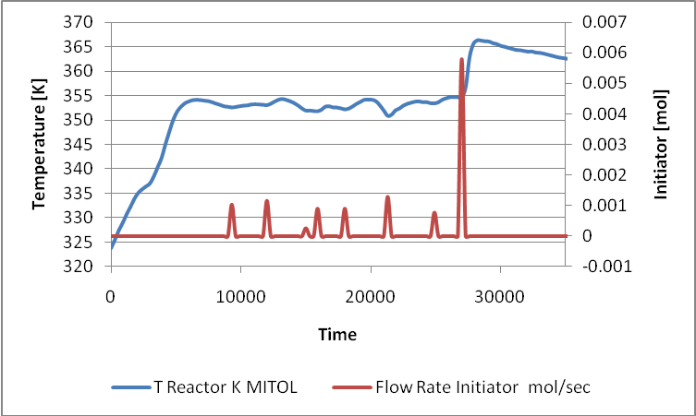
Figure 2. Initiator addition and temperature profile during batch

amount of initiator is put to finish the reaction. There are two possible reasons that the performance of the model in this part is not so good, i.e., (i) the actual heat losses are higher than estimated, (ii) the final addition of initiator was smaller than calculated. For the latter we have to take into account that the amount of initiator is obtained from the weight change of the dozing tank, so there might be some disparity of the final addition because of its larger amount. The obtained model still needs fine tuning of parameter values and close inspection of the initiator addition.
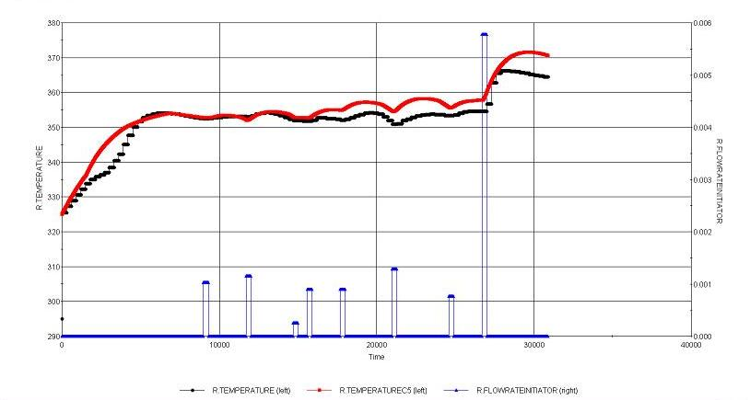
Figure 3 Temperature profile and estimated profile

The model outputs (product quality parameters) were also estimated with the model. Table II shows the validation of the model for one batch for simulation time of 31000 seconds. For the viscosity and the solids content, laboratory analyses were performed at the end of the reaction. These measurements are normally performed after mixing several batches and therefore no individual data is available.

Table II Output variables – real data and estimated data
Batch No. | Conversion (%) |  | Solids Content (%) |  | Viscosity (Brookfield 200C, 50rpm), (mPas)
Batch No. | Real Data | Modeled Data | Real Data | Modeled Data | Real Data | Modeled data
1256 | 99.37 | 69.41 | 46.4 | 33.82 | 30160 | 24881

From the table we can see that the model output variables are not in the range. They all are much lower than measured. Similar results were obtained for additional four batches. A possible reason for poor model performance is that the amount of monomer converted into polymer, as estimated by the model, is too low and is due to the inclusion of water volume in model equations (not shown in the present paper) derived in Aller et al.^{6,7}. The problem could be solved by re-tuning the corresponding model parameters.
  - Conclusion
A model for polymerization process of vinyl acetate has been developed. The model extends the work of Aller et al.^{6,7} in terms of energy balance. The improved model has two inputs – flow rate of monomer and flow rate of initiator addition. The outputs of the presented model are four – particle size diameter, solids content, viscosity and conversion. Having the temperature as an additional state variable we are able to estimate more precisely the sufficient amount of initiator which should be added into the system every time the temperature drops off. The model has been validated on a new set of real data taken from the polymerization plant. While the presented temperature model is quite satisfactory, the model output variables resulted from the extended model are underestimated. The work continues with fine tuning of model parameters, developing optimal control strategies for monomer and initiator addition, and implementing them in chemical factory in Sežana, Slovenia.
  - Acknowledgment
The support of the European Commission in the context of the 6th Framework Programme (PRISM, Contract No. MRTN-CT-2004-512233) is greatly acknowledged.
References
- J. T. O’Donnell and R. B. Mesrobian (1958). Vinyl acetate emulsion
polymerization. Journal of Polymer Science, Vol. 28, 171-177.
- S. Dunn and P. A. Taylor (1965). The polymerization of vinyl acetate in
aqueous solution initiated by potassium persulphate at 60ºC. Makromol., 83, 207-
219.
- M. B. Urquiola, V. L. Dimonie, E. D. Sudol, M. S. El-Aasser, (1992) Journal of Polymer Science: Part A: Polymer Chemistry, 30, 12, 2631-2644
- M. B. Urquiola, V. L. Dimonie, E. D. Sudol, M. S. El-Aasser, (1992) Journal of Polymer Science: Part A: Polymer Chemistry, 30, 12, 2619-2629.
- M. B. Urquiola, V. L. Dimonie, E. D. Sudol, M. S. El-Aasser, (1992) Journal of Polymer Science: Part A: Polymer Chemistry, 31, 6, 1403-1415.
- Aller, Fernando, Kukanja, D., Modeling of the semi-batch vinyl acetate emulsion polymerization in an industrial reacor, CHISA 2006, 27-31 August 2006, Prague – Czech Republic.
- Aller, F., Kandare, G., Blázquez Quintana, L. F. , Kukanja, D., Jovan, V. and Georgiadis, M. (2007). Model-based optimal control of the production of polyvinyl acetate. European Congress of Chemical Engineering (ECCE-6), Copenhagen, 16-20 September, 2007
- K.C. Berger and G. Meyerhoff, Polymer handbook, 3th edition, Wiley, New York (1989)
- C.M Gilmore, G.W. Poehlein and F.J. Schork, (1993) Journal of Applied Polymer Science, 48, 1449-1460.
- C.M Gilmore, G.W. Poehlein and F.J. Schork, (1993) Journal of Applied Polymer Science, 48, 1461-1473.

