Modelling of integrated multiscale process with microdevices

Rodolfo V. Tona Vásquez, Laureano Jiménez Esteller
Chemical Engineering Department, School of Chemical Engineering, University Rovira i Virgili, Av. Països Catalans 26, 43007 Tarragona, Spain

Abstract
Recent research has shown that miniaturised reactors support process intensification in many industrial sectors. In this work we present a modelling strategy that integrates multiscale process units with microstructured elements to support the synthesis and characterisation of perfume-containing microcapsules. In the first step, the continuous microreactors are modelled (using Matlab®) where microcapsules are produced, and it is encapsulated within AspenPlus®. Next, Aspen Plus® capabilities are used to complete the solvent recovery system. Key aspects of the work include the interchange of information in both directions and the convergence problems due to the presence of nested loops with a change of scale (micro and macro models combined). In addition, the input-output data is used to perform life cycle analysis to minimize the environmental impacts.

Keywords: micro devices, multiscale process, encapsulation.
  - Introduction
On the basis of a radical change in the paradigm, microtechnology may help to build the foundations for a new generation of chemical production plants for high added value products. Microtechnology is able to achieve process and products improvements by orders of magnitude, rather than percentage points on key sectors (pharmaceuticals, additives, pigments, coatings, food additives…). This leads to the concept of “lab-on-a-chip”: with specially designed apparatuses, it should be able to mix, heat, and change other properties of fluids using microchannels and other integrated technologies.
To sum-up, the idea behind microdevices is the combination of two concepts:
- Intensification: produce more with less energy, less solvent, less inventory and reduced transport, thus reducing the environmental impact.
- Miniaturization: supply better products with smaller volumes, higher efficiency and greater precision.
Since microtechnology industrial applications are still in its infancy, the aspects to investigate (control of flow phenomena, heat and mass transfer, mixing…) turn out to be additional challenges. The need for microsystem modelling arises for two reasons: (i) to allow the rapid penetration into the market it is essential that the design, manufacture and test loop is kept to a minimum without compromising its integrity; hence there is a need to be able to model fabrication processes and behaviour; (ii) device models can lead to a higher understanding of microdevice operation. To this end, model complexity (many of the new microsystems are very complex, including several different sensor types along with their relevant conditioning and read out electronics) and material properties (surface effects and microscopic thermal properties) are among the most important.
  - Perfume-Containing Microcapsules (PμC)
The industrial case is the synthesis and characterization of perfume-containing microcapsules (PμC). PμC are of great interest to the industrial partner from the detergent industry as they offer a mechanism for the efficient deposition of perfumes as well as provide a long-lasting fragrance benefits. Perfume deposition on textiles is an inefficient process (≈ 90 % of perfume added to a detergent is lost during washing). In addition, perfumes have to be very fabric specific and this limits the possible fragrances. Encapsulation of perfume into a microcapsule helps deposition because, with careful control of the size, PμC become entrapped into the cloth fibres during washing and resist being flushed away, thus, providing a long-lasting consumer relevant benefit.
At present, PμC are commercially made using interfacial polymerisation with melamine-formaldehyde. The process is done in large reactors, with high long-drawn-out times and using environmentally dangerous materials. Capsule robustness is not ideal and storage stability of commercially PμC is marginal.
The production of PμC using microtechnology is at the laboratory stage. The continuous encapsulation technique is phase inversion precipitation [1]. The process occurs in a two steps procedure where two microdevices are used (Figure 1). The polymeric solution (polysufone, dimethylformadime, DMF, and perfume) and the continuous phase (cyclohexane) is fed to the first microreactor. The continuous phase is immiscible with the polymeric phase, and therefore the product stream is an emulsion containing polymer and perfume microdroplets. In the second microreactor the non-solvent phase (water) is added, and precipitation of the polymer occurs. As a result, microcapsules are produced with the perfume encapsulated. To avoid any operational problem (channels have a width of 23 μm), and according to experimental data, the purity specifications of raw materials is very high (99-99.9 % w/w). In addition, the polymeric phase stream must be free of water [1], an issue that is going to have a high impact in the design of the separation section.
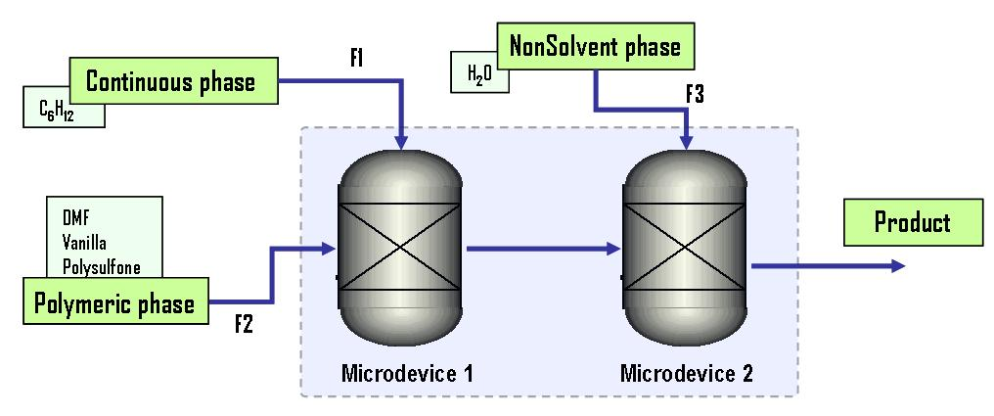
Figure 1. Microcapsule process flowsheet.
  - Integration of Process Modelling Approaches
The MICAP® module is used to perform the simulation of the PμC described in the previous section. The MICAP® tool, developed in Matlab® [2, 3], is used to link the following modelling approaches:

- Molecular simulation to study the micellization process (developed in FORTRAN), the precipitation of the polymer, size of porous and the morphology of the microcapsules including their particle size distribution. All these information are successfully predicted in comparison of experimental behaviour of the process and according to the geometry of the micromixer [1]. So, predicted features of microdoplets are optimal for the associated micromixer.
- Computer fluid dynamics simulation to predict the flow dynamics, the mixing, and mass/heat transfer processes in the microreactor. The internal structure of the microchannels has a high impact on the mixing length in both reactors, a critical factor in the second microdevice. The models are developed in Fluent®.
- Process simulation to predict the continuous production of the PμC and including the solvent recovery system. This model is described in detail in this work, and it has been developed using Matlab® and Aspen Plus®.
- Life cycle assessment to deal with the environmental impact of the process and consider the sustainability measured through the Eco-Indicator 99, as aunique measure that aggregates the different impact categories (green house effect, eutrophication…). The environmental calculations are done using SimaPro® and TEAM® using the Ecoinvent® database.
MICAP® also performs calculations to compute the effect of the operating parameters into the product of both microdevices (i. e. effect on the particle size distribution of the flow ratios between the polymeric, the continuous and the non-solvent phase).
This work is focussed at the process simulation level. Different modelling tools were used, as commercial process simulators are not prepared to efficiently handle microtechnology problems. The tasks are divided in two levels: (a) encapsulation of the MICAP® within a process simulator (Aspen Plus®); (b) PμC separation and purification/recovery of the solvents.
    - Encapsulation of MICAP® and Aspen Plus®
Current process modelling and simulating tools offer a broad variety of functionalities to develop reliable models. The process simulator selected is Aspen Plus®, but any other of the worldwide available software tools can be used (Hysys.Plant®, PROSIM®, CHEMCAD®, Pro II®, …). Any of those tools do not offer good capabilities for handling microstructured unit operations, as their main business area is to model macroscopic systems. The advantages to model process simulators in this case is minimal, as the databases (components available, thermodynamic data…) and specific build-in models are very limited. Therefore, the modelling requires an additional effort to overcame some difficulties [4].
The connection of Aspen Plus® with Matlab® has been used to extent their capabilities [5]. A link code, based on Active X and COM technology [6], was developed to allow the exchange of information between MICAP® and Aspen Plus®, thus integrating both tools in the calculation procedure. The problem of this integration is that both calculations tools are involved in several nested loops (see section 4 for more details), giving rise to convergence problems. As Aspen Plus® is a sequential-modular simulator, the modification of the process topology (inclusion/elimination of unit operations, modifications of the connectivity…) may affect the overall convergence of the system. In this way, the architecture and transfer procedure of the modules is build to promote the scalability, re-usability and flexibility of the model.
A Basic Unit Operation (BUO) was created within Aspen Plus®. The data from MICAP® is send to the BUO and the data calculated from Aspen Plus® is recovered through this BUO. The BUO acts as an encapsulate version of MICAP® within Aspen Plus® and, consequently, as a microdevice unit within the simulator (Figure 2).
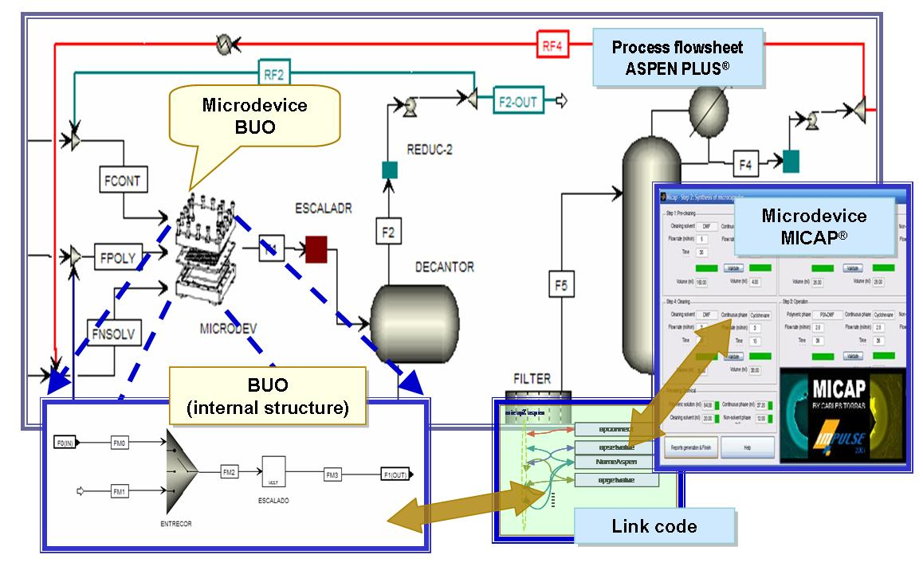
Figure 2. Encapsulation of MICAP® within Aspen Plus®.

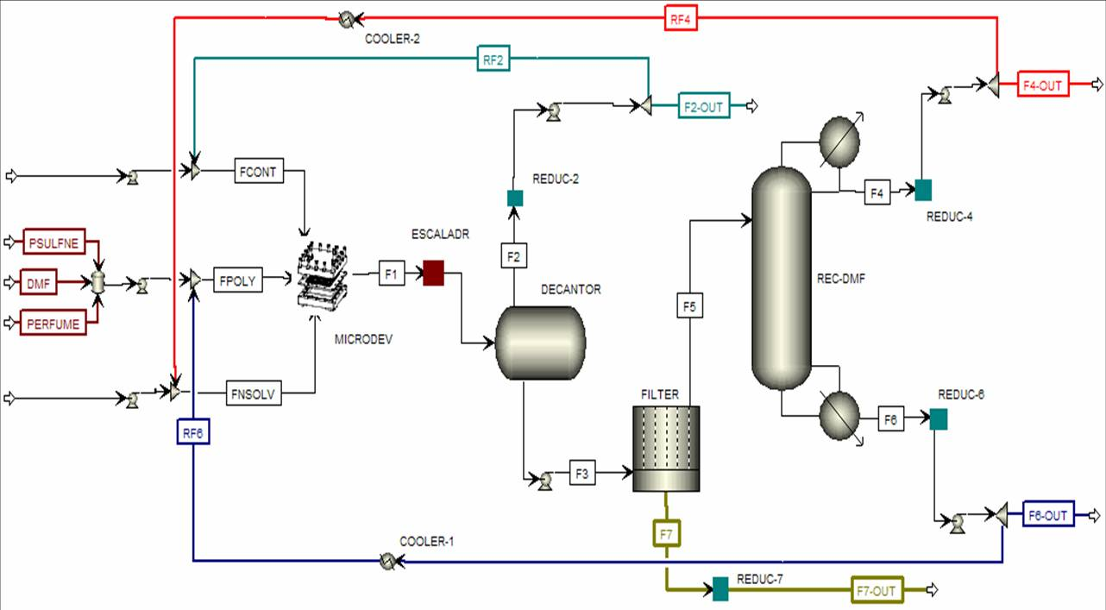
Figure 3. Flowsheet of the process in Aspen Plus®.
  - Perfume-Containing Microcapsules Separation and Solvent Recovery
The microdevice output stream contains the PμC with cyclohexane, DMF, water and perfume (vanilla). Process simulation does not alleviate the need for accurate physical property data and models. This issue becomes particularly important when the recycle stream specifications are based on the maximum impurities at trace levels. Although the separation section has not been experimentally tested, it is based in the information available. Physical properties of all components are determined by UNIFAC method except for microcapsules which properties are recovered from MICAP®. Figure 3 shows a complete diagram of the process, while component recovery and compositions are shown in Tables 1 and 2.
    - Recovery of cyclohexane
Cyclohexane is highly immiscible with water and DMF, and the modelling of the separation with a decanter is straightforward (cyclohexane recovery at the operating conditions is 98.8%). Then, the adoption of microstructured technology at the separation does not offer any a priori advantage. Therefore, the model proposed a scheme with microdevices working in parallel (N = 238) and the resulting stream is processed in a decanter, where the organic phase (cyclohexane), and the aqueous phase (PμC, DMF, water and perfume) are obtained. The number of microdevices can be modified by the user (see block ESCALADR in Figure 3), and this change of scale allows to combine multiscale process units with microstructured elements. The decanter model was improved based on the data available to consider the efficiency of the separation and the drag-out of particles.
    - Recovery of microcapsules
The average size of microcapsules in the laboratory is over 6 microns with a very small percentage under 4.5 microns (less than 2% in weight). The MICAP output provide this information in the form of a particle size distribution (psd). Based on this psd, a hydrocyclone filter has been preliminary propose to retain particles with an efficiency ≈ 98-99 % at 4.5 microns (experiment with appropriate screen and hydrocyclons filters are expected to be carried out in the near future). This is enough for PμC recovery. Due to the very small availability of experimental data, and to mimic the commercial product, PμC must be preserved in a gel media in order to keep their properties (≈ 23 % liquid). In addition, the experiments show that the porous structure of the microcapsules retains some liquid embedded (≈ 5 % w/w).
    - Recovery of water and DMF
The liquid filtrated contains DMF, water and a small fraction of perfume. Due to miscibility, perfume is recovered with the DMF (free-water). The separation is carried out in a distillation tower with very high purity degrees in the output streams. However, the energy consumption is very high in comparison of the rest of the process steps. The separation of water-DMF mixtures is the testing system for pervaporation units [7, 8]. Because energy save advantages of pervaporation units it has been currently evaluated within our work. To perform such a model, physical properties of the system, experimental validation for permeation of the pure components and for the binary mixtures and data considering real behaviour of pilot units are in progress.
    - Minimizing the environmental impacts
A key aspect in the production plant is the reuse of solvents. Recycle of 95-98 % of all solvents is achieved, thus leading to a minimization of wastes and raw materials. Nevertheless, a life cycle assessment (LCA) for the systematic evaluation of the environmental aspects of the product is performed following the cradle to grave approach, using the Ecoinvent [9] database and SimaPro® [10]. The aggregation of the impact categories (abiotic depletion, global warning, ozone layer depletion, human toxicity, photochemical oxidation, acidification, eutrophication, fresh water aquatic, marine aquatic and terrestrial ecotoxicity) into a single value (Eco-indicator 99) improves its applicability for the decision makers. Most of the environmental load is assigned to the DMF production, and the residual streams containing DMF. More effort is needed to minimize this stream, or select an alternative solvent.

Table 1. Flowrates and percentage of recovery by component.
 | F1 (kg/h) | F2 (kg/h) | F4 (kg/h) | F6 (kg/h) | Recovery (%)
DMF | 0.00087 |  |  | 0.00083 | 95.21
Cyclohexane | 0.00118 | 0.00116 |  |  | 98.80
Water | 0.01040 |  | 0.01031 |  | 99.10
Perfume | 0.00007 |  |  | 0.00003 | 50.28

Table 2. Mass fraction of the input/output process streams.
 | F1 | F2-out | F4-out | F6-out | F7-out
DMF | 0.068 | 0.000 | 0.003 | 0.962 | 0.018
Cyclohexane | 0.092 | 1.000 | 0.001 | 0.000 | 0.000
Water | 0.812 | 0.000 | 0.995 | 0.000 | 0.221
Perfume | 0.005 | 0.000 | 0.000 | 0.038 | 0.001
Polysulfone | 0.023 | 0.000 | 0.000 | 0.000 | 0.000
PμC | 0.000 | 0.000 | 0.000 | 0.000 | 0.760
  - Conclusions
There are many industrial applications of microdevices in other areas (biosensors, microprocessors…), but the state of the art in chemical engineering is below the standard application in those related areas.
The synthesis and characterisation of perfume-containing microcapsules was one of the industrial cases selected by the IMPULSE project to test the applicability of process simulation to model micro/meso/macro processes. The methodology to integrate a microdevice (developed in Matlab®) with a process simulator (Aspen Plus®) was achieved by exchanging information between the tools in both directions. The model was robust, reliable, scalable and reusable. In addition, the model was used to perform life cycle analysis. Nevertheless, the lack of experimental data has been a problem to fit some operational parameters, and more effort is required in this direction.
  - Acknowledgements
This work has been funded by the IMPULSE project (NMP2-CT-2005-011816), funded by the European Union.

Literature
[1] Production of capsules using modified lab reactor - Deliverable D3.2f. IMPULSE Project. ETSEQ-URV, February 2007.
[2] C. Torras, and R. Garcia. The [MICAP] simulator. Registered software T-177/07.
[3] Torras_MICAP_Flyer.pdf and Torras_MICAP_Oral.pdf (documents available at the IMPULSE website at the Workshop 2007 area).
[4] Aspen Plus® 12.1. User Guide. Aspen Technology Inc., Cambridge (MA), USA. 2003.
[5] A. Bojarski, L. Jiménez, A. Espuña and L. Puigjaner. Life Cycle Assessment technique coupled with simulation for enhanced sustainability of phosphoric acid production. European Congress of Chemical Engineering, ECCE-6. Copenhagen, 2007.
[6] Matlab® 7.0. External Interfaces. The MathWorks, Inc. Natick (MA), 2007. pp. (8-3) - (8-129). 2007.
[7] H. K. Lee, J. Y. Kim, Y. D. Kim, J. Y. Shin and S. C. Kim. Formation of polyurethane membranes ... effect of hard segment content. Polymer, 42, 8, (2001) 3893.
[8] D.Anjali Devi, B. Smitha, S. Sridhar and T.M. Aminabhavi. ervaporation separation of dimethylformamide/water mixtures through poly(vinyl alcohol)/poly(acrylic acid) blend membranes. Separation and Purification Technology, 51 (2006) 104.
[9] Swiss Centre for Life Cycle Inventories, The Ecoinvent database, (2006).
[10] Pré-Product Ecology Consultants, Introduction to LCA with SimaPro® 7, Pré-Product Ecology Consultants, (2006).

