Reactor Modeling for the Shenhua Direct Coal Liquefaction Project
David de Gruylª, François Parmentier^{b}
ªAxens NA, 650 College Road East, Suite 1200 Princeton, NJ, 08540, USA
^{b}RSI, ZI de Pré Millet, Montbonnot, 38330, France
Abstract
The China Shenhua Coal Liquefaction Corporation is constructing a first-of-its-kind Direct Coal Liquefaction Plant in Inner Mongolia, China, based on Axens licensing. An OTS have been developed for assisting unit start up. The main technical challenge lays in reactor modeling. The Axens Steady State modeling has been included and converted to a dynamic model by a technique similar to variable separation. The gas hold up has been modeled using an implicit multicell scheme tuned to experimental behaviour.

Keywords: Coal liquefaction reactor, steady state kinetics, gas hold up, dynamic simulation.
  - Main Text
    - Project Overview

The China Shenhua Coal Liquefaction Corporation is constructing a first-of-its-kind Direct Coal Liquefaction Plant in Inner Mongolia, China. Axens North America has developed the Basic Engineering Design for the Coal Liquefaction Unit and for the integrated H-Oil^{DC} process. The H-Oil^{DC} process is a commercially proven ebullated bed reactor process, licensed by Axens, and in this application it will hydrogenate the recycle donor solvent. Shenhua has also selected Axens and RSI to develop an Operator Training Simulator, OTS, which closely models the expected future coal liquefaction plant’s performance. Training the plant engineers and operators is critical to the success of this first-of-its-kind plant.

The coal liquefaction process utilizes a hydrogen donor solvent and hydrogen at high pressure and temperature to transfer hydrogen into the coal solids in order to produce coal derived liquids. A slurry type catalyst is used to aid this reaction. Donor solvent is produced in the H-Oil^{DC} Unit which hydrogenates coal derived liquids from the Coal Liquefaction unit.

Coal liquefaction takes place in a back-mixed reactor system with two reactors in series. The coal and hydrogen donor solvent feed are mixed with hydrogen and fed to the first stage reactor. The feeds are mixed with a recycle slurry and flow through a distributor grid at the reactor bottom which evenly distributes liquid, gas, and coal solids across the reactor. This dispersion is strongly dependent on the turbulence created by the recycle slurry stream, and this in turn has a strong effect on the gas hold-up and bubble size created. The reactor is heavily instrumented with temperature, pressure, and nuclear density level gauges at selected elevations. The physical and thermodynamic properties used in the reactor models are based on Axens’ substantial data base on coal liquefaction.

The simulation objective has been to represent precisely the behavior of the thermal effects and hydrodynamics effects and coupling between the two in-line reactors. All the modeling is done on the basis of rigorous first principles. The accumulation of various by-products (e.g. solids) have been taken into account and modeled through physical representation of an accumulation below and above the grid and effect on density readings at the various levels.

The rigorous reactor models have been completed and incorporated into the framework of the OTS. The OTS has been rigorously tested by the client and accepted. It is now in extensive use for training with the plant expected to begin operations in mid-2008.

    - Reaction Overview

The two reactors are up flow gas/liquid/solids reactors maintained with a minimum reactor temperature differential by recycling slurry product to feed via the Reactor Circulation Pumps. The outlet temperature is maintained in both reactors, thereby setting the Weight Average Bed Temperature (WABT) which is the temperature at which the reaction takes place. Hydrogen partial pressure is maintained at the outlet of each reactor to achieve the desired coal liquefaction reactions. Reactions are exothermal so a quench is used to lower the outlet temperature from the 1st Stage Reactor, and maintain the 2nd Stage Reactor temperature.

The reactions involve coal liquefaction in a slurry of donor solvent with hydrogen gas reacting directly with the donor solvent, and hydrogen transfer from the donor solvent to the coal. Coal is then transformed into liquid products, which are hydrocracked inside the same reactor.

    - OTS Emulation

The Shenhua Operator Training Simulator (OTS) was designed to mimic the control system being installed in the actual plant. As such, the graphics used in the OTS match the graphics used in the actual plant DCS.

    - Global Architecture

The reactor model is built on three distinct and parallel computation layers having specific functions.
- The first function describes the reactor’s kinetics. The kinetic model has been implemented based on Axens North America research and pilot plant results and developments. It is a first order, CSTR-like hydrodynamics. The model computes yields based on a catalytic reaction. The model takes into account the composition of the inlet coal slurry and produces light hydrocarbons from C1 to C4, 17 oil pseudocomponents of NBP from 70 to 538°C and light gases from coal hydrogenation, H2O, Ammonia, CO, CO2, and H2S. The following variables are taken into account: Arrhenius term, Average Bed temperature, Coal Hourly Space Velocity, Volumetric Gas Hold up, Hydrogen Partial Pressure and specific kinetic terms for each product. For dynamic simulation purposes, it is very important to notice that the results of the kinetic equation are steady state yields. The aim is thus to encapsulate those computation, based partly on inlet conditions and partly on reactor inventory conditions (WABT), in a computing scheme allowing dynamics to be represented. The resulting scheme is described on the attached diagram: the steady state computation and dynamic inertia are considered as separated variables. The reactor is considered as a purely inertial mass of gas and liquid characterized by a Temperature, CHSV and Gas Hold Up. The steady state kinetic computation is modeled as an operator acting on the inlet fluid stream, based on its characteristic and on pertinent reactor hold up previously mentioned variables.

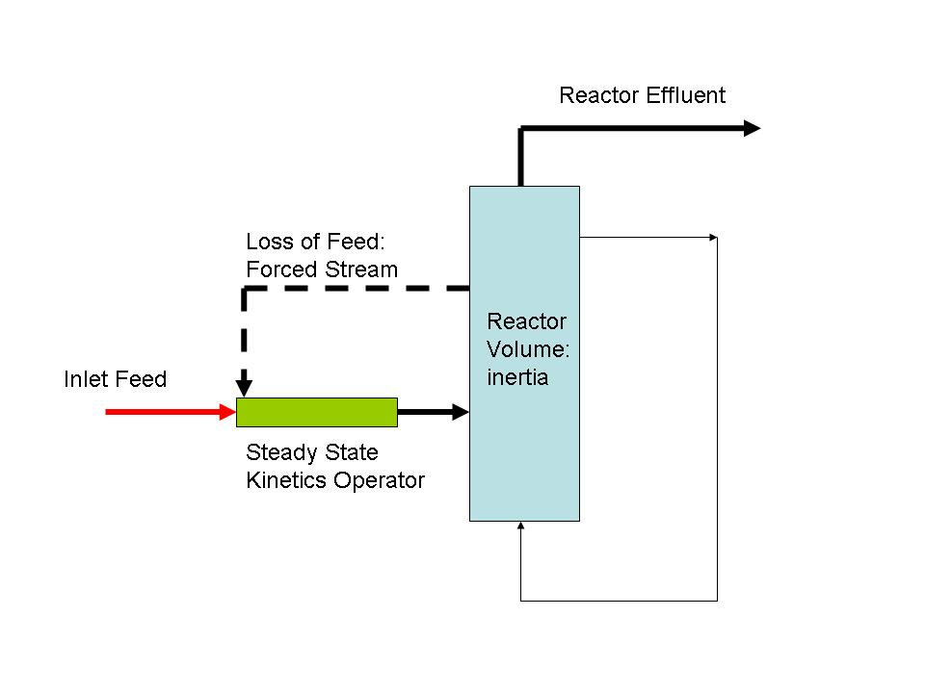

Figure 1 Kinetic Integration
- The second function is related to the management of the Heat and Mass Balance around and inside the reactor’s capacities.
- The third computing layer updates the output variables of the model. The reactor is provided with a heavy instrumentation consisting in Temperature probes, Skin Temperature probes, Pressure gauges and Nuclear Density probes.

    - Gas Hold Up modeling

The reactor dynamic computation must represent gas hold up behavior with time, in a stable, quantitative and qualitative manner. The gas hold up is the gas volume accumulation in the emulsion (ebullated) reacting in the vessel. This variable must represent some important features:

- The variation of the mixture level in the reactor: if the gas hold up decreases suddenly, the flow to the recycle pump may be stopped and recycle flow is lost, which in turn results in a bad liquid-gas dispersion, and lack of reactor homogeneity. In extreme cases, the higher nuclear density probe will measure a gas density.
- The hold up is linked to the kinetic equation, and as such has effect on yields and rates.

The modeling of this accumulation must be representative of the physical system . It must be simple enough to not create computation time problem, and it must be stable. It must be flexible enough to reproduce pilot plant and commercial plant data.
The strategy has been based on the following assumptions.
- the numerical scheme must be implicit for stability
- the reactor gas superficial velocity is dependant only of the gas hold up for small variations around one working point: no variation of bubble diameter and no effect of hold up on rising velocity for a given condition of dispersion at inlet.
- The rising velocity behavior with inlet dispersion conditions is correlated empirically by relating this velocity to total liquid flow at the reactor inlet.
- The reactor is represented as one perfectly mixed cell. The gas is assumed incompressible. This is justified by the high pressure -200 bars- and low pressure drop imposed to the reactor

From those assumptions a balance equation around a reactor cell writes:
$\frac{\text{dVg}}{\text{dt}}=\text{vi}⋅S−\text{vo}\text{.}S+τ$ (Eqn 1)
Or in finite differences:
$\frac{{\text{Vg}}_{t+1}−{\text{Vg}}_{t}}{Δt}={\text{vi}}_{t}⋅S−{\text{vo}}_{t+1}⋅S+τ_{t}$ (Eqn 2)
And taking into account that:
$\text{vo}=K\frac{{\text{Vg}}_{t+1}}{H}\sqrt{ρ_{l}−ρ_{g}}=K'⋅{\text{Vg}}_{t+1}$ (Eqn 3)
We get:
${\text{Vg}}_{t+1}=\frac{{\text{Vg}}_{t}+{\text{vi}}_{t}⋅S⋅Δt+τ_{t}⋅Δt}{S⋅K'⋅Δt+1}$ (Eqn 4)
In practice, the numerator will be computed at the beginning of each computation step as an overall initial volume by adding the volume of gas at time t in the cell with the inlet gas volume, and flashing the mixture, resulting in gas volume Vgi. The final equation reads:
${\text{Vg}}_{t+1}=\frac{{\text{Vgi}}_{t}}{S⋅K'⋅Δt+1}$ (Eqn 5)

The coefficient K is computed by the following equation:
$K=V_{\text{slip}}⋅f({\text{Ql}}_{\text{inlet}})$ (Eqn 6)
This simple model has proven highly stable and successful, as will be illustrated by the following figure.
The industrial scheme contains two reactors in cascade, meaning that the upstream upsets have a strong effect on the downstream reactor state.

Let us assume a loss of recycle on the upstream reactor due to a recycle pump failure. The dispersion of gas at inlet becomes bad and bubbles in the reactor are larger, thus rising more quickly. The figure shows the evolution of the most pertinent variables.
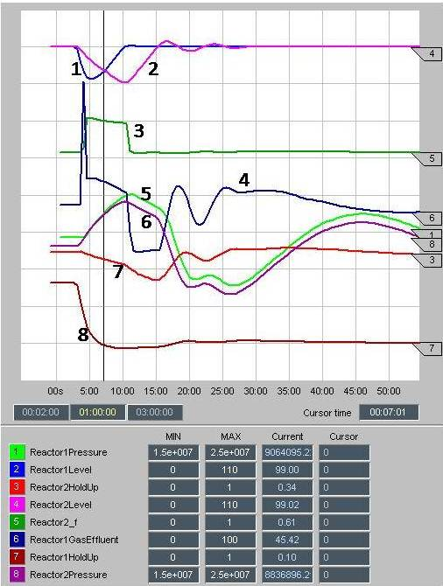
Figure 2 Process variables for pump loss Figure 5 Nuclear probes values for pump loss
For figure 4 curves references are 1 Upstream (1) reactor Level, 2 Dowstream (2) reactor Level, 3Downstream reactor f Factor, 4 upstream Reactor Gas effluent, 5 Upstream reactor Pressure, 6 Dowstream reactor Pressure, 7 Downstrean reactor Gas HoldUp, 8 Upstream reactor Gas HoldUp

The Reactor 1 hold up shows a fast decrease in gas holdup from around 26 % to 10%. This induces a strong decrease in the reactor 1 emulsion level that uncovers the highest Nuclear Density Probe. After this transient, the level increases steadily due to accumulating liquid feed. The effluent from the first reactor becomes only gas, with the volumetric flow rate of the entering mixture. Due this larger gas flow and to downstream process control strategy, the pressure increases in the reactor 1. After this transient period the reactor reach a new state with a different hold up, and the overflow becomes again two phase.
The behavior of the downstream reactor is strongly modified by the upset. The pressure follows a parallel variation. The gas hold up decreases, in two periods: in a first time when the reactor 1 overflow is full gas because the decrease in inlet liquid flow create a poorer dispersion in the grid and larger bubbles, and in a second time when the reactor 1 overflow becomes two phase because the inlet gas flow rate is low. The level in the second reactor decreases partly because of gas hold up decrease, and partly because no more liquid enters by the feed. The level increases again when the overflow of the reactor 1 becomes biphasic. After one hour the reactor train reaches a new steady state. Finally the gas hold up of the reactor 2 is recovered.
  - Conclusion
The dynamic operator training simulator has been successfully developed and demonstrated for the Shenhua direct coal liquefaction project and is now in regular use for training plant operators prior to plant startup. The OTS incorporates process kinetics as well as real commercial plant experience on the fluid dynamics and potential upset scenarios.
The steady state kinetics issued from the pilot plant studies has been included in a computational scheme allowing to represent dynamic and transient behaviour satisfactorily enough for an OTS purpose by a technique of variable separations. The implicit scheme of gas hold up computation has proven succesfull in simulating realistically a complex reactor performance and difficult phases like start up and shut down, while keeping conceptual simplicity.
  - Glossary
Vg : gas Volume in reactor emulsion (m3)
vi : inlet superficial velocity of gas (m/s)
vo : outlet superficial velocity of gas (m/s)
S: reactor section (m2)
τ : volume evolved by chemical reaction (m3/s)
t: time (s)
K: slip coefficient
H: reactor cell’s height (m)
ρ: density (kg/m3)
Ql_{inlet}: volumic flow of liquid inlet to reactor’s cell (m3/s)
V_{slip:} Uncorrected slip coefficient.
  - References

B. Wayne Bequette, 1998,Chapter 4, Process Dynamics, Prentice Hall
W.H. Press, S.A. Teukolsky, W.H. Vetterling, B.P. Flannery, 2002, Chapter 19, Numerical recipes in C++, Cambridge University Press
D de Gruyl, oct 2005 Coa l Liquefaction reactor Model, Internal document, Axens N.A

