Modelling solids transport in an industrial flighted rotary dryer
M.E. Sheehan¹, O. Ajayi¹, A. Lee¹
¹School of Engineering, James Cook University, Douglas Townsville 4810, Australia

Abstract
Flighted rotary dryers are used in a wide range of applications, including drying mineral ores and raw sugar. One such example of their application is a large flighted rotary dryer that is used to dry and granulate spherical zinc sulphide particles as part of the Zinifex Century Ltd Karumba zinc processing facility in far North Queensland, Australia. A series of residence time distribution (RTD) pulse tracer tests were performed using lithium chloride as tracer. Tests were undertaken both before and after a significant scheduled cleaning operation to remove significant internal built up scale. This paper describes the RTD collection methodology. The residence time distributions were used to fit a pseudo-physical compartment model to the Zinifex dryer. The model structure, compartment numbers and some of the model transport coefficients were derived through geometric modelling, based on flight and dryer geometry and solids physical properties. Simulations and parameter fitting were undertaken using gProms process modeling software. Fitted parameters include transport coefficients which were used to estimate the effects of air drag on particle movement as well as estimate the rate of kilning or particle rolling along the base of the dryer. Compartment model parameters and derivation of the required compartment model structure are described in this paper. The RTD was found to be able to be reasonably well reproduced by the compartment model.

Key words: experimental validation, compartment model, RTD, industrial applications, multi-scale, data-driven.
  - Introduction
Flighted rotary dryer are used for a variety of purposes including drying, heating and cooling, agglomeration and reaction in a wide range of industries such as the minerals processing, sugar and cement industries. They are an important unit operation for capable of dealing with sticky solid materials that may be difficult to fluidize. In zinc refining, undertaken by Zinifex Pty Ltd in Karumba North Queensland, zinc and lead concentrates are agglomerated and dried in a co-current flighted rotary dryer. Control of the concentrate quality including agglomerate size and moisture content are critical to the handling and shipping of these materials. In order to optimise and control these units it is necessary to be able to characterise the impact of operational variables on the performance of the dryer. In this paper, emphasis is placed on modelling in order to estimate the residence time distribution of the solids within the dryer and the development of the parameter values based on both operational variables and solids physical characteristics, such as stickiness and angle of repose. Furthermore, a model capable of determining the distribution of solids between the base of the dryer and cascading through the co-current air stream is developed, as this distribution is important in estimating drying performance.
It has been well-established that solids movement in flighted rotary dryers is not plug flow and residence time distributions obtained from tracer studies on both experimental, systems [1], and full-scale industrial dryers [2,3] consistently indicate non-normal distributions. Residence time distributions are a powerful experimental measurement used to characterise the extent of dispersion within dryers [4]. In this study the residence time distribution or RTD is utilised to determine a suitable compartment model structure for modelling the dryer solids transport.
There are many models that have been developed to estimate mean residence times and holdup in rotary dryers. The most established and widely used of these equations remains the Friedman and Marshall relation [5]. However, this correlation has significant error [6], and is invariant to internal flight geometry. Alternative models include geometric analysis of flight discharge [7,8]. A significant breakthrough in terms of dryer modelling occurred with the introduction of the two phase model of Matchett and Baker [9]. In their model the dryer holdup was separated into two interacting phases to discriminate between the active or airborne solids and the passive or “flight restrained” solids that undergo rolling along the base of the dryer and are lifted up in flights for delivery to the airborne phase. Further advances in dryer modelling have utilised the two-phase analogy of Matchett and Baker but enhanced the approach by developing appropriate compartment or “tanks in series” models [10] in order to match experimental RTD’s. These models have largely been empirical and utilize model parameters that were unrelated to physical or operational characteristics or have required dryer specific calibration and testing [2].
A recent dynamic compartment model was developed by Sheehan et al [11], with model parameters described in Britton et al [12]. Their model combined the two phase approach of Matchett and Baker within a twin tanks in series compartment model structure and utilised operational, geometric and solids physical properties to determine the majority of parameter values and also to define the compartment model structure and compartment lengths. Their model addressed many of the reported deficiencies of previous models, such as unrealistic bed depths observed in [10], and was reported [12] to be intuitively correct in its responsiveness to changes in operational parameters such as rpm and air flow. The model was derived to ensure realistic estimates of dryer solids distributions and was also capable of accurately modelling residence time distributions in industrial counter-current airflow sugar dryers. However, this model was developed and validated within the sugar industry where counter-current gas flow and constant (with respect to dryer length) flight dimensions and orientations are utilised. In many circumstances (including the Zinifex Pty Ltd zinc concentrate dryer) air flow is co-current. Furthermore, flight geometry and flight frequency is often varied along the length of the dryer to better handle changing solids properties (such as agglomeration). There are even examples were portions of the dryer length contain no flights and the process of kilning (or rolling) dominates.
This paper illustrates the alteration of the structure and parameters of the Sheehan et al [11] twin-tanks in series model to account for Zinifex Pty Ltd’s alternative flight configuration and co-current gas flow. The model is then used to compare against residence time distribution curves obtained by tracer testing, undertaken on the industrial dryer in question.
  - Experimental and Industry testing

The inlet static angle of repose was measured to be 35 ± 3º and the outlet static angle of repose was measured to be 31 ± 1º. The dynamic angle of repose, which is used in the model, was not measured directly but was assumed to be approximately 39.5º. An average bulk density for both the outlet and inlet solids was taken to be 1800 kg/m³. The geometric characteristics of the dryer were taken from design drawings and internal inspection of the dryer internals during shutdown was used to confirm the extent of flight scaling. The dryer was 23 m long and 3.9 m in diameter, is sloped at 4º and rotates at 3rpm. The dryer was represented by using four separate flighted and nonflighted sections within the dryer. These include: An un-flighted section; 30 serrated flights in the following section; 30 flights with an alternative flight design in the following section; and a final un-flighted section. During the tracer tests described below, the operational characteristics of the dryer were recorded directly from the online distributed control system

Two separate pulse tracer tests were undertaken. The first of the tests was undertaken immediately after the dryer had been cleaned to remove built up scale, which was observed to gum up almost completely the section 3 flight internals. The second tracer test was undertaken just prior to a scheduled clean when the dryer was reasonably assumed to be fully caked with solids, reducing the effectiveness of the flights and forcing the solids to kiln through the dryer. Approximately 7-9L of saturated lithium chloride solution was added to the feed hopper shute as near to instantaneous as possible and the time of addition noted. All elemental lithium analysis was undertaken using ICP-MS techniques at the Advanced Analytical Centre (AAC) at James Cook University. A mass balance was performed on the experimental residence time distributions to determine the recovery of lithium. The first RTD test showed poor recovery of lithium (65%) while the second test showed slightly improved recovery (72%). It is thought that the lithium solution in the first test was not added in the best location and some losses at the inlet shute were realised.
  - Modeling methodology
    - Model Structure

The pseudo physical compartment model presented in [11] and [12] for counter current flighted sugar dryers is modified in this paper in order to represent the Zinifex Pty Ltd’s dryer. The reader is referred to these papers for complete descriptions of the geometric properties used in this work. The original structure described in these papers accounted for counter-current air flow and flights that were of constant geometry and frequency down the entire length of the dryer. The dryer that is examined in this paper is a co-current device. Furthermore, different flight sections are used along the dryer length. The overall dryer model illustrating the four sections (C1: un-flighted, C2: type A flights, C3: type B flights and C4: un-flighted) is presented in Figure 1.
    - Model Parameters

The general structure and use of the parameter values is illustrated in Figure 2. The notation M_{P} refers to the passive solids defined as either contained in the flights or rolling along the base of the dryer whereas M_{A} refers to the active or airborne solids that are falling through the co-current air stream. Distinguishing between these two solids phases is critical to the development of energy blances on these dryers. The model parameters characterizing the flows between cells were determined by either geometric analysis (i.e. k₂, k₃, C_{L}) based on the mass contained in the flights (M_{p}) or parameter estimated (i.e. k₄ and C_{F}) based on minimising the difference between the modelled RTD and the experimental RTD data points.

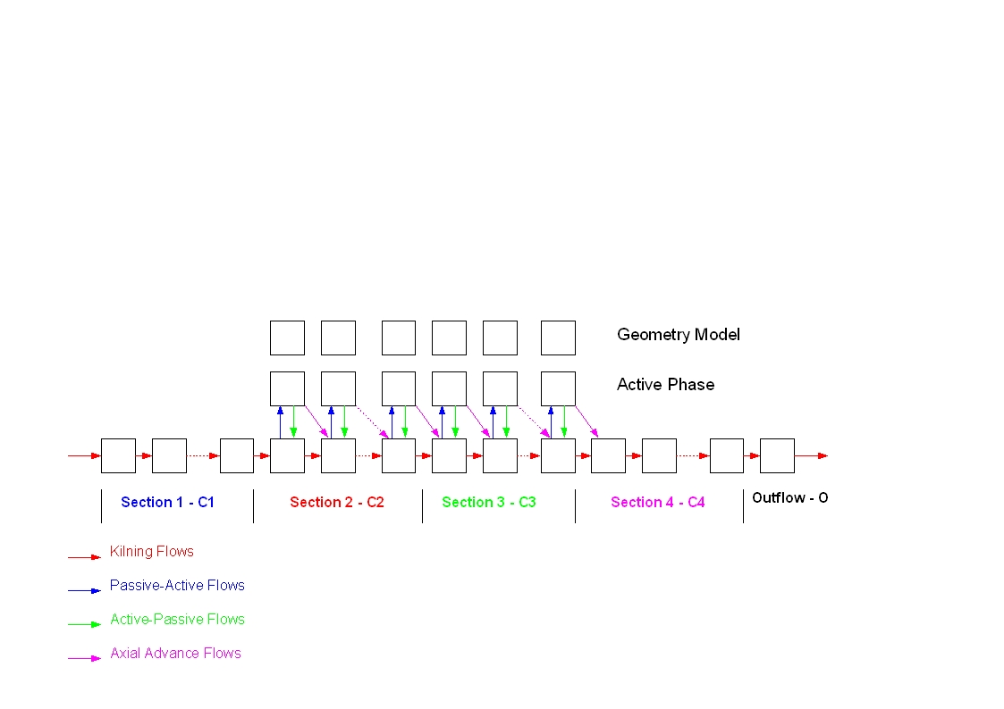
Figure 1. Overall structure of the pseudo-physical compartment model for the Zinifex Pty Ltd. industrial dryer. The outflow-O cell was used to track tracer mass and is not a component of the dryer. The Geometry Model represents an “information” cell passing relevant transport coefficients to the flighted section cells.
(C_{F}+C_{L,i-1} - C_{F}C_{L,i-1}) k_{3 i-1}

(C_{F}+C_{L,i}-C_{F}C_{L,i}) k_{3 i}

m_{A i}
m_{P i}
CELL i
k₄
k₄
k_{2 i}
(1-C_{L,i}) (1-C_{F}) k_{3 i}

Figure 2. General summary of the transport coefficients used in the pseudo-physical compartment model. When used within the dynamic model, each transport coefficient is multiplied by the mass of solids in the cell from which the flow leaves or originates. For example, the rate of kilning flow (kg/s) from passive cell i is equal to $k_{4}m_{P,i}$.
Flows between active and passive cells (k₂ and k₃) and also flighted section cell lengths were determined by undertaking geometric analysis of the free flowing particles being discharged from the flights, based on the distribution of mass between the active and passive cells. The maximum flight capacity, the maximum loading (M_{load}) at the design point as defined by Porter [13], the mass of solids actually contained in the flights (M_{p}), as well as the flight discharge rates, were all used to determined active and passive cycle times, t_{a} and t_{p,} according to the methodology presented in [12]. t_{a} is the time taken for a particle to fall through the gas stream and t_{p} is time taken for a particle to travel in the flights back to its discharge point. The parameter values for the gross flows between active and passive cells in sections C2 and C3 were set to $k_{2_{ i}}=\frac{1}{t_{P_{ i}}} \text{and} k_{3_{ i}}=\frac{1}{t_{A_{ i}}}$. Transport coefficients characterising the kilning flows between passive cells (k₄) were parameter estimated based on the constant relative variance model (standard deviation from 0.5 to 5) within the gProms modelling environment based on the fit to the clean dryer experimental RTD data points.
Minimum cell lengths in the flighted sections were pre-determined by using undertaking a particle-air drag analysis (assuming spherical 5mm diameter particles and taking the Schiller-Naumann [14] approximation to the drag) to determine the maximum longitudinal advance of the discharging particles falling through the dryer cross section. Cells were sized to ensure no particles acting under gas drag conditions would be dragged beyond the adjacent passive cell. A comparison of the “average” longitudinal advance without airflow, determined by geometric analysis and the dryer loading, was used to define C_{L}: the proportion of solids falling into the next passive cell. Because this parameter is based on the geometric analysis and masses of solids in the passive and active cells, this parameter varies in each cell pair, i. The split parameter (C_{F}) characterising the additional effects of air drag increasing the fraction of solids falling into the next passive cell (i.e. the drag influenced particles) could be determined using parameter estimation using the constant relative variance model. However, CFD simulations by the authors suggests that this effect is minimal due to gas bypassing the falling curtains. For simplicity this parameter was set to zero (i.e. C_{F} =0) in this work.
Additional constraints were added to the model to simulate the progression from un-scaled, or clean, to scaled. Based on photographic evidence, only the third section (C3) of the dryer was assumed to be scaled to a significant degree. Photographs indicate that these flights were completely covered at the time of the scaled test. A scaling factor was added to the model to simulate the effects of the flights becoming clogged, and their capacity being reduced. The scaling factor (S:0 for clean; S:1 for 100% scaled) progressively reduced the flight capacity (i.e. $M_{\text{load}}|_{\text{scaled}}=\left(1−S\right)⋅M_{\text{load}}|_{\text{unscaled}}$) in the third section of the dryer only. In this way the scaling of the dryer effected other geometrically determined model parameters (average fall time for example) and limited the transport of solids from the passive phase to the active phase.
    - Model Simulations
The model was simulated using gProms [15] using the variable timestep backward differentiable formulae. Excel was used for geometric analysis and to determine geometric correlations in terms of solids angle of repose and degree of filling (i.e. 100% full is a design loaded dryer). The R² values for the all type A and type B flight correlations were 0.999. Parameter estimation was undertaken to determine values for the kilning constant (k₄) and number of tanks in the clean dryer model. These were based on minimizing the residual errors between a simulated tracer test and the actual tracer test on the clean or un-scaled dryer using a constant relative variance model. The amount of tracer added to the model in order to simulate the experimental test was based on the amount of tracer (lithium) actually measured in the outlet rather than the tracer added to the inlet (i.e. the integral of the experimental tracer RTD curve determined via the histogram method of area determination). This was done to achieve consistency between the model and experimental lithium concentrations. Average concentrate feed rates, which were based on the distributed control system data, were used for both tests (115t/hr and 137t/hr for un-scaled and scaled tests respectively). Parameter estimations were also used to verify that the air drag coeffcient should take a value of 0.
  - Results and model comparision
The optimised model fit to the experimental RTD using parameter estimated values for K₄ (0.02095), C_{F} (0.0) and N_{tanks} (50,17,18,198) is shown in Figure 3. It can be seen that the model is not a perfect fit to the experimental RTD data. This is assumed to be a result of both percieved inaccuracies in the experimental data and deficiencies in the model structure. For example, alternative parameter estimations (K₄ (0.01758) and C_{F} (0.10)) achieved slightly larger values of the optimised objective function, but the resultant optimised model RTD’s were also very similar. Uncertainty in the precise flight geometries may be another reason for the observed inconsistencies in the match between the model and experimental RTD’s.
Figure 3. Comparison of simulated and experimental RTD’s for clean dryer system: K₄ = 0.02095 and C_{D} = 0.0.
In Figure 4 the model fit to the scaled dryer is illustrated. This Figure shows the fit to the scaled dryer using the k₄ value estimated from the clean dryer parameter estimation (0.02095) and a scale constant of S = 1 (100% scaled). It also shows the fit to the scaled dryer experimental RTD for both S= 0.5 and S = 1 using a newly parameter estimated (at S=1) value of k₄ equal to 0.0250. It is reasonable to expect the kilning constant (k₄) to be different when the dryer is scaled due to diameter reductions. The number of tanks was not altered for the scaled dryer. The model fit to the experimental data is better for the scaled dryer and is thought to be a result of improved experimental data.
  - Conclusions
In this paper a compartment model for counter-current flighted rotary dryers was modified in order to simulate an industrial co-current flighted rotary dryer. Separate sections were included to account for differences in flight geometry along the dryer length. Experimental residence time distribution data from the industrial dryer was used to determine optimal model constants. The quality of the experimental data is critical to the successful use of these types of model. A parameter was introduced to simulate the effects of material scaling inside the dryer. The fit to the experimental data for both scenarios (scaled and unscaled) was reasonable, indicating that the underlying geometric treatment of flighted rotary dryer solids transport is a sound approach.
Figure 4. Experimental RTD data for the scaled dryer at 137t/hr feed rate. Simulated RTD’s are shown using parameters estimated from the clean dryer (100% scaled) and also using parameters estimated using the scaled dryer RTD data where the optimum k₄ was found to be 0.025.
  - Acknowledgements
The authors would like to thank: Patrick Owens (JCU) and Dr Y. Hu (JCU-AAC) for their help in collection and analysis of the RTD data; Ross Ellen for his help in characterising dryer geometry; and Zinifex Pty Ltd for funding this work.
References
[1] Sherritt, R.G., Chaouki, J., Mehrotra, A.K. & Behie, L.A., Chem. Engg Sci., 58 No.2 (2003) 401-415.
[2] Renaud, M., Trusiak, J. & Thibault, A., Drying Tech., 18 No.4-5 (2000) 843-865.
[3] Sheehan, M., Schneider, P.N., Monro, A. & Vigh, S., Proc. of the ASSCT, 24 (2002).
[4] Fogler, H.S. (ed) Elements of Chemical Reaction Engineering, 3rd edition, Prentice Hall, New Jersey, 1999.
[5] Freidmann, S.J. & Marshall, W.R., Chem. Engg Prog., 45 No.8 (1949) 482-493.
[6] Shahhosseini, S., Cameron, I.T. & Wang, F.Y., Drying Tech., 18 No.4-5 (2000) 867-886.
[7] Sherritt, R.G., Caple, R., Behie, L.A. & Mehrotra, A.K., Canadian J Chem. Engg, 71 (1993) 337-346.
[8] Wang, F.Y., Cameron, I.T., Litster, J.D. & Rudolph, V., Drying Tech., 13 No.5-7 (1995) 1261-1278.
[9] Matchett, A.J. & Baker, C.G.J., J Sep. Proc. Tech., 8 (1987) 11-17.
[10] Duchesne, C., Thibault, J. & Bazin, C., Ind. Engg Chem. Res., 35 (1996) 2334-2341.
[11] Sheehan, M., P.F. Britton, P.A. Schneider, Chem. Engg Sci., 60 (2005) 4171-4182.
[12] Britton, P.F. Sheehan, M.E. Schneider, P.A. Powder Tech., 165 (2006) 153-160.
[13] Porter, S.J., Trans. Instn. Chem. Engrs., 41 (1963) 272-280.
[14] Schiller, L. and Naumann, Z., Zeitschrift des Vereines Deutscher Ingenieure, 77 (1935) 318-320.
[15] gPROMS® v 3.0.3., Process Systems Enterprise Limited, Bridge Studios, 107a Hammersmith Bridge Rd, Condon W6 9DA, UK. 2006.

