Large eddy simulation of particle dispersion in a straight, square duct flow
Michael Fairweather, Jun Yao
Institute of Particle Science and Engineering, School of Process, Environmental and Materials Engineering, University of Leeds, Leeds LS2 9JT, UK
Abstract
Numerical simulations of three sizes (1, 50 and 100 μm) of particle dispersion in fully developed turbulent duct flows at three Reynolds numbers up to 250,000 are reported. Results were obtained using large eddy simulation combined with Lagrangian particle tracking under conditions of one-way coupling between the flow and particles. The results demonstrate that particle dispersion in duct flows is not only affected by particle size, but also by the flow Reynolds number. Small particle size, or high Reynolds number, are found to cause the particles to move more erratically in the flow, and to be more influenced by the flow turbulence and secondary motions. In addition, the secondary flow formed in the cross-section of a duct has a significant effect on particle dispersion in the transverse direction, whilst gravity is more influential on particle dispersion and deposition in the flow direction. The results obtained are of relevance to nuclear waste processing applications where two-phase mixtures need to be kept as homogeneous as possible to discourage the formation of beds of solid particles which can promote pipe blockages.

Keywords: Large eddy simulation, particle dispersion, square duct flows
1. Introduction
Controlling particle dispersion in turbulent flows in pipes and ducts can be used to improve the efficiency of heat, mass and momentum transfer processes in a number of industrial and environmental applications. Of particular interest in this study are processing applications for nuclear waste treatment where it is desirable that the two-phase waste mixtures are kept as homogeneous as possible to prevent, or at least discourage, the settling out of solid particles to form beds which can promote pipe blockages. However, the turbulent dispersion of particles in pipes, and especially in square ducts, is not thoroughly understood due to the limited amount of research conducted on such flows. A number of studies have focussed on turbulent single-phase flows through square ducts, including experimental investigations (Brundrett and Baines, 1964; Launder and Ying, 1972; Gessner et al., 1979), direct numerical simulations, DNS (Gavrilakis, 1992) and large eddy simulations, LES (Madabhushi and Vanka, 1991). All of these studies have demonstrated that turbulence-driven secondary motions that arise in duct flows act to transfer fluid momentum from the core of the flow towards the walls. There exist very few studies of particle-laden turbulent flows in a square duct. Winkler et al. (2004) did, however, utilise LES to investigate the preferential concentration of finite-inertia particles in such flows, especially near the walls of the duct. Sharma and Phares (2006) also employed DNS to predict longitudinal and lateral single particle- and pair-dispersion statistics, although gravity effects were neglected in this work. More recently, Fairweather and Yao (2007) studied particle deposition in a fully developed turbulent flow in a duct at a Reynolds number of 36,500. The present work extends the latter to investigate the factors that affect particle dispersion in duct flows at various Reynolds numbers.
2. Mathematical model
2.1 Flow Configuration
A schematic diagram of the duct geometry and the co-ordinate system used is shown in Fig. 1. The flow is three-dimensional and described by a Cartesian co-ordinate system (x, y, z), in which the z axis is aligned with the flow streamwise direction, the x axis is in the direction normal to the floor of the duct, and the y axis is in the transverse direction. The corresponding velocity components in the (x, y, z) directions are, respectively, (u, v, w). The cross section of the duct is square with sides L_{x} = L_{y} = 2h, and the length of the duct is L_{z} = 8h, where h = 0.02 m. The boundary conditions for the momentum equations are no-slip at the duct walls. To avoid having to specify inflow and outflow conditions at the open boundaries of the duct, it is assumed that the instantaneous flow field is periodic along the streamwise direction, with the pressure gradient that drives the flow adjusted dynamically to maintain a constant mass flux through the duct. The computational results reported were obtained with cubic grids for which Δx = Δy = Δz, thereby ensuring a constant filter width of the LES equations in each of the three co-ordinate directions. Three flow Reynolds numbers were considered, with Re_{b} = 4410, 36,500 and 250,000, based on the centerline velocity and duct side length. The corresponding numerical grids used in the computations were 41×41×161, 61×61×241 and 81×81×321, respectively.
2.2 LES Approach
In LES only the large scales of motion are directly computed, whilst the small scales are modelled. Any function is decomposed using a localised filter function, such that filtered values only retain the variability of the original function over length scales comparable to or larger than that of the filter width. The present work used a top hat filter as this fits naturally into a finite-volume formulation. This decomposition is then applied to the Navier-Stokes equations, giving rise to terms which represents the effect of the sub-grid scale (SGS) motion on the resolved motion. The SGS stress model used was the dynamic model of Germano et al. (1991), implemented using the approximate localization procedure of Piomelli and Liu (1995) together with the modification proposed by di Mare and Jones (2003). This model represents the SGS stress as the product of a SGS viscosity and the resolved part of the strain tensor, and is based on the possibility of allowing different values of the Smagorinsky constant at different filter levels. In this formulation the model parameter is numerically well behaved, and the method is well conditioned and avoids the irregular behaviour exhibited by some implementations of the dynamic model. Test-filtering was performed in all space directions, with no averaging of the computed model parameter field. Computations were performed using the computer program BOFFIN (Jones, 1991).
2.3 Lagrangian Formulation for Particles
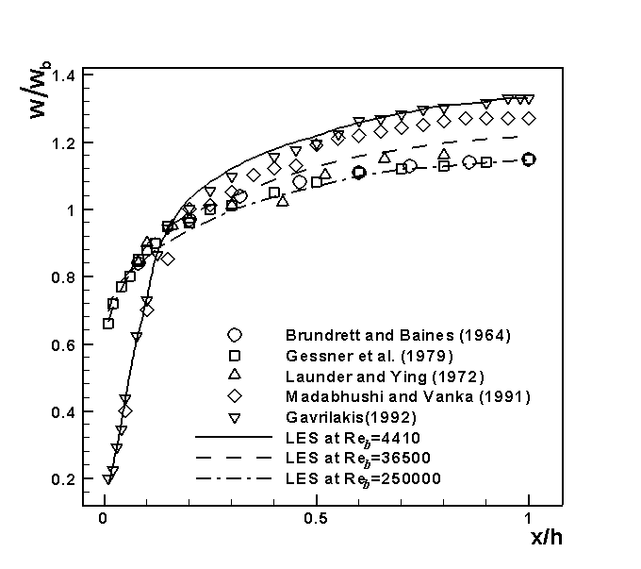
The solid phase was modelled using a Lagrangian approach (Fan et al., 2002) in which the particles are followed along their trajectories through the flow field. To simplify the analysis, the following assumptions were made: the particle-laden flow is dilute; interactions between particles are negligible; the flow and particles are one-way coupled, i.e. the effect of particles on the fluid is neglected; all particles are rigid spheres with the same diameter and density; and particle-wall collisions are elastic. The Lagrangian motion of a rigid, spherical particle suspended in a flow is governed by a force balance equation, described in detail by Maxey and Riley (1983). Even though a number of possible forces (including Stokes drag, lift, gravity, virtual mass and Basset history) can act on a particle, many of these may be neglected without any appreciable loss of accuracy, depending on the particle inertia. The most important force acting on the particle is the Stokes drag force, with gravity also important depending on the orientation of the flow. In this study, Stokes drag, gravity and buoyancy forces were considered, and a particle was assumed to interact with a turbulent eddy over a certain period of time, that being the lesser of the eddy lifetime and the transition time. A fourth-order Runge-Kutta scheme was used to solve the equation of motion, given the initial particle location and velocity. Particle and liquid densities were set to ρ_{p} = 2,500 and ρ_{l} = 1,000 kg m⁻³, respectively, with a value v_{l} = 1.00×10⁻⁶ m² s⁻¹ assumed for the kinematic viscosity of the liquid. Three particle diameters were considered, namely d_{p} = 1, 50 and 100 μm, corresponding to particle relaxation times of τ_{p} = 1.39×10⁻⁷, 6.94×10⁻⁶ and 1.39×10⁻⁵ s, where τ_{p} = ρ_{p} d²_{p}/18ρ_{l} v_{l} based on Stokes drag law. The particle calculations also assumed a periodic boundary condition in the streamwise direction.
Figure 1. Schematic of the duct geometry and the co-ordinate system.
Figure 2. Streamwise mean velocity distribution along the lower wall bisector at different Reynolds numbers: Brundrett and Baines (1964) Re_{b} = 83,000; Gessner et al. (1979) 250,000; Launder and Ying (1972) 215,000; Madabhushi and Vanka (1991) 5,810; and Gavrilakis (1992) 4,410).
3. Results and Discussion
3.1 Flow Field
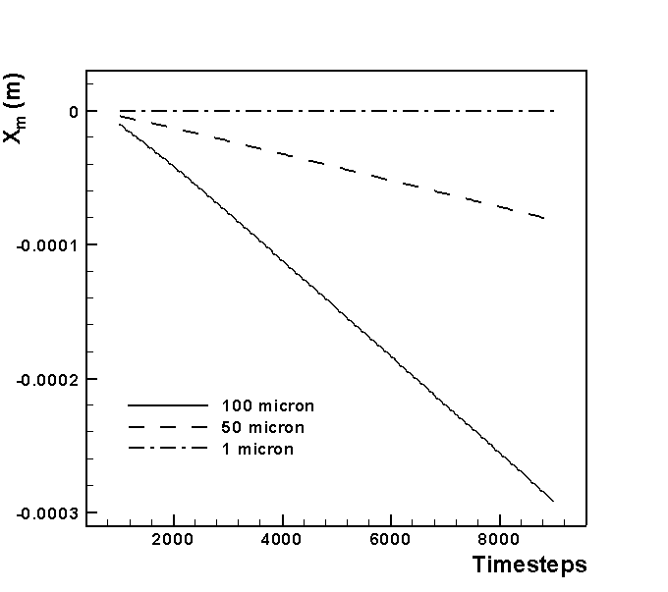
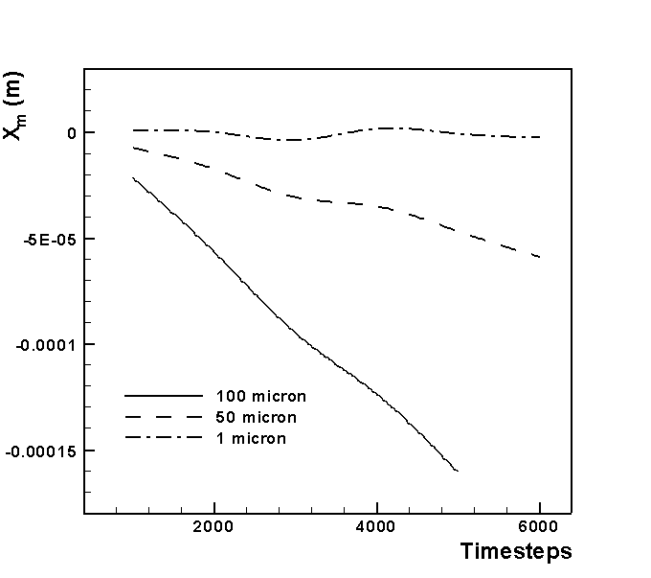
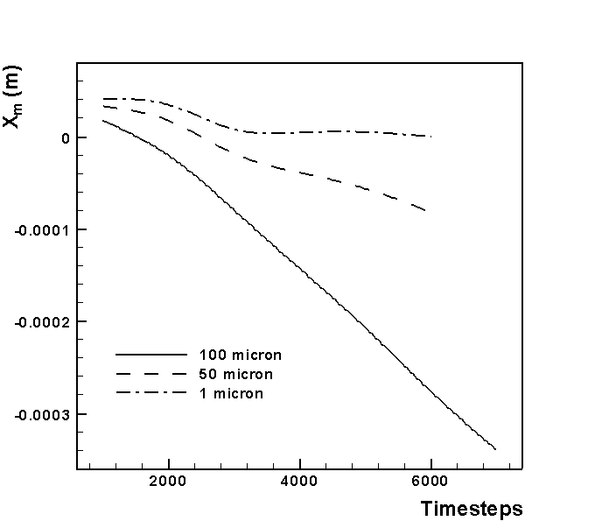
The formation of secondary flows in the duct cross-section has been successfully predicted and reported in previous work (Fairweather and Yao, 2007). The predominant effect of the secondary motion is the induced transport of streamwise momentum towards the corners of the duct, with the iso-contours of the mean streamwise velocity near the wall becoming distorted as a consequence. Velocity vectors, averaged over the four quadrants, reveal two streamwise, counter-rotating vortices in each corner that characterise the flow, with a high degree of symmetry evident about the corner bisectors. The maximum secondary velocity in the simulations was ≈ 2.5% of the bulk velocity, with Brundrett and Baines (1964) reporting a value of 2.2%. The effect of Re_{b} on the mean streamwise velocity is shown in Fig. 2, where the velocity is normalized by the bulk velocity along the lower wall bisector (y/h = 1). It can be seen that the ratio of the centerline streamwise to the bulk velocity decreases with increasing Re_{b}. This is because the profiles of streamwise velocity flatten, and gradients in the wall regions steepen, due to increased turbulent mixing at higher Re_{b}. Calculated profiles are consistent with this trend, and in agreement with the experimental and numerical studies of duct flows noted above.
(a)
(b)
(c)
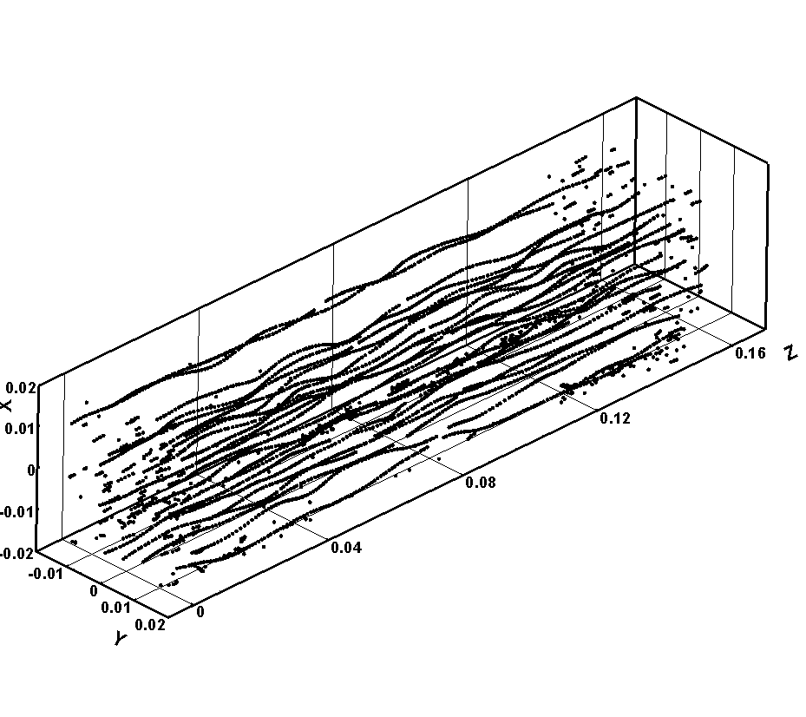
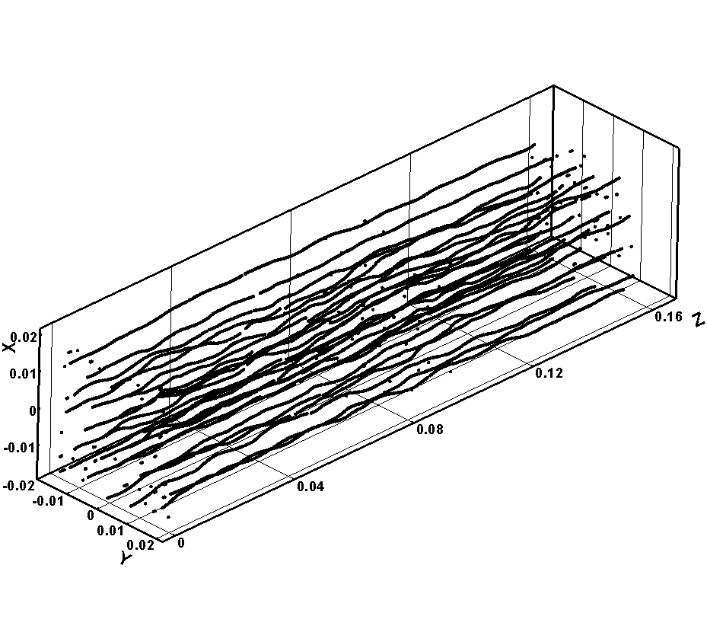
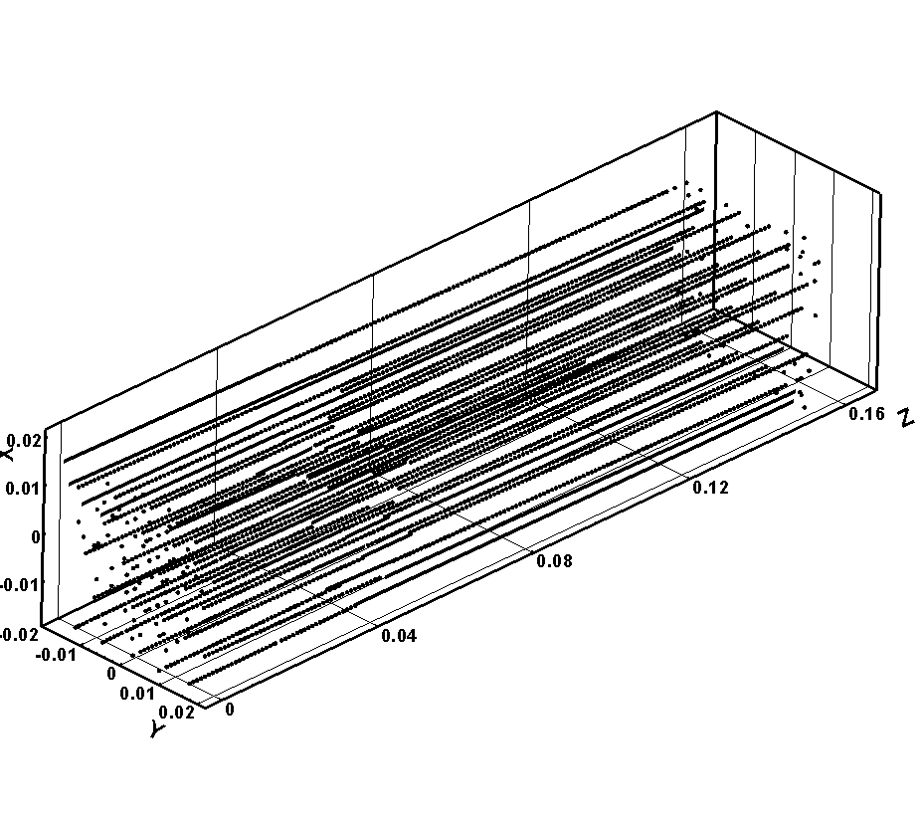
Figure 3. Mean value of particle displacement in normal direction at various Reynolds numbers (time step = 5.61×10⁻⁵ s): (a) Re_{b} = 4,410; (b) 36,500; and (c) 250,000.
(a)
(b)
(c)
Figure 4. Particle (50 μm) dispersion in duct flows at various Reynolds numbers: (a) Re_{b} = 4410, after 2 s; (b) 36,500, after 0.4 s; and (c) 250,000, after 0.2 s.
3.2 Particle Tracking
To study particle dispersion in the duct, mean values of the particle distribution in the x direction are considered (Yao et al., 2003); X_{m}(t)=∑X_{i}(t)/n_{i}(t), where n_{i}(t) is the total number of particles distributed in the computational domain at time t, X_{i}(t) is the particle displacement in the normal direction at t, and X_{m}(t) is the mean value.
Fig. 3 shows mean values of the particle distribution (X_{m}) in the duct for the three Re_{b} considered. The results demonstrate that for all cases, X_{m} decreases with time due to the effect of gravity, with the decrease with time steepening with particle size. Moreover, the profiles given in Fig. 3 become more erratic with increasing Re_{b}. This is caused by two effects. First, the flow turbulence increases with Re_{b}, causing the turbulence to have more influence on the particles, as illustrated by the results of Fig. 4. Also, the secondary flow in the x-y section increases with Re_{b} (Madabhushi and Vanka, 1991). It is noted that, in Fig. 3, the profiles also become more oscillatory with decreasing particle size, particularly in Fig. 3 (b) and (c). This is because small particles tend to maintain a near-velocity equilibrium with the carrier fluid which can be evaluated using the particle Stokes number, St, as discussed below.
Fig. 4 presents 50 μm particle trajectories in the three Re_{b} flows, and shows that in the lowest Re flow, Fig. 4 (a), the trajectories are effectively linear. However, as Re_{b} increases, Fig. 4(b), the trajectories become more erratic and, at the highest Re_{b}, Fig. 4(c), the particles’ trajectory is influenced on very short timescales. This effect is caused, as noted, by the increasing influence of flow turbulence and secondary flows in the duct. Madabhushi and Vanka (1991) argue that in duct flows turbulence in the flow normal and transverse directions increases with Re_{b}, and suggest that their contribution to the turbulence kinetic energy budget increases at higher Re_{b}. This is most likely due to the increased turbulent mixing in the transverse plane resulting in higher fluctuations in the instantaneous secondary velocities. From Fig. 4, the density of particles in the low Re_{b} flow is also observed to be greater than that of particles in the higher Re_{b} flows, indicating that particles are more likely to deposit in the former flow since gravity effects are more dominant than the streamwise and secondary turbulent motions.
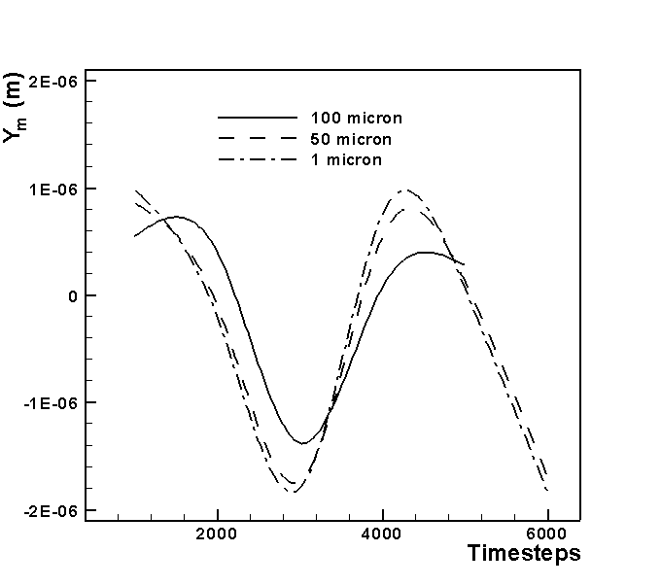
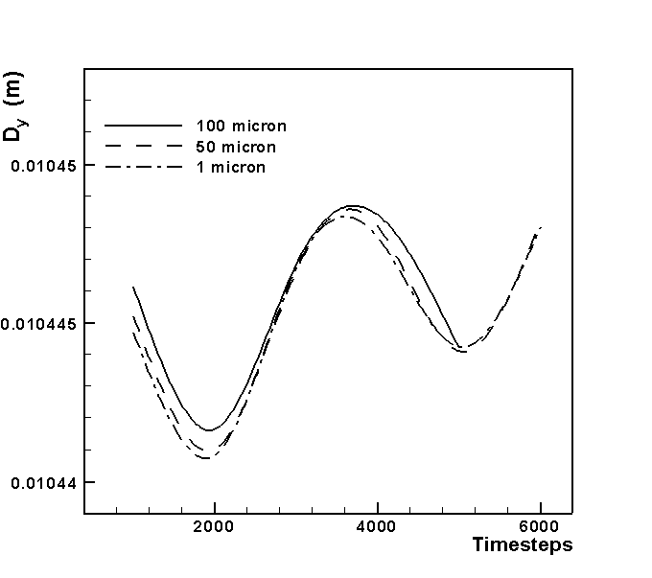
Figure 5. Time-dependent particle dispersion in duct flow (Re_{b} = 36,500; time step = 5.61×10⁻⁵ s): (a) mean value of particle displacement in transverse direction; and (b) transverse dispersion function.

To further elucidate particle dispersion in the duct, the dispersion function (Yao et al., 2003) in the transverse (y) direction is introduced; D_{y}(t)=(∑((Y_{i}(t)-Y_{m}(t))²/n_{t} ))^{1/2}, where n_{t} is the total number of particles distributed in the computational domain at time t, Y_{i}(t) is the particle displacement in the transverse direction at t, and Y_{m}(t) is the mean value.
Mean values of particle displacement (Y_{m}) in the transverse direction at Re_{b} = 36,500 are shown in Fig. 5 (a). It may be noted that Y_{m} values are two orders of magnitude lower than the X_{m} values shown in Fig. 3. This suggests that gravity is influential on particle dispersion in the normal direction. Fig. 5 (a) shows that for all particles, Y_{m} develops with time in an oscillatory fashion due to the effect of the secondary flow in the cross section of the duct. In comparison with mean values in the normal direction (X_{m} in Fig. 3), the secondary flow does have a significant effect on particle dispersion in the transverse direction because there is no gravity effect in that direction. Y_{m} also oscillates more with decreasing particle size since smaller particles follow the flow more closely that large particles.
To scale particle motion in fluids a useful parameter is the Stokes number which is the ratio of particle response time to a time characteristic of the fluid motion: St=τ_{p}/τ_{f}, where τ_{p} is the particle relaxation time, and τ_{f} is a time scale of the flow structures (τ_{f} = u²_{τ}/v, where u_{τ} is the shear velocity and v is the kinematic viscosity). For the Re_{b} = 36,500, u_{τ} is equal to 0.31 m s⁻¹. Then, for the three particles, of 1, 50 and 100 μm diameter, St = 1.33×10⁻⁴, 6.67×10⁻³ and 1.33×10⁻², respectively. In the present work, St is therefore significantly less than 1, so the particles can maintain near velocity equilibrium with the carrier fluid (Crowe et al., 1996). Lastly, Fig. 5 (b) shows the particle dispersion function in the transverse direction. The profile is similar to that of Y_{m}(t) in Fig. 5 (a), and again oscillates with time due to the effect of the secondary flow. The magnitude of the oscillations in the dispersion function is seen to increase with decreasing particle size, with an accompanied decrease in the frequency of oscillation.
4. Conclusions
Large eddy simulation has been used to study flows in square ducts at three Reynolds numbers, and results found to agree with previous studies of single-phase flows. Solid particle dispersion within these flows has also been simulated, and in all cases the mean value of the particle distribution in the normal direction decreases with time and with increasing particle size due to the effect of gravity. The particle distribution in the transverse direction is more oscillatory than in the normal direction, and two orders of magnitude lower. This indicates that the secondary flow does have some effect on particle dispersion in the former direction, but that gravity dominates in the normal direction and overall plays the most significant role in particle dispersion. In addition, particle trajectories were found to be affected by the Reynolds number and particle size, with oscillatory motions increasing with Reynolds number and decreasing particle size.
Acknowledgement
This work was carried out as part of the TSEC programme KNOO and as such we are grateful to the EPSRC for funding under grant EP/C549465/1.
References
E. Brundrett and W.D. Baines, 1964, The Production and Diffusion of Vorticity in Duct Flow, J Fluid Mech, 19, 375-394.
C.T. Crowe, T.R. Troutt and J.N. Chung, 1996, Numerical Models for Two-Phase Turbulent Flows, Ann Rev Fluid Mech, 28, 11-43.
M. Fairweather and J. Yao, 2007, Investigation of Particle-Laden Flow in a Straight Duct Using Large Eddy Simulation, Proc 11th Int Conf Environmental Remediation and Radioactive Waste Management, Bruges, Belgium, 2nd-6th September 2007.
J.R. Fan, J. Yao and K.F. Cen, 2002, Antierosion in a 90° Bend by Particle Impaction, AIChE J, 48, 1401-1412.
S. Gavrilakis, 1992, Numerical Simulation of Low-Reynolds-Number Turbulent Flow Through a Straight Square Duct, J Fluid Mech, 244, 101-129.
M. Germano, U. Piomelli, P. Moin and W.H. Cabot, 1991, A Dynamic Sub-Grid-Scale Eddy Viscosity Model, Phys Fluids, 23, 1760-1765.
F.B. Gessner, J.K. Po and A.F. Emery, 1979, Measurements of Developing Turbulent Flow in a Square Duct. In, F. Durst, B.E. Launder, F.W. Schmidt and J.H. Whitelaw (Eds.), Turbulent Shear Flows I, Springer-Verlag, New York, 119-136.
W.P. Jones, 1991, BOFFIN: A Computer Program for Flow and Combustion in Complex Geometries, Dept Mech Eng, Imperial College of Science, Technology and Medicine.
B.E. Launder and W.M. Ying, 1972, Secondary Flows in Ducts of Square Cross-Section, J Fluid Mech, 54, 289-295.
R.K. Madabhushi and S.P. Vanka, 1991, Large Eddy Simulation of Turbulence-Driven Secondary Flow in a Square Duct, Phys Fluids A, 3, 2734-2745.
L. di Mare and W.P. Jones, 2003, LES of Turbulent Flow Past a Swept Fence, Int J Heat Fluid Flow, 24, 606-615.
M.R. Maxey and J.J. Riley, 1983, Equation of Motion for a Small Rigid Sphere in a Nonuniform flow, Phys Fluids, 26, 883-889.
U. Piomelli and J. Liu, 1995, Large Eddy Simulation of Rotating Channel Flows Using a Localized Dynamic Model, Phys Fluids, 7, 839-848.
G. Sharma and D.J. Phares, 2006, Turbulent Transport of Particles in a Straight Square Duct, Int J Multiphase Flow, 32, 823-837.
C.M. Winkler, S.L. Rani and S.P. Vanka, 2004, Preferential Concentration of Particles in a Fully Developed Turbulent Square Duct Flow, Int J Multiphase Flow, 30, 27-50.
J. Yao, F. Ji, L. Liu, J.R. Fan and K.F. Cen, 2003, Direct Numerical Simulation on the Particle Flow in the Wake of Circular Cylinder, Prog Nat Sci, 13, 379-384.

