Towards a new generation heat exchanger models
Geert W. Haarlemmer ª, Jérôme Pigourier^{b}
ªRSI, Parc Technologique de Pré Milliet, Montbonnot 38330, France
^{b}AXENS, 89 bd Franklin Roosevelt, Reuil-Mailmaison 92508, France

Abstract
In the quest for more dependable process models, attending to small detail and integrating increasing their internal complexity will improve dynamic behavior and simulation accuracy. Although detailed heat exchanger models in dedicated steady state design programs are common, steady state process models and dynamic simulations have been based largely on shortcut heat exchanger calculations. However, detailed heat exchanger models can now be employed in dynamic simulations to enhance model performance significantly while maintaining reasonable computational times.
An LNG liquefaction process, the new Axens Liquefin process, was modeled employing Indiss Dynamic Simulation Software and results presented in this article. Based on brazed aluminum plate-fin heat exchanger technology it, the process contains two closed refrigerant loops making it essential to provide correct simulation of refrigerant hold-up throughout the entire process.

Keywords: Dynamic simulation, Plate-fin heat exchanger, Heat transfer.
  - Introduction
Modern process plant developments are often accompanied by dynamic process simulators. Simulators are used initially for studies, later for operator training. The dynamic studies can address equipment integrity (compressor anti surge or thermal stress in plate and fin heat exchangers), controllability or operating strategy development. Dynamic simulation studies (like any other study) cannot realistically be used to cover all operational problems but can and do help to avoid certain problems.

The scope of a dynamic simulation study should define the equipment to simulate, the thermodynamic models and the level of detail for the process models. Axens expressed the wish to create a dynamic simulator for the Liquefin process. This novel LNG liquefaction process is based on brazed aluminum plate-fin heat exchanger technology.

After careful consideration of the physical phenomena dominating the dynamics of a real plate and fin heat exchanger, it was decided to increase the level of detail in the plate and fin heat exchanger module to include a discretized hold-up model and to rigorously calculate the heat transfer coefficients. The internal hydrodynamic multi-phase behavior is solved by a dedicated network solver.

To simulate the four heat exchangers as a single heat exchanger is an oversimplification as problems with re- or mal-distribution of the fluids may be overlooked. The common assumption of constant mass flows in the different cold-boxes is no longer valid during transients and changes in fluid distribution can have an important effect on the results.
Figure 2 – Detail Cold Box
Heat exchanger inertia due to the metal and the process fluids can be important, especially at low flow rates. The discretized hold-up model greatly improves the quality of the model’s dynamic response. Another important measure is the rigorous calculation of heat transfer coefficients taking into account multi phase phenomena. A third consideration is the model’s ability to predict the temperature and pressure profiles and the true multi-phase flow profile along the flow path in the heat exchanger.

Recent correlations for computing of heat transfer coefficients for all the different fluids under the various regimes encountered during operation were carefully selected, tested and implemented. These regimes include heat transfer in gas or liquid phases, or in two phase mixtures containing vaporizing or condensation regimes. All these phenomena were introduced in a plate and fin heat exchanger code.
  - Heat Transfer Coefficients

Heat transfer coefficients vary greatly according to fluid quality, flow rate and heat exchanger geometry. Specialized heat exchanger design codes have sophisticated models to calculate the heat transfer coefficients. In dynamic simulation models, fixed film heat transfer coefficients ($α$, in W/Km²) are used most often, frequently adjusted as a function of flow rate (Reynolds number Re). A typical implementation could be:
$α=α_{\text{Ref}}⋅{\left(\frac{\text{Re}}{{\text{Re}}_{\text{Ref}}}\right)}^{0\text{.}8}$ (eqn 1)
This implementation works reasonably well for single phase turbulent flow where the heat transfer coefficients can be predicted from the following well-known equation for continuous fins.
$\text{Nu}=0\text{.}\text{023}⋅{\text{Re}}^{0\text{.}8}⋅{\text{Pr}}^{1/3}$ (eqn 2)
Here Nu (Nusselt) and Pr (Prandlt) are dimensionless numbers often used in heat transfer characterization.
$\text{Nu}={\text{Dh}⋅α}/λ$ (eqn 3)
$\text{Pr}={\text{Cp}⋅μ}/λ$ (eqn 4)
Here Cp is the fluid heat capacity, $λ$ is the heat conductivity, $μ$ is the viscosity and $\text{Dh}$is the hydraulic diameter of the fluid channel defined specifically for each geometry.
The inconvenience of this implementation is that there is little sensitivity to multi phase phenomena. Phenomena like multi phase intensification and dry-out are not really taken into account. The physical phenomena are very similar among the different geometries. However very few theoretical models exist that predict the film coefficients for a particular geometry. Correlations have been created for each geometry based on experimental results.

These correlations either predict film coefficients directly or they predict the Colburn (Jh) number. From the Colburn numbers it is possible to calculate the film coefficient. Some manufacturers of plate and fin heat exchangers can supply the curves Jh as a function of the Reynolds number.
The film coefficient ($α$ ) can be calculated from the Colburn number via the Nusselt number:
$\text{Nu}=\text{Re}⋅{\text{Pr}}^{1/3}⋅\text{Jh}$ (eqn 5)
Other formulations to calculate the heat transfer coefficients from the Colburn number are available. Care should be taken to use the correlations as they were intended. Correlations are often given for single-component fluids. If these correlations have to be applied to multi component fluids, the Silver correction can be applied (Silver, 1947).

The local film coefficient thus obtained is used to predict the local heat transfer (Q in W) between the fluid and the metal, passing through the film.
$\frac{∂Q}{∂A}=α⋅\left(T_{\text{metal}}−T_{\text{fluid}}\right)$ (eqn 6)
Integrated on a small domain this gives:
$Q=α⋅A⋅\left(T_{\text{metal}}−T_{\text{fluid}}\right)$ (eqn 7)
Each simulated fluid element exchanges heat with the metal. It is the metal that transports the fluid between the fluids. The metal and the fluids have their own thermal inertia.
The overall heat exchanger can now be solved using plate-to-plate calculation or a Common Wall model. Both models are essentially the same. The Common Wall model solves for one metal at a single temperature while the plate-to-plate model solves for as many metal temperatures as there are separation walls. The overall equation to be solved for the Common Wall model at cell i is the following:
$\begin{aligned}\sum_{\text{ in the zone}}{}j=\text{All fluides}\end{aligned}=0$ (eqn 8)
And for each of the cells i and each fluid j:

$M_{j}^{i}\text{ * }\frac{∂{\text{ H}}_{j}^{i}}{∂\text{ t}}+F_{j}^{i}\text{ * }\frac{∂H_{j}^{i}}{∂x}\text{ - }α_{j}^{i}A_{j}^{i}\text{ * }(T_{\text{Fluid}}^{i}{\text{ - T}}_{\text{Metal}}^{i})=0$ (eqn 9)

The single phase model implemented in the model is based on Shah and London for the laminar part and the equation presented above for the turbulent part. The film condensation model is based on the classical Nusselt analysis with extensions towards wavy and turbulent regimes. The boiling heat transfer is based on a two phase intensification of the heat transfer based on the Lockhart-Martinelli two phase multiplier. A full treatment of the calculation of heat transfer coefficients is not in the scope of this paper; for more information the reader is referred to work by Alpema, 2000; Greth, 1996 and Greth 1999.
  - Pressure Flow Relationship
Heat exchanger models can be treated either as a singular pressure drop model much like a valve or it can be treated as a pipeline model where the pressure flow relationship is discretized and the accumulations are taken into account for each element. For the Liquefin simulation project it was decided to discretize the hold-up model to solve the heat exchanger as a multi fluid pipe model in which the fluids are thermally coupled.

The basic pressure drop model is the following:
$\frac{∂P}{∂l}=\frac{f⋅u^{2}⋅ρ}{\text{Dh}}$ (eqn 10)
Here f is the friction factor. This can either be calculated from manufacturer’s correlations as a function of the Reynolds number, or can be maintained constant throughout the simulations.

The pressure in the cells is closely related to the mass accumulations, via the density ($ρ$ ). The overall mass balance in each of the cells is given as follows.
$\left(F_{\text{in}}−F_{\text{out}}\right)∗\text{dt}=\text{CellAccumulation}−\text{Vol}∗ρ(p)$ (eqn 11)
The density should be correctly estimated as a function of the composition, pressure and enthalpy in the cell.
  - Simulation Project
The first project to use this new technology was to simulate the Axens Liquefin process. This process has four cold boxes in parallel; it was decided to simplify the simulation to simulate only two cold boxes. Each of these two cold boxes is sized as two times 50%. All heat exchangers are multiple stream plate and fin heat exchangers. The scope of the simulation included the scrubber column, both compressor trains and the final end flash column. The thermodynamic system is based on SRK equation of state with Lee Kessler for the enthalpies.

Several dynamic simulation cases were performed; one involved closing the third (low pressure) MR1 Joule Thomson (JT) valve at Cold Box 1 causing an upset. The flow rate through this valve was reduced to zero (Figure 3) in 20 seconds. The control scheme attempted to maintain a temperature difference between the MR1 inlet and outlet of each section by adjusting the position of the JT valves. It is this mechanism that reduces the MR1 flow in Cold Box 1, the HP and MP JT valves at the upset cold box close slightly as the MR1, normally passing though the JT3 valve, no longer needs cooling. The lack of liquefaction in the upset cold box causes an increase in pressure drop and the natural gas is directed towards Cold Box 2. This causes the JT valves for this cold box to open (Figure 3). The overall LNG flow rate (Figure 4) is obviously reduced.

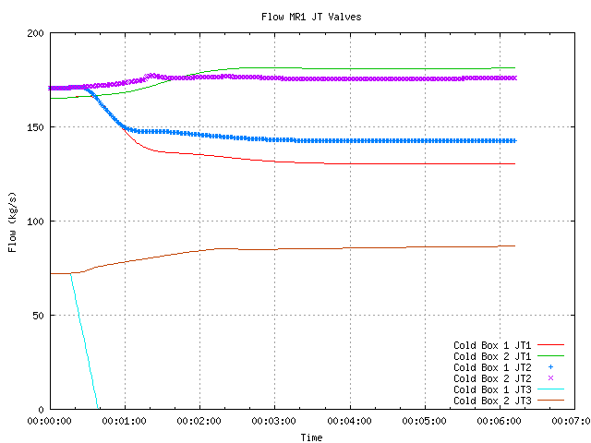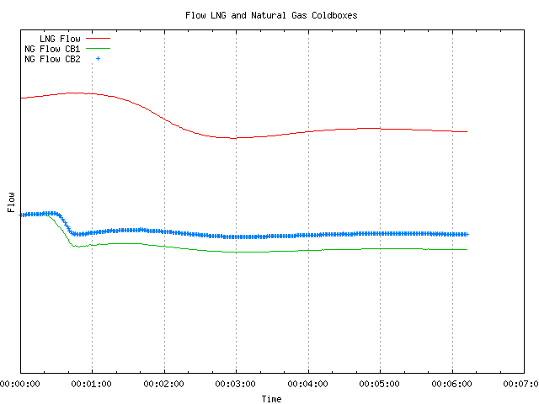
Figure 3 – JT flow rates Figure 4 –LNG flow rate (values
removed for confidentiality reasons)

The MR2 is normally liquefied in the first stage cold box. It is used as the refrigerant in the second stage. The MR2 from the upset cold box heats up and is no longer completely liquefied (Figures 5 and 6). The second stage in the upset cold box loses a large amount of its capacity.
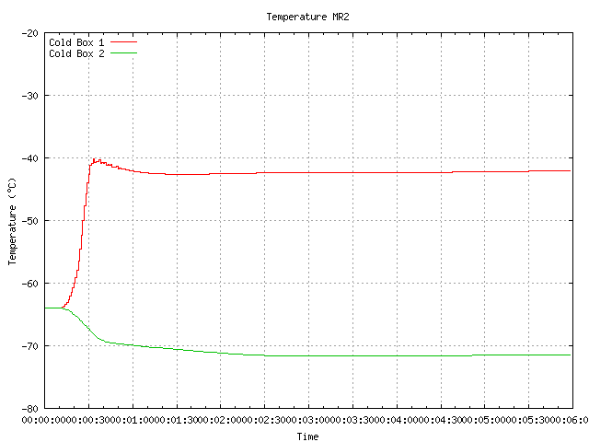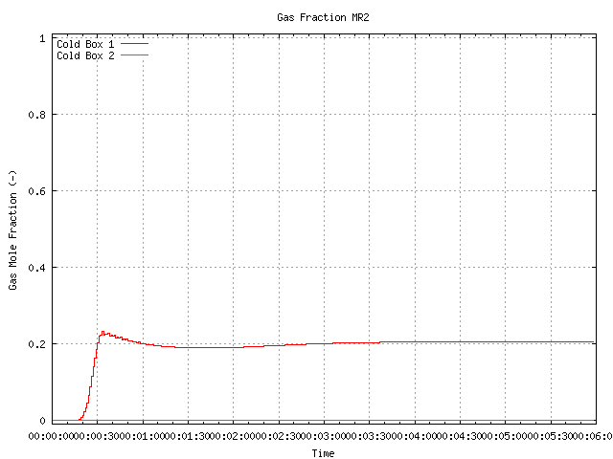

Figure 5 – Gas Fraction MR2 Figure 6 – Temperature MR2

The steady state temperature profile descending in the cold box is given below. In reality the cold-box is simulated in five sections as there are numerous inlets and outlets. This profile is initially (Figure 7) identical for each of the trains. The temperature profile in the failed cold box is drastically modified relative to the starting point (Figure 8). The upset part (LP) of the cold box displays a flat profile indicating that there is no heat transfer occurring in this part, the temperatures of the streams entering this part converge rapidly and remain constant. The MR2 flow rates remain constant owing to flow control. The second stage (MR2) of the cold box also displays a flat profile as it is now over-dimensioned relative to its cooling capacity. The expanded cold MR2 heats up slightly (Figures 7 and 8) and it has therefore less cooling capacity. For this reason it heats up rapidly and the upper part of the heat exchanger is no longer needed.

Figure 7 – Overall Temperature Profile Figure 8 – Overall Temperature Profile
Base case End of Run

  - Conclusions

The results show that it is worthwhile to invest in detailed models to obtain valid predictions of heat exchanger behavior. The obtained results show a realistic evolution of heat exchange coefficients and internal properties, such as fluid temperature and hold-up. The results show how complex phenomena such as condensing and boiling can be taken into account in dynamic simulations and contribute to the accuracy of the conclusions of dynamic studies.

References

Alpema Standards, The Standards of the Brazed Aluminum Plate-Fin Heat Exchanger Manufacturers’ Association, Second Edition 2000, Houston Texas.

Manuel Technique, Groupement pour la Recherche sur les Echangeurs Thermiques. Chapters TM11, TM14, TE7, TE9 and TC1. CEA Grenoble, 1999.

Lois de Transfert et Pertes de Pression dans les Echangeurs a Plaques et Aillettes Braisées, dans Compte-redu du Greth (Amelioration des techniques de transfert par évaporation) Annexe 11, Note Technique du Greth n° 97/422, 1996.

Silver, L. (1947). Gas Cooling with Aqueous Condensation, Trans. Inst. Chem. Eng, 25, 30-42.

B. Fischer (IFP), M. Khakoo (BP), Plate-fin heat exchangers - An Ideal Platform for LNG Process Innovation, Gastech 2002.

