Prediction of partition coefficients between food simulants and packaging materials using molecular simulation and a generalized Flory-Huggins approach
Olivier Vitracª, Guillaume Gillet^{b}
ªInstitut National de la Recherche Agronomique, UMR 1145 Génie Industriel Alimentaire, 1 avenue des Olympiades, 91300 Massy, France
^{b}Laboratoire National d’Essais, Centre Energie, Mériaux et Emballage, 29 avenue Roger Hennequin, 78197 Trappes CEDEX, France.
Abstract
Partition coefficients of n-alkanes, n-alcohols and commercial antioxidants between polyethylene and food simulants (ethanol, methanol), K_{F/P}, have been estimated using an off lattice Flory approximation and satisfactory compared to previously published values. The approach demonstrated the preponderant effect of the configurational entropic contribution on the estimate of K_{F/P}.

Keywords: thermodynamics, polymer, desorption, chemical potential, Flory theory
  - Introduction
In Europe, all materials intended to be in contact with food must comply with the new framework regulation 2004/1935/EC, which enforces a safety assessment and risk management decision for all starting substances and possible degradation products coming from the material. For plastic materials, article 14 of the directive 2002/72/EC introduces diffusion modeling as an alternative to time-consuming and costly experiments for both compliance testing and risk assessment. The fundamentals of probabilistic modeling of the desorption of packaging substances into food has been analyzed by us [1] and applied to different situations [2] including the assessment of consumer exposure to styrene originating from yogurt pots [3]. The main limitation in the use of predictive approaches for both compliance testing and risk assessment is the availability of physico-chemical properties of a wide range of substances, polymers and thermodynamical conditions (temperature, swelling). Robust approaches have been developed for the prediction of diffusion coefficients in polymers [4-5], but no appropriate method exists to predict partition coefficients between a polymer and a food or a food simulant [6]. A first attempt was made by Baner et al. [7] using the regular solution theory, but it required an empirical factor, which was dependent on the size and shape of the considered substance.
This work examines an off-lattice generalized Flory-Huggins approach to predict activity coefficients in polyethylene (PE) and in different food simulants (ethanol, methanol). The excess in mixing enthalpy is assessed by sampling the nearest-neighbor interactions energies for all possible host-substance pairs [8-9]. This method is an alternative to particle insertion or deletion methods [10], which cannot be applied reliably to penetrants much larger than fluctuation volumes in polymers.
The paper is organized as follows. Section 2 summarizes the theoretical principles used to calculate both the excess in enthalpy and entropy in both phases. Section 3 presents the results obtained for homologous series of alkanes and alcohols as well as for typical hindered antioxidants. When they are available, predictions are compared with values measured between a low density polyethylene and two food simulants with increasing polarity: ethanol and methanol [6-7].
  - Theory and methods of estimation of activation coefficients
    - Equilibrium between the packaging material and the food in contact
By noting the thermoplastic packaging, P, and the food product in contact, F, the thermodynamical equilibrium between P and F corresponds to a situation, where the cumulated free energy between P and F, noted G_{P+F}, is minimal. For a P+F system at constant temperature and pressure, the evolution towards equilibrium is accompanied by an exchange of matter between P and F. In this work, only a single species initially present in the polymer, noted i, is assumed to migrate. This model situation corresponds in particular to the contamination of an aqueous food or polar simulant by a plastic additive. For an isolated system P+F, G_{P+F} is:
(1)
where {n_{k}}_{k=P,F} and {n_{i,k}}_{k=P,F} are the number of molecules k and the number of molecules i in k respectively. They are associated to the chemical potential {µ_{k}}_{k=P,F} and {µ_{i,k}}_{k=P,F} respectively. All energetic terms are further decomposed into an ideal, ^{id}, and an excess part, ^{excess}. From a microscopic point of view, the detailed mass balance at the interface enforces that the partition coefficient at the interface between P and F, noted K_{F/P}, is equal to the ratio of frequencies of crossing the interface: k_{i,P→F} and : k_{i,F→P}. By introducing the free energy of the barrier to cross the interface, G_{i}†, the transition state theory defines K_{F/P} in the canonical ensemble as:
(2)
Where h is the Planck’s contact, k_{B} is the Boltzmann's constant and T the absolute temperature. Eq. (2) can be used to estimate K_{F/P} in the Gibbs Ensemble [11] but it requires calculating the energy of each subsystem after equilibration. An alternative relies on a macroscopic description of equilibrium (dG_{P+F}=0) for a closed system (dn_{i,F}=-dn_{i,P}), which leads to: µ_{i,F}=µ_{i,P}. By choosing the state of pure i as reference and by expressing the activities of both non ideal mixtures from their volume fractions in i, {φ_{i,j}}_{j=P,F}, K_{F/P} is approximated as:
(3)
According to the Flory-Huggins theory [12-15], the activity coefficients {γ^{v}_{i,k}}_{k=P,F} can be derived on a rigid lattice, whose mesh size is commensurable to the volume of the penetrant V_{i} or to its surface. In this work, V_{i} is chosen as the volume enclosed within the Connolly surface. For molecules of k with a volume fraction φ_{k} and consisting in r_{k} blobs of volume V_{i}, one gets at infinite dilution of i [16]:
(4)
where is the heat of mixing. The first term represents the effect of the configurational entropy associated to the increase of microstates due to the distribution of k around i without changing the effective pair interactions between i and k. The absolute value of the first term is expected to be small in polymers (r_{k}>>1) while it is expected to be significant in simulants consisting in molecules much smaller than i.
    - Estimation of χ_{i,k} from pair contact energies
The lattice method has been mainly used to predict the heat of mixing of polymer-solvent systems, which present a significant similarity. Since the blob size and the coordination number of the lattice cannot be modified, the lattice approximation is less accurate to sample the interactions between dissimilar structures including flexible penetrants. A continuous representation of interactions was used instead [8-9]:
(5)
Where stands for an ensemble averaged pair contact energy at the temperature T (T=313K as prescribed in the EU regulation) by weighting the distribution of energies p_{A+B}(ε) with the Boltzmann factor exp(-ε/k_{B}·T):
(6)
The sampling of p_{A+B}(ε) was based on a large set of conformers of A (seed molecule) and B (contact molecule) representative of their condensed state (up to 10⁴ configurations) and based on all possible contacts of their van der Waals envelopes with spherical symmetric probability (up to 10⁶ configurations). Since only the surface farthest away from the center of mass was considered, internal cavities of the seed molecule could only be sampled by a contact molecule smaller than the cavity (e.g. B). The coordination number was determined similarly on a large number of packed configurations (up to 10⁴), where van der Waals envelopes are in contact but not overlapping. Polymers based on few monomers were idealized by preventing head and tail atoms to be in contact with any surface. All conformers and sampling energies were performed using the Materials Studio environment version 4.1 (Accelrys, San Diego, USA), its scripting features and the atom-based COMPASS forcefield, which was applied without any cutoff.
  - Results and discussion
Typical configurations related to minimums of ε_{A+B} and to typical compaction values z_{A+B} are illustrated in Fig. 1. The volume of each molecule is represented either by calotte models or by their Connolly surface. Hydrogen bonding is depicted in dashed lines.
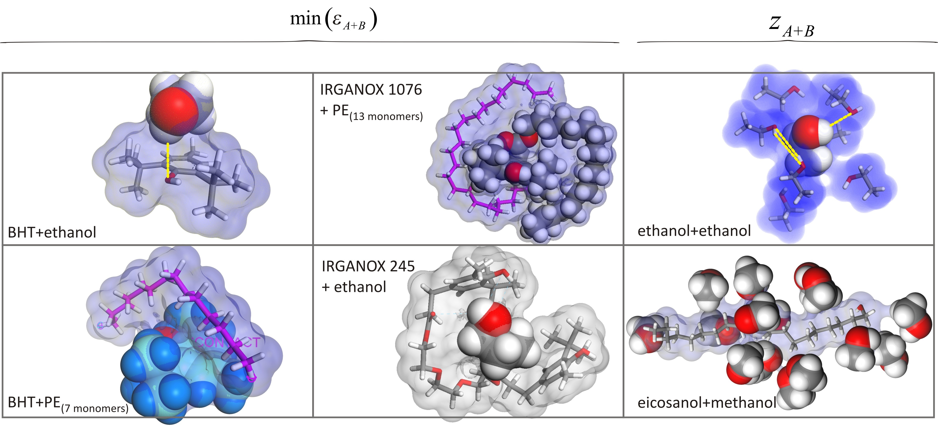
Fig. 1. Typical A+B pair interactions and packing. Tested plastic additives are: BHT (2,6-di-tert-butyl-4-methyl-phenol, CAS 128-37-0), Irganox 1076 (octadecyl 3,5-di-(tert)-butyl-4-hydroxyhydrocinnamate, CAS 2082-79-3), Irganox 245 (Ethylenebis (oxyethylene)bis-(3-(5-tert-butyl-4-hydroxy-m-tolyl)-propionate), CAS 36443-68-2), Irganox 1035 (thiodiethylene bis[3-(3,5-di-tert-butyl-4-hydroxyphenyl)propionate], CAS 41484-35-9).

Since the used off-lattice approach sampled both the conformation and the reorientation phase space, the non-combinatory entropic contribution was accounted in the estimate of χ_{i,k}. In Eq. (5), the use of a single coordination number (a non-integer value) assumes however that z and ε are independent quantities, although there are positively correlated for A≠B. Since the expected deviation is equal to covariance between z and ε, Eq. (5) tends to overestimate the true χ_{i,k}. As a result the interaction with the polymer is best estimated when A and B have similar surface areas (i.e. z_{A+B}≈z_{B+A}). Fig. 2 plots the corresponding variation χ_{i,PE} for typical substances according to number of monomers used to idealize the polymer (head and tail atoms were non-contact). For antioxidants, which do not resemble the polymer, several minima could occur.
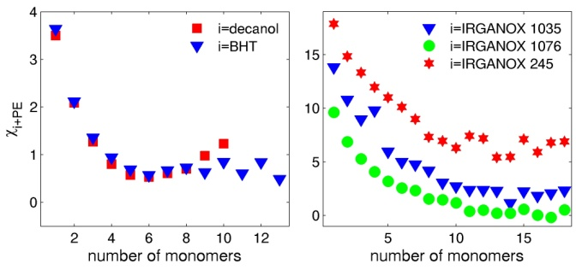
Fig. 2. Effect of the number of monomers on the estimation of χ_{i,k}.

Typical values of χ_{i,k} at 313 K for a series of n-alkanes and n-alcohols and four antioxidants are plotted in Fig. 3. A sensitivity analysis was performed for the series of alkanes and alcohols by generating different independent set of conformers by molecular dynamics at 313 K. The confidence intervals on contact energies were estimated lower than 0.5 k_{B}·T. The interactions were maximal in F and low in PE except for Irganox 245. Since all antioxidants included one or two BHT patterns, the different behaviors observed in PE were mainly related to the stiffness of the side or bridging chain, which was stiffer in Irganox 245 than in Irganox 1035 (see Fig. 1). The high values in simulants were related to the presence of large molecules which reduce the possibility of hydrogen bonding. This effect was higher when the surface of the substance i exposed to F was higher (e.g. for linear molecules rather than hindered antioxidants).
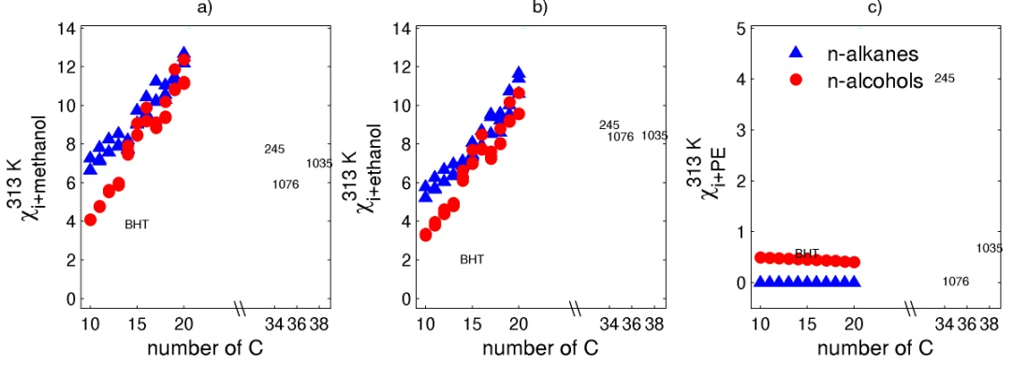
Fig. 3. χ_{i,k} estimated at 313 K in methanol, ethanol and PE. For PE, the values were derived for the number of monomers, which led to the lowest χ_{i,PE} value (see Fig. 2). Irganox molecules are depicted by their numerical codes: 245, 1035, and 1076.

Eq. (3-5) can only estimate partitioning between the amorphous regions of PE and F. Since the dense crystalline regions are assumed to be free of any substance, calculated values were compared with values obtained on a low density PE [6-7] subsequently to a correction according to the amount of amorphous phase. The entropic contribution r_{F}⁻¹ was estimated by considering that the substance i would displace a volume of F commensurable to the volume enclosed into its averaged Connolly surface. This approximation is particularly realistic at high dilution rate (non-interacting substances i), where F molecules smaller than i would act as a continuous phase with a specific volume close to its molar volume at the same temperature. The corresponding results are plotted in Fig 4.
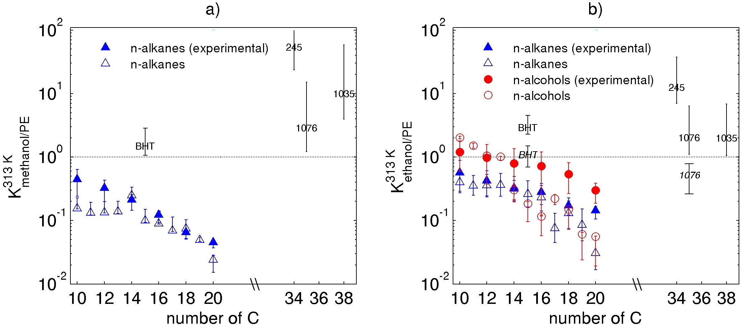
Fig. 4. Estimated and experimental (filled symbols or in italic) partition coefficients between F and amorphous PE regions at 313 K. Error bars represent either 95% confidence intervals or min/max K estimates (symbols are centered on median values).

Without any fitting, the magnitude orders were similar. The deviation was higher in ethanol, where the proposed approach tended to underestimate K_{F/P} of linear molecules while it overestimated the value of hindered additives (BHT and Irganox 1076). A sensitivity analysis demonstrated that the uncertainty was mainly related to the entropic contribution. The number of ethanol molecules associated to the blob of a linear molecule should be higher for alkyl segments and lower for hindered groups (e.g. BHT pattern), which can contribute to hydrogen bonding.
  - Conclusions
The off-lattice generalized Flory-Huggins approach seems a promising approach to predict partitioning between food packaging materials and food simulants. It does not require an explicit representation of the entangled polymer and provides further insight on molecular phenomena, which lead to the contamination of food. In particular, the simulations demonstrated that even if plastic additives have by design a good solubility in polymers, they have a higher chemical affinity for liquids consisting in small molecules. This entropic effect was underestimated in previous studies and would lead to a high migration of antioxidants in food at high temperature when their diffusion and solubility are not limiting.
References
[1] O. Vitrac and M. Hayert, 2005. Risk assessment of migration from packaging materials into foodstuffs. AIChE Journal, 51, 4, 1080-1095.
[2] O. Vitrac, B. Challe, J.-C. Leblanc and A. Feigenbaum., 2007. Contamination of packaged food by substances migrating from a direct-contact plastic layer: Assessment using a generic quantitative household scale methodology. Food Additives and Contaminants. 24, 1, 75-94.
[3] O. Vitrac and J.-C. Leblanc, 2007, Exposure of consumers to plastic packaging materials: assessment of the contribution of styrene from yoghurt pots. Food Additives & Contaminants. 24, 2, 194–215.
[4] O. Vitrac, J. Lézervant and A. Feigenbaum, 2006, Application of decision trees to the robust estimation of diffusion coefficients in polyolefines. Journal of Applied Polymer Science, 101, 2167–2186.
[5] O. Vitrac and M. Hayert, 2007, Effect of the distribution of sorption sites on transport diffusivities: a contribution to the transport of medium-weight-molecules in polymeric materials. Chemical Engineering Science, 62, 9, 2503-2521.
[6] O. Vitrac, A. Mougharbel and A. Feigenbaum, 2007, Interfacial mass transport properties which control the migration of packaging constituents into foodstuffs. Journal of Food Engineering. 79, 3,1048-1064.
[7] A. L. Baner and O. G. Piringer, 1991, Prediction of solute partition coefficients between polyolefins and alcohols using the regular solution theory and group contribution methods. Industrial and Engineering Chemistry Research, 30, 1506-1515.
[8] M. G. Bawendi and K. F. Freed, 1988, Systematic correction to Flory-Huggins theory: Polymer-solvent-void systems and binary blend-void systems, Journal of Chemical Physics, 88, 4, 2741-2756.
[9] M. G. Bawendi, K. F. Freed and U. Mohanty, 1987, A lattice field theory for polymer systems with nearest-neighbor interaction energies. Journal of Chemical Physics, 87, 9, 5534-5540.
[10] B. Widom, 1963, Some Topics in the Theory of Fluids, Journal of Chemical Physics, 39, 2808.
[11] A. Z. Panagiotopoulos, 1992, Direct Simulation of Fluid Phase Equilibria by Simulation in the Gibbs Ensemble: A Review, Molecular Simulation, 9, 1.
[12] P. J. Flory, 1941. Thermodynamics of high polymer solutions. Journal Chemical Physics. 9, 660-661.
[13] P. J. Flory, 1942, Thermodynamics of high polymer solutions. Journal of Chemical Physics. 10, 51-61.
[14] M. L. Huggins, 1942a. Derivation of Molecular Relaxation Parameters of an Isomeric Relaxation. Journal of Chemical Physics, 46, 151-153.
[15] M. L. Huggins, 1942b. Theory of Sulutions of high polymers. Journal of the American Chemical Society, 64, 1712-1719.
[16] V. J. Klenin, 1999, Thermodynamics of systems containing flexible-chain polymers. Elsevier Science, Amsterdam. 826p.

