Optimization of ideal Petlyuk sequences using a multi objective genetic algorithm with constraints
Arturo Jiménez-Gutiérrezª, Claudia Gutiérrez-Antonio^{a,b}, Abel Briones-Ramírez^{c}
ª Instituto Tecnológico de Celaya, Depto. de Ingeniería Química, Av. Tecnológico y García Cubas s/n, Celaya, GTO, 38010, Mexico, arturo@iqcelaya.itc.mx
^{b} CIATEQ A.C., Unidad Retablo, Av. del Retablo 150 Col. Fovissste, Querétaro, QRO, 76150, Mexico
^{c} Innovación Integral de Sistemas S.A. de C.V., Limas 5 Mza C Col. Don Manuel, Querétaro, QRO, 76114, Mexico
Abstract
In this work a multiobjective genetic algorithm (GA) with constraints was implemented for the optimization of Petlyuk sequences. Each search point required by the GA was obtained through an interconnection with the Aspen Plus process simulator. Several ideal ternary mixtures with different split specifications were considered. The results obtained with the proposed approach were compared with reported designs for the same separation problems that were obtained by minimizing the energy consumption through extensive search procedures without formal optimization algorithms. In general, the designs obtained with the GA show a reduction of up to 20% in energy consumption with respect to the reported designs. In contrast to the original design of the Petlyuk arrangement, the GA model was formulated so that the liquid and vapor interconnections of each thermal coupling could take place in different trays. It was found that in many cases the optimal design has a structure in which vapor and liquid interconnections do not take place in the same tray of the main column. The performance of the GA is quite robust and is practically independent on the specification of initial values for the search variables.

Keywords: Petlyuk sequence, genetic algorithms, optimization, distillation
  - Introduction

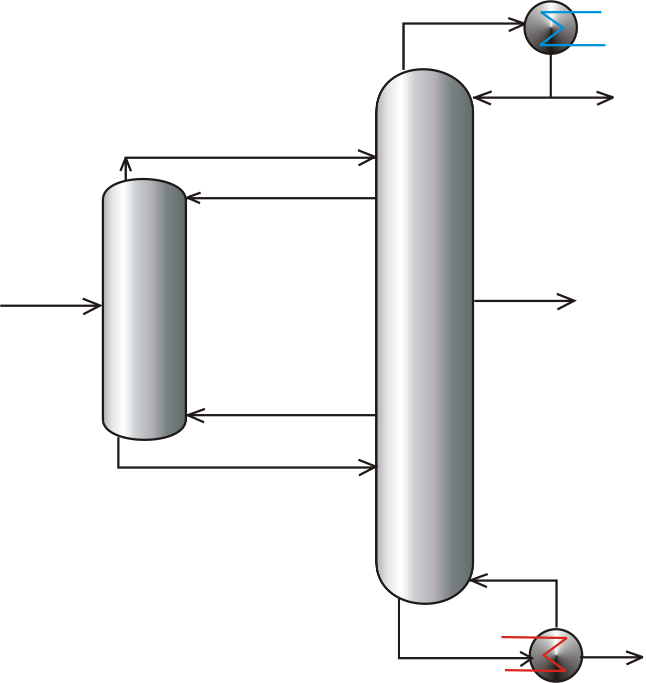
The use of thermally coupled distillation is one alternative that has been recently considered with particular interest because of the energy savings that can be achieved in relation to the operation of conventional distillation systems. Thermally coupled structures are implemented through a vapor-liquid interconnection between two column units, which eliminates the need for a condenser or a reboiler of one of the columns. For the separation of ternary mixtures, three structures have been particularly considered, the sequence with a side rectifier, the sequence with a side stripper, and the Petlyuk arrangement. The Petlyuk system is also referred to as the fully thermally coupled arrangement because it uses two vapor-liquid interconnections between the two columns, which is the highest number of thermal couplings for a ternary mixture. The structure of the Petlyuk system is shown in Figure 1. The first column of the arrangement, or prefractionator, has neither a condenser nor a reboiler, and the three product streams are obtained from the second unit, or main column. Some design methods for Petlyuk columns have been proposed. Tryantafillou and Smith [1] have reported a short cut method for Petlyuk columns that can be used to minimize either the heat duty or the number of trays of the system. Hernández and Jiménez [2] reported a design method based on tray-analogy sections, along with its use to provide designs with minimum energy consumption. The optimization problem of the Petlyuk sequence represents a fairly complicated task. The simpler problem is the minimization of the heat duty for a given tray structure of the system. The problem gets more complicated if the tray structure and the location of the interconnecting stages are
Figure 1. The Petlyuk arrangement. incorporated into the optimization problem.

This full design problem gives rise to a mixed integer nonlinear programming model, for which the initialization of search variables comprises a major task. An alternative approach is to use stochastic methods. Genetic algorithms (GAs) are stochastic searching methods that are based on the implementation of organic evolution models [3]. The solution begins with a set of solutions to the problem, or initial population, which is evaluated in terms of a fitness function. Fitness functions provide a measure of the capability of an individual to survive and reproduce in its environment. As a consequence, the individuals with best fitness values are selected as the parents of a new population. Leboreiro and Acevedo [4] proposed a genetic algorithm coupled with the simulator Aspen Plus to optimize distillation sequences. To handle the constraints they used two sets of penalties. A major penalty was applied if the simulation converged with errors, while a minor penalty was imposed for a successful simulation. However, penalty functions have some well-known limitations, one of the most important ones being the difficult to define good penalty factors [5,6].
In this work a genetic algorithm with constraints is used to optimize Petlyuk separation sequences. The genetic algorithm was coupled with the simulator Aspen Plus, so that all search points of the optimization procedure could be obtained rigorously.

  - Solution strategy and case studies

The optimization problem of the Petlyuk sequence is formulated so as to minimize the heat requirements and the number of stages of the Petlyuk sequence. The restrictions are the purities of the components in the distillate, side stream and bottom products. The minimization problem can be written as:

(1)

where Q is the heat duty, N_{i} is the number of stages in column i of the Petlyuk sequence, and y_{k} is the desired purity of product k. The equivalence of the minimization problem of Eq. 1 in terms of a fitness function for the GA can be written as:

(2)

where R is the reflux ratio, N_{i} is the total number of stages of column i, N_{j} is the interconnecting stage j, N_{s} is the side-stream stage of the main column, N_{F} is feed stage of the prefractionator, F_{j} is the flowrate of interconnecting stream j, and y_{k} is the vector of required product purities. The fitness function therefore includes the variables to minimize, the search variables and the constraints. This problem can be classified as a multiobjective optimization case because one attempts to minimize both the number of stages and the heat duty. These variables are in competition, and heuristic rules are many times used to set a practical compromise. In this work, the fitness function was tuned from the designs obtained with a reflux ratio equal to 1.3 times the minimum value. This choice allowed a comparison with Petlyuk designs reported by Ramírez-Corona [7] and by Jiménez et al. [8], who minimized the energy consumption using an extensive search procedure without a formal optimization method.
The constraints are handled with a multiobjective optimization technique, which guides the search of the genetic algorithm using the concept of non-dominance proposed by Coello [6]. The modified approach is as follows. The entire population is divided into sub-populations using the total number of satisfied constraints as a basis. Therefore, n+1 sub-populations arise for a set of n constraints, each of which will include all the individuals that satisfy n, n-1, n-2, and so forth all the way down to 0 constraints. The best individuals of a given generation are those that satisfy the n constraints, followed by the individuals that satisfy n-1 constraints, and so on. For each sub-population the individuals are ranked using their fitness function values. The difference with respect to the approach proposed by Coello [6] is that we use the value of the fitness function to rank the individuals for each sub-population, while Coello [6] used the number of constraint violations for individuals that did not satisfy at least one constraint. This slight modification was implemented to maintain a wider search space along the evolution of the genetic algorithm. It should be noted that we chose to handle the constraints using a multiobjective approach because it was very difficult to obtain a good solution when the constraints were handled with penalties.
As case studies, three ideal ternary mixtures (A,B,C, with A being the most volatile component) were chosen. Each mixture has a different ease of separation index, ESI, defined as the ratio of the relative volatility between A and B with respect to the volatility between B and C. The mixtures were n-pentane, n-hexane, n-heptane (M1, ESI: 1.04), n-butane, i-pentane, n-pentane (M2, ESI: 1.86), and i-pentane, n-pentane, n-hexane (M3, ESI: 0.47). Three feed compositions were considered: (40,20,40; F1), (33,33,34; F2), and (15,70,15; F3). The required purities were (99,92,99; F1), (98,96,98; F2), and (91,99,91; F3). The Chao-Seader model was used for the prediction of vapor-liquid equilibrium properties of the mixtures, and the operating pressures were set at 30, 70 and 30 psia for mixtures M1, M2 and M3, respectively. This set of specifications and mixtures were taken from Ramírez-Corona [7] and Jiménez et al. [8]. For the optimization of the Petlyuk sequence, we varied the flowrates of the interconnecting streams, the reflux ratio, the location of the interconnection and feed stages and the total number of stages of the sequence, for a total of eleven variables, three of which are continuous and eight are discrete.
  - Results

For each of the 9 separation problems that arise from the mixtures and feed compositions considered, 150 individuals and 200 generations were used as parameters for the GA. The results are presented in terms of heat duties, product compositions and the tray structure of the prefractionator and the main column of the Petlyuk arrangement. The heat duties of the sequence generated by the GA and those from Ramírez-Corona [7] are shown in Table 1. In six of the nine splits, the heat duties of the designs given by the GA are lower with respect to those from the work taken as a reference. Those reductions in energy consumption are up to 20%. Furthermore, the energy savings provided by the GA are accomplished with designs that meet all the product specifications, while in the reported designs at least one of the three product compositions is not met, as can be seen in Table 1.

Table 1. Heat duties and product compositions for each case study
Split | Heat duty, Btu/h |  | Product compositions.  Ramírez-Corona [7] |  |  | Product compositions.  This work
 | Ramírez-Corona [8] | This work | X_{D,A} | X_{S,B} | X_{B,C} | X_{D,A} | X_{S,B} | X_{B,C}
M1F1 | 1 818 600 | 1 560 071 | 0.9963 | 0.9272 | 0.9858 | 0.9921 | 0.9292 | 0.9911
M1F2 | 1 945 281 | 1 742 188 | 0.9989 | 0.9241 | 0.9814 | 0.9944 | 0.9353 | 0.9918
M1F3 | 3 020 117 | 2 509 541 | 0.9826 | 0.9231 | 0.9971 | 0.9900 | 0.9266 | 0.9916
M2F1 | 3 621 228 | 3 570 112 | 0.9900 | 0.9623 | 0.9739 | 0.9876 | 0.9678 | 0.9816
M2F2 | 4 194 863 | 4 212 713 | 0.9879 | 0.9605 | 0.9741 | 0.9894 | 0.9695 | 0.9815
M2F3 | 6 137 160 | 5 970 417 | 0.9655 | 0.9590 | 0.9943 | 0.9803 | 0.9621 | 0.9831
M3F1 | 3 394 701 | 3 499 140 | 0.9236 | 0.9908 | 0.9023 | 0.9122 | 0.9911 | 0.9151
M3F2 | 3 549 205 | 3 710 698 | 0.9291 | 0.9912 | 0.8985 | 0.9313 | 0.9946 | 0.9104
M3F3 | 5 628 774 | 5 093 943 | 0.8937 | 0.9907 | 0.9315 | 0.9106 | 0.9911 | 0.9166
Bold numbers indicate that the design specifications were not met.

Table 2 presents the structures of the prefractionator for all splits, including the ratio of the feed stage, N_{F}, to the total number of stages, N. In all the designs obtained by Ramírez-Corona [7], the feed to the prefractionator is located almost at the middle of the column (N_{F}/N is between 0.53 and 0.59). In contrast, the designs obtained with the GA show ratios between 0.11 and 0.76. The interval is wider because the GA looks for the best location of the feed stage for each case, and an effect of ESI values can be observed. Let us take for instance feed F2 with equimolar feed compositions. For mixture M1, ESI=1.04, the feed is located just in the middle for this case in which the split A/B is essentially as difficult as the split B/C. For mixture M2, ESI=1.86, the ratio N_{F}/N is 0.76, which means that the feed is located closer to the bottom of the column for this mixture in which the split B/C is more difficult than A/B. For mixture M3, ESI=0.47, the difficult split is A/B, and the ratio N_{F}/N is 0.17, which means that the feed should be located closer to the top of the prefractionator. It seems, therefore, that the feed stage is located so that the difficult split is primarily done in the main column. In general, the designs obtained with the use of the GA had a few more stages in the main column than those reported by Ramírez-Corona [7]. Also, we found that recoveries of the light and heavy components A and C in the prefractionator were between 90% and 99.99% for all splits. For the recovery of the intermediate component B, it was observed that if the difficult split is B/C (mixture M2) then 80% of B is sent to the bottoms of the prefractionator, but if the difficult split is A/B (mixture M3) then 80% of B is sent to the top of the prefractionator. When ESI is near 1, B tends to be evenly distributed. Material balances in the prefractionator show that the interconnecting vapor flowrates FV1 and FV2 are almost equal, and they can be viewed as pseudo binary mixtures. The flow FV1 consists of the intermediate and heavy components, with traces of the light component, while FV2 contains the light and intermediate components, with traces of the heavy component. Moreover, one can note that the flows FL1 and FV2 are rich in the intermediate component regardless of the mixture or feed composition.

Table 2. Structure of the prefractionator and the main column of the Petlyuk sequence
 | Variable | Ramírez-Corona [8] |  |  |  | This work
Prefractionator |  | M1F1 | M2F1 | M3F1 | M1F2 | M1F1 | M2F1 | M3F1 | M1F2
Prefractionator | N_{F} | 9 | 30 | 21 | 8 | 8 | 35 | 3 | 10
Prefractionator | N | 16 | 54 | 38 | 15 | 20 | 52 | 28 | 20
Prefractionator | N_{F}/N | 0.56 | 0.55 | 0.55 | 0.53 | 0.40 | 0.67 | 0.11 | 0.50
Main column | R | 3.07 | 9.86 | 7.4 | 4.3 | 2.4425 | 9.694 | 7.668 | 3.710
Main column | N | 31 | 96 | 79 | 30 | 36 | 115 | 85 | 34
Main column | N_{FV1} | 8 | 6 | 38 | 7 | 10 | 7 | 41 | 8
Main column | N_{FL2} | 25 | 61 | 76 | 23 | 24 | 65 | 82 | 24
Main column | N_{FL1} | 8 | 6 | 38 | 7 | 9 | 6 | 39 | 8
Main column | N_{FV2} | 25 | 61 | 76 | 23 | 25 | 65 | 81 | 24
Main column | N_{SIDE} | 16 | 17 | 65 | 15 | 15 | 15 | 72 | 14
Main column | FV1, lbmol/h | 38.45 | 73.3 | 51.27 | 40.34 | 38.30 | 60.68 | 52.64 | 36.25
Main column | FV2, lbmol/h | 88.94 | 110.16 | 95.68 | 87.73 | 88.20 | 94.03 | 102.21 | 82.14

The results from the GA show that a symmetric distribution of the light and heavy components in the side stream is obtained. For instance, for split M1F1 the compositions for the light and heavy components of the ternary mixture are 0.034 and 0.036. A relevant observation from the results provided by the GA has to do with the interconnecting trays. First of all, the stage for vapor and liquid interconnecting streams are different between the designs obtained with GAs and those provided with the search procedure by Ramírez-Corona [7]. The second and more important observation is that the trays for the liquid and vapor interconnections or a thermal coupling are not the same in most of the GA designs. For instance, for the top interconnecting streams, vapor interconnections are implemented in higher stages than the liquid interconnecting streams, with differences of up to four stages. There were only two cases in which both interconnecting streams were done in the same stage. The lower interconnections also take place in different stages, with only three cases with the same interconnecting stage for both liquid and vapor streams. This seems to be one of the major results from this work, since the possibility to implement thermal couplings based on different trays for the liquid and vapor interconnections had not been explored before.
  - Concluding remarks

A multiobjective genetic algorithm with constraints coupled to the Aspen Plus software simulator was implemented in order to minimize both the heat duty and the total number of stages of the Petlyuk sequence. To handle the constraints, a modification to the approach by Coello [6] was used in which the constraints are linked to a multiobjective technique. With this implementation, the GA does not work with penalties, thus avoiding issues such as tuning penalty problems, premature convergence problems associated to strong penalties, or lack of convergence problems due to soft penalties. Although penalty issues can be partially solved using adaptive and simulated annealing penalties, the implementation of the multiobjective method to handle restrictions in the GA takes care of all these limitations. The GA designs showed notable differences in the tray structures, product compositions, and heat duties with respect to reported designs [7,8], and the use of the GA provided more energy-efficient designs. The reported designs show feed locations around the middle of the prefractionator, while the GAs provide different feed tray locations depending on the ESI value for the mixture. An interesting observation from the results given by the GA is that the optimal structures may require a different tray for the liquid and the vapor interconnections (i.e. for each thermal coupling). In previous works for the design of Petlyuk systems, each interconnection has been assumed to be implemented in the same tray of the main column. This result seems to merit further exploration, along with its possible implications for process operability and control.
References

[1] C. Triantafyllou, R. Smith, 1992, The Design and Optimisation of Fully Thermally Coupled Distillation Columns, Chemical Engineering Research and Design, 70, 118.
[2] S. Hernández, A. Jiménez, 1999, Design of Energy-Efficient Petlyuk Systems, Computers & Chemical Engineering, 23, 8, 1005.
[3] D. E. Goldberg, 1989, Genetic algorithms in search optimization and machine learning, Addison-Wesley.
[4] J. Leboreiro, J. Acevedo, 2004, Processes synthesis and design of distillation sequences using modular simulators: a genetic algorithm framework, Computers & Chemical Engineering, 28 (8), 1223.
[5] J. T. Richardson, M. R. Palmer, G. Lipepins, M. Hilliard, 1989, Some guidelines for genetic algorithms with penalty functions, Proceedings of the Third International Conference on Genetic Algorithms, 191.
[6] C. A. Coello-Coello, 2000, Constraint Handling using an Evolutionary Multiobjective Optimization Technique, Civil Engineering and Environmental Systems, 17, 319.
[7] N. Ramírez-Corona, 2002, Estudio comparativo de secuencias de destilación No Convencionales para Mezclas Ternarias, M. Sc. Thesis, Instituto Tecnológico de Celaya.
[8] A. Jiménez, N. Ramírez, A. Castro, S. Hernández, 2003, Design and Energy Performance of Alternative Schemes to the Petlyuk Distillation System, Chemical Engineering Research and Design, 81, 518.

