Identifiability analysis and optimization-based state and parameter estimation in bioreactors
Harvey Arellano-Garcia^{a,c}, Anja Drews^{b,c}, Günter Wozny^{a,c}
ªFachgebiet Dynamik und Betrieb technischer Anlagen, Sekr. KWT-9
^{b}Fachgebiet Verfahrenstechnik, Sekr. MA 5-7
^{c}Technische Universität Berlin, Str. des 17. Juni 135, D-10623 Berlin, Germany
Abstract
The estimation of state variables and model parameters based on a rigorous process model together with measurement data is a key step in model-based process applications. One precondition for a successful state or parameter estimation is that the system is generally identifiable or observable. Thus, in this work an approach is applied using the analysis of the quantitative identifiability, since measurement errors are considered. Moreover, in order to determine the quantitative identifiability, the confidence region of the parameter estimates has been analyzed. Here, an asymptotic lower bound of this matrix can be given by the inverse of the Fischer Information matrix (FIM). To scale the different values in the objective function and to consider the accuracy of the measurement devices, the inverse of the variance-covariance matrix of the measurement errors is used as a weighting in the objective function. The proposed optimization-based approach has been applied to improve the predictivity of kinetic models based on available measurements together with a process model. In this study, experimental cultivation data are used for model-based parameter identification. Furthermore, based on online respiration data, the varying kinetic parameters are determined to increase the predictivity of long-term limited cultures.

Keywords: Nonlinear Optimization, Membrane Bioreactors, FIM, Parameter Accuracy, Practical Identifiability
  - Introduction
Due to constant changes on system’s biology, models which describe fermentation processes show high non linearity and time variant kinetic parameters. However, a good quality of parameter estimation enables the realization of well posed and effective control strategies. Thus, the potential to evaluate the quality of the parameters can be increased based on practical identifiability analysis i.e. using real noise-corrupted experimental data series. In this study, the dynamical behaviour of the parameter system is taken into account. The developed approach has been applied to predict changes in biokinetic constants during membrane bioreactor (MBR) fermentation. During high cell density cultivations, however, very low growth rates and changes in cell metabolism occur [1]. These have to be accounted for in the kinetic modelling. In order to validate the proposed method, initially offline data are used. In the next step, respiration data, which are available online, are also employed. In this work, an optimization-based approach is presented which recognises the switching to new parameters at a certain growth rate and thereby improves the quality of model prediction for different time horizon lengths. Setting suited horizon lengths and parameter bounds was found to be crucial for convergence and parameter estimation. Experimental data from cultivations of Ustilago maydis are used for the model-based parameter identification.
  - Process and model description
The process considered in this study is a membrane bioreactor MBR. It is a combination of a common bioreactor and a membrane unit which separates the outflow into biomass and product plus other metabolites. The biomass retained by the membrane is recycled into the reactor, and thus, increasing the biomass concentration in the reactor. The aim of the process is the production of Ferrichrome which is a siderophore with a variety of medical and agricultural applications. Ferrichrome is produced by Ustilago maydis, which is a phytopathogenic fungus growing yeast-like in oval shaped single cells (length approx. 10µm). The three different cultivations used in this work are given as follows:
Table 1: Operating conditions and experimental data.
 | MBR 1 | MBR 3 | MBR 3
Operating conditions | Different steady relations of carbon/nitrogen and residence time
Number of measurements | 31 | 25 | 41
Begin of continuous phase | after 64 h | after 47.08 h | after 47.74 h
Operation time | 337.83 h | 166.52 h | 433.86 h

The experimental measurements correspond to the volume of both drained sample and permeate. The reactor volume was not direct measured. It was calculated by balancing up the information taken from the samples and an assumed evaporation rate which varies depending on the individual cultivation. In addition, biomass, product, ammonium and glucose concentrations as well as the CO₂ production rate represents additional measurements. However, the design, monitoring, and control of such biological process require reliable models. In this work, balance equations for the individual components (biomass, nutrients, and metabolites) are used which are then coupled via yield coefficients. However, particularly at very low growth rates, other phenomena must be considered. Thus, the maintenance concept introduced by [2] is included in the model whereby part of the substrate is always used for cell survival and not for reproduction. In a previous work [3], it could be shown that long-term limited cultures cannot be described by parameters optimized for short-term limited cultures and early process phases. To overcome this issue, an approach is necessary in order to improve the predictivity of kinetic models. In fig. 1 the comparison of the experimental and simulation results gives fairly well agreement concerning the trajectories of biomass and ferrichrome concentration during the continuous growth period.

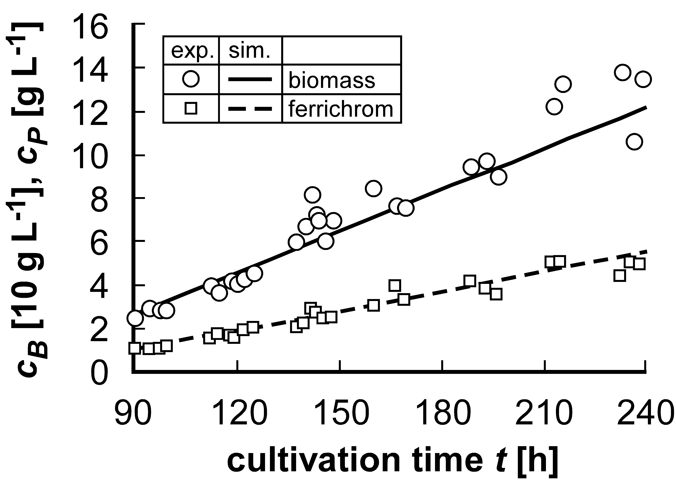
Figure 1: Biomass C_{B} and Ferrichrome C_{P} concentration in the continuous growth rate.
The model developed is used to describe the considered MBR process at the given conditions including mass balances and kinetics, with the kinetic parameters being subject to changes during the fermentation [4]. Here, the numbers of variables and parameters Θ to be estimated are 6 and 11, respectively. The resulting DAE system is discretized using the orthogonal collocation in finite elements with 5 collocation points.
  - Solution approaches
    - Parameter estimation
In this work, a constrained least squares estimation is used to decompose the problem according to the sequential three-stage estimation framework we proposed in [5]. The upper stage solves the actual parameter estimation problem in which the variables and are considered as functions of .

(1)

The nonlinear optimization is carried out with a sequential adjustment of the weighting matrix [6]. Thus, in order to scale the different values in the objective function and to consider the accuracy of the measurement devices, the inverse of the variance-covariance matrix of the measurement errors is used as a weighting in the objective function (eq. 1). Here, the variances of the optimization variables and the sensitivities of the measured variables with respect to the optimization variables are also included in addition to the variance of the measurements [7].

    - Identifiability analysis
However, prior to the parameter estimation, an identifiability analysis is carried out so as to obtain the information corresponding to the quality of the parameter estimation and the uniqueness of the optimal parameter set [8]. This depends on the nature of the experimental data and the model structure. For this purpose, the Fischer Information Matrix is used (eq. 2) which contains the information about the parameter sensitivities and measurements errors.

(2)

The eigenvectors of FIM define the principal information directions in the space state. These represent the linear combinations of the original state variables whose estimates are uncorrelated and define the confidence region of the parameter estimation. In this study, we use the E-Criterion for the identifiability analysis (). Here, the lengths of the axes of the confidence ellipsoids are proportional to the inverse of the square roots of the corresponding eigenvalues. The E-criterion maximizes the smallest eigenvalue of the FIM and thereby minimizes the length of the largest axis of the confidence ellipsoids. Thus, it aims at minimizing the largest parameter error and thereby at maximizing the distance from the singular unidentifiable case.

    - Co-linearity index
In this study, the co-linearity index is used which quantifies the minimum achievable norm of a linear combination of the sensitivity functions.

(3)

In Eq. 3 the denominator represents the application of the E-criterion. Thus, the higher the co-linearity index is the lower the confidence region and consequently the identifiability is lower. Brun et al. propose in [9] a co-linearity threshold for identifiable parameter set to be between 5 and 10. However, appropriate values of strongly depend on the number of parameters, equations, variables, linearity among others. In order to exclude parameters which are not sensitive, in this work a top-down classification of the 11 parameters were performed. Those parameters which caused the highest parameter estimation error are kept out from the parameter set which is to be identified. Thus, from the initial 11 parameters the number of parameters was reduced to 8 parameters. It was also found that the best results are given at the maximal co-linearity index value of 1.5 which represents then an upper bound. Based on this, the parameters, which cause the maximum error estimation (linear dependent from each other) are then excluded and kept constant to some initial values.

    - Tailored time horizon
In order to deal with the dynamic character of the parameters within the estimation procedure, the total time horizon is divided in sequential intervals of different lengths. The key idea is to select those intervals which guarantee the maximum possible informational content for the parameters to be identifiable while each interval is selected as short as possible such that it can address the sequential changes on parameters values regarding time. By this means, we optimize for “identifiable” subsets of the experimental data by evaluating the co-linearity index. The minimal length corresponds to 4 data points.

The solution procedure starts from the first experimental data point after the batch phase until the horizon length reaches the last experimental point. The strategy can be stated as follows: if the co-linearity index is lower than the given maximal value then this horizon length is adopted. Otherwise, the time window will be increased by one data point until the upper bound of the co-linearity index is satisfied.

Figure 2: Solution strategy for data points within the time horizon.

Figure 3: Comparison of experimental data and simulation for 5 identifiable intervals [8 5 5 6 10].
Based on the proposed approach, Fig. 3 show the results concerning the different intervals of data points in which the model is identifiable i.e. the algorithm estimates the most suitable horizon length in which the parameter adaptation/estimation should be carried out.
    - Online strategy
On-line state estimations based on the moving horizon strategy have been implemented for several applications, demonstrating an advantage over extended Kalman-filtering because of robustness despite poor initial values and the comfortable use of constraints on state and parameter variables. Moreover, taking into account only recent measurements for the estimation of kinetic parameters, it is possible to distinguish values that vary during the progress of the estimation time frame. In this section, we extent the proposed optimization-based approach in order to improve the predictivity of kinetic models based on available measurements together with a process model. The algorithm is based on a moving horizon-based approach to estimate kinetic parameters of the nonlinear model. The general moving horizon formulation follows [10] in using a number of recent measurements for the estimation, resulting in a moving time frame that keeps progressing as cultivation time proceeds during the tested experiments. However, in this case the horizon length is not previously fixed and will be adjusted.

Figure 4: Online strategy for the identifiable moving horizon window.
For this purpose, the previous proposed “offline” solution strategy so as to determine the identifiable number of data points within the time horizon can be carried forward to an online strategy following the principle of the moving horizon procedure. In this case, as the newest data point is arriving, while the experiment is running, the length of the window will be determined / adapted online. Thereafter, the parameter estimation is run as stated in the previous sections. The number of data points within the mowing horizon window is then given based on the co-linearity index. In addition, there is also an attempt to reduce the window (on the left side of the mowing horizon) by eliminating older data points
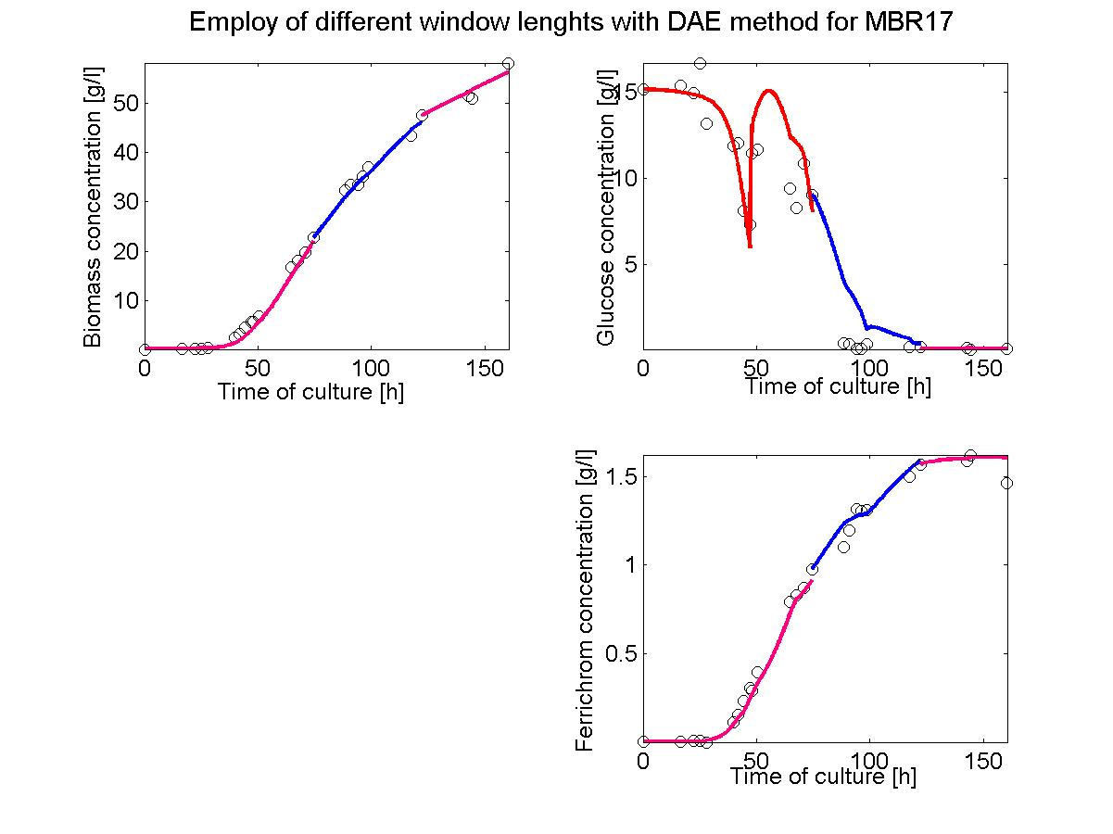
Figure 5: MHE moving horizon estimator with different window lengths [9-10-9].
In Fig. 5 the results of the moving horizon estimator with different horizon lengths is shown. Thus, setting suited horizon lengths and also parameter bounds was found to be crucial for convergence and parameter estimation.
  - Conclusions
In this work, an optimization-based approach has been applied to improve the predictivity of kinetic models based on available measurements together with a process model i.e. a dynamic automatic adjustment to varying kinetics is possible. The approach has been validated using initially offline experimental data from cultivations of Ustilago maydis. An improved MHE was successfully applied to predict changes during the membrane bioreactor fermentation. Moreover, based on identifiability analysis and the co-linearity index a suitable horizon length can be determined both for the reliable parameter estimation as well as for the moving horizon length. The developed approach is being extended to enable the implementation of model-based control.
References
[1] Ihssen, J., Egli, T., 2004. Specific growth rate and not cell density controls the general stress response in Escherichia coli. Microbiology 150, 1637-1648.
[2] Pirt, S.J., 1965. The maintenance energy of bacteria in growing cultures. Proc. Of the Royal Society of London 163 B, 224-231.
[3] Drews, A., Kraume, M., 2007. On Maintenance Models in Severely and Long-Term Limited Membrane Bioreactor Cultivations. Biotechnology and Bioengineering 96(5), 892-903.
[4] Drews A, Arellano-Garcia H, Wendt M, Kraume M, Wozny G. 2006. ESCAPE16/PSE9, CACE 21A (Eds.: Marquardt W., Pantelides C.), Elsevier, pp. 309-314.
[5] Faber, R., Arellano-Garcia, H., Wozny, G., 2007. An Optimization Framework for Parameter Estimation of Large-Scale Systems. Chemical and Process Engineering, in press.
[6] Faber R., Arellano-Garcia H., Wozny G., 2006, Improving Observability of Large-Scale Systems by Iterative Weighting Adjustment. ESCAPE16/PSE9, CACE 21A (Eds.: Marquardt W., Pantelides C.), Elsevier, pp. 1467-1472.
[7] Chen H., Asprey S., Ind. Eng. Chem. Res. 2003, 42(7), 1379-1390, doi:10.1021/ie0203025.
[8] Dochain et al. 1995, Structural identifiability of bio kinetic models of adaptive sludge respiration. Water Research, 29(11), 2571-2578.
[9] Brun et al. 2002, Practical identifiability of ASM2d parameters—systematic selection and tuning of parameter subsets. Water Research 36 4113–4127.
[10] Robertson DG, Lee JH, Rawlings JB. 1996. AIChE Journal 42:2209-2224.

