Multiobjective Optimization of a Liquid-Feed Direct Methanol Fuel Cell
Ilyong Jeong, Jiyong Kim, Junghwan Kim, Il Moon
Department of Chemical Engineering, Yonsei University, 134 Sinchon-dong, Seodaemun-gu, Seoul 120-749, Korea
Abstract
This research aims to obtain multiobjective Pareto optimal operating strategies for a liquid-feed direct methanol fuel cell. The total amount of the methanol consumption and the total number of control actions compose two conflicting objective functions both to be minimized. To consider the real operational phenomena, the multiobjective dynamic optimizations are performed under six scenarios with different history of power load. Finally, the optimal methanol feeding strategies on each Pareto point are obtained to suggest the operation basis between efficient and easy operations.

Keywords: Multiobjective optimization, Direct methanol fuel cell, Optimal operation
  - Introduction
The direct methanol fuel cell (DMFC) is a hot research topic as a power source for portable electronic and vehicular applications for its high energy density, using an inexpensive liquid fuel, employing solid polymer electrolyte, and working at relatively low temperature. However, in practice, DMFC suffers from much lower open circuit voltage (OCV) than other types of fuel cell. The major reason is that methanol permeates into the proton exchange membrane (PEM) to reach the cathode catalyst layer and form a mixed potential that decreases the cell voltage. This phenomenon, called a methanol crossover, not only causes a waste of fuel but also lowers the performance of fuel cell [1]. It is very important, therefore, to predict the methanol crossover and find the operating conditions that can reduce the methanol crossover. The DMFC consists of seven layers: a PEM, two catalyst layers, two diffusion layers, and two flow channels, and produces electricity by the flows of protons and electrons made from the anodic reaction and consumed by cathodic reaction. Fig. 1 shows the basic structure and the reaction scheme of DMFC.
CH₃OH + H₂O
CH₃OH + H₂O + CO₂
e⁻
e⁻
Anode
Cathode
Air
Air + H₂O +CO₂
Proton exchange membrane
Catalyst layer
Compartment
(diffusion layer + flow channel)
H⁺
H₂O
CH₃OH
CH₃OH
CO₂
O₂
H₂O
Figure 1. Basic structure and reaction scheme of DMFC
Recently, lots of researches have focused on predicting the methanol crossover of DMFC using modeling works [2-5] as well as experimental methods [1]. Danilov et al. [2] developed a three-dimensional, two-phase CFD model to predict the internal phenomena of a DMFC. Sundmacher et al. [3] developed a dynamic differential algebraic equations (DAEs) model and simulated the cell voltage response to dynamic changes of methanol feed concentration to find that the periodically pulsed methanol feeding can reduce the methanol crossover. They used an anodic reaction mechanism which consists of four steps and derived an analytical solution of anodic reaction rate assuming that the first reaction step is rate determining. Jeng and Chen [4] developed a one-dimensional steady-state model on the anode side of DMFC and found that the methanol crossover becomes serious at low current density and high methanol concentration. Schultz and Sundmacher [5] improved their previous work [3] into a partially one-dimensional dynamic model to show the flow directional behaviors in PEM and diffusion layers. Xu et al. [6] maximized the integration of cell voltage over the entire time domain under the constant cell current density adopting the model of Sundmacher et al. [3] to get the optimal feed concentration.
In this research, we formulate a multiobjective dynamic optimization problem for the optimal operation of DMFC. One of the two conflicting objective functions, the total amount of the methanol consumption is minimized to increase the efficiency under given power load. The other is the total number of control action to be minimized. Though both objective functions are supposed to be optimized, one cannot be improved without deteriorating another in the nature of DMFCs. From the multiobjective optimization results, the optimal feeding strategies for each Pareto optimal point are obtained to decide between the efficient and easy operations of DMFC.
  - Mathematical Formulation
For the multiobjective dynamic optimization, we developed dynamic DAEs for a single cell of DMFC and performed the parameter estimation to fit the experimental data. Based on the DAEs, the MOOP is formulated to minimize the amount of methanol consumption and the total number of control actions simultaneously.
    - Differential Algebraic Equations for DMFC
The DAEs of DMFC consist of material balances for methanol and carbon dioxide, anodic and cathodic charge balances and reaction rate equations, the flux equation of methanol crossover, and many other equations for electrochemistry and physical properties. The basic assumptions and fundamental balanced equations of this research are taken from Sundmacher et al. [3].
It is known that the reaction mechanisms of the electrochemical methanol oxidation at anode catalyst layer and the oxygen reduction at cathode catalyst layer are complicated with several possible intermediates [3,5]. However, to keep the number of unknown parameters small, Butler-Volmer type equations are applied:
(1)
(2)
The driving forces of the methanol crossover through the PEM are the methanol concentration of anode catalyst layer and the superficial velocity of the water in the PEM, v^{M} = M_{w}(λ_{w}/ρ_{w})(i_{cell}/F). The methanol crossover flux can be derived assuming both anodic and cathodic sides of the PEM to be fully hydrated [4]:
(3)
    - Parameter Estimation
We selected five parameters to be estimated from the model equations (α_{a}, α_{c}, k_{a}, k_{c}, and k^{LS}) and performed the estimation using the same manners as the experimental method as shown in Fig. 2 (a). The parameter estimation minimizes the difference between the experimental data from Sundmacher et al. [3] and the cell voltage responses to the piece-wise step inputs of cell current density for the methanol feed concentration of 500 and 2000 mol/m³ simultaneously. The polarization curves from the estimation results show a good agreement with experimental data for both feed concentrations as shown in Fig. 2 (b). Table 1 summarizes the estimated values of five parameters.
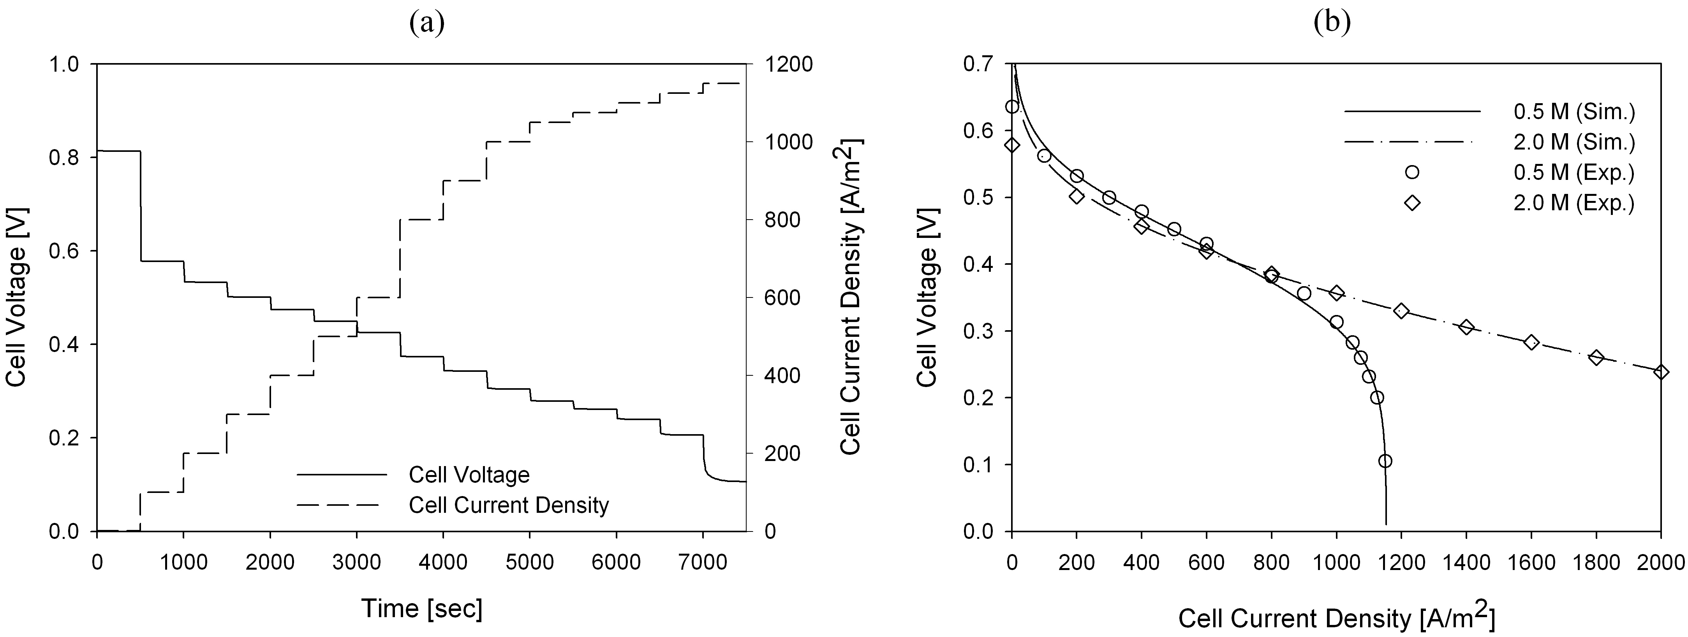
Figure 2. (a) The dynamic response of the cell voltage to the step change of cell current density when the feed concentration of methanol is set to 500 mol/m³ and (b) the predicted polarization curves with experimental data from [3].
Table 1. Parameter estimation results.
Parameter | Estimated value
Anodic charge transfer coefficient, α_{a} | 0.6033
Cathodic charge transfer coefficient, α_{c} | 0.3756
Rate constant of anodic reaction, k_{a} [mol/m²/sec] | 2.159×10⁻⁷
Rate constant of cathodic reaction, k_{c} [mol/m²/sec] | 2.285×10⁻³
Mass transfer coefficient, k^{LS} [m/sec] | 4.737×10⁻⁶
    - MOOP Formulation
      - The total amount of the methanol consumption
The first objective function to be minimized is the total amount of the methanol consumption. It consists of the amount of methanol reacted, crossovered to cathode, and left in anode compartment and catalyst layer at the end of operation.
(4)
Minimizing the methanol consumption improves the efficiency of DMFC and reduces the size of the fuel storage device to devote to the miniaturization of commercial DMFC system, but requires complicated control actions.
      - The total number of control actions
The total number of control actions (TNCA) can be defined as the multiplication of the number of control actions per control step (NCA) and the number of control steps (NS).
(5)
Minimizing the TNCA can improve the ease of operation to reduce the parasitic electrical power for control and the possibility of mechanical trouble. The efficiency, on the other hand, might be deteriorated according to the minimization of the TNCA.
      - The formulation of the multiobjective dynamic optimization
Using (4) and (5) the following multiobjective function is proposed as follows:
(6)
Where, f and I means the model equations and the initial conditions respectively. At the end of operation, the cell voltage should satisfy the lower bound. The power density can be loaded based on the operation scenario. Finally, the optimal dynamic profiles of methanol feed concentration will be determined corresponding to the Pareto optimal points as the results of multiobjective dynamic optimization.
  - Case Studies
We generated six scenarios as shown in Table 2 to consider the real operational phenomena of DMFC. Each scenario has four steps with the total operation time of 930 sec. At Step 0, the methanol of 500 mol/m³ is fed from the initial zero holdup without power density load for 30 sec. From Step 1 to 3, three different power densities are loaded to the fuel cell at each step for 300 sec respectively; 460 W/m² (high), 430 W/m² (normal), and 400 W/m² (low). The operation will be terminated with three types of power density load that strongly affect the characteristics of Pareto curves.
Table 2. Scenarios for case studies
Scenario No. | Step 0 | Step 1 | Step 2 | Step 3
1 | Feeding | High | Normal | Low
2 | Feeding | Normal | High | Low
3 | Feeding | High | Low | Normal
4 | Feeding | Low | High | Normal
5 | Feeding | Normal | Low | High
6 | Feeding | Low | Normal | High
  - Results and Discussion
    - Pareto Optimal Solutions
As the final results, this study forms the noninferior solution curves for the trade-off between the conflicting objectives as shown in Fig. 3 (a). The Pareto curve of Scenario 1 is located in the bottom and Scenario 6 is in the top among six curves to explain that the more the operation starts from high power density load and ends in low power density load, the less the system consumes the feed even though the total power generations of each scenario are equal.
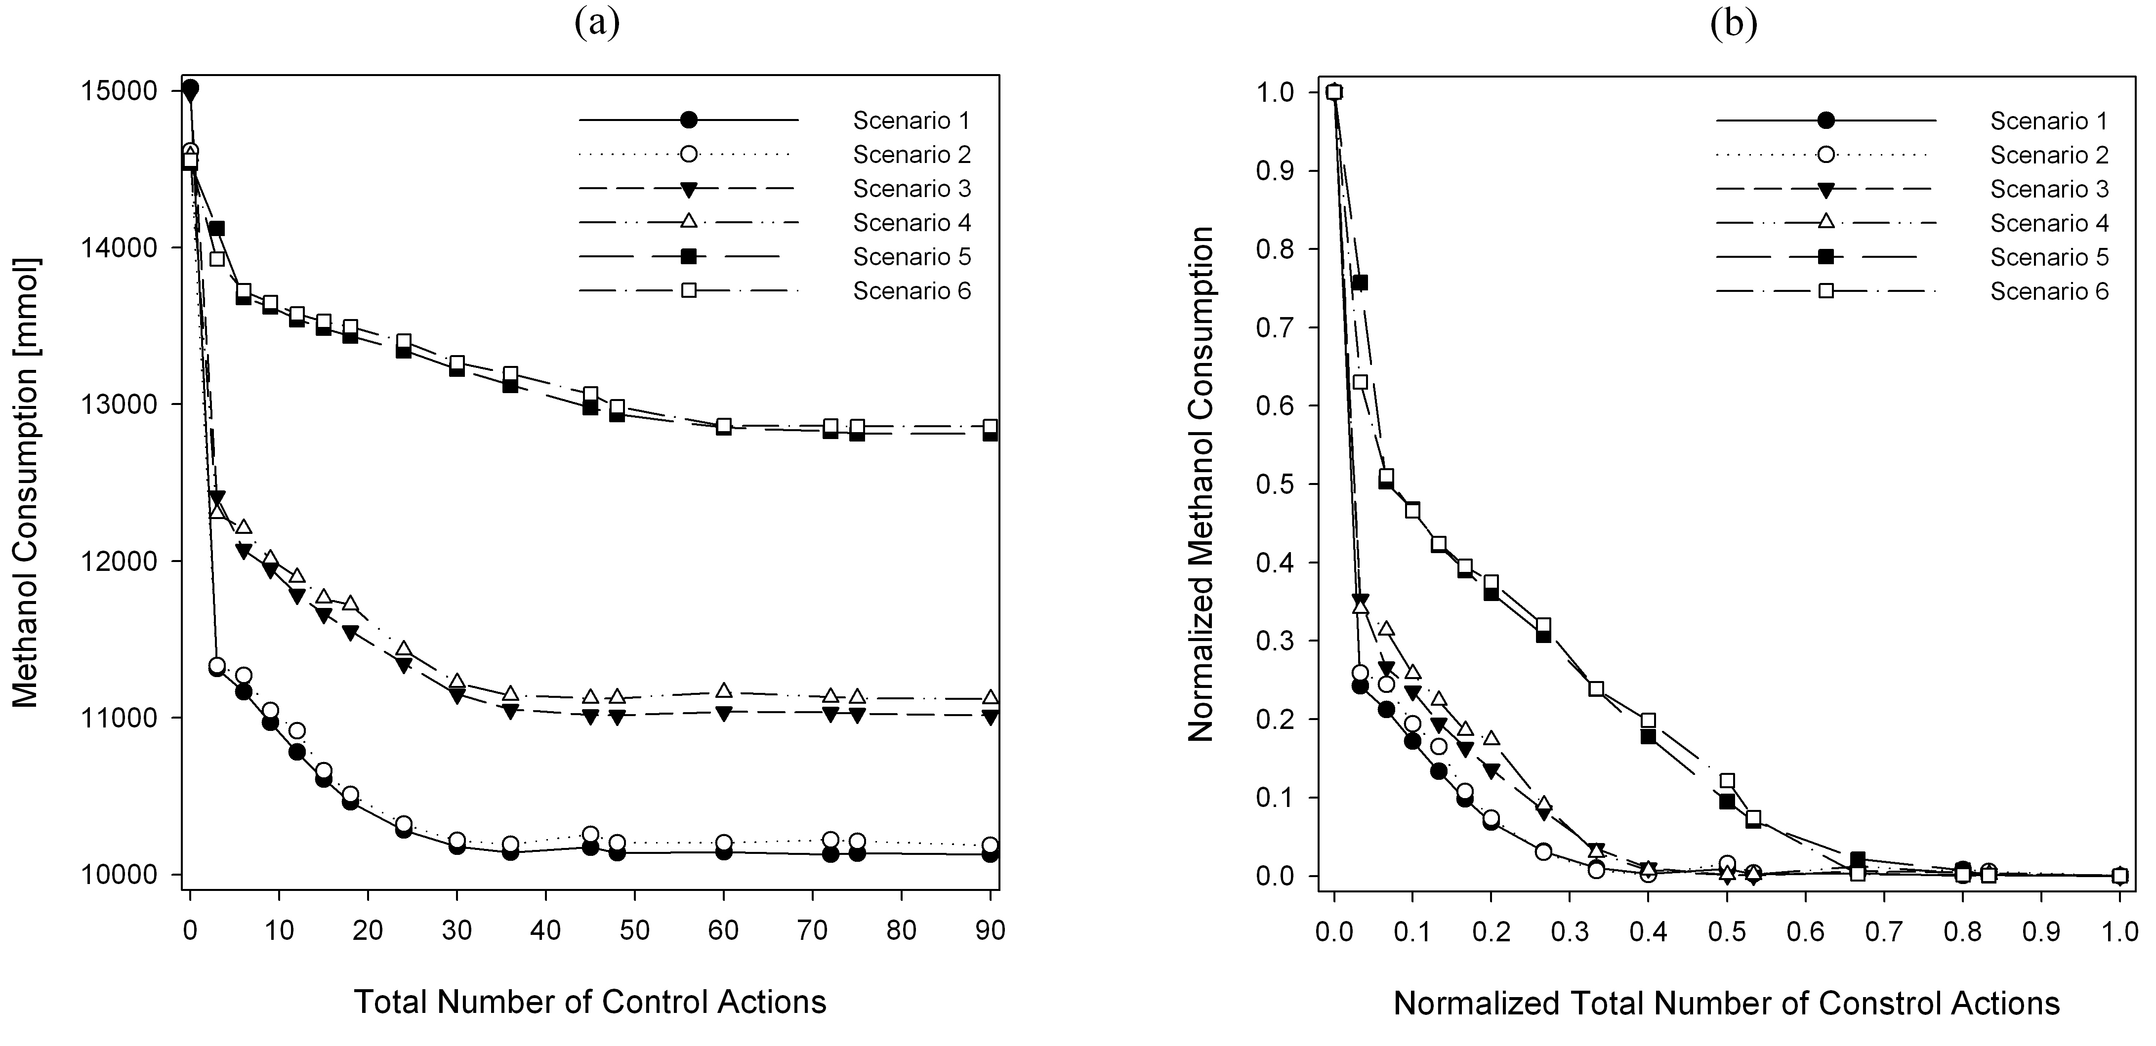
Figure 3. (a) Pareto optimal solutions and (b) normalized Pareto solutions for 6 scenarios.

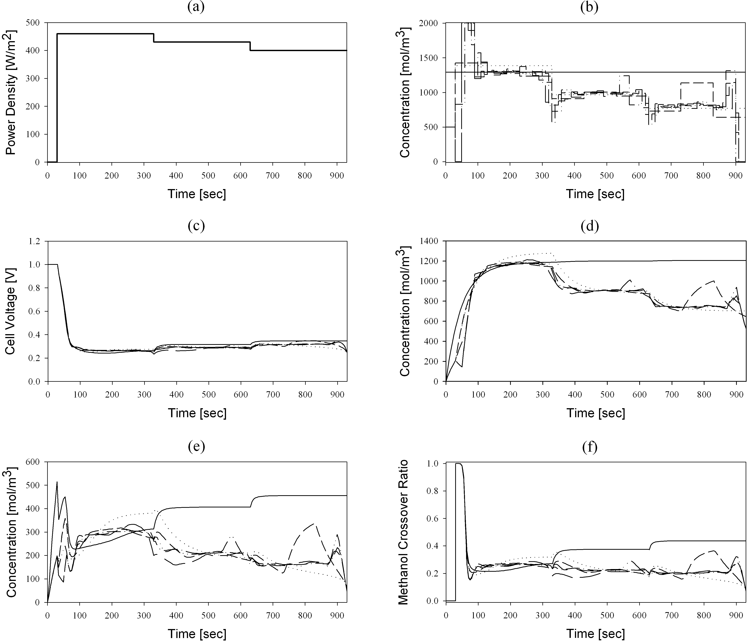
Figure 4. The optimal transient behaviors of Scenario 1. (a) Power density load, (b) optimal feed concentration of methanol, (c) cell voltage, (d) methanol concentration in anode compartment, (e) methanol concentration in anode catalyst layer, and (f) methanol crossover ratio. TNCA = 0: solid, 3: dotted, 9: short dash, 30: dash-dot-dot, 45: long dash, and 90: dash-dot.
This characteristic has influence on the degree of the convexity of the normalized Pareto curves as seen in Fig. 3 (b).
    - Transient Behaviors of Optimal Solutions
Fig. 4 shows the optimal transient behaviors of Scenario 1 when the TNCA is 1, 3, 9, 30, 45, and 90. When the power density load follows the feeding-high-normal-low strategy (Fig. 4 (a)) the optimal feed concentration of methanol changes dramatically according to the increase of the TNCA (Fig. 4(b)). This implies that the large TNCA results in the difficulty of operation in spite of improving the efficiency of DMFC. Fig. 4 (c) shows that the cell voltage remains OCV at the feeding step and drops suddenly to nearly 0.3 as the power density starts to be loaded. Fig. 4 (d) and (e) show the dynamic behaviors of the methanol concentration in anode compartment and catalyst layer respectively. From Fig. 4 (f), we can find that the methanol crossover ratio goes stiffly up to the maximum value at the start of power density load and goes down to about 0.2 after 40 sec or more regardless of the value of the TNCA. This behavior answers the well-known fact that the methanol crossover shows a predominant occurrence especially when the fuel cell starts to produce the electrical power.
  - Conclusions
In this study, we have introduced a multiobjective dynamic optimization problem to the optimal operation of DMFC. One of the conflicting objectives, the total amount of the methanol consumption is selected to consider the efficiency of the system. The other is the total number of control actions which affects the difficulty of the operation of DMFC. The dynamic MOOP minimizes the two objective functions simultaneously to obtain the optimal operating strategies corresponding to each Pareto optimal point that can be the decision basis between the efficient and easy operations. To consider the real operational phenomena of DMFC, we performed the case studies for six scenarios. The optimal transient behavior of the methanol crossover ratio proves that the methanol crossover becomes salient at the startup operation.
Acknowledgements
This work was supported by the Ministry of Education (MOE) of Korea by its BK21 Program.
References
- T. H. Kim and Y. C. Bae, A semi-empirical cell voltage model for the direct methanol fuel cell: the methanol crossover effect, Polymer, 46, 6494-6499 (2005).
- V. A. Danilov, J. Lim, I. Moon and H. Chang, Three-dimensional, two-phase, CFD model for the design of a direct methanol fuel cell, Journal of Power Sources, 162, 992-1002 (2006).
- K. Sundmacher, T. Schultz, S. Zhou, K. Scott, M. Ginkel, and E. D. Gilles, Dynamics of the direct methanol fuel cell (DMFC): experiments and model-based analysis, Chemical Engineering Science, 56, 333-341 (2001).
- K. T. Jeng and C. W. Chen, Modeling and simulation of a direct methanol fuel cell anode, Journal of Power Sources, 112, 367-375 (2002).
- T. Schultz and K. Sundmacher, Rigorous dynamic model of a direct methanol fuel cell based on Maxwell–Stefan mass transport equations and a Flory–Huggins activity model: Formulation and experimental validation, Journal of Power Sources, 145, 435-462 (2005).
- C. Xu, P. M. Follmann, L. T. Biegler, and M. S. Jhon, Numerical simulation and optimization of a direct methanol fuel cell, Computers and Chemical Engineering, 29, 1849-1860 (2005).

