Novel convex underestimators and their application to the synthesis of combined reaction distillation processes
Matthias Jachª, Achim Kienle^{b,c}*, Dennis Michaelsª, Robert Weismantelª
ªInstitut für Mathematische Optimierung, Otto-von-Guericke-Universität Magdeburg, Universitätsplatz 2, 39106 Magdeburg, Germany
^{b}Max-Planck-Institut für Dynamik komplexer technischer Systeme, Sandtorstr. 1, 39106 Magdeburg, Germany
^{c}Institut für Automatisierungstechnik, Otto-von-Guericke-Universität Magdeburg, Universitätsplatz 2, 39106 Magdeburg, Germany
Abstract
Relaxation is a powerful tool for determining global bounds on optimal solutions in chemical process synthesis. In the present paper new results for the relaxation of affine rational functions are given, which play a major role in chemical engineering. Application is discussed for combined reaction distillation processes. A metathesis reaction system is considered as a benchmark problem.

Keywords: Process synthesis, Optimization, MINLP, Reaction separation process.
  - Introduction
The optimal design of chemical processes using mathematical optimization often leads to mixed-integer nonlinear programs (MINLP). Due to nonconvexity MINLP problems are usually difficult to solve. Typically either gradient based local optimization methods are used for this purpose or stochastic optimization methods like simulated annealing or genetic algorithms (see e.g. [5]). However, in both cases no guarantee can be given that the solution found by the algorithm is the global optimum.
Figure 1: Polyhedral relaxation of a nonlinear function and successive refinement

To overcome this problem, polyhedral relaxation can be applied [2] (see Fig. 1). In this approach a hierarchy of enclosing polyhedra is constructed for the underlying nonlinear functions leading to a hierarchy of mixed-integer linear programs (MILP) which, in principle, can be solved rigorously if not too complex (see [3] for a discussion of complexity issues). Since the feasible set of the original nonlinear problem lies within the feasible set of the relaxed problem, the latter provides global lower bounds for the optimal solution of the original problem. This can be efficiently used for excluding uneconomic design alternatives already at an early stage of the process synthesis procedure. The lower bound approaches the true global optimum as the number of grid points of the relaxation is increased. Application was demonstrated in [2] for the synthesis of combined reaction separation processes for the production of 2,3-dimethylbutene-1 through isomerization of 2,3-dimethylbutene-2.

The success of this approach crucially depends on the construction of tight problem specific polyhedral relaxations. Dominating nonlinearities for combined reaction separation processes are phase equilibrium relations and reaction kinetics. In the present paper, new results are given for polyhedral relaxation of affine rational functions and bivariate quadratic polynomials. The results are applied to the global optimization of a reaction separation process for the production of 2-butene and 3-hexene from 2-pentene through a metathesis reaction. Complexity, of this benchmark problem has increased compared to the previous isomerization example due to the presence of a third component.
  - Methods
For finding good polyhedral relaxations by means of convex and concave envelopes, we can distinguish two computational approaches. In the first case, supporting hyperplanes are determined only for points of the generating sets of these envelopes. With a growing number and an appropriate choice of these hyperplanes the polyhedral relaxation can be made arbitrarily close. As an example we describe computing those hyperplanes for a family of affine-rational functions. In the other approach, the value of either envelope and the directions of a supporting hyperplane at an arbitrary point are computed. This procedure in general requires more specific algebraic properties of the given function such that the computation remains tractable. We demonstrate this approach for the case of bivariate quadratic polynomials.

    - A family of affine rational functions
Let f: D = [l,u] in R^{n} → R, $x↦\frac{a^{T}x+a_{0}}{b^{T}x+b_{0}}$, be given such that (a_{i},b_{i}) ≠ (0,0) for each variable index and the denominator is positive w. l. o. g. In the following we outline an algorithmic scheme for determining closest possible hyperplanes at the epigraph of the convex envelope vex_{D}[f] of f. The case for the concave envelope can be treated similarly.

Definition: Letting N = {1, …, n}, we define an equivalence relation via
$i\text{\sim }j⇔a_{i}b_{j}−a_{j}b_{i}=0$ (1)
with equivalence classes N₁, …, N_{k}. When k = 2, we will denote by F₂ the family of functions f that are convex, but not affine in the variables x_{i}, …, x_{m} associated with N₁ whenever the variables x_{m+1}, …, x_{n} associated with N₂ are fixed and concave (and possibly affine) vice versa.

We remark that these conditions can be easily checked by evaluating the signs of the second derivatives ∂²f/∂x_{i}². In particular, it follows from the non-affinity condition that b_{i} ≠ 0, i = 1,…,m.

We now proceed to present the steps for calculating supporting hyperplanes at the epigraph of vex_{D}[f] when f belongs to F₂. Along the description of this scheme we give arguments for the fact that by this process maximally touching hyperplanes can be constructed.

Step 1 (Generating set): Under our assumptions the generating set of vex_{D}[f] can be taken to be the set
$A:=\underset{(x_{m+1},…,x_{n})∈\left\{l_{m+1},u_{m+1}\right\}×…×\left\{l_{n},u_{n}\right\}}{}\left[l_{1},u_{1}\right]…×\left[l_{m},u_{m}\right]\left\{x_{m+1}\right\}…×\left\{x_{n}\right\},$
being the union of 2^{n−m} m-dimensional faces of the polyhedron D. This follows directly from the properties of generating sets of envelopes over faces of a polyhedral domain.

The set A can be specialized even further. To see this, consider a face F in the union A, i. e. the variables x_{m+1}, . . . , x_{n} are fixed to one of their bounds. On F, the value f(x) can be written as
$f(x)=\frac{a_{N_{1}}x_{N_{1}}+α_{0}}{b_{N_{1}}x_{N_{1}}+β_{0}},$
where α₀ and β₀ are constants and a vector v_{N1} is constructed from the vector v with its components restricted to the index set N₁. It is readily verified that for i = 2, . . . ,m, the condition
$\frac{∂f}{∂x_{i}}(x)=\frac{b_{i}}{b_{1}}\frac{∂f}{∂x_{1}}(x)$ (2)
holds. In addition, for a vector y in F and using the relation (1), the points x in F satisfying
$\left(\sqrt{\left|\frac{∂f}{∂x_{1}}(y)\right|}=\right)\frac{\sqrt{\left|a_{1}β_{0}−b_{1}α_{0}\right|}}{b_{N_{1}}y_{N_{1}}+β_{0}}=\frac{\sqrt{\left|a_{1}β_{0}−b_{1}α_{0}\right|}}{b_{N_{1}}x_{N_{1}}+β_{0}}$ (3)
form a set G(y) which is the intersection of an affine subspace of dimension m − 1 and the face F. By the equality (2), in G(y) the gradient of f restricted to the space of x₁, . . . , x_{m} is constant, i. e. f is affine on G(y). Thus, only the vertices of G(y) can be contained in the minimal generating set of vex_{D}[f]. Such a vertex necessarily lies in a one-dimensional subface of F. Indeed, each point which is contained in a one-dimensional subface is an extreme point of the graph of vex_{D}[f] since f is assumed to be strictly convex over these subfaces.

Step 2 (Selection of supporting point): Let y be any point chosen from one of the faces, sayF⁰. Set $C:=\sqrt{\left|∂f/∂x_{1}(y)\right|}$.

Step 3 (Representatives of faces): Let F be a face in the union A not containing y. In the affine space S = aff(F), the set
$H:=\left\{z∈S|\sqrt{\left|∂f/∂x_{1}\left(z\right)\right|}=C\right\}$
is an (m−1)-dimensional affine subspace. This space either has a point z_{F} with F in common (as a solution to a linear system of equations) or some vertex z_{F} of F is nearest to it (calculating the distance of finitely many points to a hyperplane. In each case, we find a representative point z_{F}.

Step 4 (Validity check): If (y,f(y)) and n−m points
$(z_{F^{1}},f(z_{F^{1}})),…,(z_{F^{n−m}},f(z_{F^{n−m}}))$
are affinely independent in R^{n+1}, the unique hyperplane which contains these points and is tangent to the graph of f in the first m components is valid for and maximally touching at the graph of vex_{D}[f] if it is valid for all points
$$(z_{\tilde{F}},f(z_{\tilde{F}})),\tilde{F}⊆A−(F^{0}∪…∪F^{n−m})\text{.}$$
Since f is convex on each face contained in A, validity is easily checked using subgradients. Maximality follows from the fact that the restriction of the hyperplane to the set F₀ is tangent to the epigraph at (y,f(y)). If the selection procedure for the point y and the points z_{F} is modified in the sense that for each i = 1,…,m, there is at least one point whose partial derivative ∂f/∂x_{i} yields one direction of the supporting hyperplane (not necessarily the point y), each maximally touching hyperplane can be constructed. We refrain from presenting the technical details of this procedure.

We remark that, to the best of our knowledge, directly applicable formulas or schemes for constructing or approximating envelopes of affine-rational functions have previously only been given for the bivariate case when |N₁| = |N₂| = 1, e. g. in [6].

    - Bivariate quadratic polynomials
In this section we present a full case distinction of bivariate quadratic functions and their convex and concave envelopes. To this end, consider the function f: D = [l,u] in R² → R defined by
$$f(x_{1},x_{2})=a_{\text{11}}x_{1}^{2}+2a_{\text{12}}x_{1}x_{2}+a_{\text{22}}x_{2}^{2}+b_{1}x_{1}+b_{2}x_{2}+c,$$
with all coefficients being real and (a₁₁,a₂₂) ≠ (0,0). Setting a₂₁ := a₁₂ we obtain the Hessian matrix H_{f} of f as H_{f} (x₁,x₂) = $\frac{1}{2}$ (a_{ij})_{1 ≤ i,j ≤ 2}.

In the case that H_{f} is positive (negative) (semi-)definite, f is convex (concave), and the envelopes are trivial to compute, since one envelope coincides with the function, and the other envelope is polyhedral. If H_{f} is indefinite and a₁₁a₂₂ < 0, the function f is convex in one variable and concave in the other one. In this case, disjunctive programming techniques as shown in [6] can be used to determine explicit formulas for the envelopes. To conclude the case distinction, we assume H_{f} to be indefinite, and w. l. o. g. that a₁₁ > a₂₂ > 0. Then f is convex in both directions, thus the concave envelope is polyhedral. Moreover, the convex envelope is composed of segments as recently described in [4], where explicit formulas are given as well.
Since a function remains a quadratic polynomial under the change of coordinates, the cases described above are likewise applicable when the domain D is a parallelogram.
  - Application
As an application example a combined reaction separation process for the production of 2-butene and 3-hexene from 2-pentene through a metathesis reaction 2 2-pentene $↔$ 2-butene + 3-hexene is considered. Reaction kinetics and phase equilibrium relations were taken from [1]. In particular, constant relative volatilities α_{i} can be assumed according to
$y_{i}=\frac{α_{i}}{1+\sum{(α_{k}−1)x_{k}}}$.
Reaction kinetics are given by
$r=M_{\text{cat}}κ_{f}(x_{\text{2-pentene}}^{2}−1κ_{\text{eq}}x_{\text{2-butene}}x_{\text{3-hexene}})$.
Both expressions are in the class of functions considered in the previous section, if, in addition, the summation condition is taken into account for the reaction kinetics. Parameters were taken from [1]. They are summarized in Table 1.

The process configuration to be considered is shown in Table 1. It consists of a nonreactive distillation column with a side reactor. In analogy to a previous paper [2], a simple optimization problem is considered for illustration purposes, i.e. the calculation of the minimum vapor flow rate for fixed process configuration using the novel relaxation method. Computational results and a comparison with our previous work will be presented at the conference.

Table 1. Configuration of the metathesis process and its parameters
Configuration | Parameter | Value
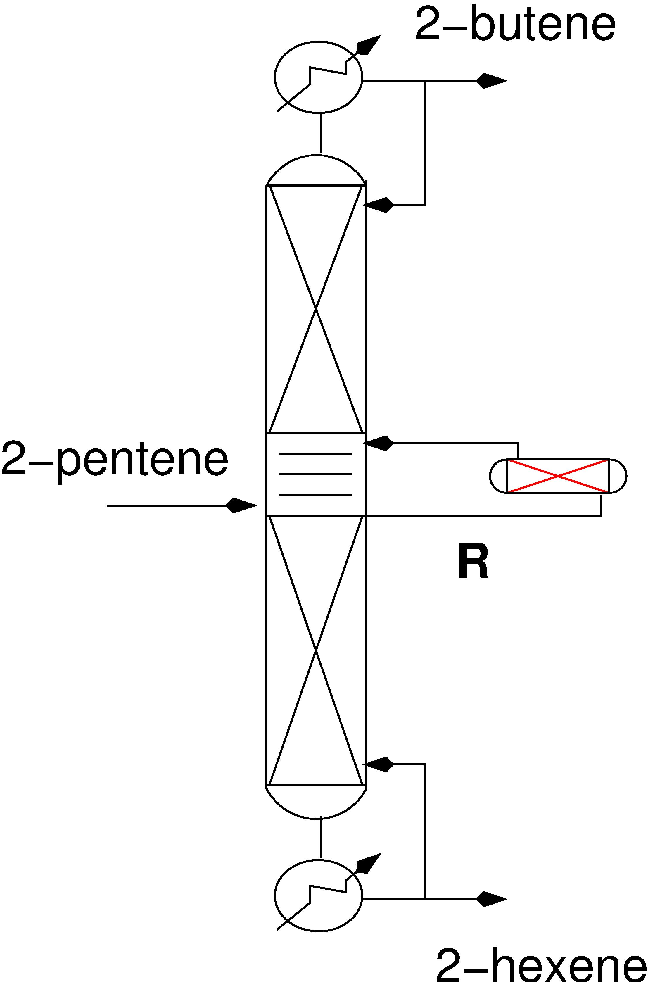 | F | 100.0
 | x_{F,pentene} | 1.0
 | M_{cat} | 200.0
 | R | 1000.0
 | α_{i} | [9.06, 2.65, 1.0]
 | κ_{f} | 2.90
 | κ_{eq} | 0.25
 | x_{D,butane} | ≥ 0.99
 | x_{B,hexane} | ≥ 0.99
 | number of trays in the
 | rectifying section | 9
 | number of trays in the
 | middle section | 4
 | number of trays in the
 | stripping section | 10
  - Acknowledgment
This research was supported by the German Science Foundation (DFG) within the joint research project 'Methods from Discrete Mathematics for the Synthesis and Control of Chemical Processes' under grants FOR 468 and KI 417/1.
References
[1] F. Chen, R. S. Huss, M. F. Malone, M. F. Doherty, Simulation of kinetic effects in reactive destillation, Comput. Chem. Engng, 24:2457–2472, 2000.
[2] J. Gangadwala, U. Haus, M. Jach, A. Kienle, D. Michaels, and R. Weismantel. Global analysis of combined reaction distillation processes, Comp. Chem. Engng., 32:343–355, 2008.
[3] J. Gangadwala, A. Kienle, U.-U. Haus, D. Michaels, and R. Weismantel. Global bounds on optimal solutions for the production of 2,3-dimethylbutene-1. Ind. Eng. Chem. Res., 5:2261–2271, 2006.
[4] M. Jach, D. Michaels, R. Weismantel, The convex envelope of (n-1)-convex functions, Manuscript, Universität Magdeburg; submitted for publication to SIAM Journal on Optimization, 2007.
[5] J. Marriott and E. Sorensen. The optimal design of membrane systems. Chem. Engng. Sci., 58:4991-5004, 2003.
[6] M. Tawarmalani, Nikolaos V. Sahinidis, Semidefinite Relaxations of Fractional Programs via Novel Convexification Techniques, Journal of Global Optimization, 20:137-158, 2001.

* Corresponding author. Email: kienle@mpi-magdeburg.mpg.de

